Workflow:

Packaged as application using

**npm install -g electron-packager --save-dev**

**npx electron-packager <appDirectory> appName --platform=win32 --arch=x64**

Eg:

npx electron-packager C:\Users\SK\Desktop\VScode\video-converter-electron video-converter-mp4-hls --platform=win32 --arch=x64

Electron application has been packaged into executable application for windows64x

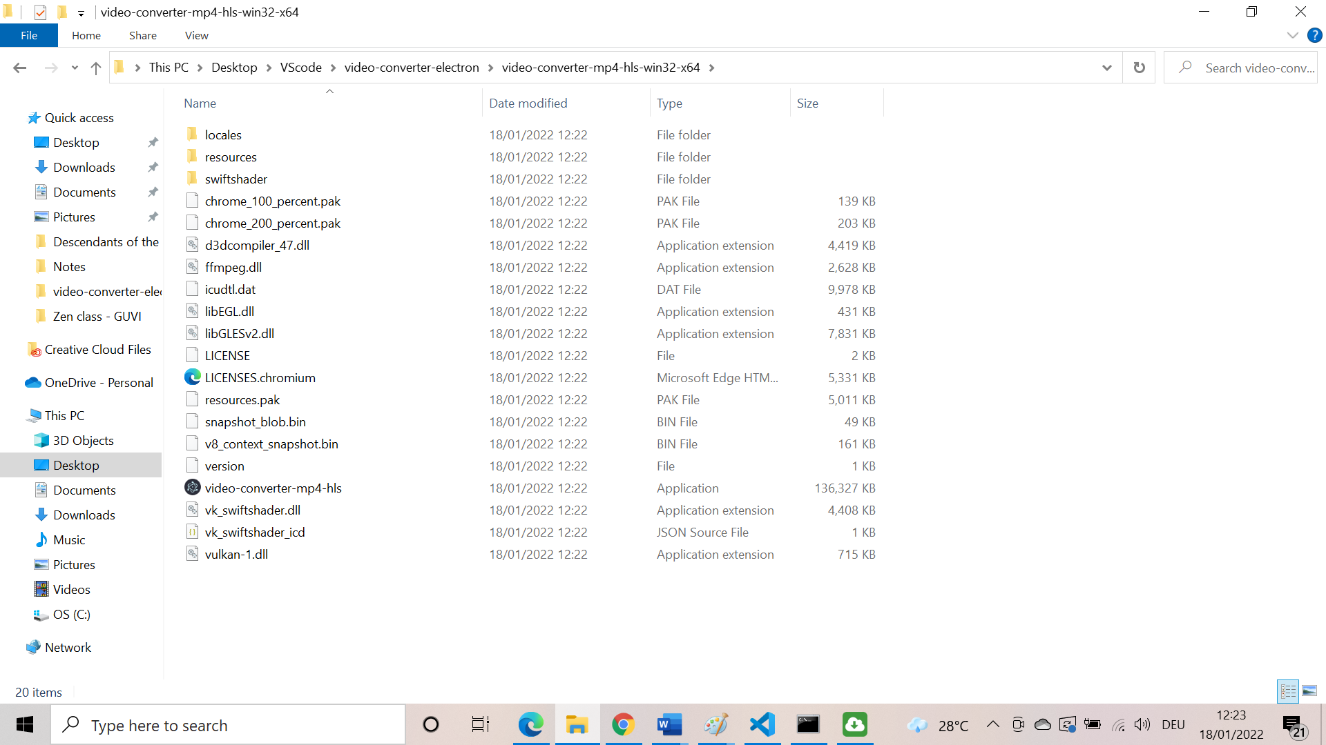

Opening the application

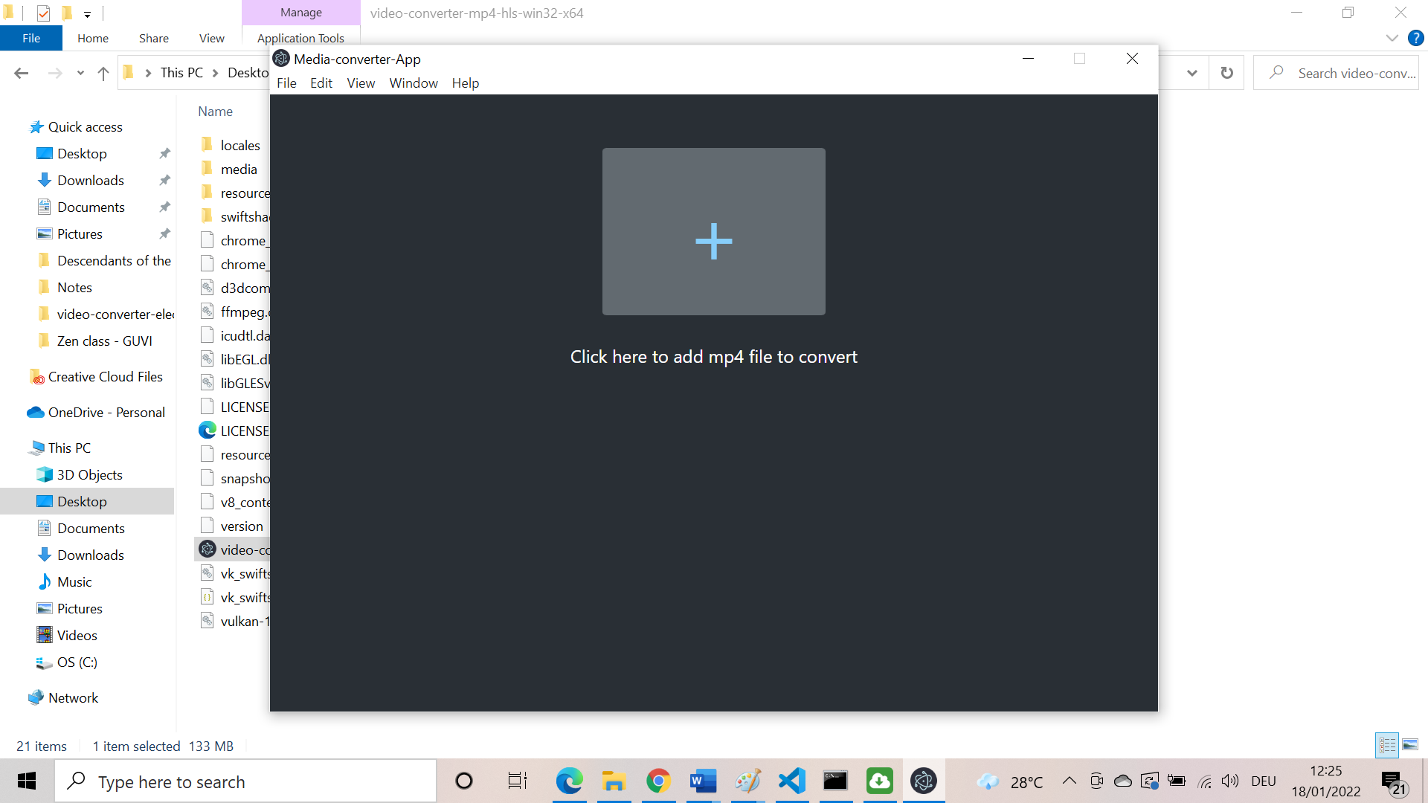

Choosing a file of different format(not mp4). It will throw an error

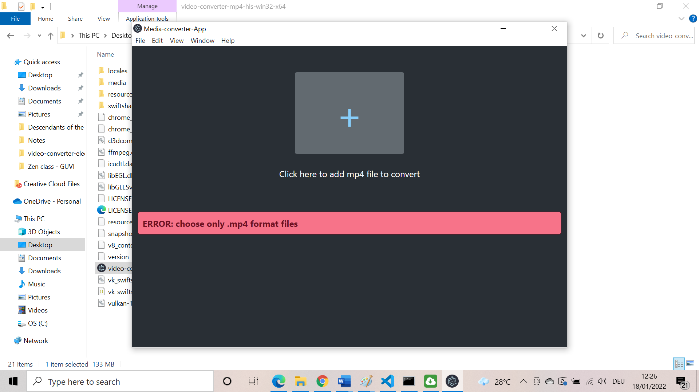

Choosing a mp4 file to convert

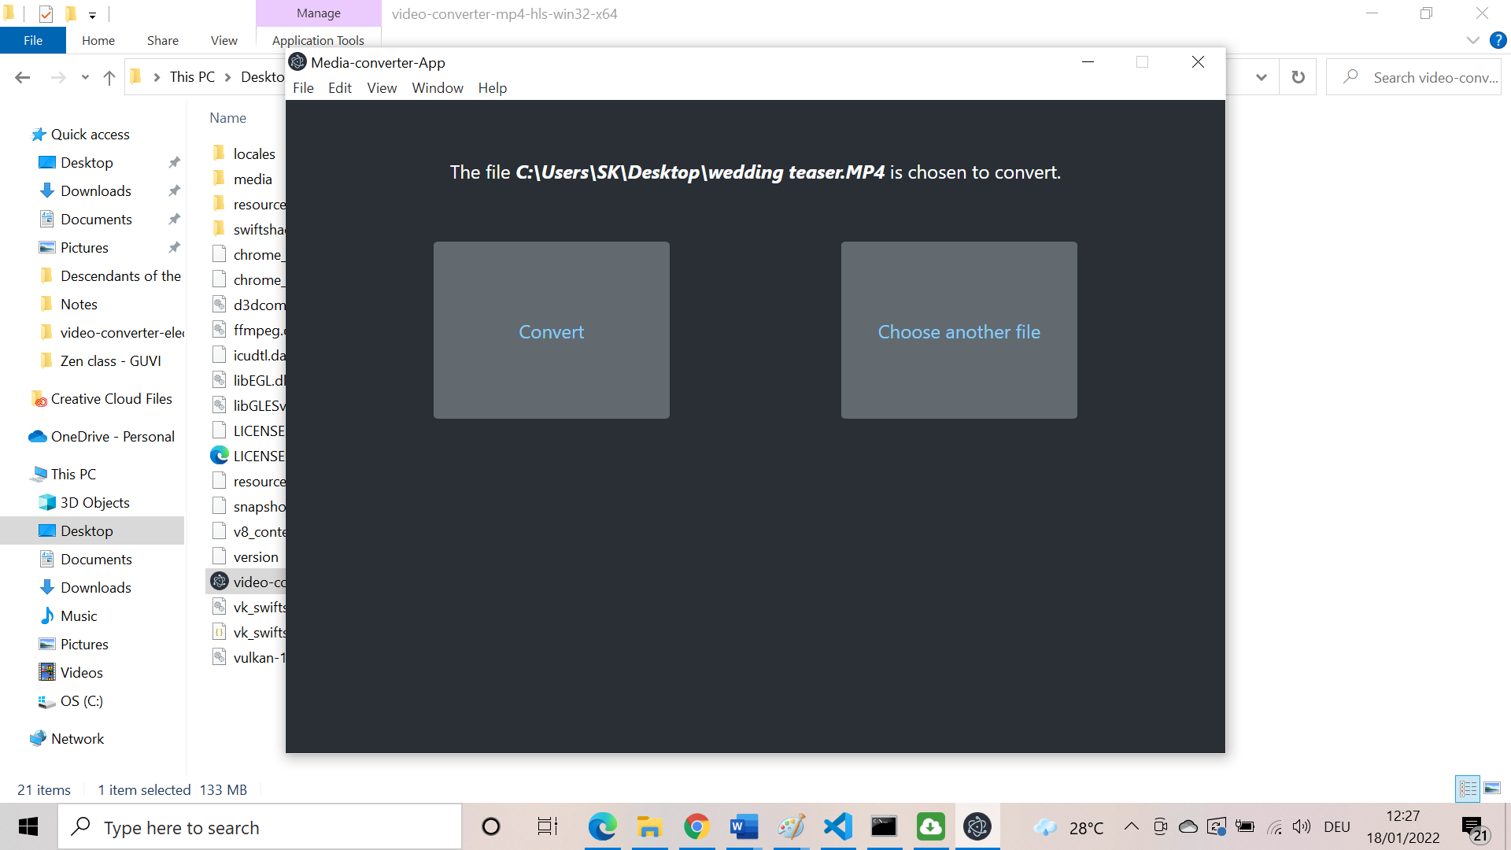

Now can choose a different file or convert the chosen file.

Clicking on choose another file

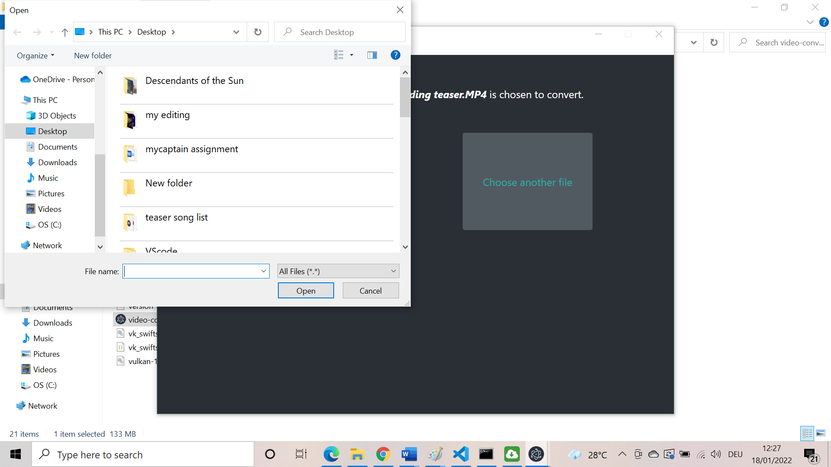

Clicking on convert button and it takes some time.

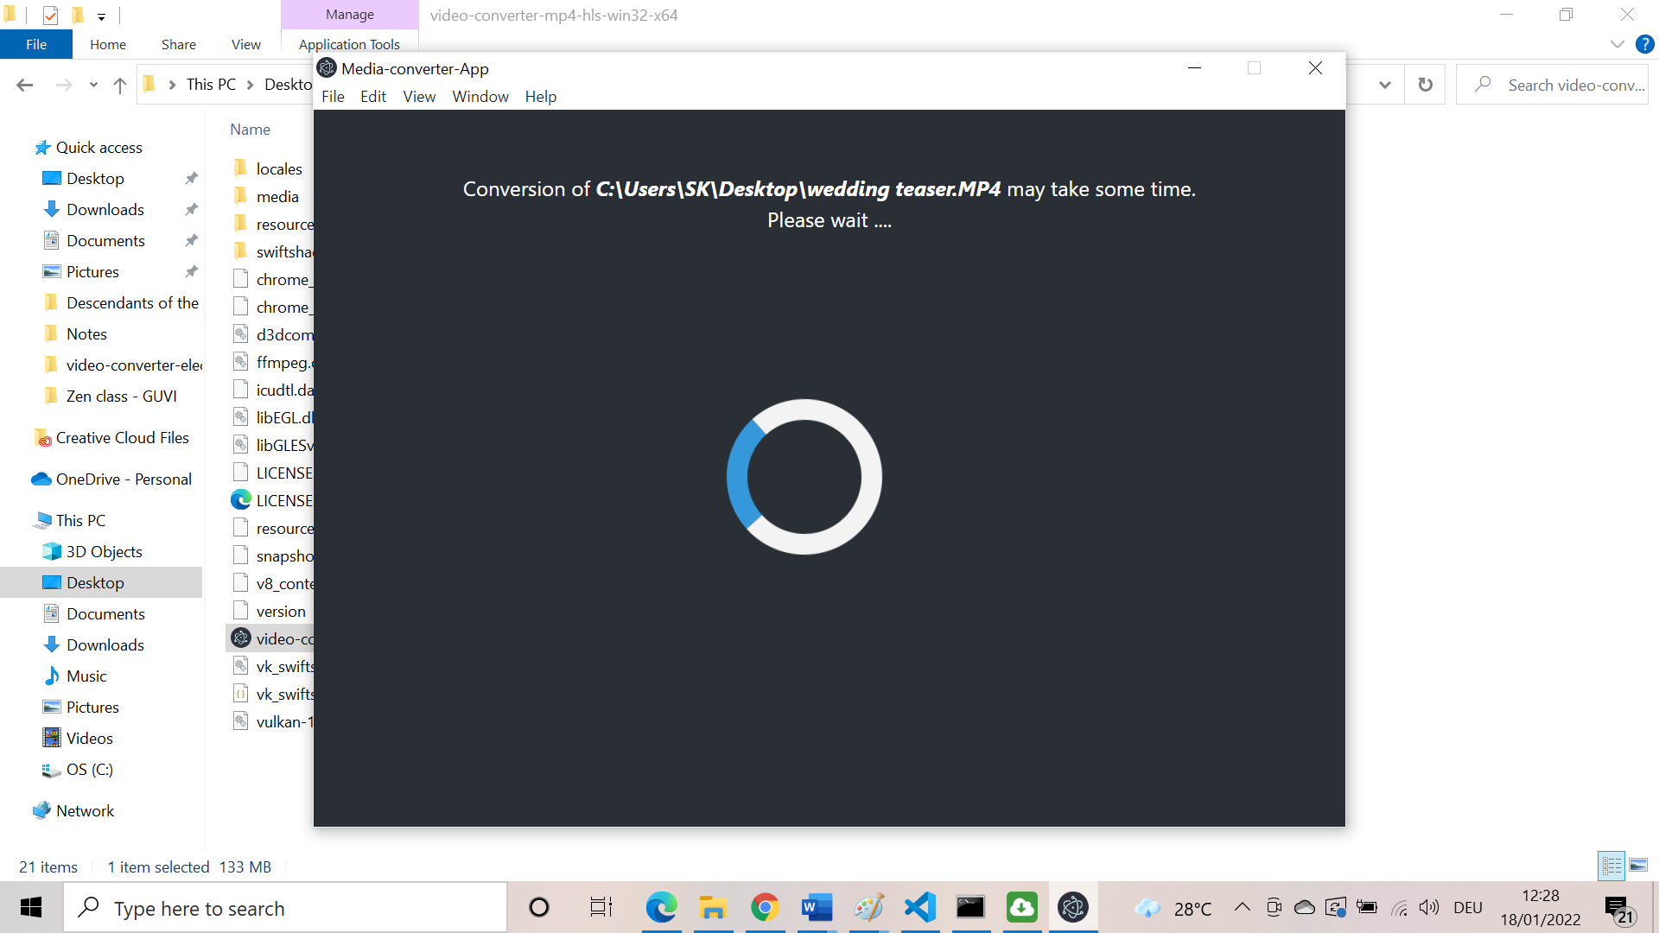

On completion Desktop notification is also sent.

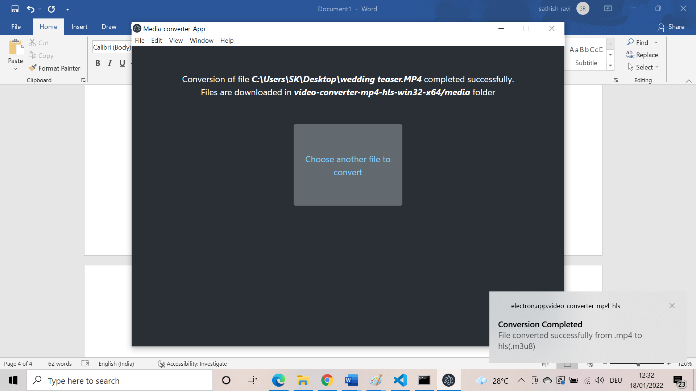

Can choose other files for conversion also.

Can see output in /media folder of app

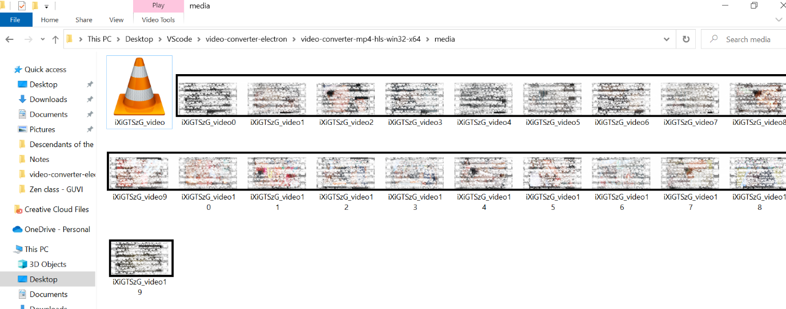

(Blurred thumbnail for this image)