PM5544 Testcard – overhaul notes

by Jeffrey Borinsky. From 4/6/24

TYPE and ORIGIN
PM5544 I/05 with BBC modifications. Serial number: KF. 1005

The PM5544 is notable as the first all-electronic colour testcard generator with a circle. A slightly modified version was known as Testcard G by the BBC.

This unit was donated to the BECG on 25/5/24 by Andrew Jellyman. It was originally used at BBC Pebble Mill. There is a folder with the main manual, notes on BBC modifications plus other related material. The manual is dated 1971. I also have a scanned copy of the manual which is for a different version. I have scanned the manual that came with our PM5544, along with BBC modifications and supplements.

INITIAL OBSERVATIONS
The IEC mains inlet has been replaced with an XLR-LNE. This was common BBC practice. Exposed mains connections have been (badly) insulated with white silicone.

Two of the three power transistors on the back panel have lost their insulated covers. We need replacements or fit an insulated panel over the transistors.

The circle data is stored in a magnetic core memory. Later versions used some kind of ROM. The scanned manual is for the ROM version.

The PM5544 uses standard TTL logic. The manual shows Philips FJ series. Most if not all of the chips fitted in the unit are 74 series equivalents. These small scale integration chips were all that were available when the original design was done. I don’t think that four bit counters were available then.

7400 FJH131 Quad 2 input NAND
7402 FJH221 Quad 2 input NOR
7410 FJH121 Triple 3 input NAND
7420 FJH111 Dual 4 input NAND
7430 FJH101 8 input NAND
7450 FJH151 Dual 4 input AND/OR/INVERT with expander inputs
7454 FJH181 8 input AND/OR/INVERT
7474 FJJ131 Dual D-type edge triggered flipflop with set and reset
7476 FJJ191 Dual master-slave JK flipflop with set and reset

The text generator uses some medium scale integration chips such as the 7493 divide by 16 and the 74150 16:1 multiplexer.

Rectifier – Unit 17
This has suffered a serious failure in the past. There is heavy scorching on both the PCB and some wiring. GR1702-4 (3x BY164 bridges in parallel for +5V supply) have been replaced. There is also a heavy duty bridge bolted to the back panel. The 1250uF main reservoir capacitors have been replaced with 2200uF 50V parts. C1702, the 2500uF reservoir for the +5V supply, has been replaced with 2x 2200uF in parallel. All this work was done at the BBC, before Andrew Jellyman’s ownership.

Fig XIII-4 in the scanned manual (internal page 58) shows a single external bridge for the +5V supply. The PCB is renamed as MA8555, Unit 19.

Voltage regulator – Unit 1
There is scorching under R123, 0R47 (5V regulator current sense) which appears to have been replaced. It should be stood off from the PCB.

All other PCBs seem to be in generally good condition.

INITIAL POWER
I ran it up slowly on a variac. There was no sign of distress. The burnt rectifier board has obviously been reasonably restored even though it looks horrible. The +5V rail settled at +5.05V which is just within tolerance (5V +/- 0.05V). There’s about a volt across R123, 0R47, which senses current on the +5V supply indicating that about 2A is being drawn.

At first using only a CVBS monitor hence only Y properly viewable. Some sort of pattern is visible on all outputs. It contains many of the expected elements but there are only hints of a circle.

The text generator is fitted and displays “BBA 3.”

Now connected to component inputs of a monitor. Several edge connectors obviously intermittent. Gold fingers cleaned with eraser, sockets sprayed with Servisol. Huge improvement. Text generator now displays “@@A 1”, still has internal intermittent. Sometimes shows “BBC 1” when rattled. Possibly dry joints. Circle still very sketchy.
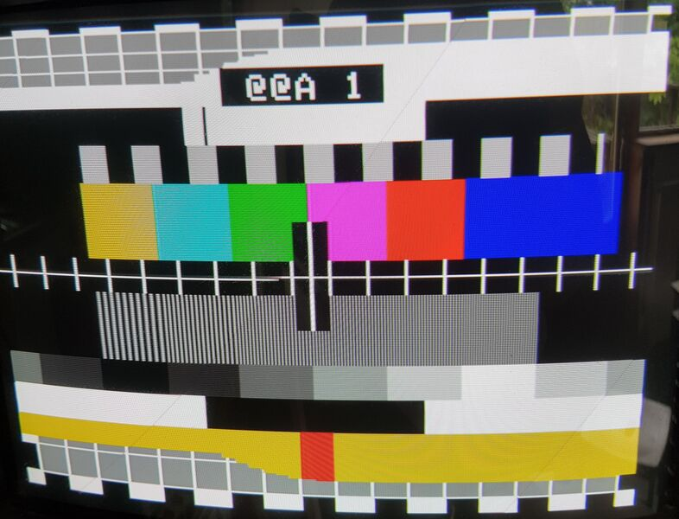

TEXT GENERATOR and CURRENT GATE
In the absence of extenders I removed the right side cheek to gain full access to the text generator. This also gives good access to the current gate. The current gate is of the (probably) later type with three chips. There is an adjustment for the text pixel width.

The current gate switches off the 5V supply to much of the text generator when not required in order to reduce power consumption. There seems to be an intermittent fault on the current gate, or associated wiring, resulting in no text at all. R2, 560R, on the current gate has overheated and is underrated. Replaced with larger part.

The text generator has a problem with IC17, 74150, one of the 16:1 multiplexers. One pin was broken, another two are dodgy. I have hardwired them to work but would consider replacing IC17. I have a small stock of 74150.

The text generator now displays BBC1 in the top box or BBC2 in the bottom box, depending on the SIGN ALT switch.

Andrew Jellyman was told by a BBC engineer that an apostrophe or quotation mark after BBC1 and BBC2 were intentional. I have found that they were due to the faults around IC17.

CENTRE LINE
The central horizontal line flickers, suggesting an interlace problem. It is on lines 164 and 475. These are 311 lines apart which is wrong. For comparison an ordinary crosshatch line was found on lines 111 and 423 which are 312 lines apart. This is also wrong but not visible on a CRT monitor. Line N would normally be paired with line N+313.

It is possible that non-standard mixed blanking could cause this. I have checked the MB (from a CY430 SPG) and it is correct. This problem was subsequently found to be due to wrong adjustment of R4 in the vertical counter. The central horizontal line has deliberately reversed interlace.

CIRCLE
Only hints of the circle are visible. It’s not immediately possible to tell if this is a fault in the circle generator or in the H and V drives to it.

The crosshatch is normal when the GRID ONLY button is pressed. When the full pattern is displayed, some squares at the top are half height. This may be related to the circle fault.

IC12, 7474, on Unit 3 was faulty. This is part of an 8 bit counter that takes data from the core memory and counts to the right edge of the circle. I didn’t have any 7474 so I used a 74LS74. Socketed in case of further problems.
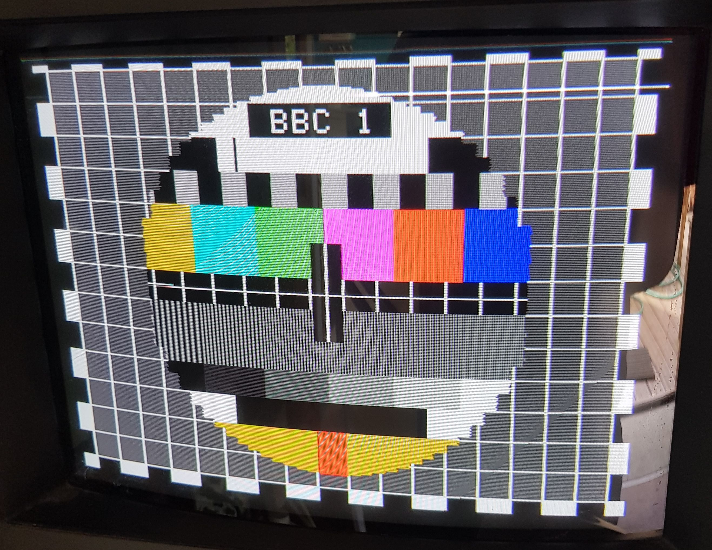

There is still a fault in the circle, possibly a missing bit from the core. Hopefully not a fault in the core store itself.

Bits 3 and 4 from the core seem to be stuck at 1. Could be the core itself or IC2, a SN7525N or LM7525 dual sense amplifier. By swapping core outputs to a different SN7525 I found that IC2 was faulty. Dave has found a couple on ebay and is buying them. In the meantime I have built an alternative with a LM319 fast dual comparator and a 74LS08. First trial did not work. Adding bias to the comparator inputs makes it work.

Dave got 2x NOS 7525 chips from ebay. I’ve removed the bodge board, and fitted one. It works.

CASTELLATIONS & INTERLACE
R4 is adjusted to give correct interlace, best seen in circle.

The top and bottom castellations are wrong. Too many lines at the bottom, too few at the top. R4 is meant to adjust this but doesn’t. After much head scratching I proved that one input to NOR gate IC3₄ was stuck at zero.

After replacing IC9 by mistake I replaced IC3 and it now works well. Both parts are 7402. Luckily I had some 74LS02 which weren’t on my stock list. Both IC3 and IC9 are now socketed.

ANALOGUE ALIGNMENT
I aligned the analogue circuits to give 700mVp-p on the RGB and Y outputs. The colour difference outputs were aligned to 525mVp-p (0.75 * 700mV) since the colour bars are 75% saturated.

I was surprised to find that several timings, such as circle centring, were analogue adjustments rather than digitally correct by design.

