AWS Application Load Balancer (ALB)
Hands-On Practice
A complete beginner-friendly setup using your resource names, visual diagrams, Nginx target instances, and health-check verification.

Learning goal
- Create an Application Load Balancer that receives HTTP requests on port 80.
- Run two EC2 instances with Nginx and register them in a Target Group.
- Verify that both targets are Healthy and test traffic distribution.

Architecture — What we are building
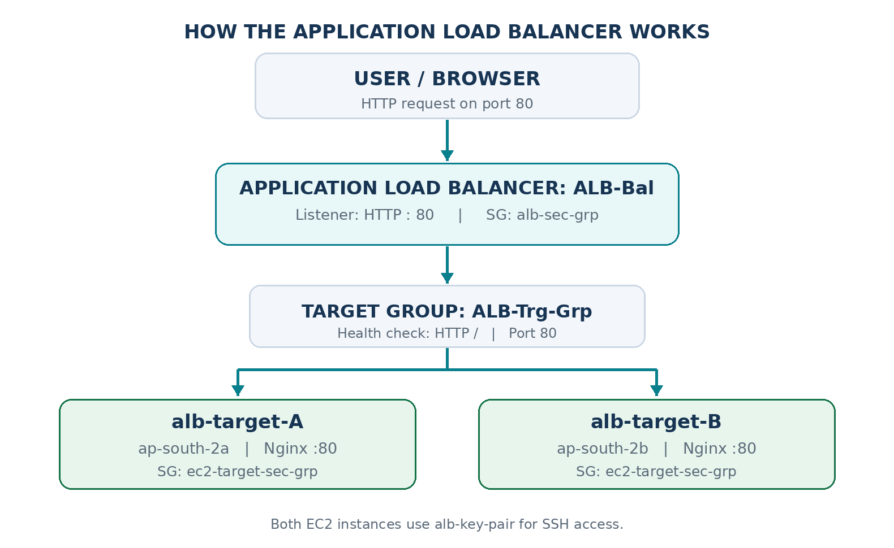
Figure 1. Browser → ALB → Target Group → two Nginx EC2 instances.

Step 1 — Create Key Pair
Go to EC2 → Network & Security → Key Pairs → Create key pair.
Setting | Value
Name | alb-key-pair
Key pair type | RSA
Private key file format | .pem

Click Create key pair and save the downloaded .pem file securely. The key pair provides SSH access to EC2; the ALB does not use it.

Step 2 — Create two Security Groups
Go to EC2 → Network & Security → Security Groups → Create security group. Use the same VPC for both groups and for your EC2 instances.

Security Group 1 — ALB: alb-sec-grp
Direction | Type / Port | Source or destination
Inbound | HTTP / 80 | Anywhere-IPv4 (0.0.0.0/0)
Outbound | All traffic | Default allowed

Purpose: allow internet users to reach the load balancer through HTTP.

Security Group 2 — EC2: ec2-target-sec-grp
Direction | Type / Port | Source or destination
Inbound | SSH / 22 | My IP (IPv4 /32)
Inbound | HTTP / 80 | alb-sec-grp (Security Group source)
Outbound | All traffic | Default allowed

For the HTTP inbound rule, choose Custom as the source and select the ALB Security Group, rather than allowing all internet traffic directly to EC2.
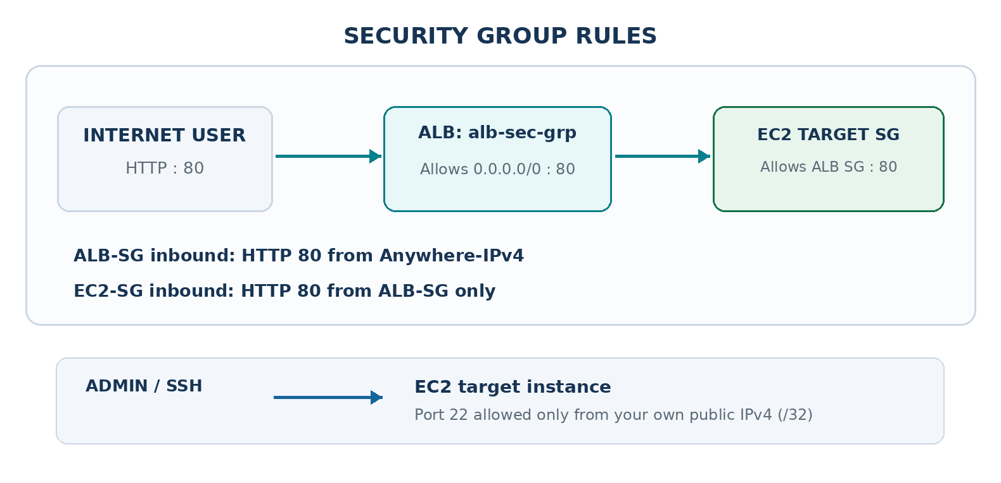
Figure 2. Port 80 follows the ALB → EC2 Security Group path; SSH goes directly from your own IP to EC2.

Step 3 — Launch two EC2 target instances
Go to EC2 → Instances → Launch instances. Create one instance at a time with these settings:
Setting | Instance A | Instance B
Name | alb-target-A | alb-target-B
AMI | Ubuntu Server | Ubuntu Server
Instance type | t3.micro | t3.micro
Key pair | alb-key-pair | alb-key-pair
Security Group | ec2-target-sec-grp | ec2-target-sec-grp
Availability Zone | ap-south-2a | ap-south-2b

Use subnets from the same VPC. For an introductory lab, public subnets with public IPv4 addresses simplify SSH access and package installation. Both EC2 targets must be Running.

Install Nginx on each instance
Connect with SSH, or paste the following into User Data when launching each instance:
#!/bin/bash
sudo apt update -y
sudo apt install nginx -y
sudo systemctl enable --now nginx

To show which target handles a request, make each Nginx home page unique:
On alb-target-A:
echo "<h1>Hello from EC2 Instance A!</h1>" | sudo tee /var/www/html/index.html

On alb-target-B:
echo "<h1>Hello from EC2 Instance B!</h1>" | sudo tee /var/www/html/index.html

Nginx should now serve HTTP on port 80 on both EC2 instances.

Step 4 — Create the Target Group
Go to EC2 → Target Groups → Create target group.
Setting | Value
Target type | Instances
Target group name | ALB-Trg-Grp
Protocol / Port | HTTP / 80
IP address type | IPv4
VPC | Same VPC as the instances
Health check protocol | HTTP
Health check path | /

Choose Next. On Register targets, select alb-target-A and alb-target-B, keep port 80, select Include as pending below, then Create target group.
The ALB will send periodic health checks to / on each registered instance.

Step 5 — Create the Application Load Balancer
Go to EC2 → Load Balancers → Create load balancer → Application Load Balancer.
Setting | Value
Load balancer name | ALB-Bal
Scheme | Internet-facing
IP address type | IPv4
VPC | Same VPC as EC2 targets
Availability Zones | ap-south-2a and ap-south-2b
Subnets | A public subnet in each enabled AZ
Security Group | alb-sec-grp
Listener | HTTP : 80
Forward to target group | ALB-Trg-Grp
Weight | 1 (100%)
Target group stickiness | Disabled

Choose Create load balancer. Wait until the ALB state becomes Active.
Important from your previous lab: If target A is in ap-south-2a but the ALB only enables ap-south-2b and ap-south-2c, target A appears Unused. Enable both AZs that contain the target instances.

Step 6 — Verify Target Group health
Open EC2 → Target Groups → ALB-Trg-Grp → Targets and check the status of both registered instances.
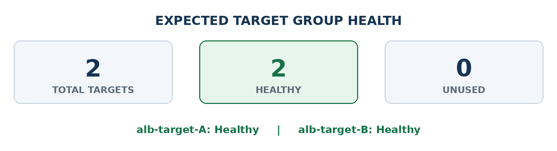
Figure 3. Expected final target health: two Healthy targets and zero Unused targets.
If Unused: enable its AZ on the ALB. If Unhealthy: check EC2 is Running, Nginx serves HTTP:80, the EC2 Security Group permits alb-sec-grp, and the health check path is /.

Step 7 — Test load balancing
Copy the ALB DNS name from EC2 → Load Balancers → ALB-Bal → Details. Open the HTTP (not HTTPS) URL in your browser.
From your local Ubuntu VirtualBox terminal, run:
curl http://ALB-Bal-93702691.ap-south-2.elb.amazonaws.com

To send ten requests and compare which EC2 instance responds:
for i in {1..10}; do
curl -s http://ALB-Bal-93702691.ap-south-2.elb.amazonaws.com
echo
done

Example response bodies (the actual order is not guaranteed):
<h1>Hello from EC2 Instance A!</h1>
<h1>Hello from EC2 Instance B!</h1>
<h1>Hello from EC2 Instance A!</h1>

If you receive responses from both A and B, traffic is reaching both healthy targets. One HTTP 200 response alone does not prove both targets are healthy.

Quick revision — Creation sequence
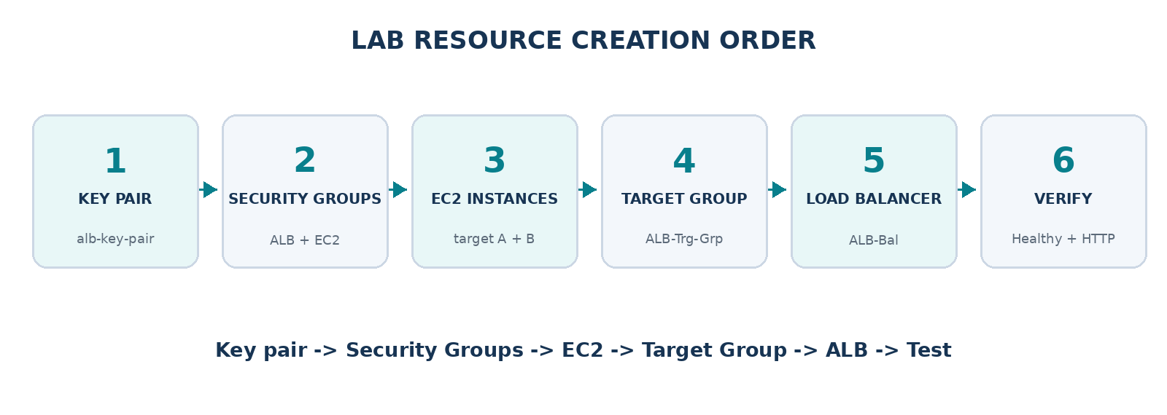
Figure 4. Recommended resource creation sequence for this lab.

Simple analogy
The ALB is the receptionist; the Target Group is the list of available employees; EC2 instances are the employees; and Security Groups are the entry rules controlling who can speak to whom.

Clean up after your lab
An ALB incurs ongoing charges even with little traffic. When the lab is complete, remove the ALB, Target Group and any EC2 instances you no longer need. Keep reusable key pairs and Security Groups if you plan to use them again.

