PL/I to COBOL
Contents

Purpose 1
Prerequisites 1
Project Clone 1
Visual Studio Configuration 2
Setup and Execution 2
Configure the Test Data Location 3
Input Files 4
Output Files 4
Troubleshooting 5

Purpose
This runbook describes the steps required to set up the PL/I to COBOL conversion demo environment, build the projects, and execute a sample conversion.

Prerequisites
- .NET SDK 8.0 with VB.NET Language
- GIT to Access Repository
- Visual Studio IDE 2026

Project Clone
Clone the following repositories to your local machine:
- GIT Link: https://codexhub.mlogica.com/liberm-suite/liberm_tulip/pli2cobol.git
- > git clone https://codexhub.mlogica.com/liberm-suite/liberm_tulip/pli2cobol.git
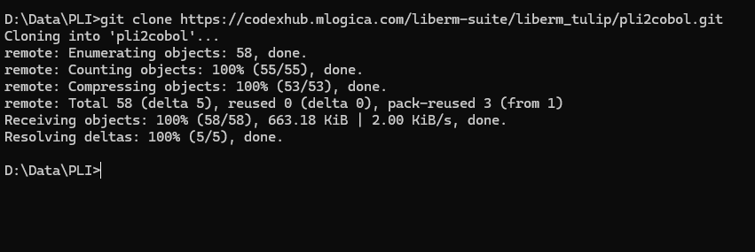

Visual Studio Configuration
- Open Visual Studio à File > Open > Select Solution File > Open
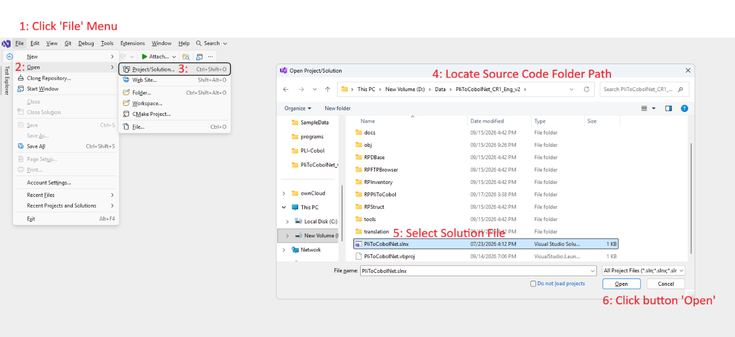

- After Visual Studio successfully opened the Solution, the Solution Explorer will show all Files List in hierarchy.
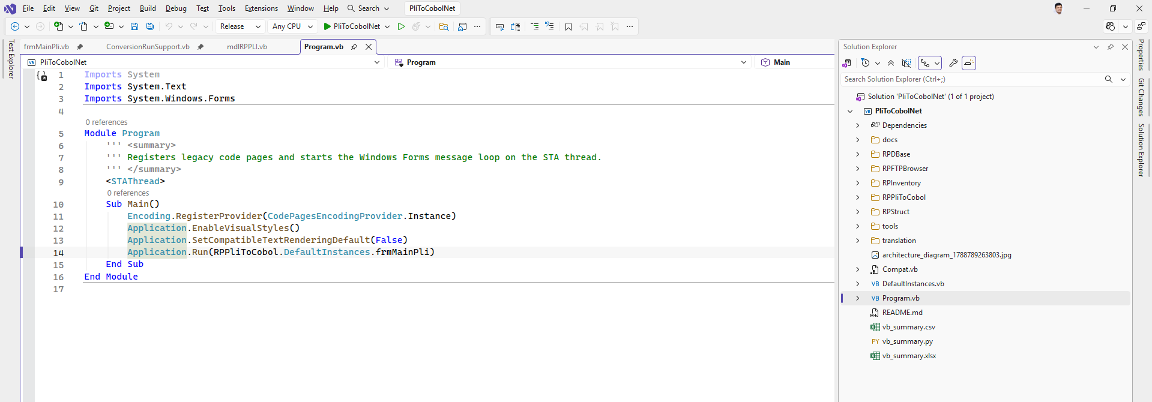
3. Inside SampleData folder, open the PLI2CBL.txt file to and set all the folder paths as pointed out in screen shot below for Source and Target folder as per your system drive.
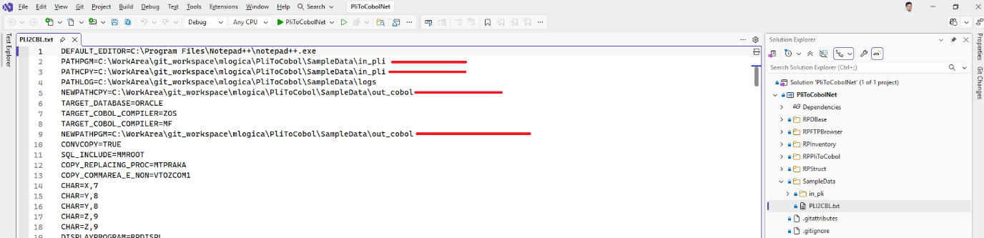

4. Go to Solution Explorer to Clean and Rebuild the Solution.

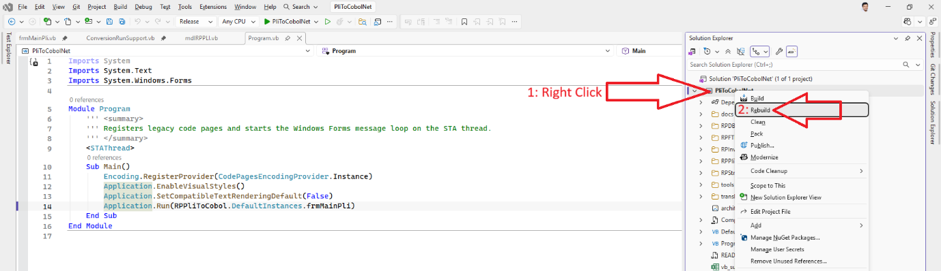

Run the compilation of programs and verify the generated output:
- At Menu bar, Click Build > Clean Solution
- At Menu bar, Click Build > Rebuild Solution
- At Menu bar, Click Debug > Start Debugging
Setup and Execution

Load the Configure File for Test Data Location
Click Menu File > Load Settings > Locate to Folder SampleData > open PLI2CBL.txt:
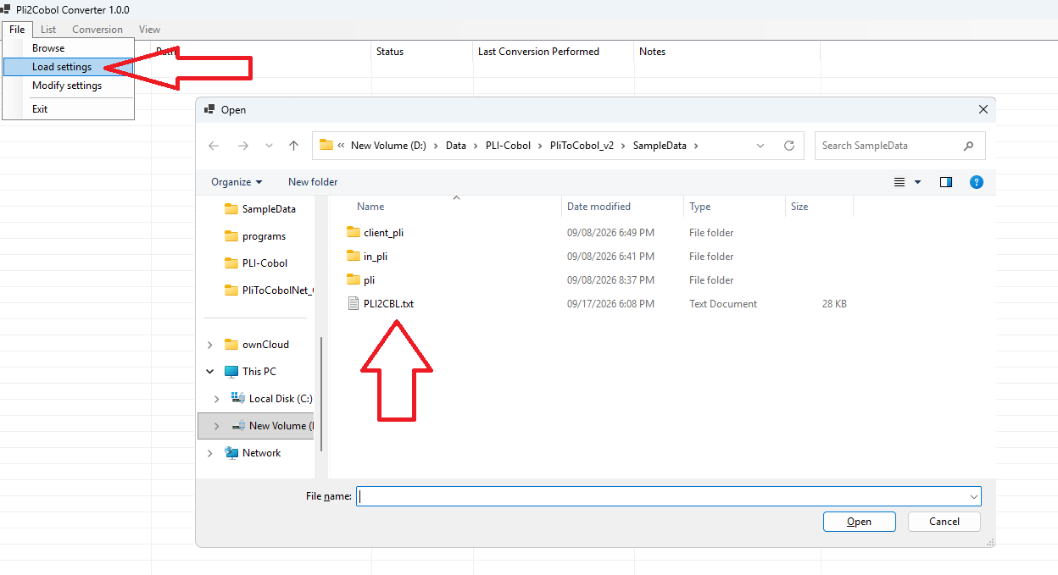

Input Files
The converter reads the following inputs from the test data directory:
- PL/I source programs: <baseDir>\KMD_ORIGINAL\program\
  - Example: DemoP2U.PLI
- Include/Copybook files: <baseDir>\KMD_ORIGINAL\include\

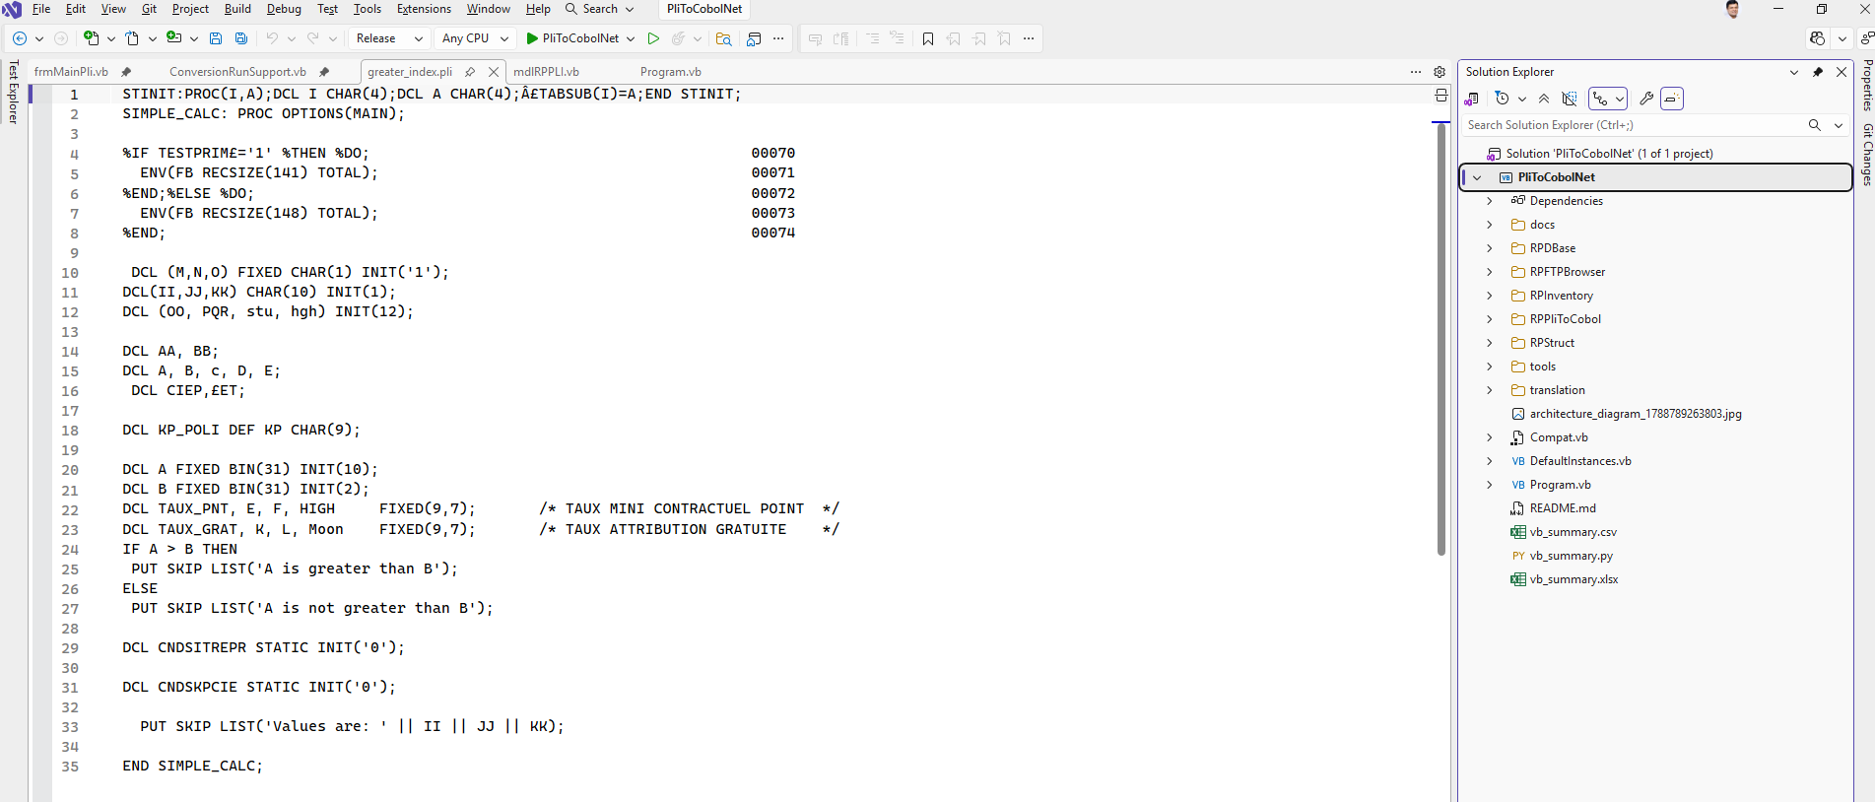
All the Files in the Input Folder will list in the Grid below and select a file or all Files. Then click menu Conversion > Start to start the COBOL Translation process.

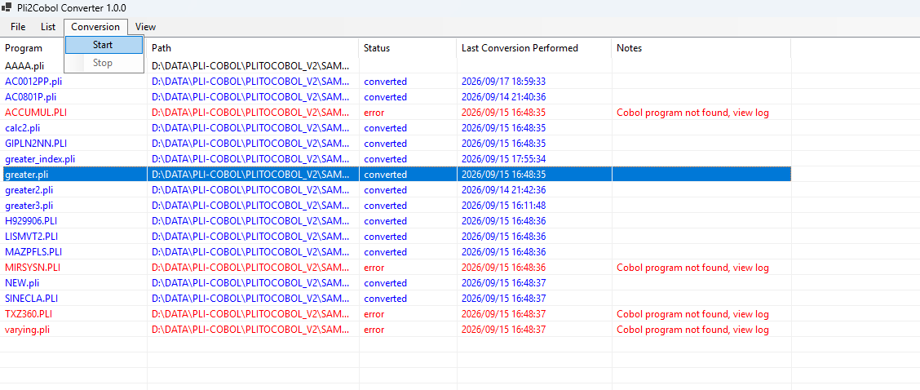

Output Files
- To View the COBOL Converted/Translated File. Go to menu View > Cobol Program.
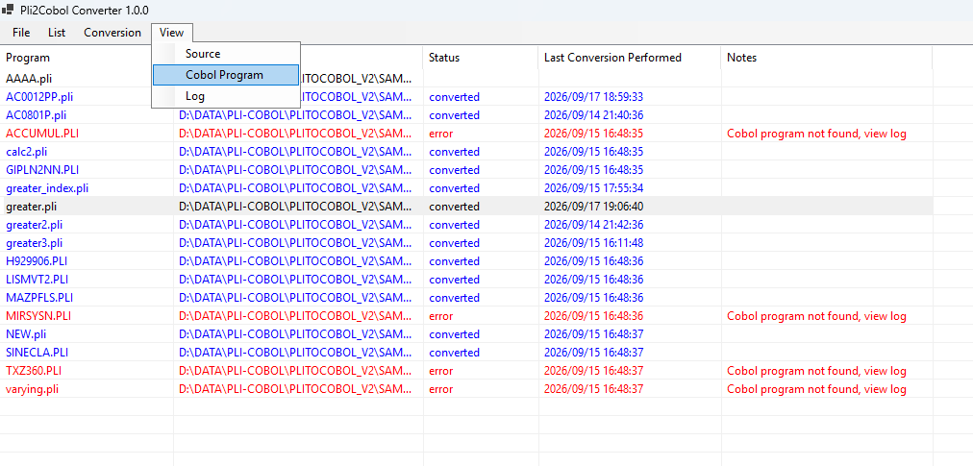

Example Conversion
- Input: greater.pli
- Output: greater.cbl
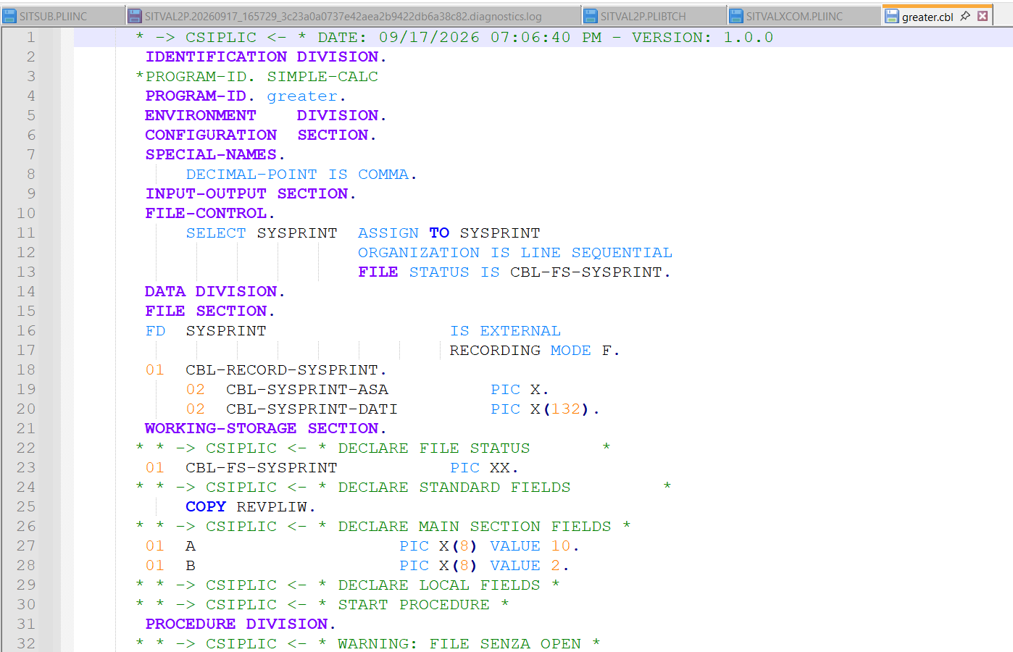
Troubleshooting

Error Log – Go to menu View > Log
