PL/I to COBOL

mLogica LLC
September 2026
Revision: __

Copyrights

Copyright 2026 mLogica, Pune. All rights reserved.

mLogica LLC, has intellectual property rights relating to technology that is described in this document. This document and the product to which it pertains are distributed under licenses restricting their use, copying, distribution, and decomplication. No part of the product or of this document may be reproduced in any form by any means without prior written authorization of mLogica LLC and its licensors, if any.

All product names mentioned in this document are trademarks or registered trademarks of their respective owners.

Confidential — Internal Use Only.

Contents

Introduction 6
Software Prerequisites 7
Software List 7
Project Structure 7
Application Execution 10
Run Application 10
Load Settings File 11
Start Conversion 12
View Files - Source / Translation / Log 13
Exit Application 15

Preface

This runbook provides PL/I to COBOL Translation with steps: download project ZIP file, extract, Configure Settings, Run Executable for migration demo environment, based on the Sample Files Translation to COBOL.
Contacting mLogica

If you have technical questions about this product that are not answered in this document, go to:

https://www.mlogica.com/contact-us

mLogica welcomes your comments

mLogica is interested in improving its documentation and welcomes your comments and suggestions. You can submit your comments with us.

Please include the title of the document with your feedback:

PL/I to Cobol Guide

CHAPTER 1

Introduction

This runbook provides PL/I to COBOL Translation with steps: download project ZIP file, extract, Configure Settings, Run Executable for migration demo environment, based on the Sample Files Translation to COBOL.

CHAPTER 2

Software Prerequisites
This chapter lists the software required before installing and running the pilot environment, and describes the structure of the sample project files used throughout this guide.

Software List
- Windows 10 or onwards
- .NET SDK 8.0
- Notepad++ to View Files PL/I and COBOL files Content

Project Structure
For PL/I to COBOL .Net project, the Project ZIP file (PliToCobolNet.zip) is available under SharePoint. So, download and extract this ZIP file on your local machine, let’s say at location D:\Data\PLI\:
- On root, PliToCobolNet.exe – This is main executable file to run the application. We will execute it in the next chapter 3 after settings/configuration.
- Inner Folder: SampleData: contains:
  - Another Folder in_pli: Place your client’s project sample PL/I Files in respective program and include folder files to be Translated to COBOL.
  - Setting file: PLI2CBL.txt: Open this text file, set following Paths as per your system drive:
    - PATHPGM=D:\Data\PLI\SampleData\in_pli
    - PATHCPY= D:\Data\PLI \SampleData\in_pli
    - PATHLOG=D:\Data\PLI \SampleData\logs
    - NEWPATHCPY=D:\Data\PLI \SampleData\out_cobol
    - NEWPATHPGM=D:\Data\PLI \SampleData\out_cobol
- Output Folder:
  - Cobol
  - Log
No need to make change in other files

Folder View of Extracted Project ZIP File
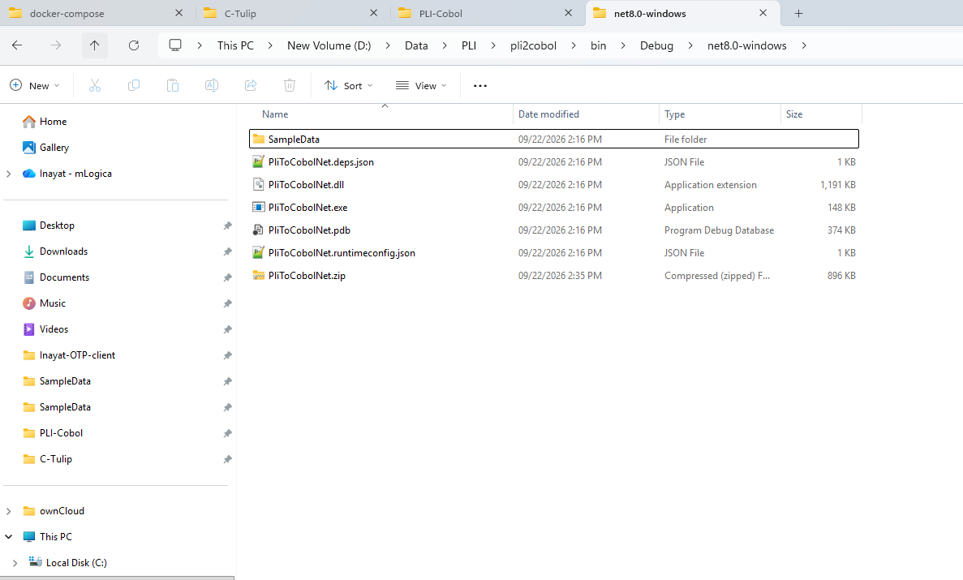

Folder View of Sample Data and Settings File “PLI2CBL.txt”
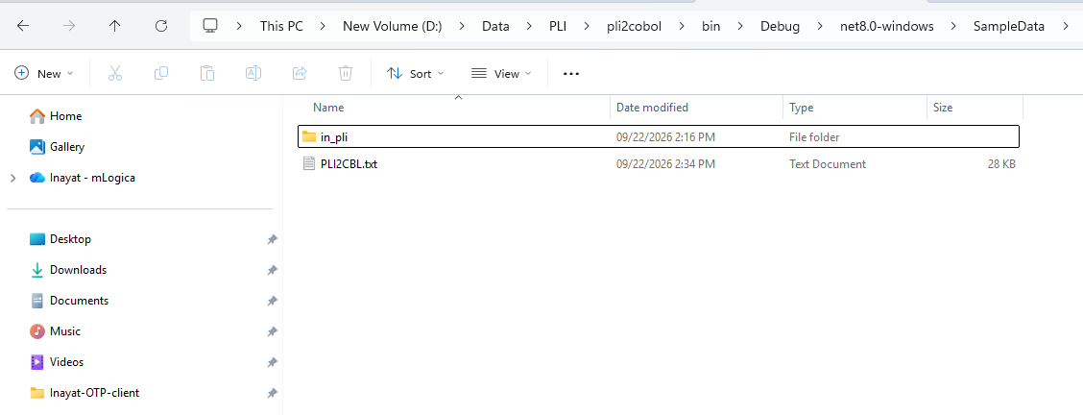

Open “PIL2CBL.txt” File and change the Folder Path to have access to Sample PL/I Files to Translate them to COBOL.

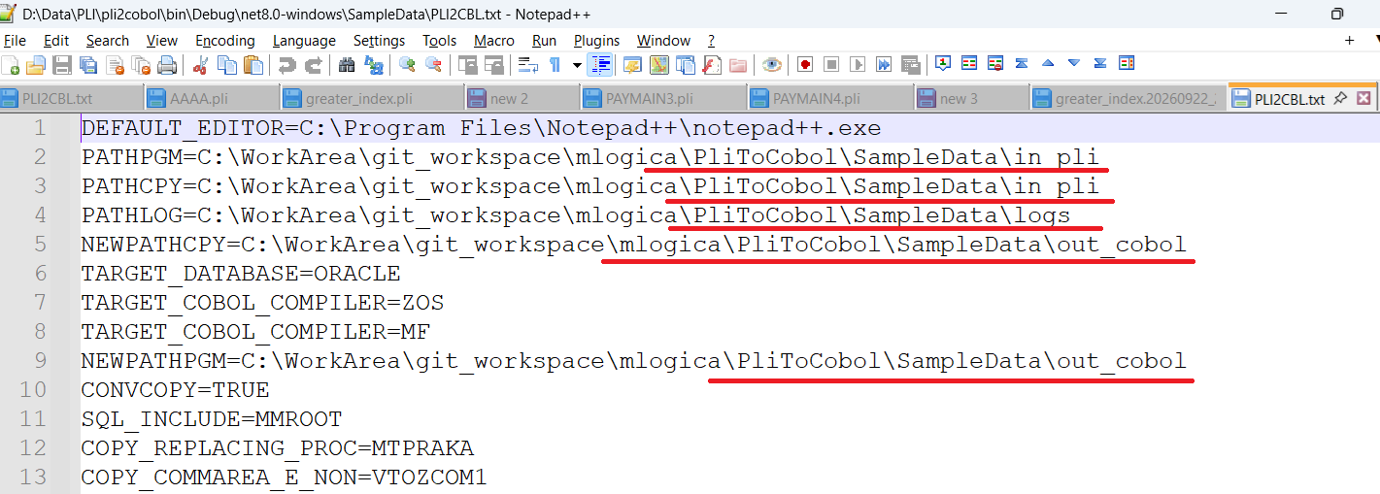

CHAPTER 3

Application Execution
Run Application
As you double click to open the Executable “PliToCobolNet.exe”. It will show up the screen:
The Application will pop-up as shown in following screen-shot:
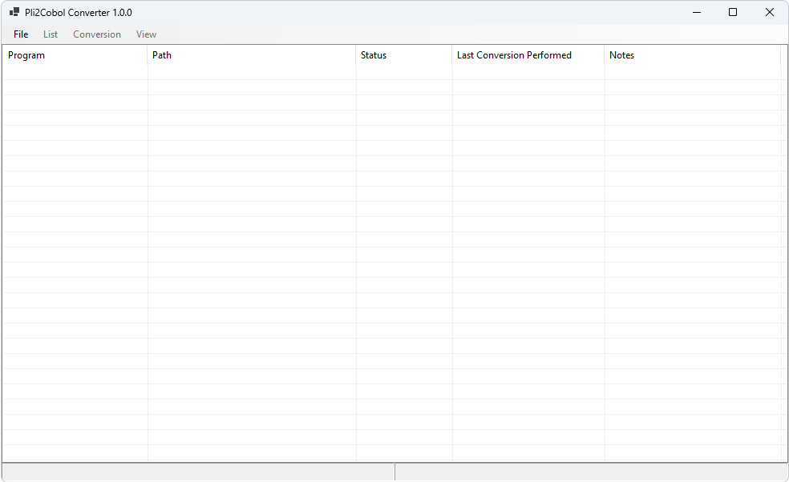
Click File > Load settings
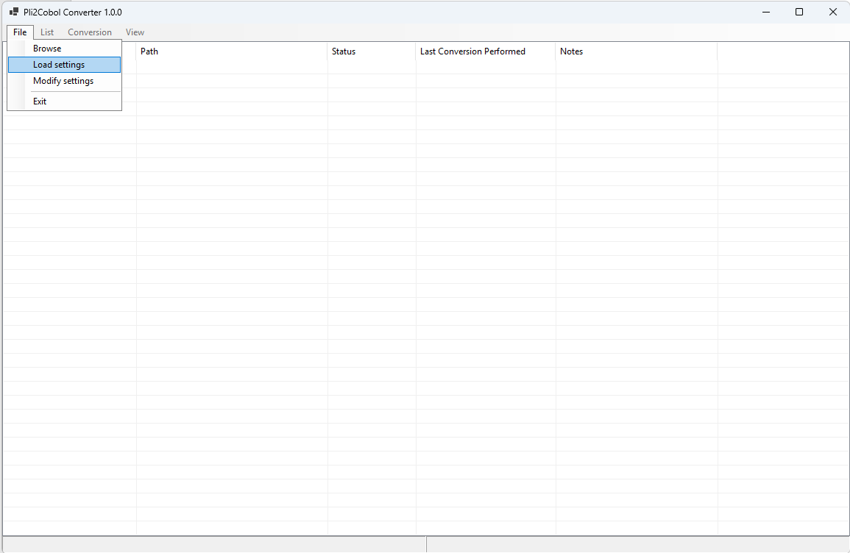
Load Settings file
Select the Settings File PLI2CBL.txt to Load the Configuration.
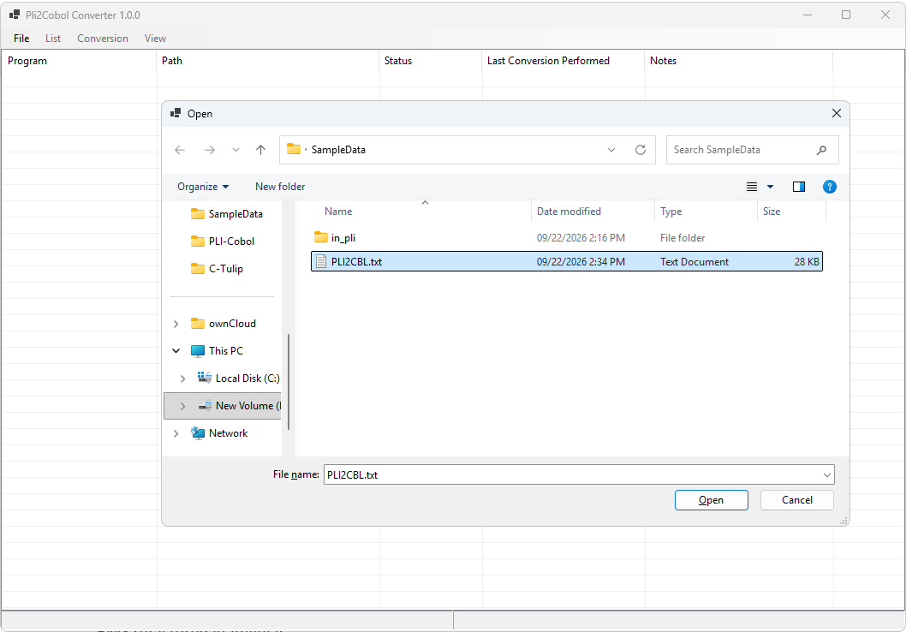
The Sample PL/I files are load. Select all or any of them with pressing Ctrl Key.
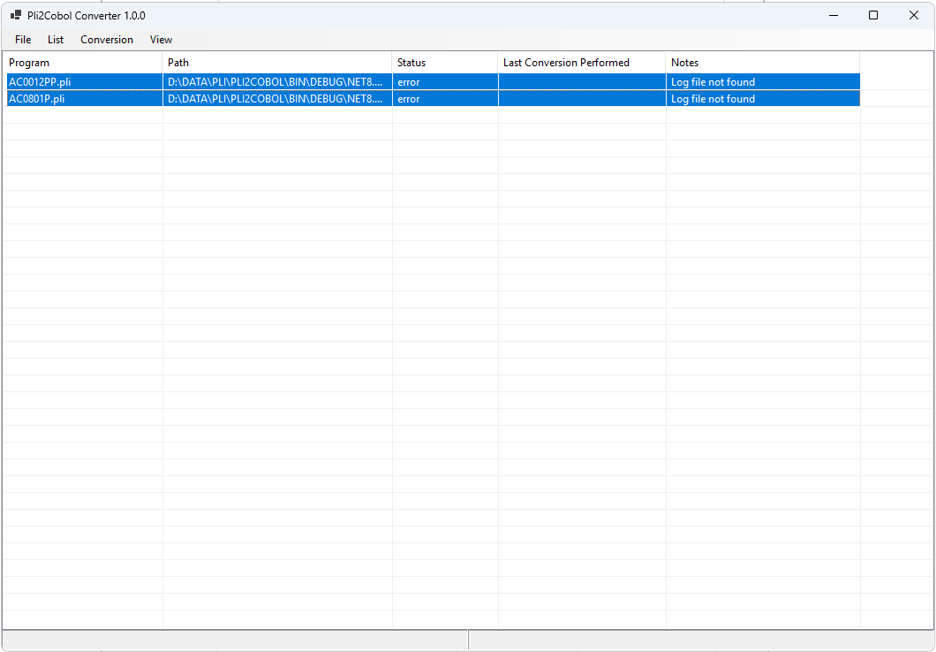
Start Conversion
After Selecting these Files. Click menu Conversion > Start
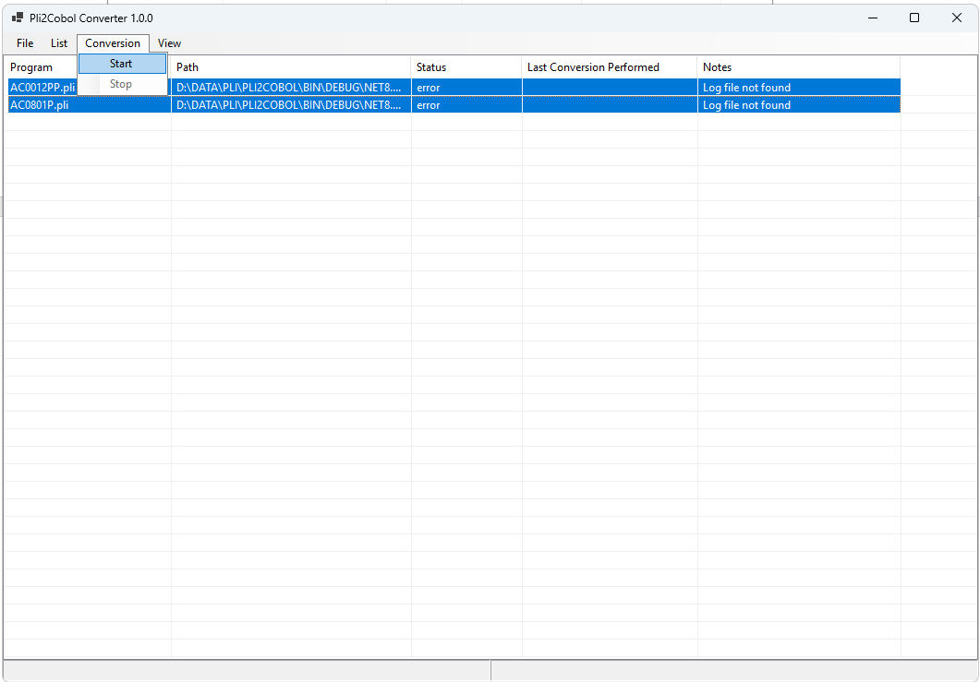
Check the Status column: Either Converted / Failed.
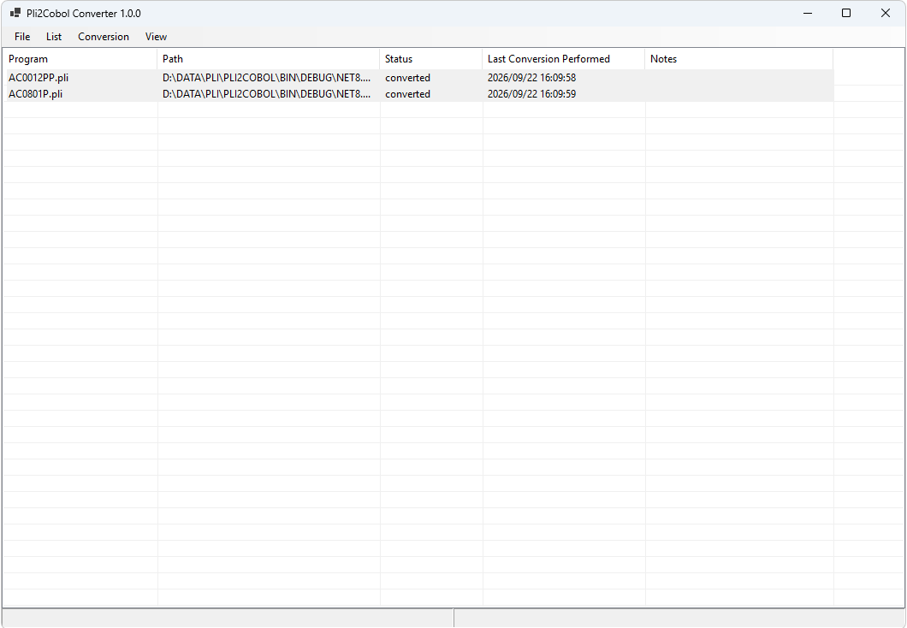
View Files - Source / Translation / Log
Click row to select a File at a time. Click menu View > with following option to open file in Notepad++
- Source – To View the PL/I Source Code
- Cobol Program – To View the Translated COBOL Code
- Log – to View Log in case Status is Failed and found Errors
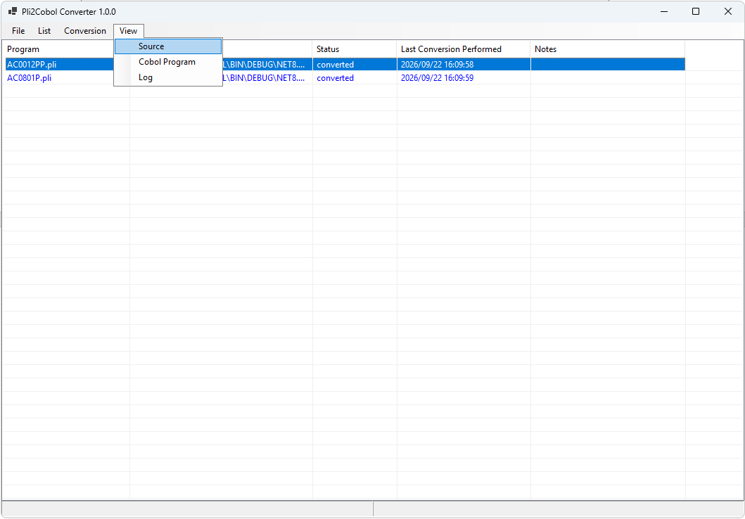

To View PL/I Source file
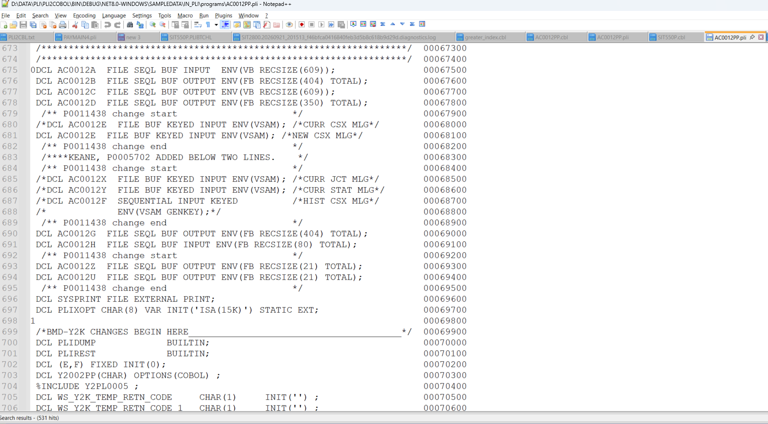

To View COBOL Translated File
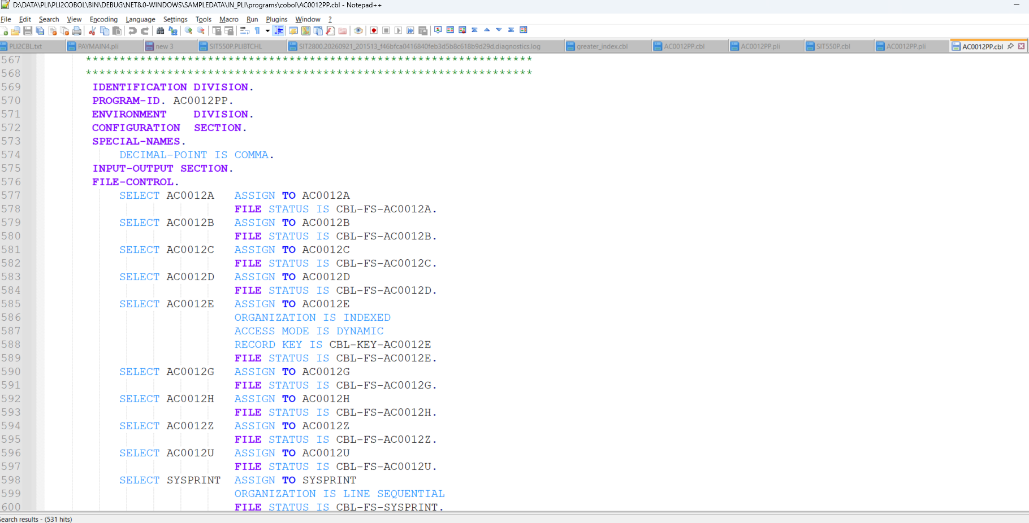

Exit Application
