Z/OS to LIBER COBOL

mLogica
September 2026
Revision: SJ

Copyrights

Copyright 2026 mLogica, Pune. All rights reserved.
mLogica has intellectual property rights relating to technology that is described in this document. This document and the product to which it pertains are distributed under licenses restricting their use, copying, distribution, and decompilation. No part of the product or of this document may be reproduced in any form by any means without prior written authorization of mLogica and its licensors, if any.
All product names mentioned in this document are trademarks or registered trademarks of their respective owners.
Confidential — Internal Use Only.

Contents

Introduction 5
France 5
Germany 5
Software Prerequisites 6
Software List 6
Project Structure 6
Optional Software 7
Environment Configuration 8
Environment Variables 8
Maven Configuration 8
Eclipse Configuration 10
Compiling the Project 11
Docker Configuration 11
Running and Accessing the Pilot Environment 13
Online and Batch Applications 13
Accessing the Environment via TN3270 Plus 13
Accessing the Environment via Angular (Web) 14
Pilot Test Cases 16
1. COBOL Program Modification and Compilation 16
2. Manual Deployment 16
3. Verification and Testing 16
4. Transaction Definition 17
5. Debugging 18
Debug Online Programs 18
Debug Batch Programs 18
6. Batch Program Workflow 18
7. COBOL Refactored to Java 19
8. BMS and the Equivalent JSON 20
9. COBOL with SQL 22
10. Files and VSAM 22
FCT and DCT Definitions 22
11. Integrations 23
Troubleshooting 24
1. Timeout Connection to TN3270 24
2. “Region is not available” 24
3. “Terminal TXXX is not defined in TCT” 25
4. Time Zone Error 26
5. ERROR-27 (PGMIDERR) 27
6. FileNotFoundException 27

Preface

This runbook provides procedures for setting up, building, deploying, validating, debugging, and operating the Z/OS to LIBER COBOL migration demo environment, based on the AWS CardDemo sample application.
Contacting mLogica

If you have technical questions about this product that are not answered in this document, go to:

https://www.mlogica.com/contact-us

mLogica welcomes your comments

mLogica is interested in improving its documentation and welcomes your comments and suggestions. You can submit your comments with us.

Please include the title of the document with your feedback:

Z/OS to Liber Cobol Guide

CHAPTER 1

Introduction

This guide describes the pilot environment for the Generali Mainframe Offloading project, which re-hosts Z/OS COBOL, CICS, and batch (JCL) workloads onto the mLogica LIBER framework using the Veryant isCOBOL runtime.
It combines the environment setup instructions from the Z/OS to LIBER COBOL Operations Runbook with the pilot walkthroughs and test cases from the Generali Pilot Environment User Guide, so that developers have a single reference for installing, configuring, running, testing, and troubleshooting the pilot.

Server Details
Two docker environments are available for the pilot, hosted in France and Germany. Each environment exposes a Docker host (running the LIBER containers) and a PostgreSQL host (used as the target relational database for VSAM/IDCAMS emulation).

France
 | Docker server | PostgreSQL server
Hostname | de0x000001fgr.groupe.generali.fr | de0x000000fgr.groupe.generali.fr
IP address | 10.29.152.66 | 10.29.152.65

Germany
 | Docker server | PostgreSQL server
Hostname | de0x000015.generalinet.com | de0x000010.generalinet.com
IP address | 10.29.152.68 | 10.29.152.67

CHAPTER 2

Software Prerequisites

This chapter lists the software, plugins, and sandbox packages required before installing and running the pilot environment, and describes the structure of the sample AWS CardDemo project used throughout this guide.

Software List
- TN3270 Plus
- JDK 21
- Docker Desktop
- Apache Maven
- Git
- Eclipse IDE
- Additional Eclipse plugins required:
  - Veryant isCOBOL Plugin (https://www.veryant.com/eclipse)
  - Groovy Development Tools (GDT)
- Veryant isCOBOL License Key file: iscobol.properties, to be copied into the user home directory (e.g. C:/Users/<your_user>/iscobol.properties)
Note: If the iscobol.properties file is not present, request the license key from your project administrator before continuing.

Project Structure
The package for the pilot is the AWS CardDemo project (nib-java-demo-cobol.zip), available under SharePoint. Clone or download this project to your local machine. It contains the following sub-projects:
- aws-carddemo-angular: the Angular app of the CardDemo
- aws-carddemo-groovy: the Groovy scripts of the CardDemo
- aws-carddemo-iscobol-batch: the batch COBOL programs of the CardDemo
- aws-carddemo-iscobol-online: the CICS COBOL programs of the CardDemo
- boot-online: the Spring Boot application for online testing and debugging
- boot-batch: the Spring Boot application for batch testing and debugging
- cics-webservices: the CICS web services COBOL programs
- deployment/docker-compose: provides an example deployment of LIBER containers using Docker Compose
Further information can be found inside the README.md files of the nib-java-demo-cobol folder and each sub-project.

Optional Software
- Veryant isCOBOL SDK (2025 R2): isCOBOL_2025_R2_1158_5_20250929_40806_Windows.64.zip
The SDK provides isCOBOL functionality from the command line. For this pilot, isCOBOL functionality is instead used directly from Eclipse (isCOBOL debugger) and Maven (isCOBOL compiler), so installing the standalone SDK is optional.

CHAPTER 3

Environment Configuration

This chapter covers configuring environment variables, Maven, Eclipse, and Docker so that the AWS CardDemo pilot project can be compiled, deployed, and run locally or against the shared Docker environments.

Environment Variables
Before building or running the project, make sure the following environment variables are set:
Variable | Description
JAVA_HOME | JDK 21 installation path
NIB_LICENSE_KEY | A valid NIB license key
NIB_JAVA_DEMO_COBOL_HOME | Set to the path of the repository root, e.g. \nib-java-demo-cobol
NIB_BATCH_CONFIG | Path to the batch config, e.g. /config/batch/nibbatch.json
USERPROFILE | Set to the path of your user home, e.g. “C:/Users/<Username>”
Note: NIB_JAVA_DEMO_COBOL_HOME can also be configured directly inside an Eclipse Run Configuration instead of as a global user variable. To set an environment variable within Eclipse: right-click the file > Run As > Run Configurations > Environment tab.
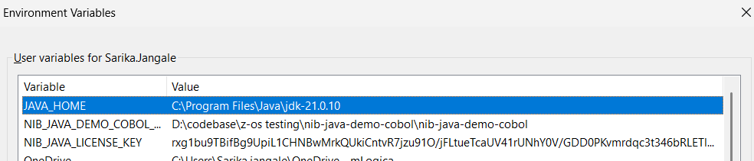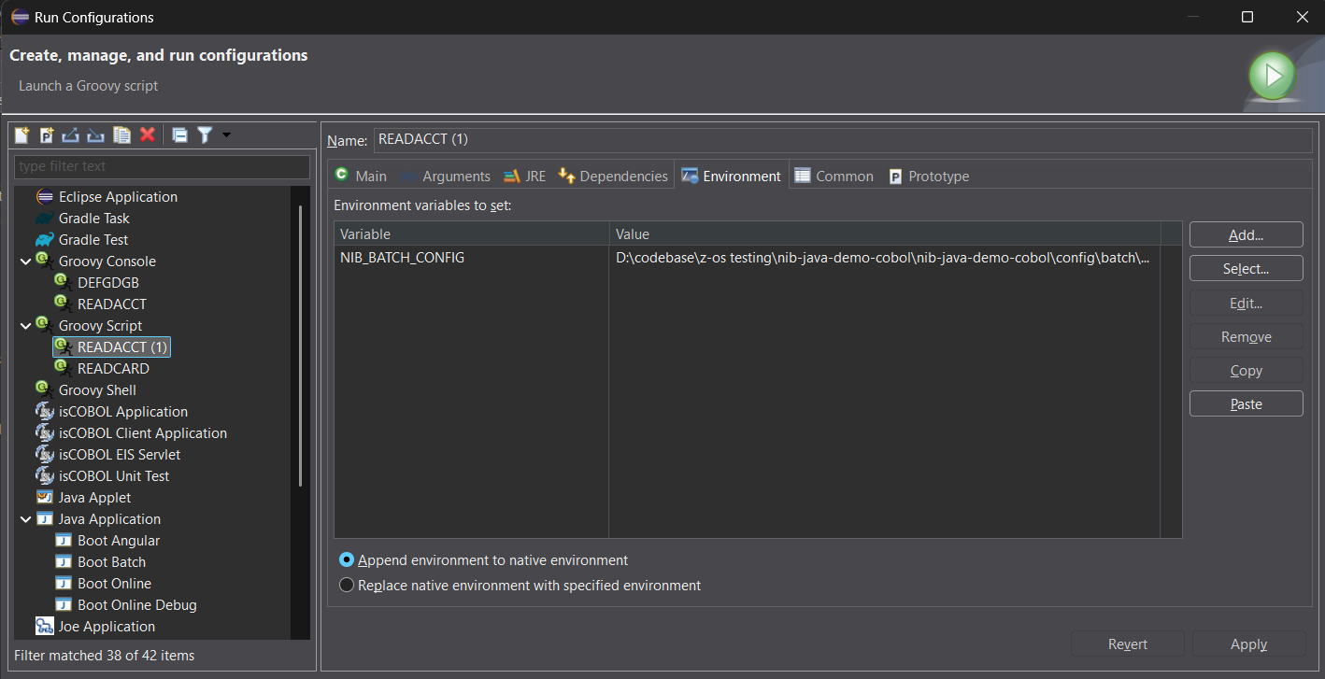

Maven Configuration
The mLogica framework is published at https://maven.pkg.github.com/nib-labs/nib-java. To use it, add the repository to your project pom.xml:
<repositories>
<repository>
<id>github</id>
<url>https://maven.pkg.github.com/nib-labs/nib-java</url>
</repository>
</repositories>

The repository is hosted on GitHub.com and, even though it is public, GitHub requires an authenticated user to download packages. Add your GitHub credentials to your Maven settings.xml file and place in C:\Users\<USER_NAME> \.m2
<settings xmlns="http://maven.apache.org/SETTINGS/1.0.0"
xmlns:xsi="http://www.w3.org/2001/XMLSchema-instance"
xsi:schemaLocation="http://maven.apache.org/SETTINGS/1.0.0
http://maven.apache.org/xsd/settings-1.0.0.xsd">

<activeProfiles>
<activeProfile>github</activeProfile>
</activeProfiles>

<profiles>
<profile>
<id>github</id>
<repositories>
<repository>
<id>github</id>
<url>https://maven.pkg.github.com/nib-labs/nib-java</url>
<releases><enabled>true</enabled></releases>
<snapshots><enabled>true</enabled></snapshots>
</repository>
<repository>
<id>central</id>
<url>https://repo1.maven.org/maven2/</url>
<releases><enabled>true</enabled></releases>
<snapshots><enabled>true</enabled></snapshots>
</repository>
</repositories>
</profile>
</profiles>

<servers>
<server>
<id>github</id>
<username>GITHUB_USERNAME</username>
<password>GITHUB_PERSONAL_ACCESS_TOKEN</password>
</server>
</servers>

</settings>

The GITHUB_PERSONAL_ACCESS_TOKEN must be created with at least the repo scope (which includes read:packages), as shown below:

Once configured, run mvn clean package (or, from Eclipse, Run As > Maven Build with goal clean install) under the /nib-java-demo-cobol folder before continuing with the next steps.
Packages and dependencies provided by the repository can be browsed under Packages.nib-labs.GitHub
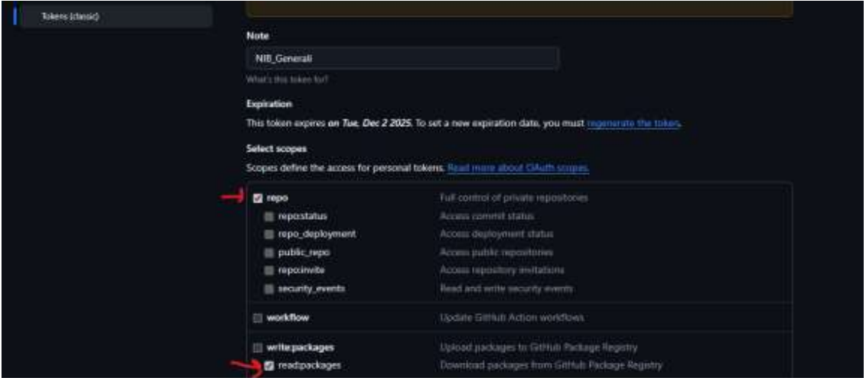

Eclipse Configuration
- Run Eclipse.
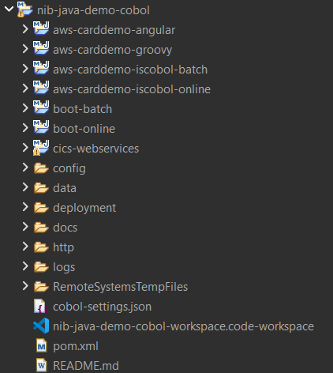
- Open the project and click Launch; this opens the folder in Eclipse.
- Go to File > Import > Maven > Existing Maven Projects > Next. Browse to your folder (e.g. nib-java-demo-cobol) and click Finish.
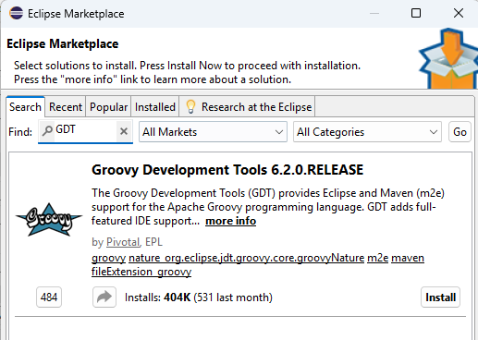
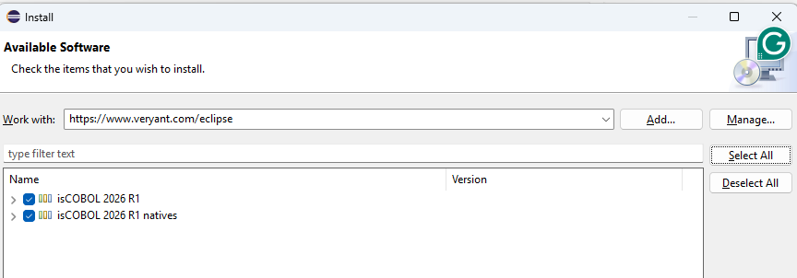
- Install the Veryant isCOBOL Plugin: Help > Install New Software, and install all packages from https://www.veryant.com/eclipse. Restart Eclipse to apply the changes.

- Install Groovy Development Tools (GDT) from Help > Eclipse Marketplace. Restart Eclipse to apply the changes.

Note: Make sure the Groovy Compiler version is 4.0.28 or higher. During installation, you may be prompted to accept an Unsigned option — trust and install the compiler.
- Set up the Groovy Compiler: Window > Preferences > Groovy > Compiler, click Switch to 4.0.28, and restart Eclipse.
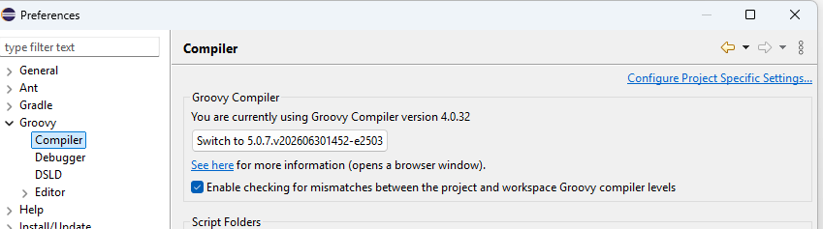

- Add the external Maven settings.xml: Window > Preferences > Maven > User Settings.

Compiling the Project
- First, perform a Maven clean install on the nib-java-demo-cobol project (right-click the folder > Run As > Maven Build, enter clean install in the Goals field, then Apply > Run).
- The aws-carddemo-iscobol-batch and aws-carddemo-iscobol-online modules contain the COBOL source programs.
- Running mvn compile in these projects starts COBOL compilation using the isCOBOL framework.
- Compiled .java and .class files are generated in the corresponding /target/classes folders.

Docker Configuration
Steps to start the containers using Docker. Make sure the environment variables described above are set before continuing.
- Open a command prompt and navigate to: cd \nib-java-demo-cobol\deployment\docker-compose
- Log in to the container registry: docker login ghcr.io -u GITHUB_USERNAME -p GITHUB_PERSONAL_ACCESS_TOKEN
- Start the containers: docker compose up --force-recreate --build -d
You can confirm that the containers have started from Docker Desktop:
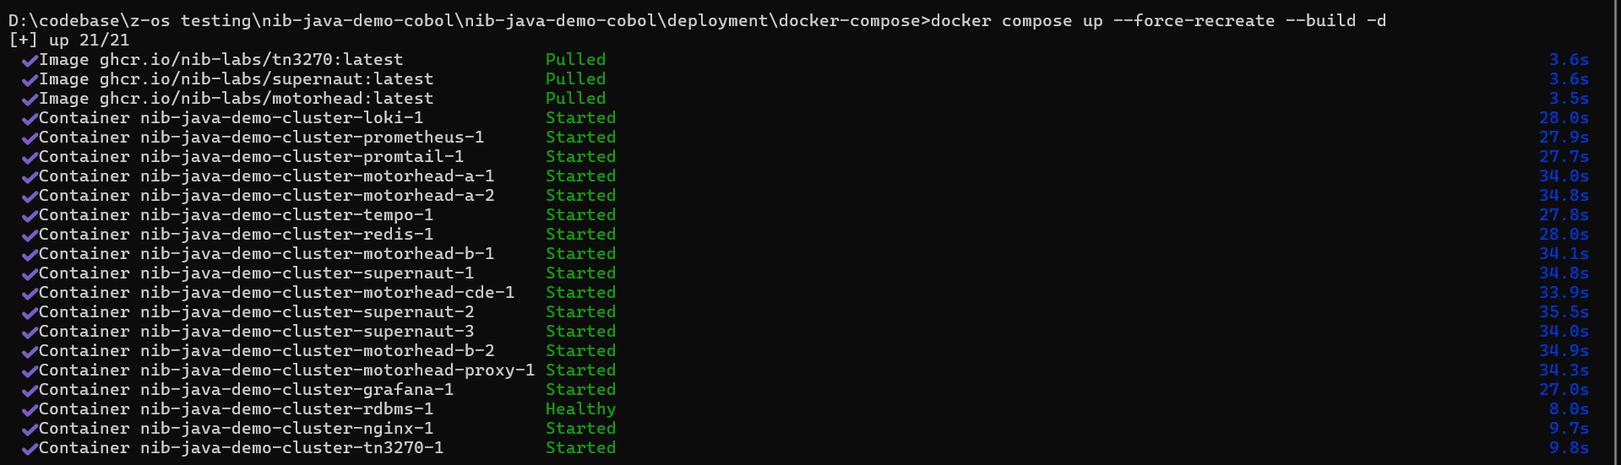
Summary of services provided by the containers:
Port | Purpose
3271 | TN3270
8090 | LIBER*TP Web Services
8081 | LIBER*Batch proxy
3000 | Grafana

CHAPTER 4

Running and Accessing the Pilot Environment

This chapter explains how to start the online and batch applications, and how to access the running pilot environment either through a TN3270 terminal emulator or through the Angular web front end.

Online and Batch Applications
The online region launches com.nib.supernaut.SupernautBootApp with the online configuration; verify successful startup through the Eclipse console logs and application access.
The batch region launches com.nib.motorhead.MotorheadNode with the batch configuration; verify successful batch initialization the same way.
Note: Minimum backend services are required to start the online region — the postgres and redis containers must be up and running.

The boot-online project comes with two run configurations, Boot Online and Boot Online Debug — both start the Supernaunt region (the debug variant additionally opens a remote debugger port; see Chapter 5).
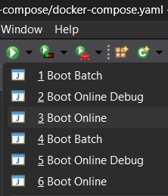
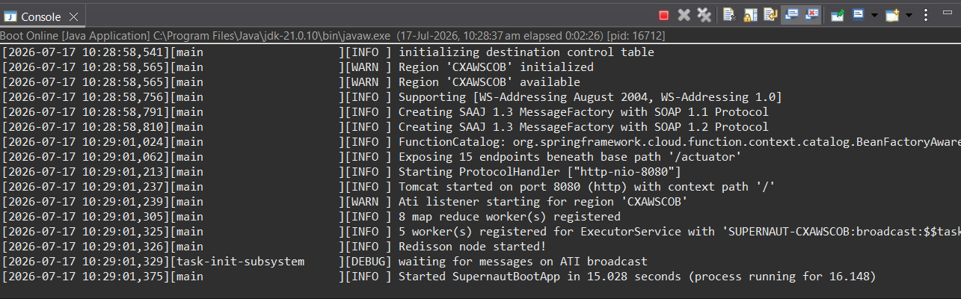
Eclipse console after starting the online region (Boot Online).

Accessing the Environment via TN3270 Plus
From the VDI, run the TN3270 Plus software. Insert a preferred session name, the IP address or hostname of the Docker VM (France or Germany — see Chapter 1), or localhost if running containers locally, together with port 3271. Then click Connect. The following map should appear.
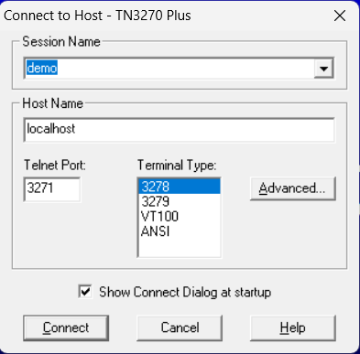
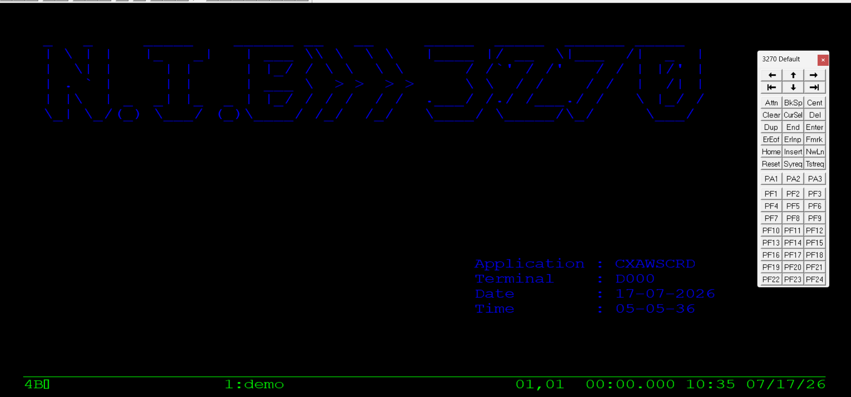
Clear it and run the initial transaction of the AWS Card Demo by typing CC00 and pressing Enter. “CC00” is a transaction ID mapped in the pct.json file under the config/online path.
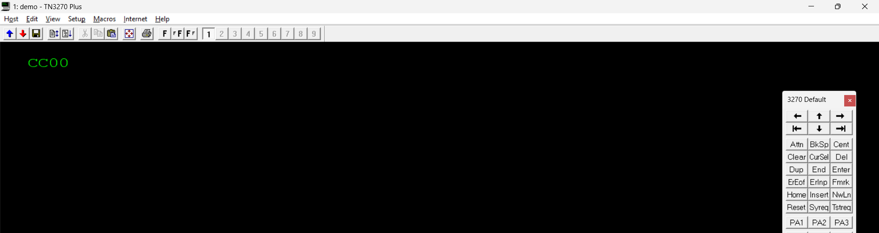
The CardDemo sign-on screen is then displayed:
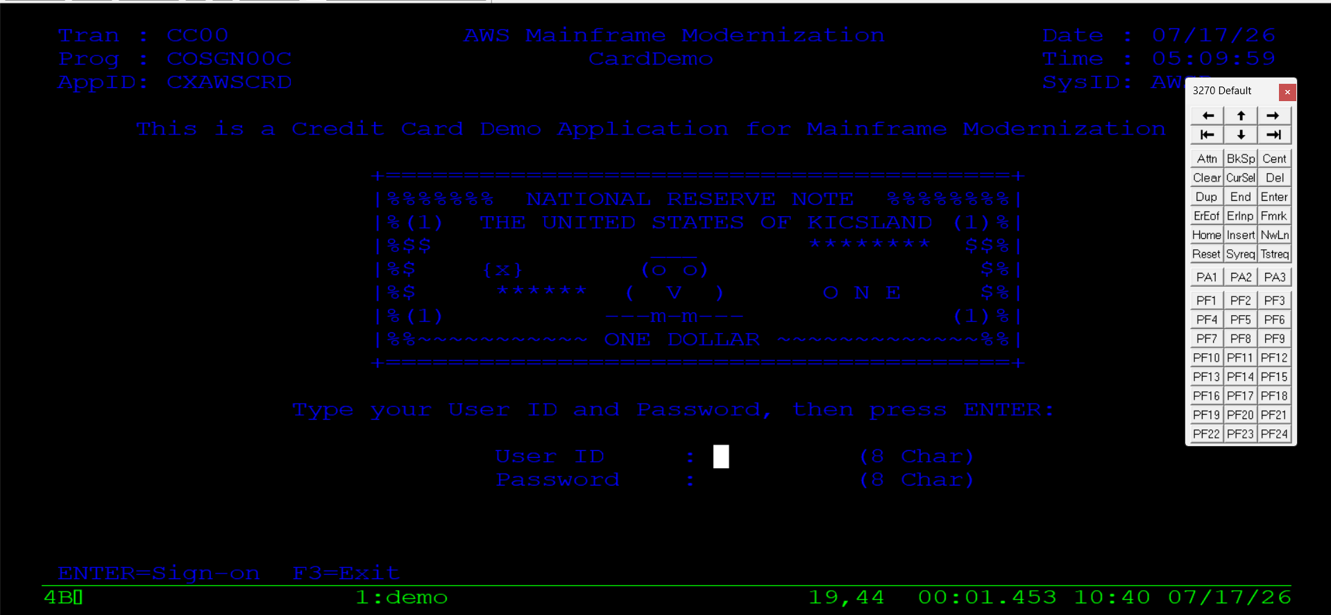
Log in and start exploring the AWS Card Demo using the following credentials:
- Admin access: user ID ADMIN001, password PASSWORD
- User access: user ID USER0001, password PASSWORD
For further information about the AWS Card Demo sample application, see https://github.com/aws-samples/aws-mainframe-modernization-carddemo.

Accessing the Environment via Angular (Web)
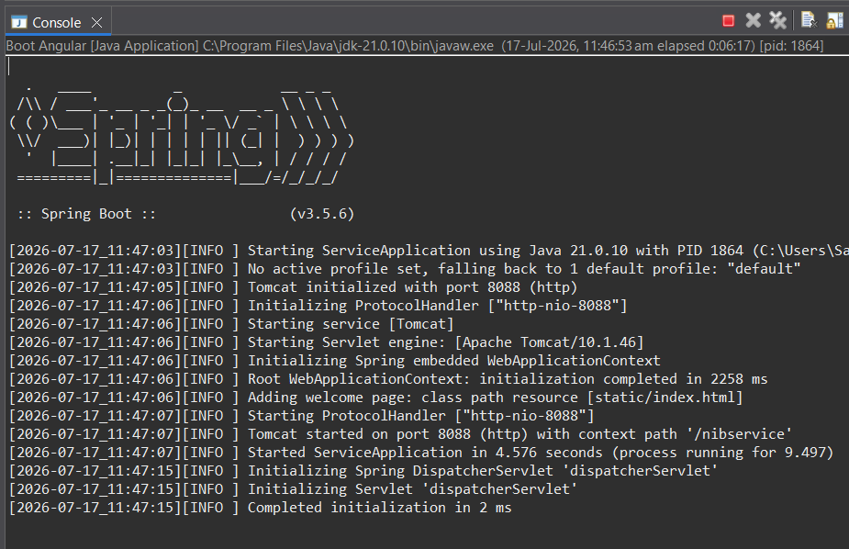
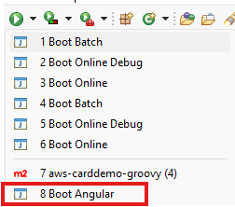
As an alternative to TN3270, the same online transactions can be reached through a browser using the generated Angular front end. From Eclipse, run the Boot Angular configuration; the console confirms that Tomcat is listening on port 8088:

Open a browser and navigate to https://localhost:8088/nibservice. Type the transaction ID CC00 and click Enter. Provide the same user ID and password used for the TN3270 session above, and the CardDemo application is displayed in the browser:
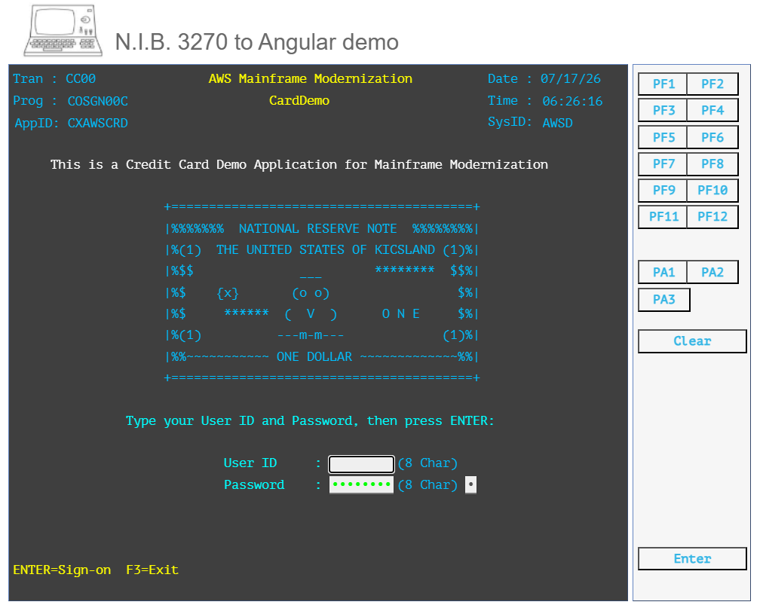

CHAPTER 5

Pilot Test Cases

This chapter walks through the pilot test cases used to validate the migrated environment: modifying and recompiling COBOL programs, deploying and verifying changes, defining transactions, debugging online and batch programs, running batch jobs, and exploring the mLogica refactoring, BMS, VSAM, and integration capabilities.

1. COBOL Program Modification and Compilation
Edit and recompile: open an existing COBOL program, make the necessary code changes, and recompile it. For example, change the following line in COSGN00C.cbl to alter the error message on the login map, then run mvn compile:
* Original
MOVE 'User not found. Try again ...' TO WS-MESSAGE

* Edited
MOVE 'Edit: Wrong credentials ...' TO WS-MESSAGE

2. Manual Deployment
Move the executable: since there is no automated CI/CD pipeline at this stage, the compiled executable (the .class file for the Java-based framework, or a load module for native mainframe systems) must be manually copied from the developer workstation to the server where the application runs. The new executable replaces the old one, making the updated program available.
- Copy COSGN00C.class from the output folder to the target environment, replacing the existing file inside /nib-java-demo-cobol/aws-carddemo-iscobol-online/target/classes/.

3. Verification and Testing
Trigger the transaction: to see the effect of a change to an online program, re-run the associated transaction. After the program is deployed, the updated message should appear on screen — for example, at a failed login, confirming the change was picked up.

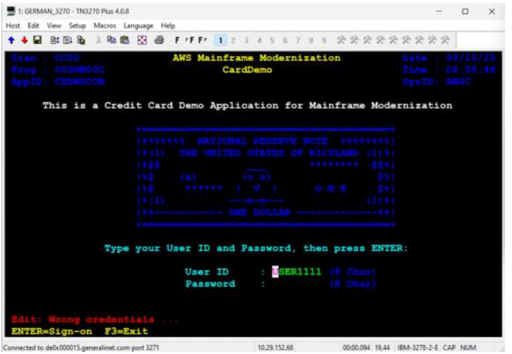

4. Transaction Definition
Define the transaction: a transaction is an entry in a CICS table — traditionally a Program Control Table (PCT) or, more recently, a TRANSACTION resource definition in the CICS System Definition (CSD) file. In the migrated environment, this is represented by an entry in /nib-java-demo-cobol/deployment/docker-compose/supernaut/pct.json:
{
"id": "CA00",
"group": "CARDDEMO",
"program": "COADM01C",
"twaLength": 0
}
This means that when a user enters CA00, CICS executes the program COADM01C.
Change the transaction ID: you can create a new transaction ID, such as CA11, and associate it with the same program COADM01C — a common practice to test new IDs or provide alternative access points without changing the underlying program. A new program is not required for this task:
- Add a new transaction entry to /nib-java-demo-cobol/deployment/docker-compose/supernaut/pct.json.
- Restart the containers.
- Run the new transaction to verify.

5. Debugging
Remote debugging: the isCOBOL Eclipse plugin provides a remote debugging feature. This allows a developer to set breakpoints in their local source and then trigger the transaction on the server; the debugger halts execution at the breakpoints, allowing the developer to step through the code, inspect variables, and troubleshoot issues.

Debug Online Programs
- Start the Boot Online Debug run configuration (requires postgres and redis containers to be up and running).
- Connect to TN3270 and run transaction CC00. The screen enters debug mode and waits for the debugger to attach; the Eclipse console shows “Debugger listen on port 9999”.
- Create a new Debug Configuration of type isCOBOL Remote Application with the default values (host localhost, port 9999) and click Debug.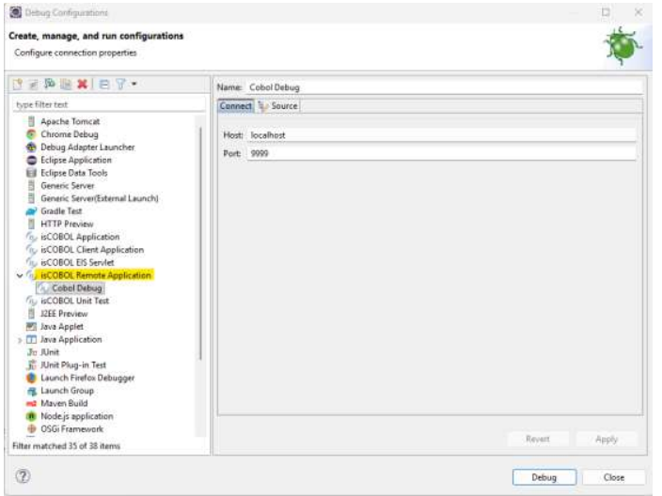

- The debug session starts from the current program, where breakpoints can be set, and the execution is stepped through as usual.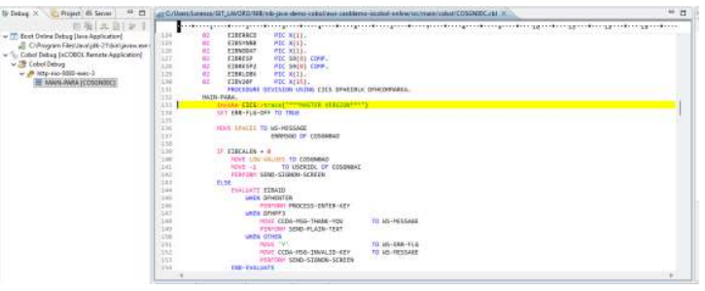

Debug Batch Programs
Same way, we can debug the batch programs, running the .groovy scripts
- Invoke the setCobolDebugger(true, false) method inside the .groovy script to be debugged (for example READCARD.groovy).
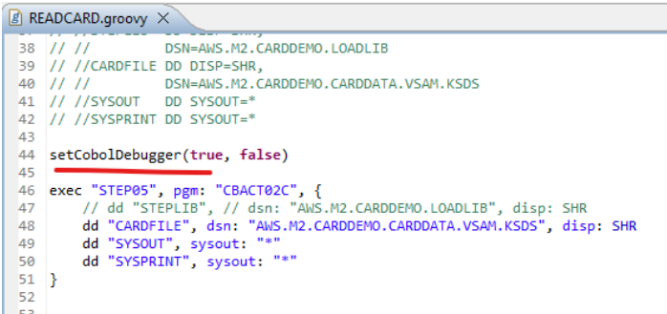

- Create a new Run Configuration for the .groovy script, adding the environment variables DATA_ROOT and NIB_BATCH_CONFIG pointing to your local nib-java-demo-cobol checkout.
- Run the script as a Groovy Script.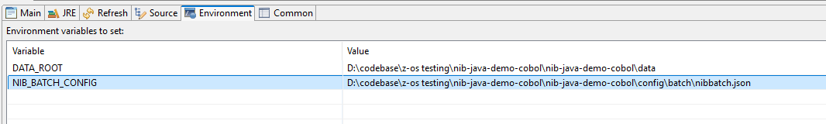
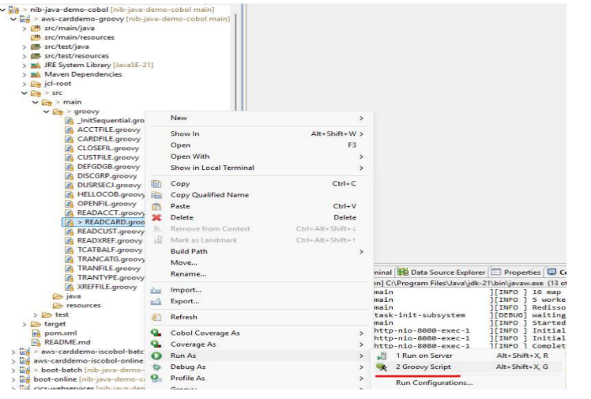

- Execute the same isCOBOL Remote Application Debug Configuration created for online debugging (host localhost, port 9999) to attach and step through the batch program.

6. Batch Program Workflow
Modify and run batch: the process for a batch program is similar to online modification, but involves a JCL job (here, a Groovy script that simulates the JCL step). Modify the COBOL batch program, recompile it, then run the job that invokes the updated program.
Verify execution log: the most important step is to check the execution log, also known as the job output or SYSOUT, which contains messages from the job and from the COBOL program itself. This can be checked via the Grafana dashboard, or through a REST API using a tool such as Postman.
- Run the READCARD job through the /job/submit API:
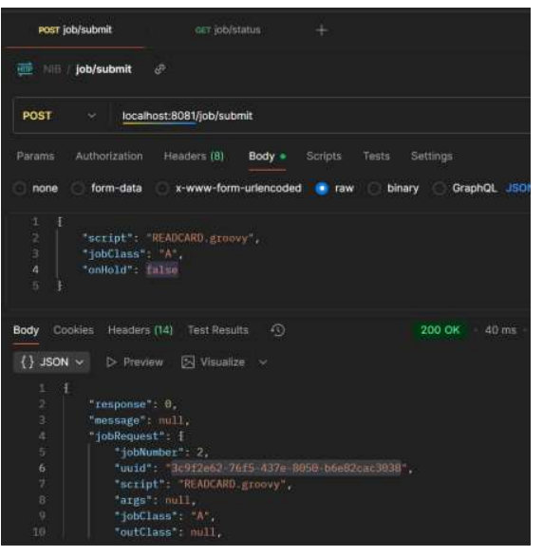
- Run the /job/status API with the uuid received in the submit response, and/or navigate to localhost:3000 to check the Grafana job logs:
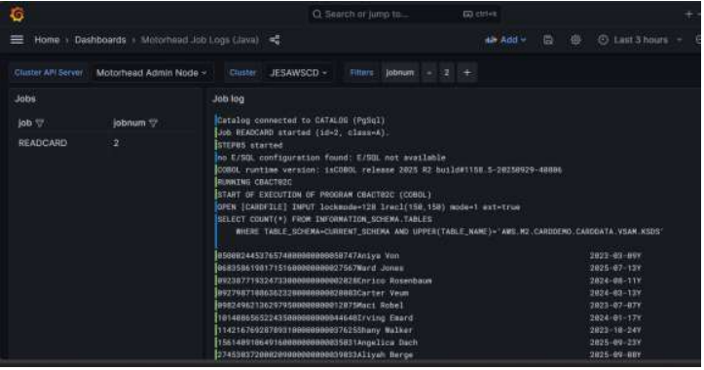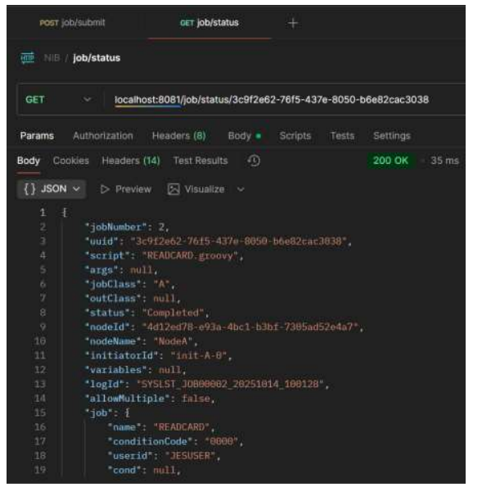

Modify the batch program invoked by the job — for example CBACT02C — by uncommenting a DISPLAY statement, then run mvn compile,
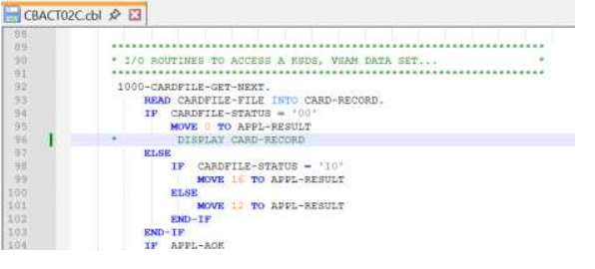
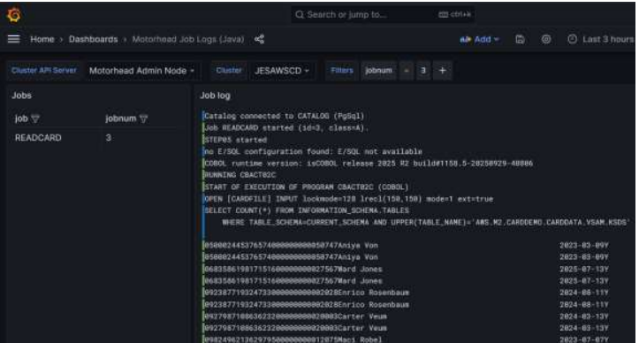
deploy the updated class under /nib-java-demo-cobol/aws-carddemo-iscobol-batch/target/classes, and run the READCARD job again through /job/submit to verify the change is reflected in the log.

7. COBOL Refactored to Java
The mLogica framework can run COBOL as Java bytecode, or the same program can be “re-factored” into Java using the mLogica refactoring tool. The refactored code separates the Working-Storage Section, the File Section (Records), and the Procedure Division into distinct Java classes:
Donwload the sample : cobol-refactor.zip
COBOL vs re-factored Java:
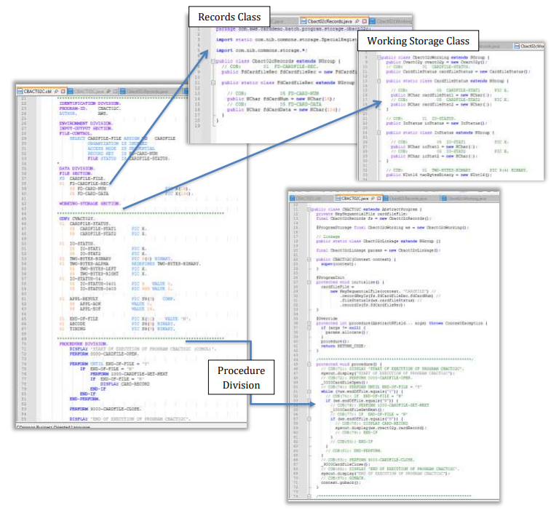

8. BMS and the Equivalent JSON
The mLogica framework transforms BMS mapsets into equivalent JSON files, preserving the map entries and field declarations (attributes, position, length, color, validation, and so on):
Download the sample: bms-refactor.zip
BMS vs equivalent JSON file:
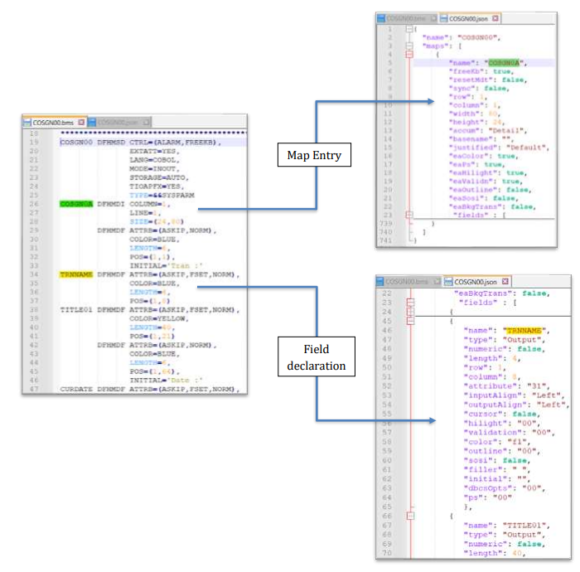

The framework can also generate Angular components directly from the BMS definition, so that the same screen can be deployed as a web application:
BMS refactored in Angular:
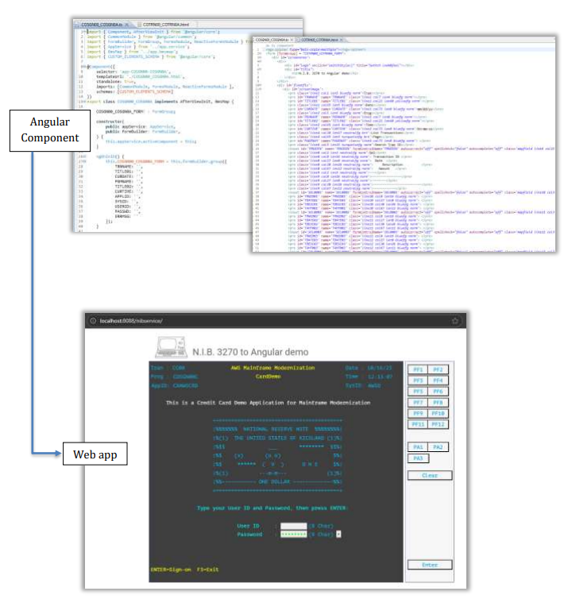

9. COBOL with SQL
Status: Work in progress — available in a future workshop.
This section will illustrate how a COBOL program that directly accesses SQL databases can be migrated within the framework. The current pilot environment (AWS CardDemo) is based on VSAM files and does not include direct database access, so for this workshop the SQL integration scenario is temporarily skipped in favor of the VSAM-based example. It will be added in a future update, showcasing how the framework can seamlessly handle database connectivity and data access migration.

10. Files and VSAM
The framework directly utilises the IDCAMS REPRO dump exported from the mainframe — whether in EBCDIC format or, as in the AWS CardDemo pilot, in ASCII.
These files are placed under the /data directory, where they become the input data sources for the migrated environment.
The migrated jobs, implemented in Groovy, accurately simulate IDCAMS behavior: when an operation such as DELETE or DEFINE CLUSTER is executed, the framework automatically drops or creates the corresponding PostgreSQL tables that represent the VSAM files.
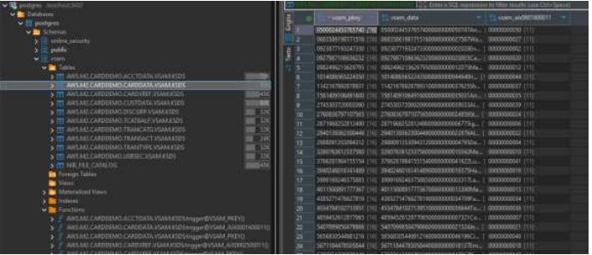

A dedicated catalog table is also maintained, mirroring the mainframe’s catalog function. This catalog keeps track of all files and their metadata — including sequential files, which, unlike VSAM datasets, are not mapped to database tables but are instead read directly as standard input files.
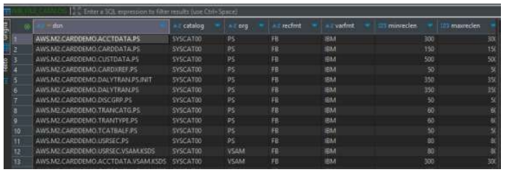

FCT and DCT Definitions
In the online environment, file and queue configurations are defined and maintained through two JSON configuration files: fct.json and dct.json.
These JSON definitions replicate the traditional CICS control tables used on the mainframe, allowing the online components to reference and access the same logical resources within the migrated environment in a consistent and portable way.

11. Integrations
The framework allows easy integration of external components through a dedicated wrapper mechanism.
This approach makes it possible to interface third-party modules, services, or libraries while maintaining consistency with the framework’s architecture and design principles.
Each integration must nonetheless be evaluated individually: the actual implementation should follow a preliminary technical analysis to verify compatibility, architectural impact, and performance requirements.
For detailed technical information and implementation guidelines, refer to the official product documentation.

CHAPTER 6

Troubleshooting

This chapter lists common issues encountered while installing, connecting to, or operating the pilot environment, along with their resolutions.

1. Timeout Connection to TN3270
TN3270 Plus cannot connect to the remote host — the selected IP address or port is wrong, or the required services are not running.
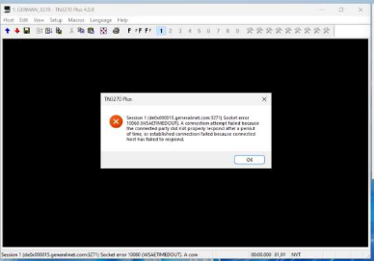
Solution: Check that all the containers are up and running in the Docker VM.

2. “Region is not available”
This can happen if the containers were restarted a few seconds earlier and the region is not yet up and running.
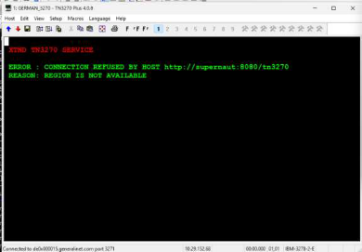
Quick solution: In a simple environment (without pipeline / service-dependency constraints), wait a few seconds for all services to become ready, then reconnect to the TN3270 service using the steps in Chapter 4.

3. “Terminal TXXX is not defined in TCT”
This can happen if the VDI IP address is not configured in the list of recognized IPs.
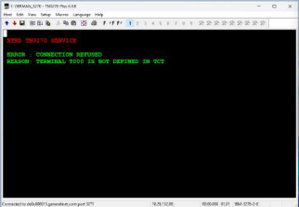
Solution: In the Docker VM, add two new entries into /nib-java-demo-cobol/deployment/docker-compose/supernaut/typeterm.json, replacing the sample values with your specific IP address and a unique “Id”, as shown below. Then restart the containers and reconnect to the TN3270 service.
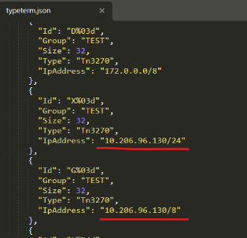

4. Time Zone Error
If you encounter a TimeZone: Asia/Calcutta error, add a VM argument to the run configuration to force the correct time zone.
Solution: Right-click the file (e.g. READCARD.groovy) > Run As > Run Configurations > Arguments tab > VM Arguments, add -Duser.timezone=Asia/Kolkata, then Apply > Run.
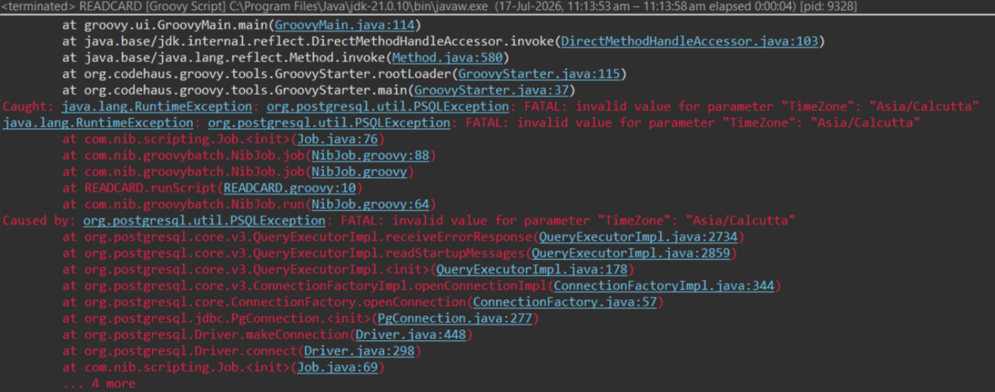
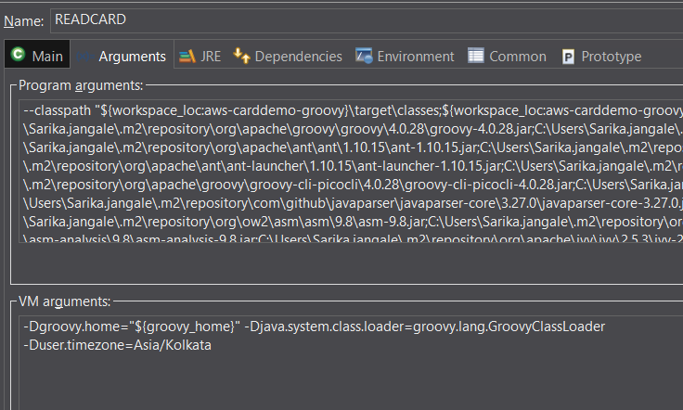

5. ERROR-27 (PGMIDERR)
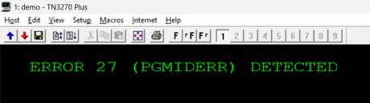

If this error occurs after executing a transaction ID in the TN3270 framework, verify the following configuration items, in order:
- Check the classpath to ensure Docker is pointing to the correct class — verify the application.yaml file located inside config/batch or config/online, as applicable.
- If the classpath is correct, check whether the program is mapped in the pct.json file.
- If this is also correct, run docker compose config from the command line to verify that Docker is using the correct path.

6. FileNotFoundException
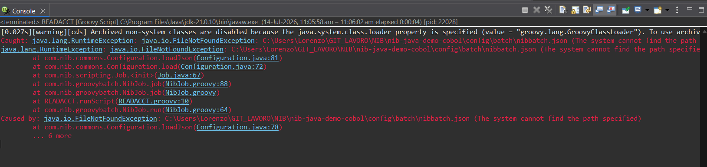
A Groovy Development Tools conflict can occur due to incorrect path references in the Groovy configuration; simply reinstalling GDT may not resolve the issue if groovy.jar still points to another user’s local path.
- Verify all Groovy-related configuration files and identify any incorrect path references.
- Replace the existing path references with the appropriate local system path.
- In this case, 24 path references required updating before the configuration issue was resolved.

