COBOL to Java Framework Testing
  - Testing & Execution Guide
Document | Execution Environment | Primary Tool
COBOL → Java Framework Testing | JDK 21 | IntelliJ IDEA

1. Purpose
This document describes the process used to test and execute PROC/JCL workloads that have been migrated to the Groovy Framework. The framework can be executed from development environments such as VS Code, IntelliJ IDEA, and Eclipse.
For this testing activity, IntelliJ IDEA was used to configure, build, and run the converted Groovy jobs. The guide covers project setup, environment configuration, Groovy run configuration, execution, and verification.

2. Software and Prerequisites
- IntelliJ IDEA
- JDK 21
- Docker Desktop Run Redis and RDBMS

3. Project Setup
- Open the nib-java-demo-apps (LIBER-REFACTOR) project in IntelliJ IDEA.
- After importing, verify that the project structure is visible in IntelliJ IDEA.
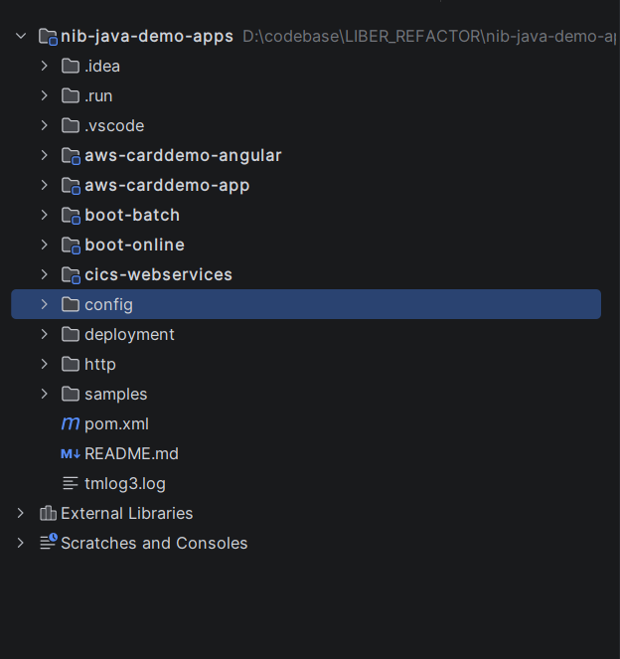
Figure 1. Imported nib-java-demo-apps project structure.

- Set the NIB_LICENSE_KEY in the user or system environment.
- From the project root, run the Maven package lifecycle. This builds the project and generates the required compiled artifacts in the target folder.

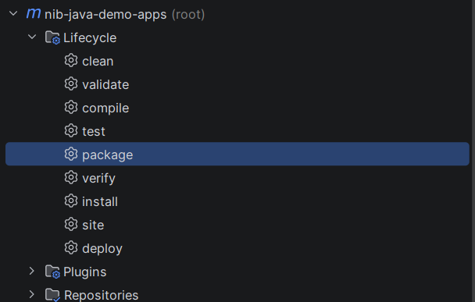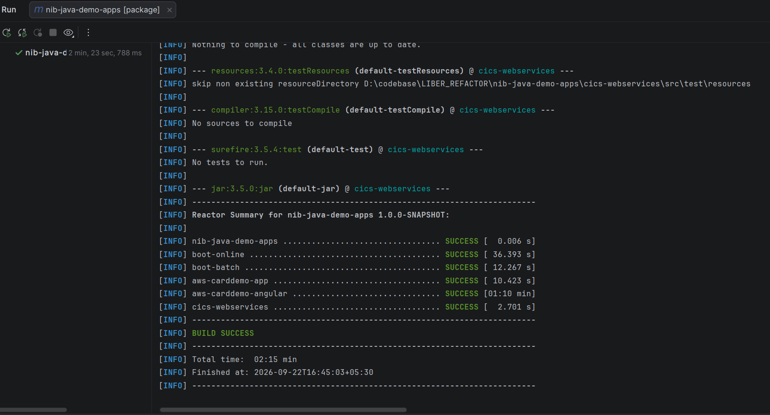
Figure 2. Maven package lifecycle and build output.

- Place the converted Groovy and Java files in their respective source folders.

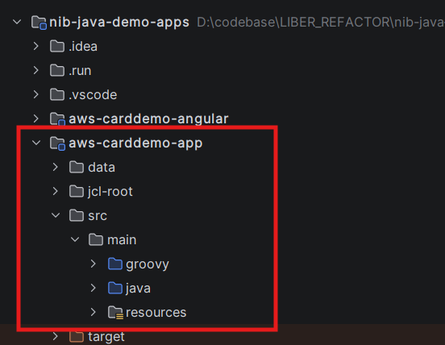
Figure 3. Location of the converted Groovy and Java source folders.

4. Run Configuration and Execution
The following screenshots document the run configuration and execution flow used during testing.

- Open Run > Edit Configurations. In the Run/Debug Configurations dialog, select Add New Configuration and choose Groovy.
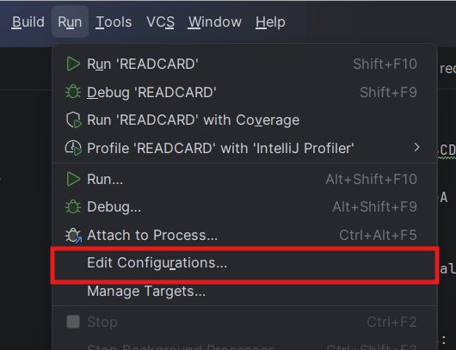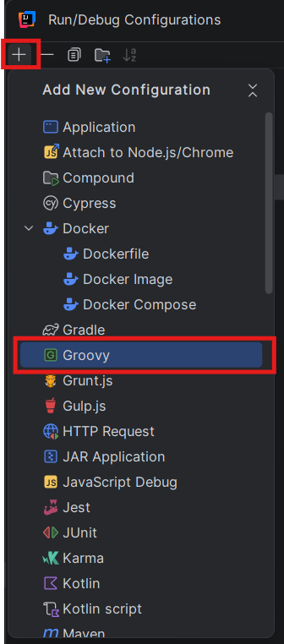
Figure 4. Opening Run/Debug Configurations and selecting Groovy.

- Configure the Groovy run configuration using the settings shown in the screenshot.
- Add the required environment variables using the Environment Variables section.
- Ensure that “Add module classpath to the runner” is enabled.
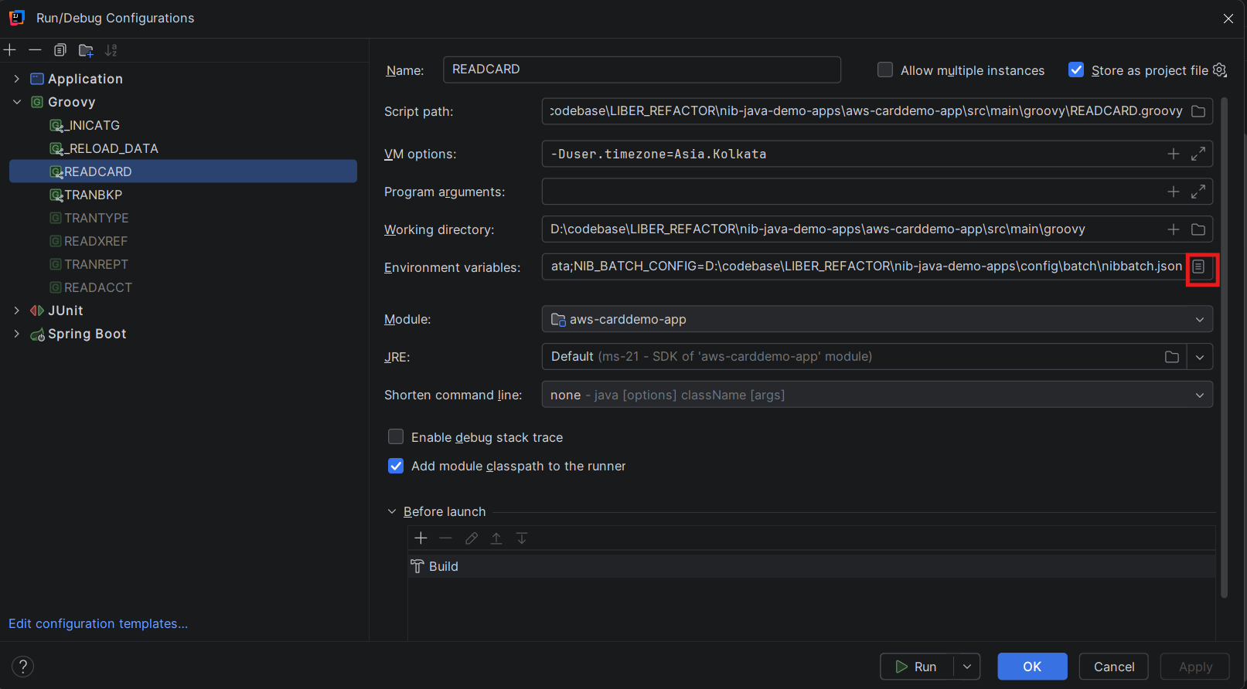
Figure 5. Groovy run configuration settings.

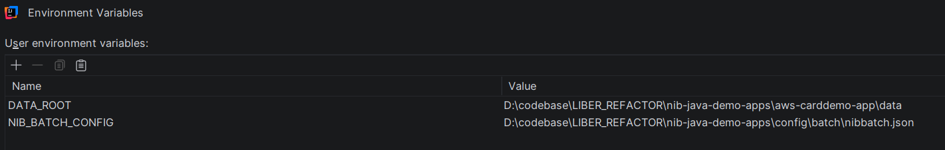
Figure 6. Environment variables configured for the Groovy job.

- Select Run to start the Groovy job. A successful execution is indicated by the job completing in the Run console without an execution error.

5. Verification
Confirm that the Groovy job completes in the IntelliJ Run console. The captured execution output shows the job completing successfully and the process finishing with exit code 0.
If the job does not start or fails during execution, review the project structure, NIB_LICENSE_KEY, environment variables, selected module/classpath, and Groovy run configuration before rerunning the job.

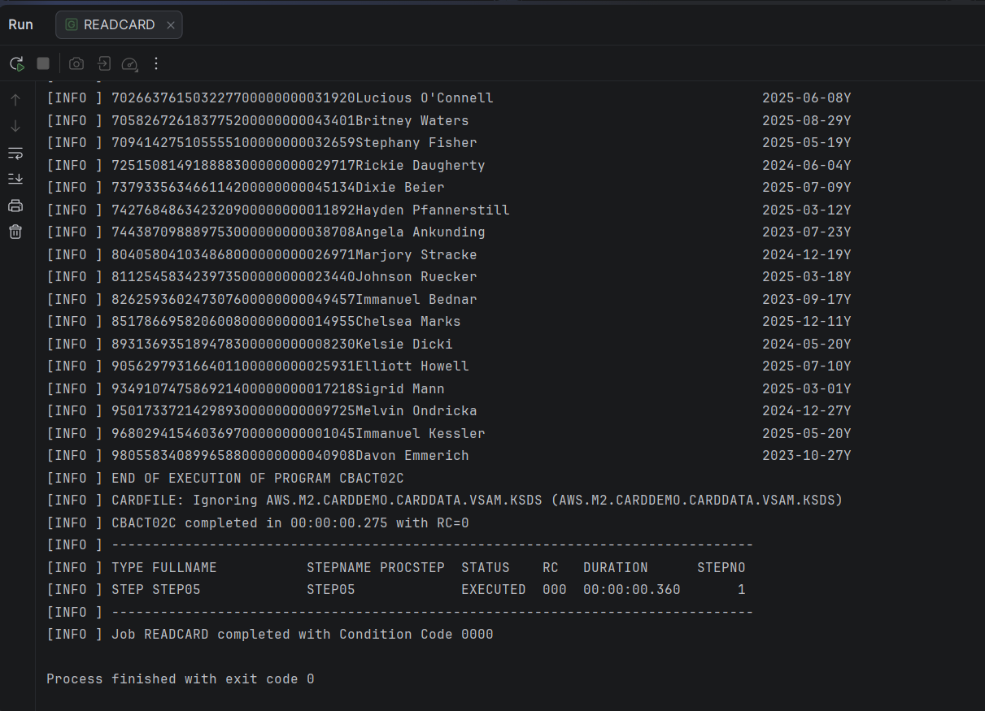
Figure 7. Successful Groovy job execution in the IntelliJ Run console.

6. Troubleshooting

Unable to Resolve NibJob/ Moterhead Class
Error: Unable to resolve class com.nib.groovybatch.NibJob / unable to resolve class com.nib.motorhead.scripting.MotorheadClass
Cause: The Groovy script is executed without the required project dependencies in the classpath.
Resolution:
- Open the Groovy Run Configuration.
- Enable: Add module classpath to the runner
- Rerun the Groovy script

Timezone Error During Job Execution
Error: Asia/Calcutta
Cause: PostgreSQL does not recognize the configured timezone.
Resolution:
- Add VM Option: -Duser.timezone=Asia/Kolkata
- and re-run the application.

Redis/PostgreSQL Connection Failure
Error: Unable to connect to Redis/PostgreSQL
Cause: Redis/PostgreSql service is not running or incorrect Redis/PostgreSQL configuration is used.
Resolution:
- Verify the redis and RDBMS are running in Docker Desktop.

