LiberM – Refactor Environment
Installation & Setup

User Guide

Date:17-Apr-2026

Contents
Revision History 3
Prerequisites 4
Setup Environment 4
Maven Configuration 4
Environment Variables Setup 5
Configure Project 5
LiberM Refactor Process 6
Convert COBOL to Java 6
Convert JCL to Groovy 6
Convert PROC to Groovy 6
Convert BMS to Angular 7
Troubleshooting 7
LiberM Runtime Configuration 7
Build Project 7
Docker Configuration 7
Online (LiberTP/Supernaut) 8
TN3270 9
Browser (Angular UI) 11
Batch (Liber Batch/ Motorhead) 12
Troubleshooting 13
Reference 13

Revision History
Date | Version | Name | Comment
26-04-2026 | 1.0 | Sethulekshmi Pisharadi | Base version
11-05-2026 | 1.1 | Sethulekshmi Pisharadi | Updated

Prerequisites
Sl. No | Pre-requisite | Details
1 | Maven Repository Access | ***URL: https://maven.pkg.github.com/nib-labs/nib-java.
2 | Software | **TN3270 Emulator
3 | IDE | IntelliJ IDEA
4 | Software | Node.js Version 21 (v21.7.3)
5 | Software | Docker Desktop
6 | Software | DBeaver
7 | IntelliJ Setup | Environment variables (see below)
8 | Optional Tool | Postman
9 | GitHub | Desktop/Bash, Github Account
10 | JDK | Java 21

Setup Environment

Maven Configuration
mLogica framework is available at https://maven.pkg.github.com/nib-labs/nib-java. In
order to use it, you need to add the repository to your pom.xml:

<repositories>
<repository>
<id>github</id>
<url>https://maven.pkg.github.com/nib-labs/nib-java</url>
</repository>
</repositories>

The repository is hosted on GitHub.com and even if the repository is public, GitHub requires
a valid user to download packages. Therefore, you need to add your GitHub credentials to
your maven settings.xml file:
<servers>
<server>
<id>github</id>
<username>GITHUB_USERNAME</username>
<password>GITHUB_PERSONAL_ACCESS_TOKEN</password>
</server>
</servers>
How to generate GITHUB_PERSONAL_ACCESS_TOKEN?
Login to Github repository, In the upper-right corner of any page on GitHub, click your profile picture, then click Settings. In the left sidebar, click Developer settings. In the left sidebar, under Personal access tokens, click Fine-grained tokens. Click Generate new token.
***Add the Git credentials to settings.xml file in .m2 folder [C:\Users\<your-user>\.m2].

Environment Variables Setup

NIB_JAVA_LICENSE_KEY:xxxx [A valid license key for LiberM]
NIB_JAVA_DEMO_HOME: Set to the path of the root project: \nib-java-demo-apps

Configure Project
Download the required packages for the LiberM refactor project from the following MLogica SharePoint location.
Also download **TN3270 Emulator from same link
Download and extract the TN3270Plus.zip package and open the .exe file for the emulator.
Mlogica External Projects Management Team - Documents - Installation and Configuration - All Documents
AWS Card Demo – Sample Project Packages
- aws_cards_demo.zip
- nib-java-demo-apps.zip
Detailed information about the projects and folder structures is available in the README.md files included with each package.
Create a folder on your local machine, then extract and copy the downloaded packages into it as shown in the screenshot below.
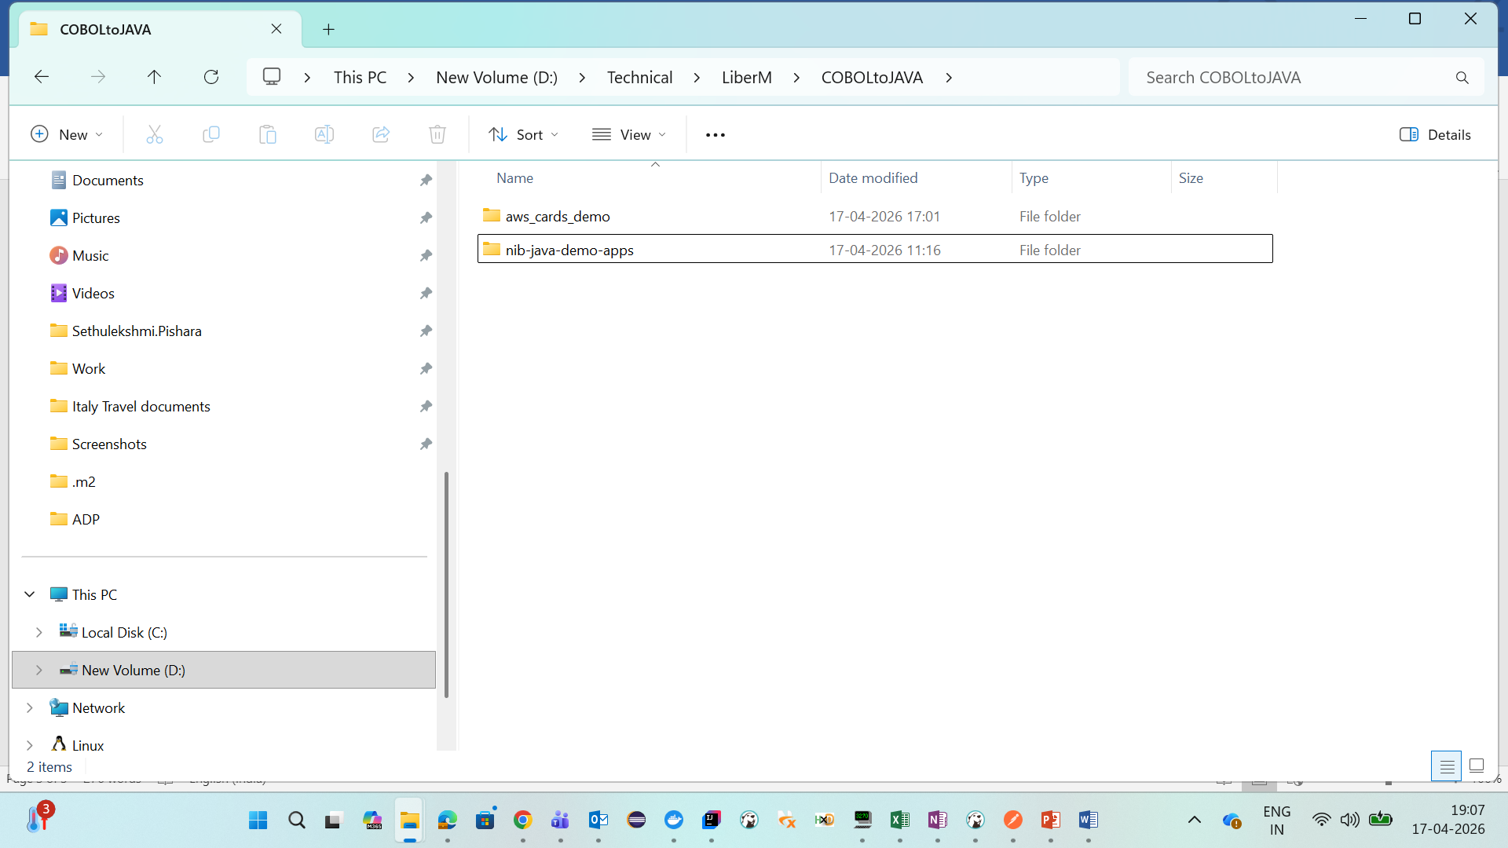
The first folder contains the mainframe source code along with the configuration files required to run the conversion tool. The second folder contains the converted code and the deployment configurations.
For more information about the AWS Card Demo project, refer to the link below:
https://github.com/aws-samples/aws-mainframe-modernization-carddemo

LiberM Refactor Process

Convert COBOL to Java
COBOL batch and COBOL online programs require different conversion processes, so they must be separated before conversion. This segregation can be performed during the assessment phase using Dahlia. Copybooks should also be separated and stored in a dedicated folder.
In the AWS Card Demo example, both batch and online COBOL programs are stored in the same directory [\aws_cards_demo\sources\cbl]. However, they are differentiated using naming conventions, where batch programs use the suffix *CB and online programs use *CO. As a best practice, it is recommended to maintain batch and online programs in separate folders.
The next step is to configure the conversion files. Before starting the conversion, update the source and target paths in the configuration XML files.
- conv_cobol_batch_java_config.xml → Batch conversion configuration
- conv_cobol_online_java_config.xml → Online conversion configuration
A sample XML configuration is shown below:
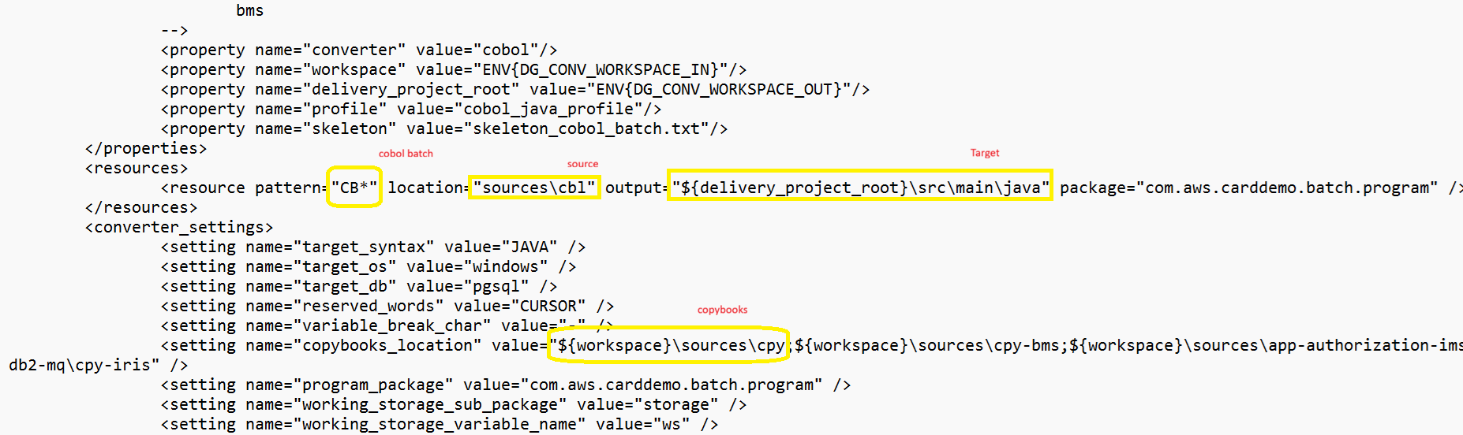
The variable ${delivery_project_root} will be replaced with the root target folder which is “\nib-java-demo-apps\aws-carddemo-angular”.
After updating the required settings in the config.xml file within the aws_cards_demo folder, execute the following command from the Command Prompt:
- run.bat or Convert.bat

Convert JCL to Groovy
Store the JCL files in the source->jcl folder, and update the configuration file with the appropriate source and target directories before starting the conversion.
conv_jcl_groovy_config.xml
The conversion process is the same as those described for COBOL-to-Java conversion.

Convert PROC to Groovy
Store the PROC files in the source->proc folder, and update the configuration file with the appropriate source and target directories before starting the conversion.
conv_proc_groovy_config.xml
The conversion process is the same as those described for COBOL-to-Java conversion.

Convert BMS to Angular
Store the bms files in the source->bms folder, and update the configuration file with the appropriate source and target directories before starting the conversion.
conv_bms_angular_config.xml
The conversion process is the same as those described for COBOL-to-Java conversion.
The converter produces 3 files from bms, which are:
- HTML
- Type Script (TS)
- JSON

Troubleshooting

All errors and issues encountered during the conversion process are logged in the following directory:
\aws_cards_demo\logs
Separate log files are generated for each program and stored in this folder.
For easier analysis, an Analyze.bat script is provided. Running this script exports the log details into an Excel report and generates a consolidated analysis report.
- Analyze.bat
Example report name:
“AnalysisReport_30-04-2026_09-33-27.71.xlsx”

LiberM Runtime Configuration
Import the project into \nib-java-demo-apps into IntelliJ. The sample demo project already contain all configuration and deployment files to run and execute the application.
Build Project
Execute the following command to build the project:
mvn clean install
Ensure that the build completes successfully without any errors.
Docker Configuration
Keep the Docker desktop open before running the docker commands.

Open the terminal from the IDE, navigate to the deployment/docker-compose directory, and execute the following command to start the Docker containers for all services:
- docker compose up --force-recreate --build -d
For additional details and configuration information, refer to the README.md file.

Open Docker Desktop and verify that all containers are up and running. If any service is stopped, try restarting it directly from the Docker Desktop application. If the issue persists, further analysis should be performed by reviewing the logs and console output of the affected container.
A reference screenshot of Docker Desktop is shown below.
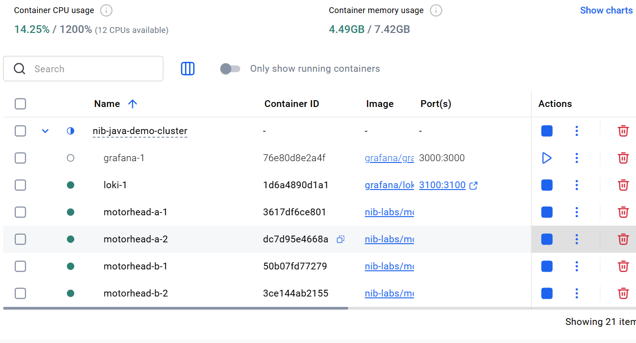

Summary of services provided by the containers:

Port | Purpose
3271 | TN3270
8090 | LIBER*TP Web Services
8081 | LIBER*Batch proxy
3000 | Grafana

Online (LiberTP/Supernaut)

Online transactions can be invoked using either of the following methods:
- TN3270 Emulator – The traditional approach, providing a user interface similar to the mainframe environment.
- Browser (Angular UI) – A modern web-based interface for accessing and interacting with the application.

TN3270
Open the emulator Tn3270.exe application and navigate to Host → Connect using the following configuration:
- Host: localhost
- Port: 3271
- Terminal Size: 24 x 80
After establishing the connection, perform a clear screen operation. To do this, use the terminal keyboard within the emulator. From the top menu, navigate to View and enable Keypad Toolbar. This will display the emulator keyboard, allowing you to access the required terminal keys.
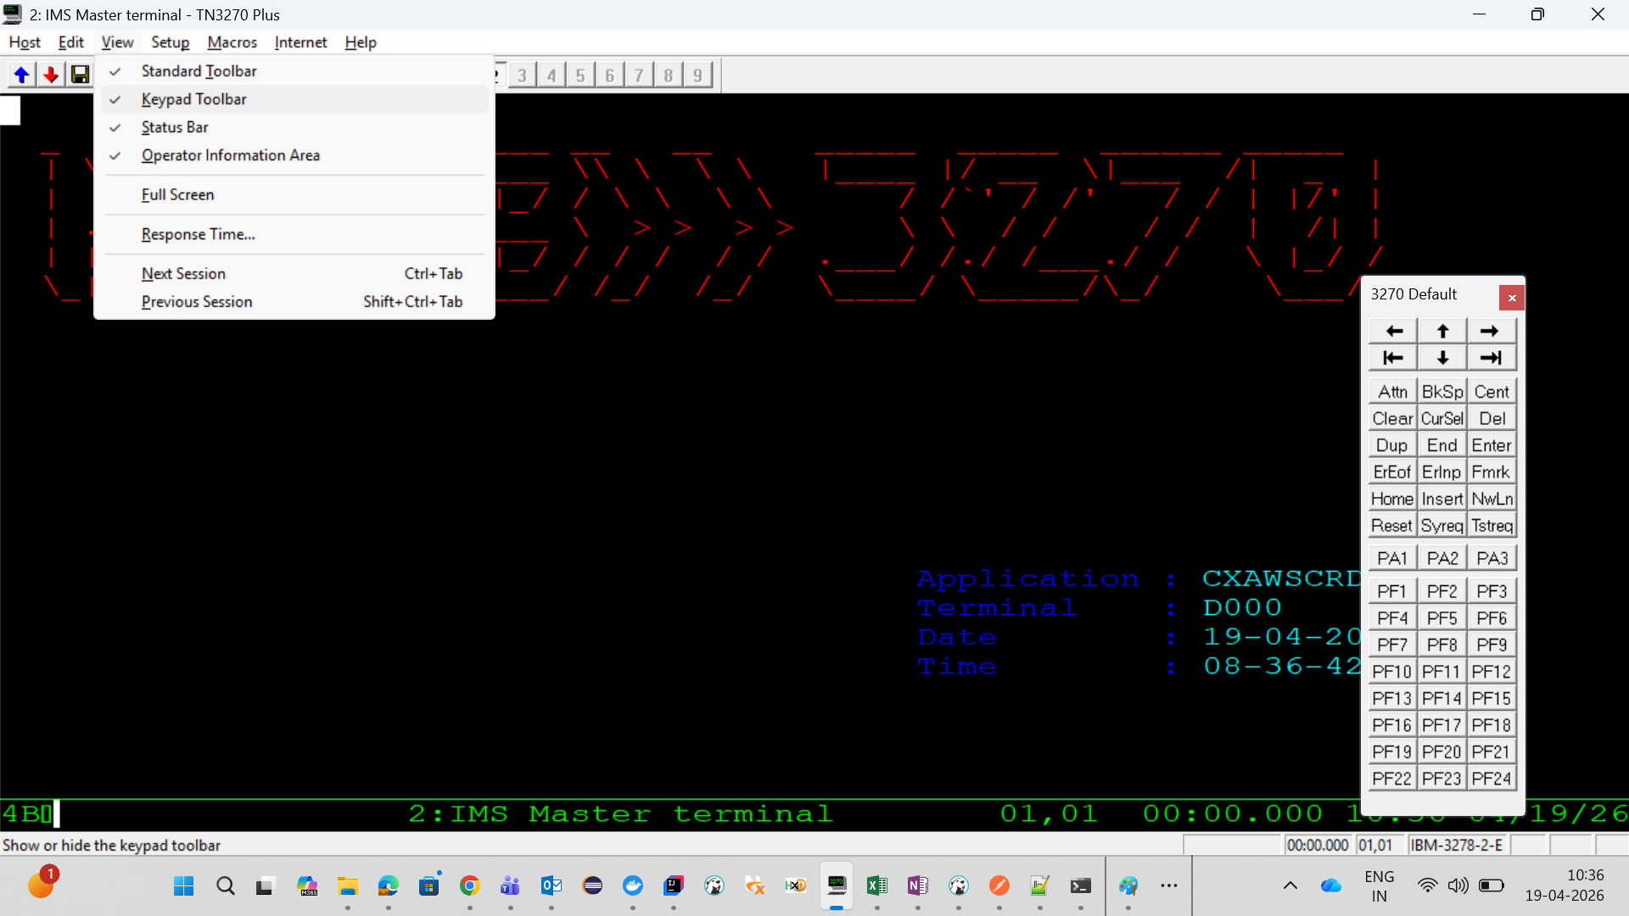
Enter the 4 digit transaction id to invoke CICS transaction
Example:
“CC00”
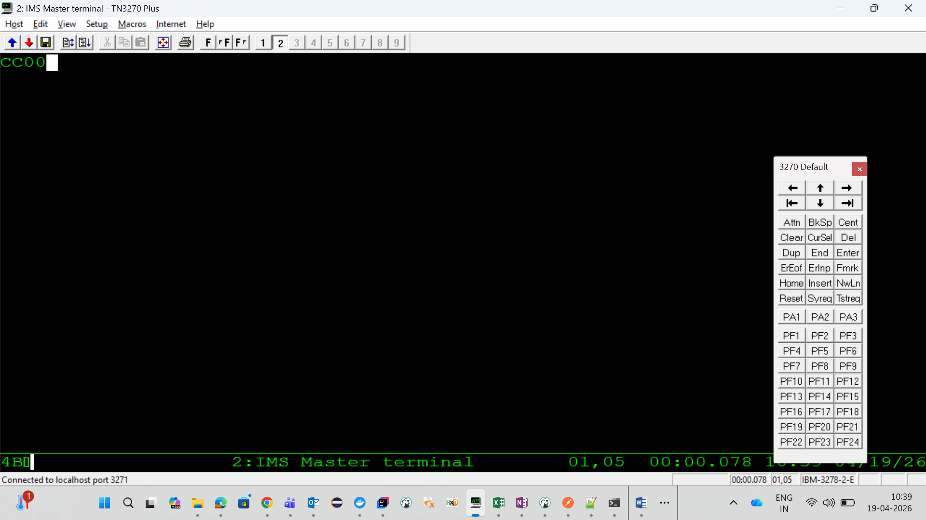
In the next screen type -> USER ID: user0001, Password: password
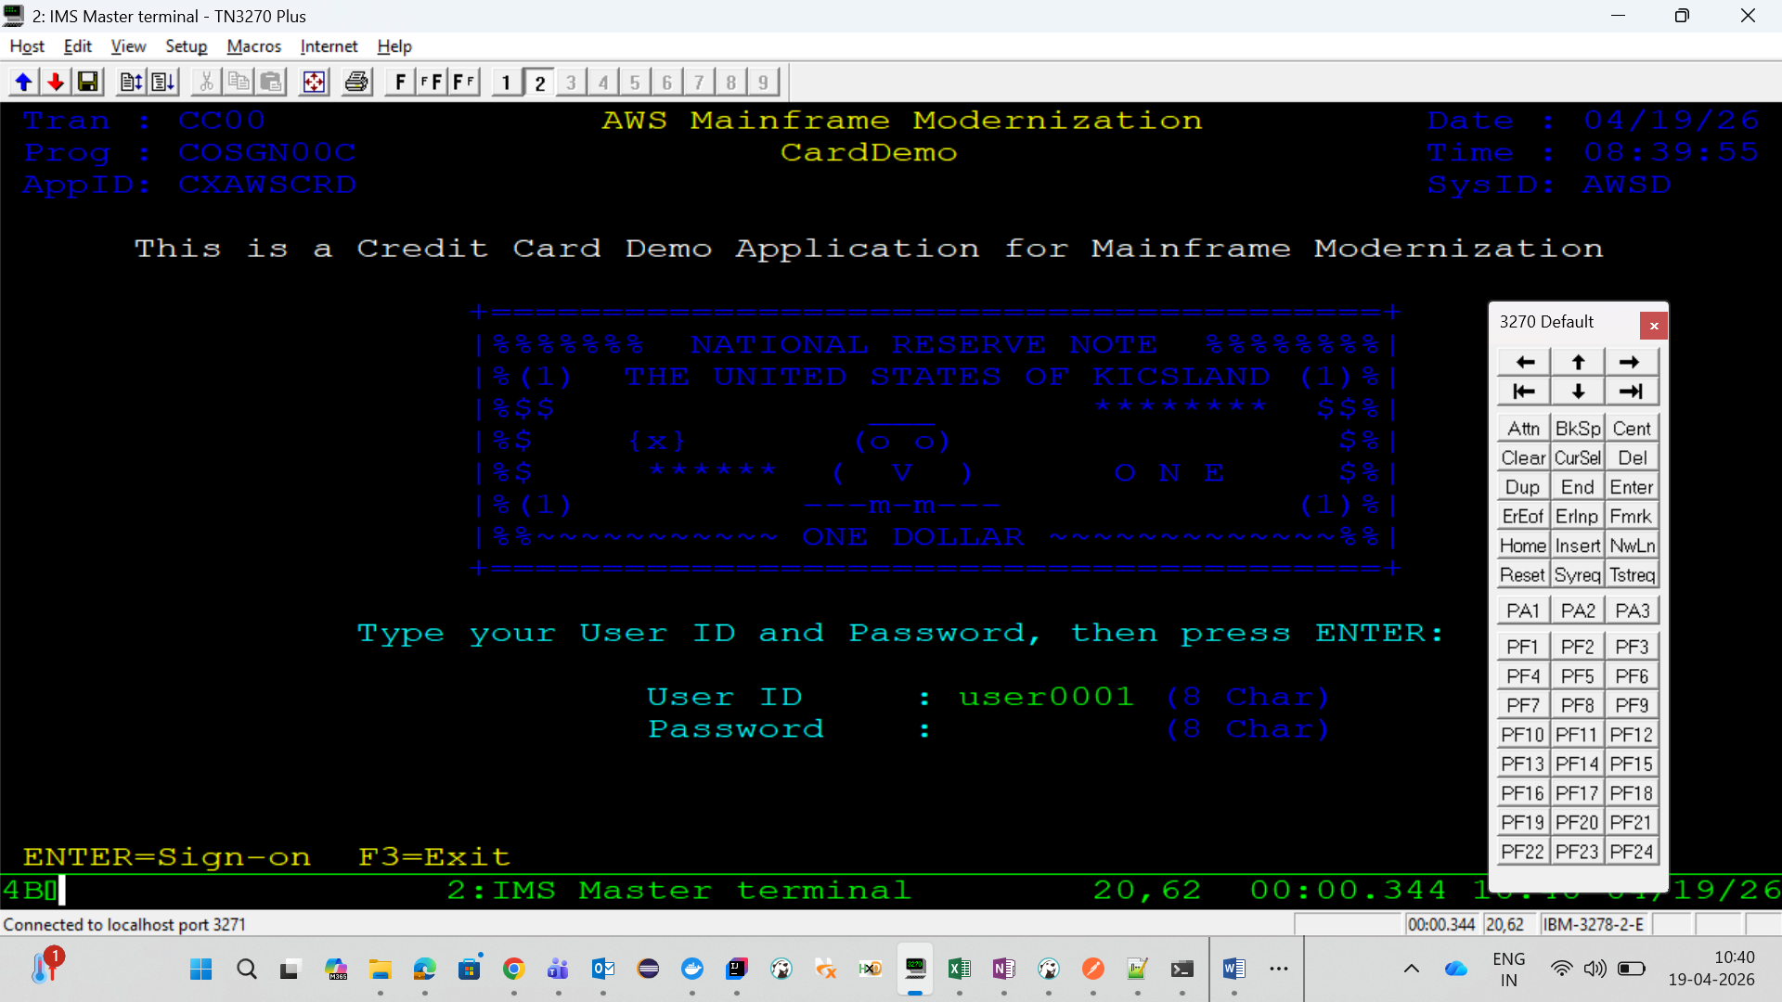

Navigate to the Docker desktop-> open the cluster supernaut-1/supernaut-2/supernaut-3 to see the logs (you can stop clusters 2 and 3 while testing, to see all the logs in one cluster).
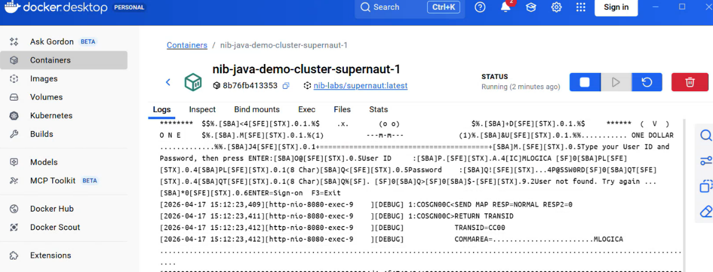
Go to TN3270 and choose the option from main menu.
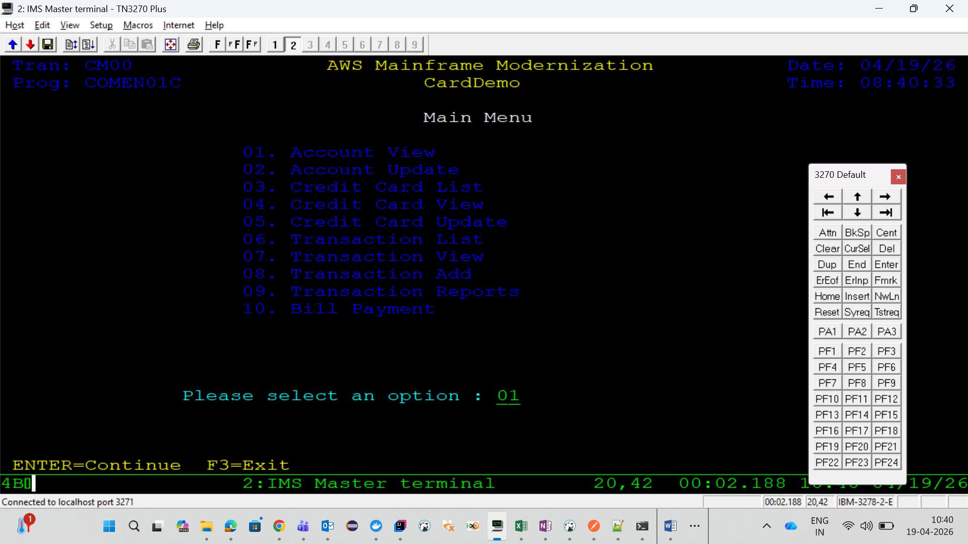

Browser (Angular UI)

The Angular application should be started locally on localhost.
In the sample demo project, the boot-online folder contains the configuration required to run the Supernaut online application. Open the project in IntelliJ IDEA and perform the following configuration steps.
From the top-right menu in the IDE, click the three-dot menu and select Edit Configurations, then apply the configuration shown below.
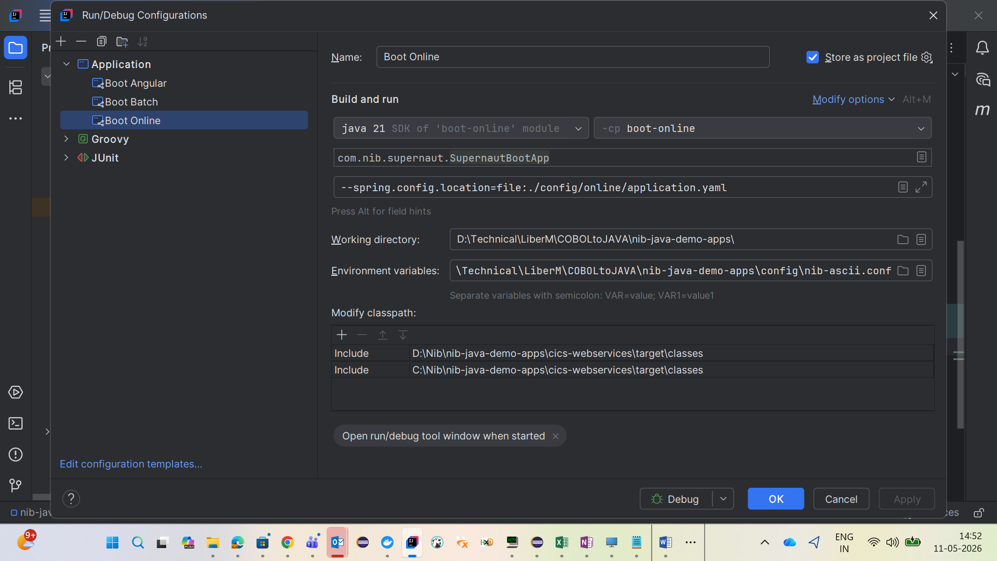

Similarly, create another application configuration for Boot Angular as shown in the screenshot below. Configure the Working Directory to point to the Angular application folder.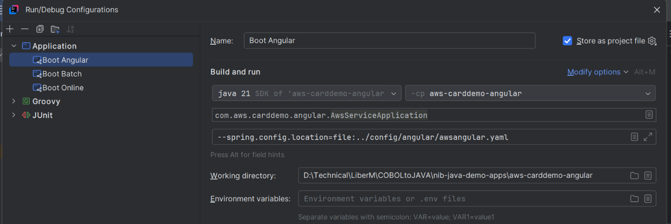
Run both boot-online and boot-angular for starting the online application. Browse the application in your localhost using the URL NIB 3270 Angular Platform. This can be configured in /config/angular/awsangular.yaml file.

Batch (Liber Batch/ Motorhead)
There are different ways to invoke the groovy in LiberM batch framework. The LiberBatch framework provides rest API’s to invoke the groovy files. This can be triggered via:
- Postman
- SwaggerUI and API docs (http://localhost:8080/swagger-ui.html)
- Powershell/CMD (cURL command)
Below are few Rest API commands/URL’s and the JSON parameters for Postman.
Application Endpoints
Completed Jobs:
http://localhost:8081/job/list
Active Jobs:
http://localhost:8081/job/ps
Job Status (UUID required):
http://localhost:8081/job/status/{uuid}
Example:
http://localhost:8081/job/status/1c0f058c-865a-4ef7-b0b0-675dd79114f1
Submit a Job
Endpoint:
http://localhost:8081/job/submit
Sample Request Body to submit:
{
"script": "CUSTFILE.groovy",
"jobClass": "A",
"onHold": true,
"variables": {
"RUNDATE": "2026-04-17",
"PREFIX": "BTC001"
}
}

Troubleshooting
- Ensure environment variables are correctly set
- Verify Maven dependencies downloaded successfully
- Check running containers: docker ps
- Check logs if needed: docker logs

Reference
More details on LiberM can be found in the API doc available in below link.
liberm_mlogica_1.6.27 1.zip

