LinguaParity: Do Multilingual LLMs Provide Equal Access to Information Across Languages?
Full Name Surname¹
¹Department, Faculty, University, City, Country
email@domain.com | ORCID: 0000-0000-0000-0000

ABSTRACT
Large language models (LLMs) are marketed as multilingual, yet multilingual capability does not guarantee that speakers of different languages receive equally reliable and complete information. This study introduces LinguaParity, a framework that treats multilingual AI as an information-access pipeline and measures parity at each stage: evidence availability, retrieval, evidence coverage, dependence on high-resource sources, and the token cost of expressing the same need. We built 32 parallel information needs on education, employment, public services and digital safety, each with three verifiable key facts, and evaluated them in English, Turkish, Urdu, Swahili, Yoruba and Amharic against the live Wikipedia editions of those languages using a model-independent retrieval-augmented generation (RAG) retriever. The canonical article for a need existed in 30 of 32 cases for Turkish, 19 for Urdu, 8 for Swahili, 0 for Yoruba and 1 for Amharic. Native evidence covered 95% of key facts for English but 10% on average for the three lowest-resource languages, while English-pivot evidence raised this to 57%. When native and English evidence competed, English passages filled 53% of top-ranked slots for these languages, and the same question cost up to 4.0 times more tokens than in English. Information inequality is therefore already present before any text is generated, and closing it through English sources trades local relevance for coverage.
Keywords: multilingual large language models, information access, low-resource languages, retrieval-augmented generation, language equity

1. INTRODUCTION
Large language models (LLMs) are increasingly used as an entry point to information about schooling, jobs, public services and online safety, and they are routinely presented as multilingual systems. The usual evidence for this claim comes from benchmarks of language understanding and generation, such as translation, reading comprehension and question answering scores [1-4]. These benchmarks show that performance falls with the amount of digital text available for a language [5, 6], and that tokenizers charge some languages several times more than others for the same content [7, 8]. They say much less about a more practical question: does a person who asks for help in Yoruba or Amharic receive substantively the same information as a person who asks in English?
Deployed assistants rarely answer from parametric memory alone. They retrieve documents and condition their answer on that evidence, following the retrieval-augmented generation (RAG) paradigm [9]. In such systems, linguistic inequality can enter at several points: the model may misunderstand the question, the documents may not exist in the user's language, the retriever may fail to find them, or the generator may ignore or distort them. Recent work shows that multilingual RAG systems prefer evidence in the query language and fall back on high-resource languages when local content is scarce [10, 11], and that factual knowledge in LLMs is not consistent across languages [12]. What is missing is a framework that separates these failure sources, so that disparities can be attributed to a stage of the pipeline rather than to "the model" as a whole.
This paper introduces LinguaParity, a framework for measuring information-access parity across languages, and reports a controlled study of its evidence layer. The contributions are: (i) a stage-wise definition of parity covering evidence availability, retrieval, evidence coverage, source-language dependence and token cost; (ii) a parallel set of 32 socially relevant information needs with verifiable key facts; (iii) a measurement of six languages, from English to Amharic, against the live Wikipedia editions that many RAG systems use as a knowledge source; and (iv) an open, reproducible implementation. The central finding is that much of the inequality is already in place before an LLM writes a single word.
1.1. Related Work
Joshi et al. [5] grouped the world's languages into resource classes and showed that most languages have almost no labelled data; Blasi et al. [6] linked performance gaps to the economic and demographic weight of language communities. Multilingual evaluations of generative models such as MEGA [3] confirm large drops for low-resource languages. Open-domain resources such as XOR QA [13], MKQA [14] and MIRACL [15] evaluate cross-lingual retrieval and answering, and Chirkova et al. [11] showed that multilingual RAG pipelines need careful choice of retriever and prompt language. Sharma et al. [10] found that LLMs in RAG settings favour information in the query language and otherwise default to high-resource sources, describing the result as a "faux polyglot" behaviour. Work on Wikipedia has long shown that language editions differ in content, not only in size [16]. LinguaParity builds on these strands but changes the unit of analysis from task accuracy to whether an equivalent information need can be served with equivalent evidence.
2. MATERIALS AND METHODS
2.1. Information Needs and Languages
We wrote 32 information needs, eight in each of four domains: education (for example scholarships and distance education), employment (minimum wage, unemployment benefits, child labour), public services (passports, birth certificates, vaccination, voter registration) and digital safety (phishing, two-factor authentication, advance-fee scams). Each need is a natural question tied to one canonical English Wikipedia article and to three key facts stated in that article's introduction, which serves as the gold reference. Questions are general rather than country specific, so the same facts are correct in every language.
Six languages span the resource classes of Joshi et al. [5]: English (class 5), Turkish (4), Urdu (3), and Swahili, Yoruba and Amharic (2). They cover Latin, Perso-Arabic and Ethiopic scripts. Questions were translated from English with NLLB-200 (distilled, 600M parameters) [17]. As a quality check, LaBSE [18] similarity between each English question and its translation averaged between 0.78 and 0.90, and between 0.81 and 0.96 after back-translation (Table 1). Machine-translated questions are a limitation that native-speaker review should remove in future versions.
2.2. Pipeline Stages and Measures
For every need q and language l, LinguaParity measures the following stages.
- Evidence availability: whether the language edition of Wikipedia contains the article linked to the canonical English article through interlanguage links, and its size relative to English.
- Retrieval: a model-independent retriever OR-combines the question tokens into a lexical query against the edition's search engine, keeps the top 10 pages and reranks their introductions with LaBSE; the top 3 become evidence. Retrieval success is whether the canonical article is among them (hit@3).
- Evidence coverage: the share of key facts present in the evidence (Eq. 1). It is computed for native evidence, for English-pivot evidence (the question is machine-translated and English Wikipedia is searched) and for a mixed pool where native and English candidates are reranked together.
- Source-language dependence: the share of English passages in the mixed top 3.
- Token cost: the number of tokens the Qwen2.5 [19] and Qwen3 [20] tokenizer (the two share one vocabulary) needs for the same question, divided by the English count.
Coverage is judged without a translation step. Each English key fact f and each evidence sentence s are embedded with LaBSE, a language-agnostic sentence encoder, and the coverage of need q in language l under evidence set E is
 | $$C\left(q,l,E\right)=\frac{1}{\left|F_{q}\right|}\sum_{f∈F_{q}}{I\left[\max_{s∈E}{cos\left(e\left(f\right),e\left(s\right)\right)}≥τ\right]}$$ | (1)
where F_{q} is the set of key facts, e(·) is the LaBSE embedding, 𝕀[·] is the indicator function and τ is a similarity threshold. τ was calibrated on English by maximising Youden's J between each fact and its own reference article versus an unrelated reference article (τ = 0.478, AUC = 1.000, true positive rate 1.00 at false positive rate 0.00, 192 pairs). Because the negatives are unrelated articles, this calibration separates on-topic from off-topic text and is deliberately lenient; coverage values are therefore upper bounds.
Paired differences across the 32 needs were tested with the Wilcoxon signed-rank test and Holm correction over the five non-English languages; 95% confidence intervals are percentile bootstraps over needs (5,000 resamples). All Wikipedia responses were cached, so every number in this paper can be recomputed from the released snapshot. Everything ran on a CPU-only laptop. The code and data are available at github.com/inayatarshad/linguaparity.
3. RESULTS AND DISCUSSION
3.1. Evidence Availability and Retrieval
Table 1 summarises the pipeline for each language. Availability falls steeply with resource level: the canonical article existed for all 32 needs in English, 30 in Turkish, 19 in Urdu, 8 in Swahili, 0 in Yoruba and 1 in Amharic. Where articles existed they were much shorter than their English counterparts (mean size ratio 0.14 for Turkish and 0.03 for Urdu, counting missing articles as zero). Raw edition size is a poor proxy for availability: Urdu Wikipedia has about as many articles as Turkish (704,932 against 702,205) yet covers far fewer of these needs, which suggests that many of its pages do not address everyday social topics. Retrieval tracks availability: the canonical article reached the native top 3 for 97% of English needs, 47% of Turkish, 38% of Urdu and 9% of Swahili needs.
Table 1. Stage-wise results per language (32 needs). Cov. = key-fact coverage of top-3 evidence; EN share = English passages in mixed top 3; Tok. = Qwen2.5 tokens relative to English.
Language | Class | Wiki articles | Article exists | Hit@3 | MT LaBSE | Native cov. | Pivot cov. | Mixed cov. | EN share | Tok.
English | 5 | 7,250,069 | 1.00 | 0.97 | 1.00 | 0.95 | 0.95 | 0.95 | - | 1.00
Turkish | 4 | 702,205 | 0.94 | 0.47 | 0.90 | 0.54 | 0.78 | 0.69 | 0.18 | 1.51
Urdu | 3 | 704,932 | 0.59 | 0.38 | 0.89 | 0.50 | 0.83 | 0.72 | 0.16 | 3.09
Swahili | 2 | 130,446 | 0.25 | 0.09 | 0.88 | 0.21 | 0.69 | 0.58 | 0.45 | 2.04
Yoruba | 2 | 41,357 | 0.00 | 0.00 | 0.78 | 0.05 | 0.38 | 0.30 | 0.60 | 3.21
Amharic | 2 | 15,733 | 0.03 | 0.03 | 0.85 | 0.05 | 0.66 | 0.57 | 0.54 | 3.99

3.2. Evidence Coverage and Dependence on English
Figure 1 follows each language through the pipeline. Native evidence covered 95% of key facts in English, compared with 54% in Turkish, 50% in Urdu, 21% in Swahili, 5% in Yoruba, 5% in Amharic. The gap to English was significant for Turkish, Urdu, Swahili, Yoruba, Amharic (Wilcoxon, Holm-corrected p < 0.05). At the level of individual needs, whether a native article existed was associated with native coverage (Spearman ρ = 0.58, p < 0.001, n = 160).
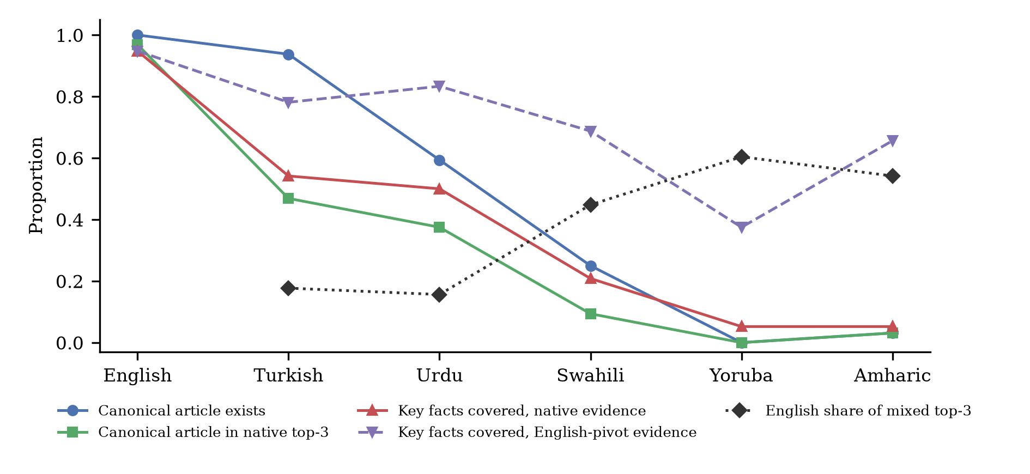
Figure 1. Information-access pipeline per language: availability of the canonical article, retrieval success, key-fact coverage of native and English-pivot evidence, and the English share of a mixed ranking.
Routing the question through English closes much of this gap. English-pivot evidence covered 78% for Turkish, 83% for Urdu, 69% for Swahili, 38% for Yoruba, 66% for Amharic; the gain over native evidence averaged 47% for the three lowest-resource languages. When native and English candidates were ranked together, English passages took 18% of slots for Turkish, 16% of slots for Urdu, 45% of slots for Swahili, 60% of slots for Yoruba, 54% of slots for Amharic. In other words, a multilingual RAG system that serves these users well does so by quietly answering from English sources. This agrees with the high-resource fallback reported by Sharma et al. [10], and it carries a cost that coverage scores do not capture: English Wikipedia describes passports, pensions or unemployment benefits mainly from the perspective of high-income countries, so the answer can be complete but locally irrelevant. The pivot also depends on machine translation of the question, which is itself weakest for the same languages (Table 1).
3.3. Domains and Token Cost
Figure 2 breaks native coverage down by domain. Public services were the best covered domain in Urdu, Swahili, Yoruba and Amharic, while digital safety and employment were the weakest: for the three lowest-resource languages, native evidence covered on average 6% of digital-safety facts and 4% of employment facts. These are the domains where new internet users most need timely, local guidance on scams, labour rights and benefits. Expressing the same question also cost more: relative to English, the tokenizer shared by Qwen2.5 and Qwen3 needed 1.5x as many tokens for Turkish, 3.1x as many tokens for Urdu, 2.0x as many tokens for Swahili, 3.2x as many tokens for Yoruba, 4.0x as many tokens for Amharic. Longer token sequences mean higher cost per query, less room for evidence within a fixed context window and slower responses, which compounds the evidence gap [7, 8].
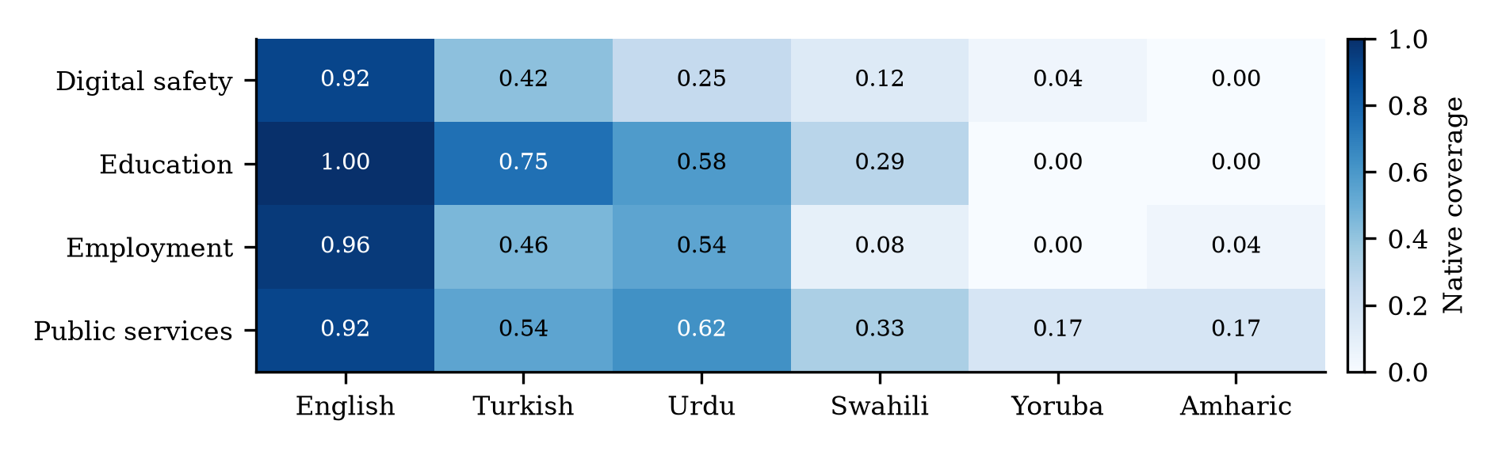
Figure 2. Key-fact coverage of native top-3 evidence by domain and language (8 needs per cell).
3.4. Limitations
This study measures the evidence layer of the pipeline; the generation layer of the LinguaParity framework (answer completeness, factual consistency, citation quality and hallucination) is specified but not yet reported, because running LLMs on CPU was beyond the compute available for this version. The evidence results nonetheless bound what any RAG-based answer can contain. Questions were machine translated, Wikipedia is only one possible knowledge source, the needs are general rather than country specific, and LaBSE similarity is a proxy for factual entailment whose reliability is itself likely to be lower for low-resource languages. The study covers six languages and 32 needs, so language-level correlations are indicative only.
4. CONCLUSION
LinguaParity reframes multilingual AI evaluation as a question of information access. Across six languages and 32 socially relevant needs, the evidence that a retrieval-augmented assistant could draw on shrank sharply with resource level, from full availability in English to almost none in Yoruba and Amharic, and retrieval and coverage followed. English sources closed much of the gap, but only by making low-resource users dependent on content written for other contexts, while tokenization made each of their questions more expensive. Because these disparities arise before generation, improving the language skills of LLMs alone will not equalise access. Investment in local-language content on public services, employment, education and online safety, in multilingual retrieval, and in evaluation of locally relevant answers is needed. Future work will add the generation-stage measurements with several open and commercial LLMs, native-speaker validation of the needs and country-specific information needs.
ACKNOWLEDGMENT
The authors thank the Wikipedia communities whose open content made this measurement possible.
DECLARATIONS
Funding: none. Conflict of interest: the authors declare no conflict of interest. Ethics: the study uses only public encyclopedic content and involves no human participants. Data availability: the information needs, cached Wikipedia responses, code and results are available at https://github.com/inayatarshad/linguaparity.
REFERENCES
- NLLB Team, M. R. Costa-jussà et al., "No language left behind: Scaling human-centered machine translation," arXiv:2207.04672, 2022.
- L. Bandarkar et al., "The Belebele benchmark: A parallel reading comprehension dataset in 122 language variants," in Proc. 62nd Annu. Meeting Assoc. Comput. Linguistics, Bangkok, Thailand, 2024, pp. 749-775.
- K. Ahuja et al., "MEGA: Multilingual evaluation of generative AI," in Proc. Conf. Empirical Methods Natural Language Process., Singapore, 2023, pp. 4232-4267.
- V. D. Lai et al., "ChatGPT beyond English: Towards a comprehensive evaluation of large language models in multilingual learning," in Findings Assoc. Comput. Linguistics: EMNLP 2023, Singapore, 2023.
- P. Joshi, S. Santy, A. Budhiraja, K. Bali, and M. Choudhury, "The state and fate of linguistic diversity and inclusion in the NLP world," in Proc. 58th Annu. Meeting Assoc. Comput. Linguistics, 2020, pp. 6282-6293.
- D. Blasi, A. Anastasopoulos, and G. Neubig, "Systematic inequalities in language technology performance across the world's languages," in Proc. 60th Annu. Meeting Assoc. Comput. Linguistics, Dublin, Ireland, 2022, pp. 5486-5505.
- O. Ahia et al., "Do all languages cost the same? Tokenization in the era of commercial language models," in Proc. Conf. Empirical Methods Natural Language Process., Singapore, 2023, pp. 9904-9923.
- A. Petrov, E. La Malfa, P. H. S. Torr, and A. Bibi, "Language model tokenizers introduce unfairness between languages," in Advances Neural Inf. Process. Syst., vol. 36, 2023.
- P. Lewis et al., "Retrieval-augmented generation for knowledge-intensive NLP tasks," in Advances Neural Inf. Process. Syst., vol. 33, 2020, pp. 9459-9474.
- N. Sharma, K. Murray, and Z. Xiao, "Faux polyglot: A study on information disparity in multilingual large language models," in Proc. Conf. Nations Americas Chapter Assoc. Comput. Linguistics, Albuquerque, NM, USA, 2025, pp. 8090-8107.
- N. Chirkova, D. Rau, H. Déjean, T. Formal, S. Clinchant, and V. Nikoulina, "Retrieval-augmented generation in multilingual settings," in Proc. 1st Workshop Towards Knowledgeable Language Models, Bangkok, Thailand, 2024, pp. 177-188.
- J. Qi, R. Fernández, and A. Bisazza, "Cross-lingual consistency of factual knowledge in multilingual language models," in Proc. Conf. Empirical Methods Natural Language Process., Singapore, 2023, pp. 10650-10666.
- A. Asai, J. Kasai, J. H. Clark, K. Lee, E. Choi, and H. Hajishirzi, "XOR QA: Cross-lingual open-retrieval question answering," in Proc. Conf. North Amer. Chapter Assoc. Comput. Linguistics, 2021, pp. 547-564.
- S. Longpre, Y. Lu, and J. Daiber, "MKQA: A linguistically diverse benchmark for multilingual open domain question answering," Trans. Assoc. Comput. Linguistics, vol. 9, pp. 1389-1406, 2021.
- X. Zhang et al., "MIRACL: A multilingual retrieval dataset covering 18 diverse languages," Trans. Assoc. Comput. Linguistics, vol. 11, pp. 1114-1131, 2023.
- B. Hecht and D. Gergle, "The tower of Babel meets Web 2.0: User-generated content and its applications in a multilingual context," in Proc. SIGCHI Conf. Human Factors Comput. Syst., Atlanta, GA, USA, 2010, pp. 291-300.
- NLLB Team, "Scaling neural machine translation to 200 languages," Nature, vol. 630, pp. 841-846, 2024.
- F. Feng, Y. Yang, D. Cer, N. Arivazhagan, and W. Wang, "Language-agnostic BERT sentence embedding," in Proc. 60th Annu. Meeting Assoc. Comput. Linguistics, Dublin, Ireland, 2022, pp. 878-891.
- Qwen Team, "Qwen2.5 technical report," arXiv:2412.15115, 2024.
- Qwen Team, "Qwen3 technical report," arXiv:2505.09388, 2025.

