GSTP Onboard AI
Hazard-Model Training: Technical Report
Progress report 1: agriculture land-use classification and wildfire burn-scar segmentation
Author | Inayat Arshad, AI/ML Engineer (Embedded team)
Project | ESA GSTP onboard Earth-observation demonstrator, Space Systems Ltd
Task owner | Ayesha Abid
Date | 22 October 2026
Code | github.com/inayatarshad/trainedmodels_gstp
Status | 2 of 5 models trained and tested; floods training in progress

1. Summary
This report covers the training stage of the AI component of the GSTP onboard demonstrator. The aim is to have trained, tested models for five hazard tasks (agriculture, floods, wildfires, forestry and air quality) for the 60 monitoring sites agreed with Ayesha, using public satellite imagery. Deployment on the Jetson is not part of this stage; every model is exported to ONNX so it can be built into a TensorRT engine later.
Two models are complete and evaluated on data they never saw during training:

Model | Task type | Test data | Result | Classic baseline
Agriculture land use | Classification (10 classes) | 5,400 Sentinel-2 patches | 99.19 % accuracy, macro-F1 99.16 % | None (thresholds cannot classify land use)
Wildfire burn scars | Segmentation (per pixel) | 264 image chips | IoU 0.805, F1 0.892 | NBR threshold: IoU 0.450, F1 0.621

Key points. The land-use classifier makes 44 mistakes in 5,400 test images. The burn-scar model nearly doubles the overlap with the true burned area compared with the standard NBR index threshold, at higher precision and higher recall. Both models are small enough for the Jetson path (11 M and 24 M parameters) and their ONNX exports were checked numerically against PyTorch.

2. Where this work fits in GSTP
The demonstrator captures an image, cleans it on the FPGA (dark-reference subtraction, FIR filtering), runs an AI model on the Jetson and sends the useful result to the ground (Path B in the architecture). This deliverable produces the AI models that sit in the Jetson box. They are trained now on public satellite data so the team has working, measured models before the camera-to-Jetson chain is integrated.
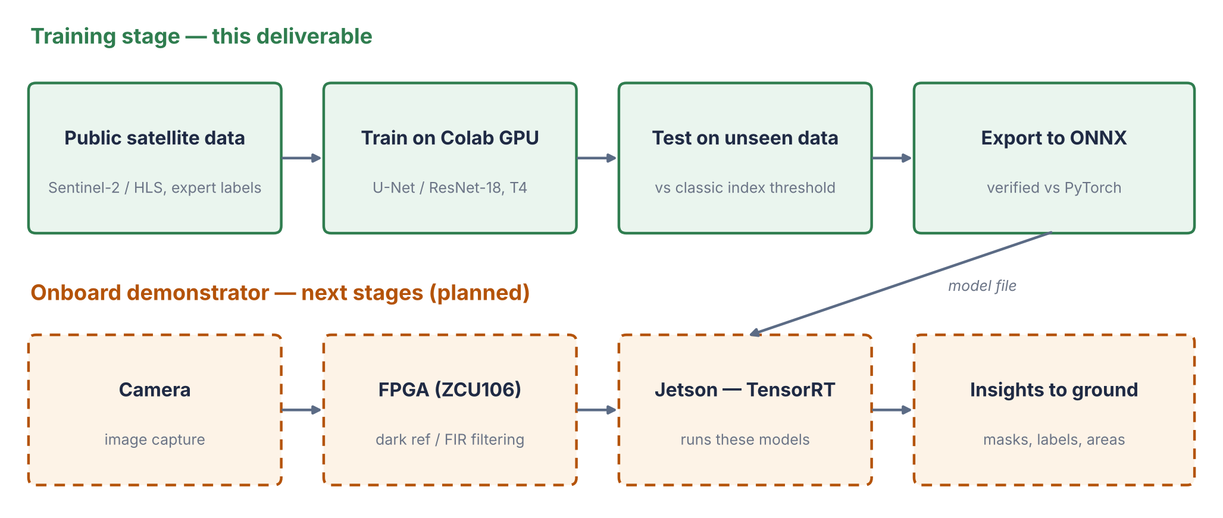
Figure 1. Training stage (this deliverable, green) and the onboard chain it feeds (planned, orange).

3. Scope: what was intended and what is done
Each hazard was given the task type that matches the question it answers. Segmentation is used where the answer is where something is (flooded area, burned area, forest cover), classification where one label per area is enough, and forecasting for air quality, where satellite gas data is too coarse (about 5 km per pixel) for an image model to learn spatial patterns.

Hazard | Task | Model | Training data | Status
Agriculture | Land-use classification | ResNet-18, Sentinel-2 pretrained | EuroSAT (27,000 patches) | Done
Wildfires | Burn-scar segmentation | U-Net, ResNet-34 encoder | HLS Burn Scars (804 chips) | Done
Floods | Water segmentation (radar, optical, both) | U-Net, ResNet-34 encoder | Sen1Floods11 (446 chips, 11 events) | Training
Forestry | Forest segmentation, loss between dates | U-Net, ResNet-34 encoder | Amazon & Atlantic Forest (Zenodo) | Next
Air quality | Next-day NO₂ / PM2.5 forecast | LightGBM, one model for all sites | CAMS + ERA5, 2022–2026 | Next
All five | Apply to the 60 sites, real events | Trained models above | Live Sentinel-1/2 imagery | After training

The 60 sites are 20 in Spain, 16 in the UK and 24 worldwide, each with a bounding box. They are stored in configs/crisp_sites.json together with the real events used for the site application step (for example the Valencia floods of October 2024 and the Pedrógão Grande fire of June 2017).

4. Method common to all models

4.1 Evaluation protocol
The same rules apply to every model, so the reported numbers are fair estimates of performance on new imagery of the same kind:
- Test data is used once. Early stopping, model selection and the decision threshold are all chosen on a separate validation split. Where a public dataset has no labelled test split, its official validation set becomes the test set and a new validation set is carved out of training.
- No leakage between neighbouring chips. Burn-scar validation chips are grouped by satellite tile, so chips cut from the same scene never sit on both sides of the split.
- Normalisation statistics come from training data only.
- Every model is compared with a baseline. For the image models this is the best single-index threshold (NBR, MNDWI or NDVI), tuned on validation and scored on the same test chips, which is a stronger baseline than a fixed textbook value.

4.2 Infrastructure
All training runs on Google Colab with an NVIDIA Tesla T4 GPU. Nothing is trained on a local laptop. Each notebook mounts Google Drive, clones the repository, trains, tests and saves checkpoints, ONNX files and figures to Drive. The shared library in src/gstp holds the data readers, models, loss, metrics and training loops, so all five notebooks use identical code paths. Ten automated tests run every training path end to end on synthetic data before any GPU time is spent.

5. Model 1: agriculture land-use classification

5.1 Purpose
Crop-health indicators such as NDVI are only meaningful over farmland. Run patch by patch over a site, this classifier produces a land-use map that shows where the cropland is, so crop-health readings are computed over the right pixels. It separates four agricultural classes (annual crop, permanent crop, pasture, herbaceous vegetation) from six other land covers.

5.2 Data
EuroSAT multispectral (Helber et al., 2019): 27,000 Sentinel-2 patches of 64 × 64 pixels (640 m × 640 m) from 34 European countries, 10 classes, with the official TorchGeo train / validation / test split of 16,200 / 5,400 / 5,400 images. Band B10 (cirrus) is dropped because it is not delivered in Sentinel-2 Level-2A products, leaving 12 bands.

5.3 Model and training
ResNet-18 initialised with weights pretrained by self-supervised learning (MoCo) on SSL4EO-S12, about one million Sentinel-2 scenes using all 13 bands. Satellite-native pretraining reaches higher accuracy with less labelled data than ImageNet weights. The pretrained first convolution is reduced from 13 to 12 input channels by removing the B10 filter, and patches are resized to 128 px inside the model so the feature scale is closer to pretraining. Training: 30 epochs, AdamW, one-cycle learning rate 1e-3, batch 128, label smoothing 0.05, random flips and rotations, 27 minutes on the T4.
src/gstp/models.py: building the classifier from Sentinel-2 pretrained weights
# Channel order of the SSL4EO-S12 weights. Inputs must follow it exactly.
SSL4EO_S2_BANDS = ["B01","B02","B03","B04","B05","B06","B07",
"B08","B8A","B09","B10","B11","B12"]

model = timm.create_model("resnet18", in_chans=13, num_classes=num_classes)
state = ResNet18_Weights.SENTINEL2_ALL_MOCO.get_state_dict()
state = {k: v for k, v in state.items() if not k.startswith("fc.")}
model.load_state_dict(state, strict=False)

# Drop B10 so the model accepts Sentinel-2 L2A (12 bands): keep the other 12 filters
keep = [i for i in range(13) if i not in drop_band_idx]
new_conv.weight.copy_(model.conv1.weight[:, keep])

A bug caught before training. TorchGeo lists the EuroSAT bands with B8A last, while the pretrained weights expect B8A after B08. Loading in the default order would have fed every band to the wrong filters and silently lowered accuracy. The band list is now set explicitly from the pretrained-weight order (above) and checked in the tests.
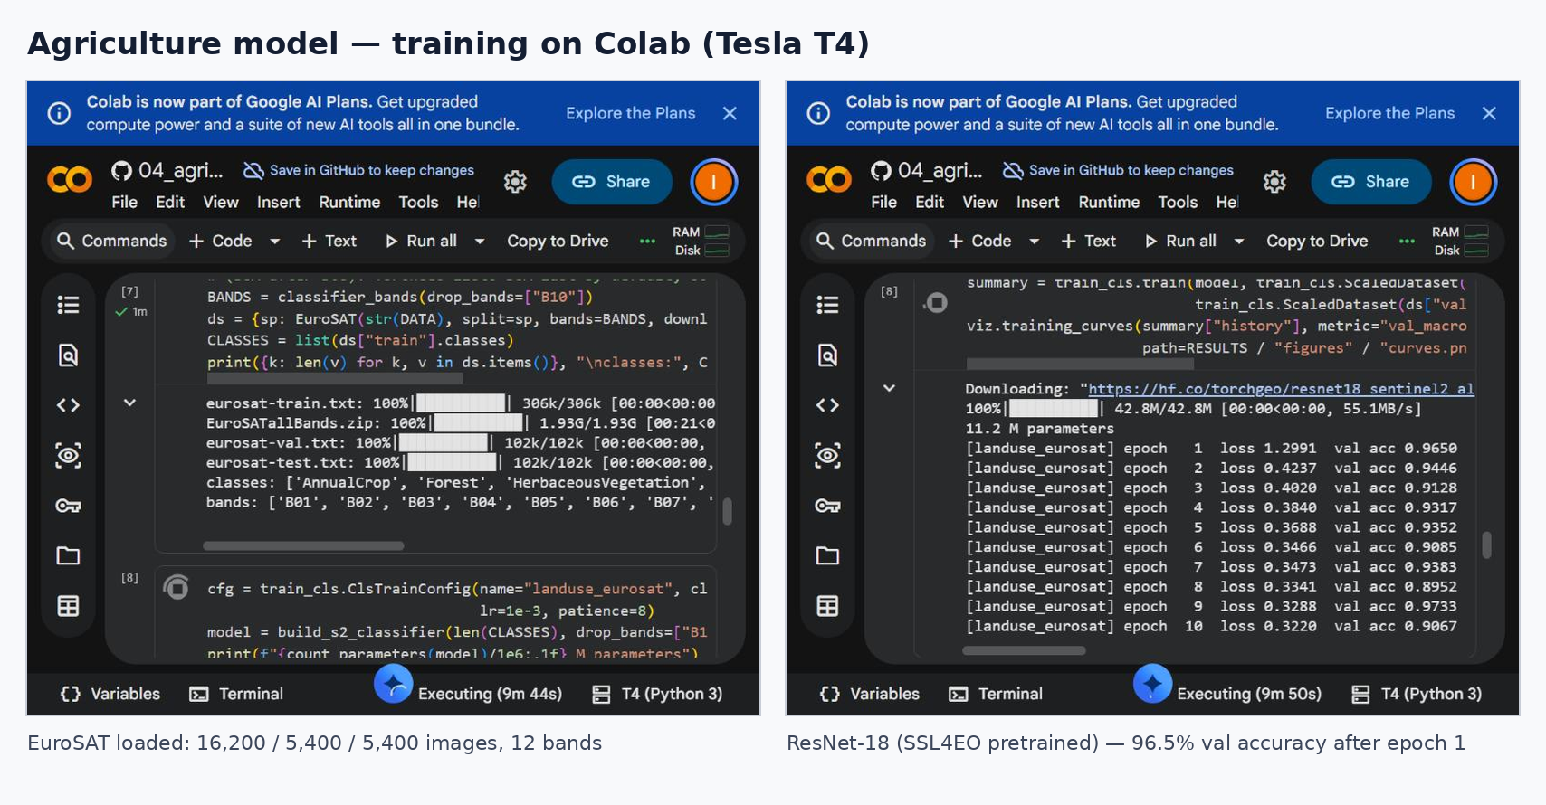
Figure 2. Training run on Colab: dataset loaded with the expected split and band order (left), first epochs (right).

5.4 Results
On the 5,400 test images the model reaches 99.19 % accuracy and 99.16 % macro-F1. The best validation epoch was 26 of 30. The four agricultural classes score between 98.7 % and 99.1 % F1. The remaining confusions are between visually similar vegetation types, mainly permanent crop versus herbaceous vegetation (6 images) and pasture versus annual crop (3 images).
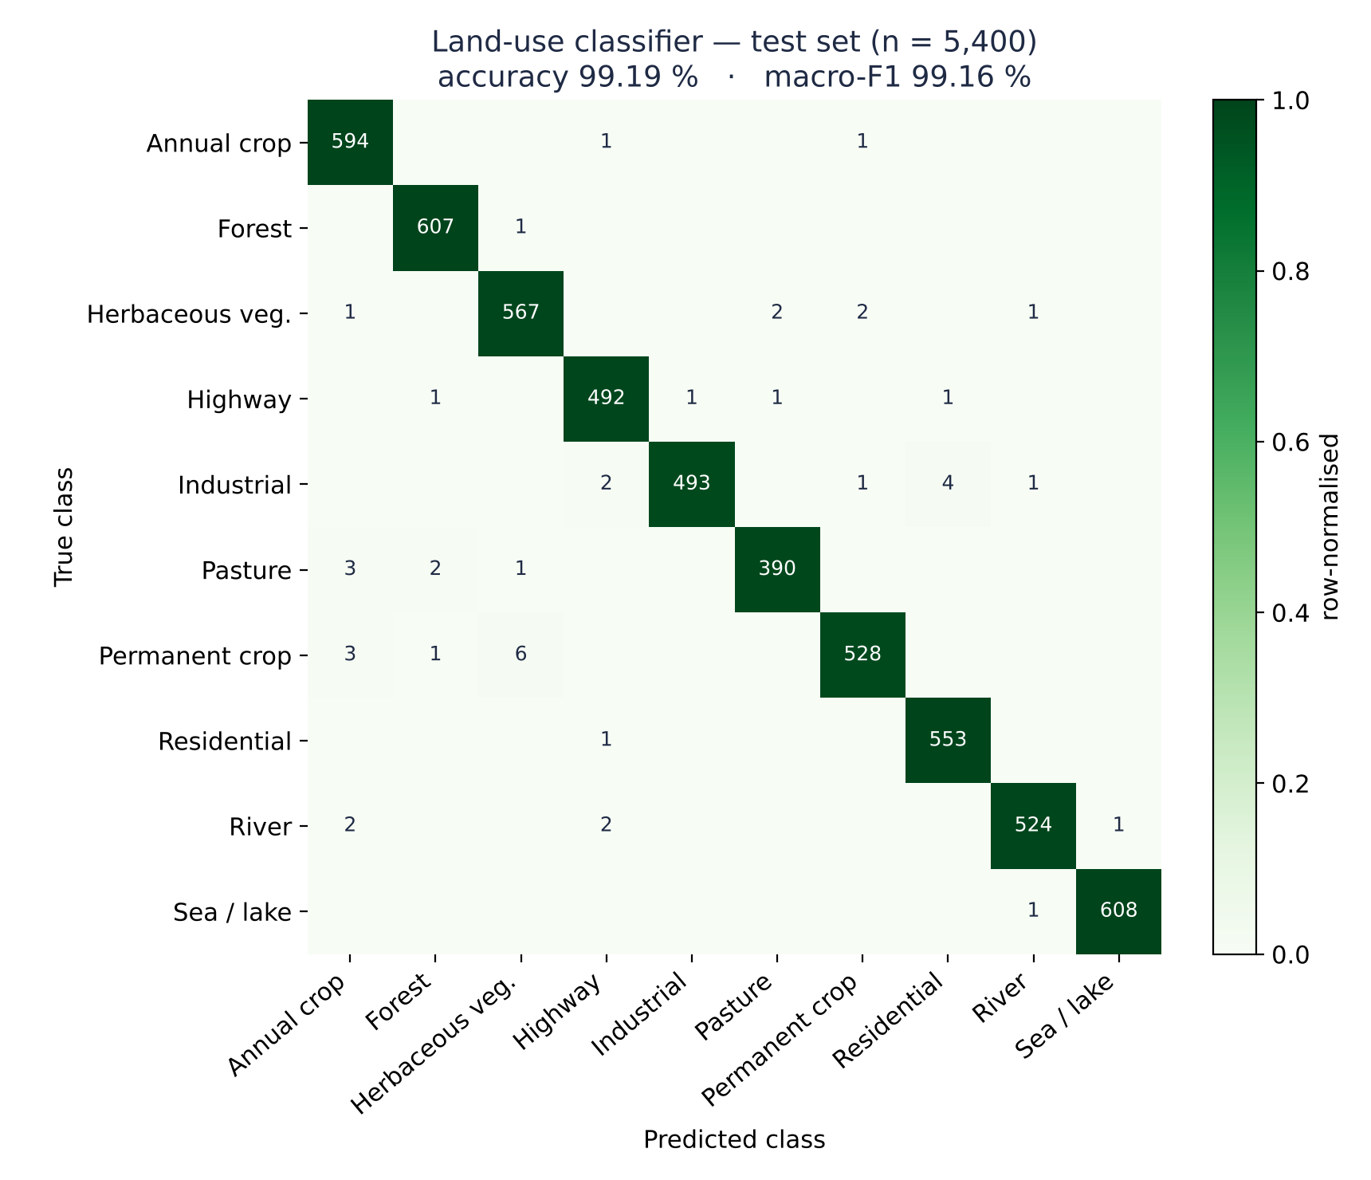
Figure 3. Confusion matrix on the test set (counts; colour = share of each true class).
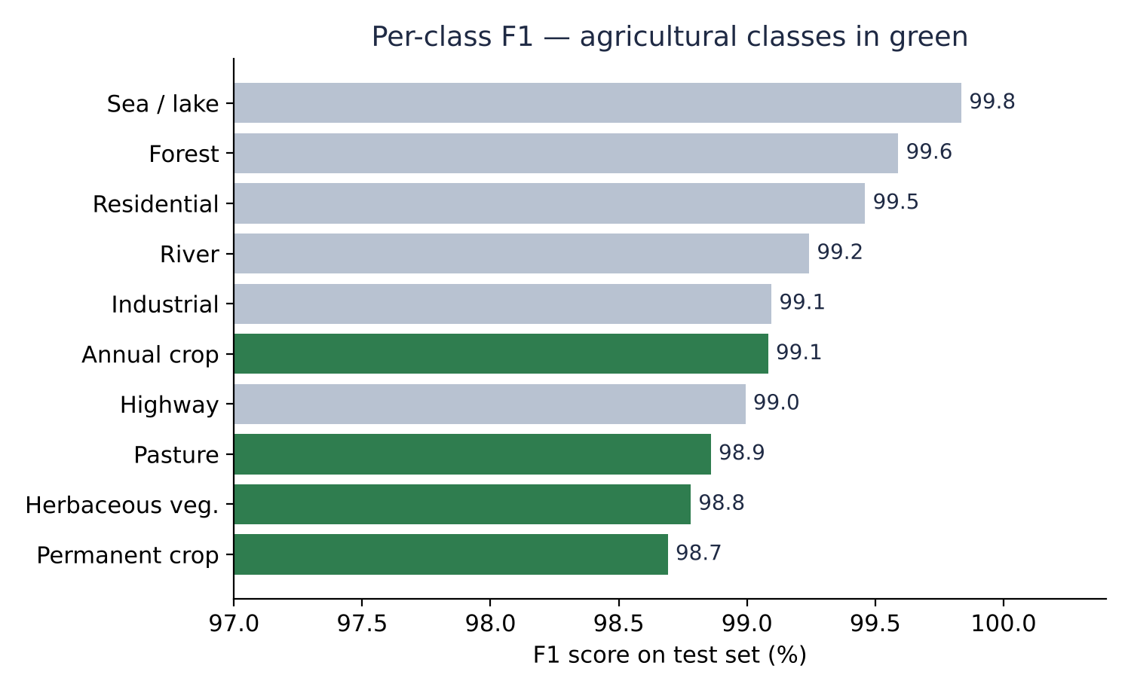
Figure 4. F1 score per class on the test set. Agricultural classes in green (axis starts at 97 %).
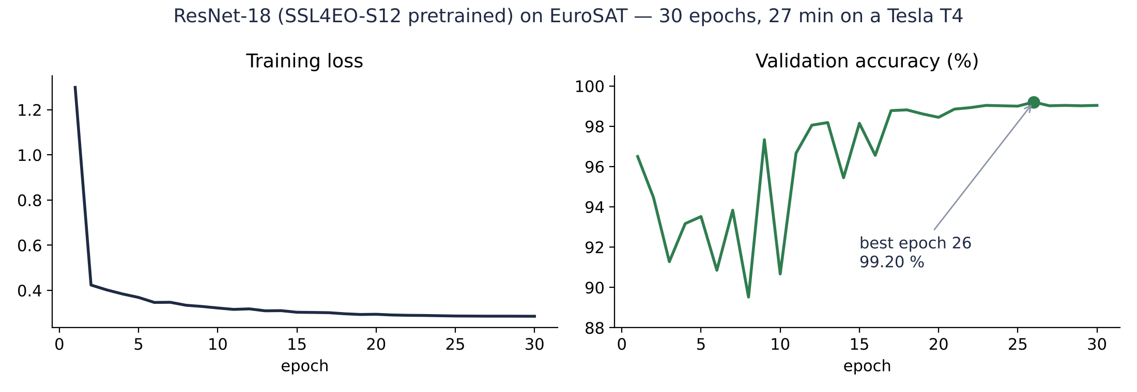
Figure 5. Training loss and validation accuracy per epoch.

6. Model 2: wildfire burn-scar segmentation

6.1 Purpose
After a fire, the useful product is a map of what burned and how large the burned area is. The model labels every pixel as burned or not burned. Applied to images from before and after a fire, the newly burned pixels give the burned area in km².

6.2 Data
HLS Burn Scars (NASA / IBM, 2023): 804 chips of 512 × 512 pixels at 30 m from fires across the contiguous USA (2018–2021), with expert burn-scar masks. Inputs are six bands that exist on Sentinel-2 (blue, green, red, narrow NIR, SWIR-1, SWIR-2), so the model applies directly to Sentinel-2 imagery. The official validation folder (264 chips) is held out as the test set; the 540 training chips are split 459 / 81 into training and validation, grouped by satellite tile.

6.3 Model and training
U-Net with an ImageNet-pretrained ResNet-34 encoder (24.4 M parameters) and the first convolution adapted to six bands. The loss combines binary cross-entropy, for stable per-pixel learning, with Dice loss, which directly optimises overlap and copes with burned pixels being a minority (about 11 % of the data). No-data pixels are excluded from both loss and metrics. Training: 60 epochs on random 256 px crops with flips and rotations, AdamW with a one-cycle schedule at 3e-4, mixed precision, 24 minutes on the T4.
src/gstp/losses.py: BCE + Dice loss with ignored pixels (condensed)
class BCEDiceLoss(torch.nn.Module):
def forward(self, logits, target):
valid = target != IGNORE_INDEX # no-data pixels are ignored
y = target.float() * valid
bce = F.binary_cross_entropy_with_logits(logits, y, reduction="none")
bce = (bce * valid).sum() / valid.sum()
p = torch.sigmoid(logits) * valid
dice = 1 - (2 * (p * y).sum() + 1) / (p.sum() + y.sum() + 1)
return 0.5 * bce + 0.5 * dice

The decision threshold is not fixed at 0.5. After training, the threshold that maximises IoU on the validation set (0.70) is selected and stored inside the checkpoint, and the test set is scored once at that threshold.
src/gstp/train_seg.py: threshold selection and one-time test (condensed)
# after training: reload the best epoch, choose the threshold on VALIDATION data
val_meter, _ = evaluate(model, val_ds, thresholds=np.arange(0.05, 0.96, 0.05))
best = val_meter.best("iou") # -> threshold 0.70 for burn scars
state["threshold"] = best["threshold"] # saved with the weights

# the test split is scored once, at that threshold
report = test_report(model, {"test": test_ds}, best["threshold"], out_path)

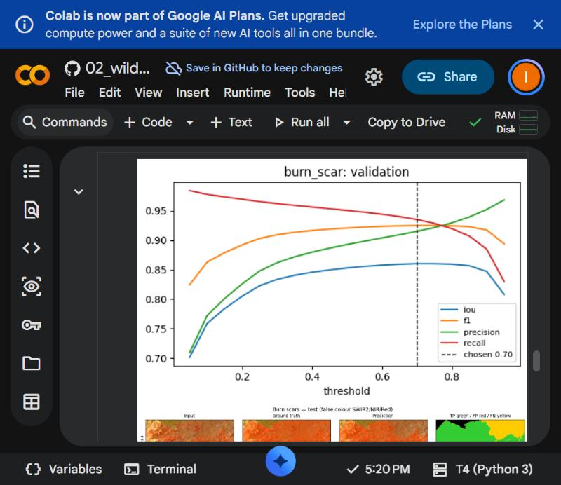
Figure 6. Validation scores against decision threshold (Colab output); 0.70 maximises IoU.

6.4 Results
On the 264 test chips the model reaches IoU 0.805 and F1 0.892 for the burned class, with precision 90.5 % and recall 88.0 %. The NBR (normalised burn ratio) threshold, tuned on the same validation chips, reaches IoU 0.450 and F1 0.621. The learned model is better on both kinds of error: it raises false alarms less often and misses fewer burned pixels. For context, the published result for NASA/IBM's much larger Prithvi foundation model on this dataset is about 0.83 burn-scar IoU.
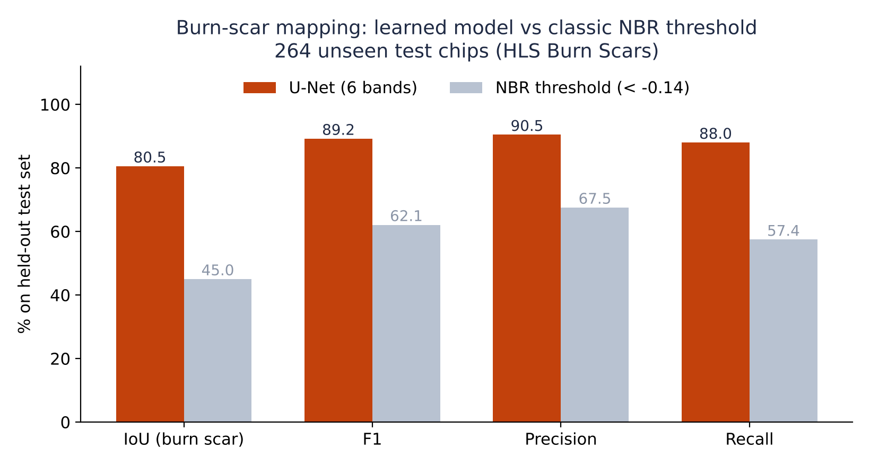
Figure 7. U-Net vs the classic NBR threshold on the same 264 test chips.
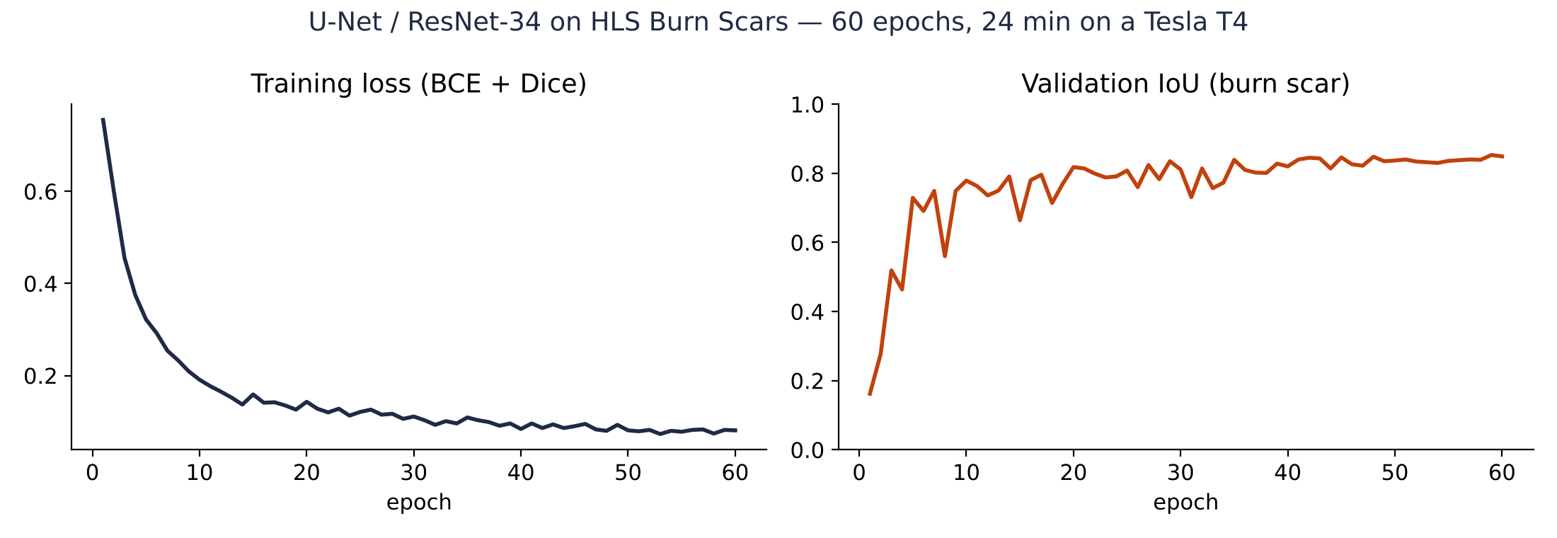
Figure 8. Training loss and validation IoU per epoch.

7. Engineering notes

7.1 Repository
trainedmodels_gstp repository layout
configs/ 60 sites (bounding boxes) + real events
notebooks/ 01 floods, 02 wildfires, 03 forestry,
04 agriculture, 05 air quality, 06 sites
src/gstp/ data readers, models, loss, metrics,
training loops, baselines
results/ metrics (JSON) and figures per run
docs/ model cards (use, data, limitations)
tests/ 10 end-to-end tests (pytest)

7.2 Export for the Jetson
Every model is exported to ONNX (opset 17, dynamic batch size) next to its checkpoint. The export is checked numerically by running the same input through PyTorch and ONNX Runtime; the maximum relative difference was 3.1 × 10⁻⁷ for the classifier and 1.3 × 10⁻⁶ for the burn-scar model. Building the TensorRT engine and checking FP16 accuracy has to happen on the Jetson itself and is part of the deployment stage.
src/gstp/models.py: ONNX export with numerical check (condensed)
torch.onnx.export(model, dummy, path, input_names=["image"], output_names=["logits"],
opset_version=17, dynamic_axes={"image": {0: "batch"}})
out = onnxruntime.InferenceSession(path).run(None, {"image": x})[0]
assert max_relative_error(out, model(x)) < 1e-3 # verified at export time

7.3 Issues found and fixed
- Band order (agriculture). TorchGeo's default band order did not match the pretrained weights; fixed before training (section 5.3).
- Mask file naming (wildfires). The released masks are named <scene>.mask.tif, not <scene>_mask.tif as documented elsewhere. A pairing check stopped the run before it could train on nothing; the reader now accepts both forms and found all 804 chips.
- Packaging. An over-broad ignore rule had excluded the data package from the first commit; caught on the first Colab run and fixed.

8. Limitations
- Training data is not the GSTP camera. The models learn from Sentinel-2-class imagery. The onboard camera will differ in bands, resolution and radiometry, so the models will need adaptation or retraining on its data before results can be compared.
- Geography. Burn-scar training fires are all in the USA, and EuroSAT covers Europe. Mediterranean, Australian and South Asian sites are outside these distributions, which is why the next step applies the models to real events at the 60 sites.
- Patch-level labels (agriculture). The classifier labels 640 m patches, not individual fields, and does not measure crop stress itself.
- Not yet measured on hardware. Latency, memory and power on the Jetson are not measured in this stage.

9. Next steps
- Finish the flood models (radar, optical, combined), scored on the official test split and on a whole flood event withheld from training (Bolivia).
- Train the forestry model and the air-quality forecaster for all 60 sites.
- Apply the trained models to real events at the sites (Valencia floods 2024, Sukkur floods 2022, Pedrógão Grande fire 2017 and others) and compare the mapped areas with published reports.
- With the embedded team: agree the input format coming from the FPGA, then build and benchmark TensorRT engines on the Jetson.

Appendix: reproducing the results
- Open a notebook from the repository in Google Colab and select Runtime ▸ Change runtime type ▸ T4 GPU.
- Select Run all. The first cell mounts Google Drive, clones the repository and installs the extra packages.
- Checkpoints, ONNX files and a results zip are written to MyDrive/gstp_runs/<module>/.
Datasets: EuroSAT (Helber et al., IEEE JSTARS 2019); HLS Burn Scars (Phillips et al., NASA/IBM 2023); pretrained weights SSL4EO-S12 (Wang et al., 2022) via TorchGeo; U-Net (Ronneberger et al., MICCAI 2015).

