Stochastic Resonance in MEC bi-stable system.

1. [Background on Stochastic Resonance]
2. [Relevance to MEC]

3. Model Specification:
a). The network consists of two inhibitory inter-neurons (I1,I2) and a corresponding pair of stellate cells (S1,S2). Each Inter-neuron forms a inhibitory synapse with the corresponding stellate cell (eg. I1→S1) and to the other inter-neuron. In addition to this stellate cells also form excitatory synapse with the opposite inter-neurons (eg. S1→I2).
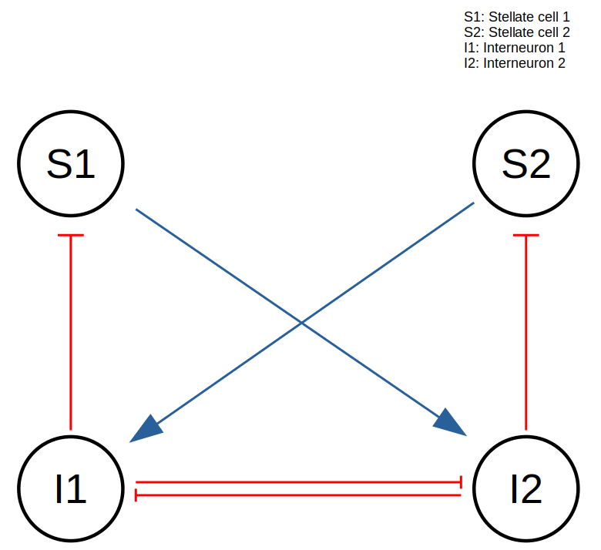

b). Stellate cells were equipped with I_{Na}, I_{K}, I_{L} , I_{Nap} and I_{H} conducting mechanisms. Inter-neurons were equipped with Fast spiking I_{Na} and I_{K} as well as I_{L} and I_{theta}. In addition the stellate cells were driven with a hyper-polarizing current through an IClamp electrode that caused sub-threshold oscillations.
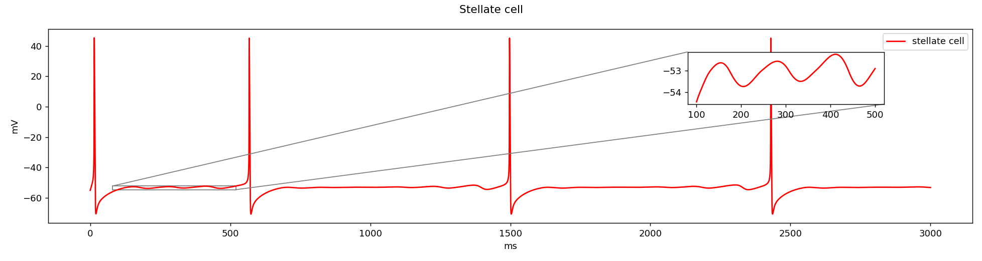

c) Interneurons were driven also driven by a depolarizing electrode current. Depending on the magnitude of the depolarizing current the system existed in two states: Autonomous oscillator and bi-stable switch.
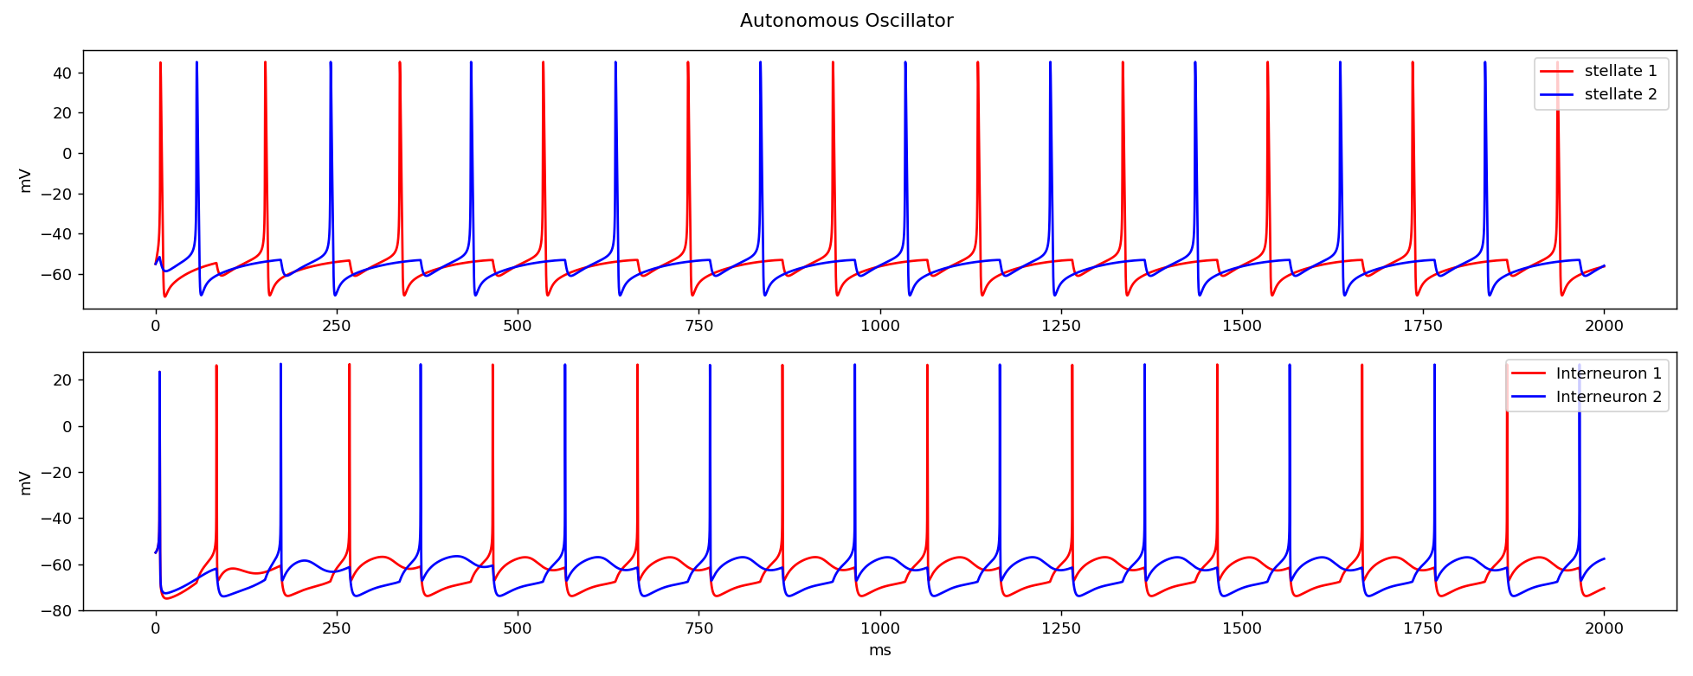
Autonomous oscillator: At low input currents the frequency of inter-neuron spikes was low enough for the stellate cells to escape inhibition and thereby excite the opposite inter-neuron which in turn inhibits the other inter-neuron causing the the stellate cells and inter-neurons to oscillate at different phase.

Bi-stable Switch: At higher input currents the frequency of firing of interneurons was high enough so as to inhibit the corresponding stellate cell throughout the firing period. The network can be switched from one state to another by applying a DC current to the non spiking interneuron.

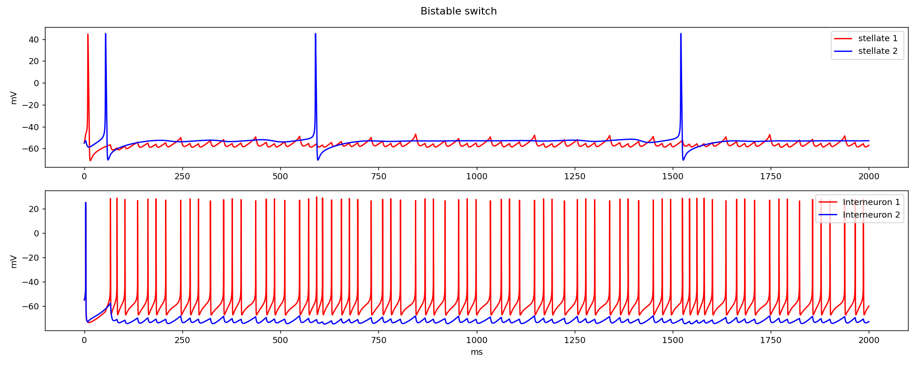
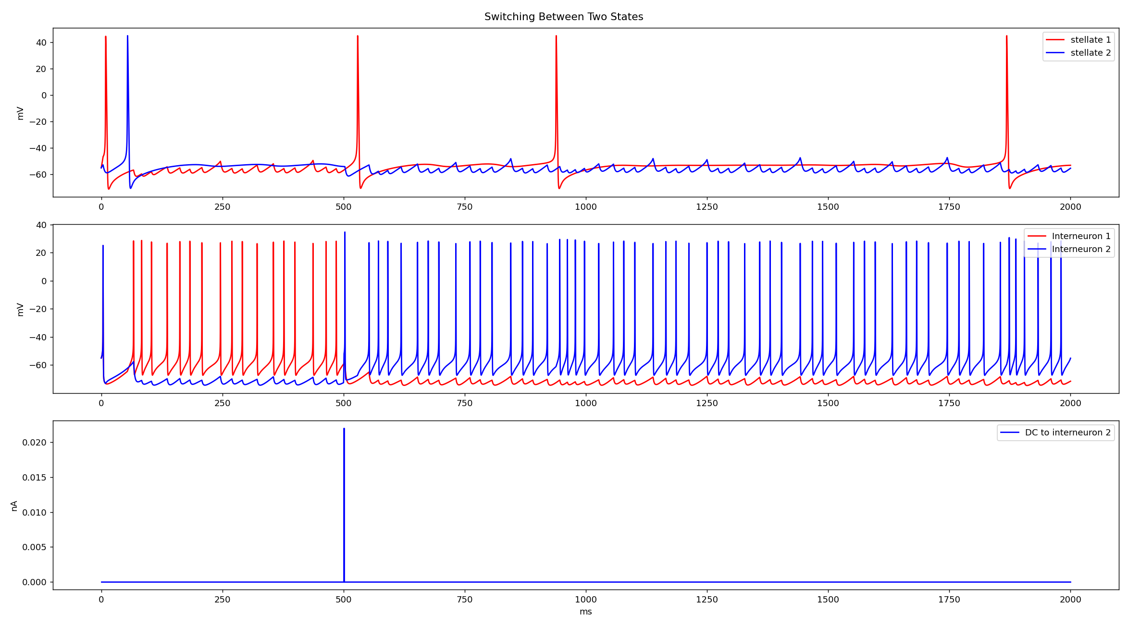
4) Adding noise:
a) A Gaussian noise was implemented as a conduction mechanism in Interneurons that were held in the bi-stable state. The noise levels could be adjusted by changing the mean values and the standard deviation of the Gaussian distribution. At each time step i.e 0.025 ms either hyperpolarizing or depolarizing current would be applied to interneurons. This caused random switching of the network at different frequencies depending upon the amplitude of the noise levels.
E.g: stdev = 0.017; mean=0
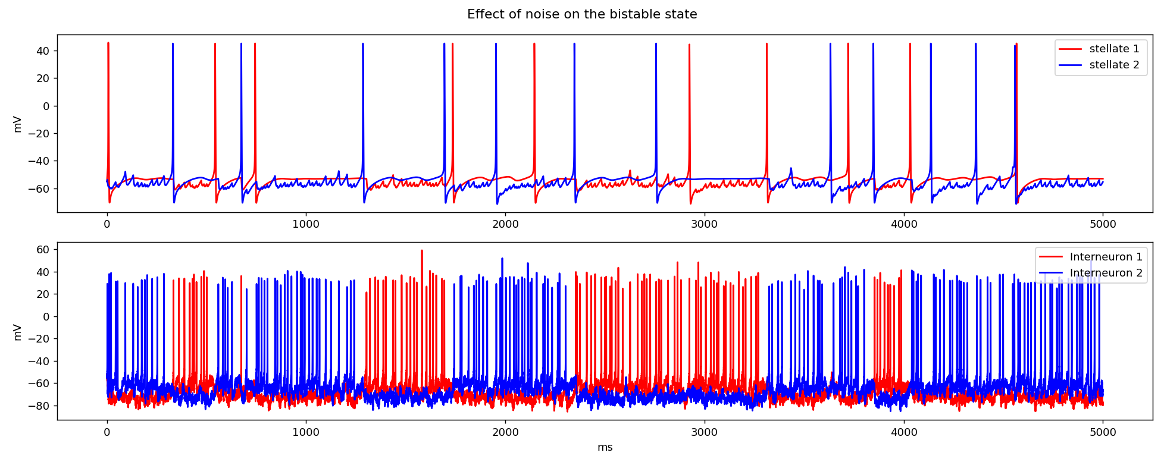

5) Exploring the existence of stochastic resonance:
a) Measuring the standard deviation of the inter-burst intervals: By measuring the standard deviation of the inter-burst interval of the inter-neurons across different noise levels, a minima would indicate regular switching of the network at fixed time intervals. Here a burst interval was defined as inter-spike interval of >50ms. The result was normalized by sqrt(N). In one trial the noise levels were modulated by increasing the standard deviation of the Gaussian noise while setting mean to zero. In another trial the standard deviation was fixed to 0.0015 and mean values were incremented. In the first trial a trend was observed towards high standard deviation. However in this regime the spikes were uncharacteristically large (upto 1000s of mV) and hence could not be further explored. In the second trial low standard deviation was observed within range of 0.0001-0.0008 of mean values. Outside this range the spikes where either non existence or the firing rate was high enough to escape the threshold of greater than 50ms as defined for a burst.
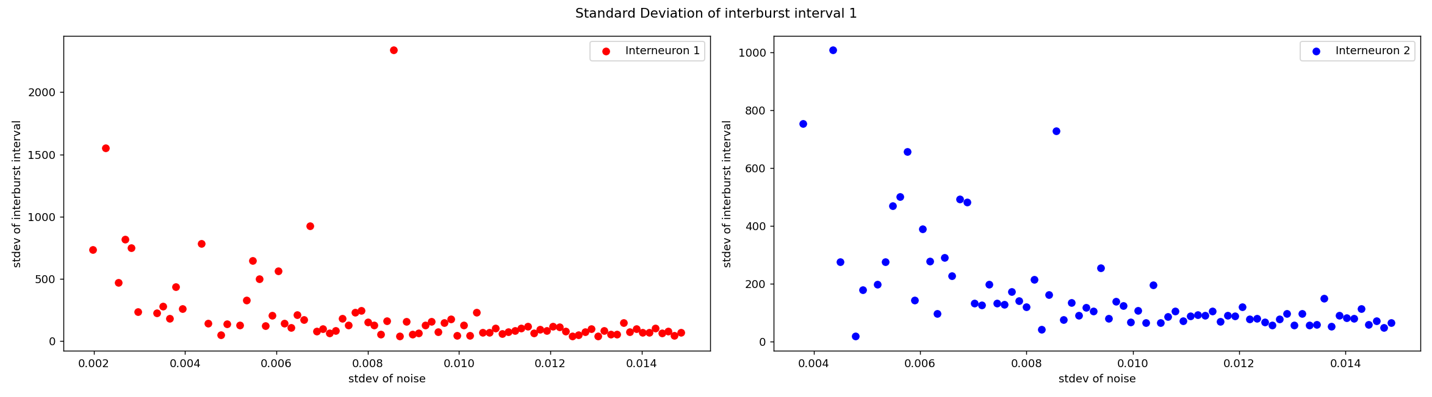
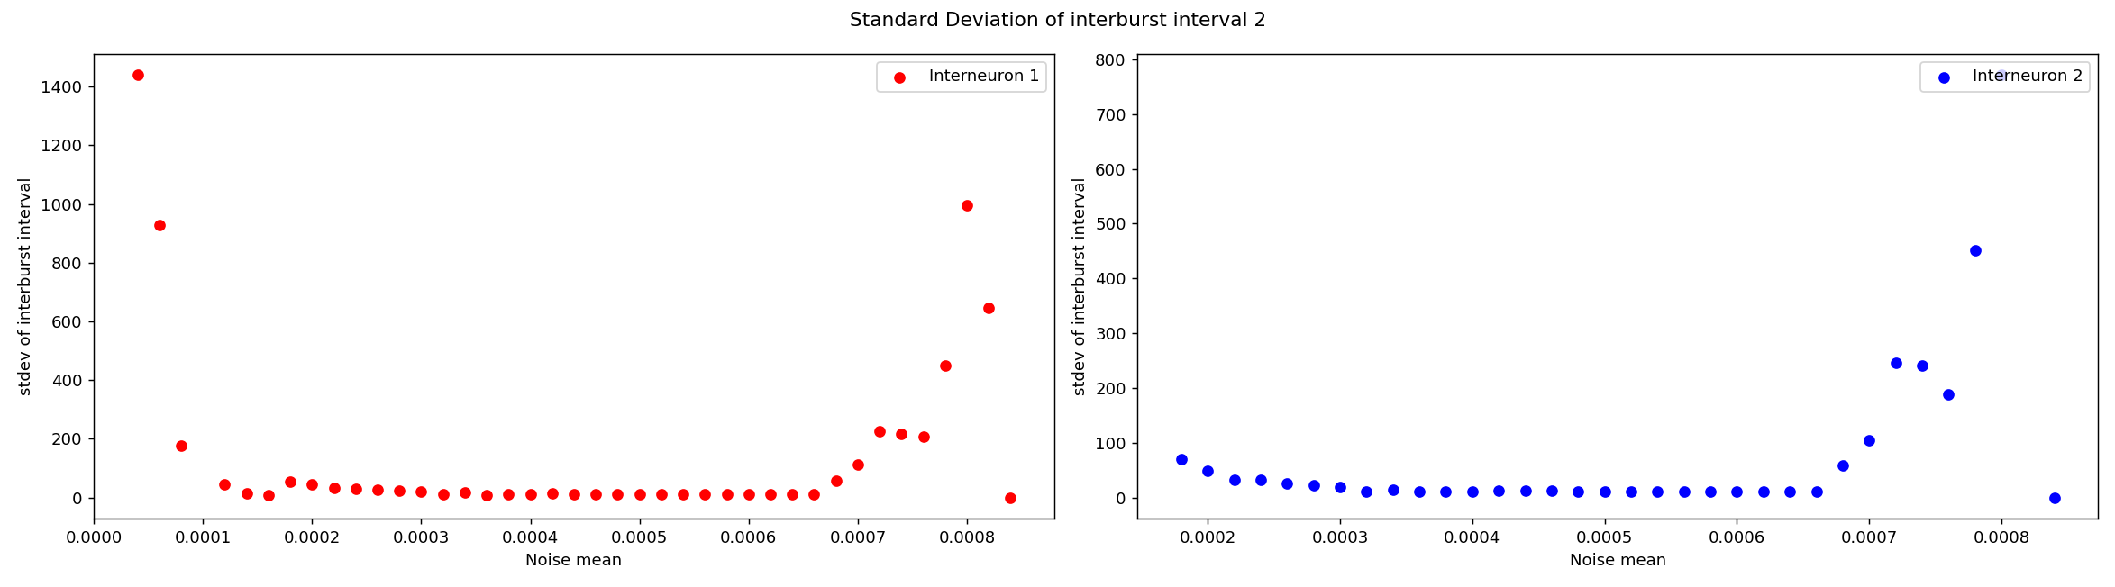
Eg of spike train at stdev of noise:0.0015 and mean: 0.0005:
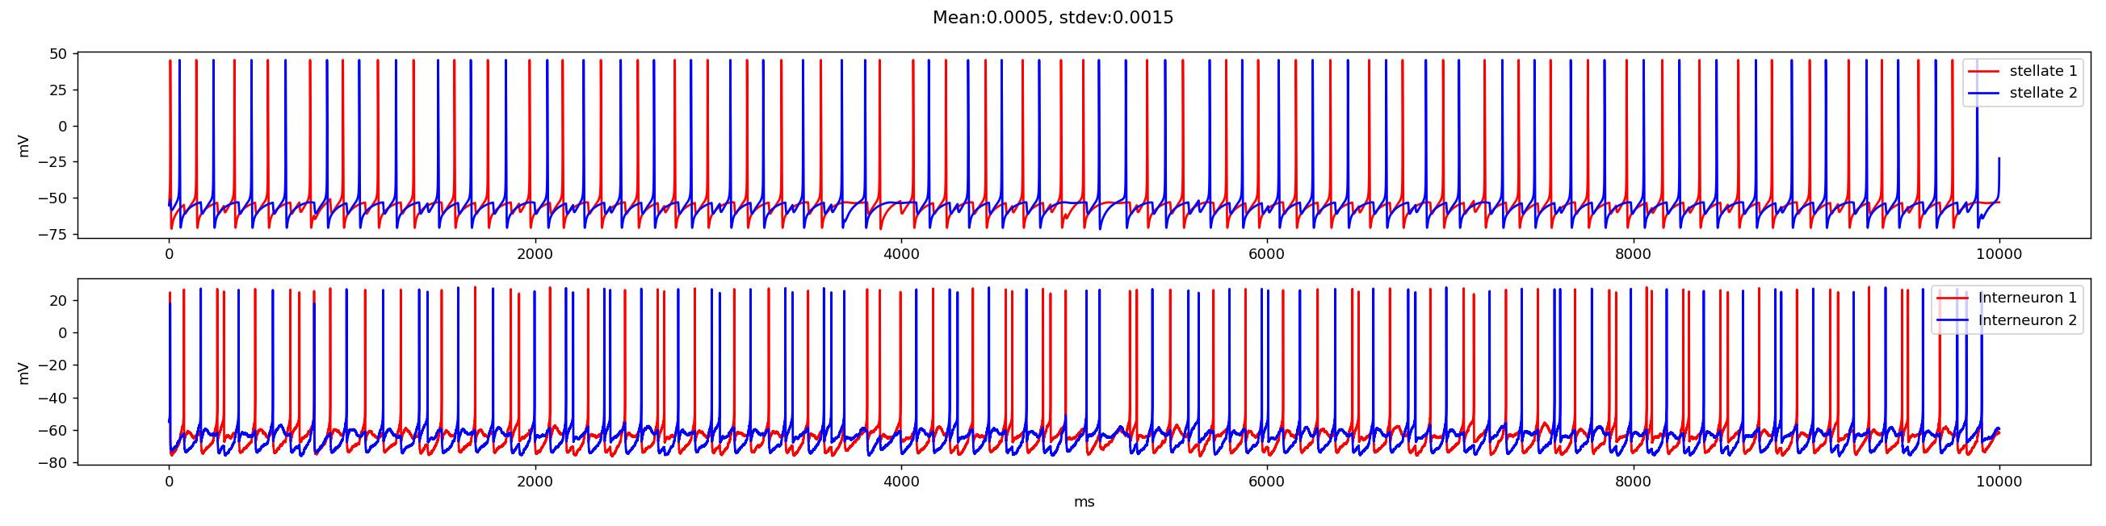
Here the stellate cells show oscillatory behavior in certain intervals. However there is variability in the inter-neuron spikes.

b) Fourier Analysis: The spike trains of the inter-neurons was first convolved with a boxcar window and its Fourier spectra was generated. For each simulation run the area under the peaks between 9.8 to 10.2 Hz was computed which were then plotted against increasing noise levels. Here the maxima would indicate the existence of stochastic resonance. Three Peaks were observed in the window of analysis near 0.0025, 0.0004 and 0.00065. Values near 0.00065 exhibited regular switching but the peak itself did not correspond to the consistent switching behavior throughout the 15 second simulation run. It was the mean values near 0.0006 that exhibited most regular switching behavior and could potentially be characterized as ‘stochastic resonance’. In the analysis first 1000 ms was ignored due to high variability at the beginning of the simulation.

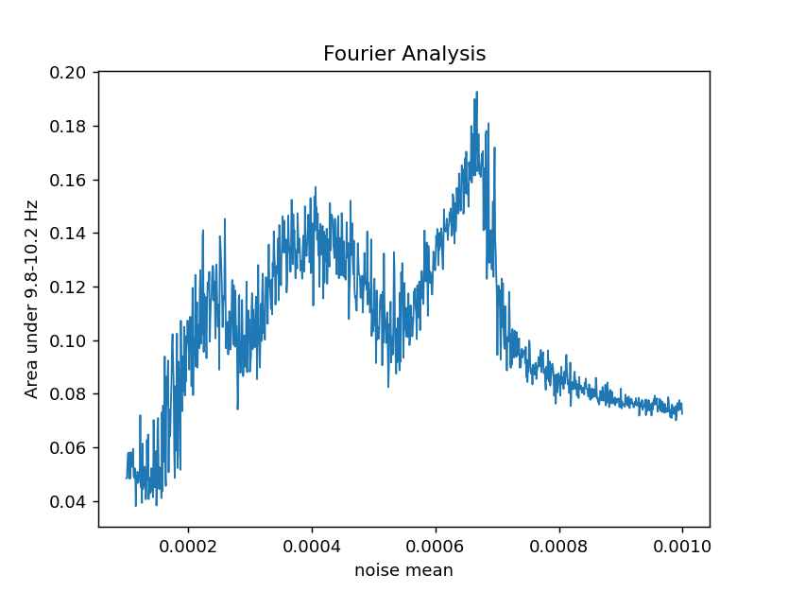

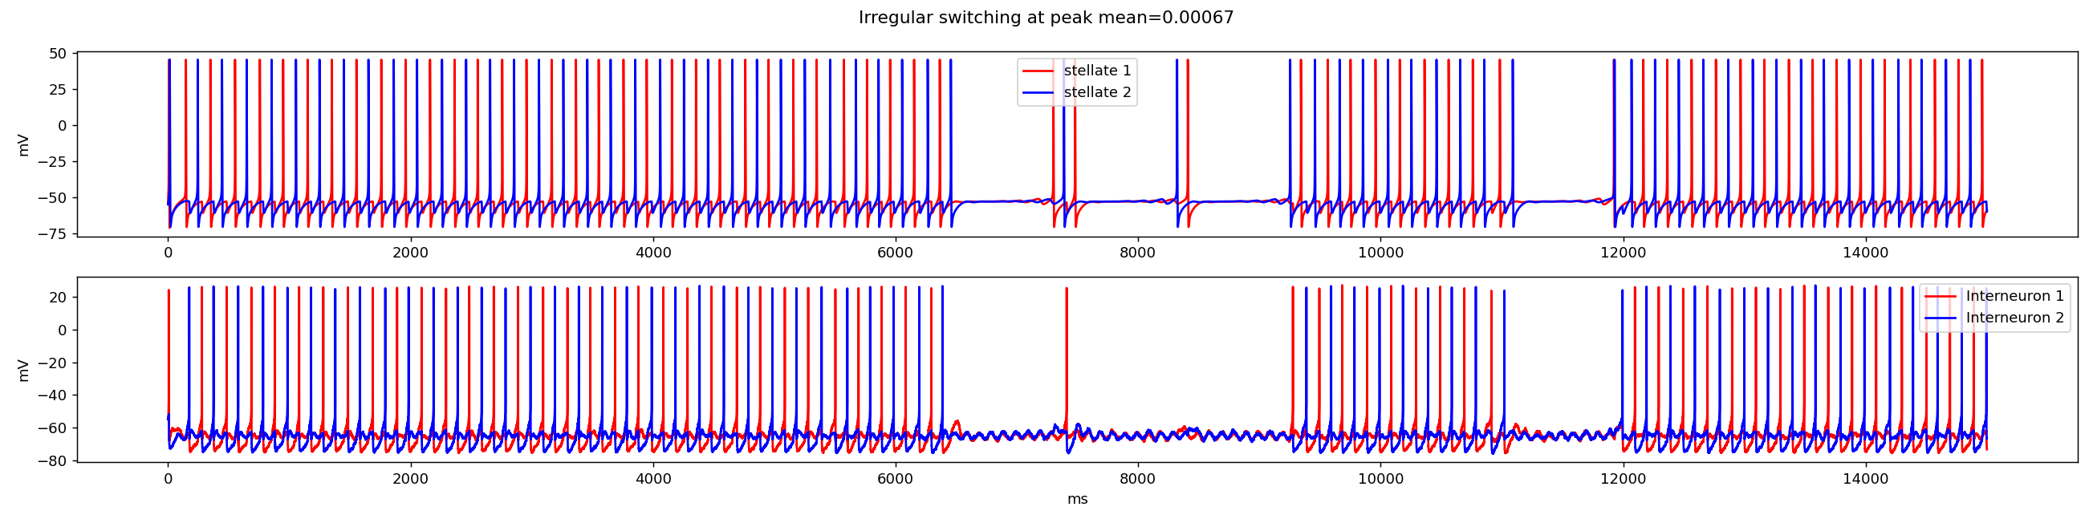
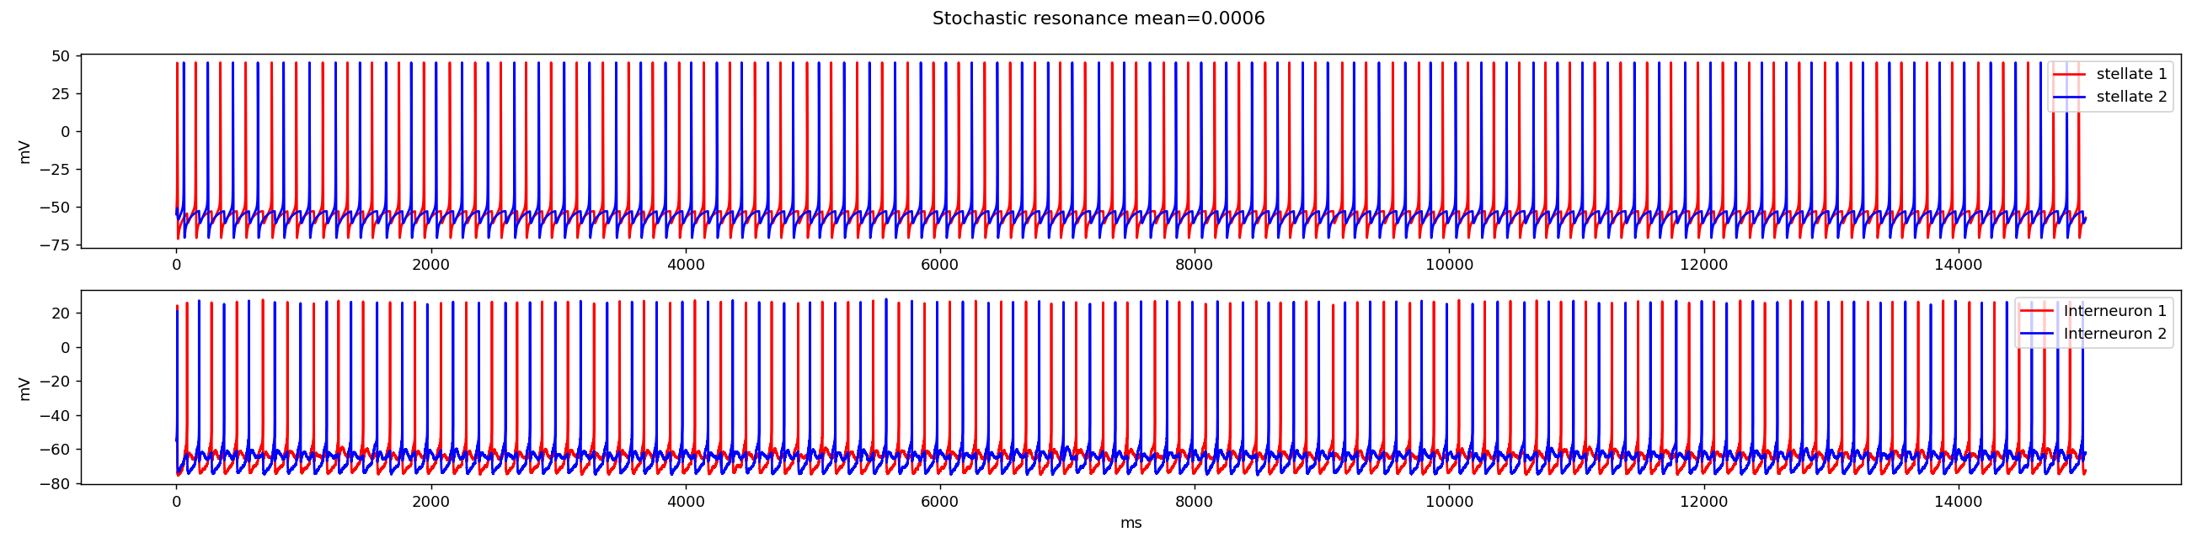

6) Appendix:
- Stellate cells: (acker)

Length | 10/pi (um)
Diameter | 10 (um)
Cytoplasmic resistivity | 100 ohm cm
Specific capacitance | 1.5 uf/cm2

- C= -I_{Na} – I_{K} – I_{H} – I_{L} - I_{isyn}
- I_{Na} = (g_{Nabar}* m_{na}³ * h_{Na}+ g_{nap} * m_{nap})*(Vm- E_{na} )
- I_{K} = (g_{Kbar}*n_{K}⁴)*(V_{m} - E_{K})
- I_{L} = g_{Lbar} * (V_{m}-E_{L})
- I_{H}=g_{Hbar}*(0.65*m_{hf}+0.35*m_{hs})*(V_{m}-E_{H})

  - m_{nap}' = α_{mNa}*(1-mna) - β_{mNa}*mna
  - h_{Na}' = α_{hNa}*(1-hna) - β_{hNa}*hna
  - m_{nap}' = (m_{nap∞}-mnap)/τ_{mNap}
  - n_{K} = α_{nK}*(1-nk) - β_{nK}*nk
  - m_{hf}' = (m_{hf∞}-mhf)/(τ_{mhf})
  - m_{hs}' = (m_{hs∞}-mhs)/(τ_{mhs})

g_{Nabar} | 0.052 (S/cm2)
g_{Kbar} | 0.011 (S/cm2)
g_{Lbar} | 0.0005 (S/cm2)
g_{Hbar} | 0.0015 (S/cm2)
g_{nap} Stochastic resonance in climatic change | 0.0005 (S/cm2)
E_{na} | 55 (mV)
E_{K} | -90 (mV)
E_{L} | -65 (mV)
E_{H} | -20 (mV)

α_{mNa}
β_{mNa}
α_{hNa}
β_{hNa}
m_{nap∞}
α_{nK}
β_{nK}
m_{hf∞}
τ_{mhf}
m_{hs∞}
τ_{mhs}
τ_{mNap} | 0.15

B) Interneuron: (wang buzsaki)

Length | 10/pi (um)
Diameter | 10 (um)
Cytoplasmic resistivity | 100 ohm cm
Specific capacitance | 1 uf/cm2

- C= -I_{Na} – I_{K} – I_{L} – I_{isyn} – I_{esyn} -I_{theta}-I_{noise}
- I_{Na} = g_{nabar}* m³ * h*(V_{m}-E_{na})
- I_{K}=?
- I_{L} = g_{Lbar} * (V_{m}-E_{L})
- I_{isyn} = g_{isynbar} *m_{isyn}* (V_{m}-E_{isyn})
- I_{esyn} = g_{esynbar} *m_{esyn}* (V_{m}-E_{esyn})
- I_{theta} = Amp*sin(2*3.14*omega*t+phi)

- m_{esyn}' = ɑ_{esyn}*Func(vpre)*(1-m_{esyn}) – β_{esyn}*m_{esyn}
- m_{isyn}' = ɑ_{isyn}*Func(vpre)*(1-m_{isyn}) – β_{isyn}*m_{isyn}

- vpre: membrane potential of the presynaptic cell
- Func(vpre) = (1+tanh(vpre/4))/2

g_{nabar} | 0.035 (mhoScm2)
g_{Kbar} | 0.009 (S/cm2)
g_{Lbar} | 1e-4 (S/cm2)
g_{isynbar} mutual | 4e-4(uS)
g_{isynbar} stellate | 2e-4 (uS)
g_{esynbar} | 0.12e-4 (uS)
E_{na} | 55 mV
E_{K} | -90 mV
E_{L} | -65 mV
E_{isyn} | -80 mV
E_{esyn} | 0 mV
Amp | 2e-4 (S/cm2)
omega | 0.01 (1/ms)
phi | 0
ɑ_{esyn} | 10 (1/s)
β_{esyn} | 0.033 (1/s)
ɑ_{isyn} | 3.33 (1/s)
β_{isyn} | 0.05 (1/s)

References:
Acker, C. D., Kopell, N., & White, J. A. (2003). Synchronization of strongly coupled excitatory neurons: Relating network behavior to biophysics. Journal of Computational Neuroscience, 15(1), 71–90. https://doi.org/10.1023/A:1024474819512

Carnevale, N.T. and Hines, M.L. The NEURON Book. Cambridge, UK: Cambridge University Press, 2006.

Neru, A., & Assisi, C. (2019). Theta oscillations gate the transmission of reliable sequences in the medial entorhinal cortex. BioRxiv, 1–43. https://doi.org/10.1101/545822

Wang XJ, Buzsáki G. Gamma oscillation by synaptic inhibition in a hippocampal interneuronal network model. J Neurosci. 1996 Oct 15;16(20):6402-13. doi: 10.1523/JNEUROSCI.16-20-06402.1996. PMID: 8815919; PMCID: PMC6578902.

