Game Design Document

Fill up the Following document

1. Write the title of your project.

Chocolate Catcher

1. What is the goal of the game?

To catch the chocolates falling from the sky , The player with the highest points win

1. Write a brief story of your game?

Once there were Four friends, they went to a park and a man had a

Key for going to a wonderland, he thought of giving the keys to the

Boys. So he gave them the keys and the boys went inside. So once they went inside, the gatekeepers of the wonderland said that only one person is allowed inside, so they said that the boys will have a competition and the winner will get to go inside. The competition is Chocolate catcher!

1. Which are the playing characters of this game?

* Playing characters are the ones which respond to the user based on the input from the user
* Cars, monkeys, dinos, wizards etc, are the playing characters in the game.

|  |  |  |
| --- | --- | --- |
| Number | Character Name | What can this character do? |
| 1 | Boy1 | Catch chocolates |
| 2 | Boy2 | Catch chocolates |
| 3 | Boy3 | Catch chocolates |
| 4 | Boy4 | Catch chocolates |
| 5 |  |  |
| 6 |  |  |
| 7 |  |  |
| 8 |  |  |

1. Which are the Non Playing Characters of this game?

* Non Playing characters are the ones which don't have an action or a behaviour when the user interacts with the game.
* Hurdles, stones, bananas, coins, etc are non playing characters in the game.

|  |  |  |
| --- | --- | --- |
| Number | Character Name | What can this character do? |
| 1 | Chocolate | Fall from the sky |
| 2 |  |  |
| 3 |  |  |
| 4 |  |  |
| 5 |  |  |
| 6 |  |  |
| 7 |  |  |
| 8 |  |  |

Draw your imagination of this game. What does this game look like?

Draw the game either on your computer or on paper,

Add images of scenes of the game to show each of the playing and non-playing characters at least once.

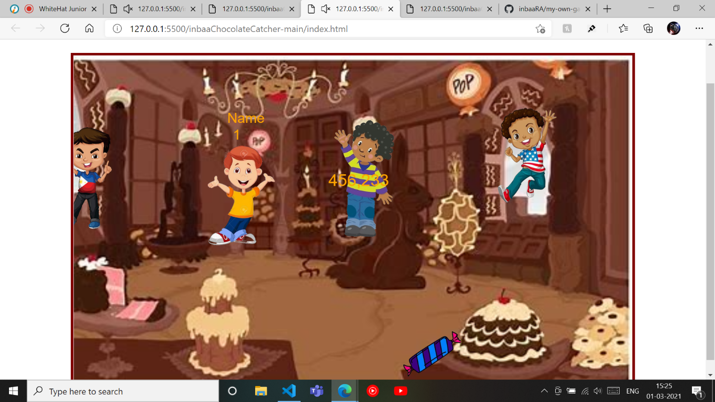

How do you plan to make your game engaging?

I will add scores to the game and a goal for the players to reach 15 score to win.