Report a bug:

bug no. 1  
subject: Checkout form – incorrect validation for single field input

Description:

on the checkout form enter value in 2 of the 3 fields and click continue, all the fields are marked as error.

Steps to reproduce:

login with valid username and password

click on ‘ shopping cart’ icon

click on Checkout

in the checkout form enter value in first name and in last name

click continue

expected: first name and last name field validation are OK, postal code with error field validation

actual: all 3 fields: first name, last name and postal codeare marked as error field validation

attached automation log and a screenshot

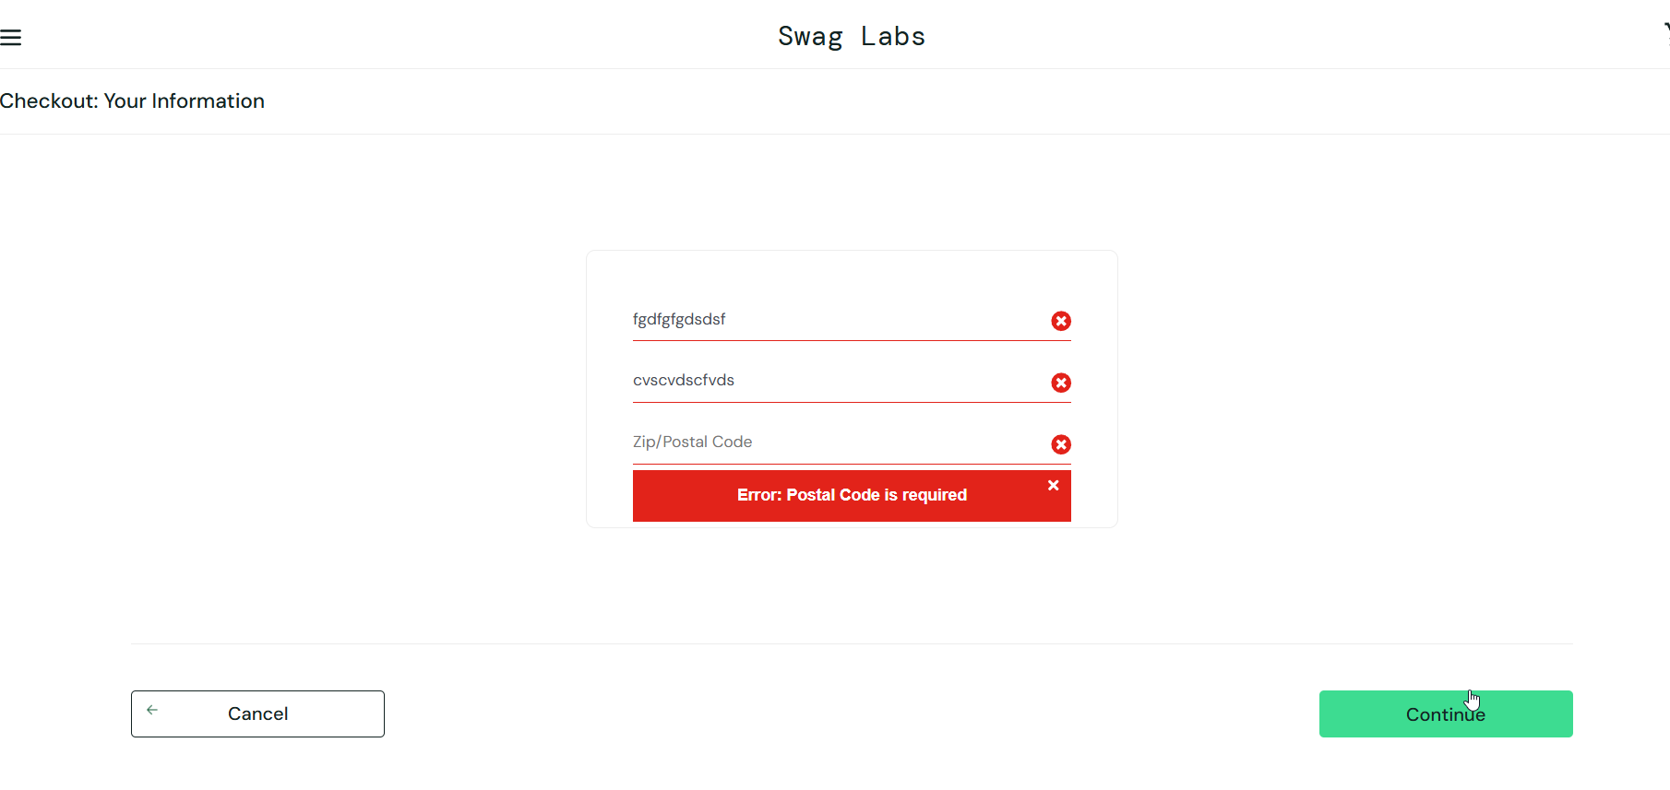

bug #2

subject: user can checkout without products

description: user can make a 0 payment without any products

Steps to reproduce:

login with valid username and password

click on ‘shopping cart’ icon and verify your cart is empty

click on Checkout

expected: checkout is disabled when there are 0 items in your cart

actual: checkout enabled when there are 0 items in your cart and process can finish with 0$ order

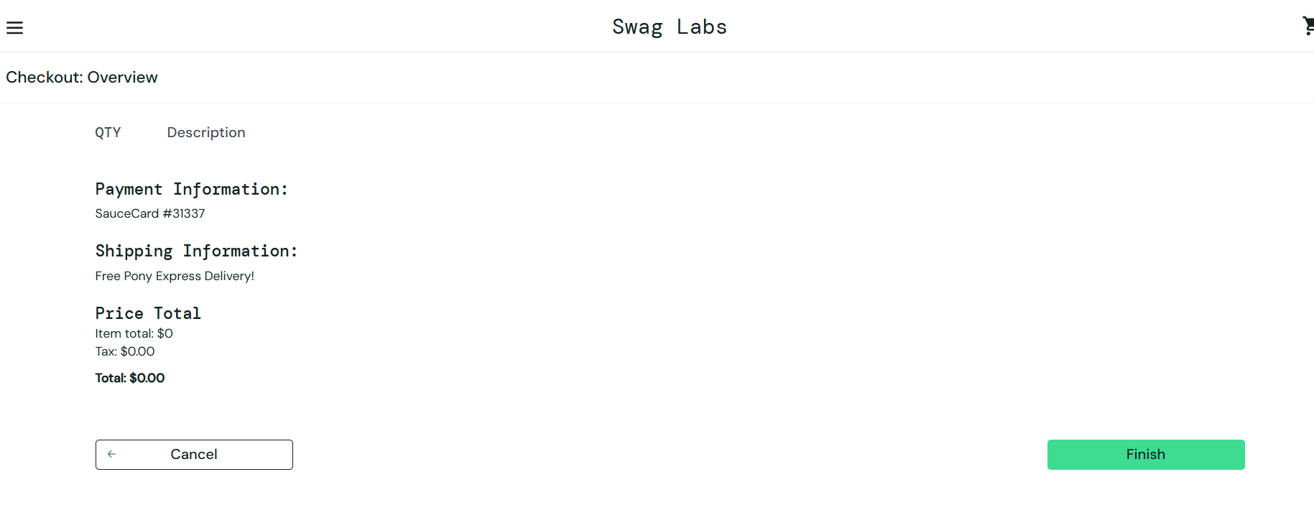attached checkout overview screenshot with 0 items and 0$ total