zeeg-detector: how the package is built
The package detects epileptiform spikes in sleep EEG almost in real time. It reads a recording 250 ms at a time and decides, for each piece, whether it contains a spike - fast enough to trigger stimulation while the patient sleeps.

1. How it works
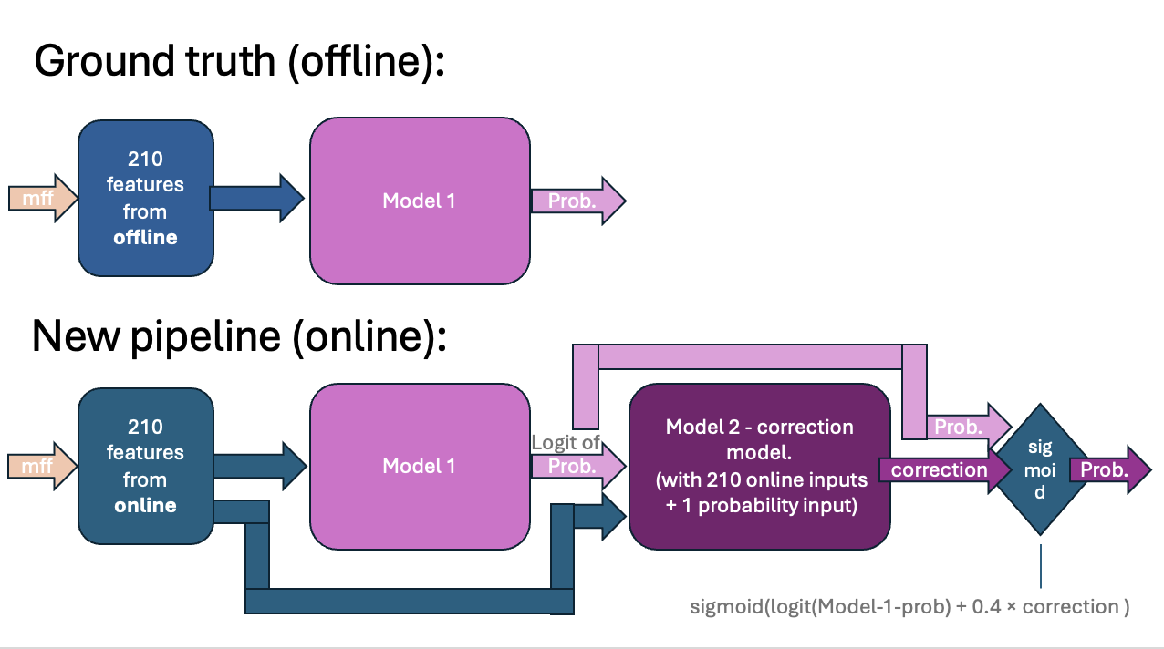
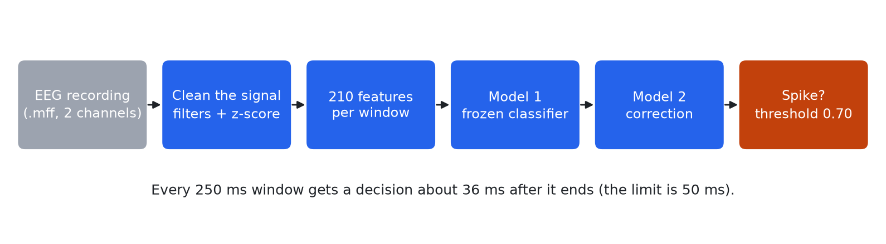
- Clean the signal: Filters remove slow drift and high-frequency noise; then the signal is normalised. Only 25 ms of 'future' signal is ever used.
- Features: 210 numbers describe each 250 ms window (105 per channel).
- Model 1: The original classifier from the lab. Never changed.
- Model 2: Our addition. It corrects model 1's score for not seeing the future signal, which improves agreement (F1 0.339 -> 0.383).
- Decision: Score 0.70 or above = spike, then 2 s of silence (refractory).
The first 20 minutes of every run are used to learn the patient's signal level, so no spikes are reported there.

2. What is in each folder
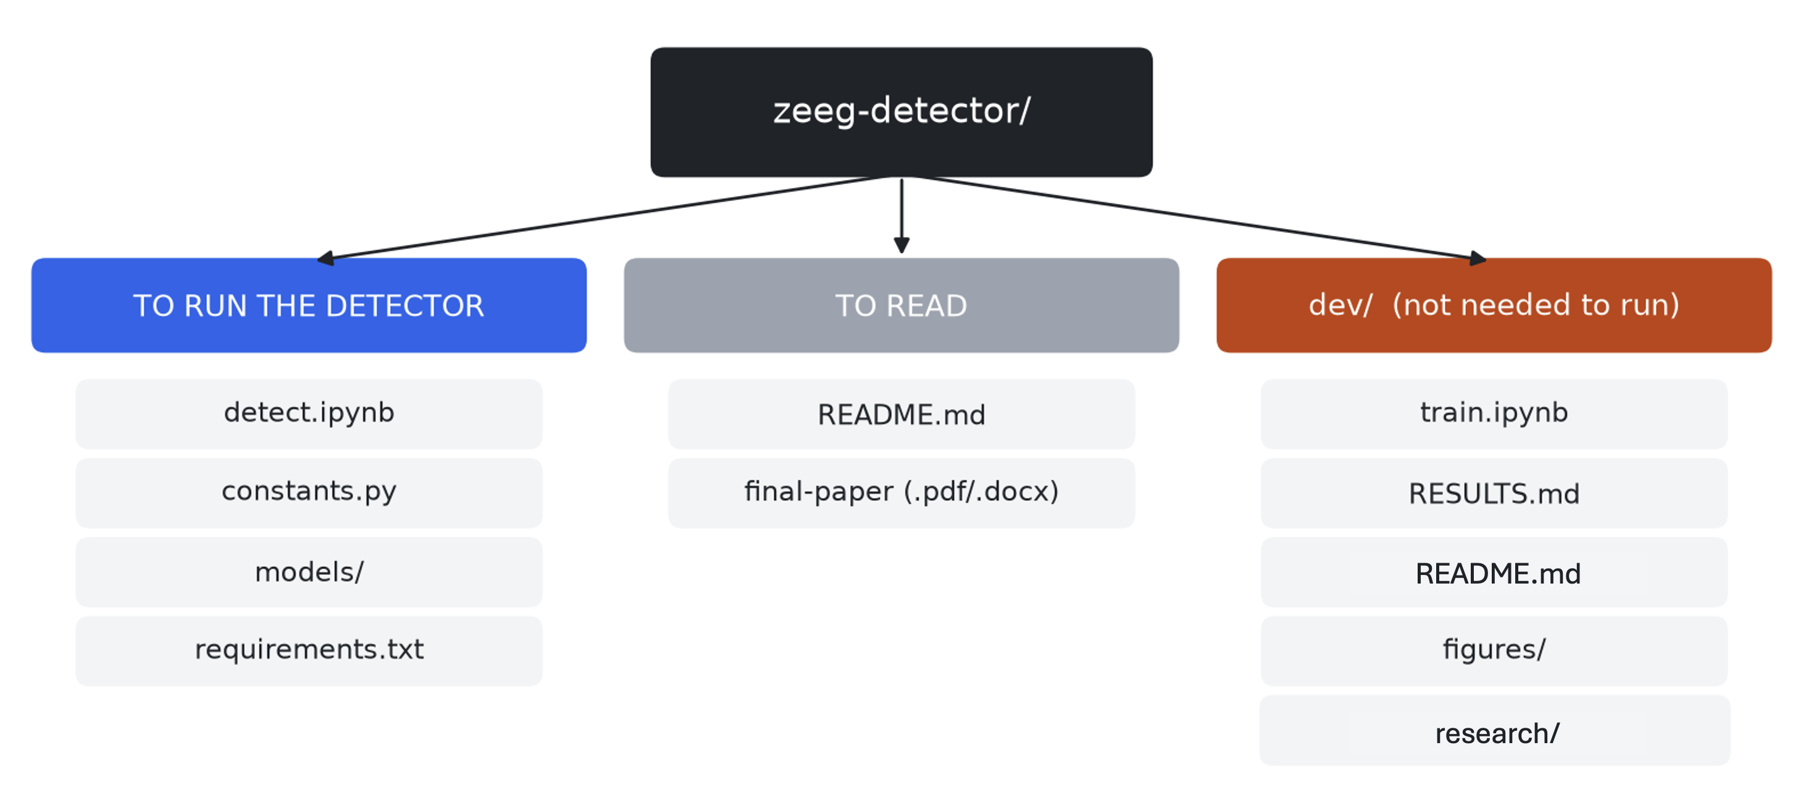
File / folder | What it is
detect.ipynb | The detector. Set the parameters at the top, then Run All. Checks itself at the end.
constants.py | Every fixed number (threshold, epoch length, ...) in one place.
models/ | The two trained models: xgb_frozen.pkl (model 1) and correction.json (model 2).
requirements.txt | The exact Python package versions to install.
README.md | Start here: how to run it, results, limits, next steps.
final-paper | The written paper.
dev/train.ipynb | Retrains model 2 on new recordings (needs data of mff recordings that are not included).
dev/RESULTS.md | Everything that was tried and why the choices were made.
dev/LIVE_FEED.md | Untested sketch for connecting a live amplifier.
dev/figures/ | Scripts that draw the paper's figures.
dev/research/ | Code that turns a raw recording into the training matrices for refitting the correction model.

3. How to run it
- Install: python3.9 -m venv .venv, then ./.venv/bin/pip install -r requirements.txt jupyterlab
- Open detect.ipynb and fill in the Parameters cell (START_MINUTE must be 1 or more).
- Run All. Spikes are saved to spikes.csv.
Important: the scores measure agreement with the lab's offline method, not with spikes marked by a clinician.

