Adapting a Sleep zEEG Epileptiform-Discharge Detector For Near-Real-Time

Laboratory of Prof. Yuval Nir, Tel Aviv University

Shani Makori and Inbal Azaria

Abstract

Epileptiform discharges (EDs) - brief bursts of abnormally synchronised neuronal activity, of the kind seen between seizures in epilepsy - arising in the medial temporal lobe during NREM (non rapid eye movement) sleep disrupt memory consolidation and are elevated in temporal lobe epilepsy, mild cognitive impairment, and Alzheimer's disease, making their quantification a promising biomarker of cognitive decline. A recently described method detects such events non-invasively from electrodes placed over the cheekbone (zygomatic EEG, zEEG), using a machine-learning classifier that scores the night in consecutive 250 ms segments, or epochs. It operates only on completed recordings, however, and therefore cannot trigger an intervention while the patient sleeps. Here we developed a near-real-time simulator for that detector, replaying overnight recordings sample by sample through a strictly causal processing chain, in which every decision uses only signal that has already arrived. The trained classifier was left unchanged, and every surrounding stage was rebuilt to read only past samples, apart from 25 ms of declared lookahead required by one filter and a running estimate of signal amplitude initialised on each night's first 20 minutes. Causality is enforced by the architecture of the software rather than by convention, so a live amplifier can replace the stored recording without any other modification. Because withholding future information distorts the classifier's output systematically rather than randomly, we also trained a second model, on recordings from other individuals, to predict and add back the gap between the causal score and the score the same classifier returns when 16.5 s of future signal is available. Across three overnight recordings, each evaluated with a correction trained only on the other two and each detection required to fall in exactly the same 250 ms epoch as the reference, the complete system reached an F1 score of 0.383 at precision 0.388, against F1 = 0.339 and precision 0.316 for the causal chain alone. These figures express agreement with the established offline method, not accuracy against clinician-marked discharges. Decisions arrived a median 35.9 ms after each epoch closed, within the 50 ms budget in which a stimulus still falls inside the discharge's window. Near-real-time zEEG-based ED detection is therefore feasible on standard computing hardware, though demonstrated by clocked replay rather than live acquisition, and once the implementation overhead inherited from batch analysis is removed, the binding constraint is not computation but the information withheld by causality.

1. Introduction

Epileptiform discharges (EDs), brief bursts of abnormally synchronised neuronal activity of the kind seen between seizures in epilepsy, are both a candidate marker of cognitive decline and a plausible mechanism of it when they arise in the hippocampus and medial temporal lobe (MTL) (Lopez & Kuller, 2019). Occurring preferentially during NREM sleep, they disrupt the coupling of slow oscillations, spindles, and hippocampal ripples on which memory consolidation depends (Gelinas et al., 2016; Lambert et al., 2020), and accompany poorer cognition in mild cognitive impairment, Alzheimer's disease, and temporal lobe epilepsy (Vossel et al., 2016; Lam et al., 2020). Quantifying them has long required intracranial electrodes, since deep temporal sources are poorly represented in scalp EEG.

Falach et al. (2025) removed that requirement using zygomatic electrodes (zEEG), which sit on the cheekbone and are therefore closer to deep temporal sources than the standard 10–20 montage, training a gradient boosting classifier - an ensemble of decision trees fitted in sequence, each correcting the errors of those before it (Chen & Guestrin, 2016) - against simultaneous intracranial ground truth in 50 neurosurgical epilepsy patients across three clinical centers. The model divides the night into consecutive 250 ms segments, or epochs, and returns for each one, from the two zygomatic channels, the probability that it contains a discharge; it generalizes to individuals on whom it was not trained. Throughout this paper we refer to that complete processing chain, from raw signal to reported events, as the offline pipeline, and to the trained classifier at its centre as the frozen classifier, since it is reused exactly as published and never refitted here.

The offline pipeline measures but does not act, analyzing the night only once it has ended. A detector reporting events as they occur could drive a closed loop (stimulation delivered automatically in response to a detected event), and such loops are well motivated: stimulation locked to ongoing sleep activity improves memory consolidation in humans (Geva-Sagiv et al., 2023), and stimulation contingent on epileptiform activity slows focal epilepsy progression in animals (Ferrero et al., 2025).

Running this detector in real time requires two different things, and they are easily confused. One is computing each decision fast enough to act on, which is a matter of implementation and was solved by rewriting the code. The other is deciding without any samples from the future, which is a matter of a new design. The offline pipeline is built from operations that read the future: a band-pass filter whose 33,001 coefficients span ~16.5 s of signal on either side of every sample, a removal of slow drift centred on the very sample it corrects, and an amplitude normalization computed over the whole recording. Each assumes data that do not exist when samples arrive one at a time, and no implementation repairs that. The information must be given up, and what its loss costs in detection performance is an empirical question. Three obstacles therefore separated the offline pipeline from a deployable device. The present work addresses each, and the structure of this paper follows them.

Causality. Every stage of the pipeline had to be rebuilt to read only samples that have already arrived, with the guarantee enforced by the software itself rather than asserted in prose.

Latency. A detection is actionable only while the discharge is still under way and can still be met with a stimulus, which allows roughly 50 ms after the epoch closes.

Detection performance. Working causally costs agreement with the offline pipeline, and the question was how much of that cost could be recovered.

One choice was settled in advance. The 250 ms epoch is the window the offline pipeline cuts the night into and the unit at which it reports, and the frozen classifier was trained on features computed over exactly that window, so the epoch came with the detector rather than being chosen here.

2. Methods

2.1 Data and reference standard

Three overnight high-density recordings sampled at 1000 Hz were analyzed, referred to below as Recordings 1, 2 and 3 (internal identifiers DH3, AO0 and MF7). Only the two zygomatic channels the frozen classifier requires were used (E227 and E254, Figure 1a), and periods of NREM sleep were delimited by expert sleep scoring. The reference standard is the unmodified offline pipeline of Falach et al. (2025) run over the same spans, which marks 261, 185, and 495 EDs in the three recordings. That pipeline is the appropriate target here, since it is the method already validated against simultaneous intracranial ground truth in 50 patients, and the question this paper asks is whether a strictly causal chain reproduces its decisions in real time. Every figure below accordingly measures agreement with it.

Agreement was scored by exact epoch: a detection counts only if it falls in the same 250 ms epoch in which the offline pipeline fired. This is the strictest available criterion and the right one for a closed loop, which acts on the timestamp of an event rather than on the count. Each detection is matched to at most one reference event, so no detection can be credited twice. Agreement is summarised by three standard quantities: precision, the proportion of the system's detections that coincide with a reference event; recall, the proportion of reference events the system detects; and F1, their harmonic mean, which is high only when both are high.

2.2 Causal signal chain

Every non-causal operation was replaced (Figure 1b). The classifier itself was left unchanged.

Table 1. Each operation in the offline pipeline, its causal replacement, and the amount of future signal the replacement requires.

Operation | Offline pipeline | Causal Replacement | Lookahead
Band-pass | 33,001-tap zero-phase 0.1–70 Hz | causal 3rd-order Butterworth 0.1 Hz high-pass, then a 51-tap symmetric 70 Hz FIR low-pass read 25 samples late | 25 ms
Detrend | centred 2 s moving-average | trailing 2 s box | 0 ms
Normalisation | z-score over the whole recording | expanding z-score, seeded on the night’s first 20 min | 0 ms
Classifier | 210 features → frozen XGBoost booster | unchanged | -
Detection | threshold 0.70, 2 s refractory, 20 min reporting bins | unchanged | -

The causal pipeline processes the night in consecutive 250 ms epochs, scoring each one independently and using only samples that have already been recorded. It has five stages. First, a band-pass filter keeps the frequencies in which discharges appear and discards the rest: a high-pass removes everything slower than 0.1 Hz, which is drift rather than brain activity, and a low-pass removes everything faster than 70 Hz, which is noise. The output of the low-pass is read 25 samples late, and those 25 ms are the system's lookahead, the only signal from after the present moment that the pipeline needs; they are imposed by the shape of the filter rather than by the way it is programmed. Second, a detrend removes slow baseline drift by subtracting the average of the 2 s preceding the present sample, so it reads nothing but the past. Third, normalization expresses amplitudes in units of standard deviation, so that the classifier sees comparable values whatever the overall scale of the recording; because a live system cannot use the whole night's statistics, the mean and standard deviation are estimated from every sample recorded so far and updated as the night proceeds, having first been established over the opening 20 minutes. Fourth, 210 numerical descriptors of the epoch, among them the power in several frequency bands, are passed to the classifier of Falach et al. (2025), left entirely unmodified, which returns the probability that the epoch contains a discharge. Fifth, the detection stage converts probabilities into events: an epoch scoring above 0.70 is declared a discharge, and a 2 s refractory interval then suppresses further detections, so that a single discharge is not reported repeatedly. Only the first three stages were rebuilt; the classifier and the detection stage already read nothing but the past.

The 25 ms of lookahead were charged in full to the reported latency. No detection is emitted during the opening 20 minutes, since the running estimate cannot standardize a recording it has not yet observed. Causality was enforced by the architecture: the pipeline cannot reach the recording directly, only request the next samples from a software component that refuses to return any sample the clock has not yet reached. Reading ahead is impossible rather than merely avoided, and that component can be replaced by a live amplifier without changing anything downstream.

Figure 1a.
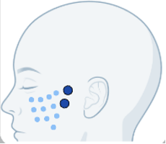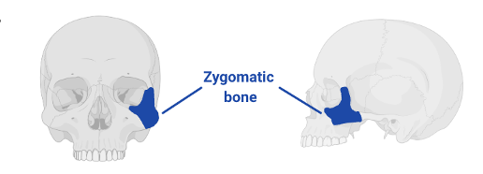
Figure 1b.
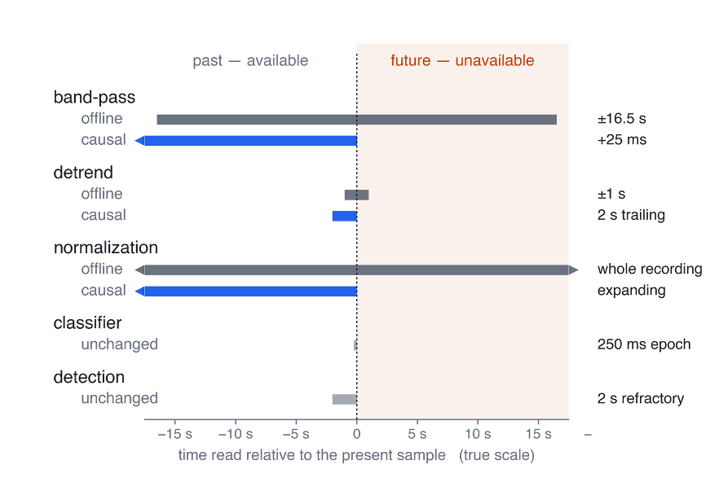

Figure 1. The zygomatic montage, and the signal each stage reads. (a) The zygomatic bone, over which the two channels the frozen classifier reads are placed. Adapted from Falach et al. (2025). (b) Signal read into the past and the future relative to the sample being processed, on a linear axis so every bar is in true proportion. Grey marks the offline pipeline, blue its causal replacement, light grey the unchanged stages.

2.3 Correction model

The causal and offline chains differ only in the information available to them, the decision rule being identical in both cases. Their disagreement was therefore expected to be systematic rather than arbitrary, and consequently learnable. A second gradient-boosted model, referred to below as the correction model, was trained to predict it. Because the quantity to be predicted is a continuous difference between two scores rather than a category, this model was fitted as a regression under squared-error loss. Its inputs were the 210 features together with the classifier's score for that epoch under the causal chain; its target was the difference between the classifier's scores under the offline and causal chains, both expressed as log-odds - the logarithm of the ratio of a probability to its complement, a scale on which a probability can be shifted by simple addition. Corrected scores were obtained by adding the predicted difference to the causal log-odds, weighted by a factor α between 0 and 1 that sets how much of the predicted gap is applied, and converting back to a probability, so that α = 0 recovers the uncorrected causal detector exactly. Scores obtained under the offline chain served as training targets only. The offline chain is not invoked when the system runs, and its 16.5 s of lookahead consequently never enters the live system.

Fitting and selection followed a leave-one-recording-out design: each recording in turn was held out for evaluation, the remaining two serving as donors - recordings from other individuals, standing in for the population a deployed device would have been trained on - and the correction applied to the held-out recording was fitted on donor data exclusively. Each such held-out recording and its two donors constitute one fold. Training data comprised every donor NREM period of at least 25 minutes, the first 20 minutes of each being discarded, as no normalised score is defined before the running estimate has been established. Most settings governing the fit were fixed in advance (learning rate 0.05, 300 boosting rounds, minimum child weight 5, L2 penalty 2, 128 histogram bins), and all observations and features were used at every round, which removes the only random element of the procedure, so that refitting yields an identical model at no cost in agreement. Two settings were searched: tree depth (3 or 6) and the correction weight α (0, 0.15, 0.25, 0.4, 0.6, 0.8, 1.0). The search was conducted within the donor pair alone, fitting on one donor and evaluating on the other at threshold 0.70, so that the held-out recording contributed to neither fitting nor selection. Depth 6 was selected in all three folds, with α = 1.00 (Recording 1), 0.15 (Recording 2) and 0.80 (Recording 3). As α = 0 was among the candidates, rejecting the correction entirely was available in every fold; a non-zero weight was nonetheless selected throughout.

2.4 Latency optimization

A causal chain is not automatically a fast one. The first assembled implementation missed the 50 ms budget, and the cost lay in the interfaces around the signal processing rather than in the processing itself, since the offline pipeline's components were written to be called once over a whole night rather than 14,400 times an hour. Five changes removed it. The dominant term was the call to the classifier: its standard prediction interface accepts a named table of features and re-checks all 210 names on every call, spending ~49 ms there against 0.40 ms on the prediction itself. The order of the features is therefore resolved once at start-up, and each epoch is written straight into a fixed block of numbers handed directly to the trained model; the two routes are compared against each other at start-up, so that any change in that order fails immediately rather than silently rearranging the features. Computing the band-power features otherwise rebuilds six band-pass filters for every epoch, ~30% of feature-extraction time; since those filters depend only on the sampling rate, the band edges and the window length, they are now built once and reused. The filter stages retain their internal state from one epoch to the next, so no earlier signal is filtered twice and processing 250 samples at a time gives exactly the result of filtering the night in one pass. Both channels are processed in a single feature-extraction call, the fixed cost of making a call outweighing the work inside it at the scale of one epoch, and a synthetic epoch is scored before streaming begins, so that the one-off cost of a first call is paid during calibration rather than in the first live decision. None of these changes alters any computed value.

2.5 Latency benchmarking and design choices

Latency was measured for every decision, over 22,671 timed epochs pooled across the three recordings, and broken down by component (Table 2); the recording was held in memory, so no time is charged for reading it from disk. End-to-end latency is lookahead plus computation, the interval a closed loop must wait after an epoch closes. It is judged against the 50 ms budget, and separately against the 250 ms duration of an epoch, within which the computation must fit if the system is to keep pace with incoming data.

3. Results

3.1 The optimized streaming implementation reproduces the causal chain detection for detection

Before measuring what the causal chain costs, we checked that it computes what it is meant to. Streaming the recording sample by sample and analysing it in one pass afterwards produced identical detection counts in all three recordings (359, 196, 366). This took one fix, and not where the discrepancy appeared to lie. The running normalization agreed with its whole-recording counterpart to within one part in 10¹⁴, and the entire gap came from a single line of the detection stage, in which the offline scorer discards a final 20-minute reporting interval shorter than half its nominal length. A live device should not apply that rule, and a continuously running device has no final interval. Four further checks passed: the accelerated feature extraction reproduced the original definitions exactly, feature values computed over arbitrarily chosen NREM periods were identical to those the offline pipeline had already produced, two fits of the correction model started from different random initialisations gave identical trees, and the packaged single-notebook version of the system reproduced the development code's detections at identical timestamps.

3.2 Decisions arrive within the intervention budget and keep pace with acquisition

The causal system delivered one decision per 250 ms epoch at a median end-to-end latency of 35.9 ms, clearing the 50 ms budget with ~14 ms of margin (Figure 2), of which 25 ms is the declared filter lookahead and only 10.9 ms computation. The slowest decisions stayed close to the median (95th percentile 36.9 ms, 99th percentile 39.1 ms), so the margin holds epoch after epoch rather than only on average.

Table 2. Latency per 250 ms decision, in milliseconds, pooled over 22,671 timed epochs. p95 and p99 are the 95th and 99th percentiles.

component | median | p95 | p99
filter + detrend (SMA) + normalise | 0.17 | 0.22 | 0.35
feature extraction (210 features, 2 channels) | 10.17 | 11.00 | 12.8
model 1 - frozen classifier (from the offline detector) | 0.40 | 0.54 | 0.72
model 2 - correction | 0.14 | 0.19 | 0.32
Total compute time | 10.89 | 11.86 | 14.1
end-to-end (25 ms lookahead + compute) | 35.9 | 36.9 | 39.1

Only two of 22,671 epochs exceeded 250 ms (0.009%), and when replaying a stored file the system sustained 34–41 times real time on eight processor cores, so neither budget limits streaming operation. These are the figures for the optimized implementation. The classifier's standard prediction interface alone had spent ~49 ms per call checking feature names, 4.5 times the final computation total; added to the lookahead, that overruns the budget before a single feature is computed. Computation was a genuine barrier, absent from Table 2 because it was removed rather than because it was never there. What could not be removed is the 25 ms of lookahead, a property of the filter rather than of the code.

Figure 2.
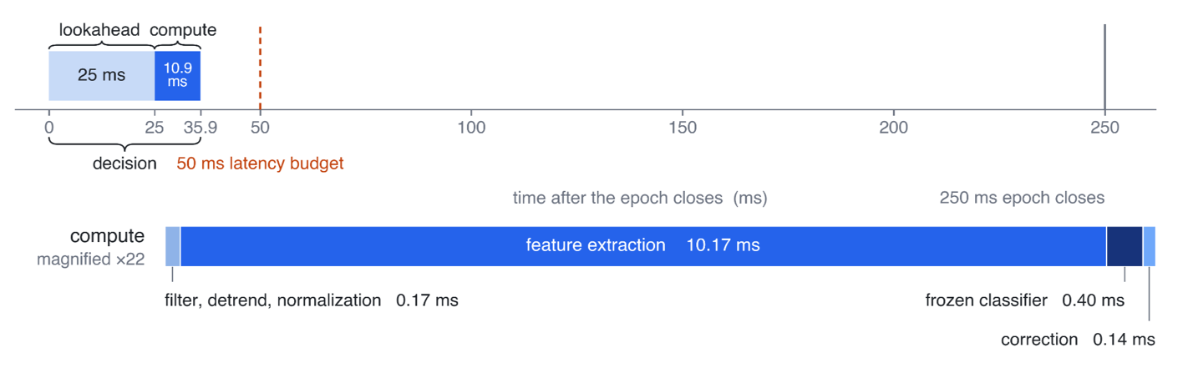

Figure 2. Latency per 250 ms decision, decomposed by component. Top: the decision timeline on a true linear axis. Declared lookahead (25 ms) is charged in full, computation adds 10.9 ms, and the decision lands at 35.9 ms. Bottom: the same computation, magnified ×22 and split into its four stages. Feature extraction is 93% of it, and the two models together 0.54 ms. Medians over 22,671 timed epochs (Table 2).

3.3 A donor-trained correction improves agreement with the offline pipeline in every recording

We next quantified what causality costs, and how much of that cost the correction model recovers (Figure 3). The frozen classifier on the causal chain reached mean F1 = 0.339 at precision 0.316 and recall 0.366. Adding the correction carried it to F1 = 0.383 at precision 0.388, a gain drawn
mostly from precision, with recall rising from 0.366 to 0.392.

Figure 3.
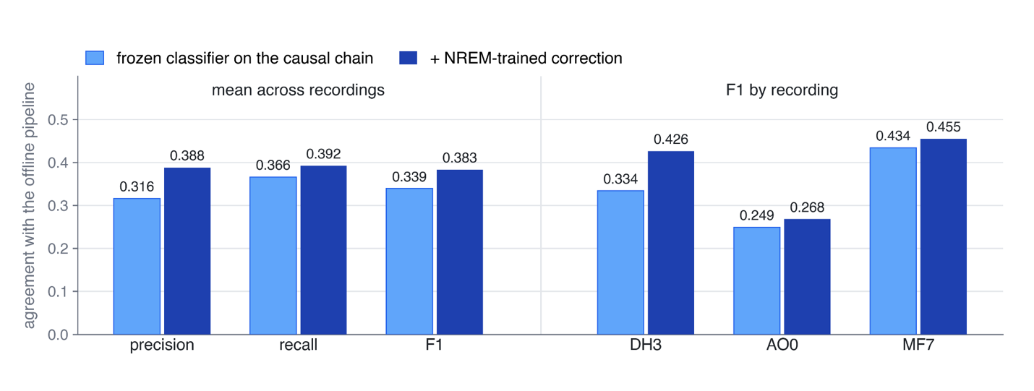

Figure 3. Agreement with the offline pipeline, with and without the lookahead correction. Left: precision, recall and F1 averaged across the three recordings. Right: F1 per recording, precision and recall being reported as means only. Light bars show a causal chain classifier, dark bars the same classifier with the correction added.

Per recording the corrected system reached F1 = 0.426 (Recording 1), 0.268 (Recording 2), and 0.455 (Recording 3), against 0.334, 0.249, and 0.434 uncorrected, an improvement in both precision and F1 in all three. The route differed. In Recording 1 the correction recovered detections, adding 36 true positives for 9 false ones. In Recording 3 it suppressed them, removing 164 false positives at a cost of 34 true ones (+0.128 precision), the largest precision gain observed and the change most relevant to a closed loop. Recording 2 improved only modestly, consistent with its smaller number of reference events and with an opening 20-minute block containing only three detections.

That a correction adds detections in one recording and removes them in another invites the objection that it is fitting the idiosyncrasies of individual recordings, and the evidence does not dismiss it entirely. Two observations indicate that something general is captured. The net effect has the same sign in every recording, and when the two detectors are compared at matched recall the corrected one is the more precise throughout, reaching on Recording 1 a recall of 0.45 that the frozen classifier cannot reach at any threshold, which a mere shift of the decision boundary could not produce.

The correction costs 0.14 ms per decision.

3.4 Much of the residual disagreement is events placed in the neighbouring epoch, not events missed

Giving up filtering that reads the future has a second consequence, distinct from the 25 ms of lookahead charged to latency above: a causal chain not only decides later, it also places events later. Part of the disagreement should therefore be real discharges assigned to a neighbouring epoch rather than events the detector missed. We rescored the same detections, without refitting anything, under progressively wider matching windows (Figure 4). No model, threshold or feature changed between the four windows, only the offset a detection is allowed to carry before it counts as matched, so the entire spread is attributable to timing.

Figure 4.

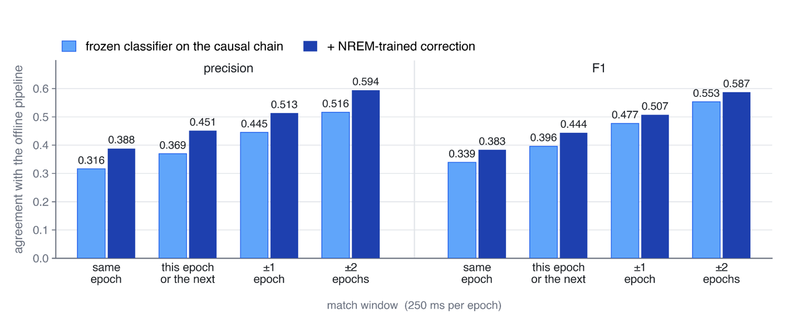

Figure 4. Agreement as the admissible offset between a detection and the offline reference is widened. Left: precision. Right: F1, both means over the three recordings at threshold 0.70. Light bars show the frozen classifier on the causal chain, dark bars the same classifier with the correction added. The leftmost pair in each block is the exact-epoch scoring reported in Figure 3; the remaining three admit a one-epoch lag only, ±1 epoch, and ±2 epochs (250 ms per epoch).

Allowing a detection to fall one epoch late, and no earlier, raises mean F1 from 0.339 to 0.396 for the frozen chain and from 0.383 to 0.444 for the corrected one, with precision rising by a comparable amount in both. The asymmetric window is the informative one, since it admits only lag, the direction a causal chain can err in. A substantial share of what exact-epoch scoring charges as a false positive plus a miss is therefore one real discharge displaced in time, which supports reading the headline figures as a lower bound. Widening further to ±2 epochs carries mean F1 to 0.553 and 0.587, though a symmetric window also admits coincidences and is the weaker evidence for that reason.

Two features of the figure bear on interpretation. Every bar climbs monotonically with the window while the classifier is untouched, which is the signature of displacement rather than of detection failure. And the gap between the frozen and corrected bars is close to constant across all four windows, roughly 0.07 in precision and 0.04 in F1, so the correction is not recovering timing: it removes false positives that no amount of tolerance would have matched. The two effects are separable, and both are real. Neither softens the deployment argument, since a stimulus an epoch late is late by 250 ms however the event is scored.

3.5 The correction's benefit depends on the amount and regime of its training data

The value of the correction depends almost entirely on the data it is fitted on, and this was the most consequential design choice in the present work (Table 3).

Table 3. Mean F1 by training set for the correction model, threshold held at 0.70.

training set for model 2 | data per fold | mean precision | mean F1
none (frozen classifier only) | - | 0.316 | 0.339
the evaluation crops | 94–111 min | 0.382 | 0.346
every donor NREM period ≥ 25 min | 287–458 min | 0.387 | 0.378
the same, seed blocks dropped, deterministic fit | 287–458 min | 0.388 | 0.383
the same + the test patient’s own later NREM | 287–458 min + the patient’s own night | 0.391 | 0.385

The gain derives from the amount of training data rather than from which recordings it came from: fitting on the evaluation segments alone reached F1 = 0.346, whereas expanding to all donor NREM periods (584 minutes of usable material against 154.5) delivered +0.032 mean F1, the one comparison in the table large enough to read as an effect. Discarding each period's opening 20 minutes removed 44% of the training examples without harming agreement, for a straightforward reason: six of the features take a constant value inside that block but vary widely outside it, so those examples taught the correction model a normalization regime the deployed detector never encounters. Adding the test patient's own later NREM sleep changed mean F1 by +0.007, indistinguishable from no change. That null result is the useful one, since a device can then ship with a correction fitted on other people's recordings and be useful from the first night.

3.6 The detection threshold is already the best available, and the precision ceiling is not a threshold effect

The detector fires when the score exceeds 0.70, a value inherited from the offline pipeline. The correction shifts scores on the log-odds scale, so they no longer sit on the scale that value was chosen for, and re-tuning it becomes the obvious next step. It does not help. We compared holding the threshold at 0.70 against three rules that set it from data: choosing the value that scores best on the donors, or fixing it so that the patient's own opening 20 minutes yields an expected count of detections, or an expected rate. Holding it fixed was the best rule on every training set: on the final correction model it reached mean F1 = 0.378, against 0.364, 0.366 and 0.372 for the three tuned rules. The donors favor a lower threshold than the test recording and that preference does not transfer, while the opening block is too sparse to tune on, that of Recording 2 holding three detections. A device therefore needs no per-patient threshold calibration.

The reason no gain is available there is visible in a sweep across thresholds of the final model (Figure 5).

Figure 5.
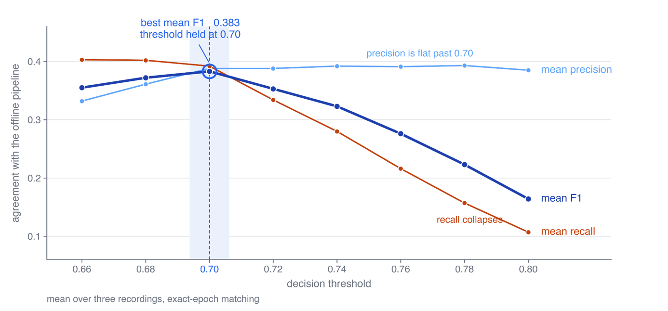

Figure 5. Agreement with the offline pipeline across the range of decision thresholds, for the final corrected detector. Precision, recall and F1 are means over the three recordings under exact-epoch matching. The threshold the system holds, 0.70, is marked; it is where mean F1 peaks.

Precision is flat from 0.70 to 0.80, moving only from 0.388 to 0.385, while recall falls over the same span from 0.392 to 0.107, and F1 peaks at 0.70 where precision has already plateaued. Buying precision by raising the threshold therefore costs recall and returns nothing, and the ceiling near 0.39 belongs to the detector rather than to the threshold.

Selection of the correction weight α shows the same pattern. The per-fold search returned α = 1.00 (Recording 1), 0.15 (Recording 2) and 0.80 (Recording 3), a nearly sevenfold spread across folds differing only in which two recordings serve as donors, and in no fold was the selected value the one that would have served that recording best. A single α of 0.60 throughout would have reached precision 0.432 at recall 0.387, against 0.388 at 0.392 for the per-fold choice. Since 0.60 was identified with all three test recordings in view it is not a deployable rule, but the point stands: a procedure with access to independent donor data was beaten by a constant.
4. Discussion
We rebuilt an established offline detector of medial temporal epileptiform discharges as a system that decides while the night is still in progress, and measured what that costs. Real-time operation was limited by information, not by computation. Computation was an obstacle, but a removable one: called in the ordinary way, each model spends about 49 ms checking feature names, and every decision makes two such calls, so that path alone would consume the whole 50 ms budget several times over. Once it is replaced, the entire chain takes about 11 ms per decision, leaving roughly 14 ms of margin after the 25 ms of lookahead is paid. The offline pipeline's 16.5 s is not computation either. It is future signal rather than time spent working: the filter reads 16.5 s beyond each sample, which is why that pipeline cannot run live at any speed, and processing the signal as it arrives removes the wait completely. What that cannot recover is the information those 16.5 s contained, and that loss is what lowers agreement to F1 = 0.339. This figure, not any timing measurement, is the true cost of real-time operation. The trade is specifically against lookahead, since the only latency term that can be tuned is the symmetric low-pass filter, whose 51 coefficients account for the 25 ms.

Causal filtering also affects timing, which the headline metrics understate. A filter that reads the future as well as the past places events at the correct moment; a causal chain can displace a real event by an epoch or more. Under exact-epoch scoring, one displaced event is counted twice against the detector, as a false positive and as a miss. False positives clustered near true events in the offline setting as well (Falach et al., 2025). We therefore read these figures as a lower bound on true detection quality. This concerns interpretation rather than deployability: a displaced stimulus is still a wrong stimulus.

The classifier stays frozen because it carries an evidence base that refitting would forfeit. That is what makes the architecture clinically relevant. Instead of refitting, we learn what the lost lookahead does to its scores: the loss is treated as a systematic distortion, and the validated decision rule is left intact, and can be restored exactly by setting α = 0. The correction adds 0.044 F1 and 0.072 precision, costs 0.14 ms per decision, is deterministic, and transfers between individuals. The negative results are equally informative. Every rule that gave the selection procedure more freedom performed worse, which is the signature of a procedure fitting the peculiarities of the small sample it is tuned on.

Four limitations should be acknowledged. First, every figure here measures agreement with the offline pipeline rather than clinical ground truth. The online system therefore inherits that pipeline's validity instead of re-establishing it, and the precision ceiling cannot yet be attributed to the causal chain rather than to the reference itself. Second, three recordings from a single laboratory, all at 1000 Hz and rich in N3, are a narrow base, and one of the three responds only weakly to the correction. Third, the configuration was chosen while observing all three recordings, so the reported figures are not an unbiased estimate of performance on a recording the system has never seen. The second and third limitations together fix the standing of this work: it is a feasibility study, establishing on three recordings that the detector can be made strictly causal and decide inside the intervention budget, and quantifying what causality costs on the material available. It is not a performance estimate for a deployed device, and the agreement figures reported here await confirmation in a larger and independent cohort. Fourth, precision near 0.39 means roughly six false stimulations for every ten true ones. That is tolerable for a benign stimulus delivered hundreds of times a night, but not for an intervention with a substantial per-delivery cost.

5. Conclusions and future work

We set out to make the laboratory's offline zEEG ED detector causal, to make it fast enough to act on, and to make it detect as well as it can. All three are addressed. A complete causal implementation now exists as a single, self-checking analysis notebook that reads a high-density recording, emits a probability for every 250 ms epoch, and decides a median 35.9 ms after the epoch closes. The cost in accuracy was quantified rather than assumed, at exact-epoch F1 = 0.339, and a correction fitted on other individuals' recordings, with the classifier left frozen, recovered part of it to F1 = 0.383, improving every recording.

Four steps follow, in the order they must be taken:

Connecting to the laboratory's zEEG acquisition system is the immediate engineering task. Everything reported here was measured on a stored recording replayed under a clock, which reproduces the timing of live operation but not the recording setup itself. The architecture was built for the transition: the component that supplies samples is the only part that must change. What remains is on the acquisition side - reading the amplifier's signal as it is written, and keeping the detector's clock aligned with the recording hardware. The rule that discards a short final reporting interval must also be removed, since it has no meaning for a night still in progress.

Additional recordings are the precondition for everything after that. Three recordings from one laboratory are too narrow a base to test generalisation across patients, electrode montages, or sleep architectures.

Retraining the correction on that larger cohort is then worth revisiting. The present model is fitted on two donor recordings per fold, and its weight α varies considerably between them, which is what one expects when each fold sees very little data.

Validation against an independent reference standard is the most important scientific step. Every figure in this paper measures agreement with the offline pipeline, so the detector currently inherits that pipeline's validity rather than demonstrating its own. Only expert annotation of individual discharges, or intracranial recordings, can establish whether the precision ceiling belongs to the causal chain or to the reference it is scored against.

References

Chen, T., & Guestrin, C. (2016). XGBoost: A scalable tree boosting system. In *Proceedings of the 22nd ACM SIGKDD International Conference on Knowledge Discovery and Data Mining* (pp. 785–794). Association for Computing Machinery. https://doi.org/10.1145/2939672.2939785

Falach, R., Zhelezniakov, V., Vekslar Hazrati, R., Gotfrid, S., Pesaty, M., Gurevitch, G., Niediek, J., Mikulan, E. P., Pigorini, A., Morris, G., Ben Shahar, M., Banner, A., Ben-Valid, S., Shani-Hershkovich, R., Budin, O., Sarasso, S., Massimini, M., Zauli, F. M., Sartori, I., … Nir, Y. (2025). Sleep zygomatic EEG detects medial temporal epileptiform biomarkers of mild cognitive impairment [Unpublished manuscript].

Ferrero, J. J., Hassan, A. R., Yu, Z., Zhao, Z., Ma, L., Wu, C., Shao, S., Kawano, T., Engel, J., Jr., Doyle, W., Devinsky, O., Khodagholy, D., & Gelinas, J. N. (2025). Closed-loop electrical stimulation prevents focal epilepsy progression and long-term memory impairment. *Nature Neuroscience, 28*, 1753–1762.

Gelinas, J. N., Khodagholy, D., Thesen, T., Devinsky, O., & Buzsáki, G. (2016). Interictal epileptiform discharges induce hippocampal–cortical coupling in temporal lobe epilepsy. *Nature Medicine, 22*(6), 641–648.

Geva-Sagiv, M., Mankin, E. A., Eliashiv, D., Epstein, S., Cherry, N., Kalender, G., Tchemodanov, N., Nir, Y., & Fried, I. (2023). Augmenting hippocampal–prefrontal neuronal synchrony during sleep enhances memory consolidation in humans. *Nature Neuroscience, 26*, 1100–1110. https://doi.org/10.1038/s41593-023-01324-5

Lam, A. D., Sarkis, R. A., Pellerin, K. R., Jing, J., Dworetzky, B. A., Hoch, D. B., Jacobs, C. S., Lee, J. W., Weisholtz, D. S., Zepeda, R., Westover, M. B., Cole, A. J., & Kapur, J. (2020). Association of epileptiform abnormalities and seizures in Alzheimer disease. *Neurology, 95*(16), e2259–e2270.

Lambert, I., Tramoni-Negre, E., Lagarde, S., Roehri, N., Giusiano, B., Trebuchon-Da Fonseca, A., Carron, R., Benar, C. G., Felician, O., & Bartolomei, F. (2020). Hippocampal interictal spikes during sleep impact long-term memory consolidation. *Annals of Neurology, 87*(6), 976–987.

Lopez, O. L., & Kuller, L. H. (2019). Epidemiology of aging and associated cognitive disorders: Prevalence and incidence of Alzheimer's disease and other dementias. In S. T. DeKosky & S. Asthana (Eds.), *Handbook of clinical neurology* (Vol. 167, pp. 139–148). Elsevier.

Nakamura, M., Kajiwara, Y., Otsuka, A., & Kimura, H. (2013). LVQ-SMOTE: Learning Vector Quantization based Synthetic Minority Over-sampling Technique for biomedical data. *BioData Mining, 6*, 16.

Scheltens, P., De Strooper, B., Kivipelto, M., Holstege, H., Chételat, G., Teunissen, C. E., Cummings, J., & van der Flier, W. M. (2021). Alzheimer's disease. *The Lancet, 397*(10284), 1577–1590.

Vossel, K. A., Ranasinghe, K. G., Beagle, A. J., Mizuiri, D., Honma, S. M., Dowling, A. F., Darwish, S. M., Van Berlo, V., Barnes, D. E., Mantle, M., Karydas, A. M., Coppola, G., Roberson, E. D., Miller, B. L., Garcia, P. A., Kirsch, H. E., Mucke, L., & Nagarajan, S. S. (2016). Incidence and impact of subclinical epileptiform activity in Alzheimer's disease. *Annals of Neurology, 80*(6), 858–870.

