**Conclusions And Suggestions – part 3**

**Key Findings from Data Analysis**

1. **Busy Times**: According to this plot we can see the most crowded hours of passengers up.

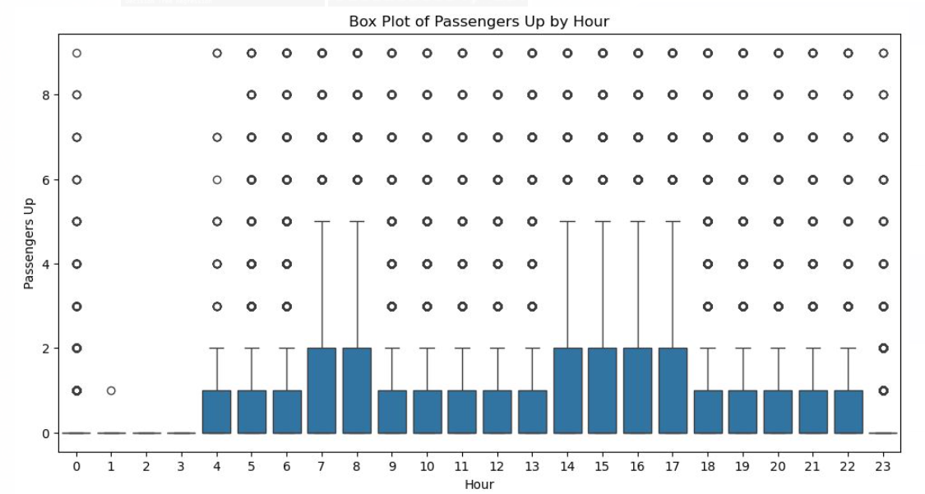

1. **Regional Bus Usage**: according to this plot we can see which key word station name are more in use.

**Recommendations for Improving Public Transit**

1. **More Buses for Busy Routes**: Find bus lines that are always crowded during busy times and suggest running more buses on these routes.
2. **Fewer Buses for Less Busy Routes**: Identify routes with fewer passengers and suggest running fewer buses on these routes to save resources.
3. **New Bus Lines for Growing Areas**: Find areas with increasing populations or high demand that don’t have enough bus service. Suggest new bus lines to serve these areas better.
4. **Improve Existing Routes**: Suggest changes to make current bus routes more efficient. For example, if certain stops always have few passengers, propose skipping these stops or combining them with nearby busier stops.

