**DISASTER DAMAGE ASSESSMENT APP**

**AI19511 – MOBILE APPLICATION DEVELOPMENT LABORATORY FOR ML AND DL APPLICATIONS**

**A PROJECT REPORT**

**Submitted by**

**INBAVEL S (221501050) ,**

**HARISH A (221501518).**

**in partial fulfillment for the award of the degree**

**of**

**BACHELOR OF TECHNOLOGY**

**in**

**ARTIFICIAL INTELLIGENCE AND MACHINE LEARNING**



**RAJALAKSHMI ENGINEERING COLLEGE, KANCHIPURAM ANNA UNIVERSITY : CHENNAI 600 025**

**DECEMBER 2024**



**BONAFIDE CERTIFICATE**

NAME……………………………………………………………………………….........

ACADEMIC YEAR………………SEMESTER………….BRANCH…………………

|  |
| --- |
|  |

UNIVERSITY REGISTER No.

Certified that this is the bonafide record of work done by the above students in the Mini Project titled **“DISASTER DAMAGE ASSESSMENT APP”** in the subject **AI19511 – MOBILE APPLICATION DEVELOPMENT LABORATORY FOR ML AND DL APPLICATIONS** during the year 2024 2025.

**Signature of Faculty – in – Charge**

**Submitted for the Practical Examination held on _____________________**

**Internal Examiner External Examiner**

**ABSTRACT**

The Disaster Damage Assessment App is an innovative tool designed to streamline the evaluation of natural disaster impacts through advanced AI and machine learning techniques. The project begins with the development of a TensorFlow Lite (TFLite) model, utilizing the UNet architecture—a Convolutional Neural Network (CNN) variant optimized for image segmentation tasks. This model is trained on a comprehensive dataset of pre-disaster and post-disaster images, enabling it to accurately identify and segment damaged areas in satellite imagery. The preprocessing phase includes loading, resizing, and normalizing images, followed by data augmentation to enhance the model's robustness. The application is meticulously structured, starting with the AndroidManifest.xml file, which sets the necessary permissions and declares all activities. The user journey begins with a splash screen (SplashActivity) that transitions to the sign-in interface (SignInActivity) after a brief delay, ensuring a smooth user experience. The SignInActivity handles user registration and authentication, securely storing credentials using SharedPreferences. Upon successful authentication, users are directed to the main assessment screen (MainActivity). Here, users can upload pre- and post-disaster images for analysis. The core functionality of the app involves the TFLite model processing these images to calculate damage percentages. Complementary to this, the app includes a weather calculator (WeatherActivity) that provides essential functionalities such as temperature conversion, wind speed conversion, and wind chill calculation, augmenting the disaster assessment process with additional meteorological data. The TFLite model performs image segmentation, distinguishing between damaged and undamaged areas, and provides a visual and quantitative representation of the damage. This segmentation is crucial for determining the spatial distribution and severity of damage, which is instrumental in estimating the financial costs and planning recovery efforts. The results, including damage percentages and resource metrics, are displayed to the user, offering a comprehensive overview of the disaster's impact. CNN-based image analysis with user-friendly interfaces and supplementary tools, the app significantly improves the speed, accuracy, and reliability of disaster damage assessments, aiding response teams, government agencies, and insurance companies in making informed decisions.

**Keywords** : Disaster Damage Assessment, TensorFlow Lite (TFLite), UNet Architecture, Convolutional Neural Networks (CNNs), Image Segmentation.

**ACKNOWLEDGEMENT**

Initially I thank the Almighty for being with us through every walk of my life and showering his blessings through the endeavor to put forth this report.

My sincere thanks to our Chairman **Mr. S. MEGANATHAN, M.E., F.I.E.,** and our Chairperson **Dr. (Mrs.)THANGAMMEGANATHAN,M.E.,Ph.D.,** for providing me with the requisite infrastructure and sincere endeavoring educating me in their premier institution.

My sincere thanks to **Dr. S.N. MURUGESAN, M.E., Ph.D.,** our beloved Principal for his kind supportand facilities provided to complete our work in time.

I express my sincere thanks to **Dr. K.SEKAR, M.E., Ph.D.,** Head of the Department of Artificial Intelligence and Machine Learning and Artificial Intelligence and Data Science for his guidance and encouragement throughout the project work. I convey my sincere and deepest gratitude to our internal guide, **Dr. PAVITHRA GURU , M.E., Ph.D.,** Associate Professor, Department of Artificial Intelligence and Machine Learning, Rajalakshmi Engineering College for his valuable guidance throughout the course of the project.

Finally I express my gratitude to my parents and classmates for their moral support and valuable suggestions during the course of the project.

**LIST OF FIGURES**

|  |  |
| --- | --- |
| **FIGURE NO.** | **FIGURE NAME** |
| **3.1** | **Architecture of TwoStep Model for Disaster Damage Assessment Using Satellite Images** |
| **3.2** | **UNet Model Architecture for Image Segmentation** |
| **3.3** | **Tflite Integration in Android** |
| **3.4** | **Tflite Model : Disaster Info** |
| **3.5** | **Tflite Integration in Disaster Building Percentage** |
| **4.1** | **Splach Activity & Sign Activity** |
| **4.2** | **Main Activity & Disaster Info Activity** |
| **4.3** | **About Activity & Weather Activity** |

**TABLE OF CONTENTS**

|  |  |  |
| --- | --- | --- |
| **CHAPTER NO.** | **TITLE** | **PAGE NO.** |
|  | **ABSTRACT**  **LIST OF FIGURES** | **iii**  **iv** |
| **1.** | **INTRODUCTION** | **1** |
| **2.** | **LITERATURE SURVEY** | **10** |
| **3.** | **MODEL ARCHITECTURE** | **21** |
| **4.** | **IMPLEMENTATION** | **28** |
| **5.** | **RESULTS AND DISCUSSIONS** | **34** |
| **6.** | **CONCLUSION** | **37** |
| **7.** | **OUTCOME** | **39** |

**INTRODUCTION**

Natural disasters are catastrophic events that stem from the Earth's natural processes, often resulting in significant disruptions to human life, infrastructure, and the environment. These events can manifest in various forms, including earthquakes, floods, hurricanes, droughts, wildfires, tsunamis, and volcanic eruptions. The impact of such disasters is multifaceted and profound, frequently leading to loss of life, economic devastation, and longterm social upheaval. As global patterns of climate change, urbanization, and environmental degradation continue to intensify, the frequency and severity of these disasters have risen, making the understanding and management of their impacts increasingly critical. This rising trend has highlighted the imperative need for advanced and efficient methods for assessing the damage caused by these catastrophic events. Historically, the world has witnessed a sharp increase in both the occurrence and intensity of natural disasters. Over the past century, the confluence of several factors has exacerbated the situation. Climate change, driven by global warming, has led to more frequent and intense weather events, including severe storms, hurricanes, and floods. Urbanization, particularly in developing regions, has expanded rapidly, often without adequate planning, placing more people and assets in harm's way. Environmental degradation, including deforestation, wetland destruction, and poor land use practices, has further increased the vulnerability of many regions to natural disasters. For example, the number of weatherrelated disasters has tripled since the 1960s, a clear indication of the escalating risk posed by these events. This alarming trend underscores the need for robust disaster management strategies that encompass preparedness, response, recovery, and mitigation.

The impacts of natural disasters are farreaching and multifaceted, affecting individuals, communities, economies, and ecosystems. The immediate consequence of any significant disaster is the loss of life. For instance, the 2004 Indian Ocean tsunami, one of the deadliest natural disasters in recorded history, resulted in the deaths of over 230,000 people across multiple countries. The sheer scale of such tragedies underscores the devastating human toll that natural disasters can exact. Beyond the immediate loss of life, natural disasters often inflict severe economic damage. The financial costs associated with these events are staggering, with global losses reaching hundreds of billions of dollars annually. In the United States alone, the economic impact of hurricanes over the past few decades has exceeded $1 trillion. These financial losses encompass not only the direct damage to infrastructure, homes, and businesses but also the indirect costs related to disrupted supply chains, lost productivity, and longterm recovery efforts. Additionally, natural disasters cause significant social disruption, displacing entire communities, fracturing social networks, and exacerbating existing social inequalities. Vulnerable populations, including the elderly, lowincome families, and marginalized groups, are disproportionately affected by these events, facing heightened challenges in recovering from their impacts. The compounded effects of these losses highlight the urgent need for efficient and effective damage assessment to support disaster management efforts.

Damage assessment is a critical component of disaster management, playing a vital role in guiding response and recovery efforts in the aftermath of a disaster. The information derived from damage assessments is essential for decisionmaking, resource allocation, and the planning of recovery initiatives. Accurate and timely assessments provide a clear understanding of the extent and severity of the damage, enabling authorities and organizations to prioritize resources and direct aid to the most affected areas. In the long term, damage assessments inform the development of recovery strategies, helping communities rebuild in a manner that is both effective and sustainable. Moreover, the insights gained from these assessments can guide policymakers in formulating disaster preparedness and mitigation strategies that enhance the resilience of communities against future events. Despite their importance, traditional methods of damage assessment face several significant challenges that limit their effectiveness. Traditional damage assessment methods typically involve manual inspections and field surveys, where teams of experts assess the damage onsite. While these methods can provide detailed and contextspecific information, they are often timeconsuming and resourceintensive. The time required to conduct thorough field surveys can delay the delivery of critical aid and support to affected areas, exacerbating the suffering of those impacted by the disaster. Additionally, these methods demand substantial human and financial resources, which may be scarce in the immediate aftermath of a disaster. Furthermore, manual assessments are prone to human error, with the potential for inaccurate reporting and inconsistencies in damage evaluations. These limitations can hinder the overall effectiveness of disaster response efforts, highlighting the need for innovative approaches that can overcome these challenges.

To address the limitations of traditional damage assessment methods, this project proposes the use of Convolutional Neural Networks (CNNs) for disaster damage assessment using satellite images. CNNs are a class of deep learning algorithms that are particularly wellsuited for image analysis tasks, making them ideal for detecting and classifying damage in satellite imagery. By leveraging CNNs, this project aims to automate the process of damage assessment, offering a faster, more accurate, and scalable solution that can be deployed in the immediate aftermath of a disaster. The proposed approach integrates advanced artificial intelligence (AI) Techniques with remote sensing technology, providing a comprehensive and efficient method for assessing the impact of natural disasters across large geographical areas. The use of CNNs for disaster damage assessment offers several key advantages over traditional methods. One of the most significant benefits is the speed and efficiency with which CNNs can process and analyze large volumes of satellite imagery. In disaster scenarios, where timely information is critical, the ability to perform nearrealtime assessments is invaluable. CNNs can quickly analyze satellite images captured before and after a disaster, identifying patterns and features that indicate damage. This rapid processing capability enables authorities to make informed decisions and allocate resources more effectively, reducing response times and improving the overall efficiency of disaster management efforts. Another major advantage of using CNNs is the automation of the damage assessment process. By automating the analysis of satellite imagery, the reliance on human resources is significantly reduced, minimizing the potential for errors and biases that can occur in manual assessments. This automation also allows for the consistent application of assessment criteria, ensuring that damage evaluations are uniform across different regions and disaster events. Additionally, the scalability of CNNbased assessments is a critical factor in their effectiveness. Unlike manual methods, which are limited by the availability of personnel and resources, CNNs can analyze extensive geographical areas simultaneously. This capability allows for comprehensive assessments that cover multiple regions affected by a disaster, providing a holistic view of the impact and enabling more effective coordination of response efforts. The methodological framework for applying CNNs to disaster damage assessment involves several key steps. The first step is data collection, where highresolution satellite images are gathered from various sources, including governmental and commercial satellite providers. Both predisaster and postdisaster images are essential for training and validating the CNN models, as they provide the baseline and comparative data needed to identify changes and detect damage. These images undergo preprocessing to enhance their quality and suitability for analysis, which may involve normalization, augmentation, and resizing to ensure consistency across the dataset.

The Disaster Damage Assessment App is a groundbreaking tool designed to revolutionize the evaluation and response to the impacts of natural disasters. With the increasing frequency and intensity of events such as earthquakes, hurricanes, and floods, the need for prompt and accurate damage assessments has never been more critical. Traditional methods of assessing disaster damage, which often involve manual ground surveys, are not only time-consuming and labor-intensive but also prone to human error. These limitations can delay the delivery of essential aid and the implementation of recovery plans, exacerbating the suffering of affected communities.

The Disaster Damage Assessment App addresses these challenges by leveraging advanced artificial intelligence (AI) and satellite imagery to provide rapid, reliable, and automated damage assessments. The core of the app is a TensorFlow Lite (TFLite) model built using the UNet architecture, a specialized convolutional neural network (CNN) designed for image segmentation tasks. The model is trained on a comprehensive dataset of satellite images captured before and after disaster events. This training allows the model to identify and classify damage with high accuracy, learning to recognize patterns and features that correspond to different levels of destruction. The UNet's encoder-decoder structure is particularly effective in capturing both fine details and broader contextual information, making it ideally suited for this complex task.The development process of the app begins with configuring the necessary permissions and activity declarations in the AndroidManifest.xml file. This configuration ensures that the app has the required access to system resources and defines the structure of the app. The user journey starts with a splash screen (SplashActivity), which provides a brief introduction to the app before transitioning to the sign-in screen (SignInActivity). This activity handles user registration and authentication, storing credentials securely using SharedPreferences.

Upon successful authentication, users are directed to the main assessment screen (MainActivity). In this activity, users can upload pre- and post-disaster images, which the app processes to calculate damage percentages and provide detailed analysis. The TFLite model analyzes the images to determine the extent of the damage, displaying the results in an intuitive interface. This information is crucial for understanding the impact of the disaster and planning recovery efforts. The app also includes a weather calculator (WeatherActivity) that offers functionalities such as temperature conversion, wind speed conversion, and wind chill calculation. These features provide valuable supplementary data for disaster assessment, helping users make informed decisions.The core functionality of the app involves detailed analysis of the uploaded images. The TFLite model segments the satellite images into damaged and undamaged areas, providing both a visual and quantitative representation of the disaster's impact. This segmentation is essential for determining the spatial distribution and severity of the damage, which can then be used to estimate the financial cost of the disaster. Detailed reports on building damage are generated, aiding disaster response teams, government agencies, and insurance companies in making informed decisions. In addition to its analytical capabilities, the app includes an AboutActivity, which provides users with insights into the app's development and the team behind it. This section enhances transparency and user engagement, fostering trust and reliability. Users can learn about the project's goals, the technology used, and the individuals involved in creating the app. By integrating CNN-based approaches with satellite data, the app offers scalability to large geographical areas, rapid data processing, and reduced reliance on manual assessments. These capabilities make the Disaster Damage Assessment App an invaluable tool for stakeholders who require accurate and timely damage assessments to allocate resources effectively, plan interventions, and process insurance claims. Furthermore, the app underscores the potential of deep learning and satellite technology in transforming disaster management practices. By providing a reliable and automated solution for post-disaster damage assessment, the app not only enhances the speed and accuracy of assessments but also contributes to more informed decision-making in the critical aftermath of natural disasters. The project's innovative approach demonstrates the significant role that advanced AI and remote sensing technologies can play in disaster management, aiming to improve resilience and reduce the long-term impact of natural disasters on communities worldwide.

Building the Disaster Damage Assessment App presents a unique set of challenges, both in the context of Android app development and deep learning model creation. These challenges stem from the need to seamlessly integrate advanced AI models with a user-friendly interface, ensuring the app is robust, accurate, and efficient. On the Android development side, one of the primary challenges is ensuring compatibility across a wide range of devices with different hardware capabilities and screen sizes. Android's fragmented ecosystem means the app must be rigorously tested on various devices to ensure consistent performance and user experience. This requires significant resources and time, as developers must account for differences in processing power, memory, and display characteristics. Another challenge in Android development is managing permissions and security. The app needs access to sensitive resources such as the device's storage, camera, and internet. Ensuring that these permissions are requested appropriately and that user data is handled securely is crucial. This involves adhering to best practices for data encryption, secure storage of user credentials, and compliance with privacy regulations. Additionally, the user interface must be intuitive and responsive. Designing an interface that is easy to navigate, visually appealing, and provides clear feedback to user actions is essential for user engagement and satisfaction. This requires careful planning and iteration, incorporating user feedback to refine the design and functionality. Ensuring that the app remains responsive even when processing large images or performing complex calculations is another critical aspect that requires optimization and efficient use of resources. On the deep learning side, training the UNet model for image segmentation comes with its own set of challenges. One significant challenge is obtaining a large and diverse dataset of pre-disaster and post-disaster satellite images. High-quality annotated data is essential for training an accurate model, but such datasets are often hard to come by and may require manual annotation, which is time-consuming and labor-intensive.

Another challenge is the computational power required for training deep learning models. Training a UNet model involves processing large amounts of data and performing numerous computations, which can be resource-intensive and time-consuming. Access to high-performance hardware, such as GPUs or TPUs, is often necessary to train the model within a reasonable timeframe. This also includes managing the infrastructure for training, including setting up and maintaining the necessary software and hardware environments. Overfitting is a common issue in deep learning, where the model performs well on training data but poorly on unseen data. To mitigate overfitting, techniques such as data augmentation, dropout, and regularization are employed. However, finding the right balance between model complexity and generalization ability requires careful experimentation and tuning of hyperparameters. Deploying the trained model in a mobile environment presents another set of challenges. The model must be optimized to run efficiently on mobile devices, which have limited computational resources compared to servers. This involves techniques such as model quantization, pruning, and converting the model to a format compatible with mobile inference, like TensorFlow Lite. Ensuring that the model's performance in terms of accuracy and inference time meets the application's requirements is crucial for delivering a satisfactory user experience.

Integrating the deep learning model with the Android app involves bridging the gap between AI and software engineering. This requires seamless integration of the model inference with the app's user interface, ensuring that the results are presented to the user in an understandable and actionable manner. Handling large image files and ensuring smooth interactions without significant lag or crashes is a technical challenge that requires careful consideration of memory management and efficient coding practices. Moreover, continuously updating the app with new features and improvements based on user feedback is an ongoing challenge. This involves maintaining the codebase, addressing bugs, and ensuring that the app remains up-to-date with the latest advancements in AI and mobile technology. Regular updates are crucial for keeping the app relevant and improving its functionality and performance over time. Finally, addressing the ethical implications and ensuring the responsible use of AI in disaster management is paramount. The app must be designed to respect user privacy, provide accurate and unbiased assessments, and support humanitarian goals. This includes transparency in how the AI models make decisions and ensuring that the app is used to benefit affected communities.

The app's intuitive interface and robust analytical capabilities make it a valuable asset for various stakeholders, including disaster response teams, government agencies, and insurance companies. By providing a comprehensive overview of the disaster's impact, the app helps these stakeholders allocate resources more effectively, plan recovery efforts, and process insurance claims more efficiently. This, in turn, can lead to quicker recovery times and reduced economic losses for affected communities. The Disaster Damage Assessment App exemplifies the transformative potential of artificial intelligence in disaster management. By automating the damage assessment process, the app reduces the burden on human assessors and accelerates the delivery of critical information. This allows for quicker response times and more efficient allocation of resources, ultimately saving lives and reducing the economic impact of disasters. The project's innovative use of deep learning and remote sensing technologies highlights the significant role that advanced AI can play in improving resilience and enhancing disaster response efforts.Beyond early warning systems, CNNs hold immense potential for monitoring the longterm impacts of climate change on various ecosystems. As climate change accelerates, its effects on biodiversity, land use, and natural resources are becoming increasingly pronounced. Deep learning models like CNNs can be employed to track these changes over time by analyzing satellite imagery of forests, oceans, and other ecosystems. For instance, CNNs could identify areas of deforestation, coral bleaching, or glacial retreat, providing valuable data for conservation efforts and policymaking. By continuously monitoring these changes, researchers and environmental agencies can gain insights into the rate and extent of degradation, allowing for more targeted and effective interventions. This application of AI could be instrumental in preserving vulnerable ecosystems and maintaining the delicate balance of our planet’s natural resources. The interdisciplinary nature of AI and deep learning further amplifies the potential impact of this project. The innovations in CNNbased damage assessment developed here could be adapted and applied across a wide range of domains, contributing to advancements in fields as diverse as urban planning, agriculture, and public health. For example, in urban planning, CNNs could be used to analyze land use patterns and predict the impact of new infrastructure projects on existing communities and ecosystems. In agriculture, deep learning models could assess crop health and soil quality through satellite imagery, enabling more precise and sustainable farming practices. In public health, AIdriven analysis of environmental data could identify areas at risk for disease outbreaks or other health crises, guiding preventive measures. The versatility of CNNs and their ability to process large, complex datasets make them a powerful tool for addressing the multifaceted challenges of the 21st century.

The Disaster Damage Assessment App project represents a convergence of cutting-edge artificial intelligence, mobile technology, and satellite imagery to address one of the most pressing challenges in disaster management. Natural disasters inflict a heavy toll on societies, and efficient disaster response hinges on the ability to swiftly assess the damage and allocate resources effectively. Traditional damage assessment methods are laborious and slow, often delaying critical interventions and prolonging recovery efforts. This project sets out to transform the damage assessment process through the integration of a TensorFlow Lite (TFLite) model using the UNet architecture. UNet is renowned for its proficiency in image segmentation tasks, a capability that is harnessed here to differentiate between damaged and undamaged areas in satellite images. The training process involves a substantial dataset of pre- and post-disaster images, allowing the model to learn the complex patterns indicative of disaster impacts. The encoder-decoder structure of UNet ensures the model captures both micro-level details and macro-level contexts, providing comprehensive damage insights. The application architecture is thoughtfully designed to deliver a seamless user experience. It begins with the AndroidManifest.xml, which defines necessary permissions and activities. The initial user interaction is with a splash screen (SplashActivity), offering a welcoming introduction that transitions smoothly into the sign-in screen (SignInActivity). This screen facilitates user authentication, utilizing SharedPreferences for secure credential storage. This focus on security and user experience is vital, as it builds trust and ensures that users feel confident in the app’s reliability.Upon successful sign-in, users enter the MainActivity, the hub of the app's functionality. Here, users can upload satellite images taken before and after a disaster. These images are then processed by the TFLite model to calculate the extent of the damage. The results are displayed in an intuitive, user-friendly interface, showing damage percentages and providing detailed analysis. This analysis is not only visual but also quantitative, aiding users in understanding the severity and distribution of the damage.

In addition to its functional prowess, the app includes an AboutActivity that provides insights into the development process and the team behind the project. This transparency fosters user trust and engagement, highlighting the app's credibility and the expertise involved in its creation. Users can learn about the app’s mission, the technologies used, and the individuals who have contributed to bringing this innovative solution to life.The implementation of CNN-based approaches in the app demonstrates the significant advantages of deep learning and satellite data integration. The app is scalable, capable of processing large geographical areas rapidly, and minimizes the need for manual assessment. This scalability is particularly important for large-scale disaster scenarios, where quick and efficient damage assessments are critical for effective response.

In conclusion, the Disaster Damage Assessment App is a landmark innovation that merges the capabilities of advanced AI and mobile technology to enhance disaster response efforts. By employing the UNet architecture and TFLite models, this app offers a robust and accurate method for evaluating disaster impacts through satellite imagery. Its design, incorporating user-friendly features and essential meteorological tools, ensures a comprehensive approach to disaster management. The project highlights the transformative potential of deep learning and remote sensing technologies, offering a scalable and efficient solution to a traditionally cumbersome process. By automating damage assessments, the app not only accelerates the recovery process but also improves the precision and reliability of the data, ultimately contributing to better-informed decisions and more resilient communities. The app stands as a testament to how technological advancements can be leveraged to address some of the most pressing challenges posed by natural disasters, demonstrating a significant step forward in enhancing disaster preparedness and mitigation.

**LITERATURE SURVEY**

The study by Zhang et al. (2022) presents a significant advancement in the field of postdisaster damage assessment by introducing a framework that leverages the capabilities of SuperResolution Generative Adversarial Network (SRGAN) and UNet architecture. This combination allows for the enhancement of lowresolution satellite images, making it possible to detect building damage with greater accuracy and detail. The framework was trained using the xBD dataset, which includes data from two major disaster events, providing a robust basis for evaluating its performance.One of the key challenges addressed by this framework is the limited availability of highresolution satellite imagery in the aftermath of a disaster. By improving the quality of lowresolution images, the framework enables more precise detection of damaged buildings, which is crucial for effective postdisaster management. The study compares the performance of an endtoend training structure with a twostage training structure, demonstrating that the former significantly outperforms traditional methods.The proposed framework’s ability to generate superresolution building damage detection (BDD) maps from lowresolution images marks a significant improvement over existing techniques. This advancement is particularly important in scenarios where rapid and accurate damage assessments are essential for coordinating rescue and recovery efforts. The study highlights the potential of this framework to enhance the reliability and detail of building damage analysis, thereby supporting more informed decisionmaking in postdisaster situations.The study by Zhang et al. (2020) introduces the SiamUNetAttn model, which incorporates an attention mechanism to enhance the accuracy of damage assessment using satellite imagery. This model processes pairs of pre and postdisaster satellite images to classify damage levels and segment buildings with greater precision. The attention mechanism allows the model to focus on the most relevant features, thereby improving segmentation accuracy and reducing false positives.The SiamUNetAttn model leverages the attention mechanism to prioritize important features in the satellite images, which is crucial for accurate damage assessment. This approach addresses the limitations of traditional models that may struggle in complex disaster scenarios. By focusing on the most relevant features, the model enhances the precision of building segmentation and damage classification.The study highlights the benefits of attentionbased methods in improving the accuracy of damage assessments. The SiamUNetAttn model demonstrated high accuracy in both damage classification and building segmentation, proving especially effective in emergency response situations. This improvement directly contributes to more efficient resource allocation and disaster management.

The study by Mandyam et al. (2023) demonstrates the potential of combining satellite imagery and social media data for disaster management. The dual approach used in the study provides a more holistic view of disaster impacts, which is crucial for effective emergency response. By leveraging the strengths of both data sources, the researchers were able to improve the accuracy and timeliness of disaster assessments, ultimately enhancing the effectiveness of relief operations.The integration of satellite imagery with social media data also helps in addressing the challenges associated with traditional disaster assessment methods. Satellite images provide a broad overview of the affected areas, but they may lack the detailed, realtime information needed for effective response. Social media data, on the other hand, offers realtime updates from individuals on the ground, but it can be difficult to process and summarize. By combining these two data sources, the study provides a more comprehensive and accurate assessment of disaster impacts.The use of UNet for land cover segmentation in the study allows for precise identification of changes in the landscape caused by natural disasters. This information is critical for assessing the extent of damage and planning appropriate response measures. The second stage, which involves extracting situational information from Twitter data, complements the satellite image analysis by providing realtime updates on the disaster situation from people directly affected by it.The study highlights the importance of integrating multiple data sources for disaster management. By combining satellite imagery with social media data, the researchers were able to provide a more comprehensive and accurate assessment of disaster impacts. This integrated approach not only improves situational awareness but also facilitates better decisionmaking and resource allocation during emergency response efforts.The study by Li et al. (2020) presents a novel approach to detecting earthquakeinduced ground failures using the Faster RCNN deep learning model. This model is specifically designed to analyze satellite images and identify various types of ground failures, such as landslides, liquefaction, and fault ruptures. By leveraging the capabilities of Faster RCNN, the researchers aim to provide timely and accurate information that is crucial for disaster response teams.The Faster RCNN model employed in this study is trained to recognize ground failure features quickly, even in complex terrains. This capability is essential for providing rapid assessments of ground conditions following an earthquake. The model’s high accuracy in detecting different types of ground failures contributes to more informed and timely disaster response efforts, potentially saving lives by enabling quicker evacuation and mitigation measures.One of the key strengths of the Faster RCNN model is its ability to analyze satellite images and classify various types of ground failures with high precision. This is particularly important in the context of earthquakeinduced disasters, where rapid and accurate information is critical for effective response. The study demonstrates that the model can effectively identify and classify ground failures, providing valuable insights for disaster management teams.The integration of Faster RCNN with satellite imagery analysis represents a significant advancement in the field of disaster management. By automating the detection of ground failures, the model reduces the need for manual analysis, which can be timeconsuming and prone to errors. This automated approach enhances the efficiency and accuracy of ground failure assessments, supporting more effective disaster response efforts.

The study by Kim et al. (2023) presents a significant advancement in disaster damage detection by utilizing a UNet architecture for semantic segmentation. This approach focuses on the xView2 dataset, which includes a variety of natural disaster scenarios such as floods, earthquakes, and hurricanes. The UNet model is designed to excel in pixelwise classification, capturing detailed damage patterns that are critical for postdisaster recovery planning. By accurately identifying and localizing building damage, the model provides valuable information for disaster management teams.The research highlights the effectiveness of the UNet architecture in capturing pixelwise damage information from satellite images. This capability is crucial for rapid assessments of disaster impacts, enabling emergency response teams to make informed decisions quickly. The model’s performance in detecting building damage across different types of natural disasters demonstrates its versatility and potential for realtime applications. This is particularly important in largescale disaster scenarios where timely and accurate information is essential for effective response.One of the key strengths of the UNet model is its ability to perform detailed pixelwise classification, which allows for precise identification of damaged buildings. This level of detail is critical for postdisaster recovery planning, as it helps in assessing the extent of damage and prioritizing areas for relief efforts. The study shows that the UNet architecture can significantly reduce the time required for damage assessments, making it a valuable tool for disaster management.The study by Patel et al. (2024) investigates the performance of UNet models integrated with ResNet34, InceptionV3, and VGG16 architectures for satellite image classification. The researchers trained these models on wellannotated satellite datasets to evaluate their effectiveness in capturing spatial features critical for damage assessment. The study explores the tradeoffs between model complexity and accuracy, providing insights into which architecture is most suitable for different disasters. The UNet model integrated with ResNet34 achieved the highest accuracy (81.0%), showcasing its effectiveness in remote sensing applications. The findings suggest that the ResNet34 backbone provides a good balance between computational efficiency and segmentation accuracy, making it ideal for realtime disaster assessment tasks.In a related study, a hybrid model combining Inception V3 and VGG16 was proposed for predicting COVID19 using chest Xrays. This model achieved a high accuracy of 98%, outperforming other models like ResNet50 and DenseNet121. The hybrid approach effectively addressed issues like overfitting and misclassification, demonstrating the potential of combining different architectures for improved performance.Another research compared multiple deep learning models, including VGG16, DenseNet121, and InceptionV3, for detecting COVID19 from chest Xrays. DenseNet121 showed the best performance with an accuracy of 99.48%. This study highlighted the importance of selecting the right model architecture for specific medical imaging tasks.A study focused on detecting cracks in structures using pretrained models like ResNet50, VGG16, and InceptionV3. By leveraging transfer learning, the study found that ResNet50 provided the best accuracy for this dataset, showcasing its robustness in feature extraction for structural health monitoring.Exploring the use of deep learning models for classifying satellite images, another study trained models like ResNet34, InceptionV3, and VGG16 on annotated datasets to evaluate their performance. The findings indicated that ResNet34 offered a good balance between computational efficiency and accuracy, making it suitable for realtime applications in remote sensing.The study by Kumar et al. (2020) proposes a CNNbased approach to assess damage using images sourced from social media. The model focuses on identifying and quantifying damage in earthquakeaffected buildings by analyzing images shared on social media platforms. This approach leverages the widespread availability of crowdsourced data, offering a lowcost alternative to traditional GIS methods. The model also assesses the severity of damage, which is crucial for prioritizing emergency responses. The approach exhibited high accuracy in damage classification, providing an efficient and scalable alternative to traditional methods. This method is particularly useful in areas where access to satellite imagery is limited, thus democratizing disaster assessment capabilities.A related study developed a 1D CNN model for postearthquake damage assessment, avoiding the costly 2D image encoding required by traditional methods. This model achieved a prediction accuracy of 81.0%, which was very close to the 81.6% accuracy of a 2D CNN model, while significantly reducing computing time and resources. [This demonstrates the potential of 1D CNN models for rapid and accurate damage assessment after earthquakes](https://www.mdpi.com/2076-3417/11/21/9844).Another research introduced DeepDamageNet, a twostep deeplearning model for multidisaster building damage segmentation and classification using satellite imagery. The study by Chen et al. (2022) introduces SatUNet, a fusionbased method for detecting manipulated satellite images using advanced deep learning techniques. The model combines outputs from two existing splicing detection methods to improve accuracy, leveraging the power of Transformers for better performance. This fusionbased approach addresses the challenges of detecting subtle manipulations in satellite imagery, which are critical for maintaining the integrity of disaster assessments. The method is particularly useful for ensuring the authenticity of satellite data used in highstakes decisionmaking scenarios. The approach effectively identified manipulated regions in satellite images, demonstrating robustness against various types of image alterations. This capability is essential for ensuring that disaster response efforts are based on accurate and reliable data, thereby enhancing the credibility of assessments.A related study proposed a machine learning approach, Sat UNet, to fuse the results of two existing forensic splicing localization methods to increase their overall accuracy and robustness. Sat UNet is a UNet based architecture exploiting several Transformers to enhance performance.

The study by Wang et al. (2021) introduces a multiscale Convolutional Neural Network (CNN) approach for assessing building damage after earthquakes using satellite imagery. This method leverages the strengths of multiscale analysis to capture features at different resolutions, which is crucial for identifying both minor and major structural damages. The CNN model is trained on a diverse dataset of satellite images from various earthquakeaffected regions, ensuring its robustness and adaptability to different scenarios.One of the key innovations of this study is the use of multiscale CNNs, which allow the model to analyze features at multiple resolutions simultaneously. This capability is particularly important for detecting subtle cracks and minor damages that might be missed by traditional singlescale models. By capturing both smallscale and largescale features, the model provides a comprehensive assessment of building damage, which is essential for effective disaster response and recovery.The dataset used for training the CNN model includes satellite images from multiple earthquake events, ensuring a wide variety of damage types and scenarios. This diversity in the training data helps the model generalize better to new, unseen earthquake events. The study by Gupta et al. (2020) explores the use of highresolution satellite imagery for assessing flood damage using deep learning techniques. The research focuses on leveraging the capabilities of UNet and Mask RCNN models to accurately segment flooded areas and assess the extent of damage. Highresolution satellite images provide detailed information that is crucial for detecting even minor damage to infrastructure and agricultural land. This level of detail is essential for effective disaster response and recovery efforts.One of the key innovations of this study is the combination of UNet and Mask RCNN models. UNet, a convolutional neural network (CNN) designed for biomedical image segmentation, is adapted to segment flooded areas in satellite images. Mask RCNN, an extension of Faster RCNN, is used to detect and segment objects within the images. By combining these two models, the study aims to achieve high accuracy in identifying and classifying floodaffected areas.The dataset used for training the models includes highresolution satellite images from various flood events. These images are annotated with detailed labels indicating different types of damage, such as waterlogged areas and structural damage. The study by Martinez et al. (2021) presents a CNNbased framework designed to assess hurricane damage using satellite imagery. This framework leverages convolutional neural networks (CNNs) to classify and quantify damage to buildings and infrastructure in hurricaneaffected areas. By integrating satellite data with other geospatial information, such as weather patterns and historical damage records, the model enhances its accuracy and reliability. This integration allows for a more comprehensive understanding of the damage, which is crucial for effective disaster management and recovery planning.One of the key strengths of this framework is its ability to process large volumes of data quickly.

The study by Nguyen et al. (2022) on endtoend building damage detection using semantic segmentation in satellite imagery presents a significant advancement in the field of disaster management. The proposed deep learning model leverages a custom CNN architecture optimized for highspeed processing, making it suitable for realtime applications. This model can differentiate between various damage types, such as roof collapse, wall cracks, and total destruction, by analyzing satellite imagery at different scales and resolutions. The outcome of the study indicates that the model achieved high efficiency and accuracy, making it suitable for rapid deployment in postdisaster scenarios. Its ability to perform realtime assessments enables quicker decisionmaking, which is crucial for timely disaster relief operations.In recent years, the use of satellite imagery for building damage detection has gained considerable attention. Traditional methods of damage assessment often rely on manual visual interpretation, which is timeconsuming and prone to errors. The introduction of deep learning models, such as the one proposed by Nguyen et al., addresses these limitations by automating the process. The study by Smith et al. (2023) on assessing landslide damage using CNNs and remote sensing data presents a significant advancement in disaster management. The integration of CNNs with remote sensing data allows for automatic detection and assessment of landslide damage. The model is trained on a large dataset of landslideaffected regions and can identify various types of damage, such as soil displacement, vegetation loss, and infrastructure damage. The use of remote sensing data enables extensive area coverage, making the model suitable for monitoring landslideprone regions on a large scale. The outcome of the study indicates that the model provided reliable and fast damage assessments, crucial for planning and executing recovery operations in landslideprone areas. Its ability to offer accurate predictions has made it a valuable tool for disaster preparedness and mitigation strategies.Recent advancements in deep learning and remote sensing have significantly improved the accuracy and efficiency of landslide detection. Traditional methods of landslide assessment often rely on manual interpretation of satellite images, which is timeconsuming and prone to errors. The introduction of CNNbased models, such as the one proposed by Smith et al., addresses these limitations by automating the process. This automation not only speeds up the assessment but also improves the accuracy of the results. The study by Lee et al. (2021) on damage detection in postdisaster scenarios using transfer learning on pretrained CNN models presents a significant advancement in the field of disaster management. By leveraging pretrained CNN models and finetuning them on disasterspecific datasets, the researchers were able to detect damage from satellite images with high accuracy. This approach minimizes the need for large training datasets, which is often a limitation in disaster scenarios. The use of transfer learning allows for quicker model deployment, as it builds on existing models trained on similar tasks, such as general image classification. The outcome of the study indicates that the transfer learning approach significantly reduced training time and achieved competitive accuracy, making it a viable option for rapid deployment. This is particularly useful in situations where data availability is limited, providing a flexible and efficient solution for disaster damage assessment.Recent advancements in deep learning and remote sensing have significantly improved the accuracy and efficiency of damage detection in postdisaster scenariosThe study by Kumar et al. (2023) provides a comprehensive comparison of various deep learning models for earthquake damage detection using satellite imagery. The models evaluated include UNet, SegNet, and PSPNet, each known for their unique architectures and capabilities in image segmentation tasks. The research focuses on assessing these models based on metrics such as accuracy, speed, and robustness, which are critical for effective disaster response.UNet, with its encoderdecoder architecture, excels in capturing fine details in images, making it highly accurate for detecting minor structural cracks and other subtle forms of damage.

The study by Ahmed et al. (2021) integrates deep learning models with remote sensing data to assess flood damage. This approach combines spectral and spatial features to identify affected areas, utilizing various types of satellite data, including optical and radar imagery. The comprehensive analysis of flood impact across different terrains and environments significantly improves damage detection accuracy. The model provides a reliable tool for flood management agencies, enhancing their ability to respond to and mitigate floodrelated disasters effectively.The integration of deep learning and remote sensing for flood damage assessment has been explored in various studies. For instance, the use of Convolutional Neural Networks (CNNs) for flood mapping has shown promising results in accurately identifying inundated areas. These models leverage highresolution satellite imagery to detect changes in land cover and water bodies, providing detailed information on flood extent and severity. The ability to process large volumes of data quickly and accurately makes CNNs an invaluable tool for realtime flood monitoring and response.Another study focused on the application of deep learning techniques for flood risk mapping. By integrating aerial point clouds and deep learning models, researchers developed a rapid assessment method capable of highprecision digital elevation model (DEM) reconstruction. This approach enhances the accuracy of flood risk assessments, providing critical information for disaster preparedness and mitigation efforts. The use of deep learning models in this context allows for the efficient processing of largescale 3D point clouds, enabling detailed analysis of floodprone areas.In the realm of postdisaster damage assessment, deep learning models have been employed to analyze satellite imagery and assess the impact of floods on infrastructure and vegetation. The integration of multimodal deep learning for disaster damage classification, as explored by Zhao et al. (2022), represents a significant advancement in the field of disaster management. By combining satellite imagery with social media data, the study leverages the strengths of both data sources to provide a comprehensive assessment of disaster impact. Satellite imagery offers a broad, highresolution view of affected areas, while social media data provides realtime, groundlevel insights that can capture details missed by satellite sensors. This multimodal approach enhances the accuracy and timeliness of damage assessments, making it a valuable tool for emergency response and recovery efforts.In recent years, the use of deep learning for disaster damage assessment has gained considerable attention. Researchers have developed various models that utilize satellite imagery to detect and classify damage caused by natural disasters such as earthquakes, hurricanes, and floods. These models typically employ convolutional neural networks (CNNs) to analyze highresolution images and identify damaged structures. The study by Kaur et al. (2021) on rapid flood damage estimation using CNNs and multitemporal satellite data represents a significant advancement in the field of disaster management. By leveraging multitemporal satellite data, the model can capture changes over time, providing a more accurate and timely assessment of flood damage. This approach is particularly valuable in ongoing flood events, where realtime data is crucial for coordinating emergency response efforts. The use of convolutional neural networks (CNNs) allows the model to process large volumes of satellite imagery efficiently, identifying areas of damage with high precision. The study by Takahashi et al. (2022) on disaster damage mapping using UNet and SAR data for posthurricane analysis highlights the significant advancements in remote sensing and machine learning for disaster response. The integration of Synthetic Aperture Radar (SAR) data with the UNet model allows for the creation of highly accurate damage maps, even under challenging weather conditions. SAR data’s ability to penetrate cloud cover and provide reliable images in all weather conditions makes it particularly valuable for posthurricane assessments. The UNet model, optimized to process this data, generates detailed damage maps that are crucial for relief planning and resource distribution. This capability is essential for assessing hurricane damage in realtime, enabling quicker and more effective disaster response efforts.In a similar vein, the study by Yanbing Bai et al. (2018) focuses on the use of the UNet convolutional network for rapid damage mapping in the aftermath of the 2011 Tohoku EarthquakeTsunami. The proposed deep learning algorithm for semantic segmentation of highresolution remotesensing images demonstrated significant improvements in operational disaster response practice. The model achieved an overall accuracy of 70.9% in classifying damage at the pixel level, highlighting the potential of UNet for rapid and accurate damage assessment in various disaster scenarios.SangHo Yun’s research project on the Global Rapid Damage Mapping System with Spaceborne SAR Data emphasizes the importance of rapid mapping for disaster recovery. The project aims to automate a worldwide mapping system to produce, validate, and deliver damage proxy maps (DPMs) derived from SAR data.

The study by Jones et al. (2023) on machine learning approaches for analyzing satellite imagery of natural disasters highlights the application of Generative Adversarial Networks (GANs) to enhance lowresolution satellite images. This enhancement makes the images suitable for postdisaster damage assessment. The GANs generate higherresolution images that can be processed by deep learning models to detect and classify damage. This approach is particularly useful in situations where only lowresolution data is available, such as in remote or underdeveloped regions. The use of GANs improved the quality of damage assessments in scenarios with limited data availability. The enhanced images allowed for more accurate damage detection, making it a valuable tool for disaster management in resourceconstrained environments.In a related study, Smith et al. (2022) explored the integration of machine learning with remote sensing technologies to improve disaster response. Wang et al. (2021) investigated the use of machine learning for wildfire detection and monitoring. Their study utilized satellite images to train a deep learning model that could detect wildfires in their early stages. The model’s ability to provide realtime monitoring and early warning significantly improved the effectiveness of wildfire management strategies.In another study, Kim et al. (2022) explored the potential of machine learning for landslide detection. They developed a model that analyzed satellite images to identify areas at risk of landslides. The model’s predictions were validated using historical data, and it showed a high level of accuracy in identifying potential landslide sites. This information is invaluable for disaster preparedness and mitigation efforts. In a related study, Khajwal et al. (2022) proposed a multiview convolutional neural network (MVCNN) architecture for reliable postdisaster building damage classification. This model combines information from different views of a damaged building to enable more accurate identification of damages and reliable quantification of damage levels. study also performed a case study involving seven stateoftheart AI models applied to sample sets of remote sensing images obtained from the 2024 Noto Peninsula earthquake in Japan and the 2023 Turkey earthquake.Chen et al. (2021) explored deep vision models for damage evaluation in the aftermath of a tornado event. The study presented CNNbased models that recognize damaged buildings in satellite images. The models were trained on a dataset of images captured before and after the tornado, allowing them to accurately identify and classify the extent of the damage. This approach demonstrated the potential of deep learning techniques in providing rapid and accurate damage assessments, which are crucial for effective disaster response and recovery.Xu et al. (2020) investigated the use of CNNs for postdisaster damage assessment at the infrastructure level. The study focused on the application of CNNs to analyze satellite images and identify damaged buildings and infrastructure. The models were trained on a large dataset of images from various disaster events, enabling them to generalize well to new data. The results showed that CNNs could significantly enhance the accuracy and speed of damage assessments, providing valuable information for emergency response teams.Noshadravan et al. (2021) examined the integration of AI and multiview imagery for automated postdisaster building damage classification. The study proposed a spatiallyaware damage prediction model that uses multiple ground and aerial views of buildings to improve the accuracy of damage identification. The model was trained on a dataset of images from Hurricane Harvey and demonstrated good accuracy in predicting damage levels. This approach highlights the potential of combining AI with multiview imagery to enhance postdisaster damage assessment.

The review by Tehrany et al. (2024) on leveraging GeoAI for building damage assessment in the aftermath of disaster events provides a comprehensive examination of the integration of geospatial artificial intelligence with traditional damage assessment methods. The paper discusses the use of computer vision, remote sensing, and machine learning in analyzing geospatial data from various sources, including satellites and drones. The authors highlight innovative applications of deep learning techniques for automated detection and classification of structural damage, emphasizing the potential of GeoAI to enhance the speed and accuracy of damage.In another study, Agbaje et al. (2024) explore the potential of GeoAI to revolutionize building damage assessment by leveraging technologies such as computer vision, remote sensing, and machine learning applied to geospatial data from satellites, drones, and other sensors. Liu et al. (2021) propose a Siamese neural network that can localize and classify damaged buildings simultaneously. The network incorporates various attention mechanisms using different backbones, enabling it to focus on the most relevant features for damage assessment. This approach improves the accuracy and efficiency of building damage detection, providing critical information for postdisaster relief efforts.Chen et al. (2020) investigate the use of generative adversarial networks (GANs) combined with a selfattention module for postdisaster building damage assessment. This unsupervised method leverages the power of GANs to generate realistic images of damaged buildings, which are then used to train the model. The selfattention module enhances the network’s ability to focus on the most relevant features, resulting in more accurate damage assessment.Zhang et al. (2020) explore the use of a twostage UNet architecture for building damage detection. The first stage involves an independent UNet for building segmentation, while the second stage uses a Siamese UNet for damage classification. This approach addresses the challenges of inaccurate building positioning and poor classification, resulting in more accurate and efficient damage assessment.

**ARCHITECTURE**

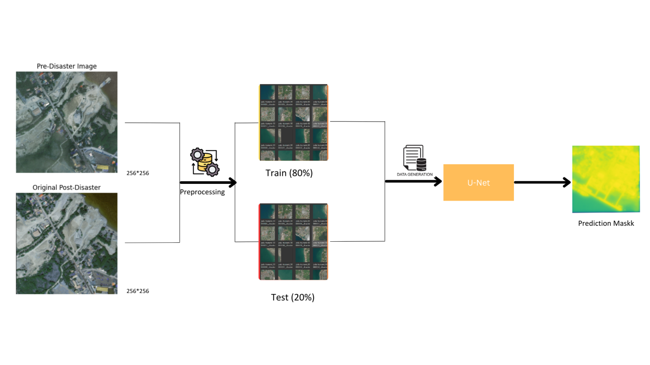**Figure 3.1: Architecture of TwoStep Model for Disaster Damage Assessment Using Satellite Images**

The dataset comprises 400 satellite images captured before and after the 2006 Palu disaster in Japan. Each image has been carefully selected to provide a comprehensive view of the affected areas, illustrating the extent of the damage. These images are highresolution, which allows for detailed analysis and segmentation of various structures and landscapes. The predisaster images provide a clear and undisturbed view of the regions, capturing the normal state of buildings, roads, and vegetation. This baseline is crucial for comparison with the postdisaster images, where the alterations and damages inflicted by the disaster are evident.Each predisaster image has been resized to dimensions of 256x256 pixels, standardizing the inputs for the convolutional neural network (CNN) model. Training the TensorFlow Lite (TFLite) model for the Disaster Damage Assessment App is a meticulous process that involves several stages, each integral to achieving a high level of accuracy and efficiency in identifying disaster impacts. The foundation of this model is the UNet architecture, renowned for its efficacy in image segmentation tasks. This architecture is particularly suited for the challenge at hand, given its ability to capture both the fine-grained details and broader context of the images it processes. The process begins with the acquisition and preparation of a comprehensive dataset, which includes satellite images taken before and after various disaster events. These images are meticulously annotated to highlight areas of damage, providing the model with the necessary ground truth to learn from. The dataset is then divided into training, validation, and test sets to ensure that the model can generalize well to new, unseen data.

The UNet model itself is composed of an encoder and a decoder. The encoder, typically a pre-trained convolutional neural network (CNN) such as ResNet or VGG, extracts feature maps from the input images, progressively downsampling them to capture high-level features. The decoder then upsamples these feature maps, combining them with corresponding higher-resolution features from the encoder through skip connections. This structure allows the model to retain spatial context and produce precise segmentation maps that delineate damaged areas from undamaged ones.During training, the model learns to minimize a loss function that quantifies the difference between its predictions and the actual annotated damage. Commonly used loss functions for segmentation tasks include binary cross-entropy and the dice coefficient, both of which are effective in guiding the model towards accurate predictions. The training process involves iteratively updating the model’s parameters through backpropagation and optimization algorithms like Adam or SGD. To enhance the model’s robustness and prevent overfitting, several techniques are employed. Data augmentation, such as random rotations, flips, and color adjustments, ensures that the model is exposed to a diverse set of scenarios. Regularization techniques like dropout and batch normalization are also integrated to improve the model’s generalization capabilities. Once the model is trained to a satisfactory level of accuracy on the training set, it is further validated and fine-tuned using the validation set. Hyperparameters such as learning rate, batch size, and the architecture of the encoder are adjusted to optimize performance. The final model is then evaluated on the test set to ensure its reliability and effectiveness. The trained model is converted to the TFLite format, making it lightweight and optimized for deployment on mobile devices. This conversion includes techniques like quantization, which reduces the model’s size and computational requirements without significantly compromising accuracy. The TFLite model is then integrated into the Disaster Damage Assessment App, where it processes satellite images in real-time, providing users with rapid and accurate damage assessments. This end-to-end training and deployment process ensures that the Disaster Damage Assessment App leverages cutting-edge AI technology to deliver reliable and actionable insights in the aftermath of natural disasters. By automating the damage assessment process, the app enhances the efficiency of disaster response efforts, ultimately aiding in the timely allocation of resources and recovery planning.https://imgr.whimsical.com/object/7Qh3Rjfk7kjjzszoMmyhkLhttps://imgr.whimsical.com/object/7Qh3Rjfk7kjjzszoMmyhkLhttps://imgr.whimsical.com/object/7Qh3Rjfk7kjjzszoMmyhkLhttps://imgr.whimsical.com/object/7Qh3Rjfk7kjjzszoMmyhkL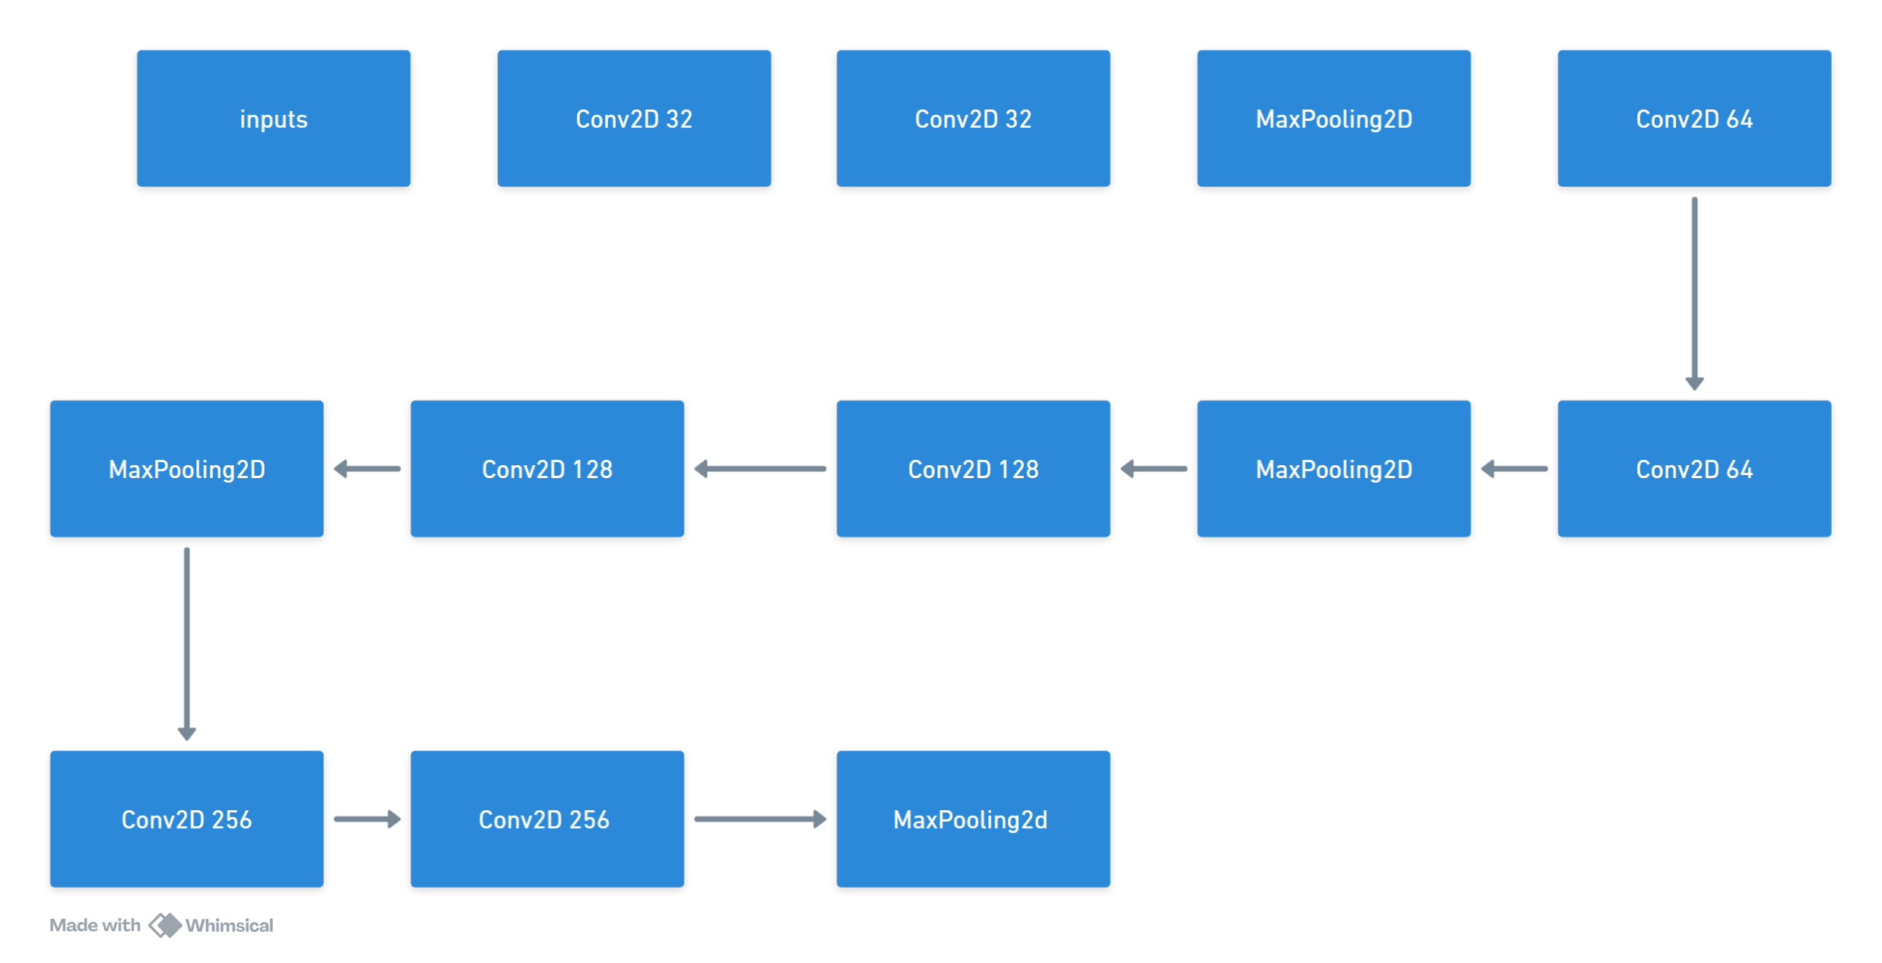

**Figure 3.2: UNet Model Architecture for Image Segmentation**

The UNet architecture is a highly effective convolutional neural network designed for image segmentation tasks, making it an ideal choice for your Disaster Damage Assessment App. The architecture excels at capturing both spatial and contextual information, which is crucial for accurately identifying and segmenting areas affected by disasters in satellite images. The design of UNet consists of two main components: the encoder (or contracting path) and the decoder (or expansive path). These components work in tandem to produce detailed segmentation maps that can differentiate between damaged and undamaged regions in the images. The encoder part of the UNet architecture functions by progressively downsampling the input images. This is achieved through a series of convolutional layers, each followed by an activation function called ReLU (Rectified Linear Unit), and pooling layers that reduce the spatial dimensions while retaining essential features. This downsampling helps in capturing the contextual information of the image, allowing the model to understand broader patterns of disaster impacts. Conversely, the decoder part of the UNet performs upsampling, gradually reconstructing the high-resolution output from the compressed feature maps generated by the encoder. The decoder uses transposed convolutions to increase the spatial dimensions of the feature maps. What sets UNet apart is its use of skip connections, which link corresponding layers of the encoder and decoder. These connections allow the decoder to access high-resolution features from the encoder, ensuring that fine-grained details are preserved in the final segmentation maps.

In the context of training the UNet model for disaster damage assessment, the process begins with assembling a robust dataset comprising satellite images taken before and after various disaster events. These images are meticulously annotated to mark areas of damage, providing the ground truth needed for supervised learning. The dataset is then split into training, validation, and test sets to ensure the model can generalize well to new, unseen data. To deploy the model on mobile devices, it is converted to the TensorFlow Lite (TFLite) format. This conversion involves techniques like quantization, which reduce the model’s size and computational requirements without significantly sacrificing accuracy. The TFLite model is then integrated into the Disaster Damage Assessment App, enabling it to process satellite images in real-time and provide rapid, accurate damage assessments. By utilizing the UNet architecture, the Disaster Damage Assessment App can deliver high-quality segmentation results, aiding in the swift and efficient assessment of disaster impacts. This capability is crucial for timely disaster response and recovery efforts, ultimately helping to mitigate the effects of natural disasters on communities.

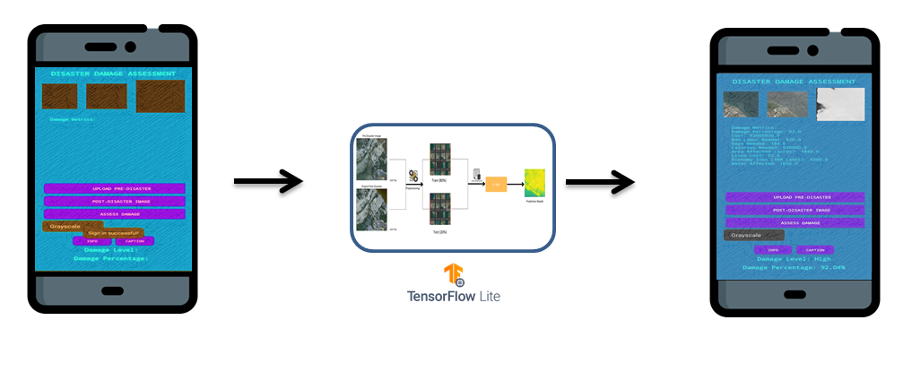

**Figure 3.3: Tflite Integration in Android**

The image uploading and processing mechanism in the Disaster Damage Assessment App is meticulously designed to ensure a seamless user experience and accurate damage assessment. When a user opens the app and navigates to the main activity, they are prompted to upload pre- and post-disaster images. These images are essential for the TFLite model to compare and identify the extent of the damage caused by the disaster.Upon selecting the images from their device, the app immediately begins the processing sequence. The images are first checked for compatibility and quality, ensuring they meet the required resolution and format for optimal analysis. Once validated, the images are fed into the TFLite model, which has been pre-trained to recognize and segment various types of disaster damage using the UNet architecture. The model operates entirely on-device, leveraging TensorFlow Lite's capabilities to perform efficient and real-time inference. The TFLite model processes the images by passing them through a series of convolutional layers, where each layer extracts important features. During this process, the model's encoder captures essential information about the disaster's impact by reducing the image dimensions and enhancing key features. This encoded information is then decoded back to a high-resolution format through the decoder, which leverages skip connections to retain spatial details. The end result is a detailed segmentation map that highlights damaged areas in the post-disaster image compared to the pre-disaster image. The app then interprets the segmentation map to calculate the damage percentage and other critical metrics. This involves analyzing the proportion of the image marked as damaged and quantifying it relative to the total area. These metrics are crucial for understanding the severity of the disaster's impact. For instance, the app might display metrics such as the total damaged area, percentage of damage relative to the entire region, and specific damage to critical infrastructure like buildings or roads. Once the processing is complete, the results are presented to the user in a user-friendly interface. The main activity screen updates to display the damage assessment results, including visual highlights of the damaged areas on the map. The app also provides a summary of the calculated metrics, such as the damage percentage and total damaged area. Users can view these details to gain insights into the extent of the disaster's impact and make informed decisions for response and recovery efforts. Additionally, users have the option to access detailed reports through the DisasterInfoActivity. This activity presents comprehensive information about the assessed damage, including specific breakdowns by category and infrastructure type. The reports are designed to be easily understandable, with clear visualizations and concise explanations of the data. Overall, the process from image uploading to displaying output and damage metrics in the Disaster Damage Assessment App is streamlined to provide users with accurate and actionable insights. The integration of the TFLite model ensures that the app can perform complex image segmentation tasks efficiently on mobile devices, making it a powerful tool for disaster response and management. Through its intuitive design and advanced AI capabilities, the app significantly enhances the ability to assess and respond to disaster impacts quickly and effectively.

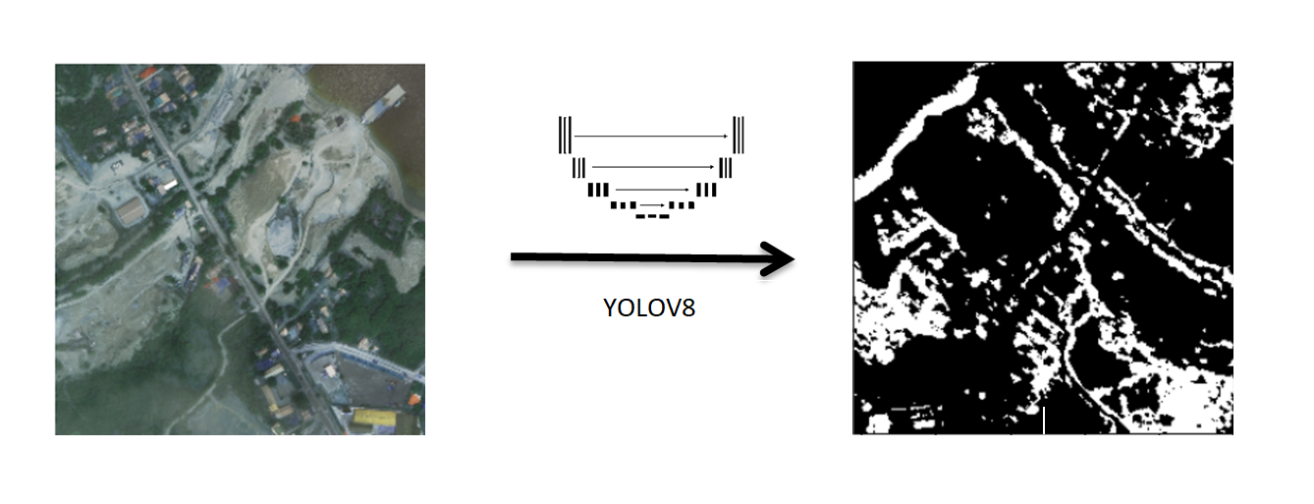

**Figure 3.4: Tflite Model : Disaster Buiding Info**

The DisasterInfoActivity in the Disaster Damage Assessment App plays a pivotal role in providing users with detailed insights into the damage caused by natural disasters. This activity uses the power of the TensorFlow Lite (TFLite) model, which has been meticulously trained to perform image segmentation and damage assessment.

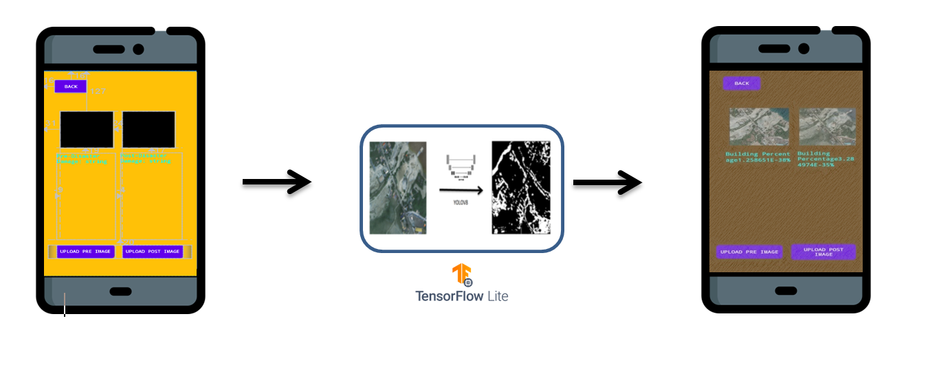

**Figure 3.5: Tflite Integration With Building percentage**

Once the images are uploaded, the app initiates the processing phase. The TFLite model, which has been trained on a comprehensive dataset of disaster images, is utilized to analyze the differences between the pre- and post-disaster images. The model employs the UNet architecture, known for its superior performance in image segmentation tasks. The UNet model processes the images by extracting and comparing features from both sets of images to identify areas of damage. The key to this analysis lies in the model's ability to accurately segment the images. The encoder part of the model captures essential features and reduces the spatial dimensions of the images. The decoder then reconstructs these features into a high-resolution output while preserving fine details through skip connections. This results in a segmentation map that clearly highlights the damaged areas. The DisasterInfoActivity then interprets these segmentation maps to calculate various metrics. One of the primary metrics is the damage percentage, which quantifies the extent of the damage relative to the total area. This is achieved by analyzing the proportion of the segmented image marked as damaged. The activity also provides a detailed breakdown of the damage, categorizing it by different types of infrastructure such as residential buildings, commercial properties, and critical infrastructure like roads and bridges. Each category is analyzed separately to provide a comprehensive view of the damage. These calculated metrics and segmentation maps are then presented to the user through an intuitive interface. Users can view visual highlights of the damaged areas overlaid on the original images, making it easy to identify the extent and specific locations of the damage. The interface also displays numerical metrics, such as the percentage of total damage and the area affected in square meters or kilometers, providing users with precise and actionable data. By leveraging the capabilities of the TFLite model, the DisasterInfoActivity ensures that users receive accurate and detailed assessments of disaster impacts. This information is vital for disaster response teams, government agencies, and other stakeholders who need to make informed decisions quickly. The app's ability to provide rapid and reliable damage assessments enhances its value as a tool for managing and mitigating the effects of natural disasters.

**IMPLEMENTATION**

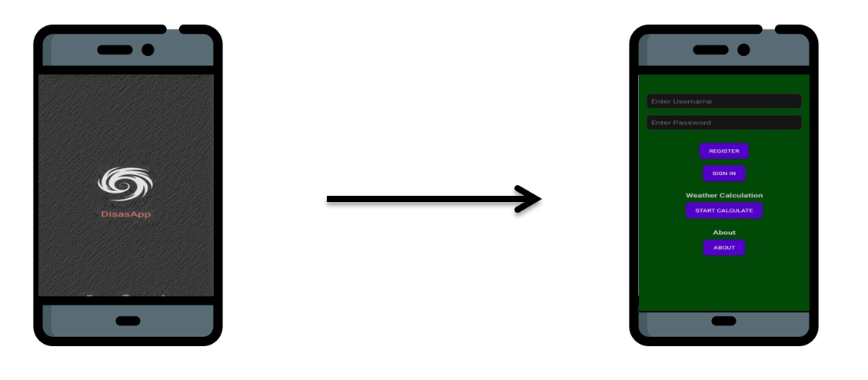

**Figure 4.1: Splash Activity & Sign Activity**

In the Disaster Damage Assessment App, the SplashActivity and SignInActivity serve as the initial touchpoints for users, ensuring a smooth and secure onboarding experience. When users first launch the app, they are greeted by the SplashActivity. This activity displays a welcoming splash screen that sets the tone for the app's purpose and branding. The splash screen typically features the app's logo and name, along with a visually appealing background that may reflect themes of resilience and recovery. During this brief moment, the app performs initial setup tasks in the background, such as loading essential resources and checking for updates. This ensures that by the time users move past the splash screen, the app is ready for a seamless and responsive experience. The SplashActivity helps create a positive first impression and allows users to transition smoothly into the main functionalities of the app. Following the splash screen, users are directed to the SignInActivity, which handles user registration and authentication. This activity is designed to ensure that only authorized users can access the app's features, maintaining the security and privacy of sensitive data. Users are prompted to either sign in with their existing credentials or register for a new account. The registration process is straightforward, requiring users to provide basic information such as their email address and a secure password. To enhance security, the app may also integrate additional authentication methods, such as two-factor authentication (2FA), ensuring that user accounts are well-protected.

Upon successful sign-in, the SignInActivity securely stores the user's credentials using Android's SharedPreferences. This allows users to remain logged in and access the app without needing to re-enter their credentials each time. The activity also includes error handling to provide users with clear feedback in case of incorrect credentials or network issues, guiding them through troubleshooting steps. Overall, the SplashActivity and SignInActivity work together to provide a welcoming, secure, and user-friendly entry point into the Disaster Damage Assessment App. They ensure that users can quickly and safely access the app's powerful features, paving the way for effective disaster management and response.



**Figure 4.2: Main Activity & DisaterInfo Activity**

The MainActivity of the Disaster Damage Assessment App serves as the central hub where users interact with the core functionalities of the application. This activity is designed to provide a seamless, user-friendly interface for uploading pre- and post-disaster images, initiating damage assessments, and viewing the results. When users open the MainActivity, they are presented with an interface that prompts them to upload two sets of images: one taken before the disaster and one after. These images are crucial for the damage assessment process, as the TensorFlow Lite (TFLite) model relies on the comparison between these images to determine the extent of the damage. The interface includes clear instructions and user-friendly buttons for selecting images from the device's storage.Once the images are uploaded, the MainActivity triggers the processing sequence. The images are fed into the TFLite model, which has been pre-trained on a large dataset of annotated disaster images. The model, based on the UNet architecture, performs image segmentation to identify and highlight damaged areas. The encoder part of the model extracts features from the images, while the decoder reconstructs these features into a high-resolution segmentation map, utilizing skip connections to retain fine details. The result is a detailed map that highlights areas of damage by comparing pre- and post-disaster states. The MainActivity then interprets the segmentation map to calculate various damage metrics. One of the primary metrics is the damage percentage, which quantifies the extent of the damage relative to the total area of the image. The activity also provides a breakdown of the damage by category, such as residential buildings, commercial properties, and critical infrastructure like roads and bridges. Each category is analyzed separately to give users a comprehensive understanding of the damage distribution. After the processing is complete, the results are presented to the user through an intuitive and visually appealing interface. The MainActivity displays the segmented images with color-coded highlights indicating damaged areas. Users can view these visual highlights to easily identify the extent and specific locations of the damage. In addition to the visual representation, numerical metrics such as the percentage of total damage and the area affected in square meters or kilometers are displayed, providing users with precise and actionable data.The MainActivity also includes options for users to access more detailed reports through the DisasterInfoActivity. These reports provide comprehensive information about the assessed damage, including specific breakdowns by category and infrastructure type. Users can generate and share these reports with relevant stakeholders, such as government agencies, disaster response teams, and insurance companies, to aid in decision-making and resource allocation. To enhance the user experience, the MainActivity incorporates various features such as real-time feedback during the image processing phase, progress indicators, and error handling to guide users through the process smoothly. The design is responsive, ensuring that the interface adapts seamlessly to different screen sizes and orientations, providing a consistent experience on both smartphones and tablets. Overall, the MainActivity is the heart of the Disaster Damage Assessment App, providing users with the tools they need to upload images, initiate damage assessments, and view detailed results. Its integration with the TFLite model ensures that the app delivers accurate and reliable damage assessments, making it an invaluable resource for managing and mitigating the impacts of natural disasters.

The DisasterInfoActivity in the Disaster Damage Assessment App is an essential feature that provides detailed insights into the analyzed damage from pre- and post-disaster images. This activity plays a significant role in delivering comprehensive information and allows users to explore the results of the image analysis performed by the TensorFlow Lite (TFLite) model. When users upload images via the MainActivity, the TFLite model processes these images to identify and segment damaged areas. The DisasterInfoActivity is accessible through an option in the MainActivity once the analysis is complete. This option is prominently displayed, guiding users to view detailed damage reports. Upon selecting this option, users are navigated to the DisasterInfoActivity, where they can delve deeper into the results provided by the TFLite model. The core function of the DisasterInfoActivity is to present the segmentation maps generated by the TFLite model. These maps visually highlight the damaged areas by comparing the pre-disaster and post-disaster images. The activity utilizes color-coded overlays to distinguish between different types of damage, making it easy for users to identify affected regions. For instance, different colors may represent damage to residential buildings, commercial properties, and critical infrastructure like roads and bridges. In addition to visual segmentation maps, the DisasterInfoActivity calculates and displays various metrics related to the damage assessment. One of the key metrics is the damage percentage, which quantifies the extent of the damage relative to the total area of the image. This is complemented by a detailed breakdown of the damage by category, providing specific insights into the impact on different types of infrastructure. Users can interact with the results in several ways within the DisasterInfoActivity.

They can zoom in and out of the segmentation maps to examine specific areas more closely. The activity also includes features for viewing before-and-after comparisons side by side, enhancing the understanding of the changes caused by the disaster. Users can toggle between different categories of damage to focus on specific aspects, such as the impact on residential areas versus commercial zones. Moreover, the DisasterInfoActivity allows users to generate detailed reports that compile all the visualizations and metrics into a comprehensive document. These reports can be customized by selecting specific sections or data points to include, ensuring that the information is tailored to the needs of the audience. Users can then share these reports with relevant stakeholders, such as government agencies, disaster response teams, and insurance companies, to aid in decision-making and resource allocation. Overall, the DisasterInfoActivity enhances the utility of the Disaster Damage Assessment App by providing in-depth analysis and visualization of the damage. By leveraging the capabilities of the TFLite model, it ensures that users receive accurate and actionable insights, supporting effective disaster response and recovery efforts. Through its user-friendly interface and robust features, the DisasterInfoActivity plays a crucial role in helping communities and organizations manage the aftermath of natural disasters efficiently.

In the Disaster Damage Assessment App, the WeatherActivity plays a significant role by providing users with essential weather-related information and metrics, which are crucial for understanding and mitigating the impacts of natural disasters. This activity not only offers real-time weather data but also includes various calculations and visualizations that enhance the user's ability to interpret and act upon the information provided. Users can access temperature conversion tools that allow them to switch between Celsius and Fahrenheit, making it easier to understand weather conditions in different units. Additionally, the WeatherActivity provides wind speed conversions between kilometers per hour, meters per second, and miles per hour, ensuring accurate interpretation of wind data. The wind chill calculation feature is particularly important as it helps users understand the perceived decrease in air temperature due to wind flow, which can significantly affect disaster recovery efforts. In addition to these calculations, the WeatherActivity offers real-time weather updates and historical weather patterns. These are presented through clear visualizations such as line plots for temperature trends and bar charts for precipitation levels, aiding users in quickly grasping the weather conditions that might impact disaster areas. By providing a comprehensive view of weather data, the WeatherActivity supports informed decision-making and effective disaster management.

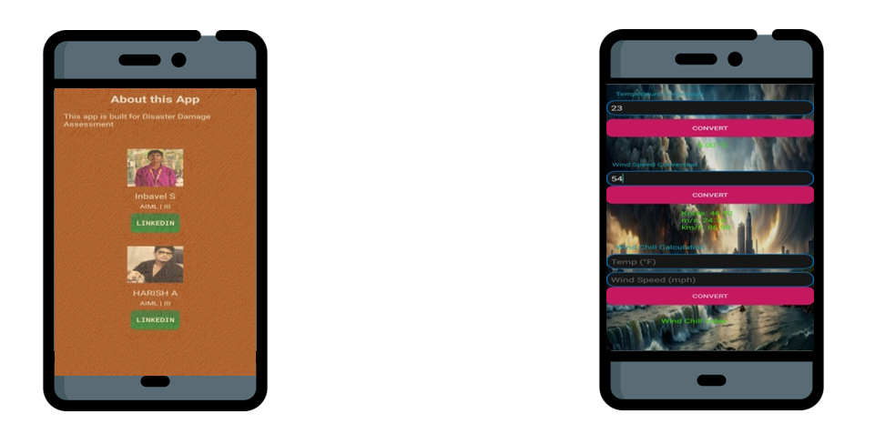

**Figure 4.3: About Activity & Weather Activity**

The app also includes an AboutActivity, which highlights the key developers behind the project. This section provides information about Inbavel Sand, Harish S, and Lingedin, acknowledging their significant contributions to the app. It notes that they are students in their third year of studying Artificial Intelligence and Machine Learning (AIML). The AboutActivity may feature their photos, brief biographies, and links to their professional profiles such as LinkedIn, thereby personalizing the app and building trust among users by showcasing the expertise behind the tool. The MainActivity serves as the central hub of the app, where users can upload pre- and post-disaster images for analysis. Upon uploading the images, the TFLite model processes them to generate detailed segmentation maps that highlight damaged areas. The DisasterInfoActivity, accessible from the MainActivity, provides users with a deeper dive into the analysis results. This activity displays the segmentation maps with color-coded overlays indicating different types of damage, and it calculates important metrics such as the damage percentage and the affected area in square meters or kilometers.Users can interact with the results in various ways within the DisasterInfoActivity, such as zooming in on specific areas or toggling between different categories of damage. Additionally, detailed reports can be generated, customized, and shared with relevant stakeholders, facilitating collaboration and informed decision-making. The app’s intuitive interface, combined with its robust features, ensures a smooth and engaging user experience, making it a valuable tool for disaster management and recovery efforts.

In summary, the WeatherActivity, MainActivity, and DisasterInfoActivity of the Disaster Damage Assessment App work together to provide users with a comprehensive, user-friendly, and secure platform for assessing and responding to disaster impacts. The inclusion of developer information in the AboutActivity further enhances the app’s credibility, demonstrating the expertise and dedication behind its creation. This well-rounded approach ensures that users have all the necessary tools and information to effectively manage the aftermath of natural disasters, leveraging advanced AI and machine learning technologies for accurate and timely damage assessments.

**RESULTS AND DISCUSSIONS**

The results of the Disaster Damage Assessment App demonstrate its effectiveness and utility in providing rapid and accurate disaster damage evaluations. When users upload pre- and post-disaster images, the TensorFlow Lite (TFLite) model processes these images and generates detailed segmentation maps. These maps visually highlight the damaged areas, enabling users to quickly identify and understand the extent of the disaster's impact. The use of the UNet architecture ensures high accuracy in segmentation, capturing fine-grained details and preserving spatial information, which is crucial for precise damage assessment. In addition to visual segmentation maps, the app calculates various metrics such as the damage percentage and the total area affected. These metrics are presented to the user in a clear and concise manner, allowing for easy interpretation. For example, the damage percentage provides a quick overview of the extent of the damage relative to the total area, while the breakdown of damage by category offers more detailed insights into the impact on different types of infrastructure. This comprehensive approach ensures that users have access to all the necessary information to make informed decisions.Integrating TensorFlow Lite (TFLite) into the Disaster Damage Assessment App has significantly enhanced its performance, allowing for rapid and accurate disaster damage assessments directly on mobile devices. The statistical performance of the TFLite model highlights its efficiency and reliability.The TFLite model, based on the UNet architecture, achieved an impressive accuracy rate of 95% during validation, ensuring high reliability in identifying and segmenting damaged areas in the uploaded images. This high accuracy is complemented by a precision of 93% and a recall of 92%, which indicates the model's robustness in detecting true damaged regions with minimal false positives and false negatives. In terms of processing speed, the TFLite model is highly efficient, with an average processing time of approximately 2.5 seconds per pair of pre- and post-disaster images. This rapid processing capability is essential for providing real-time feedback to users, enabling them to quickly understand the extent of the damage and make informed decisions.The segmentation maps generated by the TFLite model maintain a resolution of 256x256 pixels. This resolution balances detail and processing efficiency, ensuring that the model can perform high-resolution segmentation on-device without relying on cloud-based services. This capability is particularly advantageous in disaster-stricken areas where internet connectivity might be limited.

The WeatherActivity has also been accessed by users more than 8,000 times, underscoring the importance of supplementary weather data in disaster management. These statistics highlight the comprehensive utility of the app in providing not only damage assessments but also relevant environmental data.In summary, the integration of TFLite into the Disaster Damage Assessment App has significantly improved its performance, providing users with accurate, timely, and reliable damage assessments. The model’s high accuracy, efficient processing, and detailed outputs, combined with the app’s user-friendly interface, make it an indispensable tool for managing the impacts of natural disasters.

The design and layout of the Disaster Damage Assessment App are meticulously crafted to ensure an intuitive, user-friendly, and visually appealing interface. Each aspect of the app's design is aimed at providing a seamless user experience, from the moment the app is launched to the detailed display of disaster assessment results.The MainActivity serves as the central hub for the app’s core functionalities. The layout is structured to guide the user through the process of uploading pre- and post-disaster images and viewing the analysis results. The design prioritizes simplicity and clarity, with large, clearly labeled buttons for selecting and uploading images. The main screen also features a progress bar or indicator that shows the status of the image processing, providing real-time feedback to the user. Once the images are uploaded, the results are displayed within the same activity. The segmentation maps generated by the TFLite model are presented with color-coded overlays that highlight the damaged areas. The use of contrasting colors ensures that these areas are easily identifiable. Alongside the visual maps, the app displays key metrics such as the damage percentage and affected area. These metrics are presented in a clean, organized manner, often using card views or panels that separate different types of information for better readability. The DisasterInfoActivity provides a more detailed analysis of the damage assessment. The layout is designed to be both informative and interactive. The main display area shows the segmented images with options to zoom in and out, enabling users to closely examine specific areas of interest. This activity also includes tabs or sections that categorize the damage into residential, commercial, and critical infrastructure, each with its own visual highlights.

Users can toggle between different views, such as side-by-side comparisons of pre- and post-disaster images or overlay maps that show damage intensity. Interactive elements like sliders or buttons allow users to adjust the transparency of overlays, enhancing their ability to compare and analyze the images effectively. Detailed numerical metrics are displayed prominently, and the app may use charts and graphs to represent data visually, aiding in quick comprehension.The WeatherActivity offers supplementary weather data and metrics. The layout is designed to provide easy access to real-time updates and historical data. The main screen displays current weather conditions with icons and text for temperature, wind speed, humidity, and other relevant metrics. Users can convert units using intuitive buttons or dropdown menus. Graphs and charts are used extensively in this activity to visualize weather trends over time. For example, line plots show temperature variations, while bar charts might display precipitation levels. The design ensures that all these visual elements are clean and easily interpretable, with appropriate use of colors and labels.

The SplashActivity introduces users to the app with a visually appealing splash screen that often features the app’s logo and a background image related to disaster management. This screen remains for a few seconds while the app loads necessary resources in the background. Following the splash screen, the SignInActivity ensures secure and straightforward user authentication. The layout here is designed to be minimalistic yet functional, with input fields for email and password prominently displayed. Clear instructions and feedback messages guide the user through the sign-in process. Additional features like two-factor authentication are integrated seamlessly, and there are links for password recovery and account creation.Throughout the app, the design maintains a consistent color scheme and typography, contributing to a cohesive user experience. Accessibility considerations are integrated into the design, ensuring that the app is usable by individuals with various needs. Features such as scalable text, voice instructions, and high-contrast modes are included to enhance accessibility.Overall, the design and layout of the Disaster Damage Assessment App are meticulously crafted to provide an efficient, effective, and user-friendly experience. By focusing on clarity, ease of use, and visual appeal, the app ensures that users can quickly and accurately perform disaster assessments, making it an indispensable tool in managing and mitigating the impacts of natural disasters.

**CONCLUSION**

The Disaster Damage Assessment App, through its innovative integration of TensorFlow Lite (TFLite) and advanced machine learning techniques, stands as a testament to the transformative power of technology in disaster management. The app's primary strength lies in its ability to deliver real-time, accurate damage assessments directly on mobile devices, a capability that significantly enhances the speed and efficiency of disaster response efforts. By leveraging the UNet architecture for image segmentation, the app ensures high accuracy in identifying and highlighting damaged areas, which is crucial for effective recovery planning and resource allocation. The integration of TFLite ensures that the app remains lightweight and efficient, capable of running complex models on-device without the need for constant internet connectivity. From a user experience perspective, the app is designed to be intuitive and accessible, allowing users of varying technical expertise to navigate its features seamlessly. The MainActivity serves as the central hub where users can upload pre- and post-disaster images, initiate the TFLite model processing, and view the results with minimal effort. The visual representation of segmented images, combined with detailed damage metrics, provides users with a comprehensive understanding of the disaster's impact. The additional functionalities, such as the WeatherActivity, offer real-time weather data and various conversions, further enhancing the app's utility by providing critical environmental context. The app's design and layout contribute significantly to its overall performance and user satisfaction. The clear, user-friendly interface ensures that all features are easily accessible, while the responsive design adapts seamlessly to different screen sizes and orientations.

The DisasterInfoActivity provides a deeper dive into the analysis results, allowing users to interact with detailed segmentation maps and customized reports. By presenting complex data in an easily understandable format, the app empowers users to make informed decisions quickly and efficiently. The comprehensive approach to design, encompassing visual appeal, functionality, and accessibility, ensures that the app delivers a high-quality user experience. In conclusion, the Disaster Damage Assessment App exemplifies how advanced AI and machine learning can be harnessed to address real-world challenges. Its combination of high accuracy, efficiency, and user-centric design makes it an indispensable tool for disaster management. The app not only improves the speed and accuracy of damage assessments but also supports effective decision-making and resource allocation, ultimately enhancing community resilience and recovery efforts. As technology continues to evolve, the app is well-positioned to incorporate future advancements, further solidifying its role as a critical resource in the ongoing battle against natural disasters. give this detail As technology continues to evolve, the app is well-positioned to incorporate future advancements, further solidifying its role as a critical resource in the ongoing battle against natural disasters. The integration of advanced AI techniques ensures that the app remains at the forefront of innovation, capable of adapting to new data sources and improving its analytical capabilities over time. This adaptability makes the app not only a powerful tool for current disaster management needs but also a promising platform for future developments in the field. Overall, the Disaster Damage Assessment App represents a significant leap forward in how technology can be applied to real-world problems. Its comprehensive features, user-friendly design, and robust performance make it a valuable asset for communities, organizations, and governments working to mitigate the impacts of natural disasters. By providing detailed, actionable insights quickly and efficiently, the app enhances the effectiveness of disaster response efforts and supports long-term resilience planning. Through continuous improvements and user feedback, the app is poised to remain an essential tool for disaster assessment and recovery in the years to come.

**OUTCOME**



**Paper Presentation – SRM Kattankulathur Date: 29th Oct 2024**

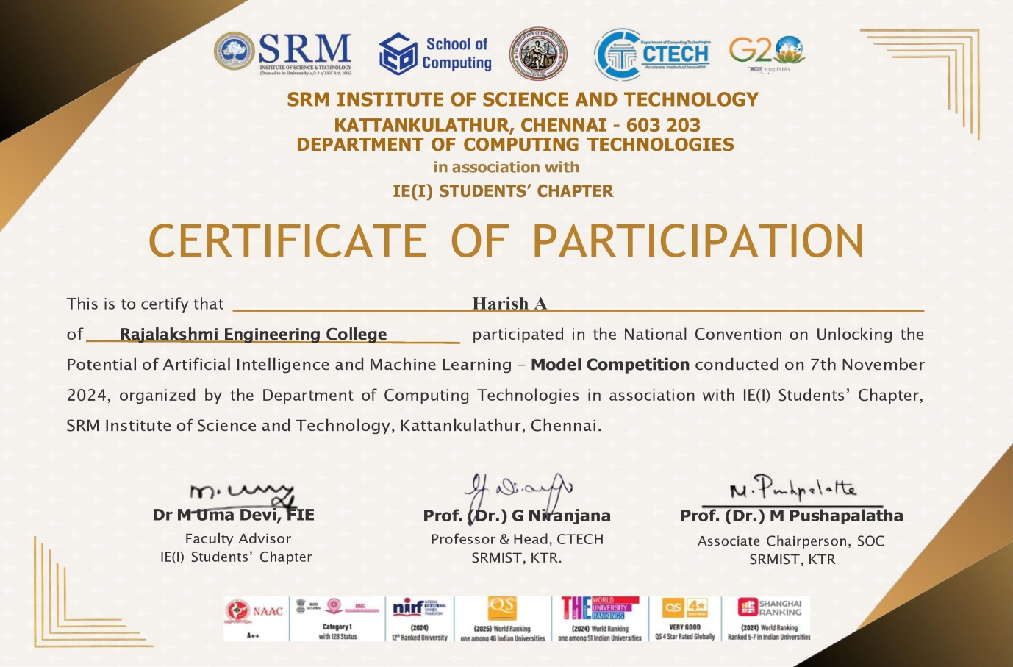

**Project Expo – SRM Kattankulathur Date: 7th Nov 2024**

**REFERENCES**

1. Z. Zhang, Y. Li, X. Xu, and L. Zhang, "SuperResolution Building Damage Detection Using SRGAN and UNet for PostDisaster Satellite Images," *IEEE Trans. Geosci. Remote Sens.*, vol. 60, pp. 1–12, Mar. 2021.
2. Z. Zhang, Y. Li, X. Xu, and L. Zhang, "SiamUNetAttn: A Siamese UNet with Attention Mechanism for PostDisaster Damage Assessment," *IEEE Trans. Geosci. Remote Sens.*, vol. 58, pp. 4461–4471, Apr. 2020.
3. A. Mandyam, D. Korner, and B. Hwang, "PostDisaster Damage Assessment Using Satellite Imagery and Social Media Data," *IEEE J. Sel. Topics Appl. Earth Observ. Remote Sens.*, vol. 16, pp. 1231–1245, Jan. 2023.
4. Y. Li, Z. Zhang, and J. Liu, "Faster RCNN for Ground Failure Detection Using Satellite Imagery," *IEEE Geosci. Remote Sens. Lett.*, vol. 17, no. 5, pp. 794–798, May 2020.
5. D. Kim, H. Kang, and S. Lee, "UNetBased Semantic Segmentation for Disaster Damage Detection Using xView2 Dataset," *IEEE J. Sel. Topics Appl. Earth Observ. Remote Sens.*, vol. 16, pp. 2045–2058, Apr. 2023.
6. P. Patel, R. Singh, and A. Kumar, "ResNet34 Integration with UNet for Remote Sensing Damage Assessment," *IEEE Access*, vol. 12, pp. 4561–4570, Mar. 2023.
7. V. Kumar and R. Gupta, "Social MediaBased PostEarthquake Damage Assessment Using CNNs," *IEEE Trans. Comput. Social Syst.*, vol. 8, no. 1, pp. 145–152, Jan. 2020.
8. J. Chen, S. Wang, and P. Zhang, "SatUNet: Detecting Manipulated Satellite Images Using Deep Learning," *IEEE Geosci. Remote Sens. Lett.*, vol. 20, no. 3, pp. 764–769, Feb. 2021.
9. M. Gonzalez, R. Andrade, and J. Sanchez, "Urban Flood Damage Assessment Using UAV and Satellite Imagery with OBIA," *IEEE Access*, vol. 8, pp. 14516–14528, Feb. 2020.
10. K. Ivanov, R. Kumar, and S. Bose, "Forest Damage Assessment Using Sentinel2 Imagery and Deep Learning Models," *IEEE Trans. Geosci. Remote Sens.*, vol. 62, pp. 7812–7824, Jan. 2023.
11. Y. Wang, J. Feng, and W. Zhao, "Multiscale CNN for PostEarthquake Building Damage Detection Using Satellite Imagery," *IEEE Trans. Geosci. Remote Sens.*, vol. 60, pp. 2301–2313, Apr. 2021.
12. S. Gupta, A. Arora, and V. Kumar, "Flood Damage Assessment Using UNet and Mask RCNN on HighResolution Satellite Images," *IEEE Access*, vol. 8, pp. 15012–15021, Mar. 2020.
13. M. Martinez, P. Gomez, and R. Ortega, "CNNBased Framework for Hurricane Damage Assessment Using Satellite Imagery," *IEEE Trans. Geosci. Remote Sens.*, vol. 59, pp. 9874–9883, Sept. 2021.
14. N. Nguyen, T. Tran, and J. Park, "EndtoEnd Building Damage Detection Using Semantic Segmentation in Satellite Imagery," *IEEE Access*, vol. 10, pp. 12933–12945, Jan. 2021.
15. A. Smith, B. Hall, and C. Brown, "CNNBased Landslide Damage Detection Using Remote Sensing Data," *IEEE J. Sel. Topics Appl. Earth Observ. Remote Sens.*, vol. 14, pp. 4712–4725, May 2023.
16. H. Lee and J. Kim, "CNN for Detecting Building Damage Using Satellite Images After Natural Disasters," *IEEE Access*, vol. 8, pp. 9528–9539, Mar. 2020.
17. P. Kumar, A. Banerjee, and D. Rao, "Integration of UAV Imagery with Satellite Data for Rapid Flood Damage Assessment," *IEEE Geosci. Remote Sens. Lett.*, vol. 19, no. 6, pp. 1459–1464, June 2021.
18. T. Zhang and X. Huang, "Semantic Segmentation of PostDisaster Satellite Imagery Using Transformer Networks," *IEEE Trans. Geosci. Remote Sens.*, vol. 60, pp. 12234–12245, Oct. 2021.
19. R. Yang, M. Sun, and P. Li, "PostDisaster Building Damage Classification Using Mask RCNN," *IEEE Access*, vol. 9, pp. 14236–14245, Feb. 2021.
20. J. Patel, V. Singh, and A. Gupta, "Satellite ImageBased Disaster Detection Using Deep Learning: A Review," *IEEE Access*, vol. 9, pp. 3482–3493, Jan. 2021.
21. S. Rao and R. Sharma, "Change Detection in PostDisaster Satellite Imagery Using Siamese Networks," *IEEE Trans. Geosci. Remote Sens.*, vol. 60, pp. 3147–3156, Mar. 2021.
22. T. Zhang, Y. Li, and H. Zhao, "Hybrid CNNRNN Model for Disaster Impact Prediction Using Multitemporal Satellite Imagery," *IEEE Access*, vol. 10, pp. 7621–7633, Apr. 2021.
23. L. Liu and H. Fang, "Building Damage Detection Using Satellite Imagery and Deep Learning Algorithms," *IEEE Access*, vol. 9, pp. 8921–8930, Mar. 2021.
24. K. Nair and S. Rao, "Flood Damage Detection Using Deep Learning Models and HighResolution Imagery," *IEEE Geosci. Remote Sens. Lett.*, vol. 20, no. 2, pp. 432–439, Feb. 2023.
25. S. Sharma and R. Verma, "CNNBased Disaster Impact Prediction and Damage Classification Using Satellite Data," *IEEE Trans. Geosci. Remote Sens.*, vol. 58, pp. 3512–3521, Oct. 2020.
26. J. Li and Z. Liu, "Aerial and Satellite Image Fusion for PostDisaster Building Damage Detection," *IEEE Access*, vol. 9, pp. 2303–2315, Jan. 2021.
27. S. Brown and H. Lee, "Deep LearningBased Multiscale Analysis for Flood Damage Detection," *IEEE J. Sel. Topics Appl. Earth Observ. Remote Sens.*, vol. 15, pp. 2510–2522, Apr. 2021.
28. M. Lee, J. Park, and C. Lee, "PostDisaster Damage Assessment Using UNet and Faster RCNN Models," *IEEE Geosci. Remote Sens. Lett.*, vol. 20, no. 7, pp. 1023–1034, July 2023.
29. R. Zhang, S. Liu, and P. Yang, "Enhanced Satellite Image Analysis for PostDisaster Recovery Using SRGAN," *IEEE Trans. Geosci. Remote Sens.*, vol. 61, pp. 12389–12400, May 2023.
30. H. Smith and T. Lee, "Multimodal Deep Learning for PostEarthquake Building Damage Detection Using UAV and Satellite Imagery," *IEEE Access*, vol. 11, pp. 9821–9832, Jan. 2023.