Student Data Aggregation Calculator
by


Developer Guide

Version: 1.0

Date: February 21, 2013

Table of Contents

inBloom REST API 9
inBloom REST API Features 9
Example response for customRoles 11
inBloom REST API Example Requests & Responses 12
Example response for applicationAuthorization 14
Example response for applicationAuthorization/{uuid} 15
Example response for customRoles 16
inBloom REST API Example Requests & Responses 16

Overview

Student Data Aggregation Calculator (SDAC) is a flexible and intuitive app that allows teachers to mark, create and store flags with specific conditions as per the preferences of the user, and run these particular conditions across the student database to identify further subsets of the students who meet the set criteria.
These flags can even be saved for future use, thus creating an easy-to-use tool that can quickly identify students who, for example, have turned in specific homework assignments, achieved academic honors or got a specific grade on an exam or assignment.

The inBloom through its shared technology infrastructure has initialized open doors for district school staff, who have typically only interacted with software systems as a means for data entry, creating and viewing static reports and generating spreadsheets, that are often outdated as well as incomplete, not to be mentioned the complicacy of the structure and searching process of the data. Given the vastness and depth of the data the inBloom Data Store encompasses, access to real- time, accurate and relevant student data is now within touching distance, and success of the project will ensure a faster and more efficient student assessment system.

With a simple, user friendly, yet highly effective user interface in place along with the features and functions that have been provided with an extensive focus on the usability and the technology stack can be termed as highly reliable and scalable. SDAC is sure to make an instant impact on the way that data-driven decisions have been affecting the student achievements through the years, and it can be stated with absolute and utmost confidence that there are multiple stakeholders who will be benefitting from the introduction of SDAC on field.

System Requirements

Client Requirements
- Supported client browsers include: IE 8+, Firefox 4+, Safari 4+, Chrome 12+
- Also supports iPad

Server Requirements
- Windows Server 2008 R2 64bit
- Microsoft .NET Framework 4.0 SP2 or higher
- Microsoft Internet Information Services (IIS) 7.0+ or Visual Studio 2010/2012 built-in web server.
- Microsoft SQL Server 2008 R2, 2012 (supports free SQL Server Express Edition)

Internet Information Services (IIS)

Create a New site in IIS 7
The following section explains how to create a new website on your Windows server in IIS 7. There are two types of websites that can be configured, IP based sites and Name based sites.

Step 1: Log into your server through Remote Desktop Connection
Step 2: From Visual Studio, publish your Web application.
Step 3: Copy the published application folder to "C:\intepub\wwwroot" [default] folder.
Step 4: From Run - > inetmgr -> OK or Use Start-> Internet Information Services (Manager)

The following screen will display and is the main page for any application, where you can add your new website or configure your website in IIS.
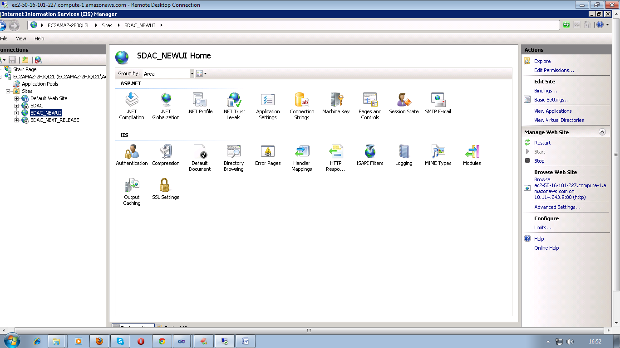

Step 5: To add new website Right click on Sites Choose Add Website option

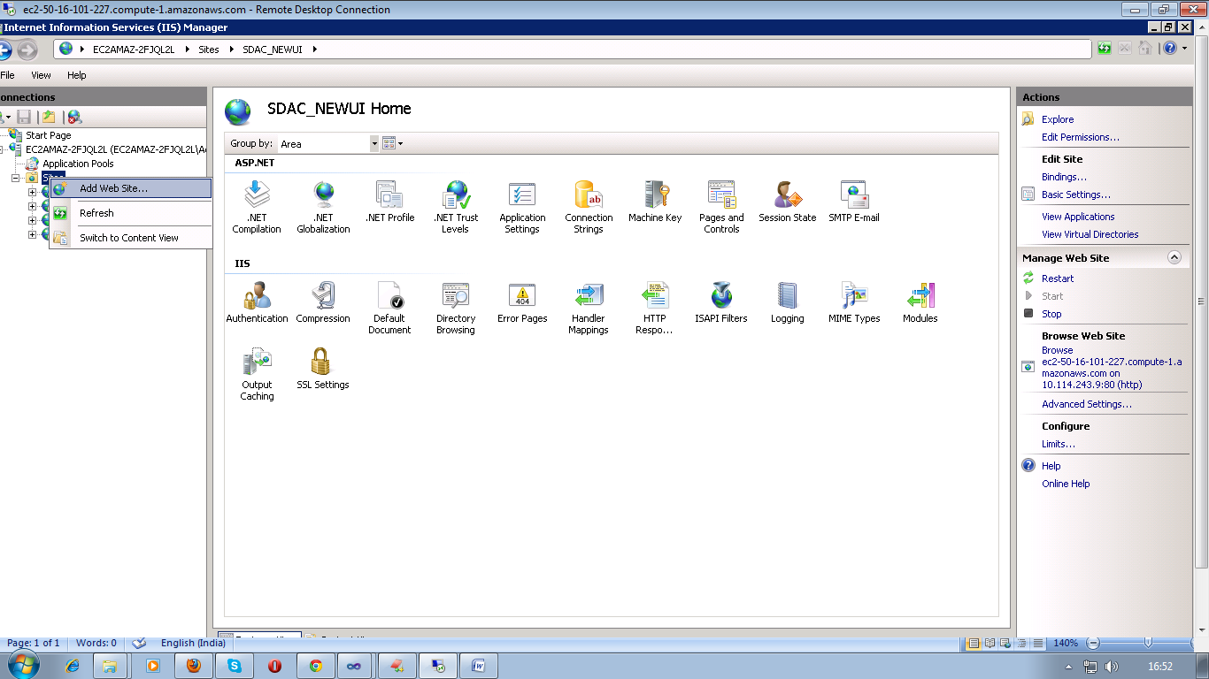

Step 6: Type in the Site Name. A description or the domain name is best to put into this field. This will automatically create an Application Pool for the site.

Step 7: Enter or browse to the path where the website will have its root directory. This is the directory where the home page should go.

Step 8: For the Binding, choose HTTP, choose an IP address that is free, leave the port as port 80, and enter in your domain name (i.e. www.domain.com) as the Host Name. Leave the checkbox for Start Web site immediately checked and click OK.

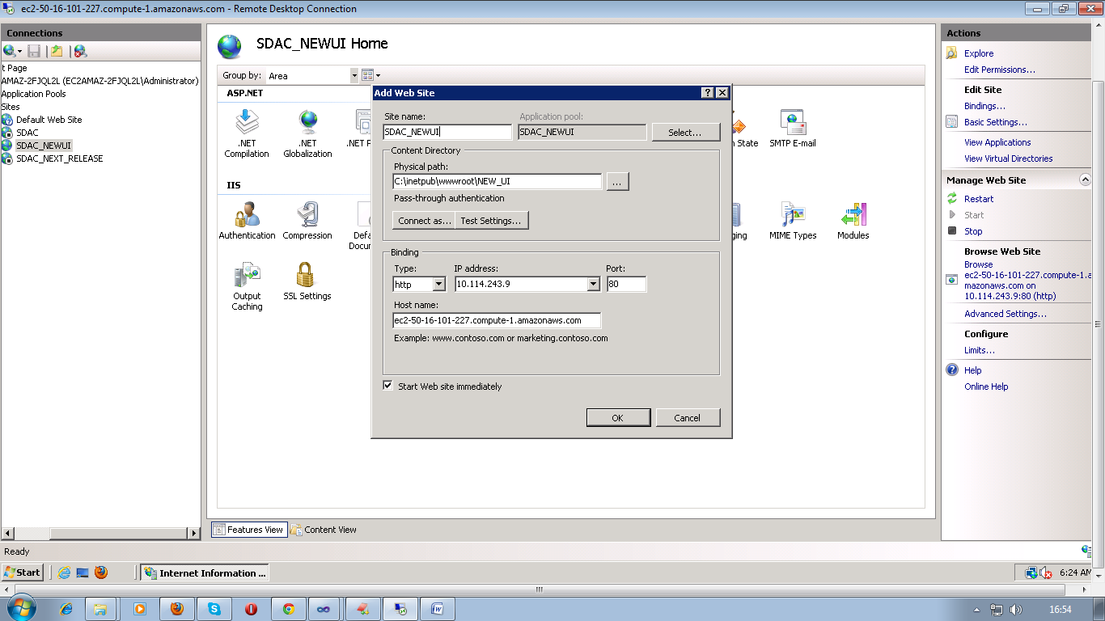

Step 9: Go back to the IIS7 main screen and select the site under the Sites folder. Click Bindings… on the right sidebar so there is a host header for domain.com as well.

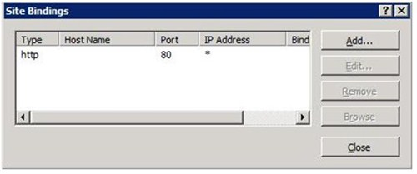

Step 10: Click the Add button, choose HTTP, use the same IP address as setup in step 7, leave the port as port 80, and enter in your domain name (i.e.domain.com) as the Host Name. Click OK

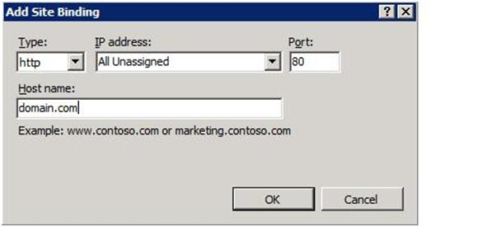

An IP-based website has a unique IP address therefore no other website can use this IP address. If you need multiple IP-based websites, you will need to contact us to add the IP addresses to your server.
A name-based website shares a single IP address with each website on the server. You are able to make as many name-based sites as you wish with your single IP address.

API Reference

Overview of API

The Application Programming Interface contains the building blocks that are necessary to create inBloom applications. Application access to the inBloom Data Store is strictly governed by this API.

Objective
The overall objective of the API is to provide a stable, well-defined interface for software developers to build applications that use the inBloom Data Store and adapt existing applications to leverage the inBloom Data Store. The API is a real-time transactional interface intended for interactive applications. It is not intended to provide bulk data load or file extract and download services.

Integration Approach
Application integration approach depends on the scope of the application integration effort being proposed.

How to Use this Reference

The inBloom REST API is the interface that enables you to interact with the inBloom Data Store and services. This reference lists the API resources that developers need when forming the URIs in their REST API calls.
Each resource listing includes the following information:
- A description of the resource and its context
- The URI path
- Request body and response code information for each method
- Links to relevant schema documentation (for the data store URIs)
- Resource-specific fields and parameters
- Links to examples

See the inBloom developer documentation at inbloom.org/for-developers for more details about the REST API itself and how to develop applications that use API calls, including:
- Example usage scenarios
- URI patterns with examples
- Media types
- Global parameters
- Query operators
- Authentication and authorization

inBloom REST API
inBloom provides this Restful, client-server Web service that includes these features:
- Predictable, resource-oriented URIs
- HTTP methods to exchange representations of resources
- HTTP response codes to indicate API errors
- Built-in HTTP features such as HTTP basic access authentication
- Support of JSON and XML data-interchange formats
- Hypertext As The Engine Of Application State (HATEOAS) constraint to provide standardized link relations

inBloom REST API Features
The following table provides an overview of the inBloom REST API for quick reference. The chapters and sections that follow cover the details you need for your application development tasks.

REST API Feature | inBloom Implementation | Explanation
Architecture | RESTful | REST-style client/server architecture with HATEOAS constraint.
Protocol | HTTPS | APIs are exclusively exposed through HTTPS.
Base URL | $BASE_URL/api/rest | Use this URL to locate REST API resources.
HTTP methods | GET, PUT, POST, DELETE | Standard REST implementation.
Media Types | JSON, XML | To explicitly request a content type in the Accept header, specify one of these:  - application/vnd.slc+json  - application/vnd.slc+xml
Response Codes | HTTP | inBloom uses conventional HTTP response codes to indicate success or failure of an API request.
Application Authentication | OAuth 2.0, SAML 2.0 | inBloom uses a combination of OAuth 2.0 and SAML 2.0 protocols to allow web-based authentication and authorization, including single sign-on (SSO).
Encryption | HTTPS | Network traffic between an application and the inBloom requires SSL/TLS. Connecting over HTTPS is handled by the inBloom API libraries over standard ports to ensure portability, accessibility, and mobility.
REST API Version | vN URI path element | The version of the API is requested by a vN URI path element, for example:

Example response for ApplicationAuthorization
The following is the JSON syntax of a response when making a GET request to this URL as an LEA administrator:
[{
"authId": "b2c6e292-37b0-4148-bf75-c98a2fcc905f",
"authType": "EDUCATION_ORGANIZATION",
"appIds": ["78f71c9a-8e37-0f86-8560-7783379d96f7"],
"link": "http://localhost:8080/api/rest/applicationAuthorization/4726e42f-b265-372a-3c17-dc8d5d5fb263",
"id": "4726e42f-b265-372a-3c17-dc8d5d5fb263"
}]

Example response for applicationAuthorization/{uuid}
The following is the JSON syntax of a response when making a GET request to this URL:
{
"id": "4726e42f-b265-372a-3c17-dc8d5d5fb263",
"authId": "b2c6e292-37b0-4148-bf75-c98a2fcc905f",
"authType": "EDUCATION_ORGANIZATION",
"entityType": "applicationAuthorization",
"appIds": ["78f71c9a-8e37-0f86-8560-7783379d96f7"],
"metaData": {
"tenantId": "Midgar",
"updated": 1352993607658,
"created": 1332785105123
}
}

Example response for customRoles
The following is the JSON syntax of a response when making a GET request to this URL:
[{
"id": "4f6718f4-18bc-4a35-83d5-1817e6d72961",
"roles": [{
"groupTitle": "Educator",
"isAdminRole": false,
"names": ["Educator"],
"rights": ["READ_GENERAL", "AGGREGATE_READ", "READ_PUBLIC"]
}, {
"groupTitle": "IT Administrator",
"isAdminRole": true,
"names": ["IT Administrator"],
"rights": ["WRITE_RESTRICTED", "READ_GENERAL", "AGGREGATE_READ", "READ_PUBLIC", "READ_RESTRICTED", "WRITE_GENERAL"]
}, {
"groupTitle": "Leader",
"isAdminRole": false,
"names": ["Leader"],
"rights": ["READ_GENERAL", "AGGREGATE_READ", "READ_PUBLIC", "READ_RESTRICTED"]
}, {
"groupTitle": "Aggregate Viewer",
"isAdminRole": false,
"names": ["Aggregate Viewer"],
"rights": ["AGGREGATE_READ", "READ_PUBLIC"]
}],
"customRights": [],
"entityType": "customRole",
"metaData": {
"tenantId": "Midgar"
},
"realmId": "e5c12cb0-1bad-4606-a936-097b30bd47fe"
}]

inBloom REST API Example Requests & Responses
Request: Requests the specified resource or collection of resources.

There is no request body for GET. When forming your GET request URI, use REST API's global parameters and URI patterns.
GET https://localhost/api/rest/v1/sections/{id}
Response: TheTotalCount header contains the number of items that were returned. The response body contains the requested resource representations, including HATEOAS links to reachable URIs.
Response:

{
"id": "{id}",
"sessionId": "{id}",
"courseOfferingId": "{id}",
"populationServed": "Regular Students",
"sequenceOfCourse": 3,
"mediumOfInstruction": "Independent study",
"uniqueSectionCode": "World History II - Sec 6s10",
"links": [
{
"rel": "self",
"href": "https://local.slidev.org/api/rest/v1/sections/{id}"
},
{
"rel": "custom",
"href": "https://local.slidev.org/api/rest/v1/sections/{id}/custom"
},
{
"rel": "getSchool",
"href": "https://local.slidev.org/api/rest/v1/schools/{id}"
},
{
"rel": "getEducationOrganization",
"href": "https://local.slidev.org/api/rest/v1/educationOrganizations/{id}"
},
{
"rel": "getSession",
"href": "https://local.slidev.org/api/rest/v1/sessions/{id}"
},
{
"rel": "getCourseOffering",
"href": "https://local.slidev.org/api/rest/v1/courseOfferings/{id}"
},
{
"rel": "getGradebookEntries",
"href": "https://local.slidev.org/api/rest/v1/gradebookEntries?sectionId={id}"
},
{
"rel": "getStudentSectionAssociations",
"href": "https://local.slidev.org/api/rest/v1/sections/{id}/studentSectionAssociations"
},
{
"rel": "getStudents",
"href": "https://local.slidev.org/api/rest/v1/sections/{id}/studentSectionAssociations/students"
},
{
"rel": "getTeacherSectionAssociations",
"href": "https://local.slidev.org/api/rest/v1/sections/{id}/teacherSectionAssociations"
},
{
"rel": "getTeachers",
"href": "https://local.slidev.org/api/rest/v1/sections/{id}/teacherSectionAssociations/teachers"
},
{
"rel": "getStudentGradebookEntries",
"href": "https://local.slidev.org/api/rest/v1/studentGradebookEntries?sectionId={id}"
}
],
"programReference": [

],
"schoolId": "{id}",
"entityType": "section"
}

Example response for applicationAuthorization
The following is the JSON syntax of a response when making a GET request to this URL as an LEA administrator:
[{
"authId": "b2c6e292-37b0-4148-bf75-c98a2fcc905f",
"authType": "EDUCATION_ORGANIZATION",
"appIds": ["78f71c9a-8e37-0f86-8560-7783379d96f7"],
"link": "http://localhost:8080/api/rest/applicationAuthorization/4726e42f-b265-372a-3c17-dc8d5d5fb263",
"id": "4726e42f-b265-372a-3c17-dc8d5d5fb263"
}]

Example response for applicationAuthorization/{uuid}
The following is the JSON syntax of a response when making a GET request to this URL:
{
"id": "4726e42f-b265-372a-3c17-dc8d5d5fb263",
"authId": "b2c6e292-37b0-4148-bf75-c98a2fcc905f",
"authType": "EDUCATION_ORGANIZATION",
"entityType": "applicationAuthorization",
"appIds": ["78f71c9a-8e37-0f86-8560-7783379d96f7"],
"metaData": {
"tenantId": "Midgar",
"updated": 1352993607658,
"created": 1332785105123
}
}

Example response for customRoles
The following is the JSON syntax of a response when making a GET request to this URL:
[{
"id": "4f6718f4-18bc-4a35-83d5-1817e6d72961",
"roles": [{
"groupTitle": "Educator",
"isAdminRole": false,
"names": ["Educator"],
"rights": ["READ_GENERAL", "AGGREGATE_READ", "READ_PUBLIC"]
}, {
"groupTitle": "IT Administrator",
"isAdminRole": true,
"names": ["IT Administrator"],
"rights": ["WRITE_RESTRICTED", "READ_GENERAL", "AGGREGATE_READ", "READ_PUBLIC", "READ_RESTRICTED", "WRITE_GENERAL"]
}, {
"groupTitle": "Leader",
"isAdminRole": false,
"names": ["Leader"],
"rights": ["READ_GENERAL", "AGGREGATE_READ", "READ_PUBLIC", "READ_RESTRICTED"]
}, {
"groupTitle": "Aggregate Viewer",
"isAdminRole": false,
"names": ["Aggregate Viewer"],
"rights": ["AGGREGATE_READ", "READ_PUBLIC"]
}],
"customRights": [],
"entityType": "customRole",
"metaData": {
"tenantId": "Midgar"
},
"realmId": "e5c12cb0-1bad-4606-a936-097b30bd47fe"
}]

inBloom REST API Example Requests & Responses
Request: Requests the specified resource or collection of resources.

GET : https://localhost/api/rest/v1/sections/{id}

Response: The TotalCount header contains the number of items that were returned. The response body contains the requested resource representations, including HATEOAS links to reachable URIs.

Response:

{
"id": "{id}",
"sessionId": "{id}",
"courseOfferingId": "{id}",
"populationServed": "Regular Students",
"sequenceOfCourse": 3,
"mediumOfInstruction": "Independent study",
"uniqueSectionCode": "World History II - Sec 6s10",
"links": [
{
"rel": "self",
"href": "https://local.slidev.org/api/rest/v1/sections/{id}"
},
{
"rel": "custom",
"href": "https://local.slidev.org/api/rest/v1/sections/{id}/custom"
},
{
"rel": "getSchool",
"href": "https://local.slidev.org/api/rest/v1/schools/{id}"
},
{
"rel": "getEducationOrganization",
"href": "https://local.slidev.org/api/rest/v1/educationOrganizations/{id}"
},
{
"rel": "getSession",
"href": "https://local.slidev.org/api/rest/v1/sessions/{id}"
},
{
"rel": "getCourseOffering",
"href": "https://local.slidev.org/api/rest/v1/courseOfferings/{id}"
},
{
"rel": "getGradebookEntries",
"href": "https://local.slidev.org/api/rest/v1/gradebookEntries?sectionId={id}"
},
{
"rel": "getStudentSectionAssociations",
"href": "https://local.slidev.org/api/rest/v1/sections/{id}/studentSectionAssociations"
},
{
"rel": "getStudents",
"href": "https://local.slidev.org/api/rest/v1/sections/{id}/studentSectionAssociations/students"
},
{
"rel": "getTeacherSectionAssociations",
"href": "https://local.slidev.org/api/rest/v1/sections/{id}/teacherSectionAssociations"
},
{
"rel": "getTeachers",
"href": "https://local.slidev.org/api/rest/v1/sections/{id}/teacherSectionAssociations/teachers"
},
{
"rel": "getStudentGradebookEntries",
"href": "https://local.slidev.org/api/rest/v1/studentGradebookEntries?sectionId={id}"
}
],
"programReference": [

],
"schoolId": "{id}",
"entityType": "section"
}

The following example shows how the school list is returned for the user currently logged on by calling the API:
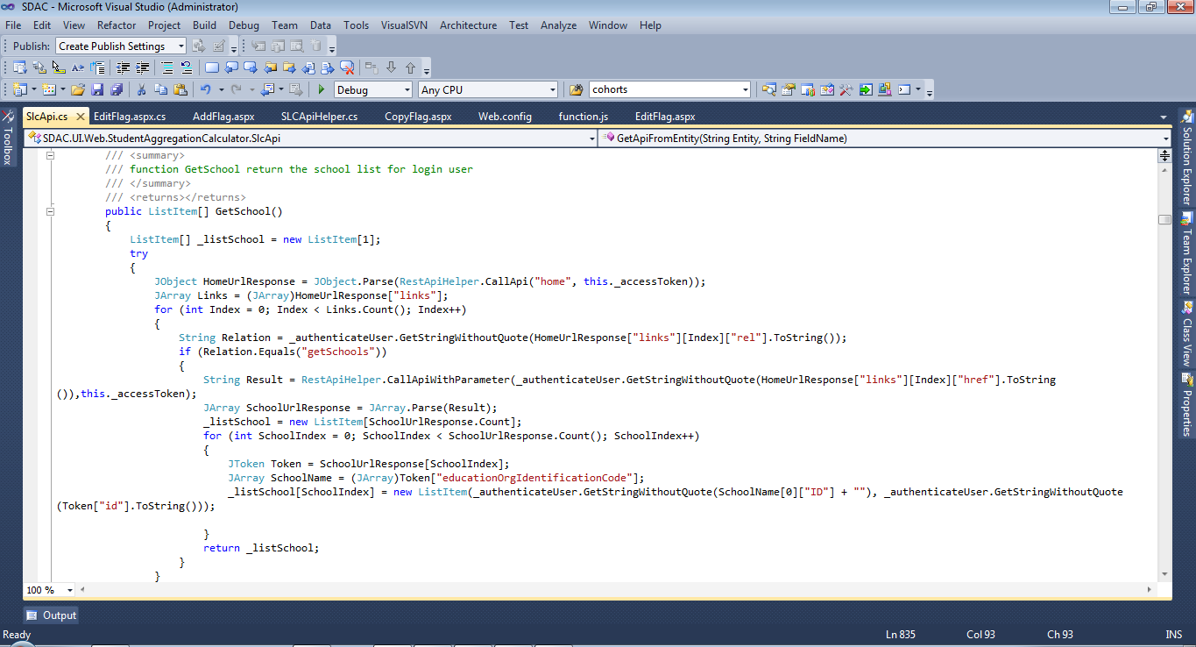

To get the API call from the entity we can call APIs for example to get the Student Academic Record we have the API "studentAcademicRecords?studentId={StudentId}".

How to call an API according to the entity is shown as follows:
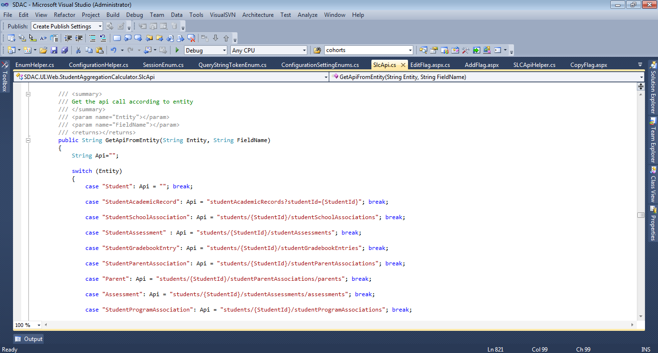

To get the API call with the parameter the method which is used contains the API call, student Id, school Id, course Id, and Section Id by which the data is fetched:

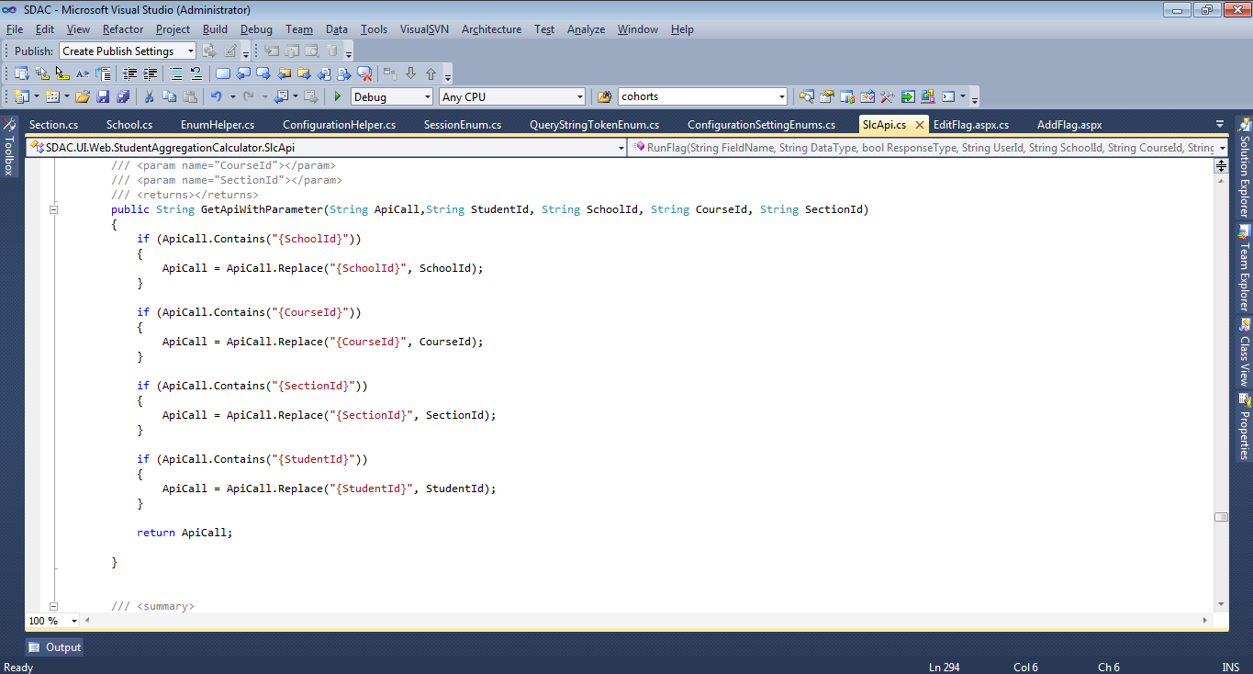

Source Code Directory Structure
This directory holds the all the main system source code and has the following files and directories.

It contains two projects:
- SDAC.Core
- SDAC.Data
- SDAC.DomainModel
- SDAC.UI.Web
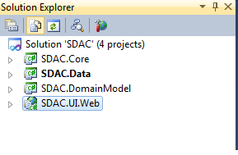

SDAC.Core
This includes core logic of the application and following are the files and folders.
- Properties
- Reference
This contains the required references for the entity model.
- Classes
These are classes which will contain business logic of the application.

SDAC.Data
This includes .NET wrapper integration logic of the application and following are the files and folders.
- Properties
- Reference
This contains the required references for the entity model.
- Classes
These are classes which will interact with RESTful APIs from the .NET wrapper of the application.
See the inBloom and Upeo .NET wrapper detailed documentation at https://github.com/upeo.

SDAC.DomainModel
This includes the entity model and contains the following files and folder.
- Properties
- Reference
This contains the required references for the entity model.
- App.config file
This contains the connection string of the entity model.
- SDACEntityModel.edmx File
An .edmx file is an XML file that defines a conceptual model, a storage model, and the mapping between these models. An .edmx file also contains information that is used by the ADO.NET Entity Data Model Designer (Entity Designer) to render a model graphically. The recommended practice for creating an .edmx file is to use the Entity Data Model Wizard. Changes are made to an .edmx file when you use the Entity Designer to modify your model and when you use the Update Model Wizard to update your model based on changes to the underlying database.

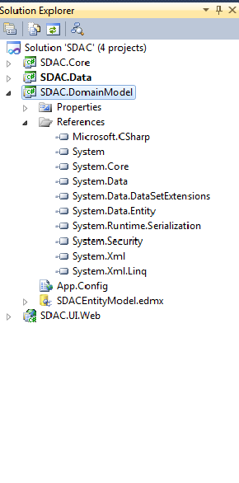

SDAC.UI.Web
Contains the following folders which include the classes, images, CSS files, JavaScript and UI files.
- Properties
- References
This contains the references which are required for the solution.
- Bin
Contains the DLL files required for the project.
- Classes
This folder contains the API related classes including authenticate user, call for API, get data through API.
- CSS
It contains all CSS files.
- Enum
- Helpers
- Images
It contains all of the images used in the project.
- JS
This contains the JavaScript files.
- Obj

UI Files (aspx pages)
- AddFlag
- AggregateFlag
- CopyAggregateFlag
- CopyFlag
- CustomFlagPage
- EditAggregateFlag
- EditFlag
- ErrorPage
- Help
- Login
- Result
- Search
- SDAC Master page

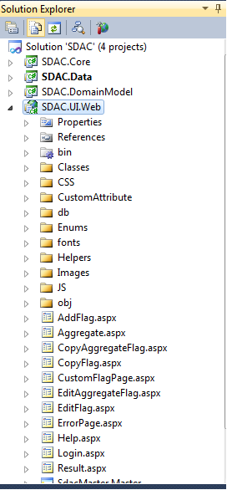

Error Page
The default error page will display when an unexpected error occurs in the application.
The page will display the specific error message as to why the application has stopped. This information may be useful when debugging the application and to determine the cause of the error.

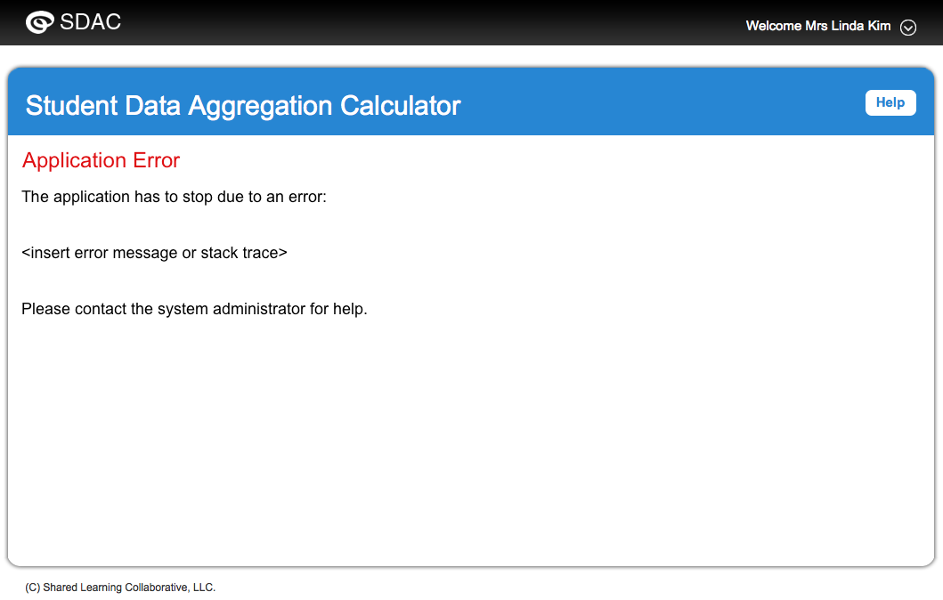

Custom Entity
Entities stored in the inBloom Data Store include an option for persisting custom data. When custom data is an option for an entity, one can use the includeCustom global parameter when forming API calls with the URI for that entity. The data type associated with custom data fields in the inBloom REST API is the JSON binary large object (blob) type.

Only a user with admin privileges can access the custom data. To permit non-admin users with this ability, set the WRITE_GENERAL permission for each role in the Admin Settings of the inBloom portal.

How to Retrieve Custom Entity Data
Get custom data associated with the entity

Get the flags custom data using the variables

Once the flag is added successfully we get the custom entity data.

We get the custom entity data shown as follows:

Custom data associated with an entity can be created and queried through the custom end point for the entity. One can use GET & PUT methods to manage the data.

