Student Data Aggregation Calculator
by


Technical Design Overview

Version: 1.0

Updated: February 21, 2013

TABLE OF CONTENTS

SYSTEM OVERVIEW 3
SOLUTION ARCHITECTURE 4
Solution Architecture Description 4
Presentation Layer / User Interface 4
Business / Application Layer 5
Data Layer 5
DATABASE 6
Data Dictionary 7
USER INTERFACE 11
Search 11
Search Results 12
Add/Edit Flag 13
Aggregate Flag 14
OTHER ASPECTS 15
Error Handling 15
Objects in the SDAC System 15
Logs 15
SYSTEM CAPABILITIES 16
IMPLEMENTATION TOOLS & TECHNOLOGIES 17
Project Technology 17
Database 17
Tools 17

SYSTEM OVERVIEW
inBloom through its shared technology infrastructure is opening doors for school district staff that have typically only interacted with software systems as a means for entering student data or viewing static reports that are often outdated and incomplete. Given the breadth and depth of data the inBloom Data Store encompasses, access to real-time, accurate and relevant student data is now possible.

The approach in designing the Student Data Aggregation Calculator (SDAC) is focused on delivering an intuitive tool that will enable district personnel to view student data that is both relevant to their needs and that can lead to some actionable outcome.

The user interface is simple yet effective, the features and functions are extensive with a focus on usability and the technology stack is reliable and scalable. There are many stakeholders in the district who will benefit from the SDAC as a way to make data-driven decisions that impact student achievement.

To support this vision, the solution architecture will have the following characteristics:
- Accessibility of data and content anywhere and anytime by user role.
- Extensibility of functionality in the system environment.
- Interoperability with inBloom to support access management, access control, and data exchange.
- Adhere to standard security policies in the education domain.
- System usability & accessibility of web-based information and applications

SOLUTION ARCHITECTURE

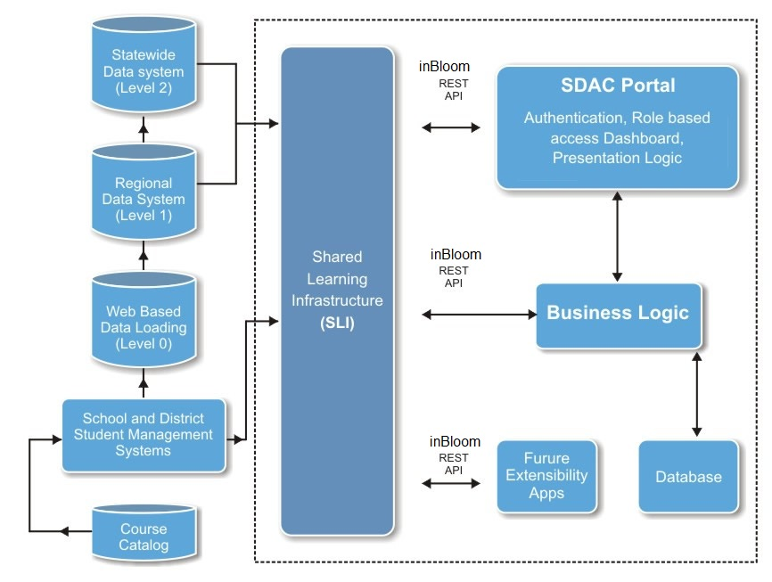

Solution Architecture Description
The SDAC (Student Data Aggregation Calculator) application consists of a 3-tier architecture. The flag based search solution is designed to be a simplistic tool for district and school administrators, providing various reports.

The architecture is comprised of three distinct layers.

Presentation Layer / User Interface
The presentation layer consists of the user interface designed for the web. The presentation layer presents relevant information in a context that is meaningful to end-users, allows discovery of information using flags (Individual Flags and Aggregate Flags) and provides for the communication with inBloom infrastructure using the inBloom API for authentication and student data.

The UI interface will ensure consistency and that users can access the information they need in a predictable, user-friendly, accessible environment.

Business / Application Layer
The functions of the business/application layer are to:

- Secure access to information and applications
- Support the business process logic
- Integrate with disparate systems and applications
- Process user data and applications interactions
- Facilitate communication and collaboration.

This requires a reference SDAC.DomainModel.dll which is an entity framework model used to call all data access fields from the presentation/application layer.

Data Layer
The SDAC portal is using Microsoft Entity Framework, which has many benefits including:

- The conceptual model can be represented in a better way by using relationships among entities.
- The underlying data store can be replaced without much overhead since all data access logic is present at a higher level.

This requires a reference to inBloomApiLibrary.dll which is a .NET wrapper framework (for inBloom Restful API’s) in the Data layer. It contains all of Restful API calls.

See the detailed document regarding inBloomApiLibrary at https://github.com/upeo

This layer generates business objects and entities according to the database tables and provides the mechanism for:
- Performing basic CRUD (Create, Read, Update, and Delete) operations.
- Easily managing "one to one", "one to many", and "many to many" relationships.
- Ability to have inheritance relationships between entities.

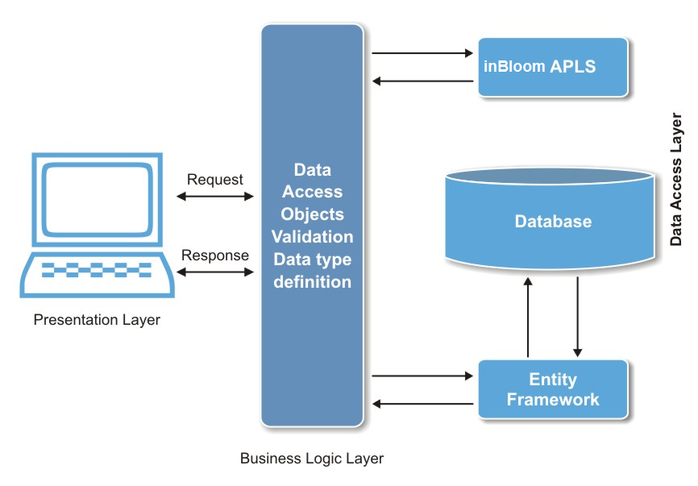

DATABASE

Entity Relationship Diagram
The following is an Entity Relationship Diagram outlining the tables and relationships that support the operation of the SDAC application.
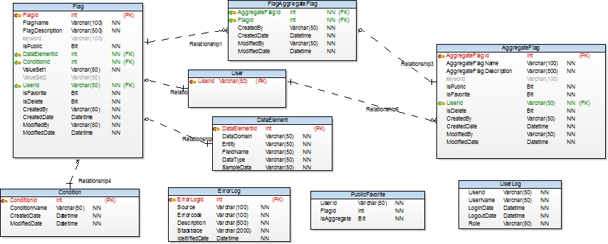

Data Dictionary
Table Name: Flag
Description: Table to create a new flag
Column Name | Type | Size | IS Null | Constraints | Description
FlagID | int |  | No | Primary Key | Identity Column
FlagName | varchar | 100 | No |  | Name given to a flag
FlagDescription | varchar | 500 | No |  | Description of the flag
Keyword | varchar | 100 | Yes |  | Keywords for the flag
IsPublic | bit |  | No | Default | Type of flag. 0 = Private and 1 = Public. Default is set to 0
ConditionID | varchar | 50 | No | Foreign Key | Condition selected for the flag
DataElementId | int |  |  | Foreign Key | Data Element selected bu the user
ValueSet1 | varchar | 50 | No |  | First value set for the flag
ValueSet2 | varchar | 50 | No |  | Second value set for the flag
UserID | varchar | 50 | No | Foreign Key | Id of user who created the flag
IsFavorite | bit |  | No |  | Set flag as favorite. 0 = No and 1 = Yes. Default is set to 0
IsDelete | bit |  | Yes |  | For soft delete. 0 = Default and 1 = Delete
CreatedBy | varchar | 50 | No |  | name of the user who created the flag
CreatedDate | datetime |  | No | Check | Created date
ModifiedBy | varchar | 50 | No |  | name of the user who modified the flag
ModifiedDate | datetime |  | No | Check | Modification date

Table Name: Aggregate Flag
Description: Table to create a new aggregate flag
Column Name | Type | Size | IS Null | Constraints | Description
AggregateFlagID | int |  | No | Primary Key | Identity Column
AggregateFlagName | varchar | 100 | No |  | Name given to an aggregate flag
AggregateFlagDescription | varchar | 500 | No |  | Description of the aggregate flag
Keyword | varchar | 100 | Yes |  | Keywords for the aggregate flag
IsPublic | bit | 10 | No | Default | Type of flag. 0 = Private and 1 = Public. Default is set to 0
IsFavorite | bit |  | No | Default | Set flag as favorite. 0 = No and 1 = Yes. Default is set to 0
UserID | varchar | 50 | No | Foreign Key | Id of user who created the aggregate flag
IsDelete | bit |  | Yes |  | For soft delete. 0 = Default and 1 = Delete
CreatedBy | varchar | 50 | No |  | Who created the aggregate flag
CreatedDate | datetime |  | No | Check | Created date
ModifiedBy | varchar | 50 | No |  | Who modified the aggregate flag
ModifiedDate | datetime |  | No | Check | Modification date

Table Name: Flag Aggregate Flag
Description: Table to describe the relationship between an individual flag and aggregate flag
Column Name | Type | Size | IS Null | Constraints | Description
AggregateFlagID | int |  | No | Foreign Key | Identity Column
FlagID | number |  | No | Foreign Key | Flag id used to create aggregate flags
CreatedBy | varchar | 50 | No |  | Who created
CreatedDate | datetime |  | No | Check | Created date
ModifiedBy | varchar | 50 | No |  | Who modified the combination
ModifiedDate | datetime |  | No | Check | Modification date

Table Name: Condition
Description: Table to select conditions for a flag
Column Name | Type | Size | IS Null | Constraints | Description
ConditionID | int |  | No | Primary Key | Identity Column
ConditionName | varchar | 50 | No |  | Name given to the condition
CreatedDate | datetime |  | No | Check | Created date
ModifiedDate | datetime |  | No | Check | Modification date

Table Name: User Log
Description: Table to maintain history of user
Column Name | Type | Size | IS Null | Constraints | Description
UserLogID | varchar | 50 | No | Primary Key | Identity Column
Role | varchar | 50 | No |  | Role of the user who has logged in
UserName | varchar | 50 | No |  | Name of the user who has logged in
LoginDate | datetime |  | No | Default | login time of the user
LogoutDate | datetime |  | No | Default | logout time of the user

Table Name: Error Log
Description: Table to maintain errors that occur during execution
Column Name | Type | Size | IS Null | Constraints | Description
ErrorLogID | int |  | No | Primary Key | Identity Column
Source | varchar | 100 | No |  | file/function where error has occured
ErrorCode | varchar | 100 | No |  | Error number of the error that occurred
Description | varchar | 500 | No |  | Description of the error
Stacktrace | varchar | 1000 | No |  | Message text of the error that occurred
IdentifiedDate | datetime |  | No | Check | Date and time when error occurred

Table Name: Public Favorite
Description: Table used to track public flags designated as Favorite
Column Name | Type | Size | IS Null | Constraints | Description
UserId | varchar | 50 | No |  | Id of the user who set it to favorite
FlagId | int | 50 | No |  | Flag id to set flag to public
IsAggregate | bit |  | No |  | Check whether flag is aggregate or not. 0 = Normal flag and 1 = Aggregate flag

Table Name: Data Element
Description: Table to select a data element and its data type
Column Name | Type | Size | IS Null | Constraints | Description
DataElementId | int |  | No | Primary Key | Identity column for data element
DataDomain | varchar | 50 | No |  | Data domain for data element
FieldName | varchar | 50 | No |  | Field name of data element
Entity | varchar | 50 | No |  | Entity of the data element
DataType | varchar | 50 | No |  | Data type of particular data element
SampleData | varchar | 50 | No |  | Sample Data for data element

USER INTERFACE

Search
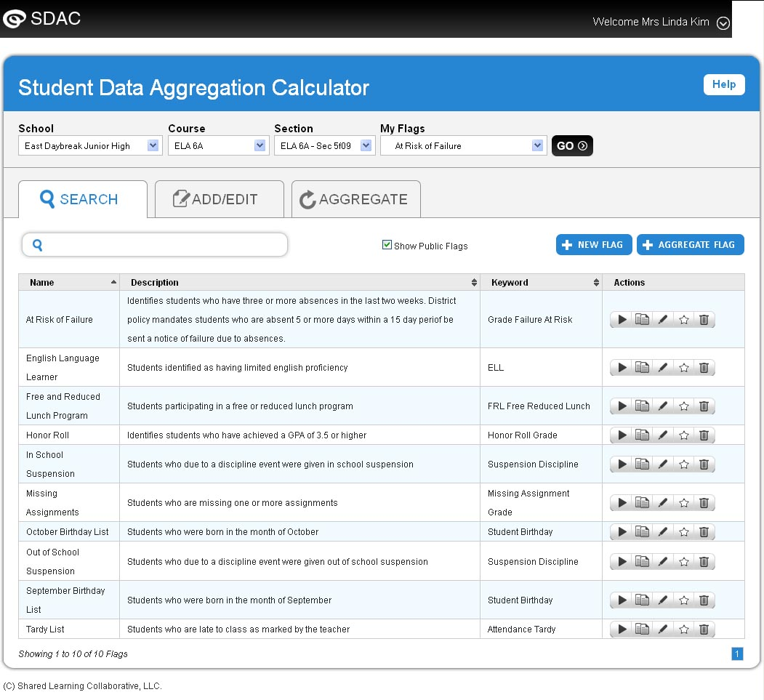

Search Results
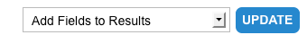
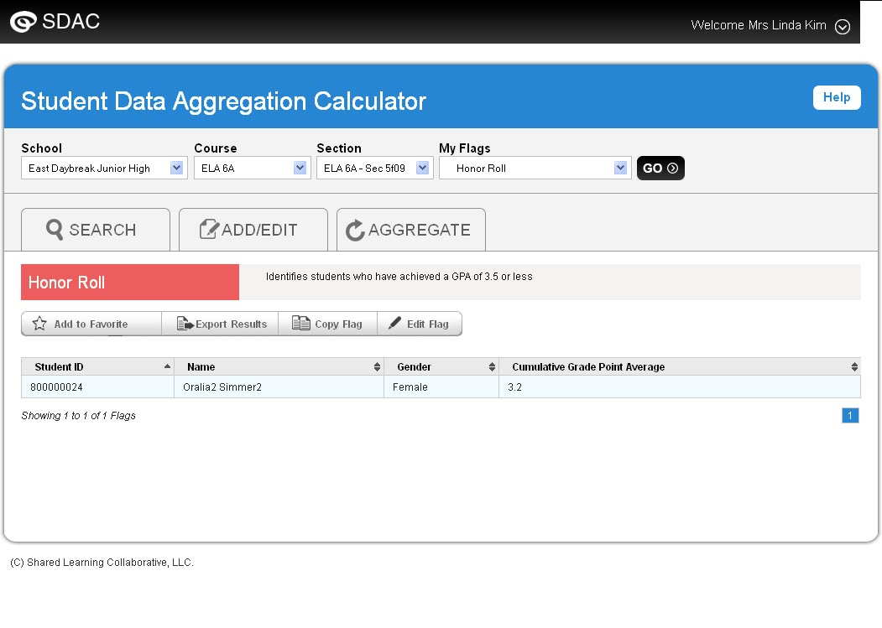

Add/Edit Flag
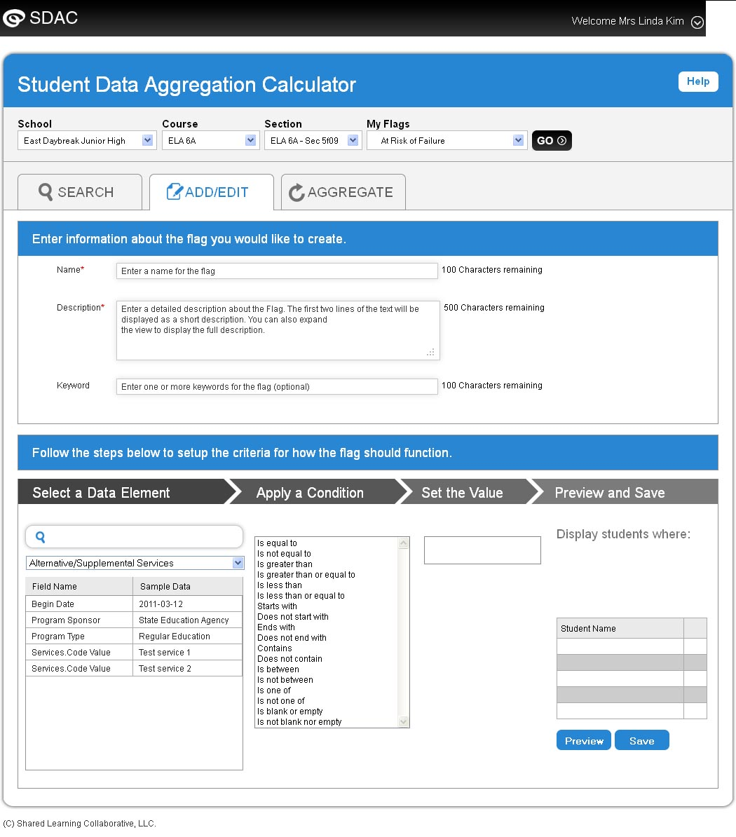

Aggregate Flag
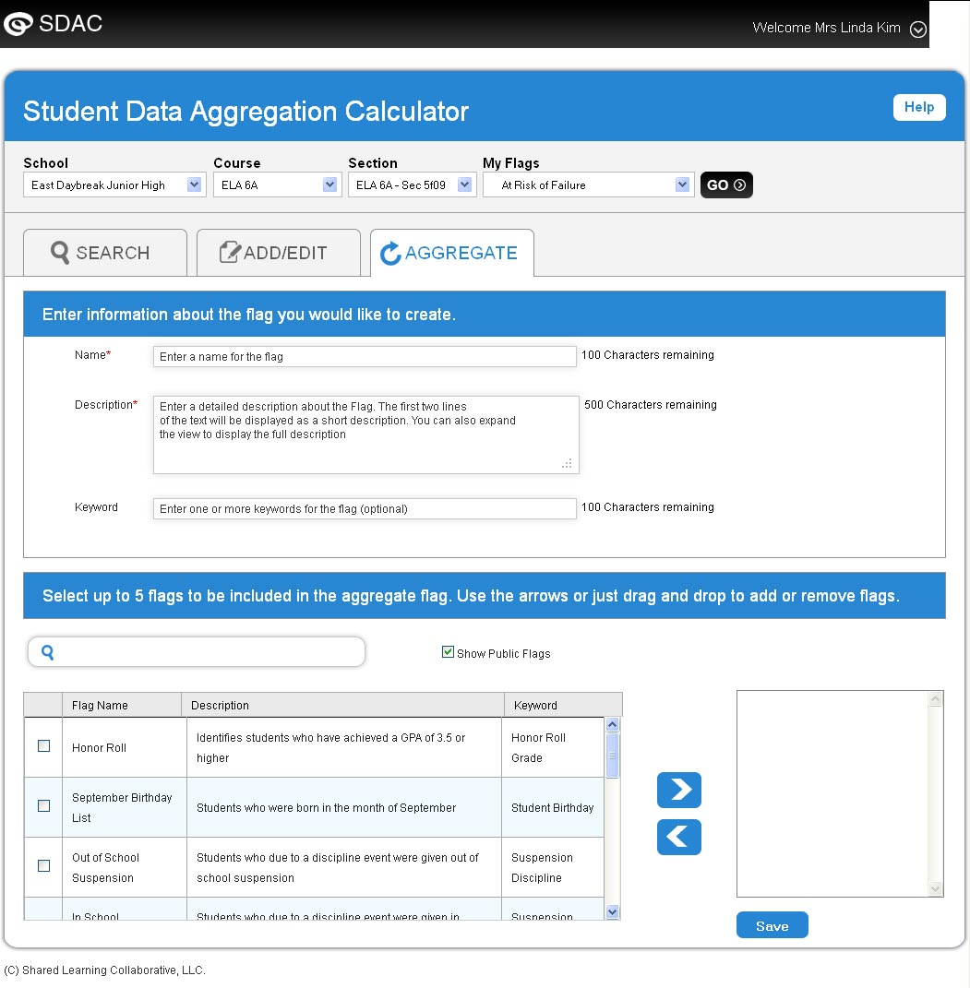

OTHER ASPECTS

Error Handling
The most specific technique for exception handling, and the most useful in terms of gracefully recovering from the exception, is structured exception handling. Structured exception handling is a standard practice in .NET. It provides built-in support for structured exception handling. In structured exception handling, you wrap code that may throw an exception in a Try...Catch block and logs the exception in the database.

Objects in the SDAC System
- Student
- Course
- Section
- District
- InBloomApi
- AuthenticateUser
- InBloomApiHelper
- EnumHelper
- ConfigurationHelper
- DescriptionAttribute
- ConfigurationSettingEnums
- QueryStringTokenEnum
- SessionEnum

Logs
The SDAC application will log all the error messages generated in the system with the error source, error number, and error description so that erroneous activities can be understood by looking at the logs. The SDAC will also keep track of every time the user signs into the system.

SYSTEM CAPABILITIES
- Event logging—offers a centralized logging framework, assists developers, quality assurance, support teams, and operations teams to troubleshoot issues, as well as track flow of data within a business transaction, and ability to track/audit user operations done via the exposed user interfaces.

- Role based access control (RBAC)—offers a flexible RBAC framework, supports views for various roles like educators and roll up data for administrators. The system will restrict, in a timely manner, access based on changes in association with a student.

- Interacts with a rich API layer (inBloom API) for service creation, orchestration, access, and management.

IMPLEMENTATION TOOLS & TECHNOLOGIES

The SDAC application is architected, designed and implemented using a subset of the Microsoft Technology stack. This technology stack provides a firm foundation for building robust, scalable and maintainable applications. In addition, standard and open web technologies are also included in the design and development of the solution.

SDAC Technology Stack
SQL Server 2008
WAS
IIS 7.x
Windows Server 2008 R2
Visual Studio 2010
HTML5
CSS3
jQuery
.NET Framework 4.0
C#
ASP.NET 4.0
MVC 3.0
Entity Framework
ADO.NET

Project Technology
- ASP.NET 4.0
- C#, JSON, LINQ, REST Services, JQuery, CSS

Database
- Microsoft SQL Server 2008 R2

Tools
- Project Management: Microsoft Project
- Development: Visual Studio 2010
- Source Control: SVN

