Management_graphs

Sander Devisscher

2022-08-17

Currently there is only 1 dataset but in the future there will be 2

# GRAPH: Total number of bullfrogs caught

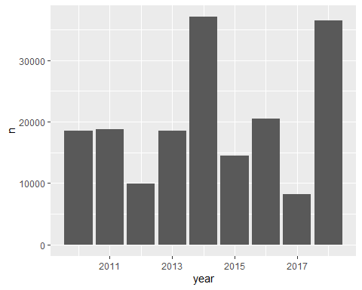

# GRAPH: Absolute number of bullfrogs caught by lifestage

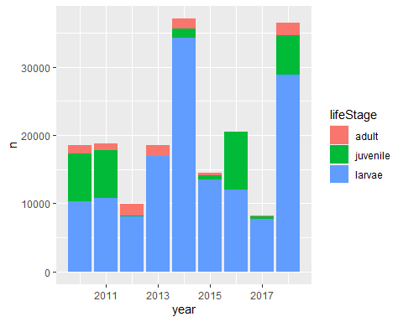

# GRAPH: Cumulative number of bullfrogs caught

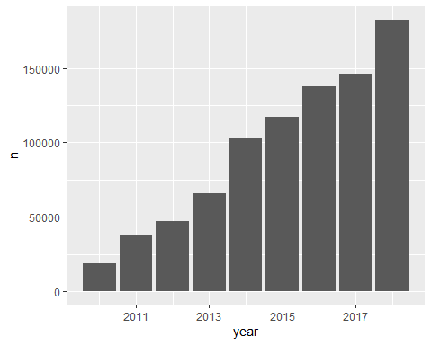

# GRAPH: Catch per unit of effort

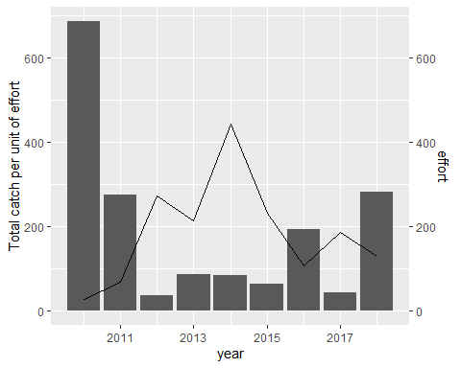

# GRAPH: Catch per unit of effort per lifstage

## Warning: Removed 1 rows containing missing values (position_stack).

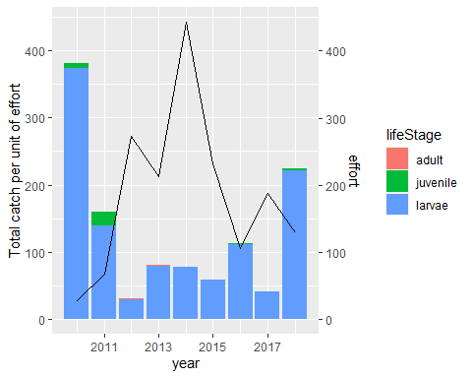

# Management map

## `summarise()` has grouped output by 'year', 'NISCODE'. You can override using  
## the `.groups` argument.  
## Joining, by = c("NISCODE", "NAAM")

# MAP: Bullfrog management in 2018

Suggested filters: - year - region-scale (province/commune) - unit (absolute/cpue)

