- GROUP BY ... HAVING
Use case: Find mechanics who have handled more than 1 service, along with their total labor cost earned.
Query:
SELECT
m.name AS mechanic_name,
COUNT(s.service_id) AS total_services,
SUM(s.labor_cost) AS total_labor_earned
FROM SERVICE s
JOIN MECHANIC m ON s.mechanic_id = m.mechanic_id
GROUP BY m.name
HAVING COUNT(s.service_id) > 1
ORDER BY total_labor_earned DESC;

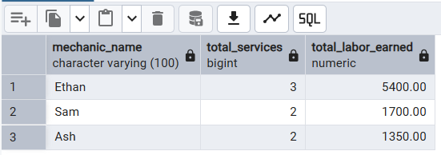

- ORDER BY
Use case: List all services in chronological order along with the vehicle number and service type, most recent first.

SELECT
s.service_id,
v.vehicle_number,
s.service_type,
s.service_date,
s.labor_cost
FROM SERVICE s
JOIN VEHICLE v ON s.vehicle_id = v.vehicle_id
ORDER BY s.service_date DESC;
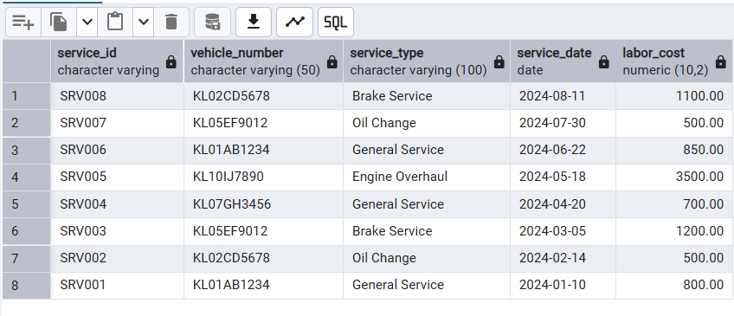
3. INNER JOIN
Use case: Display customer name, vehicle number, and all services availed, to get a complete service history.

SELECT
c.name AS customer_name,
v.vehicle_number,
s.service_type,
s.service_date,
s.labor_cost
FROM CUSTOMER c
INNER JOIN VEHICLE v ON c.customer_id = v.customer_id
INNER JOIN SERVICE s ON v.vehicle_id = s.vehicle_id
ORDER BY c.name, s.service_date;

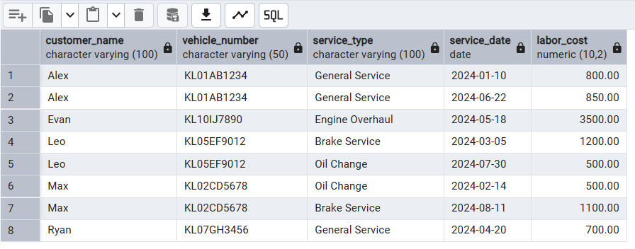
LEFT OUTER JOIN
Use case: List all customers along with their vehicles, including customers who have no vehicle registered.

SELECT
c.customer_id,
c.name AS customer_name,
v.vehicle_number,
v.vehicle_id
FROM CUSTOMER c
LEFT OUTER JOIN VEHICLE v ON c.customer_id = v.customer_id;

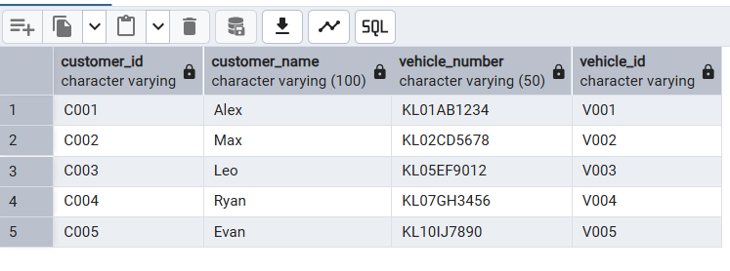

SELF JOIN
Use case: Find pairs of mechanics who work at the same service center (to identify co-workers).

SELECT
e1.center_id,
sc.name AS center_name,
e1.mechanic_id AS mechanic_1,
m1.name AS mechanic_1_name,
e2.mechanic_id AS mechanic_2,
m2.name AS mechanic_2_name
FROM EMPLOYS e1
JOIN EMPLOYS e2 ON e1.center_id = e2.center_id AND e1.mechanic_id < e2.mechanic_id
JOIN MECHANIC m1 ON e1.mechanic_id = m1.mechanic_id
JOIN MECHANIC m2 ON e2.mechanic_id = m2.mechanic_id
JOIN SERVICE_CENTER sc ON e1.center_id = sc.center_id;
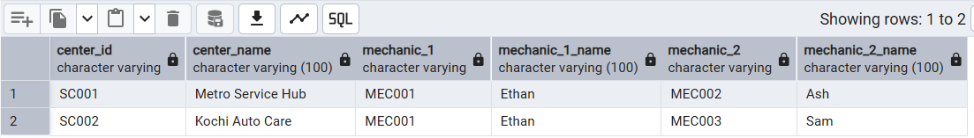

NATURAL JOIN
Use case: Retrieve service records naturally joined with service to show descriptions per service.

SELECT
service_id,
service_type,
service_date,
record_id,
description,
time_taken
FROM SERVICE
NATURAL JOIN SERVICE_RECORD;
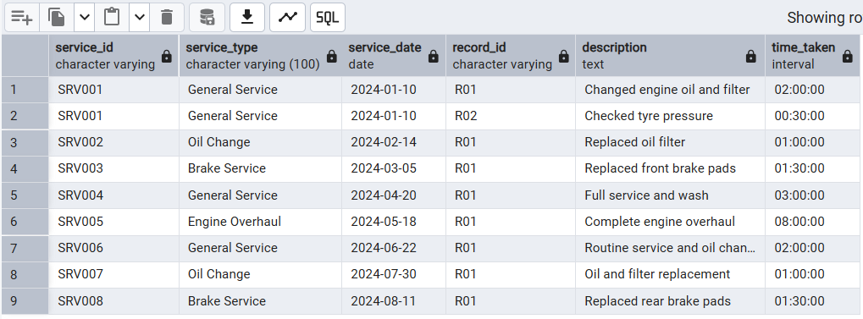
- INDEPENDENT SUBQUERY
Use case: Find all vehicles that have undergone 'Brake Service', to identify vehicles with brake issues.
SELECT
vehicle_id,
vehicle_number
FROM VEHICLE
WHERE vehicle_id IN (
SELECT vehicle_id
FROM SERVICE
WHERE service_type = 'Brake Service'
);
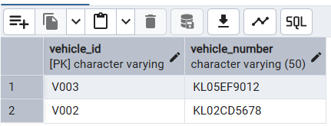
CORRELATED SUBQUERY
Use case: Find customers who have at least one vehicle that has been serviced more than once.
SELECT
c.customer_id,
c.name
FROM CUSTOMER c
WHERE EXISTS (
SELECT 1
FROM VEHICLE v
WHERE v.customer_id = c.customer_id
AND (
SELECT COUNT(*)
FROM SERVICE s
WHERE s.vehicle_id = v.vehicle_id
) > 1
);

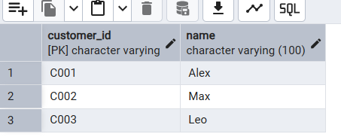
5.AGGREGATE FUNCTIONS
Use case: Get the total, average, minimum and maximum labor cost across all services.
-- ─────────────────────────────────────────────────────────────
SELECT
COUNT(service_id) AS total_services,
SUM(labor_cost) AS total_labor_cost,
ROUND(AVG(labor_cost),2) AS avg_labor_cost,
MIN(labor_cost) AS min_labor_cost,
MAX(labor_cost) AS max_labor_cost
FROM SERVICE;

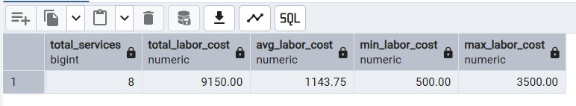

6. BOOLEAN OPERATORS (AND / OR / NOT)
Use case: Find services that are either 'General Service' or 'Oil Change', cost more than 600, and are NOT done by mechanic MEC004.

SELECT
service_id,
service_type,
service_date,
labor_cost,
mechanic_id
FROM SERVICE
WHERE (service_type = 'General Service' OR service_type = 'Oil Change')
AND labor_cost > 600
AND NOT mechanic_id = 'MEC004';

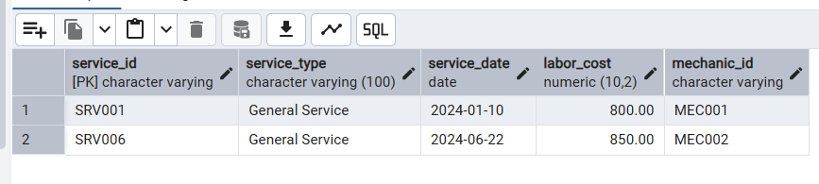
7. ARITHMETIC OPERATORS
Use case: Calculate the total bill for each service by adding labor cost and total parts cost.

SELECT
s.service_id,
s.service_type,
s.labor_cost,
COALESCE(SUM(sp.quantity_used * p.price), 0) AS parts_cost,
s.labor_cost + COALESCE(SUM(sp.quantity_used * p.price), 0) AS total_bill
FROM SERVICE s
LEFT JOIN SERVICE_PARTS sp ON s.service_id = sp.service_id
LEFT JOIN SPAREPARTS p ON sp.part_id = p.part_id
GROUP BY s.service_id, s.service_type, s.labor_cost
ORDER BY total_bill DESC;
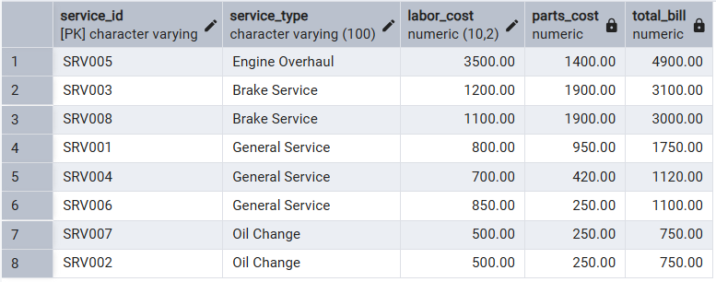
8. STRING OPERATORS (LIKE / ILIKE)
Use case: Search for spare parts whose name contains the word 'Filter' (case-insensitive search).
SELECT
part_id,
part_name,
price,
supplier_id
FROM SPAREPARTS
WHERE part_name ILIKE '%filter%';

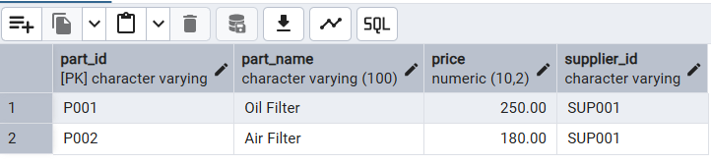
9. TO_CHAR AND EXTRACT
Use case: Display service month, year and day of week for all services to analyse peak service periods.
SELECT
service_id,
service_date,
TO_CHAR(service_date, 'Month YYYY') AS service_month_year,
TO_CHAR(service_date, 'Day') AS day_of_week,
EXTRACT(MONTH FROM service_date) AS month_number,
EXTRACT(YEAR FROM service_date) AS year_number
FROM SERVICE
ORDER BY service_date;
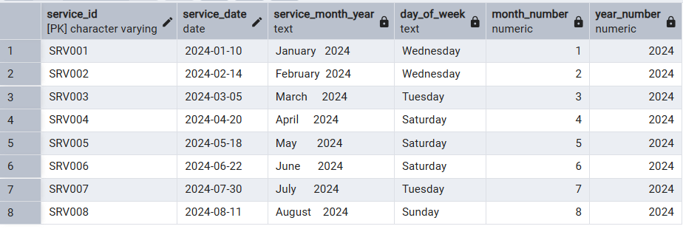
10. BETWEEN, IN, NOT BETWEEN, NOT IN
Use case: Find spare parts whose price is between 100 and 500,supplied by specific suppliers, and exclude parts
-- with price between 300 and 400.
SELECT
part_id,
part_name,
price,
supplier_id
FROM SPAREPARTS
WHERE price BETWEEN 100 AND 500
AND supplier_id IN ('SUP001', 'SUP002')
AND price NOT BETWEEN 300 AND 400
AND part_id NOT IN ('P999');
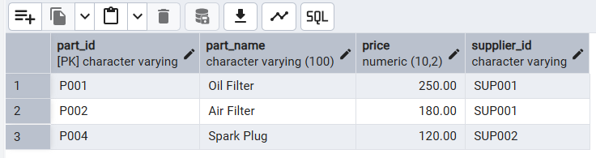

11. SET OPERATIONS (UNION)
Use case: Get a combined list of all vehicle IDs that have either had a 'General Service' OR a 'Brake Service', to identify vehicles needing regular attention.
SELECT vehicle_id, 'General Service' AS service_category
FROM SERVICE
WHERE service_type = 'General Service'

UNION

SELECT vehicle_id, 'Brake Service' AS service_category
FROM SERVICE
WHERE service_type = 'Brake Service'

ORDER BY vehicle_id;
