 SUMMATIVE ASSESSMENT I
[SESSION 2016-2017]
SOCIAL SCIENCE SAMPLE PAPER
CLASS VI
DURATION: 3 HOURS NAME: ____________________ M. Marks: 90
GENERAL INSTRUCTIONS:
- READ ALL THE QUESTIONS CAREFULLY.
- ATTEMPT ALL THE QUESTIONS IN NEAT HANDWRITING.
- DRAW THE DIAGRAMS NEATLY AND LABEL THEM.
- DRAW MARGIN LINES ON BOTH THE SIDES.
- ATTEMPT THE MCQs IN THE ANSWER SHEET.
_____________________________________________________________________________________________________

Q 1] Read the given text and answer the questions that follow: [5]

We know about people who lived in the subcontinent as early as two million years ago.Today, we describe them as hunter-gatherers. The name comes from the way in which they got their food. Generally, they hunted wild animals, caught fish and birds, gathered fruits, roots, nuts, seeds,leaves, stalks and eggs. The immense variety of plants in a tropical land like ours meant that gathering plant produce was an extremely important means of obtaining food. None of these things was easy to do. There are several animals that run faster than us, many that are stronger. To hunt animals or catch fish and birds, people need to be alert, quick, and have lots of presence of mind. To collect plant produce, you need to find out which plants or parts of plants are edible, that is, can be eaten, as many can be poisonous. You also need to find out about the seasons when the fruits ripen. There are at least four reasons why hunter gatherers
moved from place to place.First, if they had stayed at one place for a long time, they would have eaten up all the available plant and animal resources. Therefore, they would
have had to go elsewhere in search of food. Second, animals move from place to place —
either in search of smaller prey, or, in the case of deer and wild cattle, in search of grass and leaves. That is why those who hunted them had to follow their movements.

1.Who are Hunter Gatherers? 1
2.Which two qualities were required by the people mentioned in the passage? 1
3.Why did hunter gatherers moved from one place to another? 2
4.Which period is referred in the above mentioned passage? 1

Q 2] Read the given text and answer the questions that follow: [5]

Raw materials are substances that are either found naturally (such as wood, or ores of metals) or produced by farmers or herders. These are then processed to produce finished goods. For example,cotton, produced by farmers, is a raw material that may be processed to make cloth. While some of the raw materials that the Harappans used were
available locally, many items such as copper, tin,gold, silver and precious stones had to be brought from distant places.The Harappans probably got copper from present-day Rajasthan, and even from Oman inmade of terracotta and faience. These were used
to spin thread.Many of the things that were produced were probably the work of specialists. A specialist is a person who is trained to do only one kind of work,
for example, cutting stone, or polishing beads, or carving seals. and see how well the face is carved and how carefully the beard is shown. This must have been the work of an expert crafts person.Not everybody could have been a specialist. We do not know whether only men were specialistsor only women were specialists. Perhaps some
women and men may have been specialists.

1.What do you understand by raw materials? 1
2. Name the raw materials used by the Harappans. 2
3.Who is a specialist? 1
4.How do we come to know from the passage that trade was carried out in Harappan period? 1

Q3] What is prime meridian? [1]
Q4] In which season is Christmas celebrated in Australia? [1]
Q5] Which important latitude passes through India? [1]
Q6] What do we do when we move towards the east of International date line?[1]
Q7] Some people move from place to place in search of food. What are they known as? [1]
Q8] What are organised group of people living in developed society termed as? [1]
Q9] What is the earliest civilization “The Harappan Civilisation”also known as? [1]
Q10] Mention any one harmful effect of stereotypes ? [1]
Q11] Which is the law enforcing organ of the government in our country? [1]
Q12] Name the form of government people do not have the right to elect their
representatives? [1]
Q13] Observe the given map carefully and identify the important latitudes and longitudes
Marked as A,B & C. Write them in your answer sheets in order. [1x3=3]

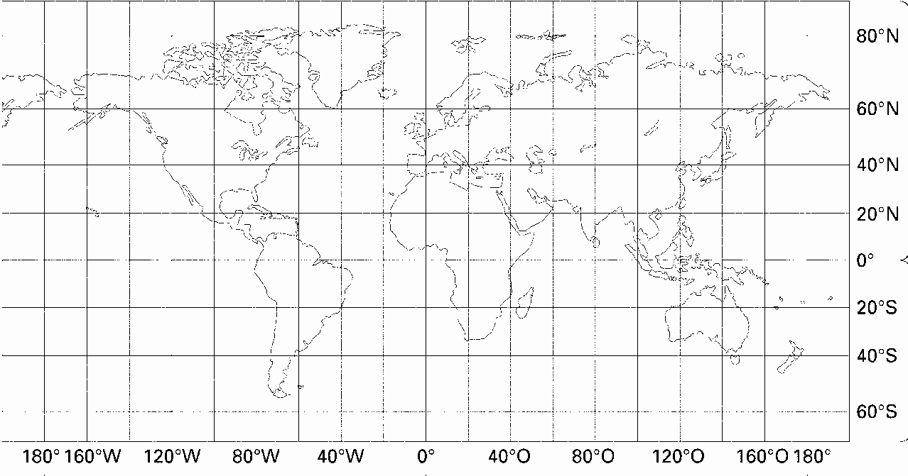
A
B
C

Q14] What is Government ? How can people participate in law enforcement? [1+2=3]
Q15] If the Illiterates and poor are not given right to participate in the government what type of discrimination is it? Support your answer with two reasons how it is an essential feature of the government in India? [1+2=3]
Q16]How do we know that cloth was used in Harappan civilisation? [1x3=3]
Q17] Observe the image and answer the following: [1x3=3]
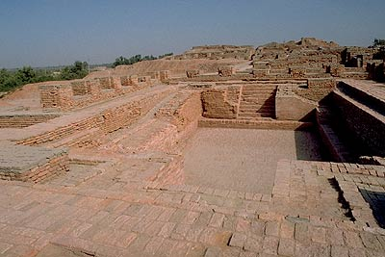
(i) Identify the image.
(ii) What does it depicts about Harappan period?
(iii) Which source was used to get water to this area?

Q18] Differentiate between latitudes and longitudes. [1x3=3]
Q19] Why do we experience longer days and shorter nights during June in Northern
hemisphere? [1x3=3]
Q20] Observe the image carefully and answer the following questions: [1x3=3]
E
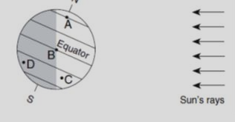
F

- What does the line joining E and F represent?
- What season is it at place D?
- Which places experiences winter?

Q21] The Neolithic people used pottery as utensils. Mention at least two uses of pottery
in the present times. Had you been a Neolithic man, how would you have used those utensils? [2+1=3]
Q22] How has farming helped people to lead a better life. Support your answer with three examples. [1x3=3]
Q23] Draw a neatly labelled diagram of the earth representing the following. Marks are allotted for accuracy, neatness and labelling. [1+1+3=5]
A] Orbital plane
B] Tilt of Axis
C] Perpendicular to orbital plane
Q24] Calculate the local times of place A ( 60ᴼE)and place B(60ᴼ W) when the GMT is 6 a.m. [5]
Q25] Draw a timeline on an appropriate scale to represent three stages of stone age along with its period. [5]
Q26] Streets in Harappa was one of the excellent features of the Harappan cities. Elaborate the statement by answering the following questions: [5]
- Write one feature about the construction of streets in Harappa 1
- How did they help in commuting of heavy carts? 1
(iii) On which part of the town was it located? 1
(iv) Which were two famous structure of this part of the town ? 2
Q27] Make a flow chart to represent the three levels of government and their respective roles. [5]
Q28] Draw a bubble chart to explain the different types of functions performed by the government. [5]
Q29] Identify the type of discrimination from the following statements: [1x5=5]
A]Sona did the chores at home whereas her younger brother was pursuing education.
B]Raj the son of a maid was not allowed to enter the society park and play with the children of the society where his mother worked.
C]Pallavi a dalit girl was not allowed to drink water from her friend’s bottle who was a Brahmin.
D] Javed a Muslim boy was not allowed to enter the Jain temple with his friend Raman and
was asked to stay out of the premises.
E]Jeet was not accepted by his new classmates as he could speak only Tamil .
Q30] On the Map of India Mark the following states through which the tropic of Cancer passes: [5]
A]Tripura
B] Gujarat
C] Jharkhand
D]Rajasthan
E]Madhya Pradesh

