**SAMPLE PAPER (ANSWER KEY)**

**SUMMATIVE ASSESSMENT I**

**[SESSION 2016-2017]**

**MATHEMATICS**

**CLASS VI**

**DURATION: 3 HOURS __________________ M. Marks: 90_____**

**SECTION A**

Ans 1 : 26,000

Ans 2: 375034

Ans 3: a) 1025981 ˃ 1024876

b) 28759520 < 28759621

Ans 4: South

**SECTION B**

Ans 5: (2+3) and (3+7)

Ans 6: (11,13) and (17,19)

Ans 7: X= -200 Rs, Y = 2000 Rs, Z= 300 Rs

Ans 8: 2+5=7

Ans 9: Triangle and Pentagon (in both figures)

Ans 10: (1,3),(0,4),(-1,5),(-2,6)

**SECTION C**

Ans 11: i) 6,99,93,000

ii)6,993

Ans 12: Rs 168

Ans 13: 699300

Ans 14: (125×6)×75 = 750×75=56250 (Associative property of multiplication)

Ans 15: i) (-2)

ii) 22 steps to the left on the numberline

Ans 16: a) (-15), b) (-9)

Ans 17: Isosceles acute angled triangle (55⁰, 55⁰, 70⁰)

Ans 18: a) West, b) South, c) West

Ans 19: a) Triangular Pyramid: Face-4, Edges – 6, Vertices – 4

b) Cylinder: Face-3, Edges-2,Vertices-0

Ans 20: Rs 150

**SECTION D**

Ans 21: Greatest- 99430 Successors-99431, 99432 Predecessors-99429, 99428

Smallest-30049 Successors-30050, 30051 Predecessors-30048, 30047

Ans22:

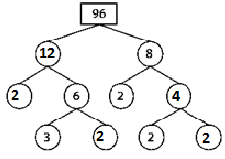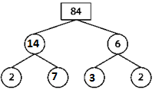

Ans 23: 1) Trapezium 2) Rectangle 3) Scalene Triangle 4) Isosceles right angled triangle

Ans 24: 1050

Ans 25: Rhombus :1) All the sides are equal i.e. AB=BC=CD=CA

2) Opposite sides are parallel to each other i.e. AB||CD and BC||AD

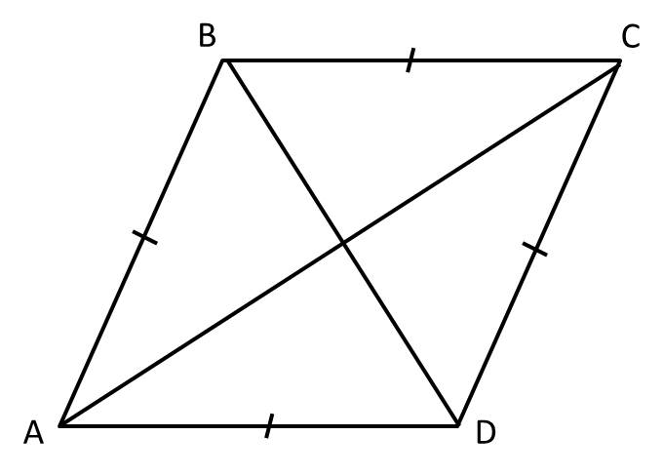Rhombus

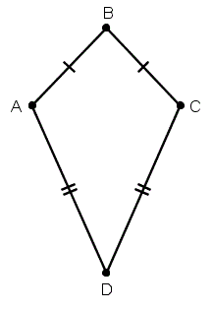

Kite

Kite : 1) The disjoint pair of consecutive sides in a kite are equal i.e. AB=BC and AD=CD

2) Diagonals intersect each other at 90°

And 26: 1) 1 , 2) (-1) , 3) 2 , 4) (-16)

Ans 27: a) No, because sum of all the digits is 28 which is not divisible by 3.

b)Yes, because sum of all the digits is 12 which is divisible by 3.Also the number is an even number. So, it is divisible by both 2 and 3.

Ans 28A: 1) +700 Rs , 2)+100m , 3)-220Rs , 4) 4

Ans 28 B:

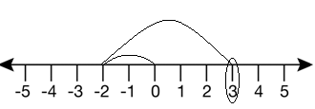 (i) 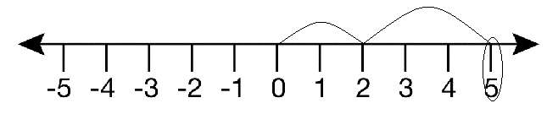 (ii)

Ans 29: Team A scored more by 32 units.

Ans 30: Angle A=50° and Angle B=60° Name of triangle is Acute angled triangle

Ans 31: a) (-20) b) 11