** SAMPLE PAPER**

**SUMMATIVE ASSESSMENT I**

**[SESSION 2016-2017]**

**MATHEMATICS**

**CLASS VI**

**DURATION: 3 HOURS __________________ M. Marks: 90_____**

**GENERAL INSTRUCTIONS:**

* ***Attempt all the questions***
* ***Question paper consists of four sections – A, B, C, D***
* ***Section A consists of Q1-Q4 of 1 mark each.***
* ***Section B consists of Q5-Q10 of 2 marks each.***
* ***Section C consists of Q11-Q20 of 3 marks each.***
* ***Section D consists of Q21-Q31 of 4 marks each.***

***__________________________________________________________________________________________________***

**SECTION A (4×1=4 Marks)**

Q1. Round off the number to the nearest thousands: 25618

Q2. Write the following in the standard form: 300000+70000+5000+30+4

Q3. Compare the numbers and put the appropriate symbol of comparison for the following:

1. 1025981 _______ 1024876
2. 28759520 _________ 28759621

Q4. You are standing at East. Which direction will you face if you turn clockwise one right angle?

**SECTION B (6×2=12 Marks)**

Q5. Write two pairs of prime numbers whose sum is divisible by 5.

Q6. Write two pairs of twin primes between 11 and 35.

Q7. A shopkeeper is calculating the profit and loss on 4 days. Help him to complete the table by filling the values of x, y and z.

|  |  |  |  |
| --- | --- | --- | --- |
| Transaction Date | Transaction | Amount(Rs) | Total Balance(Rs) |
| 12 August | Profit of Rs.1500 | +1500 | 1500 |
| 13 August | Loss of Rs.200 | x | 1300 |
| 13 August | Profit of Rs.700 | +700 | Y |
| 14 August | Loss of Rs.1700 | -1700 | Z |

Q8. Study the given figure carefully and complete the boxes.

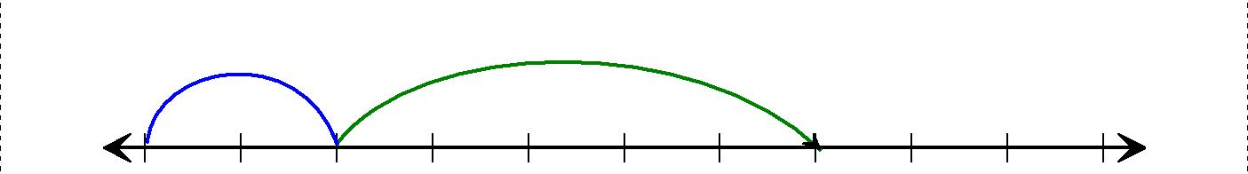



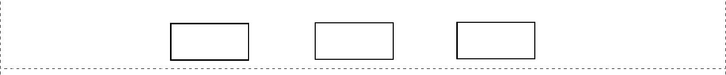

|  |  |  |  |  |  |  |  |  |  |  |
| --- | --- | --- | --- | --- | --- | --- | --- | --- | --- | --- |
| 0 | 1 | 2 | 3 | 4 | 5 | 6 | 7 | 8 | 9 | 10 |
|  |  |  | + |  |  | = |  |  |  |  |

Q9. Identify the two types of polygons highlighted in the figure given below.

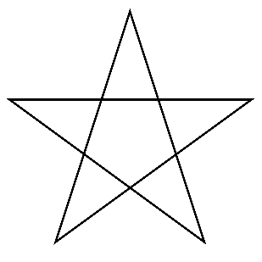

Q10. Write 4 pair of integers which are at the same distance from 2 on the number line.

**SECTION C (10×3=30 Marks)**

Q11. Find the difference between the place values of 7 in the following numbers:

1. 72687319 ii) 357647

Q12. The cost of 2 tons of iron is Rs. 12,000. Find the cost of 28 kg of iron.   
Q13. Find the place values of two 7’s in 57,41,782. Write the successors of these place values and find their difference.

Q14. Solve 125×75×6 by using suitable property of whole numbers. Also mention the name of the property being used.

Q15. Answer the following by drawing a number line for each question:

1. Which number will we reach if we move 5 steps to the right of (-7).
2. If we are at (7) on the number line, how much and in which direction should we move to reach (-15)

Q16. Solve using number line: a) 7+ (-6) + (-16) b) -20 - (-28) - (17)

Q17. In the given figure, if one of the angles is 55°, name the type of triangle. Find all the angles using

properties of triangles.

55°

Q18. Name the direction that you will face if you stand facing:

N

1. East and make $\frac{1}{2}$ of a revolution anti-clockwise?

E

W

1. North and move 180° clockwise?
2. South and make $\frac{1}{4 }$ of a revolution clockwise?

S

Q19.Identify the geometrical shape of given figures. Write the number of faces, edges and vertices of each.

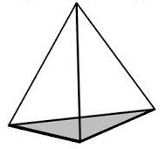

(A) Triangular Pyramid (B) Cold Drink Can

Q20. The cost of 2 ton of iron is Rs.12000. What will be the cost of 25 kg of iron?

**SECTION D (11×4=44 Marks)**

Q21. Write the greatest and the smallest five digit numbers using the digits4,3,0,9. You can use only one digit twice. Write their 2 successors and predecessors.

Q22.Complete the prime factor tree:

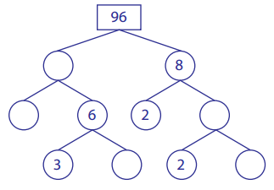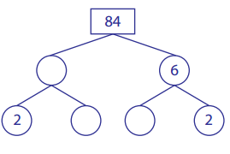

Q23. Answer the following:

1. A quadrilateral with only one pair of parallel sides is called _________ .
2. A quadrilateral with the opposite sides equal is called __________.
3. In ∆LMN, LM = 7cm, MN=10cm and LN=8cm. Name the triangle.
4. In ∆ XYZ, http://whatis.techtarget.com/WhatIs/images/angl-sym.gifY = 90° and XY=YZ. Name the triangle.

Q24. Find the least number of four digits which is exactly divisible by 15,25 and 30.

Q25.Draw the figures of the following and write any two properties of each of them.

1. Rhombus b) Kite

Q26. Answer the following:

1. The difference of two consecutive whole numbers is ____.
2. ___ is the biggest negative integer.
3. ___ is the smallest even prime number.
4. (-4) more than (-12) is equal to ___.

Q27. Using divisibility tests, determine which of the following numbers are divisible by 2 and 3? Give reasons in support of your answer.

1. 128476
2. 32412

Q28. A) Write these in the form of integers.

|  |  |
| --- | --- |
| 1. Profit of Rs.700 | 2. 100m above sea level |
| 3. 220 AD | 4. 6 steps to the right of (-2) |

B) Represent the following on a number line: (i) (-2) – (-5) (ii) 2 – (-3)

Q29. In a quiz competition, team A scored 74, -20,-37, 13 and team B scored 17, -15, -32, 28 in four successive rounds. Which team scored more and by how much?

Q30. Find the missing angles in the below given figures and then name the triangle.

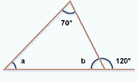

Q31. Solve the following:

1. (-2) – 7 + (-9) – 2 b) 3 + (-1) + 4 – (-5)