**SUMMATIVE ASSESSMENT I**

**[SESSION 2016-2017]**

**SAMPLE PAPER SCIENCECLASS VI**

**DURATION: 3 HOURS NAME: ________MMarks: 90**

***GENERAL INSTRUCTIONS:***

* ***The question paper comprises of two sections A and B. All questions are compulsory.***
* ***Attempt both the sectionsseparately.***
* ***Question number 1 to 3 are one mark question and to be answered in one word or one sentence.***
* ***Question number 4 to 6 are two marks questions and to be answered in about 30 words each.***
* ***Question number 7 to 18 are three marks questions and to be answered in about 50 words each.***
* ***Question number 19 to 24 are five marks questions and to be answered in about 70 words each.***
* ***Question number 25 to 33 are multiple choice questions based on practical skills. Each question is of one mark.***
* ***Question numbers 34 to 36 are two marks question based on practical skills and to be answered in about 30 words each.***

_________________________________________________________________________________________________________

**SECTION A**

Q 1] What happens when a magnet is freely suspended? [1]

Q 2] Synthetic fibres should not be worn while working with flame. Give reason. [1]

Q 3] We should breathe through our nose and not from the mouth. Justify. [1]

Q4] Will frying be easier using ladles having steel handles or wooden handles? Why? [2]

Q 5] Tanima uprooted a plant. She cutoff its root with a knife and planted it back in the soil. What will happen to the plant? [2]

Q 6] What are syntheticfibres?Give its 2 examples. [2]

Q 7] ] ‘A sieve having small holes can be used to separate salt dissolved in water’. Do you agree with this statement? Give reason. [2]

Q 8] Explain how the salt is obtained from sea water. [3]

Q 9] We cannot cook in utensils made of wood. Give reason for your answer. [3]

Can any part of the utensil be made of wood? If yes, name it.

Q 10] List any three properties to differentiate a metal key from a football.[3]

Q 11] Draw a diagram to show the parts of a flower. Label any 6 parts. [3]

Q 12] List three ways by which our daily activities lead to air pollution. [3]

Q 13] How will you separate a mixture of mud, tea leaves and pebbles? [3]

Q 14] Draw a flow chart to show the processing of jute fibre.[3]

Q 15] Identify the difference between the two experimental setups. Name the process responsible for water drops formed in second setup. Define the process. [3]

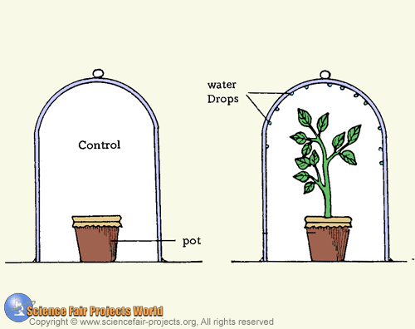

Q 16] State any three uses of wind energy. [3]

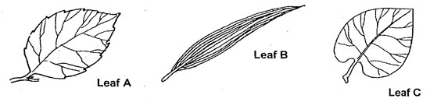Q 17] Thediagram below shows different arrangement of veins. Name the term used to describe the arrangement of veins on a leaf. Identify the type of arrangement in each leaf.[3]

Q 18] Shyam’s mother by mistake mixed a tablespoon of sugar in a bowl of flour.Shyam helped her by separating the mixture by using a method he learnt in his science class.[2+1]

a] Which method do you think he adopted for separating the mixture of sugar and flour?

b] What values are shown by Shyam?

Q 19]Observe the picture and answer the following questions: [2+1+2]

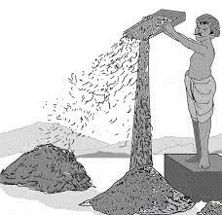

a] Identify the method shown in the picture and define it.

b] Give another example of a mixture separated by same method.

c] Name a method to separate a mixture of solid and liquid.Mention the property involved.

Q 20]Study the pictures given below and answer:[1+2+2]

**A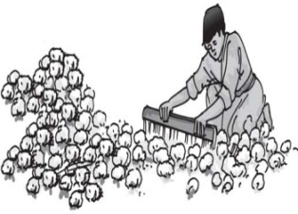B**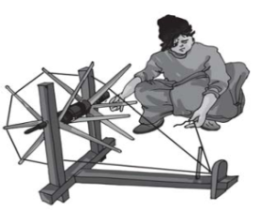

a] Whichfibre is being processed in the above pictures? b] Identify the two processes A and B and give one point of difference between them. c] Name any two conditions required for the growth of this plant.

Q 21]Mahibought some vegetables in a carry bag. [3+1]

a) Which material should she prefer?Why? b) CanMahi use a carry bag made of metal? Explain your answer.

Q 22] Study the picture given below and answer: [1+1+3]

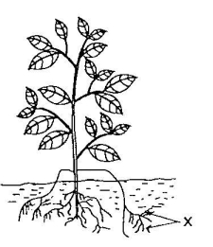**X**

a] Identify the structure X. b] State any two functions of X in a plant. c] State two types of X and differentiate between them. [2 points]

Q 23] a] Draw a pie chart for the composition of air.[2+3] b] List one use of each component of air.

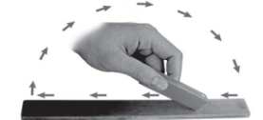Q 24]Look at the picture given below and answer the questions that follow. [1+1+3]

a] What is a magnet? b] Identify the method shown in the picture and explain it.

**SECTION B**

Q 25]The given method of separation is called [1]

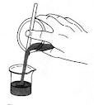

a) decantation b) filtration c) handpicking d)filtration

Q 26]Anemometer is used to measure __________________of wind. [1]

a) direction b) speed c) temperature d) pressure

Q 27] The process of converting yarn into fabric [1]

a)ginning b) spinning c)weaving d) knitting

Q 28] Stones can be separated from sand by the process of [1]a] decantation b] handpicking c] condensation d) threshing

Q 29] The part marked is[1]

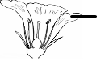a)petal b)anther c)stigma d)sepal

Q 30]Which group contains all transparent objects? [1]

a) mirror,air b) air,wallc) air,waterd) paper, plastic

Q 31] In sieving the property used is the difference in the _______ of particles. [1]

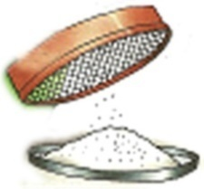

a) size b)weight c) colour d)appearance

Q 32]Which of the following is a function of part X? [1]

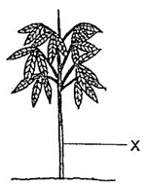

a)absorbs water b)exchange of gases c)prepares food d) transports water

Q 33] Air is used for [1]

a)separating husk from grains b) flying birds c) dispersal of seeds d) all of these

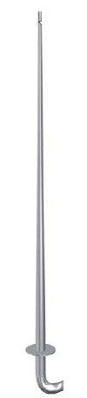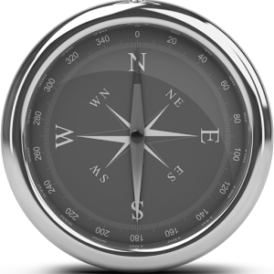Q 34] Why do sailors and navigators use magnetic compass?What happensif a magnet is broughtcloser to a magnetic compass?[2]

|  |
| --- |
| N S |

Q 35] Look at the picture given below and answer the questions that follow: [2]

a] Name the device.

b] Name the process it is used for.

Q 36] In the picture shown below, water enters the bottle when it is tilted. [2]

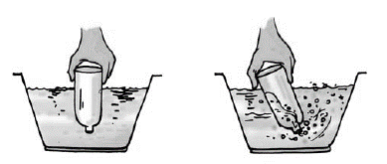

a] Why was the water unable to enter the bottle in upside down position?

b] Mention the property of air investigated in the setup.