**Want to run ServletSample?**

1. If are able to read this file; it means ServletSample.zip is unzipped to folder ServletSample.
2. ServletSample has below giving folder structure,

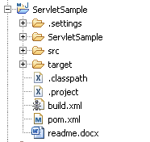

1. You need four tools to quickly run this application.
   1. Java development Kit: **JDK 1.7**
   2. Web server : **Apache Tomcat**
   3. Data base : **Mongo DB 2.6.3**
   4. build tool : **Apache Maven**
2. Download JDK 1.7 from <http://www.oracle.com/technetwork/java/javase/downloads/index.html>
   1. In your windows environment variable. Create a variable named **JAVA_HOME**. This variable should point to the latest JDK directory e.g. **D:/opensource/JDK_7**
3. Download Mongo DB from <http://www.mongodb.org/downloads>
   1. Unzip the downloaded file to your file system e.g. **D:\opensource\mongodb-2.6.3**
   2. Create a folder named db in it e.g. D:\opensource\mongodb-2.6.3\db.
   3. Start MongoDB by following command:

**D:\opensource\mongodb-2.6.3\bin\mongod --dbpath=D:\opensource\mongodb-2.6.3\db**

1. Download latest version Apache Maven from <http://maven.apache.org/download.cgi>.
   1. Unzip the to your local system something like: **D:/opensource/Maven_3**
   2. In your windows environment variable. There is predefined variable named **PATH**. Update this variable to add Maven commands. Add **D:/opensource/Maven_3/bin** path in **PATH** variable.
   3. The purpose of PATH variable is to add new commands in Windows Dos executable.
   4. To test whether PATH includes latest Maven commands; open DOS command prompt and type following command,

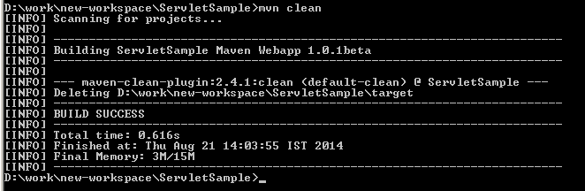

* 1. If this command works; your maven is ready to build ServletSample application. **mvn clean** command will clean the project.
  2. Second step is to build the project ServletSample. Fire **mvn install -Dmaven.test.skip=true** command, refer the screen below

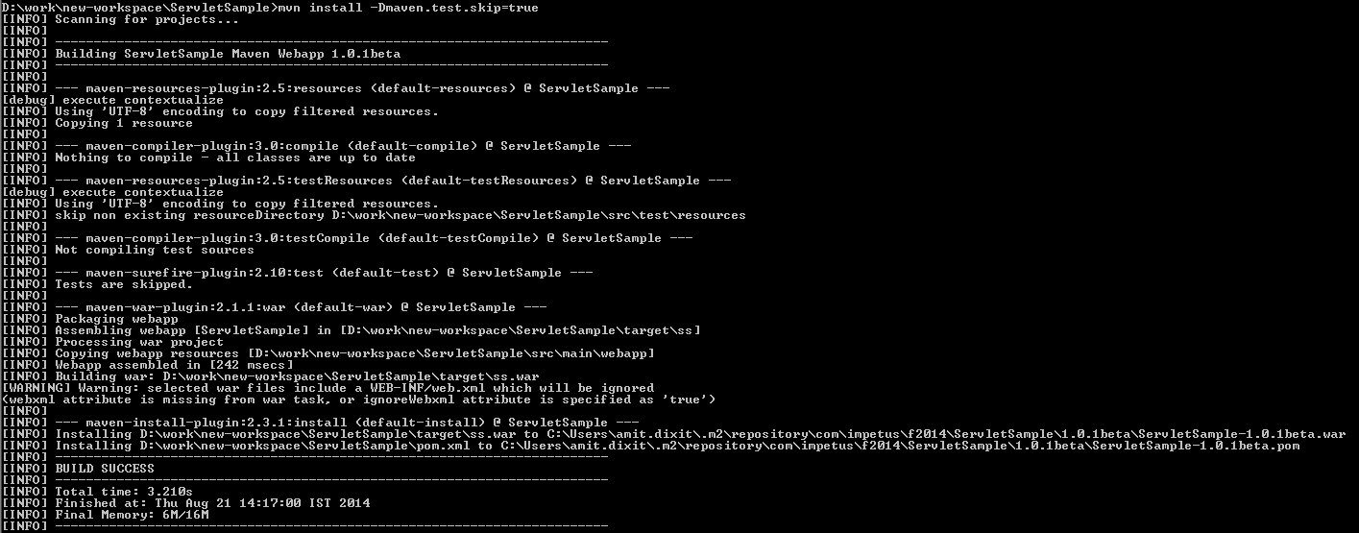

* 1. The last command will generate a war at **D:/ServletSample/target/ss.war**. WAR file is the main deployable web application.

1. Apache Tomcat version 7. Download the zip from <http://tomcat.apache.org/download-70.cgi>.
   1. Unzip the to your local system something like: **D:/opensource/Tomcat_7**
   2. Now copy **D:/ServletSample/target/ss.war** to **D:/opensource/Tomcat_7/webapps** folder
   3. Start Tomcat using command **D:/opensource/Tomcat_7/bin/startup.bat**
   4. Remember that JAVA_HOME environment variable should be present before starting Tomcat.
   5. Hit URL: <http://localhost:8080/ss/jsp/employee/employeeService.ser> to access the application