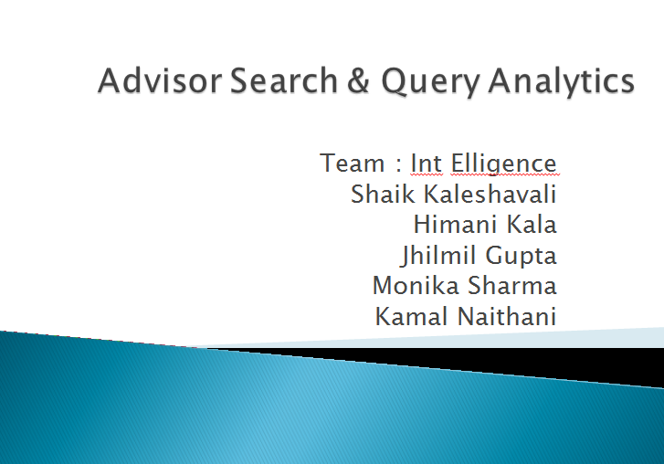

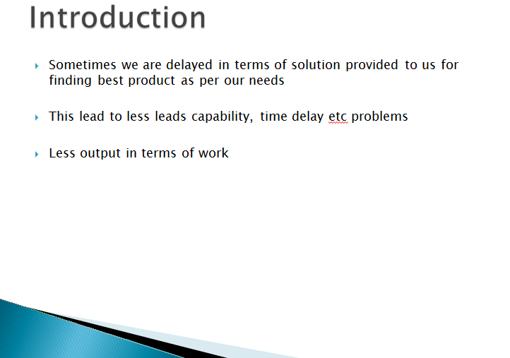

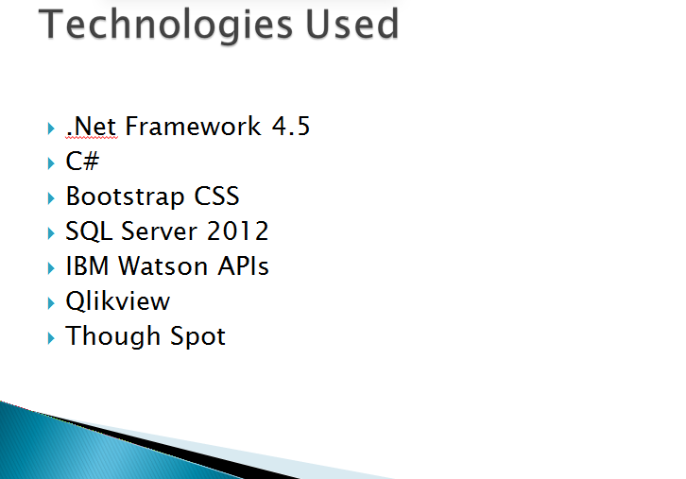

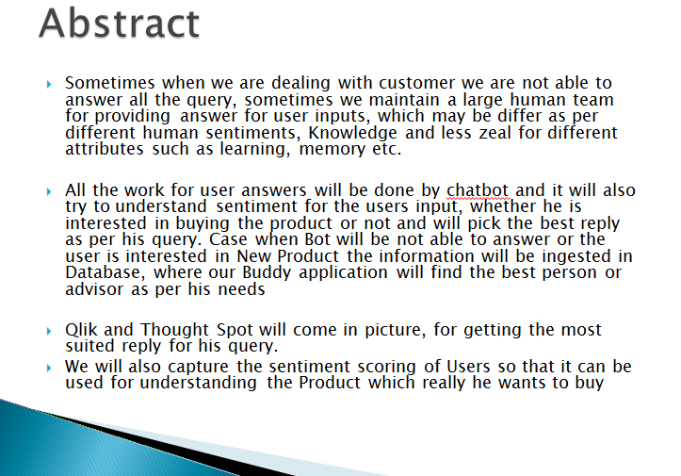

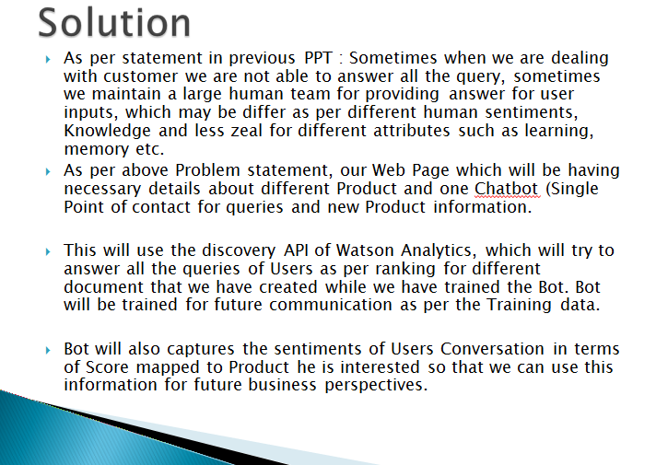

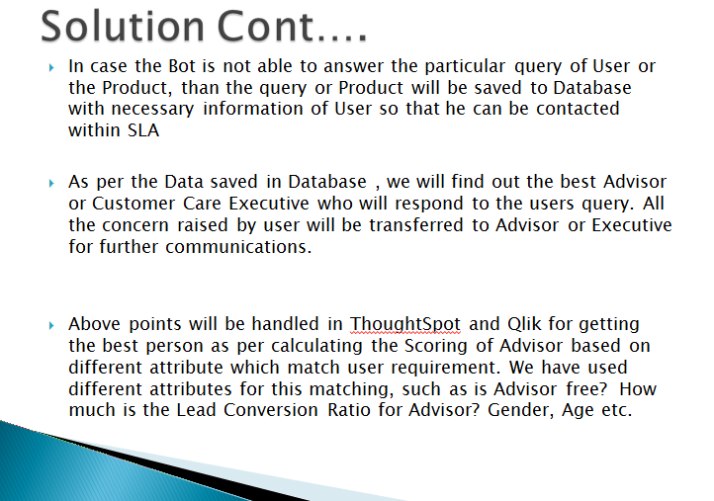

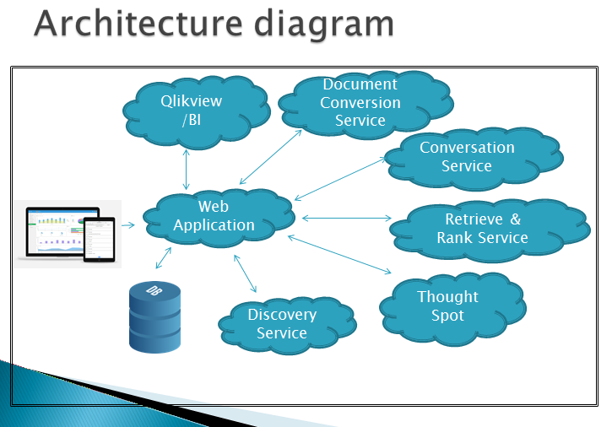

We are getting the request from Web Page, where the user is asking his query to Chatbot. Chatbot uses the Conversation API, Document Conversion, and Discovery API of IBM Watson and provide the solution to user as per its finding. In case it is not able to get the solution, it ingests query and user details in Database. Qlik and Though Spot use the data by Bot and provide best solution for his query in case if he looking for Advisor as per his needs for buying the products or Executive who is specialized in answering queries raised by him.

