Title:
Auto –support tool

Abstract
Auto-Support will be web based/online service that primarily targets to provide automatic support to customers by analysing their uploaded data to resolve known issue, recommend solutions, best practice, etc. Framework will provide a first level analysis/recommendations to customer. Framework design will be product agnostic. It will support existing products and will be extensible to future products. New product shall be added into the system easily and quickly with minimal efforts.

Approach
Analyzing customer support data usually involves extensive computation, network and disk IO activities. Whenever any issue occurs, customers provide us huge log files, which costs us lot of human-hour effort to analyze these files. Many times these issues turn out to be the duplicate bugs/issues, which leads to wastage of resources in analysis. This framework will provide a first level analysis to customer collectors file, which will save the efforts on the redundant work.

Message oriented middleware is a commonly adopted technique to address such needs. To be adaptive to evolving nature of product, framework adopts plugin-based architecture. When new issue condition is identified in a supported product, a new plugin can be developed or an existing plugin can be enhanced, which helps to grow the efficiency of the tool, and the customer is always served by best.

Business Impact
- Identification and Resolution of Known problems in product.
- Shorted support cycle.
- Effective tool for support and/or engineers for analysis.
- Pro Active support
- Self-service for customers.
- Saving hours of human efforts for analysing logs and duplicate effort.
- Predictive analysis issues based on data gathered from various customers.

Design Architecture

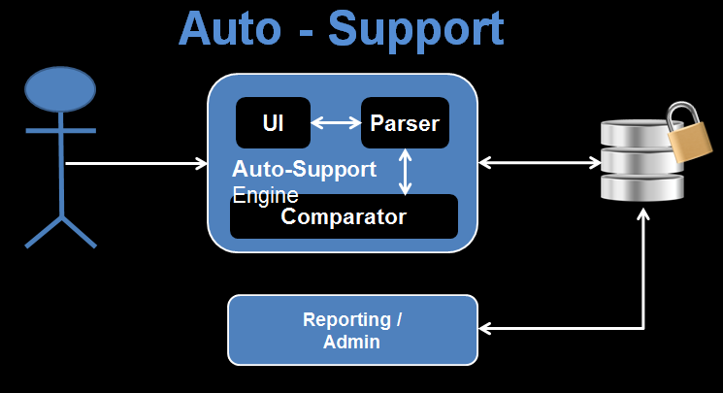

Mode of operations:
- User uploads data to UI page portal.
- Uploaded data is saved to backend storage.
- Upload notifies framework of the newly uploaded data.
- The upload data task is picked up by backend logic.
- Backend Logic:
  - Unpacks data
  - Detects product
  - If not analyse-able, the process ends.
- Backend Logic performs analysis by accessing backend storage for customer data.
- Analysis results are saved into database.
- Web server constructs analysis report from database.
- User view will have link to view report.
- Once clicked on the view report link, results are rendered as HTML pages which are sent back to user’s browser.

