**IHRP**

**Intelligent Hiring Resume Parser**

**Document Version: 0.2**

**Confidential**

*Proprietary & Confidential*

**Copyright 2017 - 2018 INCEDO INC**. All Rights Reserved. No part of this document may be reproduced, stored in a retrieval system, distributed or transmitted, in any form, or by any means, electronic or otherwise, including photocopying, reprinting, or recording, for any purpose, without the express prior written permission of Incedo Inc.

**REQUESTS** For information requests or for obtaining permission for the use of this work, please submit a written request to: Marketing and Communications, Incedo Inc, Plot No. 248 Udyog Vihar, Phase IV, Gurgaon - 122015. Email: communications@incedoinc.com

**Document Revision History**

|  |  |  |  |  |  |
| --- | --- | --- | --- | --- | --- |
| **S.No.** | **VERSION NO.** | **DATE** | **AUTHOR** | **APPROVAL BY** | **Remarks** |
| 1 | 0.1 | 31-01-2018 | Ashok Mishra  Shivangi Saxena  Pranjal Srivastav  Isha Dutta  Kalicharan | Incedo Hackathon Evaluation Team / HR Team |  |
| 2 | 0.2 | 01-02-2018 | Isha Dutta |  |  |

**Table of Contents**

1. Title 4

2. Abstract 5

3. Solution Approach 5

4. Business Impact 5

5. Design & Architecture 5

6. Algorithm 6

# Title

**Intelligent Tool for matching Job Description with resume**: Search most relevant resumes for given Job Description.

# Abstract

Organizations receive process and manage thousands of resumes from job applicants. These resumes will be automatically processed by the information extraction system. Extracted information such as name, phone/contact details, emails id's, qualification, experience, skill-sets etc. can be stored as a structured data in a DB and then can be used in various different areas/fields.

In contrast to many non-structured document types, information in resumes is in a little structured form, where information is stored in separate blocks. Each block contains related information about a person’s contacts, education or work experience.

To parse these resumes effectively and efficiently, the system should be independent of the order and type of information in the documents. We have assumption that resumes have a three level hierarchical structure where upper most level contains segments. These segments consist of blocks that contain related information. Each block can contain several chunks which are named entities.

# Solution Approach

Screening a stack of profiles can be a daunting task for even experienced users. However, with a little preparation and an organized approach, the process can be streamlined to help select the best candidates to interview .Our software will do the below for achieving goal

* Analyze job description to predict the relevancy of a resume
* Analyze resume
* Generate analytics
* Portray recommended resume to the user
* Accept feedback/comment from the user

# Business Impact

Organization with the help of solution will be able to get below benefits

* Detailed analytics on resume which can be missed by naked eyes
* Quick analysis over resume as top ranked resumes are
* Assist HR to find a possible Pre joining buddy once a candidate is shortlisted
* Higher visibility to the relevant resume

# Design & Architecture

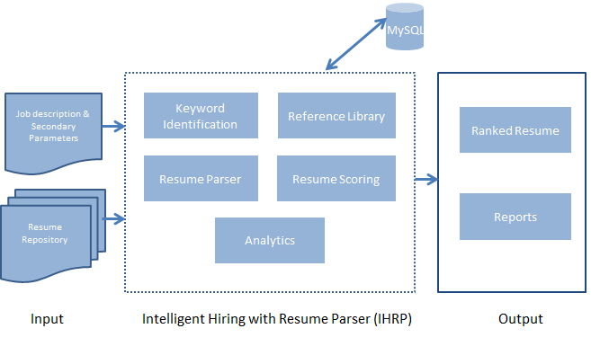

# Algorithm

1. **JD Input:** Input/Upload Job description(JD) in IHRP application in doc file/HTML/copy-paste JD content in **conceptual search text box** and provide **secondary parameters** if any. (Example: Gender, Experience etc.)
2. **Parsing & Categorization Module:** Parse JD & create categorization of data keywords using python code
3. **Auto Logging to Job board:** Auto Logging into job board sites using employer credentials like Naukri, Indeed, Monster, Linkedin etc.
4. **Fill Search Criteria:** After successful log-in fill search criteria.
5. **Decision to alter search criteria:** If search results are greater than certain number (>1000 resume) thenadd more search criteria to derive required results (i.e. <100 resume).
6. **Download Resume:** Download all resumes in directory named with searched JOB Title.
7. **Parse Resume & Score:** Parse resume and score them.
   * 1. **Scoring:** Parameters used in our tool for scoring are Job title, primary/key skills, experience, location of picking up resumes, location constraint, notice period and qualification from highest to lowest priority
     2. **Ranking** of the collected resumes based on the primary keywords.
8. **Connect UI to Analytics:** UI will connect with DB to display analytics.
9. **Predict Job Buddy:** Match **education/previous company** of “desired candidate” with existing INCEDO employee’s **education/previous company.**

