**Title - Reference Data Management**

A company has grown inorganically by taking over its competitors It wants to do financial reporting at group level and wants to report its financial metrics for various branch levels e.g.

National branches, regional branches, Sub regional branches, county level, city level. Its various constituent companies however have different levels of branch hierarchy and call various branch levels by different names. For example : one company may have 5 different levels of branches starting from Zonal, region, state, City, district level branches, while another just has county, city and local branches Our utility needs to create a harmonized reference hierarchy and map the various different branch levels of the various companies to one of the levels of master hierarchy. This will allow for group level reporting of financial numbers for various branch levels.

**Abstract of solution**

A Dynamic Solution to create Organizational hierarchies, Data Model with Aggregated Fact tables at different levels, and visualization on the top of Aggregated fact tables to improve performance at reporting level, our complete solution will give the flexibility to map different hierarchies of different levels to master hierarchy, even the master hierarchy will be configurable to support multiple levels and to support any of the financial metrics.

**Solution Approach**

We have created a Data model to support a dynamic solution that can handle any levels of hierarchy and can map different hierarchy levels of different companies to master hierarchy.

Users will be able to add/modify organization hierarchy via Role Based access on UI.

Granular and aggregated fact tables will be created to support financial reporting at multiple levels.

Any level of hierarchy will be supported with this solution.

Our solution consists of following –

1. UI for Dynamic Hierarchy at company level and mapping different branches of company to master hierarchy.
2. Pre build Data Model to support dynamic hierarchy and Reporting.
3. Mongo DB to support Structured and unstructured data and to support Tree level structure of any company.
4. Machine Learning algorithms to do predictive analysis and financial forecasting in case.
5. Tableau/R for Financial Reporting and Data Visualization at different branch and hierarchy level.

**Design Architecture**

**System Integration Flow**

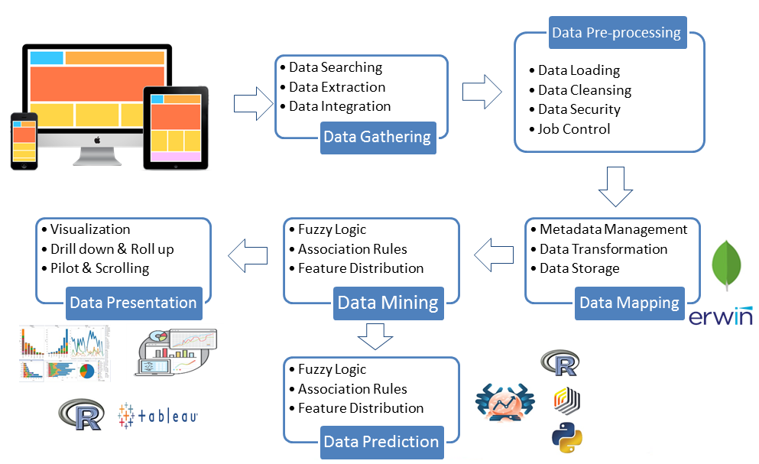

**Solution**

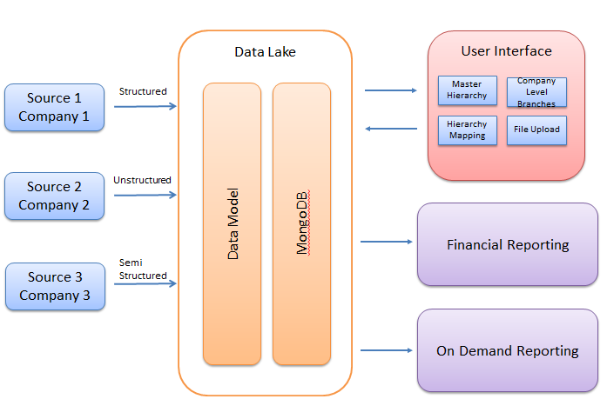

**Data Flow**

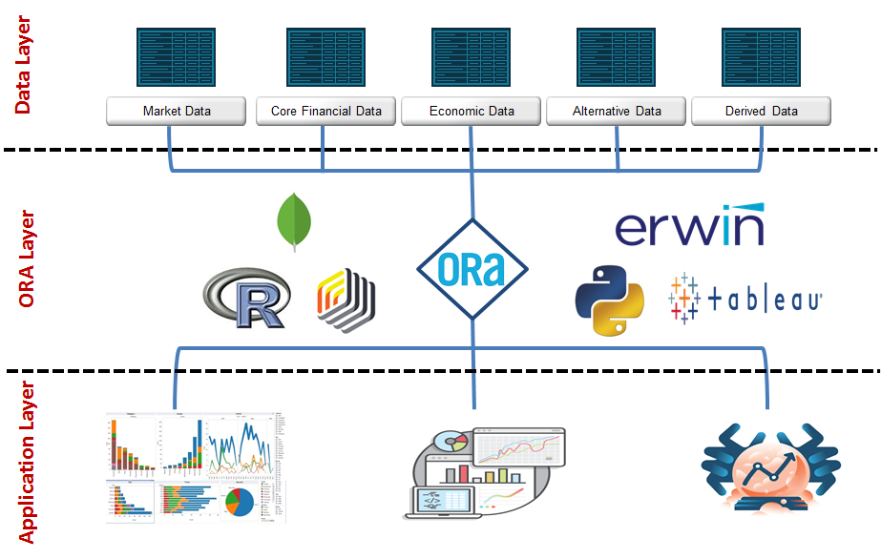

**UI**

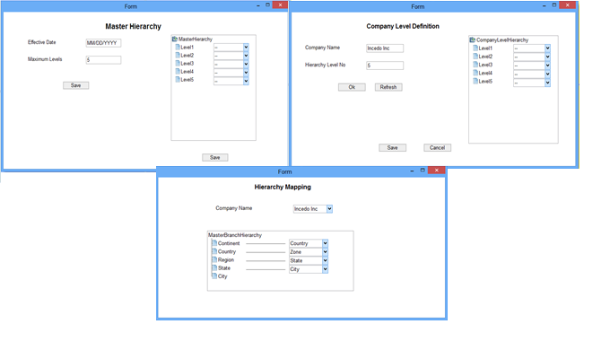

**Data Model**

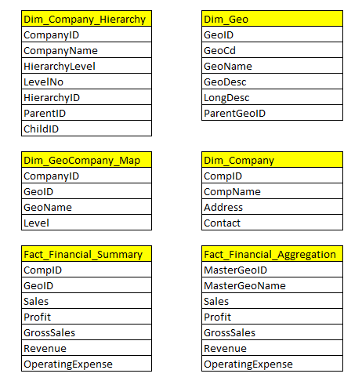

**Business Impact**

