Flex!Plex! 

Abstract:
Implementing a integrated rule based platform using AWS services giving us the control to provide painless upgrades and high adoption as multiple devices can be connected at once. An internet connection and a user machine is all the infrastructure you need for using this. The platform emcompasses data generation, collection and processing. A cloud based architecture which will make use of free/cost efficient API’s and low compute on processing algorithms. Rule driven processing will give us integrated result which in-return will display consolidated reports and notifications to the designated user. The abiltiy to choose the way any data will be processed by this platform depending on easily understandable user-rules is the essence of Flex!Plex!.

Solution Approach:
We are working on building a prototype platform using wide variety of aws services such as Lambda, S3 etc. along with the public API for Virustotal to help identify malicious content being downloaded/installed on the monitored machines. The user activities will be captured by the, system independent, python powered, background processes running on all the monitored machines on the network and transmitted to a common location on S3 which would consolidate all the data and further transmit the info to Lambda functions over cloud for analysing the infected files with the help of Virustotal API and gather the info generated by various anti-virus clients to conclude the integrity/relevancy of the file. The user would also have flexibility to upload the file manually or provide access to the service running in the background to schedule the auto upload of data.
Consolidated report would be generated in order to graphically represent the overall health of the monitored system and also the designated Admin/users will be alerted via mail for any unwanted files being handled.
The platform will be rule driven and the future scope would be to enable user to identify the type of cloud processing needs to be performed on data being captured from the systems connected over a network.

Design Architecture:

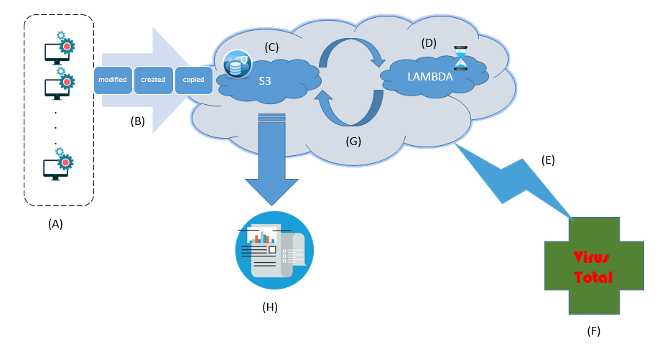
(A) - All the systems with a python watchdog process running in background and monitoring user activities.
(B) - Any file modified, created or copied will be identified and limited data will be reported to S3 cloud service in a structured format.
(C) - User will also have access to manually upload the file to S3 for validation or configuring the auto upload batch.
(D) - As soon as the data gets loaded to S3, the Lambda function on the cloud will be triggered for execution. There will continuous interaction between S3 and Lambda.
(E) - The Lambda function implemeted in Java will then take the data present in flat file format and make a call to publicly available VirusTotal API.
(F) - VirusTotal will then queue the file SHA-256 and run it through its system to identify malicious content.
(G) - Lambda function will then take the output from Virus total to send processed data back to S3 in JSON format.
(H) - System will then send a mail to Admin, alerting him of activity and sending a consolidated report of all the systems being monitored in graphical representation.

Business Impact:
Data and cloud has been the buzz words in industry and the hype around it is justified considering the time we live in, this age calls for not just storing the data but processing and making it available to the end user on his fingertips.
With growing number of SME’s, the need for cost efficient services are on the uprising. Cutting the corners does not mean compromising the integrity of the system.
That’s were Flex!Plex! comes into picture, it uses the widely adopted and secure services of aws clubbed with flexibility of automated data provision. Rule engine will play a prominent role in driving the data processing over cloud which would in-return enable us to cater the needs of different requirements.
Each day we come across whole bunch of new threats lurking around to take down systems and our working prototype just about provides a balanced solution between the cost and security, it utilizes the free API’s made available by VirusTotal for threat detection along with cost efficient services of aws to provide data processing.
Disclaimer: This is not an alternative to your anti-virus client, it is merely a service which enables you to only identify and provide graphically intuitive reports on a broader spectrum for the system admin to easily monitor the integrity of the system.

