**Rekroot**

**Software Architecture Document**

**Version 1.0**

1. **Abstract**

In our application we are going to solve the problem of finding best matches for a job description (JD).

From the tons of candidate profiles stored at a common location our solution will find out the best fits for your requirements on the basis of their suitability score.

Above suitability score will be calculated by our ranking algorithm considering parameters like but not limited to education background, skills/technologies worked, experiences, organizations worked in and experience etc.

1. **Solution approach**

Our integrated approach will help you find not only the best quality candidates, but more of them; streamline the process so you can save time and money; and make smarter, more informed decisions that improve your ROI.

1. **Business Impact**
   1. Reach thousands of targeted job seekers for your vacancy and start reviewing qualified candidates the same day.
   2. It is an intelligent tool that automates the manual task of searching and sorting the profiles matching a particular JD.
   3. Power CV Search helps you pinpoint the best-qualified candidates in less time.
   4. It provides a cost-effective solution to filling specific vacancies in selected domains.
2. **Design Architecture**

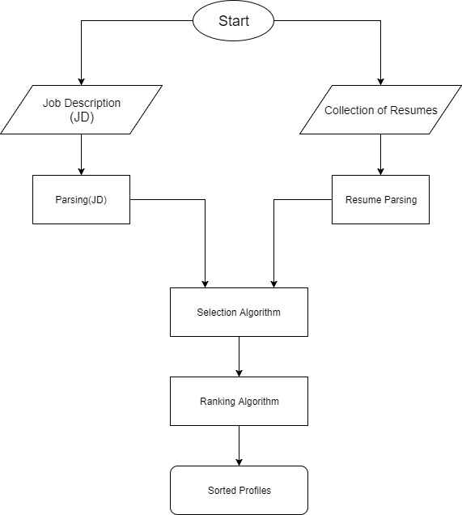

Fig1- Flow diagram

**4.1. Technologies used:**

Frontend: AngularJS,HTML,Bootstrap

Backend: NodeJS,R

Database: MongoDB

Hosting/Server :AWS EC2, S3 etc as required

**4.2. Product Functions:**

Application will help recruiters with finding most suitable candidates for a given JD.

* A recruiter will provide JD and set of resumes and will submit
* On click of some button ‘Process/Find’ (say) system will provide list of profiles in suitability order.

**4.3. Use case diagram**

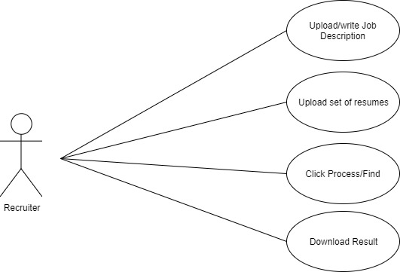

Fig2- Use case diagram