A
PROJECT REPORT ON
Institute Management System
SUBMITTED IN
PARTIAL FULFILLMENT OF

DIPLOMA IN ADVANCED COMPUTING (PG-DAC)
BY
Karan Narkhede
Ajit Kulwant
UNDER THE GUIDENCE OF

<Girish Barhate >
AT

SUNBEAM INSTITUTE OF INFORMATION TECHNOLOGY,
KARAD

SUNBEAM INSTITUTE OF INFORMATION TECHNOLOGY,
KARAD.
CERTIFICATE
This is to certify that the project
Institute Management System

Has been submitted by
Karan Narkhede
Ajit Kulwant
In partial fulfillment of the requirement for the Course of PG Diploma in Advanced Computing (PG-DAC AUG2019) as prescribed by The CDAC ACTS, PUNE.
Place: Karad | Date: 30-JAN-2016
<Project Guide Name> | <Alumni Mentor Name>
Girish Barhate | Alumni Mentor

ACKNOWLEDGEMENT

ABSTRACT
Online Institute Management System provides a common platform for student,teacher and admin to manage activities like adding course , joining course , viewing various details about there activities like attendance, marks etc . This will help teachers to keep track of various important details like making announcement, sharing various info about the course he is going to teach. Admin will have all mode access as he will be able to all the details about students, teachers and courses and will be able to track activities off institute.
INDEX
 | INTRODUCTION | 1
 | 1.1 Introduction | 2
 | Product Overview and Summary
 | 2.1 Purpose
 | 2.2 Scope
 | 2.3 User Classes and Characteristics
 | 2.4 Design and Implementation Constraints
 | REQUIREMENTS
 | 3.1 Functional Requirements
 | 3.1.1 Use case for Administrator.
 | 3.1.2 Use case for Customer.
 | 3.2 Non - Functional Requirements
 | 3.2.1 Usability Requirement
 | 3.2.2 Performance Requirement
 | 3.2.3 Reliability Requirement
 | 3.2.4 Portability Requirement
 | 3.2.5 Security Techniques
 | PROJECT DESIGN
 | 4.1 Data Model
 | 4.1.1 Database Design
 | 4.2 Process Model
 | 4.2.1 Functional Decomposition Diagram
 | 4.2.2 Data Flow Diagram (DFD)
 | TEST REPORT
 | PROJECT RELATED STATISTICS
 | CONCLUSION
LIST OF TABLES
Section | Table Title | Page

LIST OF FIGURES
Section | Figure Title | Page

INTRODUCTION

1.1 Introduction

Online Institute Management System provides a common platform for student,teacher and admin to manage activities like adding course , joining course , viewing various details about there activities like attendance, marks etc . This will help teachers to keep track of various important details like making announcement, sharing various info about the course he is going to teach. Admin will have all mode access as he will be able to all the details about students, teachers and courses and will be able to track activities off institute.

Product Overview and Summary

Functionalities of design pages

Project contain modules:
1-Teacher
2-Admin
3-Student

Teacher

1.Login:
In teacher login page it contains teacher's username and password if teacher’s is already registered then teacher click login button, otherwise click on the registration button. Before proceeding with login they have to verify CAPTCHA. It will prevent any unwanted attack to crash the site. This will allow us to prevent unauthorized access.

2.Registration:
In student registration we are taking input from student like email-id as username, password should be 8 character including special character, number, date of birth in the form of like dd/mm/yyyy format, gender, address, mobile number etc. and after filling these information click on register button. Here also we are providing CAPTCHA verification system.

3.Payment Paid Details:
Here teacher will be able to see all the details about student who paid the course fees and details of student who still not paid any fees.

4.Profile:
Personal and academic information about himself can be seen here.

Student

1.login:
In student login page it contains student’s username and password if student is already registered then student click login button,otherwise click on the registration button. Before proceeding with login they have to verify CAPTCHA. It will prevent any unwanted attack to crash the site. This will allow us to prevent unauthorized access.

2.Registration:
In student registration we are taking input from student like email id as username, password should be 8 character including special character, number, date of birth in the form of like dd/mm/yyyy format, gender, address, mobile number etc. and after filling these information click on register button. Here also we are providing CAPTCHA verification system.

3.Take admission to course:
It contains list of courses for which student can take admission, all the course details can be seen here. This is going to help to keep track of all course activities like attendance record, marks, time table etc.

4.Make Payment:
After selecting course for making payment click on Payment in that there is option for net banking or credit card or debit card after that click on make payment.

5.Course Schedules
This page contains information about schedule of courses.

6. Notification:
Various notification regarding exams, batch schedule, announcement will be displayed here.

7.Profile:
Personal and academic information about himself can be seen here.

ADMIN

1.Log in:
In admin login page it contains admin’s username and password. After taking input from admin click on login button.

2. Student’s Detail:
After login admin can see buttons like student details and all the course joined by student . Managing feedback and complaint about all the issues posted by teacher and students.

3. Teacher’s Detail:
After login admin can see buttons like teacher details and all the course taught by teacher .Managing feedback and complaint about all the issues posted by teacher and students.

4. Courses details
After login admin can see buttons like student details,teacher details and all the course provided by institute . Adding new courses for different classes. Managing feedback and complaint about all the issues posted by teacher and students.

5.Profile:
Personal and academic information about himself can be seen here.

Main Page
When non-registered user wants to explore this website he/she will be redirected here.
This page will contain following pages.
1-Home Page
2-All courses
3-Batch registration
4-Careers

Home Page:
It will contain info regarding how website works, how to register to courses, general inquiry pages, contact information, information regarding branches etc.

All courses:
It will provide information regarding all course provided by institute. It will have fees structure , syllabus details, batch timing etc

Batch registration
Students can register for any active course through this page.

Careers
It will contain information regarding current opening in institute. If anyone interested they can apply for job through this page.

Use Case

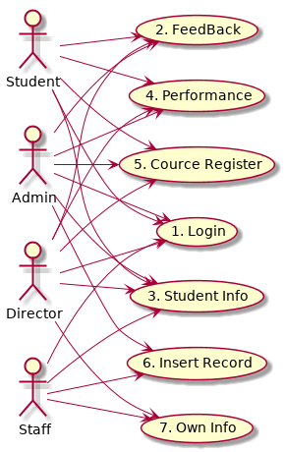

Project Design
DataBase Design

ADDRESS TABLE

ADMIN_TABLE

COURSE_TABLE

FEEDBACK_TABLE

COURSE_EXPERT_TABLE

EXPERT_REGISTRATION_TABLE

STUDENT_COURSE_TABLE

STUDENT_REGISTRATION_TABLE

USER_LOGIN_TABLE

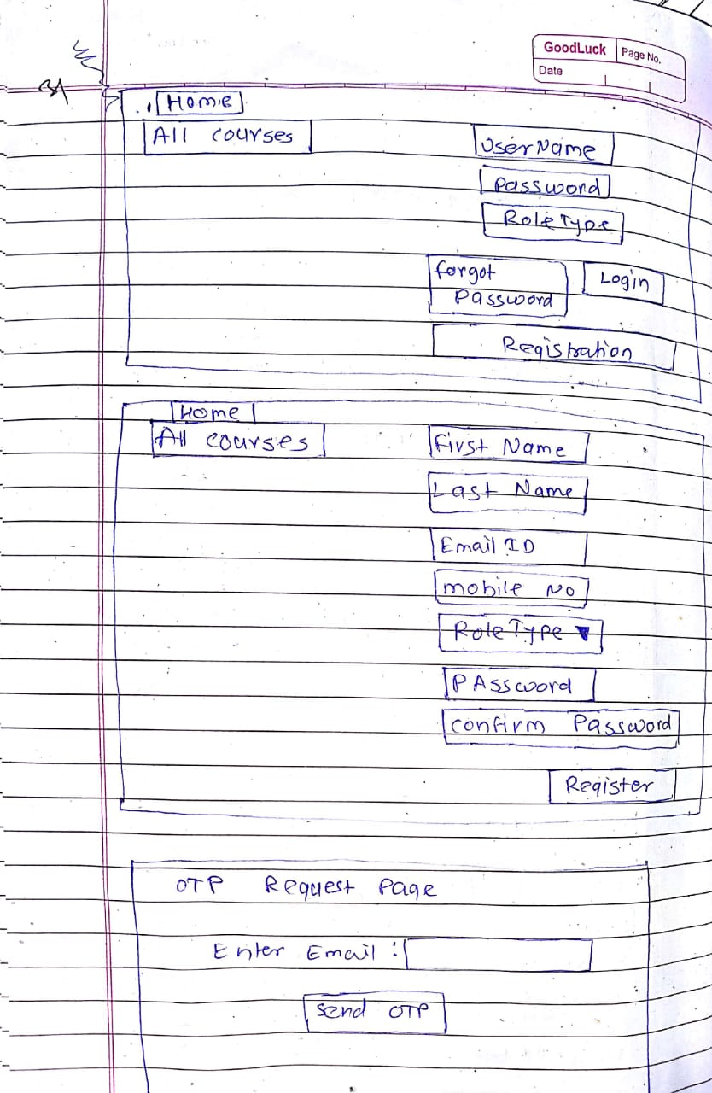
Appendix B

