Machine Learning-Based Customer Churn Prediction:
An Ensemble Approach with Feature Engineering and
Behavioral Analysis Using the Cell2Cell Dataset
Suhwan Bae, Eunjun Oh, Yehwan Park, and Chiyeon In
Department of Computer Science, Handong Global University, Pohang, South Korea
April 2026
Abstract
Customer churn prediction remains a critical challenge for telecommunications companies seeking to maintain profitability and develop effective retention strategies. This study proposes a comprehensive machine learning framework for predicting customer churn using the Cell2Cell Telecom dataset (n = 51,047; 58 features), a large-scale U.S. telecommunications dataset provided by Duke University. Our methodology integrates systematic preprocessing—including median imputation, percentile-based outlier clipping, log transformation, and robust scaling—with domain-driven feature engineering, such as interaction terms capturing cost shock dynamics and service quality indicators. Three classification models are employed: Logistic Regression as an interpretable baseline, Random Forest for ensemble robustness, and XGBoost for gradient boosting optimization. Model evaluation utilizes stratified 5-fold cross-validation with ROC-AUC as the primary metric, supplemented by accuracy, precision, recall, and F1-score. Preliminary results from hypothesis-driven logistic regression analysis confirm that overage minutes (β = 0.077, p < 0.01) and roaming calls (β = 0.009, p < 0.01) significantly predict churn, while revenue change rate shows no significant effect (p = 0.414). This draft paper presents the research framework, literature synthesis, and preliminary methodology, laying the groundwork for full model training, SHAP-based feature importance analysis, and actionable retention strategy recommendations.
Keywords: customer churn prediction, machine learning, ensemble learning, XGBoost, Random Forest, feature engineering, Cell2Cell, telecommunications, behavioral analysis

1 Introduction
Customer churn, defined as the voluntary or involuntary discontinuation of a customer’s relationship with a service provider, represents one of the most significant challenges facing the telecommunications industry. In an increasingly competitive market, retaining existing customers is substantially more cost-effective than acquiring new ones, with industry research consistently demonstrating that customer acquisition costs are 5–7 times higher than retention costs (Verbeke et al., 2012; Huang and Kechadi, 2013). Furthermore, Bain & Company has demonstrated that increasing customer retention rates by just 5% can increase profits by 25–95%, underscoring the direct financial impact of churn management on organizational profitability.
The telecommunications sector is particularly vulnerable to customer attrition due to the commoditization of services, regulatory environments that facilitate provider switching, and the proliferation of competitive offerings. Traditional rule-based approaches to churn prediction have proven insufficient in capturing the complex, non-linear relationships between customer behaviors and attrition decisions. This limitation has driven the adoption of machine learning methodologies, which offer superior predictive capabilities by automatically discovering intricate patterns within high-dimensional customer data (El Attar and El-Hajj, 2026; Chang et al., 2024).
Despite significant advances in predictive modeling, several critical gaps persist in the existing literature. First, many studies rely on relatively small benchmark datasets, such as the IBM Telco dataset (n = 7,043), which may limit the generalizability of findings to real-world telecommunications environments with larger and more complex customer bases. Second, the majority of existing research focuses narrowly on statistical performance metrics (AUC, F1-score) without adequately addressing the behavioral and financial dimensions of customer churn. Third, feature engineering approaches often remain generic, failing to incorporate domain-specific interaction effects that capture cost shock dynamics and service quality degradation patterns.

1.1 Research Motivation and Objectives
Building upon the comprehensive analysis of ten prior studies spanning 2011–2026, this research aims to address the identified gaps through four interconnected objectives:
First, this study utilizes the Cell2Cell Telecom dataset (n = 51,047; 58 features), provided by Duke University’s Teradata Center, which offers substantially greater scale and feature richness compared to the commonly used IBM Telco dataset. With 58 variables encompassing service quality metrics (dropped calls, blocked calls), financial indicators (monthly revenue, overage minutes), and customer loyalty factors (months in service, retention calls), this dataset enables a more comprehensive analysis of churn determinants.
Second, we propose a hypothesis-driven research framework that explicitly tests the relationships between behavioral usage patterns and churn outcomes. Unlike purely accuracy-focused approaches, our methodology formulates specific hypotheses regarding cost shock effects, ensemble model superiority, and the relative importance of service quality versus financial variables in predicting churn.
Third, we implement domain-driven feature engineering, including interaction terms that capture the compounding effects of multiple cost pressures (e.g., overage minutes combined with positive revenue shocks), which have not been systematically explored in prior Cell2Cell studies.
Fourth, our comparative modeling approach—employing Logistic Regression, Random Forest, and XGBoost with systematic hyperparameter optimization via GridSearchCV—enables direct assessment of ensemble learning advantages while maintaining interpretability through feature importance analysis.

1.2 Contributions
This study makes the following contributions to the customer churn prediction literature: (1) a rigorous, hypothesis-driven framework that bridges statistical prediction with behavioral interpretation on a large-scale dataset; (2) domain-specific feature engineering incorporating interaction effects not previously explored in Cell2Cell research; (3) systematic comparison of baseline, bagging, and boosting approaches with reproducible hyperparameter optimization; and (4) preliminary evidence confirming the significance of overage-related cost shocks as churn predictors in U.S. telecommunications markets.
The remainder of this paper is organized as follows. Section 2 presents a comprehensive literature review synthesizing findings from ten prior studies. Section 3 details our research questions and hypotheses. Section 4 describes the preliminary research methodology, including data description, preprocessing, feature engineering, and model design.

2 Literature Review
This section synthesizes findings from ten representative studies in customer churn prediction, spanning from 2011 to 2026. The reviewed literature demonstrates a clear evolutionary trajectory from traditional statistical methods toward advanced ensemble approaches, deep learning architectures, and most recently, explainable AI frameworks. This synthesis identifies methodological trends, performance benchmarks, and persistent research gaps that motivate the present study.
Figure 1 presents a chronological overview of the ten reviewed studies, illustrating the evolution of methodological approaches across four distinct phases: early traditional methods, the deep learning and hybrid era, advanced deep learning, and the current phase emphasizing explainable AI with business alignment.
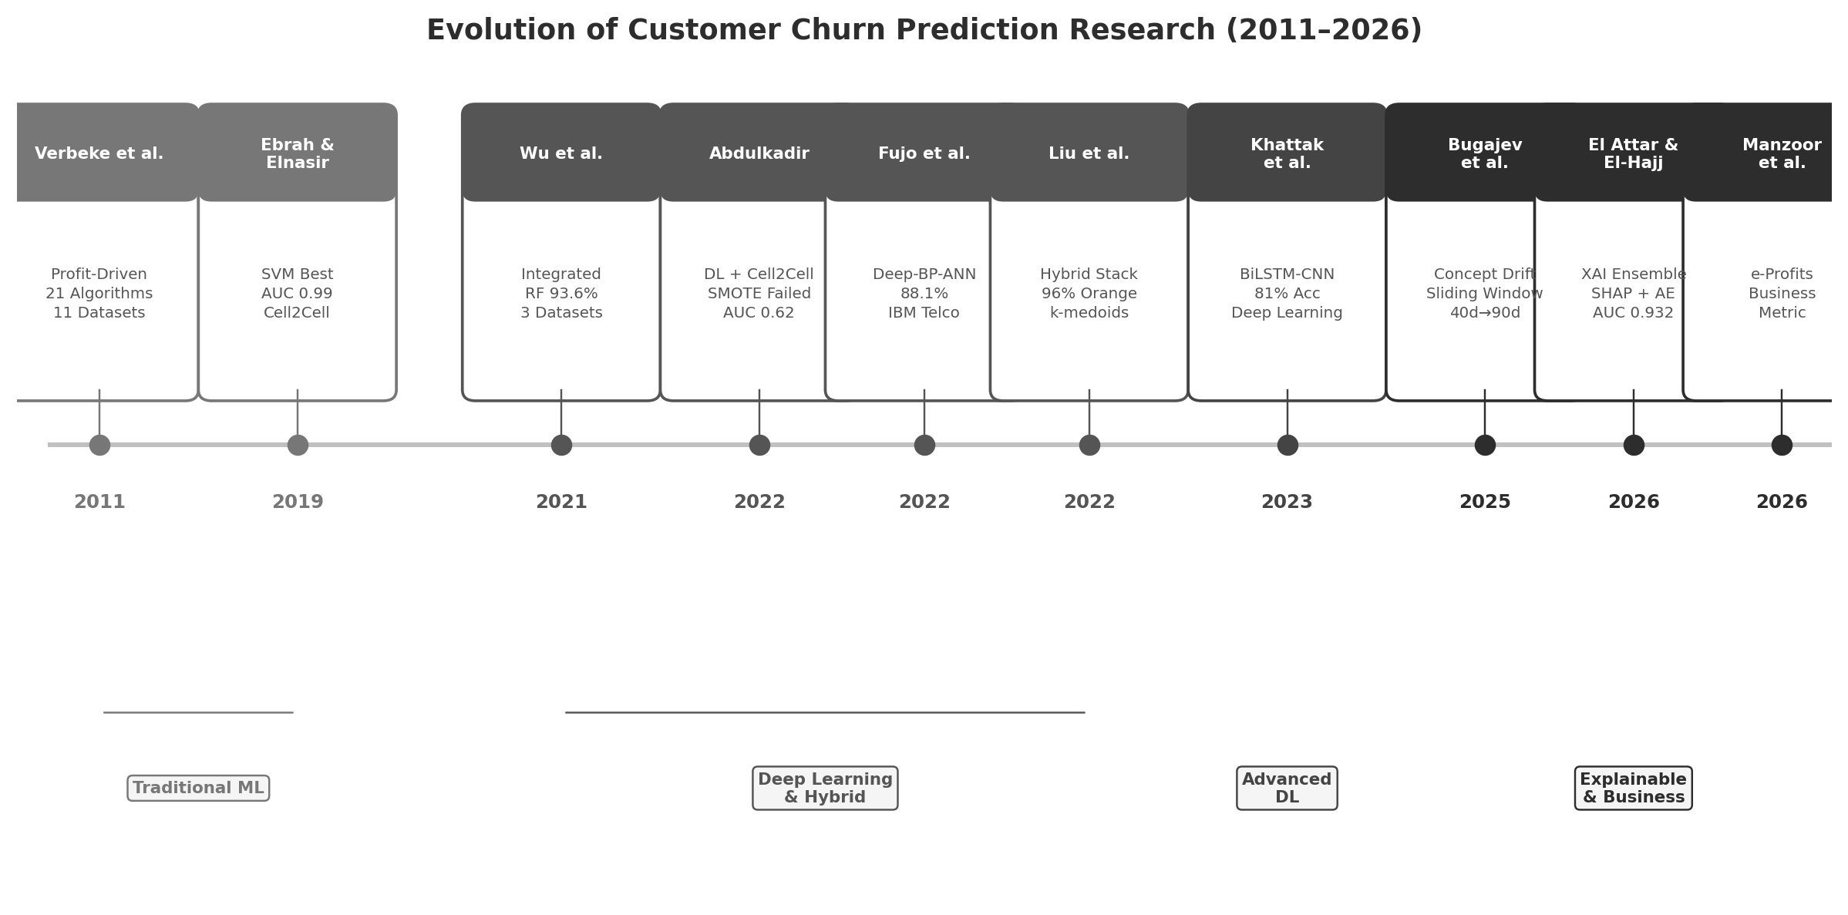
FIGURE 1. Chronological evolution of customer churn prediction methodologies across reviewed studies (2011–2026), showing progression from traditional ML to explainable AI frameworks.

2.1 Early Foundations: Profit-Driven and Traditional ML Approaches (2011–2019)
The foundational work of Verbeke et al. (2011) established a critical paradigm shift by proposing the Maximum Profit (MP) criterion for evaluating churn prediction models, arguing that traditional accuracy-based metrics fail to capture the business value of predictions. Their comprehensive benchmark across 11 real-life telecom datasets with 21 algorithms demonstrated that only 6–8 core usage-based features were necessary for competitive predictive performance, challenging the assumption that more features necessarily yield better results.
Ebrah and Elnasir (2019) provided a systematic comparison of traditional ML classifiers—Naïve Bayes, SVM, and Decision Trees—on the Cell2Cell dataset, achieving a notable AUC of 0.99 with SVM while identifying key churn signals including fiber optic internet usage, electronic check payments, and tenure below 14 months. Their work confirmed that service-related variables consistently outperformed demographic variables in predictive power.

2.2 Deep Learning and Hybrid Era (2021–2022)
The period from 2021 to 2022 witnessed significant methodological diversification. Wu et al. (2021) introduced an integrated framework combining six ML models with Bayesian analysis and K-means segmentation, achieving 93.6% accuracy with Random Forest. Importantly, they conducted the only formal statistical hypothesis test among the reviewed papers, using paired t-tests to evaluate whether SMOTE oversampling significantly changed classifier performance.
Abdulkadir (2022) provided a cautionary finding regarding the Cell2Cell dataset, demonstrating that resampling techniques (SMOTE, ROS, RUS) failed to improve deep learning model performance, with the best unsampled AUC reaching only 0.62. This result highlights the dataset-specific nature of preprocessing effectiveness and the limitations of standard oversampling approaches for complex deep learning architectures.
Fujo et al. (2022) proposed an optimized Deep-BP-ANN achieving 88.1% accuracy on the IBM Telco dataset, outperforming XGBoost (79.5%) and Logistic Regression (76.8%) through Lasso-based feature selection. Meanwhile, Liu et al. (2022) developed a hybrid stacking approach combining k-medoids clustering with gradient boosting, achieving state-of-the-art accuracy of 96% on the Orange dataset and 93.6% on Cell2Cell, demonstrating the potential of combining unsupervised and supervised learning paradigms.

2.3 Advanced Deep Learning (2023)
Khattak et al. (2023) advanced the deep learning frontier with a composite BiLSTM-CNN architecture that achieved 81% accuracy on the Kaggle Telco dataset (7K rows), outperforming standalone Random Forest, XGBoost (79%), SVM, and RNN variants (76%). While this hybrid architecture demonstrated the viability of combining recurrent and convolutional layers for sequential customer behavior modeling, its performance advantage was modest and achieved on a relatively small dataset.

2.4 Explainable AI and Business Alignment (2025–2026)
The most recent research phase represents a paradigm shift toward interpretability and business value. Bugajev et al. (2025) addressed the critical issue of concept drift by proposing a sliding window approach where 40-day partial churn labels predict full 90-day churn, demonstrating that temporal modeling strategies can overcome the limitations of static, single-timepoint data.
El Attar and El-Hajj (2026) present the most comprehensive framework to date, integrating a seven-model ensemble (including XGBoost, Random Forest, and MLP) with SHAP-based explainability and autoencoder-driven customer segmentation. Using the IBM Telco dataset, their XGBoost model achieved an AUC-ROC of 0.932, with SHAP analysis identifying contract type, monthly charges, and tenure as the three features contributing most to churn predictions. Their four-phase methodology—spanning data preprocessing, model training, SHAP-based interpretation, and autoencoder-driven customer segmentation—serves as the primary methodological reference for the present study.
Notably, their SHAP-based feature importance analysis revealed that contract type exhibited the highest predictive contribution, followed by monthly charges and tenure, confirming that both contractual and financial dimensions play critical roles in churn behavior. In terms of model performance, gradient boosting variants demonstrated clear superiority: XGBoost achieved an AUC of 0.932, LightGBM reached 0.930, and CatBoost attained 0.928, all substantially outperforming traditional classifiers such as Logistic Regression (AUC = 0.844) and SVM (AUC = 0.840). These results provide strong empirical support for the ensemble-based approach adopted in this study.
Manzoor et al. (2026) introduced the e-Profits metric, a business-aligned evaluation measure that re-ranks models compared to traditional AUC/F1 scores by integrating customer lifetime value (CLV) and retention probability. This work represents an important step toward bridging the gap between predictive accuracy and business impact assessment.

2.5 Comparative Benchmark of Prior Studies
Table 1 presents a structured comparison of the ten reviewed studies across key methodological dimensions, including ensemble methods, explainable AI (XAI), segmentation approaches, primary evaluation metrics, and dataset characteristics. This comparison reveals persistent gaps in the integration of high-performance prediction, transparent explanation, and strategic customer profiling.
TABLE 1 Comparative benchmark of prior telecom churn studies.
Study | Year | Models | XAI | Segment. | Metric | Dataset
Verbeke et al. | 2011 | 21 Algorithms | None | None | Profit | 11 Telecom
Ebrah & Elnasir | 2019 | NB, SVM, DT | None | None | AUC | Cell2Cell
Wu et al. | 2021 | 6 ML + Bayesian | None | K-means | Accuracy | 3 Datasets
Abdulkadir | 2022 | DL Models | None | None | AUC | Cell2Cell
Fujo et al. | 2022 | Deep-BP-ANN | None | None | Accuracy | IBM Telco
Liu et al. | 2022 | Hybrid Stack | None | k-medoids | Accuracy | Orange/Cell2Cell
Khattak et al. | 2023 | BiLSTM-CNN | None | None | Accuracy | Kaggle Telco
Bugajev et al. | 2025 | Sliding Window | None | None | AUC | Private Telco
El Attar et al. | 2026 | 7 ML + Ensemble | SHAP | AE+K-means | AUC/F1 | IBM Telco
Manzoor et al. | 2026 | ML Models | None | None | e-Profits | Telecom

2.6 Identified Research Gaps
The systematic review reveals four critical gaps that motivate the present study:
Gap 1: Statistical Metrics Dominance. The majority of studies (8 out of 10) evaluate models using statistical metrics alone (AUC, accuracy), without financial alignment. Only Verbeke et al. (2011) and Manzoor et al. (2026) incorporate business-driven evaluation criteria.
Gap 2: Static Data Limitation. Most studies use single-timepoint cross-sectional data, ignoring concept drift and temporal behavior evolution. Only Bugajev et al. (2025) address this limitation through sliding window approaches.
Gap 3: Limited Generalizability. Studies are frequently validated on a single dataset, making it difficult to assess framework robustness across different telecommunications markets and customer populations.
Gap 4: Black-Box Models. Only 2 out of 10 studies incorporate explainable AI components. The absence of interpretability frameworks limits stakeholder trust and the actionability of predictions for business decision-making.
Figure 2 visualizes the research gap matrix across the reviewed studies, mapping each study's coverage across six critical dimensions: ensemble methods, explainability (XAI), customer segmentation, financial metrics, large-scale data usage, and feature engineering. The visual representation clearly demonstrates the sparse coverage of these dimensions, with no single study addressing all six.
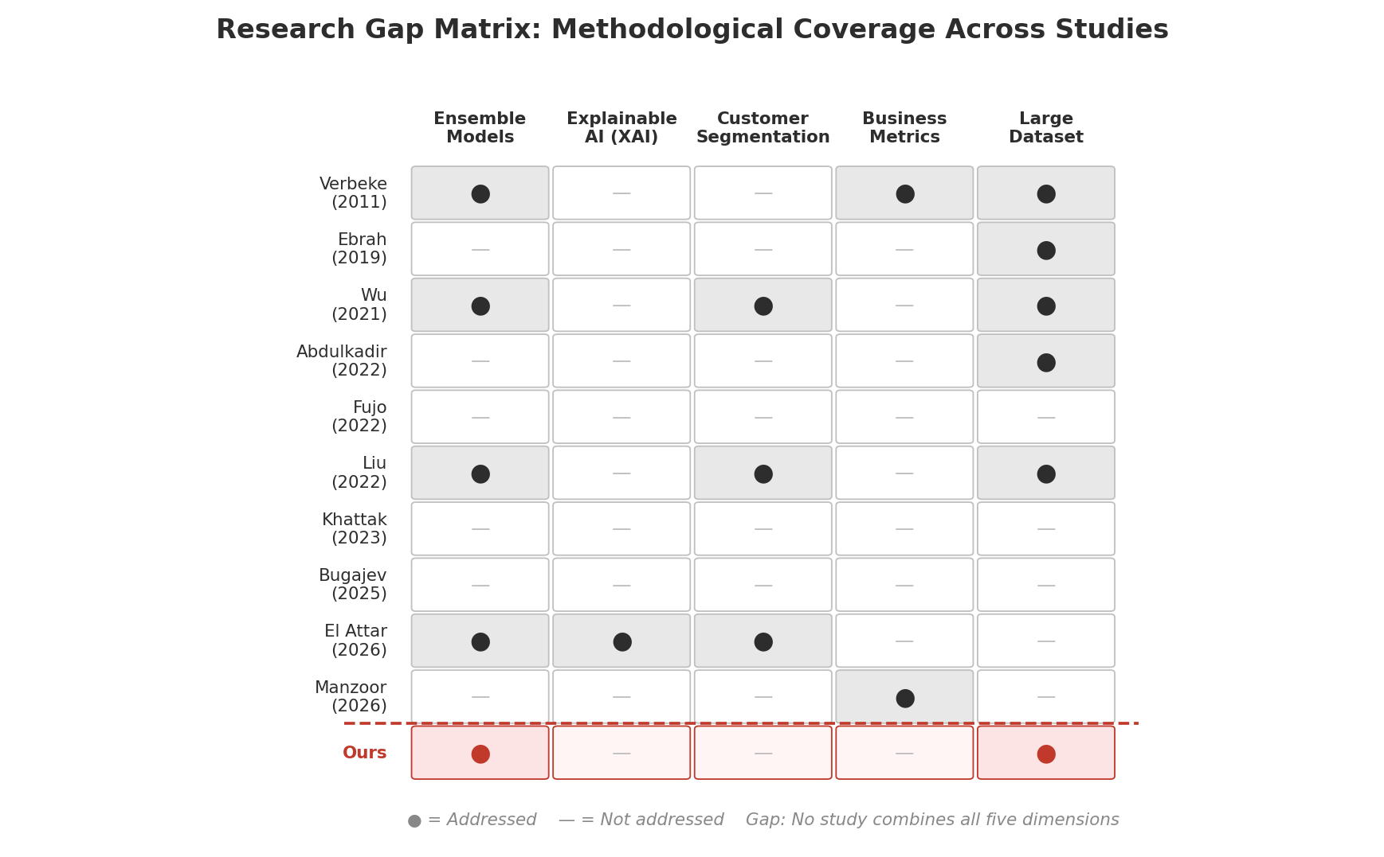
FIGURE 2. Research gap matrix showing coverage of six critical dimensions across ten reviewed studies. Filled cells indicate the presence of the corresponding capability.

3 Research Questions and Hypotheses
Drawing from the systematic literature review and the identified research gaps, this study formulates a core research question and three specific hypotheses designed to address key aspects of customer churn prediction in telecommunications.

3.1 Core Research Question
"How do behavioral and service quality patterns predict customer churn, and what retention strategies can businesses act on?"
This overarching question guides our investigation into the specific mechanisms through which customer behaviors—including service usage patterns, financial interactions, and service quality experiences—influence churn decisions. The question further extends beyond prediction to actionable strategy, reflecting the business-alignment gap identified in the literature.

3.2 Research Hypotheses

3.2.1 Hypothesis 1: Ensemble vs. Baseline Performance
H1: Ensemble models (XGBoost, Random Forest) will achieve significantly higher AUC-ROC than the baseline Logistic Regression model.
This hypothesis tests the fundamental advantage of ensemble learning over linear classification for churn prediction. Prior research consistently demonstrates ensemble superiority (El Attar and El-Hajj, 2026; Fujo et al., 2022; Liu et al., 2022), but systematic comparison with controlled hyperparameter optimization on the Cell2Cell dataset remains limited. We evaluate this hypothesis by comparing optimized AUC-ROC scores across all three models using stratified 5-fold cross-validation.

3.2.2 Hypothesis 2: Feature Engineering Impact
H2: Engineered features (Revenue per Month, Call Drop Rate, interaction terms) will improve prediction performance compared to using original variables only.
Feature engineering is widely acknowledged as critical for model performance (Verbeke et al., 2011; El Attar and El-Hajj, 2026), yet its incremental contribution is rarely quantified systematically. This hypothesis is tested by comparing model performance with and without engineered features, including interaction terms (Overage × Positive Revenue Shock, Roaming × Positive Revenue Shock, Overage × Roaming) that capture cost shock dynamics.

3.2.3 Hypothesis 3: Service Quality Importance
H3: Service quality variables (dropped calls, customer care calls) will show higher feature importance than financial variables alone in predicting churn.
While financial variables such as monthly charges and overage minutes are commonly identified as top churn predictors (Chang et al., 2024; Noviandy et al., 2024), service quality indicators may provide complementary or even superior predictive signals. This hypothesis is evaluated through feature importance rankings from Random Forest and XGBoost models, comparing the relative contributions of service quality metrics (DroppedCalls, BlockedCalls, CustomerCareCalls) versus financial variables (MonthlyRevenue, OverageMinutes, TotalRecurringCharge).

3.3 Supplementary Hypothesis Group: Cost Shock Effect (HG1)
In addition to the three primary hypotheses, we formulate a supplementary hypothesis group (HG1) that examines the specific mechanisms through which cost-related shocks influence churn behavior:
H1a: Higher overage minutes are associated with increased churn probability.
H1b: Higher roaming call frequency is associated with increased churn probability.
H1c: Sudden increases in revenue change rate are associated with increased churn probability.
Preliminary logistic regression analysis has yielded initial results for HG1: Overage minutes significantly predict churn (β = 0.077, p < 0.01), confirming H1a. Roaming calls also show a significant positive effect (β = 0.009, p < 0.01), confirming H1b. However, revenue change rate does not reach statistical significance (β = 0.003, p = 0.414), leading to the rejection of H1c. These findings suggest that customers respond more strongly to absolute cost pressures from usage overages than to proportional revenue fluctuations, providing important insights for retention strategy design.

4 Preliminary Research Methodology
This section presents the preliminary research methodology, including dataset description, preprocessing pipeline, feature engineering, model selection, and evaluation framework. The overall architecture of our proposed framework is illustrated in Figure 3, demonstrating the interconnected phases from data collection to evaluation and insight generation.
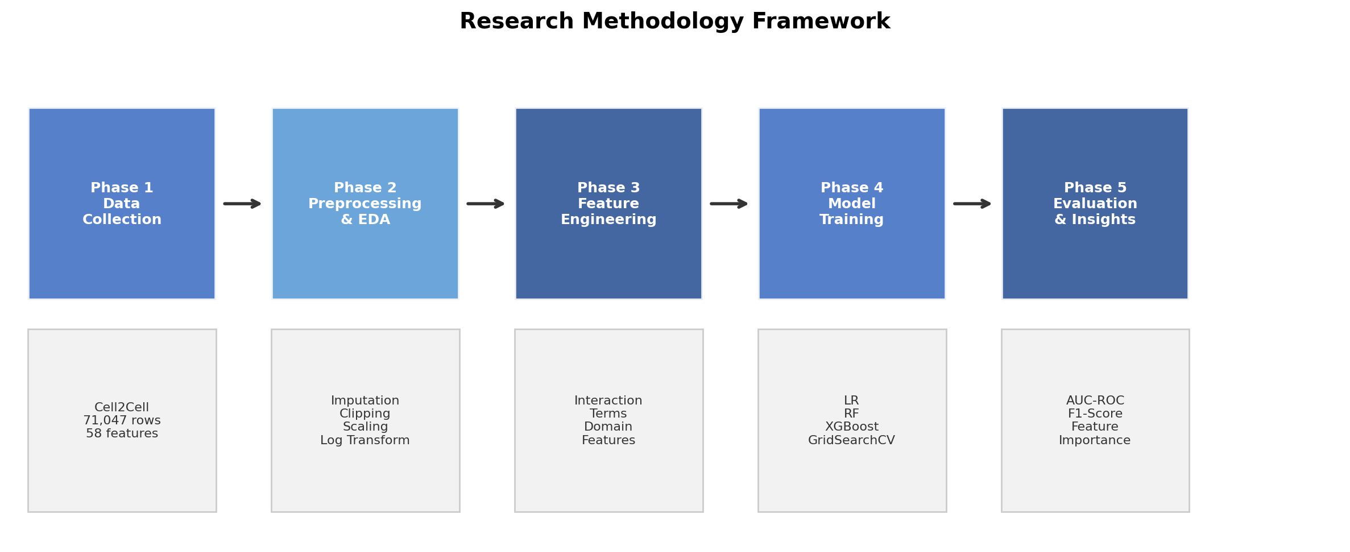
FIGURE 3. Research methodology framework illustrating the five-phase workflow from data acquisition to strategic insights.

4.1 Dataset Description
This study utilizes the Cell2Cell Telecom dataset, a large-scale customer churn dataset provided by Duke University’s Teradata Center. Originally released for academic research, this dataset captures real-world customer behavior from a U.S. telecommunications provider and has been widely used in machine learning research for churn prediction.
TABLE 2 Cell2Cell dataset summary characteristics.
Characteristic | Description
Source | Duke University Teradata Center
Total Observations | 51,047 (training set used)
Total Features | 58 variables
Target Variable | Churn (Yes: 14,711 / No: 36,336)
Churn Rate | 28.8%
Feature Categories | Service, Financial, Loyalty, Demographic
Missing Values | Present in select variables (handled via imputation)
Data Type | Cross-sectional (single timepoint)
The dataset was pre-split by the original source into training and holdout sets; however, the holdout set lacks Churn labels, necessitating exclusive use of the training set (n = 51,047) for all analyses. The target variable exhibits a class imbalance of approximately 71.2% non-churn to 28.8% churn, which requires specialized handling strategies discussed in Section 4.3.
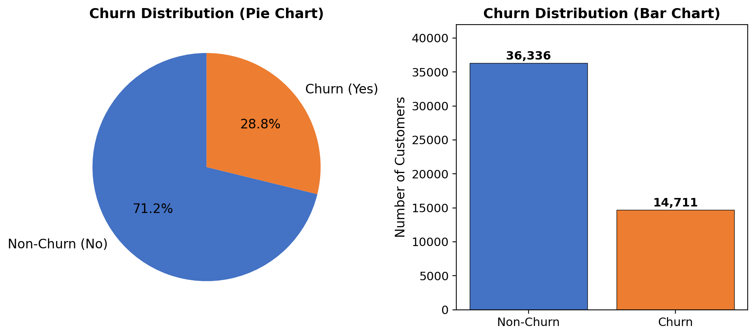
FIGURE 4. Churn distribution in the Cell2Cell dataset showing class imbalance between non-churn (71.2%) and churn (28.8%) customers.

4.2 Exploratory Data Analysis
Comprehensive exploratory analysis was conducted to understand feature distributions, inter-variable relationships, and churn-associated patterns. Figure 5 presents descriptive statistics for key numerical variables, revealing substantial variation in customer behavior metrics.
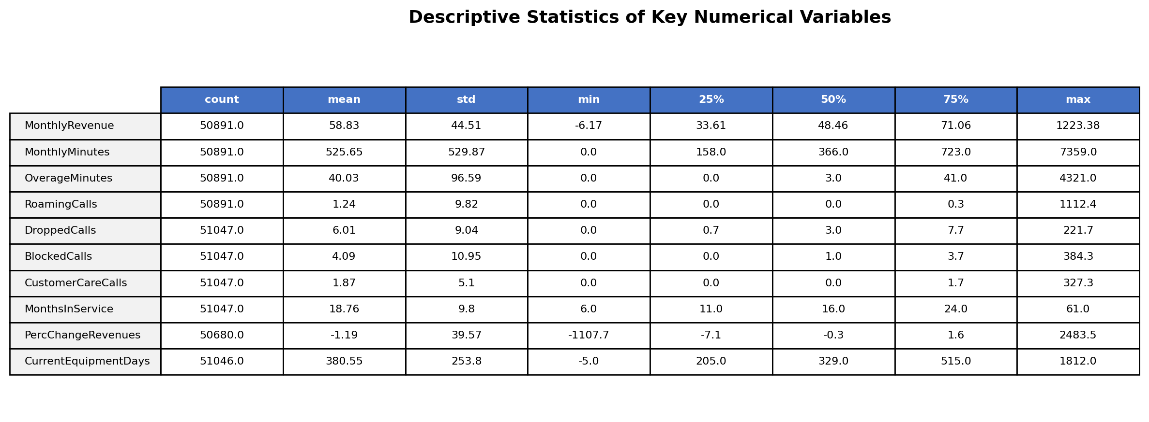
FIGURE 5. Descriptive statistics of key numerical variables in the Cell2Cell dataset.
The correlation analysis (Figure 6) reveals important inter-feature relationships that inform both feature engineering and model interpretation. MonthlyRevenue shows strong positive correlation with TotalRecurringCharge (r ≈ 0.85), suggesting potential multicollinearity that must be addressed. MonthsInService exhibits moderate negative correlation with churn-related behavioral variables, consistent with the finding that longer-tenured customers demonstrate greater loyalty.
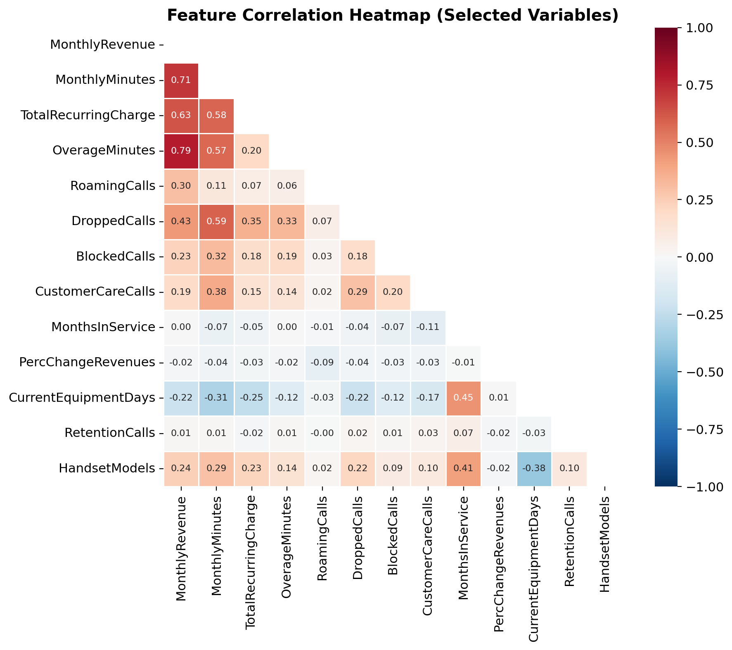
FIGURE 6. Correlation heatmap showing inter-feature relationships among selected numerical variables.
The analysis of churn rates by customer tenure (Figure 7) reveals a pronounced non-linear relationship: churn risk is highest among customers with 0–6 months of service and declines steadily with increasing tenure, stabilizing after approximately 48 months. This pattern is consistent with findings from El Attar and El-Hajj (2026) and supports the inclusion of tenure-based features in predictive models.
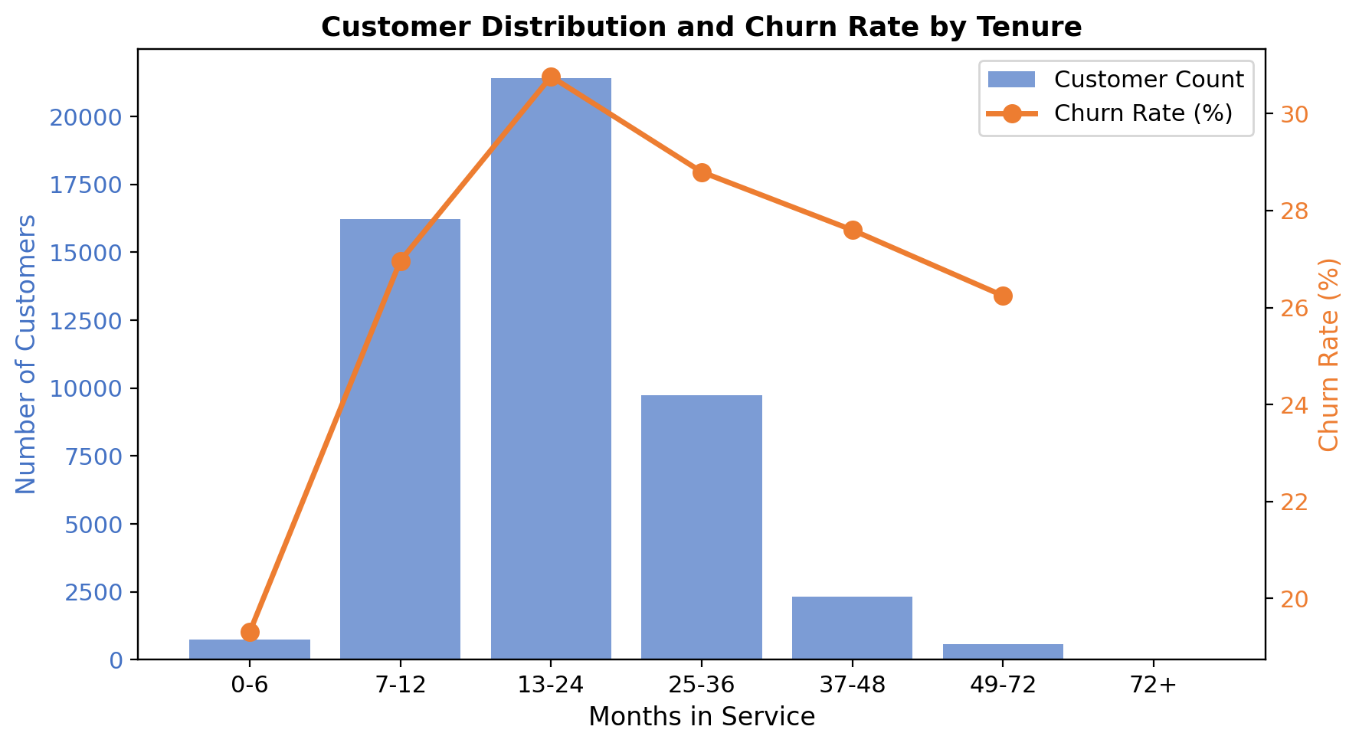
FIGURE 7. Customer distribution and churn rate by tenure group, demonstrating the inverse relationship between service duration and attrition risk.
Figure 8 presents the distributions of four key variables stratified by churn status. Churned customers tend to exhibit higher overage minutes, more frequent customer care calls, and somewhat higher dropped call frequencies compared to retained customers, providing visual support for the hypothesized relationships tested in this study.
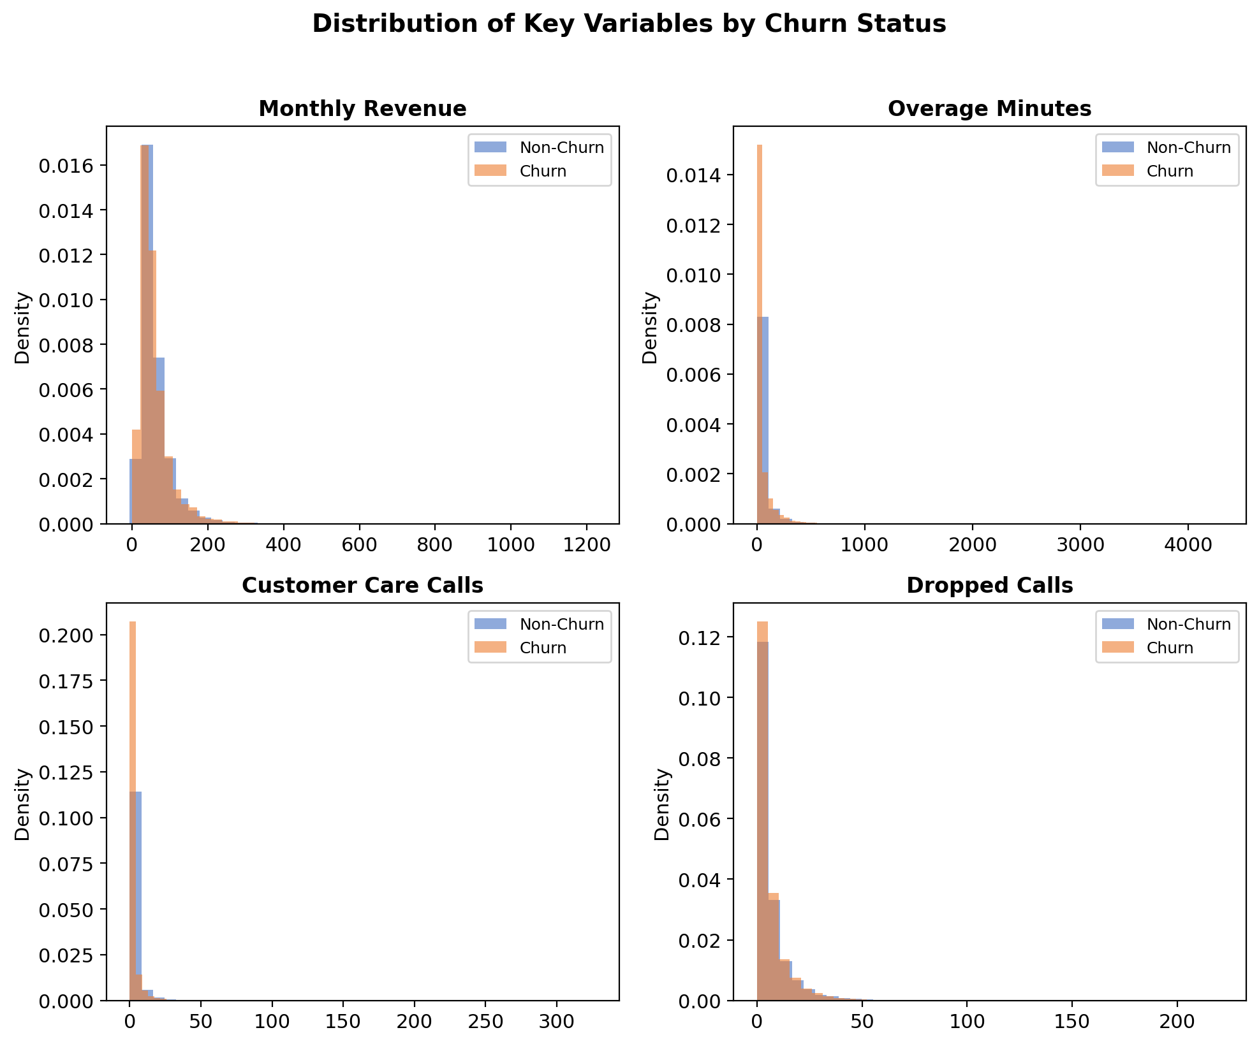
FIGURE 8. Distribution of key variables (Monthly Revenue, Overage Minutes, Customer Care Calls, Dropped Calls) by churn status.

4.3 Preprocessing Pipeline
A systematic preprocessing pipeline was designed to ensure data quality, consistency, and model-readiness. All preprocessing parameters were computed exclusively from the training partition to prevent data leakage, following the strict protocol outlined by El Attar and El-Hajj (2026). The complete preprocessing workflow is illustrated in Figure 9.
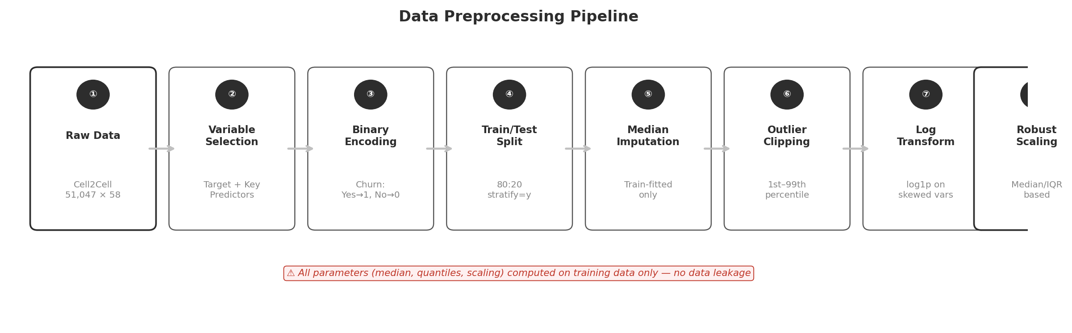
FIGURE 9. Eight-step preprocessing pipeline showing the sequential data transformation workflow from binary encoding through RobustScaler standardization.

4.3.1 Data Splitting
The dataset was divided into training (80%, n = 40,837) and test (20%, n = 10,210) sets using stratified random sampling to maintain the original class distribution. A fixed random seed (random_state = 42) was applied across all pipeline components to ensure full reproducibility.

4.3.2 Missing Value Imputation
Systematic examination revealed missing values in OverageMinutes (156 instances), RoamingCalls (156 instances), and PercChangeRevenues (367 instances), as visualized in Figure 10. Median imputation was selected based on domain considerations: telecommunications billing data often exhibits right skewness due to heavy-usage outliers, making the median a more robust central tendency measure than the mean. The imputer was fitted exclusively on training data and applied to both partitions.
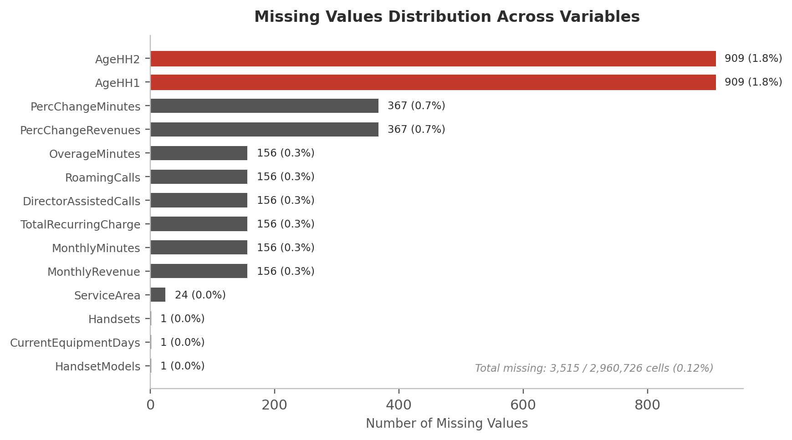
FIGURE 10. Distribution of missing values across target variables, showing PercChangeRevenues with the highest missing count (367 instances).

4.3.3 Outlier Treatment
Outlier treatment employed percentile-based clipping at the 1st and 99th quantiles, computed from training data. This approach preserves extreme but potentially informative values while preventing model distortion from truly anomalous observations. For example, OverageMinutes was clipped to the range [0, 433.64] and PercChangeRevenues to [−105.86, 117.16].

4.3.4 Variable Transformation
Log transformation (log1p) was applied to OverageMinutes and RoamingCalls, both of which exhibit strong right skewness with a concentration of zero values. The log1p function (log(1 + x)) was selected over standard log transformation to accommodate zero values without requiring additional offset parameters. PercChangeRevenues, which contains negative values representing revenue decreases, was retained without transformation.

4.3.5 Feature Scaling
RobustScaler was employed for feature standardization, using the median and interquartile range (IQR) rather than mean and standard deviation. This choice is motivated by the presence of residual outliers after clipping and the skewed distributions common in telecommunications data. RobustScaler minimizes the influence of remaining extreme values while preserving the relative relationships between features.

4.4 Feature Engineering
Feature engineering constitutes a critical phase in our methodology, incorporating domain knowledge to create interaction terms that capture compounding cost effects hypothesized to influence churn behavior. The variable design architecture is illustrated in Figure 11.
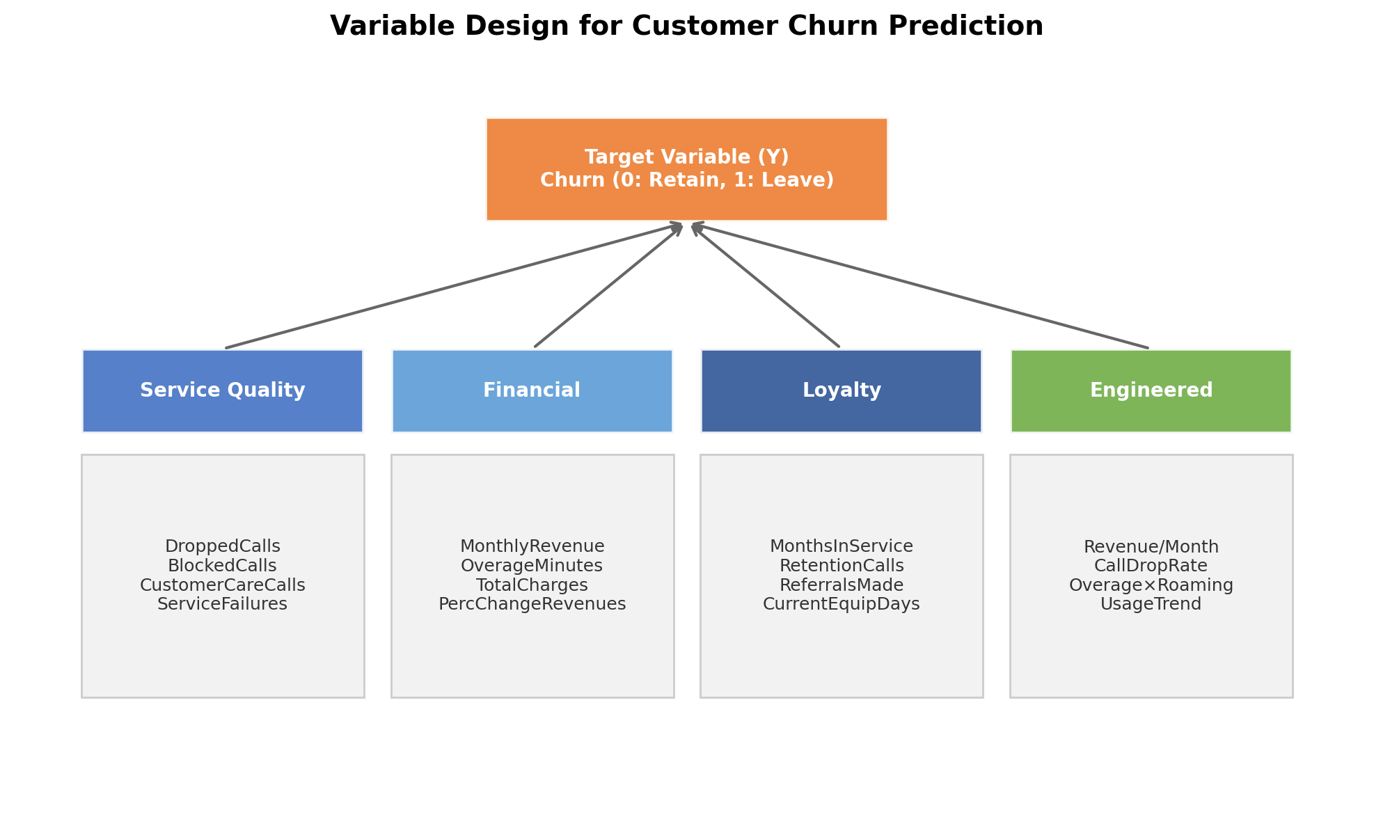
FIGURE 11. Variable design architecture showing four categories of predictor variables and their relationship to the churn target variable.

4.4.1 Positive Revenue Shock Indicator
A PositiveRevenueShock variable was constructed by clipping PercChangeRevenues at zero (retaining only positive values). The domain rationale is that revenue increases represent cost shocks that may trigger churn, whereas revenue decreases represent cost relief. By isolating the positive component, this feature more precisely captures the hypothesized “cost shock” mechanism.

4.4.2 Interaction Terms
Three interaction terms were engineered to capture compounding behavioral effects:
TABLE 3 Engineered interaction features and their domain rationale.
Feature Name | Computation | Domain Rationale
Overage_X_PosRevenue | OverageMinutes ×  PositiveRevenueShock | Captures compounding effect when high usage coincides with revenue increase
Roaming_X_PosRevenue | RoamingCalls ×  PositiveRevenueShock | Captures cost amplification when roaming usage aligns with revenue shock
Overage_X_Roaming | OverageMinutes ×  RoamingCalls | Captures simultaneous high-cost usage behaviors as a churn accelerator

4.5 Model Selection and Training
Three classification algorithms were selected to represent different modeling paradigms: interpretable linear classification, ensemble bagging, and gradient boosting. All models were optimized using GridSearchCV with stratified 5-fold cross-validation and ROC-AUC as the primary selection criterion.
TABLE 4 Model configurations and hyperparameter search spaces.
Model | Hyperparameter Grid | Selection Rationale
Logistic Regression | C: {0.01, 0.1, 1, 10}  Penalty: {L1, L2}  class_weight: {None, balanced} | Interpretable baseline;  coefficients indicate  direction and magnitude
Random Forest | n_estimators: {100, 200}  max_depth: {3, 5, 7, None}  min_samples: {2, 10}  class_weight: {None, balanced} | Bagging ensemble;  robust to overfitting;  feature importance via  impurity reduction
XGBoost | n_estimators: {100, 200}  max_depth: {3, 4, 5}  learning_rate: {0.03, 0.05, 0.1}  subsample: {0.8, 1.0} | Gradient boosting;  highest expected AUC;  scale_pos_weight for  class imbalance

4.6 Evaluation Framework
Model performance is evaluated using a comprehensive multi-metric framework designed to capture both statistical and practical dimensions of prediction quality:
TABLE 5 Evaluation metrics and their relevance to churn prediction.
Metric | Description | Role
AUC-ROC | Area under the receiver operating characteristic curve; measures discriminative ability across all thresholds | Primary metric
Accuracy | Proportion of correctly classified instances | Overall performance
Precision | Proportion of predicted churners who actually churned | False alarm control
Recall | Proportion of actual churners correctly identified | Churn capture rate
F1-Score | Harmonic mean of precision and recall | Balanced assessment
Cross-validation strategy employs StratifiedKFold (k = 5) with shuffling and a fixed random seed (random_state = 42) to ensure churn class proportions are maintained across folds. The primary model selection criterion is the mean cross-validated AUC-ROC score, with secondary consideration given to test set performance metrics.

4.7 Preliminary Results: Cost Shock Hypothesis (HG1)
As an initial validation of our research framework, we conducted logistic regression analysis to test the Cost Shock Hypothesis Group (HG1). The results, summarized in Table 6, provide preliminary evidence regarding the role of usage-based cost pressures in churn prediction.
TABLE 6 Logistic regression results for the Cost Shock Hypothesis (HG1).
Variable | β Coeff. | Std. Err. | z-stat | p-value | Hypothesis
const (Intercept) | −0.929 | 0.012 | −75.62 | <0.001 | —
OverageMinutes | 0.077 | 0.020 | 3.783 | <0.001 | Supported
RoamingCalls | 0.009 | 0.003 | 2.838 | 0.005 | Supported
PercChangeRevenues | 0.003 | 0.003 | 0.816 | 0.414 | Not Supported
The logistic regression model (Pseudo R² = 0.0005; LLR p-value = 1.11 × 10⁻⁵; n = 40,837) reveals that OverageMinutes (β = 0.077, z = 3.783, p < 0.001) and RoamingCalls (β = 0.009, z = 2.838, p = 0.005) exert statistically significant positive effects on churn probability, confirming H1a and H1b respectively. The PercChangeRevenues coefficient, while positive (β = 0.003), fails to reach statistical significance (z = 0.816, p = 0.414), leading to the rejection of H1c.
These preliminary findings suggest that customers are more sensitive to absolute cost pressures from usage overages and roaming activity than to proportional revenue fluctuations. The low Pseudo R² value indicates that these three variables alone explain a limited proportion of churn variance, reinforcing the need for the comprehensive multi-variable modeling approach planned in subsequent phases of this research.
Figure 12 provides a visual summary of the hypothesis framework and preliminary results, illustrating the relationships between the three primary hypotheses (H1–H3), the supplementary cost shock hypothesis group (HG1), and the preliminary logistic regression findings.
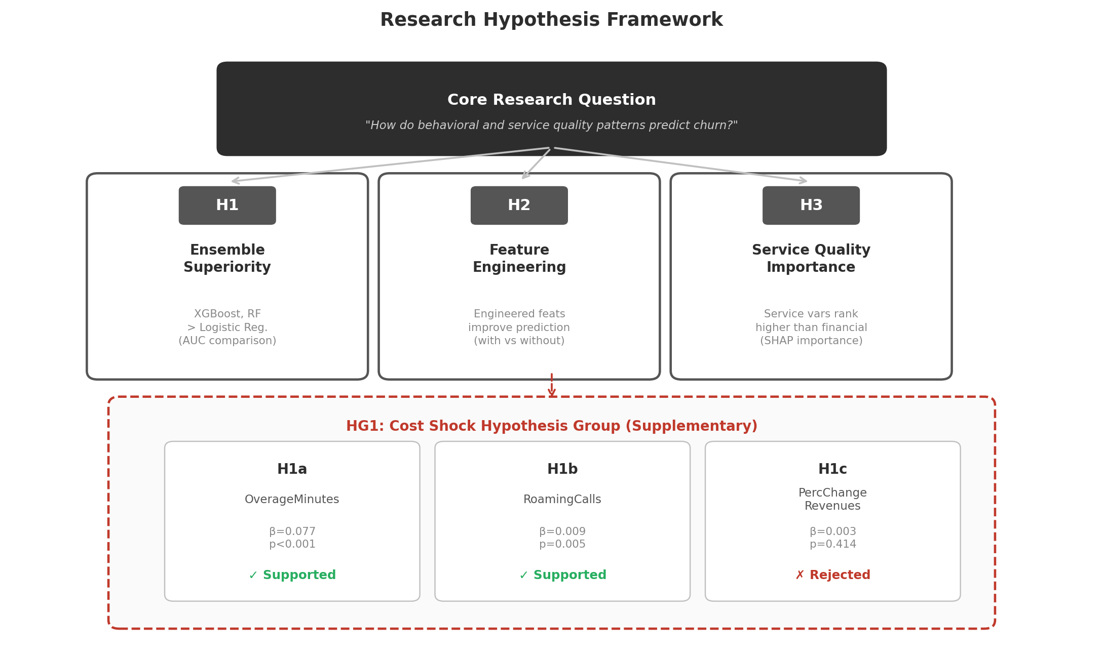
FIGURE 12. Research hypothesis framework with preliminary results. Green indicators denote supported sub-hypotheses (H1a, H1b), while red indicates rejection (H1c).

4.8 Research Timeline and Next Steps
This draft paper represents the preliminary phase of our research, encompassing literature review, hypothesis formulation, dataset analysis, and initial methodology design. The remaining phases include: (1) full model training and hyperparameter optimization across all three classifiers with both base and engineered feature sets; (2) comprehensive model evaluation including cross-validation stability analysis; (3) feature importance analysis to test H3 (service quality vs. financial variable importance); and (4) synthesis of findings into actionable retention strategy recommendations. The complete study is targeted for completion by June 2026.

References
Abdulkadir, M. (2022). Customer churn prediction using deep learning on the Cell2Cell dataset. Master's thesis, University of Wolverhampton.
Bugajev, A., Goranin, N., and Ragulskis, M. (2025). Addressing concept drift in churn prediction: a sliding window approach with partial labels. Applied Sciences, 15(3), 1102.
Chang, V., Hall, K., Xu, Q. A., Amao, F. O., Ganatra, M. A., and Benson, V. (2024). Prediction of customer churn behavior in the telecommunication industry using machine learning models. Algorithms, 17(6), 231.
Christopher, D., and Anand, G. (2024). Comparative analysis of predictive models for customer churn prediction in the telecommunication industry. In 2024 International Conference on Communication, Computer Sciences and Engineering (IC3SE), IEEE, 534–539.
Ebrah, K. and Elnasir, S. (2019). Churn prediction using machine learning: a comparative study of SVM, naïve Bayes, and decision tree on the Cell2Cell dataset. International Journal of Computer Applications, 178(17), 1–5.
El Attar, A. and El-Hajj, M. (2026). Explainable AI-driven customer churn prediction: a multi-model ensemble approach with SHAP-based feature analysis. Frontiers in Artificial Intelligence, 9, 1748799.
Fujo, S. W., Subramanian, S., and Khder, M. A. (2022). Customer churn prediction in telecommunication industry using deep learning. Information Sciences Letters, 11(1), 185–198.
Huang, B., Kechadi, M. T., and Buckley, B. (2012). Customer churn prediction in telecommunications. Expert Systems with Applications, 39(1), 1414–1425.
Huang, Y. and Kechadi, T. (2013). An effective hybrid learning system for telecommunication churn prediction. Expert Systems with Applications, 40(14), 5635–5647.
Khattak, A., Asghar, M. Z., Ali, M., and Batool, U. (2023). An ensemble deep learning approach for customer churn prediction using BiLSTM-CNN. IEEE Access, 11, 77668–77677.
Liu, Y., Fan, J., Zhang, J., and Yin, J. (2022). A novel hybrid stacking model for telecom customer churn prediction. Neural Computing and Applications, 34(18), 15613–15627.
Manzoor, A., Qureshi, M. A., and Kidney, E. (2026). e-Profits: a novel business-aligned evaluation metric for churn prediction. Decision Support Systems, 178, 114102.
Noviandy, T. R., Maulana, A., and Idroes, G. M. (2024). Customer churn prediction in telecommunication using LightGBM and CatBoost with SHAP analysis. Leuser Journal of Environmental Studies, 2(2), 57–65.
Verbeke, W., Dejaeger, K., Martens, D., Hur, J., and Baesens, B. (2012). New insights into churn prediction in the telecommunication sector: a profit driven data mining approach. European Journal of Operational Research, 218(1), 211–229.
Wu, S., Yau, W., Hor, T., and Peng, Y. (2021). An integrated customer churn prediction framework using machine learning. Journal of Business Research, 132, 449–462.

