**Setting up email alias in Gmail**

1. Log into Gmail with the forwarding address provided
2. 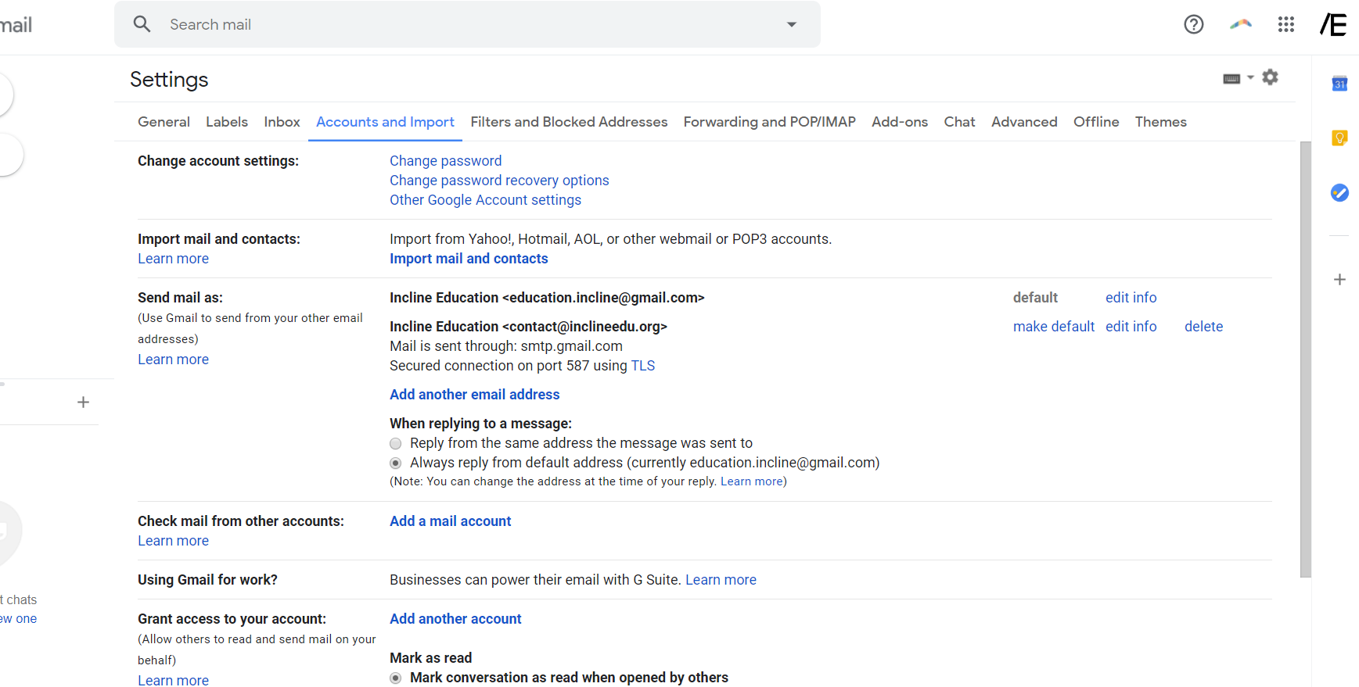Click cog button in top right corner of page, then click settings  
   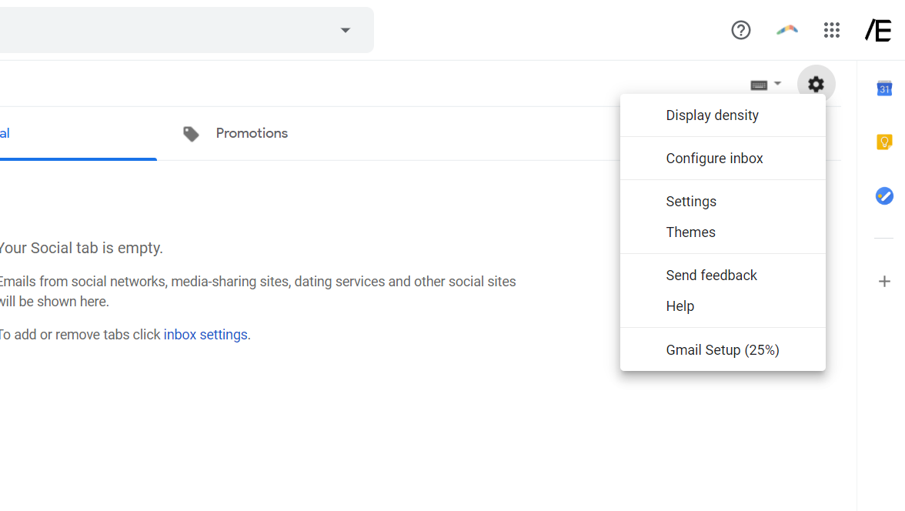

**2**

**1**

1. Under “Accounts and Import”, click “Add another email address”

**2**

**1**

1. In the new window, **type your name in the “name” form**, **and your @inclineedu.org email in the “email address” form**. Keep “Treat as an alias” checked, and click “Next Step”  
   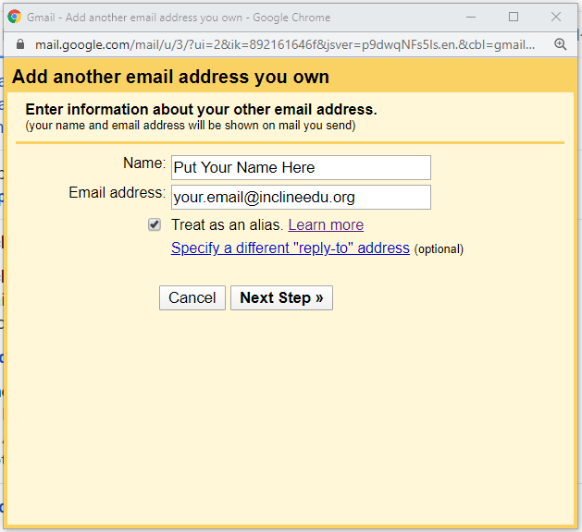
2. **If you have multi-factor authentication enabled, follow** [**this**](https://www.lifewire.com/get-a-password-to-access-gmail-by-pop-imap-2-1171882) **guide to create an application specific password. Otherwise, proceed to step 6.**you
3. 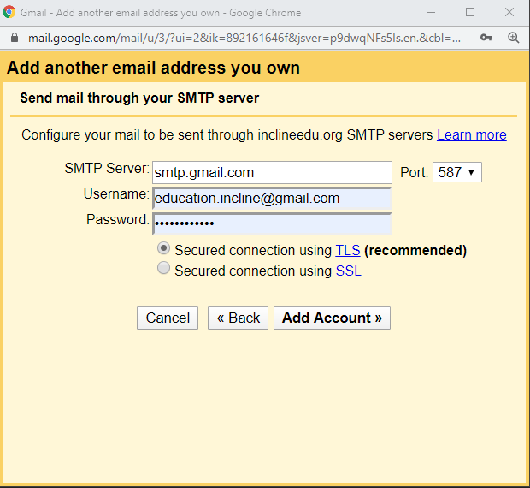In the next window**, type *smtp.gmail.com* in the “SMTP Server”** form, and your **personal Gmail login details in “Username” and “Password”**. Make sure that “secured using TLS is enabled, and click “Add Account”  
   note: your username is your personal Gmail email.  
   **note2: if you have multi-factor authentication enabled, paste the application specific password you generated in step 5 as your password instead of your real password.**
4. 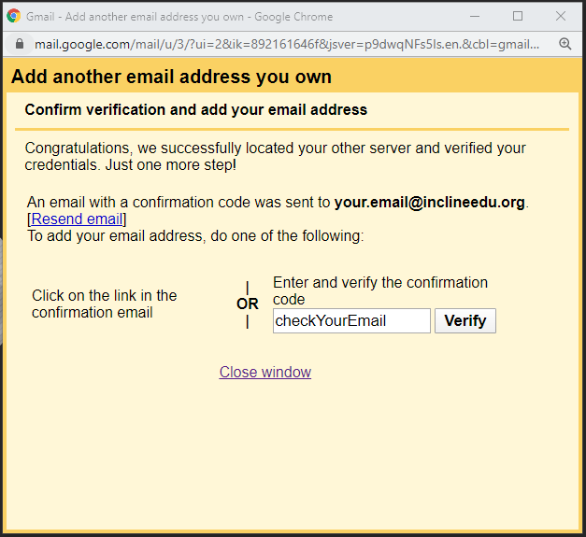Check your email for an email from Google with your confirmation code, and click the link in the email, or enter your code in the corresponding input box.
5. After verifying your email, you can now send emails from your brand new @inclineedu.org email by clicking on the “from” email in the Gmail compose window, and selecting the appropriate email address.

