Department of Computer Science and Engineering

**PE-III Lab (ADS Lab), CS3322**

Experiment No. 9

Title: Implementation of Object Based Databases: Queries on SQL for complex data types,Arrays, Multisets

Aim: To implementation of Object Based Database Queries

Objectives: To study & implement OODB

Output Screenshots:

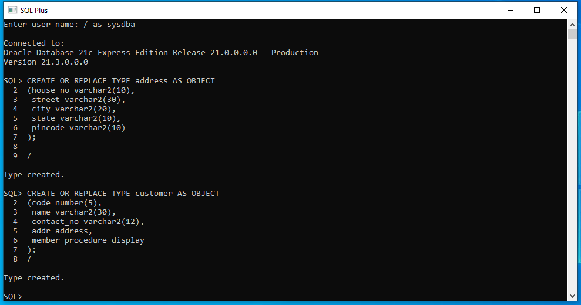

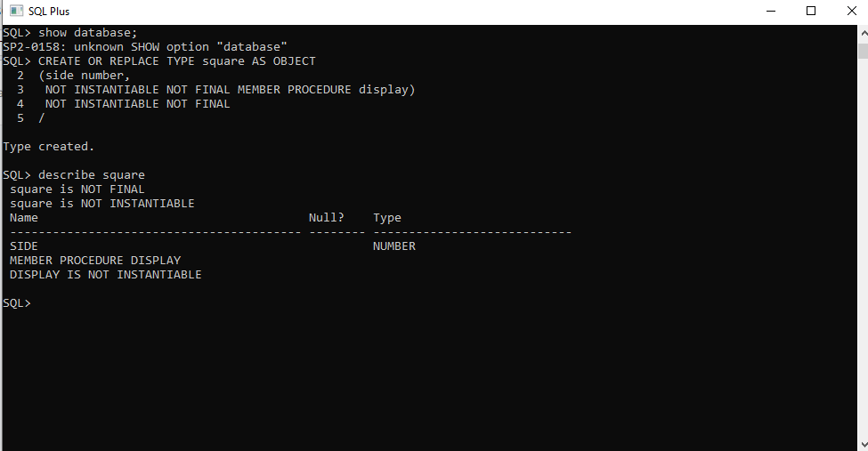

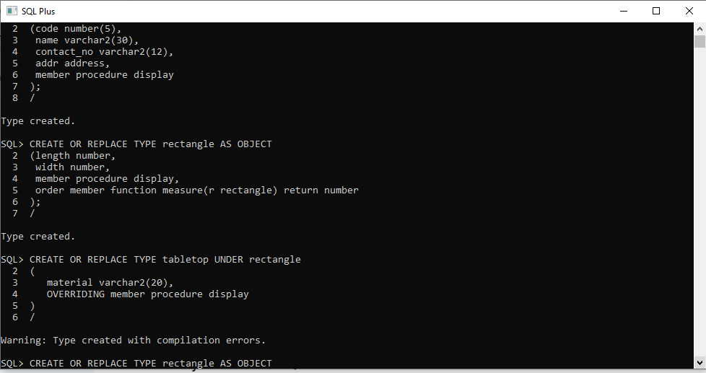

Code:

CREATE OR REPLACE TYPE address AS OBJECT

(house_no varchar2(10),

street varchar2(30),

city varchar2(20),

state varchar2(10),

pincode varchar2(10)

);

/

CREATE OR REPLACE TYPE customer AS OBJECT

(code number(5),

name varchar2(30),

contact_no varchar2(12),

addr address,

member procedure display

);

/

CREATE OR REPLACE TYPE rectangle AS OBJECT

(length number,

width number,

member procedure display,

order member function measure(r rectangle) return number

);

/

CREATE OR REPLACE TYPE tabletop UNDER rectangle

(

material varchar2(20),

OVERRIDING member procedure display

)

/