A Review of the Standards Development Process:

Identifying areas and ways to improve inclusion of people with disabilities.

Project made possible with funding from:



Delivered to:

Accessibility Standards Canada

[Attribution 4.0 International (CC-BY 4.0)](https://creativecommons.org/licenses/by/4.0/)  
Date: March 31, 2024

# Collaborators and Contributors

This work is the collective effort of over 20 contributors including more than 16 co-design experts with disclosed disabilities and the team of researchers at the [Inclusive Design Research Centre](https://idrc.ocadu.ca/) (IDRC).

This project was led by the team at the [Inclusive Design Research Centre](https://idrc.ocadu.ca/) at OCAD University in collaboration with co-design experts.

Attribution 4.0 International (CC-BY 4.0) <https://creativecommons.org/licenses/by/4.0/>

Date: March 31, 2024

Funder: Accessibility Standards Canada <https://accessible.canada.ca/>

Review of the Review Website: <https://idrc.ocadu.ca/projects/rotr/>

Table of Contents

Collaborators and Contributors 2

Executive Summary 10

Introduction 13

Our approach: 13

Recommendations 13

Capacity building, education and communication 14

1. Build capacity in the community to engage in standards development. 14

2. Create audience-appropriate learning content. 15

3. Make standards understandable 15

4. Make the message of standards discoverable and accessible 15

Diversity and representation 16

5. Embark on an ongoing journey toward diversity and representation. 16

6. Be transparent and accountable to support diversity and representation. 16

7. Broadly announce the accessible enquiry stage 16

8. Seek opportunities beyond enquiry. 17

Empowering Participation 17

9. Provide flexible and understandable onboarding and training 18

10. Engage with individuals regarding any necessary accommodations. 18

11. Leverage technical knowledge of people with disabilities. 18

12. Take regular pauses for critical reflection 18

13. Increase public engagement 18

14. Be transparent and accountable. 19

Decision-making and stakeholder synergy 19

15. Reduce risk with curb-cut decision-making. 19

16. Leverage informal decision-making in a formalized process. 19

Researching the Space 20

Co-design 21

Co-design challenges 21

A Game to Play 21

Game development 22

Game prototype co-design with ASC 23

Recruiting co-design researchers 23

Fair compensation for time and expertise 24

Co-Design 1 – Education 24

Co-Design 2 – Play the Game 25

Co-Design 3 – Hack the Game 25

Feedback from Survey 26

Communicate in more ways about being involved. 26

Involve the public and people with disabilities from the beginning 26

Be transparent about decisions that are made and how disagreement is handled 26

Who should be involved? 27

Spread the word 27

Connecting with SDOs and different technical committee leads 28

Setting the Technical Committee for Success 28

Facilitation matters! 28

Cross-committee communications 29

Inclusion Self-Assessment Instrument 32

Instruments vs Lens, Frameworks and Guidelines 32

What is the ISAI 32

ISAI Mapping Diagram 33

ISAI Mapping Table 34

How to use the ISAI 35

Assessment Areas 35

Subjective Interpretations of Effort and Resource Allocation 35

Getting Started 38

Area 1: General Considerations 38

Approaches for general considerations 38

Self-reflection questions for general considerations 38

Area 2: Public Engagement 40

Approaches for public engagement: 40

Self-reflection questions for public engagement: 40

Area 3: Communication 41

Approaches for public understanding of standards 41

Self-reflection questions for public understanding of standards: 42

Approaches for inviting others 42

Self-reflection questions for inviting others: 43

Area 4: Organizing Technical Committees 43

Approaches for selection of technical committee members 43

Self-reflection questions for selection of technical committee members: 44

Approaches for technical committee member onboarding and support 44

Self-reflection questions for technical committee member on-boarding and supoprt: 45

ISAI Mapping Diagram and Table for Reproduction 45

Opportunities to Improve Inclusion: A Review of ASC Policy Documents 48

Standards Development Operational Requirements 48

4.2.1. Technical Committee Requirements, p. 52 48

4.7.1.2 Notice of Public Review, p. 85 49

4.7.1.4 Notice of Withdrawal (p. 88) and Withdrawal Stage 95 (p. 47) 49

4.10.3. Performance-Based Standards, p. 84 50

5.3.12. Stakeholder Comments, p. 125 50

Accessibility Policy and Guidelines 51

Accommodating Accessibility Standards Canada’s Employees, Board Members, and Committee Members with Disabilities, p. 23 51

Annex A – Accessible Meetings: A Handbook for Federal Public Servants, p. 43 51

Annex C – Links to accessible documents development, p. 45 51

ISO-71 Guide for addressing accessibility in standards 52

6 Accessibility goals, p.10 52

4.3.1 Stage 1: Define the standards project and determine the applicability of this Guide, p. 5 52

Appendix A: Suggested Inclusive Standards Development Process Considerations 53

Education of Standards and Standards Organizations (SOs) 53

Membership 54

Consensus and voting 54

Mentorship /resources 54

Approachability/Accessibility to the process 55

Standards Development Review Process 55

Paid/voluntary participation 55

Meetings 55

Group dynamics 55

Inclusive meetings with insights borrowed from UN UNECE Guidelines on Developing Gender-Responsive Standards 56

Public consultation 56

Inclusive Data with insights borrowed from: British Standards Institute (BSI) Enabling the development of inclusive standard 56

Declaration of No Conflict 57

Iterative process 57

Timeline: 57

Responsibility of Standards Organization (SO) 57

Reflect on how the standard impacts people differently 57

Show your work 58

Registry of harms 58

Adaptability and Stability 58

Alternatives to Standards 58

Appendix B: Existing Instruments within the standards development landscape 60

1 - Standards development framework 60

2 - Standards development process 60

3- Risk assessment 60

4- Impact assessment 60

5- Auditing and Standards Review 60

6- Community engagement / Public feedback 61

7- Monitoring and oversight 61

8- Development Process Tools 61

9 - Standards Implementation tools 61

10 – Reform through judicial systems 61

11 – Education 62

Appendix C: Standards Development Game Overview 63

About the game 63

About the game board 64

What are the three phases of the game? 65

What does gameplay look like? 65

How do I collect tokens? 65

What are Event Cards? 66

What are role-specific actions? 67

Project Manager (SDO) / Researcher (TC) / 📝 67

Board Member (SDO) / Industry Expert (TC) 🛠️ 67

COO (SDO) / Policymaker (TC) 🏢 67

CEO (SDO) / Lived experience expert (TC) ♿ 67

What is the Feedback Loop? 68

What are End Game Cards? 69

Appendix D: Event Cards 70

Standards Development Board Game Event and End Game Cards 70

Event Cards 70

End Game Cards 75

Appendix E: Co-design with ASC game prototype revisions 76

Appendix F: A Simpler way to Describe Standards Development Process 78

About the Standards Development Stages 78

1 Preliminary (What and why?) 78

Core Purpose: 78

People involved: 78

Inputs: 78

2 Proposal (Ready. Set. Go.) 79

3 Preparatory (Putting together a team) 79

4 Committee (Making a draft) 80

5 Enquiry (Public review of the draft) 81

6 Approval 82

7 Ratification (The second review) 82

8 Publication (Making it official) 83

9 Recommendation (Using the standard) 83

10 Review (Upkeep and maintenance) 83

11 Withdrawal (Standard is no longer needed) 83

What is Accessibility Standards Canada (ASC)? 83

7 Priority Areas 84

What are ‘Terms of Reference’? 84

What is a SEED document? 84

What is a Standard? 84

What is a Technical Committee? 85

References 86

Table of Figures

**Figure 1: Self-assessment map** 34

**Figure 2: ISAI Mapping Table** 34

**Figure 3: Areas denoting degrees of flexibility.** 36

**Figure 4: Levels of effort** 37

**Figure 5: New opportunities and existing practices** 37

**Figure 6: Sample mapping of general considerations for an SDO** 39

**Figure 7: Public Engagement Considerations for SDOs** 41

**Figure 8: Gameplay components 63**

**Figure 9: Gameboard 64**

**Figure 10: Token Vault 66**

**Figure 11: Event Cards 66**

**Figure 12: Technical Committee team roles 68**

# Executive Summary

Standards development is complex and difficult to explain. Standards have a deep, fundamental impact on the ways people do things. In this report, we focus on the development and review process of Accessibility Standards Canada (ASC); ASC standards can influence standards for many sectors but must be followed by [federally regulated industries and workplaces](https://www.canada.ca/en/services/jobs/workplace/federally-regulated-industries.html).

ASC reached out to the Inclusive Design Research Centre (IDRC) at OCAD University to help review the standards development process and the way it is actioned to reveal opportunities for increasing the accessibility of the process and the involvement of people with disabilities (from the public) in the process.

Unlike other standards development organizations (SDOs) ASC, is solely focused on creating standards for accessibility, which can itself have a profound impact on accessibility in Canada. ASC, as created by the Accessible Canada Act (ACA), is focused on creating accessibility standards for the ways we work and provide services in seven priority areas identified in the ACA:

1. Employment,
2. Built environment,
3. Information and communication technologies,
4. Communication, other than information and communication technologies,
5. Service delivery,
6. Transportation, and
7. Procurement

ASC is in a unique position to create *equity-based standards* that establish a forward-looking approach to accessibility. Through its work ASC has a chance to create progressive accessibility standards that guide where we *can and should* be rather than prescribe a bare minimum of compliance that will meet accessibility needs. Too often in accessibility resources, a minimum is established and interpreted as all that *must* be done. This contributes to an approach that is limited in vision, scope, and adoption of accessible solutions that we need to realize a Canada without barriers by January 2, 2040.

ASC can model a progressive approach to creating accessibility standards that embodies accessibility from the beginning and within each stage of the process: showing by doing by producing accessibility standards that are broad, forward-looking, and facilitate regulated entities in going beyond a bare minimum.

This project focused on opportunities within the standards development process stages to achieve the following objectives:

1. make the documentation and explanation of the standards development process more accessible and inclusive.
2. more deeply and authentically involve people with disabilities in standards development.

We address Objective 1 with a review of ASC documentation on how to create a standard: namely, the *Standards Development Operational Requirement* document, technical committee orientation materials, and the *Accessibility Policy and Guidelines*. Our review of these culminates in the section on Direct Feedback on ASC Standards Development Policy Documents and with A Simpler Way to Describe Standards Development.

All outputs are informed by the IDRC research team’s scan of standards development processes as laid out in the Research section, a series of co-design sessions with people with disabilities covering and critiquing the standards development process, and conversations with another SDO (CSA Group, Accredited by the Standards Council of Canada (SCC)) and with three Technical Committee Chairs for current ASC Standards.

We address (Objective 2) opportunities for improved involvement of people with disabilities through the development of the Inclusion Self-Assessment Instrument (ISAI). This instrument can be used by ASC (and other SDOs) to self-assess how they can increase the depth and inclusivity of their engagement of people with disabilities within their processes. Where there are no clear answers, the instrument pushes standards development team members to talk through several thought-provoking questions to ascertain where they are and how their decisions impact the depth and authenticity of their approaches. It then leaves SDOs in a position to be transparent about their work and their efforts to continually practice inclusion.

Finally, we have aggregated our findings from all project activities into opportunities for improved accessibility and inclusion within the Standards Development process in our 16 recommendations below.

1. Build capacity in the community to engage in standards development.
2. Create audience-appropriate learning content.
3. Make standards understandable.
4. Make the message of standards discoverable and accessible.
5. Embark on an ongoing journey toward diversity and representation.
6. Be transparent and accountable to support diversity and representation.
7. Broadly announce the accessible enquiry stage.
8. Seek opportunities beyond enquiry.
9. Provide flexible and understandable onboarding and training.
10. Engage with individuals regarding any necessary accommodations.
11. Leverage technical knowledge of people with disabilities.
12. Take regular pauses for critical reflection.
13. Increase public engagement.
14. Be transparent and accountable.
15. Reduce risk with curb-cut decision-making.
16. Leverage informal decision-making in a formalized process.

# Introduction

Prepared by the Inclusive Design Research Centre (IDRC) for Accessibility Standards Canada (ASC), this report presents pivotal insights from our collaborative research with co-design experts with lived experiences of disability. Our aim is to illuminate effective strategies for the meaningful inclusion and active participation of individuals with disabilities in the standards development process.

## Our approach:

* Foremost Recommendations: We begin with our principal recommendations, encapsulating the essence of our findings.
* Analytical Discussion: Subsequently, we delve into the inputs that informed these recommendations.
* Comprehensive Appendices: The report culminates with appendices, enriched with resources to further explore and replicate our research.

# Recommendations

Recommendations and considerations in this report are informed by co-design workshops, literature research, conversations with members of SDOs and technical committees, and reviews of process documentation shared by ASC.

The 16 overall recommendations from this project fall into the following themes that are expanded below:

Theme 1: Capacity building, education and communication

1. Build capacity in the community to engage in standards development.
2. Create audience-appropriate learning content.
3. Make standards understandable.
4. Make the message of standards discoverable and accessible.

Theme 2: Diversity and Representation

1. Embark on an ongoing journey toward diversity and representation.
2. Be transparent and accountable to support diversity and representation.
3. Broadly announce the accessible enquiry stage.
4. Seek opportunities beyond enquiry.

Theme 3: Empowering Participation

1. Provide flexible and understandable onboarding and training.
2. Engage with individuals regarding any necessary accommodations.
3. Leverage technical knowledge of people with disabilities.
4. Take regular pauses for critical reflection.
5. Increase public engagement.
6. Be transparent and accountable.

Theme 4: Decision-making and stakeholder synergy

1. Reduce risk with curb-cut decision-making.
2. Leverage informal decision-making in a formalized process.

Many of these recommendations are interconnected and build upon each other. It is possible that addressing one recommendation begins to address another.

## Capacity building, education and communication

Even though standards have a broad impact, many individuals are not familiar with the standards that impact their daily activities nor with the process for developing standards. This lack of familiarity creates a barrier to engaging people in the standards development and review processes. Building capacity in disability communities and the general public to engage with standards development is a key step to bringing diverse perspectives to technical committees, public feedback, greater participation during enquiry stages, and boosting transparency and accountability. Capacity building in communities, is only a starting point, once engaged, capacity building should continue to ensure that those participating in the process can participate effectively and with confidence.

Communication can fall into two categories: the subject matter, and the methods in which it is communicated. An effective communication strategy will enable someone to learn about standards, discover what it means to them, and equip them with the information and pathways needed for them to get involved if they wish. Effectiveness in these two areas will help improve the approachability of standards development and form the foundation for other recommendations like Building capacity in the community to engage in standards development and Empowering Participation.

### Build capacity in the community to engage in standards development.

Through co-design research, it was revealed that co-researchers became interested in standards but had no idea they would be interested until they were introduced to it by participating in the co-design. The approach used in the co-design research models an approach that SDO’s can use to support diverse engagement and equitable participation.

We began by reaching out to members of the disability community directly and through disability advocacy organizations. We have been able to build an extensive mailing list of disability community members through our public activities and events where we have built relationships of trust and demonstrated fairness and respect. Over time, SDOs can build similar lists that can expand by “word-of-mouth” as trust is built.

In our co-research, standards development was a foreign concept to co-design researchers, many of whom have intersectional identities. Preparing adequate scaffolding for understanding and engagement required some trial-and-error, understanding the audience, and customizing the content to fit (see Co-design, below). Ultimately, co-designers were enthusiastic and eager to be involved in standards development and they had a nuanced understanding of it after just three co-design sessions.

### Create audience-appropriate learning content.

Effective participation requires understandable materials that engage and empower individuals. Communications and learning materials about the standards work that are relatable and accessible are the beginning of the welcoming experience that signals to individuals with disabilities that their access needs are being thought of. Once individuals engage in the process, they must be provided with learning materials that support their understanding and empowers them to actively engage.

The co-design demonstrated that the complex process of standards development can be effectively communicated and taught to those unfamiliar with it. Participants ultimately felt familiar enough with the process to be able to suggest changes and improvements to the process which are documented throughout this report.

Learning content should “speak their language” in a way that makes standards and standards development relevant to the audience. This starts with listening to and learning from those affected by standards, especially those with intersectional identities as they are impacted by standards (and policies created from standards) in amplified ways.

### Make standards understandable

Making standards understandable to others begins with knowing and understanding the intended recipients of the message. What are their experiences and encounters with standards? How has it impacted them? For example, the content created for a technical committee should be different than the content for a community advocacy group. Working with the intended recipients will help guide the creation of the content in a way that is understandable and relevant to them.

Using simple language, defining obscure terms, using examples, explaining logic, minimizing acronyms, etc. can help. See The Instrument for more approaches.

### Make the message of standards discoverable and accessible

There are many ways to get the message out about standards, and the methods used should reflect the diversity of the intended audience. Do they use a particular social media network, or do they prefer more analog methods, or both? Is the content easily accessible in different ways, in different languages (e.g., does it unintentionally exclude immigrants who might not know much English)? While it may be efficient to publish content to the Web or in a single format, it may not be easily discoverable or accessible. An unintended consequence of assuming one method of dissemination (e.g., digital) is that it will not include those for whom the method is not preferred, is not easy, or is not accessible.

## Diversity and representation

Diversity and representation can seem like a challenging and unachievable task, especially if viewed from a goal-oriented perspective. Diversity and representation should be viewed as a journey or progression where each successive step includes more diverse perspectives. Keep in mind that people with diverse, intersectional backgrounds and identities *want* to be involved throughout the entire process not just at the enquiry stage. For people at the edges – people with intersectional needs and diverse backgrounds – their own lived experience should lead the development of standards. If standards are going to have an amplified impact on their lives, then their needs and voices must be central to the work.

### Embark on an ongoing journey toward diversity and representation.

Diversity and representation can begin with meeting people where they are and understanding and actively listening and learning from their experiences. By building these relationships, SDOs can earn trust and begin to see opportunities for deeper engagement and co-creation. This process will take mutual time and effort, and a commitment to continually nurture relationships and interconnectedness.

Throughout the process, SDOs should ask themselves “Who are we missing?” and the process of listening and learning begins again. With more diverse perspectives and trusted relationships fostered, more opportunities will be created for engagement and input into the creation of standards.

### Be transparent and accountable to support diversity and representation.

Many people with a lived experience of disability or those with intersectional identities experience tokenism and exploitation by others. A clear way to avoid both is to communicate intentions using both transparency and accountability. To avoid the pitfalls of tokenism and superficial diversity

* Be clear and open about goals and intentions
* Keep thorough records of meetings, minutes, and recordings that are accessible by others outside of the organization.
* Track and publish how decisions are made.
* Publicly demonstrate how diversity and representation are making tangible differences within the organization, its processes, and the standards created.
* Involve people with diverse backgrounds in decision-making and engage them from the outset.

### Broadly announce the accessible enquiry stage

Many co-design participants expressed that they were not aware they could be part of a public enquiry for a standard. Once learning about the opportunity, it was not clear to participants how they could get involved.

Opportunities for public enquiry should be announced broadly using different methods and formats (not just electronic platforms). Using the knowledge gained from building relationships with diverse communities (see Build capacity in the community) will help.

The tools and methods used to gather input during the enquiry stage can facilitate or create barriers to someone contributing. Care should be taken to use a variety of methods to gather input during enquiry – not just relying on a digital platform or electronic forms of access. The Instrument provides a way to help assess practices and brainstorm possible approaches.

Allow anonymous comments on the standard as some may feel reluctant to identify themselves. A way to do this is to communicate that at minimum name or email is required to submit comments, but there will be no associated identification when the comments are published or reviewed. This can help de-bias the process of dispositioning in the Enquiry stage.

### Seek opportunities beyond enquiry.

Many co-design participants expressed the desire to have more involvement and more opportunity to have input in the creation of a standard, not just at the Enquiry stage. They did not want to be consulted superficially.

ASC can seek to involve people with disabilities and diverse backgrounds throughout the standards development process, especially early in the process when the Terms of Reference are created. Since the Terms of Reference set the process in motion, it would be a valuable place to have the public’s input. Another point where public input could be harnessed is in the nomination of technical committee members. However, this level of change cannot just materialize – there needs to be capacity-building and trust-building.

This does beg the question, how do SDOs know they have successfully or even sufficiently engaged people with disabilities? As has been stated, this cannot be *accomplished* but rather must be seen as a commitment. So, when an SDO gets thousands of comments in the Enquiry stage, but they come from 60 people across Canada, then the SDO must (through introspection and reflection) determine what success looks like and if 60 people is ‘enough.’ This is a moment when transparency and setting future intentions can be useful in building trust and relationships.

## Empowering Participation

The goal of the technical committee is to consider issues and specify solutions for them. Several problems can arise that impede this goal. Members of the committee may have important technical expertise but are not familiar with standards or the standards development process. Members may have needs and preferences that the SDO did not anticipate. Members may need accommodations just to participate; furthermore, the customary processes and tools used by the committee might create other barriers as they may prove inflexible or inaccessible when used in the context of long, complex, edited, shared documents. Anticipating and addressing these needs will empower participation and foster committee success. Diversity is a strength. However, properly supporting and nurturing diversity requires constant and consistent listening, learning, reflection, and adaptation.

### Provide flexible and understandable onboarding and training

Use shorter sessions and smaller groups to gently introduce members to the process. Use a combination of online synchronous, offline asynchronous, and hybrid methods of communication. Encourage knowledgeable members to help informally educate others and encourage all members to engage in self-directed training. In group work there will be extra work that some will voluntarily take on. The SDO should work to support those doing ‘extra’ work. Provide training materials in multiple modalities and formats.

### Engage with individuals regarding any necessary accommodations.

Some committee members will have a disability and will have experienced accessibility issues in their lives and have a favoured means for dealing with them. For example, members may use assistive technology and have set it up in a way that works for them. Where accommodations for a member are needed, involve them from the start to determine how to proceed effectively. They have the expertise and can contribute to the process. If the SDO knows of other solutions, they should consult with the individual as to whether they are appropriate.

### Leverage technical knowledge of people with disabilities.

Standards developed by ASC are concerned with what is needed to remove accessibility barriers. People with disabilities often have technical knowledge about what they need and are their own technical experts. They understand the value of flexible approaches that support individual choice in “solutions.” This perspective will enrich a committee’s ability to develop a successful standard that removes barriers. ASCs performance-based standards are built to welcome the technical expertise of those who encounter barriers. That is a powerful way to build standards that can work for everyone.

### Take regular pauses for critical reflection

The SDO and the technical committee should establish regular checkpoints to critically evaluate progress and participation by people with disabilities. These checkpoints should explore what has worked and what has not worked and commit to improving both. These are inflection points where a group could use The Inclusion Self-Assessment Instrument to check on, reflect upon, and potentially adopt different practices for future technical committees.

### Increase public engagement

The Enquiry stage is the only touch point where the public is openly invited to participate, but that is not sufficient. Seek opportunities to engage public communities and interest groups earlier and often to continually receive feedback on the development of the standard.

### Be transparent and accountable.

Be open regarding progress, meetings, updates, upcoming teleconferences, and reviews. Maintain and make available meeting minutes, decisions made at committee meetings and the rationale for those decisions. Overall, the goal should be to create a culture of learning, unlearning, and continually improving.

## Decision-making and stakeholder synergy

“Majority rules” is a popular way of making decisions. It is efficient and can satisfy requirements quickly. However, when working with populations that often do not make up the majority, be aware of the history of others making decisions that ultimately create barriers. Conversely, an inclusive approach to decision-making that recognizes the importance of the margins can lead to a more robust decision. Greater participation in decision-making by the public and their enhanced collaboration with SDOs and the technical committee can counter the unintended silos that occur from the linear standards development process.

### Reduce risk with curb-cut decision-making.

A ramp where a path meets the road, known as a curb cut, was originally designed so wheelchair users could move unimpeded between the street and sidewalk. Though these ramps were designed to address a need at the margins, curb cuts have come to be a metaphor because they truly benefit everyone: those with baby strollers, bundle buggies, people walking their bicycles, people with heavy luggage on wheels, and more.

A laudable goal is to aim for the curb cut decisions whenever possible – those that can help create inclusion for everyone by taking into consideration perspectives and viewpoints that would have been lost or ignored in a traditional majority rules approach.

Disagreements and conflicting needs are an essential part of realizing inclusion in a complex context. With careful, inclusive facilitation it can be beneficial for everyone.

### Leverage informal decision-making in a formalized process.

The formalized development process serves as the scaffolding around which the standard is built. Within this defined process, there are moments where informal decision-making – often considered “soft” decisions or design choices – has an impact on the standard. These soft decisions and design choices often happen at the edges of formalized processes among a trusted few people involved.

The SDO can play a key role in creating similar moments with community groups, persons with disabilities and intersectionality in the creation of a standard. Inviting diverse perspectives informally throughout the process can give a technical committee much-needed insight before the Enquiry stage.

# Researching the Space

The team started with a literature review of standards across several domains. We explored existing tools used in standards development and assessment as outlined in Appendix B. We explored international standards development, different federal standards development efforts, jurisdictional standards and more. We looked for standards or lenses that specifically addressed people with disabilities or diversity in general. We found various tools for assessments of standards. We looked at open tools, tools that encouraged transparency, and open-ended tools. The research can be found in this link to the [Standards Development database](https://airtable.com/appIBFRAQqmDnogtX/tblyN6MOeS2QPbalK/viwlWaKpR0zQ3tx5t?blocks=hide).

Our scans included literature, international standards, policies, laws, and practices. This includes an examination of:

* standards development processes published and publicly accessible by national and international SDOs.
* development of regulations and policies from standards.
* tools and resources (or “lenses”) that can help SDOs create more inclusive standards.
* existing approaches and practices used by other organizations and jurisdictions like government agencies.
* activities in emerging standards such as artificial intelligence as it impacts people with disabilities.
* tools and resources related to standards for people experiencing disabilities.

As part of the research, we reviewed the documents from Accessibility Standards Canada to understand the standards development process and approach thoroughly. After those efforts, we came to a point where we had become familiar with the standards development domain. The project activities then needed to shift to carry out co-design activities.

This is a pivotal moment in project work where teams make decisions that can and will have an impact on the inclusiveness of the work. It is one of the points of reflection where teams must check in on ‘who is missing’. The risk is going too far into the research before including people with disabilities. If we went too far, we were in danger of “solutioning” before we engaged people with a lived experience of disability. This would not only bias the co-designs but would result in (however well-intentioned) outcomes that were designed *for* and not *by and with*.

We slowed down our solutioning and switched our focus to designing the co-design sessions to ensure that we were aligned with the disability movement dictum, “nothing about us without us.”

# Co-design

To authentically honour “nothing about us without us,” we created a series of three co-design sessions that brought people with disabilities from across Canada together. No two co-designs are the same and, in this project, we took seriously the challenge of asking people with disabilities to contribute to and critique a process that they were not previously aware of in many cases. The standards development process takes time to understand, and co-designers might not have felt comfortable critiquing an existing process that was unfamiliar and complex.

In the co-design sessions we conducted, we made clear that people with a lived experience with disability were the experts in the room simply by being themselves and living a life where the environment, services, and tools are often disabling. This is an approach that builds upon the social model of disability. It centres people experiencing disabilities as experts and innovators in solving the barriers they encounter in the socially disabling world often with great technical proficiency.

## Co-design challenges

The co-design process needed to address two main complexities:

* **How could we help co-designers to meaningfully engage with an existing process that is opaque and difficult to understand?** The standards development process is complicated and contains a lot of jargon and terminology not intuitive to people outside of standards development. To re-envision or disrupt the process for the better, we first needed to help co-designers have a deeper understanding of what happens in the existing process.
* **How could we empower co-designers to envision a different process when the existing process contains fixed phases and aspects that cannot be changed significantly?** Because standards development is governed by standards accreditation bodies and must follow a consistent set of steps and procedures, there were some limitations we wanted to clearly communicate to co-designers to set up realistic expectations.

## A Game to Play

The IDRC team conceived a light-hearted approach to solving the problem of asking co-design experts to weigh in on the confusing, existing, formal standards development process. Play is a great way to break from deeply formal processes and to help co-designers feel free to try something, break something, or impact something that might otherwise seem intimidating.

The first session of the co-designs needed to be dedicated to education to familiarize participants with the basics about ASC, standards, standards development, and how co-designs function. The risk with beginning with a didactic experience was that co-designers might feel too overwhelmed by all the new information. Introducing the game to play later (during the second session), was both necessary and intentional to allow experts time and space to process what they have learned.

During the second session, co-designers were divided into groups playing the standards development game developed and designed by the IDRC. The game helped experts engage with the standards development process they had only just learned, and the low-stakes setting helped enhance understanding.

The game is intended to:

* Teach co-designers about the standard development process in a more active and engaging manner, going beyond a didactic presentation.
* Keep things light, fun, and open to empower co-designers to share ideas freely without feeling intimidated or worried about getting things wrong.
* Promote discussion and questioning of aspects of the process in a more approachable way.
* Invite co-designers to “hack” the game, asking them to re-imagine how standards development could engage them more meaningfully.
* Use game mechanics to provide constraints, differentiating between aspects of the process co-designers could not change (the stages of the standards development process), and those they could re-envision (who participates and how, what happens at each stage, etc.)

## Game development

An early prototype of the game was created based on the Standards Development Operational Requirements document. The prototype was designed to have four players collaborate to develop and pass a standard working their way from the Preliminary stage all the way to Review and Maintenance. Along the way, the players encounter situations they must resolve as a team using special abilities assigned to roles adopted by each player. To complete the game, players need to collect a certain number of “progress tokens” before reaching the 10th step. We wanted to find a balance between abstracting the process, while also representing some of the complexities of standards development.

* Collaboration is a key component of the game. The team must work together and strategize how to use their unique powers to progress through the board.
* To complete the standard the team needs to collect a certain number of progress tokens. Participants can gain tokens through event cards, or by performing role-specific actions.
* To represent the non-linear aspects of standard development, it is possible for the players to lose progress tokens but have a chance to redeem them. In the game, this is captured by the Feedback Loop. Each time the team loses progress tokens, the tokens are moved to the Feedback Loop, and feedback can then be traded back into progress tokens. This process of losing and redeeming tokens illustrates how a technical committee or SDO can learn from mistakes to improve the standard they are developing.
* In the early prototype, the game had four roles:
  + Researcher
  + Industry expert
  + Policy maker
  + Lived experience expert

Each role represents one of the four stakeholder groups within a Technical Committee that works on developing a standard. Each role has a special ability (also called “Superpowers”) in the game, representing the unique perspectives and strengths of each stakeholder group. There may be more roles that could be added to the game, but these four were chosen to keep the game manageable while being representative of the groups that contribute to an actual standard.

The design of the game helps the co-designers playing the game accomplish a few things. First, the co-designers have to work collaboratively and understand the superpowers they each have to help the team make progress – highlighting the importance of diverse perspectives and experiences in the creation of a standard. Second, the game provides a way for co-designers to challenge and tweak the standards development process by questioning the game rules and structure. Finally, the game challenges typical notions of completion when players have to slow down to further understand the standards development stages and ensure that each member can contribute to the team’s progress – emphasizing the importance of unity and iteration in creating a standard.

See Appendix C for a complete set of game rules, and Appendix D for event cards from the game.

## Game prototype co-design with ASC

The IDRC team played through the first game prototype with a team of ASC members. With insights and feedback provided by ASC, adjustments were made to reflect the standards development process more accurately. The additional detail and nuance added to the game because of this co-design helped our invited experts better understand the process. Reference Appendix E: Co-design with ASC game prototype revisions for details on the changes made to the game prototype.

## Recruiting co-design researchers

Co-design researchers were recruited by the IDRC team via an open call for expert collaborators using a large contact list maintained by the IDRC, leveraging connections with organizations by and for people with disabilities, and through membership of accessibility and inclusive design communities, groups, and forums. Within a week, 150 applications were received for the intended 16 co-designer positions.

One of the goals of the co-design sessions was to maintain small working groups so that co-designers could engage more freely and be able to receive needed support if required. The group of applicants was chosen based on their availability, willingness to play a game online, and their self-disclosure of having a disability. The aim in selecting the participants this way was to represent a diversity of experiences on all levels of human diversity including ability, language, culture, gender, age, and other forms of human difference. The following information was gathered from the co-design session application process:

* if the applicant was above 18 years old,
* if they could attend all 3 co-design sessions planned,
* their first and last name, their email address,
* if they required CART/Captions, ASL, or any other accessibility needs to support their full participation,
* if they had ever played an online game in a video conference before,
* if they wanted to disclose their disability,
* if they identified as having a disability.

Applicants were selected to have a diversity of perspectives and experiences. Applicants who did not have experience playing an online game were not excluded from participating and were grouped with co-designers who had online game experience.

## Fair compensation for time and expertise

To acknowledge and value the life experience and skills of people with disabilities, and to respect their time and commitment honorariums were provided as a way to acknowledge the co-designer’s contribution to the research. The team especially made efforts to convey appreciation and commitment to the integrity of their feedback to us as experts.

## Co-Design 1 – Education

In the first session, we introduced co-designers to the standards development process. A member of Accessibility Standards Canada, Collinda Joseph, delivered a presentation explaining the ASC process and respectfully answered questions. Facilitators intervened to encourage questions, clarify terminology and concepts, and initiate a discussion on how the standards development process fits in with regulations and laws. The entirety of the session was focused on learning, answering questions, and getting clarification on the process. The participants were all deeply engaged: asking questions and sharing personal experiences.

One challenge in the session was the need to keep the vocabulary as plain language as possible while still using terminology specific to the standards development process and including meaningful words that differentiate things like jurisdictional scope.

From a facilitation perspective, the goal of co-design 1 was to educate, include, welcome, and create a tone of openness and playfulness. This was important given what we wanted participants to do in Sessions 2 and 3.

## Co-Design 2 – Play the Game

In the second session, co-designers were introduced to the standards development game. Co-designers were divided into small groups which became their team during the game. The facilitators in each small group led the would-be players through the instructions and transitioned to playing the game to demonstrate how it worked.

Some co-designers were eager to jump in and start playing, while others desired more clarity and instruction before starting. The facilitators helped each team become comfortable with the gameplay, and the collaborative gameplay (unlike a competitive game) helped encourage everyone to be united and progress in learning the game together.

The facilitators helped participants understand their roles, their ‘superpowers,’ and the ways they could collaborate within their teams. Each team created a community of their own in playing the game and came to know each other and trust each other as they progressed through the game.

Through play, each team was familiarizing themselves with the real events that can and do happen during standards development processes – such as situations that can help advance a standard or circumstances that can slow or set back progress.

Facilitators needed to balance the progressing gameplay with highlighting important details (such as transitioning between development stages) so co-designers could get a better understanding of the standards process and how they might want to change it to better fit their lived experiences.

Teams and facilitators also had to contend with the online nature of the game and the virtual meeting platform which can disconnect people from actively engaging. This required everyone, especially facilitators, to be encouraging and patient to help teams along.

The smaller groups helped to encourage openness and free conversations. This was important as these discussions helped each participant deepen their understanding of the standards process that will allow them to critique the process in the third session – hacking the game.

## Co-Design 3 – Hack the Game

By the third co-design session, participants became more familiar with the game, the standards process, and the goals of the co-design. Teams were comfortable replaying parts of the game and making suggestions and changes to the rules along the way. Contrasting the feedback and suggestions from Session 1, the comments and insights from co-designers were more nuanced and complex – demonstrating an understanding of the larger ecosystem of standards and the elaborate process that creates them.

## Feedback from Survey

A survey was administered to co-designers asking them for their expert opinions on the different development stages. The survey, through guided questions, provided some members the needed time to think through and digest all they had learned.

### Communicate in more ways about being involved.

Numerous participants advocated for better ways to advertise the need for people with disabilities to be on technical committees, using methods that stretch beyond those used now. Public media including radio, television, news, ads in transportation (buses and subways), and ads on YouTube were mentioned to get digital and non-digital native inclusion.

“Make your website more easy for people to read!” – co-designer.

### Involve the public and people with disabilities from the beginning

Participants suggested that involving the public only at the point of enquiry was too late in the process and it would be beneficial for the public to be involved at the beginning stages, for example at the point of the Terms of Reference. Suggestions for this also included hiring people with disabilities to write the Terms of Reference.

“There need to be opportunities for engagement early and often.” – co-designer.

### Be transparent about decisions that are made and how disagreement is handled

Participants said that in the committee work, there should be efforts to respect disagreement and try to gather more opinions. This is an opportunity to get more people than those just on the committee involved in a point that might impact them.

This approach would help include the voices of people with various types of disabilities, including physical, sensory, cognitive, and invisible disabilities.

“In some cases, the voting can't be made public but if there are concerns with the draft by some members, I would think that if there is a way to share some of those concerns with the public that would be good.” – co-designer.

“I think the people who have lived [sic] experience [and who are most impacted] should get to decide [if there is a conflict].” – co-designer.

### Who should be involved?

The participants had some suggestions for how someone should be chosen to be involved in the committee work in standards development. Representation of a diverse group of people with disabilities, and a broad perspective were preferred – not checklist approaches to representation.

“[Pick] someone [sic] whose lived experience is relevant to the standard being created. Someone who has knowledge of the standards development process. Someone optimistic about changes to increase accessibility.” – co-designer.

Participants also reflected on what feels like a tension between universalist language in standards and inclusively designing something with awareness for each individual. It motivated some to comment on who would be the ideal person to be on the technical committee.

“Bringing a person with disabilities who acknowledges that all disabilities are not the same is what I would do. A person with a specific experience is not something I want to see.” – co-designer.

This tension is not a small one and for ASC to continue to make progressive, forward-looking, best practice standards, it does feel as though it is a conflict that will persist. This is a conundrum that many are contending with.

### Spread the word

Participants all expressed an interest in hearing more about the standards that are created. It is hard to say if they simply didn’t know when they were hearing about standards creation what it was or if they are indeed not seeing information posted about standards. In any case, this group of people is now primed to be engaged with and interested in standards development news and updates.

“Create visibility of the new standard by inviting local organizations that serve the community impacted by the standard, to make it part of the information that is shared and the housekeeping when dealing with their clients.” – co-designer.

## Connecting with SDOs and different technical committee leads

We reached out to CSA Group to get the perspective of another SDO. We also spoke with different technical committee leaders to hear about their experiences and inputs for standards development. The following are some of the themes that arose from those conversations.

### Setting the Technical Committee for Success

As is the case with diverse groups of people, their needs are diverse too. There is always room for improving accommodations and these groups mentioned the need for ASL/LSQ, different formats for forms, an understanding of how technology decisions will impact team members, and a budget for providing these resources. Team members spoke of having to pay for accommodations out-of-pocket.

There will be learning curves whenever a group of people come together to collectively understand how they can best engage with large documents (even if, technically speaking, the documents are accessible). Some participants spoke of having technical issues with being involved in the committee – from inaccessible application forms to difficulties choosing technologies that worked for everyone.

Especially in the case of participants with diverse needs, accommodations to fully participate can feel like asking for help or begging for forgiveness for inconvenience. It is a good reminder that it does not just take money and services to remove barriers, though those are requirements. For example, some team members expressed not having clarity about the time commitment needed to be part of standards development, and then felt overwhelmed by the demands. The pressure to produce something that helps others plus the burden on self was too big a burden to carry.

“We didn’t all realize that the technical committee writes the whole standard. We were thinking we might edit or augment an existing standard.”

### Facilitation matters!

Though much of the standards development process is a formalized experience, there are humans involved and so there will be human tendencies. This is why we heard from participants and chairs that the person making those small design decisions about how to facilitate sets the tone for the work in many cases. That person can help alleviate inefficiencies, can help connect people, can help the group realize that it needs outside expertise and more. The role of facilitation becomes monumental when a diverse group of people is tasked with coming up with something together. Facilitation must bridge the gaps of ability, participation, and access. Facilitation must be aware of participants’ feelings such as belonging (or not), intimidation, and more that will impact their participation in the committee work.

The relational aspects of groups can be mitigated in some ways by having depth and breadth of representation of people with disabilities, people with experience working in disability advocacy, and people with disabilities with technical expertise. This is one area that we imagine ASC continuing to push and experiment.

### Cross-committee communications

Because some standards include details that might be covered in another committee’s standard, there is some concern among the technical committee members that they might suggest something inconsistent with another standard. This doesn’t necessarily seem as though it is universally an undesirable thing – it could represent a diversity of perspectives, and it is likely to be the case that multiple standards will be advancing through the process at different stages at any given time. So, where one standard might already exist, one that is just being developed can contain more up-to-date information. It does create a challenge for ASC though to somehow make sense of how and where to get the most up-to-date information. Or is there an interest in harmonization of the various standards? If so, that will require some structure to accomplish across standards processes at different stages of development.

Inclusion   
Self-Assessment   
Instrument

Mapping the path to greater inclusion in standards development processes

***Inclusion Self-Assessment Instrument 32***

**Instruments vs Lens, Frameworks and Guidelines 32**

**What is the ISAI 32**

ISAI Mapping Diagram 33

ISAI Mapping Table 34

**How to use the ISAI 34**

Assessment Areas 34

Subjective Interpretations of Effort and Resource Allocation 35

***Getting Started 37***

**Area 1: General Considerations 37**

Approaches for general considerations 38

Self-reflection questions for general considerations 38

**Area 2: Public Engagement 39**

Approaches for public engagement: 39

Self-reflection questions for public engagement: 40

**Area 3: Communication 41**

Approaches for public understanding of standards 41

Self-reflection questions for public understanding of standards: 42

Approaches for inviting others 42

Self-reflection questions for inviting others: 43

**Area 4: Organizing Technical Committees 43**

Approaches for selection of technical committee members 43

Self-reflection questions for selection of technical committee members: 44

Approaches for technical committee member onboarding and support 44

Self-reflection questions for technical committee member on-boarding and supoprt: 45

Inclusion Self-Assessment Instrument

The Inclusion Self-Assessment Instrument (ISAI) enables standards development organizations (SDOs) to self-assess their standards development processes and understand the opportunities to improve them. The instrument provides new approaches to consider and questions for self-reflection in a number of areas. The ISAI was developed based on input from ASC, our research, CSA, 3 chairpersons from ASC standards technical committees, and through conducting co-designs (3 sessions) with people with disabilities who are interested in standards development.

Instruments vs Lens, Frameworks and Guidelines

Terms like lens, framework, and guidelines carry negative associations and do not represent the intent of using the ISAI. Lens refers to taking a different perspective. While useful as a metaphor and reminder to step out of a default perspective, “lens” perpetuates the notion that accessibility is something that is stepped into or taken on as an empathy exercise, not something that is the default expectation or cultural norm. When we perpetuate accessibility as an extra, it can too easily fall into an afterthought. A framework similarly has a sense of framing a problem instead of re-framing the default. Frameworks can also be rigid and inflexible, making it challenging to adapt quickly and easily to accessibility concerns. Guidelines, on the other hand, can be interpreted as optional and can be too general and lack actionable items.

What is the ISAI

An instrument supports collection of information, analysis and monitoring. The ISAI is a set of thought-provoking questions plus a matrix for understanding where current approaches and decisions measure on continuums of inclusion and innovation. The ISAI will help SDOs reflect upon the following:

* + How is the SDO doing in the area being assessed?
  + What are the next steps to deepen or broaden the SDO’s efforts in inclusion in this area?

**The ISAI is not binary**—depicting right/wrong or good/bad. The ISAI is a spectrum where ideas, practices, approaches, and processes can coexist and overlap in unpredictable ways.

**The ISAI is not a checklist**—the intent is not to do everything and be “done”. The ISAI, its ideas and concepts are meant to evolve, grow, be refined over time, and be applied multiple times as a way of continual improvement.

**The ISAI is flexible** and can be used to examine anything from high-level concepts to low-level implementation details. For example, the ISAI can cover the practices at a particular stage of the standards development process; it can then be applied to focus on a specific aspect of the stage or used on another stage.

ISAI Mapping Diagram

The ISAI includes a diagram on which to map what you are doing now and what you could endeavour to do (either deepening existing practices, or trying something new). An alternative to the visual map is the mapping table. The diagram is structured in this way:

* **Approaches** (current and hypothetical) are mapped left to right with more fixed or traditional approaches on the left progressing to more flexible approaches to the right.
* **New ideas** such as novel opportunities and practices to consider are placed in the top half.
* **Existing practices** are represented on the bottom half of the diagram. Those practices can be interrogated and improved.
* **Level of effort required** is represented by the distance from the centre point, increasing in effort as you radiate away from the centre. Effort here can be measured differently for each SDO and each question. Examples of ways to measure ‘level of effort’ are degrees of difficulty, cost, time, quality, etc.

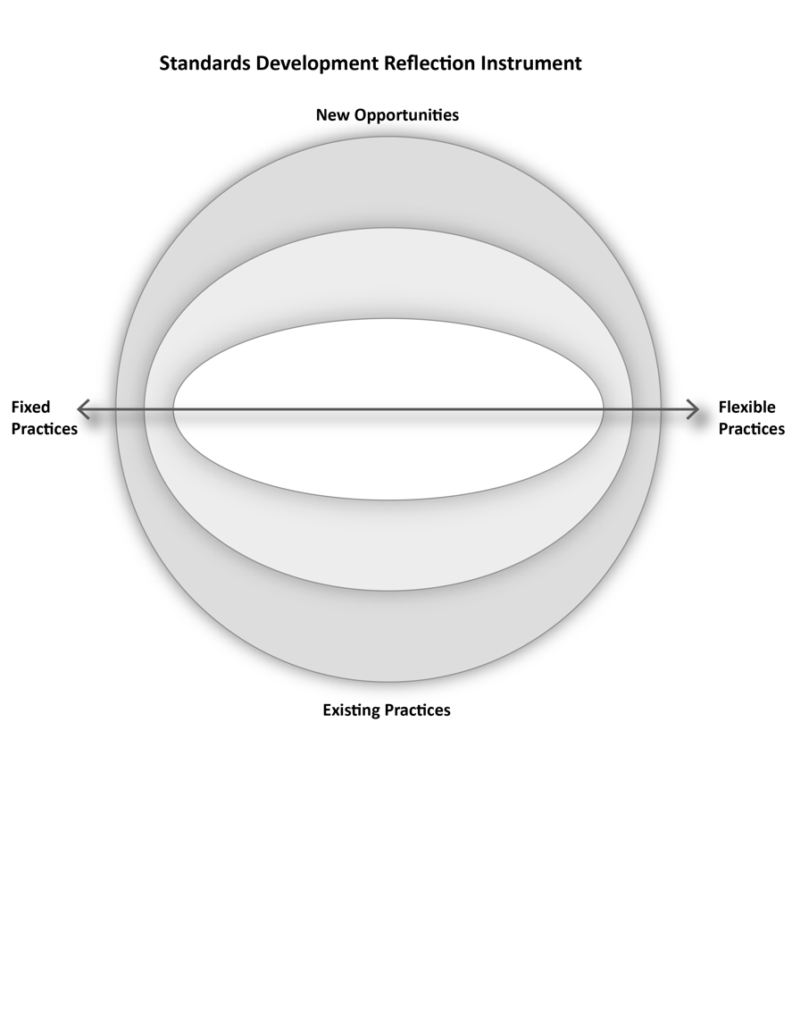

**Figure 1: Self-assessment map**

ISAI Mapping Table

An alternative to the mapping diagram is this assessment table.

| Dimension of the area under assessment | Position on Fixed/Flexible Practices Continuum | New Opportunity or Existing Practice | Level of Effort Required | Reflections |
| --- | --- | --- | --- | --- |
|  |  |  |  |  |
|  |  |  |  |  |
|  |  |  |  |  |
|  |  |  |  |  |

**Figure 2: ISAI Mapping Table**

How to use the ISAI

The people who gather to use this instrument will vary depending on organizational readiness within any of the areas that are being assessed. Individuals involved can include any person involved in development of or impacted by standards. Generally, team members within SDOs can come together to first, rank your own practices based on the approaches prompts (where approaches are areas that SDOs make some decisions that can have an impact on accessibility and inclusion) and then Second, reflect on it with the self-reflection questions. Have conversations about different ways to improve inclusion and accessibility. And ideally involve people with disabilities in the conversations.

1. Choose an area or issue to assess.
2. Begin with subjective interpretations for that area/issue and map them using the self-assessment map or table.
3. Reflect on where you are and where you want to go using the provided questions and prompts.
4. Do this for as many areas and issues as you like
5. Iterate on your plan and continue to assess and add diverse perspectives.

Assessment Areas

There are four areas in this ISAI:

1. General Considerations
2. Public Engagement
3. Communication
4. Organizing Technical Committees

However, these are just starting points, the ISAI approach can be used in multiple areas and levels of granularity.

Subjective Interpretations of Effort and Resource Allocation

Organizations and individuals will differ in where they place concepts on the diagram. The interpretation of where you are is meant to represent where you *think* you are now. For example, a more well-resourced SDO may deem a specific approach as low effort, while a less well-resourced one may consider it to be high effort. There is no one, correct answer. The instrument is meant to facilitate reflection and discussion rather than “correctly” define where a concept belongs within the space.

**Reflect on where the SDO is currently:** use the list of approaches in each area to map out existing processes and practices. Then use the self-reflection questions to engage in conversation about if that is where the SDO wants to be.

**Brainstorm more inclusive approaches:**  use the ISAI to inspire thinking in any area where you want to change the SDO’s maturity of addressing a particular issue:

* map new practices and processes that would move the SDO in a more inclusive direction.
* map how existing processes could be made more inclusive.
* Brainstorm using the self-reflection questions to get you started

**Monitor your efforts by mapping your practices over time and reflect on your progress.**

The diagram is split into 6 vertical sections along the x axis. From left to right: highly fixed, more fixed, somewhat fixed, somewhat flexible, more flexible, highly flexible. 



**Figure 3: Areas denoting degrees of flexibility.**

When mapping consider the above six demarcations along the continuum between fixed and flexible practices. This continuum is not one of judgment. You can have inclusive, fixed practices and inaccessible flexible practices.

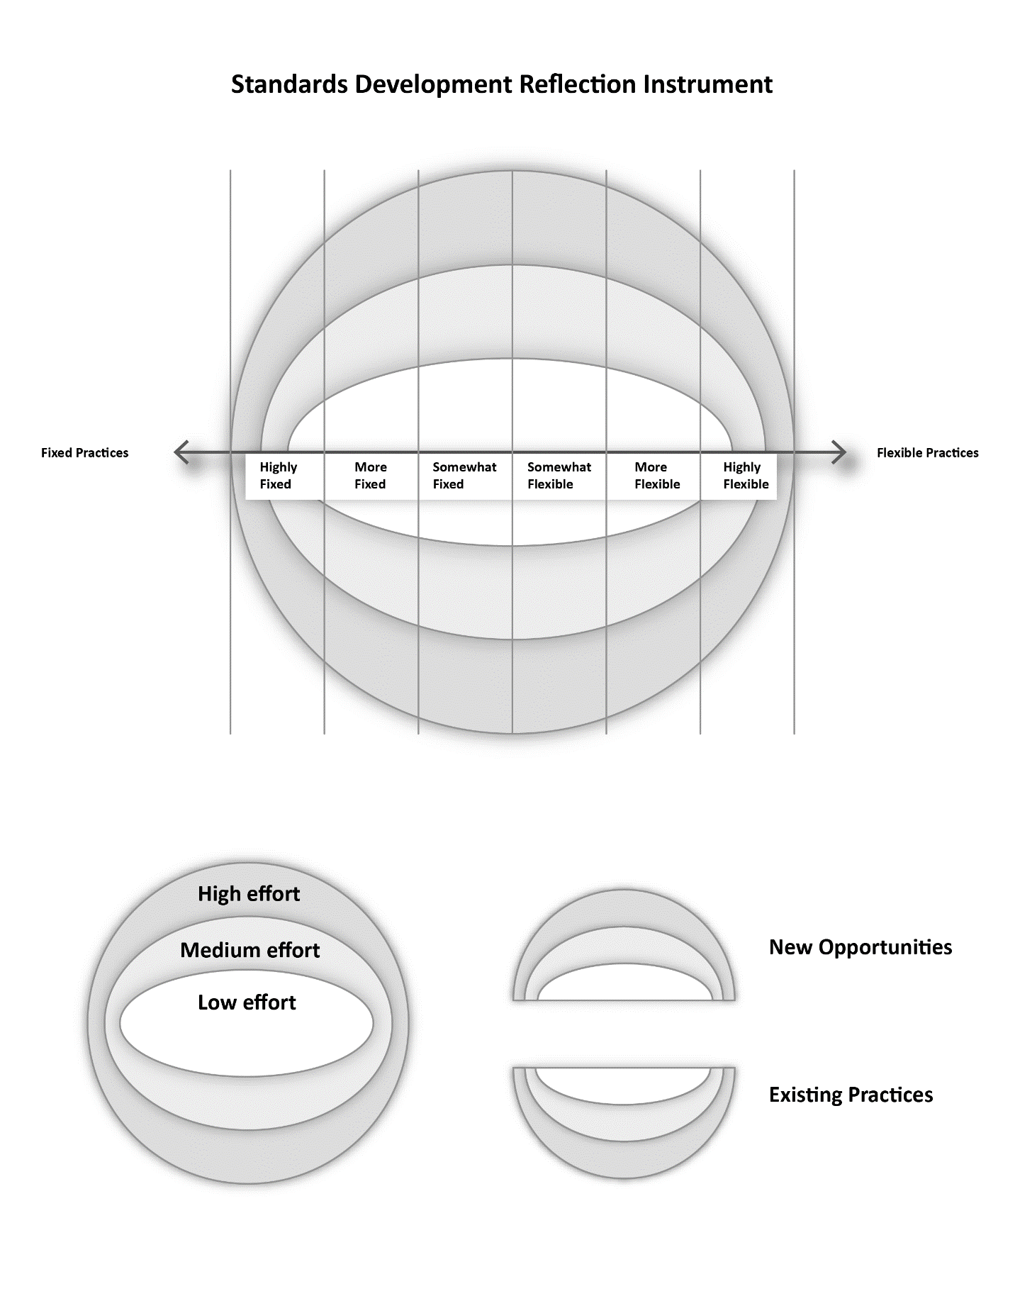

**Figure 4: Levels of effort**

Map the level of effort for yourself or your organization using the concentric rings. The level of effort is something you will determine based on the factors meaningful for your own organization. Examples of ways you might measure “level of effort” include difficulty, cost, time, quality, etc.



**Figure 5: New opportunities and existing practices**

If you want to use the instrument to map existing practices, then all of your approaches will be represented in the bottom hemisphere.

Getting Started

The ISAI is presented with four areas; however, new areas for self-assessment may be created as needed. We provide sample self-assessments for the first two areas. Each area, begins with approaches where your SDO has considered, has culturally established an informal or established way, or formalized a way of addressing an aspect of standards development. Once you have read through the approaches, ask yourself where your SDO might map your practice onto the diagram. E.g., How does your SDO make decisions? In particular, what is your approach to using data to make decisions? Where would you place yourself on the diagram?

Area 1: General Considerations

This area refers to overarching aspects of the organization and its processes.

Approaches for general considerations

* “One-size-fits-all” universalist approaches may give the benefit of efficiency and reproducibility, but at the expense of understandability, relevance, and usability. Universalist approaches can make it harder for those at the margins to engage meaningfully. Aim to have more flexible approaches that can be easily adapted and customized to meet particular needs and unanticipated situations.
* Decision-making based on statistical trends or averages can inadvertently exclude critical/important edge cases or confirm biases by giving an incomplete picture. Invert trend-seeking decisions by looking at the statistical outliers and consider how decisions made by including the edges can often benefit the whole.
* Consider the frequency and opportunity for checkpoints to help make iterative improvements and course corrections. These checkpoints can involve gathering input or feedback from other parties (like the public) or introspection by the team.
* Flexible systems, formats, processes, etc. make it easier to adapt and adjust to new circumstances. Flexible systems naturally and gradually improve over time.

Self-reflection questions for general considerations

1. How do you continually strive for better in all aspects (communication, tech committee management, public engagement, etc.) the next time around? What are the checkpoints to pause and examine/reflect on the process? What are the known pain points?
2. How are metrics being used? Do they confirm biases or exclude critical outliers?
3. Are standards that are created the minimum for others to follow, or an exemplar of better practices? Can the standard be written to convey both the minimum and the ideals to strive for?

We’ve provided a sample mapping for this area that includes several examples of approaches and how they can be mapped onto the instrument.

**Note: this example is not complete**

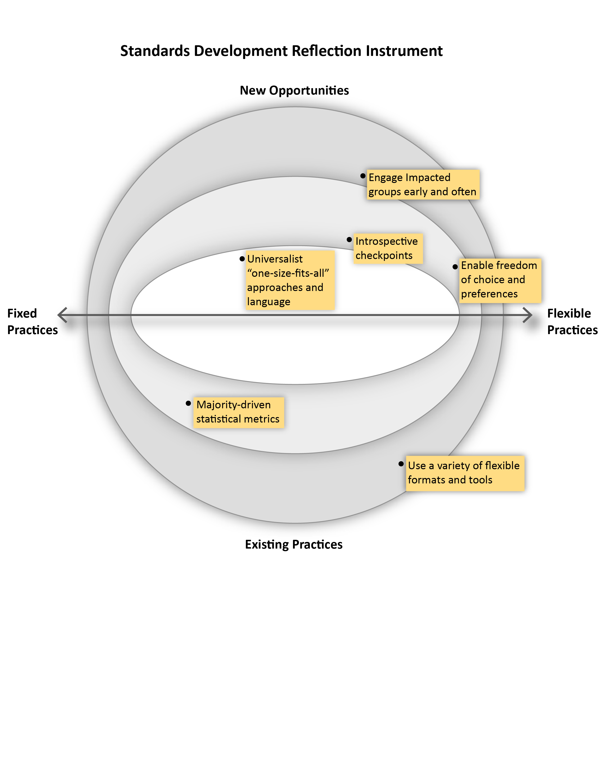

**Figure 6: Sample mapping of general considerations for an SDO**

Area 2: Public Engagement

This area refers to the way and moments that the general public is engaged in the standards development process.

Approaches for public engagement:

* In most standard development processes, the Enquiry stage is the only major touch point for public involvement. Consider additional opportunities to engage the public earlier at the 3Ps (Preliminary, Proposal, Preparatory stages), and more frequently.
* Consider public engagement to build relationships, capacity, understanding, and knowledge with underrepresented groups. These groups can then be invited to engage in feedback (i.e., at the Enquiry stage or other opportunities).
* There is no single, fixed way to communicate. Communication should be an ongoing and malleable process that involves learning, listening, and adapting.
* Provide different feedback loops for the public that are accessible and easy for their context. Engaging with groups early to understand their needs will help inform the different modes of access and features needed to support their meaningful contribution. For example, a particular community may desire analog ways of participating in an Enquiry. Collaborating with this community may reveal different approaches such as mail-in forms, phone hotlines, or small group focus meetings.
* Ensure communication across all channels is consistent, current, clear, and complete.
  + For example, if a standard is open for public feedback can it be easily found on the website and other communication channels?

Self-reflection questions for public engagement:

1. People “at the margins” will experience the impacts of standards more acutely – how are they being involved in its development?
2. How are people unfamiliar with standards learning about standards?
3. Who is receiving your message and is it reaching the broadest possible audience?
4. How are you listening and learning from affected groups? How does this impact the way you communicate?
5. Is the Enquiry stage receiving the desired feedback? How is this being measured? How might the Enquiry stage adapt to give more opportunities for more public involvement?

We’ve provided a sample mapping for this area that includes several examples of approaches and how they can be mapped onto the instrument.

**Note: this example is not complete**

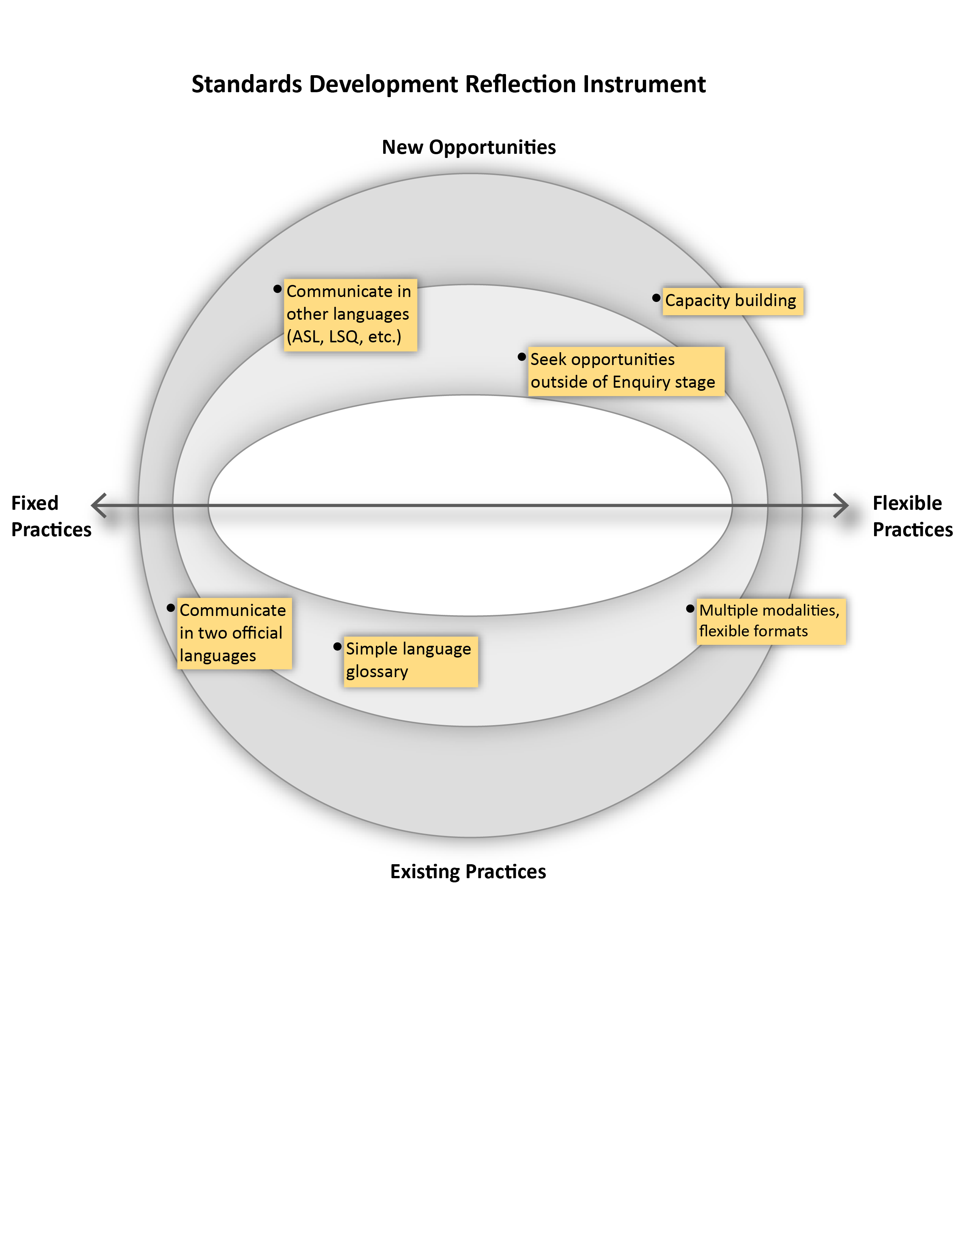

**Figure 7: Public Engagement Considerations for SDOs**

Area 3: Communication

This area is subdivided to represent two aspects of communication: 1) being understood and 2) inviting others.

Approaches for public understanding of standards

* Standards development is unfamiliar to many people. Make sure to define important unfamiliar terms and use simple language.
* There are many different audiences with different backgrounds. Therefore a “one-size fits all” approach to communicating will not be effective. Consider approaches that enable ease of access (i.e., different formats and modalities) and ease of transformation (i.e., translations or other interpretations) that enhance understanding by specific audiences. For example, talking about the standards process to a newcomer to Canada should be different.
  + Build relationships with specific communities to understand their needs to effectively communicate with them.

Self-reflection questions for public understanding of standards:

1. How might the process benefit from communication other than the official languages?
2. How might translations or transformations be facilitated in your process?
3. How do you evaluate comprehension and/or effectiveness of communication?
4. What details are necessary to communicate?
5. What communication channels are being used? Are these channels reaching the intended audience?
6. How are standards being published and announced? How do people become aware of them?
7. Think outside the page – how else can this content be presented to be more engaging?

Approaches for inviting others

* Use multiple ways to announce a standard is open to public input including different media channels, modalities, and formats. Also, see “Engage the public to better understand the standards development process” above**.**
* During the enquiry, consider different ways to get focused feedback. For example:
  + Seek input on portions of a standard instead of the whole.
  + Intentionally invite specific communities to give feedback on the draft standard.
* Provide multiple ways of contributing comments to a standard (i.e., not just through an online portal). Consider different degrees of accessibility and modality, and not just for electronic/online interactions. Possible approaches:
  + Provide an email address for feedback and input.
  + Allow the public to download a copy of the draft standard in different, accessible formats so they can add their comments and submit it.
  + Analog approaches like postal mail, telephone hotlines, and small group workshops.
* People with lived experiences can benefit from additional time to make their contributions. This gives them the freedom to move at a pace that fits their needs and allows them time to address any issues they may encounter like technical or access barriers.
* When providing feedback during enquiry, there can be a tension between the desire for privacy (anonymity) and the desire to share personal information and experiences that are relevant to the standard. Strict privacy can be more secure but can diminish the richness of feedback. There should be ways for individuals to make informed choices about their private information and provide safeguards.
  + Be aware that personal stories or experiences shared by persons with disabilities and intersectional identities can uniquely identify an individual, even if their identity is obscured or anonymous. Consider tactical curation/editing especially if publishing content for transparency purposes.

Self-reflection questions for inviting others:

* What are the ways the public is being informed about public enquiries? What are some different ways to boost public engagement?
* What are the possible barriers to participating in a public enquiry? Go ask them!
  + Lack of awareness
  + Availability and time requirements
  + Perceived required expertise or knowledge in the subject matter.
  + Lack of understanding of standards in general
  + Accessibility of materials or platform used.
* How do you measure the effectiveness of the enquiry stage? Quality, quantity, diversity of representation, or some other metric?
  + A lack of feedback or feedback from a small population is not an indicator of support for a draft standard.
* Does the enquiry process allow the public to share their personal experiences and contextual information that may be relevant to the standard? How is their privacy protected?

Area 4: Organizing Technical Committees

This area refers to the timing and ways that technical committees are formed as well as the practices within those committees.

Approaches for selection of technical committee members

* Selecting technical committee members from a pool of known experts (i.e., industry experts, researchers, policymakers, advocacy groups etc.) can be efficient and bring some diverse input but can lack critical perspectives that lie outside of the usual pool of expertise. Ensure more diversity on a technical committee by making the selection an open process by informing the public that a standard is to be drafted and an open application process is being held. Committee members are selected according to published criteria including lived experience and intersectionality. The selection process is transparent.
* Consider the phrase “nothing for us, without us”. If a new standard is going to impact certain groups more significantly than others, then those groups should be involved in the creation of the standard and not just at the enquiry stage.
* Consider how the composition of the technical committee can be more flexible and change over time depending on the need.
* Those who are not selected for a technical committee can be given the option to participate in other ways like being involved in a working group or invited to the enquiry.
* People who applied but were not selected for a technical committee should be informed.
* Communicate expectations to allow committee candidates to make informed decisions before joining. This includes payment details, time commitment, how the work is to be done, accessibility, etc.
* The public should be able to find some general/abstracted information about who is on a technical committee for a standard that impacts them. This can help increase transparency and accountability.

Self-reflection questions for selection of technical committee members:

1. How do you achieve diverse representation on a technical committee?
2. Is membership on the technical committee fixed or flexible?
3. How are candidates for a technical committee decided upon?
4. How do people learn about joining a technical committee and what is involved in being a committee member?
5. What is the process of deciding who will be on a technical committee? What role does diversity play in this?
6. Is there transparency and accountability in this process? How does someone learn more about the committee that is creating the standard? What information can be shared that balances privacy, accountability, and transparency?

Approaches for technical committee member onboarding and support

* Standardized tools and procedures for technical committees can make administration easier but can be a significant barrier for some members. For example, a software tool may be popular and widely used but may have accessibility or interoperability issues for someone using an assistive technology. Consider how technical Committee members are supported throughout the process that enables them to fully participate in the standard development process.
* Don’t assume training materials are enough to help a committee member in their role. Provide regular and ongoing support.
* Be mindful of cognitive load and not expect members to learn everything in one setting. Consider what is important for new committee members to understand right now and what can be addressed as needed.
* Issues with technology, accessibility, and language (not just official languages) can create barriers and fatigue that prevent members from participating fully.
* Understand the unique needs of technical committee members, especially those experiencing disabilities, and make it a baseline for all technical committees. For example, if some members require additional time to make their contributions the process should allow for more flexible schedules if needed and this should be the default going forward.
* Ensure that the SDO / project manager understands access needs and is equipped to help the technical committee. This may require regular training and upkeep of knowledge and skills.

Self-reflection questions for technical committee member on-boarding and support:

1. How can the experiences of the technical committee improve the way a standard is created for the SDO as a whole? Is there a way for a committee member to ask questions or give feedback?
2. How are the needs of committee members addressed? What are some ways to anticipate the needs of diverse technical committee members?
3. Are all materials, tools, platforms, etc. equally accessible to all members?
   1. How are documents shared?
   2. How is communication happening?
   3. Synchronous and asynchronous methods of collaboration – is it all accessible?
4. What are the checkpoints for the Technical Committee to reflect on progress?
   1. How is the pace? Need to go slower to get sufficient input/research?

ISAI Mapping Diagram and Table for Reproduction

The following pages contain a blank mapping diagram and table that can be copied and re-used or printed.

**Area of assessment: ________________________________________**

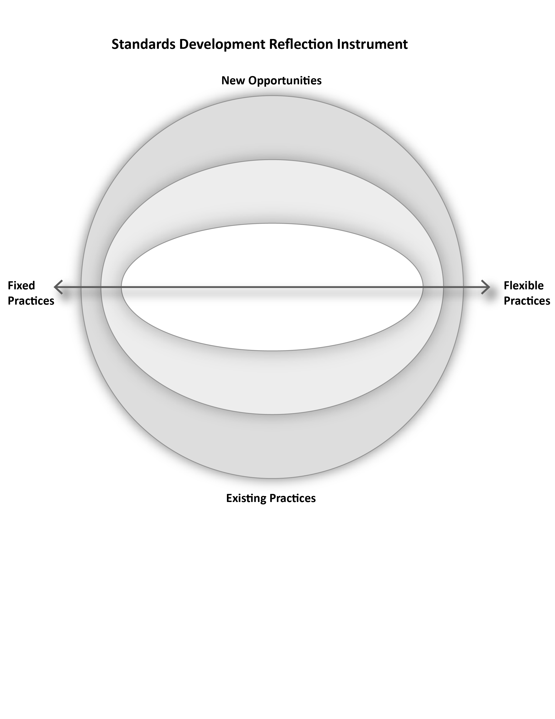

**Notes:**

| Dimension of the area under assessment | Position on Fixed/Flexible Practices Continuum | New Opportunity or Existing Practice | Level of Effort Required | Reflections |
| --- | --- | --- | --- | --- |
|  |  |  |  |  |
|  |  |  |  |  |
|  |  |  |  |  |
|  |  |  |  |  |
|  |  |  |  |  |

# Opportunities to Improve Inclusion: A Review of ASC Policy Documents

One of our objectives in this project was to make the documentation and explanation of the standards development process more accessible and inclusive. As part of addressing this objective, we undertook a review of three policy documents provided by ASC to identify potential areas to improve inclusion. The documents reviewed were:

* “Standards Development Operational Requirements” (2023-Jun-25; V2F-20230615)
* “Accessibility Policy and Guidelines” (2022-22)
* “ISO-IEC 71 Guide for addressing accessibility in standards” (2014)

For each of the documents, clauses that can be modified to improve accessibility are discussed in terms of how they are currently phrased and then followed by a suggestion to improve inclusion or accessibility. Some of the suggestions are operational, some address tactical issues (e.g., missing links), and others are points that warrant further conversation among ASC team members.

## Standards Development Operational Requirements

### 4.2.1. Technical Committee Requirements, p. 52

One of the requirements for choosing members of the technical committee is that the selection process follows the SCC’s definition of balanced representation: “a representation of interest groups in a Technical Committee such that no single category of interest can dominate the voting procedures.” This is good from a representative viewpoint since the more diverse the committee, the greater the chances of unexpected solutions to problems encountered. Another plus is that no one interest group dominates the committee.

The key phrase in this requirement is “interest groups” and the sections that follow list the relevant types of groups. These include persons with disabilities, academic/research bodies and NGOs, policymakers, and standards users (commercial interests). Also highlighted are equity-deserving groups, such as women, visible minorities, LGBTQ2+, and indigenous peoples. The Canadian perspective is noted as mandatory using geographic representation based on Statistics Canada population estimates, as well as language balance at least between English and French, but also consideration for ASL, LSQ, and Indigenous languages.

#### Suggestion

Regarding formal accounting of how committee members are selected, a problem is that one must pick which interest group a committee member belongs to. This could have the unintended effect of eliminating those with intersectional identities. On the other hand, selecting multiple identities creates a risk of tokenism and of finding someone who checks multiple ‘identities’ as a way of satisfying intersectionality and diversity. Care should be given to ensure no one is a token (representing a diverse group with only one perspective) or expected represent just one aspect of their self-identity. This can be accomplished within the relational work of the committee and will have to be seen as a priority of the facilitator or lead.

### 4.7.1.2 Notice of Public Review, p. 85

This requirement details how the public is notified that the draft standard is ready for public comments, listing information such as the ASC designation number, the title, the scope a link to the public review draft, and so on. It is not clear from the section how difficult it is, in general, for someone in the public to understand what this notice is all about. The wording suggests it is quite technical.

#### Suggestion

There should be a note that the notice is given in plain language which makes the announcement more approachable and inclusive. There is language to that effect in the “Introduction” on page 9: “All standards are accompanied by a brief plain language executive overview in English and French”; and in section “4.1.2 Accessibility of Standards Documents”, p. 50. It would be beneficial to reiterate that here, and to ensure that the public announcement is accessible to everyone.

We heard from technical committee leads that there has been confusion about who can be involved and how. Committee members were not aware *they* would be responsible for writing the review and were worried they were not expert enough or technical enough to take on that responsibility. Communications will have to convey both, that committee members are experts by virtue of their lived experience, and that they will also be tasked with creating a standard that addresses their needs as well as the needs of others.

### 4.7.1.4 Notice of Withdrawal (p. 88) and Withdrawal Stage 95 (p. 47)

Only the Technical Committee determines whether a standard is to be withdrawn. The committee is required to investigate if the withdrawal of the standard has implications for other standards and legislation. However, these sections of the requirements do not say whether the technical committee elicits input from the public, specifically from the persons with disabilities who may be affected by the termination of the standard.

The public notice of withdrawal appears to be final. That is, it is not clear whether the public has an opportunity to raise objections to the termination of the standard. If the public notice *is* intended to solicit opinions from the public and persons with disabilities, or indeed while the technical committee decides whether to withdraw a standard, it is not clear how affected individuals can raise their concerns.

#### Suggestion

There should be a public “notice of withdrawal” that gives the public the ability to respond and inform ASC how the removal of the standard affects them if it affects them negatively. In other words, there should be an opportunity for dialogue with affected persons with disabilities at this stage or just before it.

Note that this is consistent with the [Living Standard](https://whatwg.org/faq#living-standard) approach, where the stages of standards development are elided in favour of continuous improvements; anticipating or reacting to specific problems as they are encountered. With this kind of approach, the public always has opportunities to contribute.

The goal of the living standards approach is to avoid the relatively long time between a published standard and its updates. Instead, revisions are added more frequently, just a little ahead of implementations, and they are based on input from anyone who is affected by the standard. The important lesson from the living standards approach is to open the standards development process so that any company, organization, or individual affected by the standard can make meaningful contributions to its development.

### 4.10.3. Performance-Based Standards, p. 84

ASC standards are performance-based in that they prescribe the required outcome, but not how that outcome is achieved. This is a case where lived experience is useful. Persons with lived experience know what they want or need, but not necessarily how to get it. It is the former, the “what”, that is important for the standard.

#### Suggestion

Having the advice of people who have lived the issues is very beneficial. Conveying that people with a lived experience of disability have *technical* expertise is important and essential to the standards development process. There should be a focus to engage more people with disabilities and to convey to them that they have the technical expertise to be part of this work.

### 5.3.12. Stakeholder Comments, p. 125

During the Enquiry phase when soliciting public review comments on the draft standard, ASC employees and its Board of Directors can provide comments.

#### Suggestion

Since ASC and the Board of Directors can be seen as experts or authorities on the standard, it might be better for them to post the comments anonymously to avoid giving them more weight than other comments. Also, in general, is anonymous posting allowed during the Enquiry phase? There may be other reasons why a member of the public, or a person with a disability, prefers anonymity when they comment on the standard; having the ability to do so would encourage their participation.

## Accessibility Policy and Guidelines

### Accommodating Accessibility Standards Canada’s Employees, Board Members, and Committee Members with Disabilities, p. 23

There is a sequence of questions in this section. Answers to these questions are intended to determine whether and how to set up any accommodations that individuals require to work effectively.

The fifth question in the sequence is, "Has the person been asked about possible accommodations?". This should be the first question. It follows first a question about identifying barriers and how they limit the individual, secondly identifying tasks that are difficult for the individual, and thirdly identifying accommodations for those barriers and tasks. Consulting with the individual from the start would help to address all these prior inquiries.

The sixth question is "Should we meet with the individual after they have the accommodations to see whether changes are needed?". The answer is an obvious "yes". And, as noted above, involving the individual from the start will provide useful information about what is needed. Consultation with the individual should be from the very beginning and ongoing as barriers are confronted and solutions developed.

#### Suggestion

It is likely that the individual already uses some form of accommodation in their daily lives. They are an expert in that regard and can make significant contributions to the accommodation process. While there may be accommodations with which they are unfamiliar, that other accessibility experts are aware of, nonetheless it is best to involve the individual from the start to explore novel potential alternative solutions.

### Annex A – Accessible Meetings: A Handbook for Federal Public Servants, p. 43

There are several errors in the annexes. These are listed here and in the next section for Annex C.

The is a single sentence in Annex A that, visually, looks like a link. The link is missing, however. Check "Accessible Meetings: A Handbook for Federal Public Servants”.

### Annex C – Links to accessible documents development, p. 45

There is a list of ten links in this annex. The first five and the tenth are "file:" links, e.g.,

file:///\\\\hrdc-drhc.net\\nc_common-commun$\\CASDO-OCENA\\Common\\Communications%20Products\\Accessible%20COMs\\Accessibility%20of%20Documents_EN.pptx

These links cannot be accessed because they are pointing to a file local to some desktop.

Link seven, while an "https:" link, leads to a Microsoft Word error, "Sorry we ran into a problem", and does not open the intended target.

Links six, eight, and nine are "https:" links, and they work.

## ISO-71 Guide for addressing accessibility in standards

### 6 Accessibility goals, p.10

Clause 6.2 is focussed on a variety of known accessibility issues and how to address them, for example, “6.2.8 Usability”. This presents a great opportunity where people with lived experience can speak to specific accessibility issues from their perspective. Another way of looking at it is that instead of trying to judge if something from the 6.2 taxonomy applies, ask an experienced person for their perspective and recommendations. A similar rationale applies to Clause 8 “Strategies for addressing accessibility needs and design considerations in standards”, p. 34.

#### Suggestion

As the various issues and strategies are considered, encourage the participation of people with lived experience in determining those strategies and how effectively they are applied.

### 4.3.1 Stage 1: Define the standards project and determine the applicability of this Guide, p. 5

There is a test to determine if ISO-71 applies, and if the proposed standard does not focus on systems that users interact with, that the guide should be ignored. It goes on to suggest that even if it is deemed that ISO-71 does not apply, it should be kept in mind, and perhaps used until such time as it clearly does not apply.

#### Suggestion

Perhaps this goes without saying, but since the standards developed by ASC are always associated with accessibility, this guide should always be used as a resource, among others.

# Appendix A: Suggested Inclusive Standards Development Process Considerations

Standards, by their very nature, aim to solidify, establish, standardize, be fixed, predictable, and stable. This is both a benefit and one major weakness for standards creation. To fix something human is to fall into the folly of pinning down something that is in constant movement. The social, the systems, and the complexities therein are by their very nature dynamic. The temptation is to fix them pin them or find a way toward completion or clarity. There will always be these tensions and perhaps that is beneficial – it forces us to explain why we’ve decided what we have and to acknowledge that the work is iterative and will never be done.

The parts of processes that are difficult to solidify are the human relational, fundamentally dynamic ones. Largely, we have found in our research that the social, soft aspects of process development are missing or obscured from process documentation. Things like social processes, feedback, feedforward, expectations, ways to value engagement, and ways to measure success are obfuscated or not mentioned at all. Below we try to surface some observations about these ephemera that, when considered in earnest, make up a large part of what we socially, culturally, and politically accomplish.

One example of a standard development process we found interesting was the [WHATWG Living Standard](https://whatwg.org/faq#what-is-the-whatwg) development process, where standards are continuously updated based on feedback from any interested party; from developers, vendors and end-users. The intent is to add features and fix errors faster than the typical way standards are developed, which requires a relatively long time, sometimes years before the standard is published. Instead, revisions are added more frequently, just a little ahead of implementations, and they are based on input from anyone who is affected by the standard. The important lesson from the living standard approach is that open standards development processes allow any company, organization, or individual affected by the standard to actively participate in its development.

We can contrast that with a ‘typical’ standards development process that is tightly structured (usually by the standards accreditation body). Below we hope to surface some of what participation could feel like for people on the edges, for people with disabilities whose needs and preferences are not addressed.

## Education of Standards and Standards Organizations (SOs)

* + How/where does someone from the public learn about Standards? SDOs and what they do?
  + Provide standards education that can be geared toward everyone, not just technical professionals.
  + More methods of notice for standards to support public understanding – not just digital methods.
  + Is there a way to have more physical presence? Subways? Buses? Libraries? Other public spaces? Can there be a hotline?

## Membership

* + Recruitment needs to appeal to the people most impacted by the standard – what is the Return on Investment (ROI), and what is the Social Return on Investment (SROI)? And how are those being communicated to the public?
  + Track members’ affiliations in committees to ensure balanced representation, multidisciplinarity, and include end users from the public.
  + Representation - Include persons with disabilities (and diversity within that population)
    - How do you support everyone’s participation?
    - How do you have representation without tokenization (e.g., a member who is deaf feeling as though they need to represent all deaf and hard-of-hearing individuals)?
  + How were members invited and chosen?
  + What was the rationalization for the people chosen? Who decides?
  + Who joined/declined?
  + Are minorities invited to fill a quota or to actively participate?
  + What are some recognized membership needs that have yet to be met? (i.e., acknowledge areas where there is a lack of representation or experience).
  + What does membership entail? What is the commitment?
  + What is the onboarding like?
    - For example, how is intimidation of being on such an important body mitigated? How do you communicate that participants don’t need to know everything – there are people who can help?

## Consensus and voting

* + Is consensus required? Is it possible to have multiple voices represented in a standard?
  + Consensus can sometimes be perceived as giving up one’s voice to compromise for the majority. How is the act of consensus achieved?

## Mentorship /resources

* + Develop an onboarding system for new members (e.g., W3C has a buddy system for technical and content questions).
  + Provide training for all participants specific to disabilities.
  + Provide resources to support new members and specific to persons with disabilities.

## Approachability/Accessibility to the process

* + Comprehensibility – language, wording, technical vocabulary – these can all intimidate and leave participants feeling unqualified.
  + Access to resources that can help make sense of complex issues.

## Standards Development Review Process

* + Some standards organizations use web portals as a way of submitting reviews or feedback for SDCs (i.e., <https://csds.ul.com/Login>) – how accessible are these portals? How much of a barrier to participation do they create?
    - Video: [https://dwlan53sxbm2w.cloudfront.net/CSDS/20170822_What is CSDS.mp4](https://dwlan53sxbm2w.cloudfront.net/CSDS/20170822_What%20is%20CSDS.mp4)

## Paid/voluntary participation

* + What is the time commitment? Generally, requires volunteer time.
  + Who is being excluded if participation is voluntary (e.g., persons without another source of income)

## Meetings

* + Time of meetings – Who benefits? Who doesn’t?
  + Shorter meetings – Who benefits? Who doesn’t?
  + Clear agendas to increase efficiency.
  + Hybrid options
  + Flexibility in meeting options
  + Remote access to meetings (e.g., teleconferences, zoom, facetime)
  + How do you allow everyone to participate? Especially in large groups, long meetings, or on a platform that doesn’t meet everyone’s needs?
  + What are the methods of communication? Is all relevant information being sent to all channels?

## Group dynamics

* + Define the roles of each participant.
  + Are power dynamics being created? How does this impact voting? Who manages this in the group? How is it managed?
  + Are there incentives affecting the process (e.g., conflicts of interest)?

## Inclusive meetings with insights borrowed from UN UNECE [Guidelines on Developing Gender-Responsive Standards](https://unece.org/sites/default/files/2022-12/ECE_TRADE_472E.pdf)[1]

* + Establish meeting rules, code of conduct, and conflict resolution early.
  + Support brave space to share opinions.
  + A democratic process where no one person dominates.
  + How are participants’ input considered, how is feedback incorporated, and conflicts reconciled?
  + Speaking time limits, hand raising, chair to monitor, go around the room,
  + Offer other ways to contribute (polls, share before/after meeting)—great ideas *will* happen outside of meeting times.
  + Establishing a common starting point rather than attempting to reach a consensus.

## Public consultation

* + Consult widely (individuals, groups, businesses, interest groups, etc.)
  + Provide easy-to-read summaries (something that emerging AI tools can automate)
  + Regular consultation with outside agencies.
  + Build in public comment phases.

## Inclusive Data with insights borrowed from: British Standards Institute (BSI) [Enabling the development of inclusive standard](https://pages.bsigroup.com/l/35972/2023-08-02/3t6ltn4/35972/16909688368yNeaJsm/BSI_Flex_236_Version_2.pdf)[2]

* + Verify if data are inclusive, debiased, and diverse.
  + Collect inclusive data if data is not appropriate.
  + State limitations of data.
  + If inclusive data is not available, bring in appropriate experts, and note and amend the standard when data is available.
  + Provide education to the standards committee on data bias and implications.
  + Use self-reflection questions, impact assessment, and publish results.

## Declaration of No Conflict

* + Be explicit about affiliations or sources of capital that might conflict with participation.
  + Be explicit that contributions to the standard are not encumbered by patents or other intellectual property rights.

## Iterative process

* + There should be a continuous improvement process where information about the use of standards is collected, and ongoing changes are made and actively shared.
  + Feedback and feedforward mechanism - closing the feedback loop to something that gets done and can be traced back to a specific need.
  + How do we maintain living standards/decisions? Let go of “final”?

## Timeline:

* + Lead time to feedback, publication and participation.
  + Frequency of iteration, evaluation, and re-evaluation.

## Responsibility of Standards Organization (SO)

* + SO to take ownership of standard
  + If possible, it would be beneficial to know who is using the standard and how it is being used.
  + Know who and how standards implicate the public, minorities, and persons with disabilities.
  + Reach out to organizations to involve their participation in the standards development process.
  + Solicit feedback from stakeholders.
  + Educate and update stakeholders on changes and the impact of standards.
  + Advance notification to the public regarding standards development, scope of work, conditions for participation
  + Provide access to information and decisions made.
  + Provide a public comment period.
  + Internalization of public accountability (not just transparency)

## Reflect on how the standard impacts people differently

* + Assume every decision has the potential to include or exclude certain groups.

From UNECE:

* + - start with the assumption that gender/disability differences are relevant to the content of the standard.
    - gather evidence to quantify and elucidate the impact of those gender/ability differences for the standard.
      * Process of self-reflection
      * Probing questions
      * Requires persons with knowledge, and expertise.
      * Requires use of appropriate data [– WHO functioning and disability disaggregation tool](https://archpublichealth.biomedcentral.com/articles/10.1186/s13690-022-01001-2)[3]
      * May need to collect appropriate data or note data limitations in standard and potential implications.
    - take targeted action to mitigate the impact of gender/ability differences on the standard.
      * share any differences and implications the standard may have on persons with disabilities.
    - From WAI-ARIA working group:
      * Solicit input from various Assistive Technology developers,
      * Solicit input from Assistive Technology users,
      * Invite Assistive Technology users (or, more generally, “persons with disabilities”) to join the working group.

## Show your work

* + How were decisions made?
  + Reflection questions (include in public information, include some open-ended questions).

## Registry of harms

* + A database for standards; a radical act of transparency.

## Adaptability and Stability

* + How easy is it to make changes or revisions to a standard?
  + How do you build a sense of stability while you have a standard that works?
  + Any flexibility you build into the system can be misused.

## Alternatives to Standards

Objective-based code and alternative solutions instead of a standard

* + <https://www.welland.ca/Building/devForms/AlternativeSolutionCodeDesign.pdf>
  + <https://www.nationallifesafetygroup.ca/news-1/performance-based-code-alternative-solutions>
  + <https://www.toronto.ca/services-payments/building-construction/apply-for-a-building-permit/building-permit-application-guides/guides-for-other-buildings/alternative-solutions/>
  + <https://nrc-publications.canada.ca/eng/view/accepted/?id=ad81d6f2-e76c-4eff-a428-de7e001d3527>

# Appendix B: Existing Instruments within the standards development landscape

Note: Below does not represent a linear process, it is a numbered list of instruments.

## 1 - Standards development framework

* **What:** A description of the goals, objectives, or obligations for a standards framework including implementation, monitoring, and reporting.
* **Who:** Standards development entities, regimes, and organizations
* **Example:** [UN - Frameworks for Implementing and Monitoring the UN Convention on the Rights of Persons with Disabilities](https://www.un.org/development/desa/dspd/wp-content/uploads/sites/22/2022/01/Frameworks-English-.pdf)
  + [W3C Charter Process](https://www.w3.org/2023/Process-20230612/#group-lifecyle)

## 2 - Standards development process

* **What:** The methodology by which a standard is created. Typically, this process defines the stages, the stakeholders, and the ratification of a potential standard.
* **Who:** Standards development entities, regimes, and organizations. Stakeholders who represent parties that are affected by the potential standard.
* **Example:** [IEEE Standards Development](https://standards.ieee.org/develop/)
  + [ISO Standards Development Process](https://www.iso.org/stages-and-resources-for-standards-development.html)

## 3- Risk assessment

* **What:** Process taken to identify and understand factors that affect stakeholders.
* **Who:**
* **Example:** [WEF AI Risk Assessment Tool](https://www3.weforum.org/docs/WEF_AI_Procurement_in_a_Box_Workbook_2020.pdf), [Government of Canada – Guide to Integrated Risk Management](https://www.canada.ca/en/treasury-board-secretariat/corporate/risk-management/guide-integrated-risk-management.html#toc1_1)

## 4- Impact assessment

* **What:** Process to understand what a system does and is permitted to do, who it affects, and who can affect (make changes to) the system.
* **Who:**
* **Example:** [Assembling Accountability: Algorithmic Impact Assessment for the Public Interest](https://datasociety.net/wp-content/uploads/2021/06/Assembling-Accountability.pdf)

## 5- Auditing and Standards Review

* **What:** Process in which a standard that has been implemented is evaluated in its effectiveness and impact, and revisions or actions are suggested.
* **Who:**
* **Example:** [2019 Legislative Review of the Accessibility for Ontarians with Disabilities Act, 2005](https://www.ontario.ca/page/2019-legislative-review-accessibility-ontarians-disabilities-act-2005)

## 6- Community engagement / Public feedback

* **What:** Processin which the public is consulted to provide feedback on standards that affect them.
* **Who:**
* **Example:** [Disability Participation and Consultation Network, Ireland](https://www.gov.ie/en/consultation/a3ef2-launch-of-disability-participation-and-consultation-network/?s=04)
  + [W3C Standards Review Process](https://www.w3.org/standards/review/)
  + [CSA Public Review Portal](https://publicreview.csa.ca/)
  + [ASC Public Feedback Process](https://accessible.canada.ca/accessibility-standards-canada-accessibility-plan/feedback-process)

## 7- Monitoring and oversight

* **What:** Systems, processes, and institutions in place to monitor implementation of standards, its effects, and its oversight.
* **Who:** State organizations, non-government organizations
* **Example:** [Canada Human Rights Commission](https://www.chrc-ccdp.gc.ca/en), [Canadian Disability Policy Alliance](https://www.disabilitypolicyalliance.ca/wp-content/uploads/2018/03/dispollens-2017-New-Document.pdf),

## 8- Development Process Tools

* **What:** Tools used to help guide standards development committees in decision-making. Such examples include self-assessment tools, guidelines or tools used during specific phases of the standards development process.
* **Who:**
* **Example:** [CDPA - The Disability Policy Lens, 2nd ed.](https://www.disabilitypolicyalliance.ca/wp-content/uploads/2018/03/dispollens-2017-New-Document.pdf)
* [**Gender Responsive Standards ISO and IEC**](https://www.iec.ch/resources/tcdash/smb/ISOIEC_JSAG_GRS.pdf)

## 9 - Standards Implementation tools

* **What:** Tools used to assist in the implementation of standards or regulations based on standards.
* **Who:** Employees, Managers, Compliance officers
* **Example:** [Federal Public Service Inclusive Appointment Lens](https://www.canada.ca/en/public-service-commission/services/appointment-framework/federal-public-service-inclusive-appointment-lens.html), [Gender-based Analysis Plus](https://women-gender-equality.canada.ca/en/gender-based-analysis-plus.html),
  + [W3C: Validators and Tools](https://www.w3.org/developers/tools/) (Note: these are tools that meet one or more of the W3C standards and can be used to demonstrate that some standard is feasible. Others are validation tools that are used to make sure that authored content meets the standard, e.g., the [CSS Validator](https://jigsaw.w3.org/css-validator/).
  + [W3C: Web Accessibility Evaluation Tools List](https://www.w3.org/WAI/ER/tools/)

## 10 – Reform through judicial systems

* **What:** Legal process to challenge and change regulations and standards.
* **Who:** Affected individuals, community groups, non-government organizations
* **Example:** [ARCH Disability Law Centre](https://archdisabilitylaw.ca/),

## 11 – Education

* **What:** Educating the public about standards, the standards process, how it affects them, and how to get involved / make changes
* **Who:**
* **Example:**
  + [W3C Standards Review Process](https://www.w3.org/standards/review/)
  + [National Fire Protection Association – Standards development – how the process works](https://www.nfpa.org/Codes-and-Standards/Standards-Development/How-the-process-works)

# Appendix C: Standards Development Game Overview

You can use this document to familiarize yourself with the game you will be playing next week. Your facilitator will be managing the game components while screen sharing and describing the play. It’s a new game for everyone so we will also be learning as we go. Let’s have fun!

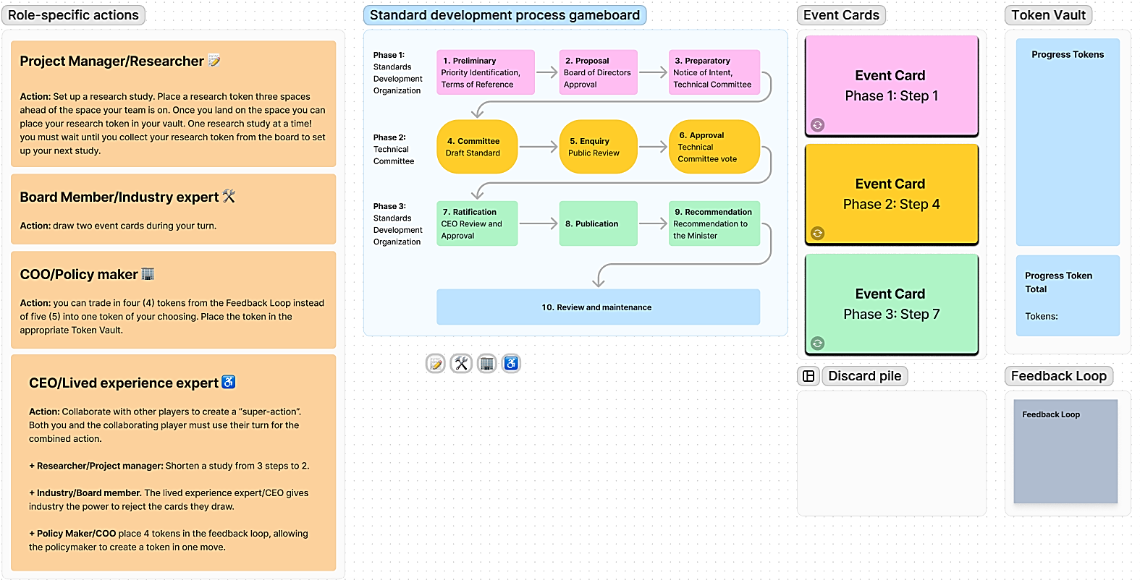

Figure 8: Gameplay components

## About the game

The goal of the Standards Development game is to create a Standard. While this is what your team is trying to accomplish, don’t rush to the end. Focus on the process of the game. Stay present and curious and question the process.

The Standards Development game is a collaborative game of strategy played as a team.

The game has three phases. In Phase 1 and 3 your team will represent the Standards Development Organization (SDO), in Phase 2, your team will represent the Technical Committee (TC). The game rules and the abilities of team members are the same for all three phases.

Your team is made up of four different dual roles each with their own “superpowers” during gameplay. At the beginning of game play each team member chooses their role. *All four roles must be represented on your team; in teams of more than four, you can have duplicate player roles*:

* Project Manager (SDO) / Researcher (TC)
* Board Member (SDO) / Industry Expert (TC)
* COO (SDO) / Policymaker (TC)
* CEO (SDO) / Lived experience expert (TC)

You will have successfully created a Standard when your team lands on the last space of the board, with 10 progress tokens (or more) in your vaults.

## About the game board

The playing board is made up of ten (10) spaces divided into three phases ending with a final review and maintenance step. The team plays the gameboard in sequence from one to ten. Once you reach space 10, the team counts the tokens in their vault and chooses an End Game card to complete the game.

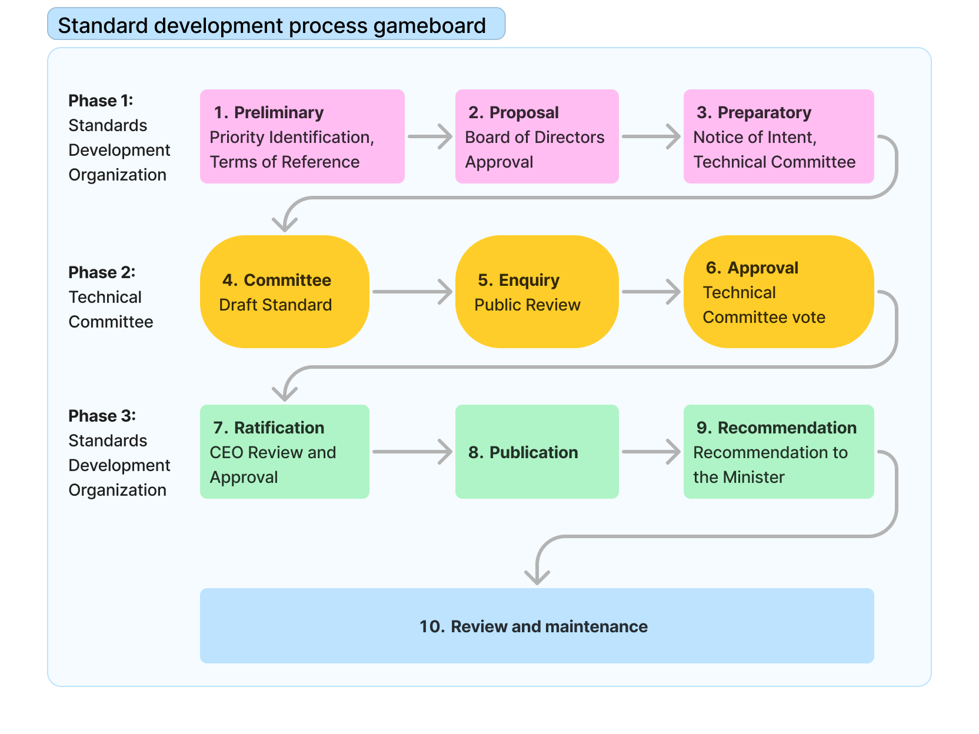

Figure 9: Gameboard

## What are the three phases of the game?

The gameplay steps are divided into three phases. Phase 1 and Phase 3 are guided by the Standards Development Organization (SDO). Phase 2 is guided by the Technical Committee (TC). Depending on the phase, your role will either represent a member of the Standards Development Organization (SDO) or a member of the Technical Committee (TC). Your “superpowers” will remain the same in all phases.

## What does gameplay look like?

* Each space on the gameboard represents a gameplay round. One gameplay round includes one action from each member of the team. A player can perform one of the following actions:
  + 1. Select an event card.
    2. Perform a role-specific action.
    3. Trade in Feedback Loop tokens.
  + Once each player has performed their action your team moves to the next space on the gameboard.

## How do I collect tokens?

* To successfully create a Standard, you need 10 tokens in your Token Vault when your team reaches the last space on the game board. *If your team has more than 10 tokens at the end, give yourselves extra congratulations and fist bumps :-).*

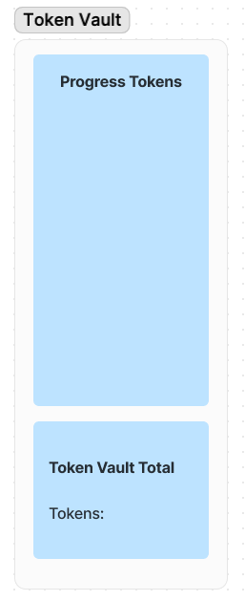

Figure 10: Token Vault

* You collect tokens through event card actions and role-specific actions.
* Some event card actions will take away your tokens. If this happens, strategize with your team on how to build up the number of tokens in your vault.
* If you lose a token, place it in the Feedback Loop.
* If you have 5 tokens in the Feedback Loop, learn from your mistakes and take back one token of your choice, discarding the rest.
  + Exception: COO (SDO) / The Policy Maker (TC) can trade in 4 rather than 5 tokens at their turn.
* During a round consider when might be the best time to convert tokens from the Feedback Loop into tokens for the Token Vault. For example, you may want to wait until the end of the round to trade in your tokens because it may be less likely that you will lose them during a gameplay round.

## What are Event Cards?

Event cards can be selected by any player at each turn. You can gain or lose Progress Tokens when you select an event card.

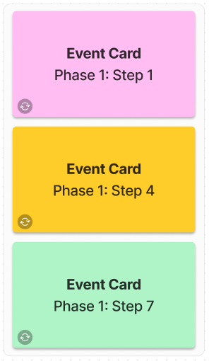

Figure 11: Event Cards

## What are role-specific actions?

Each player is assigned a role, and each role can perform certain unique actions – your superpower! The roles and their actions are:

### Project Manager (SDO) / Researcher (TC) / 📝

Your research can help inform a great standard.

**Action:** Set up a research study. Place a research token three spaces ahead of the space your team is on. Once you land on the space you can place your research token in your vault. One research study at a time! you must wait until you collect your research token from the board to set up your next study.

### Board Member (SDO) / Industry Expert (TC) 🛠️

You have a technical and financial understanding of the requirements.

**Action:** draw two event cards during your turn.

### COO (SDO) / Policymaker (TC) 🏢

You have an in-depth understanding of bringing standards into practice and can address feedback.

**Action:** you can trade in four (4) tokens from the Feedback Loop instead of five (5) for one Progress token. Place the token in the Token Vault.

### CEO (SDO) / Lived experience expert (TC) ♿

Your expertise gives you the ability to collaborate with other players.

**Action:** collaborate with other players to create “super-actions”. Both you and the collaborating player must use their turn for the combined action.

Collaborations and super-actions are:

* With the **Project Manager (SDO) / Researcher (TC):** Shorten a study from 3 steps to 2.
* With the **Board member (SDO) / Industry (TC):** The lived experience expert gives industry the power to reject the cards they draw.
* With the **COO (SDO) / Policy Maker (TC):** place 4 tokens in the feedback loop, allowing the policymaker to create a token in one move.

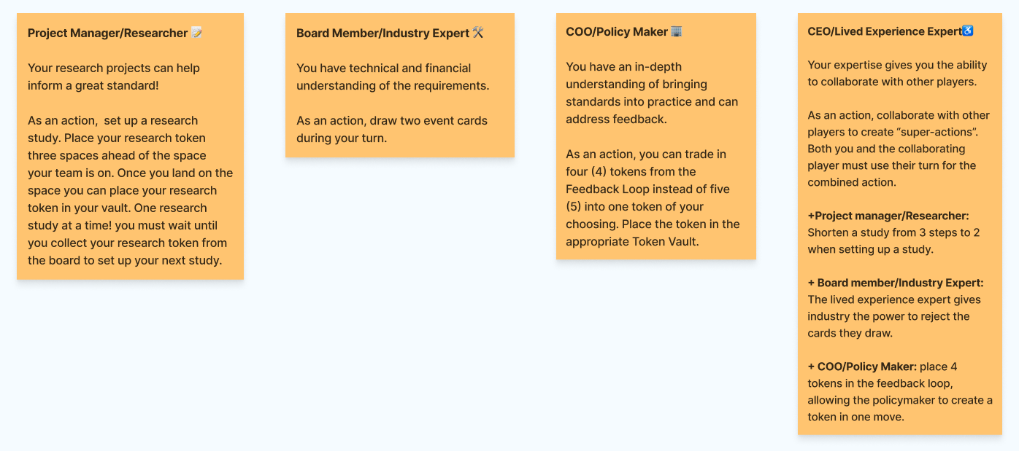

Figure 12: Technical Committee team roles

## What is the Feedback Loop?

The Feedback Loop is where the team learns from losing tokens. For example, an event card indicates that you lose a token from the Vault because the document the technical committee team has published receives a negative comment from the public. Yes, you lose a token, but your team learns from the experience and the feedback can result in a better standard in the long run.

Feedback is an important part of the standard’s iteration process. Once feedback is integrated into the standard it is no longer relevant. Tokens are, therefore, removed from the Feedback Loop at the end of each gameplay step.

Tokens are moved to the Feedback Loop in three ways:

1. You select an event card that indicates that you lose a token.
2. You select an Event Card that asks you to repeat a step or go back to a previous step.
3. A lived experience expert places a token in the Feedback Loop as an action, in collaboration with the COO (SDO) / Policy Maker (TC).

Once there are 5 tokens in the Feedback Loop, any player can redeem them into a single token as an action during their turn.

Two player roles have special powers when it comes to tokens in the feedback pile:

1. A COO (SDO) / Policy Maker (TC) can redeem 4 rather than 5 tokens from the Feedback Loop into a single Progress Token.
2. A Lived Experience Expert can place 4 feedback tokens in the feedback loop as a collaborative action with the COO (SDO) / Policy Maker (TC) to create a progress token.

## What are End Game Cards?

Once you have reached the end of the game (Step 10), count your tokens and select the card from the End Game decks that matches your team status. Your card will reveal more details about your game results. There are two possible end-game scenarios:

* You have enough progress tokens to successfully complete a standard.
* You do not have enough progress tokens to complete the standard.

Enjoy the game!

# Appendix D: Event Cards

## Standards Development Board Game Event and End Game Cards

### Event Cards

#### Phase 1: token event cards

##### Preliminary

Gain

* Seed Document researchers identified all gaps in standards that have already been published in this field. Gain one token.
* Your seed document is informed by a brand-new report from the EU. Gain one token.
* It’s the Friday before a long weekend and you’ve just emailed the final Terms of Reference document to the Board of Directors. You feel a great sense of relief. Gain one token.

Lose

* Your idea falls outside of the 7 priority areas. Lose one token.
* An idea for the standard is dependent on a new standard you know is coming from another Standards Development Organization, your team slows down and waits for the new standard to be published. Lose one token.
* The Board of Directors does not approve the Terms of Reference for the standard and asks for significant changes. More research is required. Lose one token.

##### Proposal

Gain

* Good news, the Board of Directors received the Terms of Reference document! Gain one token.
* All (part-time) Board of Directors members are working on the same day at the same time. They work synchronously to review the Terms of Reference document and get back to you quickly with a positive response. Gain one token.
* Your partnership with an academic group reveals new relevant research. Gain one token.

Lose

* The Board of Directors has some questions about your Terms of Reference document. This slows down progress as you set up meetings. Lose one token.
* Five Board members have reached the end of their appointment and must have an extension, renewal, or replacement with new Board members. Lose one token.

##### Preparatory

Gain

* Offer letters are sent out to qualified technical committee member applicants. Good news! All applicants accept the letter of offer. Gain one token.
* The chair and vice-chair of the technical committee have been selected! Congratulations, Gain one token.
* The members of the technical committee represent a wide range of diverse perspectives. Gain one token.

Lose

* Your researcher is busy scoping/completing the seed document and needs to take a leave of absence. A new researcher happily joins the team. The seed document is delayed. Lose one token.
* You are alerted to another standard being done that is similar to your priority area – you are told it would be a duplication to publish the Notice of Intent. Place all tokens gained at this step into the Feedback Loop and repeat the Preliminary Step.
* Oh dear, you did not receive enough technical committee applications to proceed. You need to reopen the application process to find more candidates. Lose one token.
* Oh no! All qualified technical committee applicants are from the same geographic region. You cannot select them because they do not meet the geographic diversity requirements. A new application process needs to be started. Lose a progress token.

Neutral

* Offer letters are sent out to qualified technical committee member applicants. One applicant has to decline the offer because of other commitments. Project manager must reach out to an alternate candidate. Neither gain nor lose a token.
* You’ve received a large number of technical committee applications, and many are highly qualified. How will you ever decide who will be on your technical committee? You do not gain or lose a token (but you may lose some sleep).

#### Phase 2: token event cards

##### Committee

Gain

* An organization completes a Seed Document, and you hand it over to the new technical committee. Gain one token.
* Your technical committee is diverse and represents a wide range of perspectives. Your draft receives positive feedback from the public. Gain one token.
* An impact report has been published that provides insight into the standard being developed. Gain one token.
* A coalition of disability organizations submits a series of recommendations for the draft standard. Gain one token.

Lose

* The minimum number of committee members cannot make a scheduled meeting and it is cancelled. Lose one token.
* The committee decides the document is not ready to proceed to the next step. Lose one token.
* An industry stakeholder insists that parts of the document are not economically feasible. Lose one token.

##### Enquiry

Gain

* The committee has a two-day, inclusive hybrid meeting and gains some momentum in pushing the standard forward. Gain one token.
* You received a positive comment on your document from the public. Gain one token for public support.

Lose

* You have taken too long to respond to feedback and your technical committee forgot the context. Lose all of the tokens in your Feedback Loop.
* You do not get substantial public engagement on the Draft Standard. You have doubts about moving forward. Lose one token.
* The Technical Committee can’t access the documents from the SDO. Lose one token.

Misc.

* The legal team asks that you make two publishable documents for public review: one in standard language and the other in plain language. This slows down the publication process but communicates the documents more clearly. Neither gain nor lose tokens, but good on ya!

##### Approval

Gain

* The technical committee votes to approve the Draft Standard. Gain one token.
* Another jurisdiction (USA) is influenced by your Draft and wants to incorporate it into their work. Gain one token.
* Your standard receives positive feedback from the public because your technical committee is diverse, and a wide range of perspectives is represented. Gain one token for public support.
* The draft standard is shared using different formats including different modalities and languages. Gain one token.

Lose

* You missed something! Your technical committee lacks representation from an impacted group. Lose one token.
* There is an ongoing disagreement among committee members, and they are unable to find a solution that meets everyone’s needs. Lose one token.

Misc.

* Urgent safety issues have been identified. The public review period is shortened from 90 days to 45 days. You accept that your standard will be timely but will have less input from the public. Neither gain nor lose a token.
* The public review period is lengthened from 90 days to 120 days. You accept that you take longer but gain more feedback from the public. Neither gain nor lose a token.

#### Phase 3: token event cards

##### Ratification

Gain

* The CEO is so proud of what the committee has put together that they write a blog post about the new Standard coming out. Gain one token.
* The CEO is excited about the new standard. They give everyone who worked on it a day off. Gain one token.
* The CEO incorporates some aspects of the standard into their own workflow immediately, improving inclusion at the SDO. Gain one token.

Lose

* The CEO breaks their ankle ice skating on the Rideau and has to have surgery. They can’t review the Standard, so you have to wait. Lose one token.
* More work is needed and you’re not quite ready to proceed to the next step. Place all tokens gained at this step in the Feedback Loop and repeat the turn.
* The Board has some questions about the Standard the CEO passes along. Lose one token.

##### Publication

Gain

* Your Standard will be reviewed to see if it can be published. Your team included all relevant evidence in an understandable way to support the publication of a National Standard of Canada. Gain one token.
* The legal team reviews your standard and provides comments. Changes from legal improve the standard and are doable by the team in a timely manner. The project stays on track. Gain one token.

Lose

* Oops! The standard contains copyrighted materials. The issue is identified too late in the process to be able to proceed. Standard is delayed as the licencing agreement is dealt with. Lose a token.
* The SDO server crashes and the document versions are lost. Lose one token.
* The legal team reviews your standard and provides comments. While the changes will improve the standard, they will take time and delay the project. Lose one token.

##### Recommend

Gain

* Your standard is heading to the Minister with a gold star of recommendation on it. Gain one token.
* The Minister sends an email asking for the Standard – they’re already eager to start the process of making it into a regulation. Gain two tokens.

Lose

* Somehow a bunch of public review comments that had been submitted were found. They weren’t DISPOSITIONED in Step 5: Enquiry. Lose all tokens and head back to Step 5.
* The team has identified significant accessibility challenges to some requirements. Lose half of the tokens in your vault and return to stage 4.

Misc.

* You must abandon the standard. Move all tokens to the Feedback Loop and go back to Step 1.

Repeat steps

* More work is needed and you’re not quite ready to proceed to the next step. Place all tokens gained at this step in the Feedback Loop and repeat the turn.

### End Game Cards

#### Not enough tokens

* Although there was consensus on the technical committee, public consultations have revealed that more public outreach and consultation is needed before continuing in the process.
* The draft standard your technical committee was deliberating on has been withdrawn because a competing standard has gained wider support and was approved.
* Public consultation has revealed unanticipated potential impacts. More time is needed to conduct research to revise the draft standard.
* A similar standard was approved in another jurisdiction and has been undergoing scrutiny by the public and industry. The technical committee has decided to monitor and research the emerging criticism.
* The standards development board has recognized the importance of the draft standard and its overlap with another standard under development. The board has decided to withdraw the draft your team has been working on and merge efforts with the other standard.

#### Approved Standard Cards

* The standard has been approved and the federal government has begun drafting a new regulation based on the standard.
* The standard has been approved and various federal agencies have begun to incorporate it into their departmental policies.
* The standard has been approved and several industry organizations have begun to comply with the standard without regulation to compel them.

# Appendix E: Co-design with ASC game prototype revisions

Based on an early co-design with ASC, the following changes were made:

1. **Split the game into 3 phases.** In the first iteration of the game, the entire game was played from the perspective of the technical committee. The ASC team suggested that we break the game into 3 phases, two of which are led by the SDO, and one led by the technical committee:
   * Phase 1 lead by the SDO: stages 1 (Preliminary) to 3 (Preparatory)
   * Phase 2 lead by the technical committee: stages 4 (Committee) to 6 (Approval)
   * Phase 3 lead by the SDO: stages 7 (Ratification) to 9 (Recommendation)
   * Step 10: End game
2. **Added SDO player roles.** The ASC and IDRC teams decided that during stages 1-3, and 7-9, the player team plays SDO roles, during stages 4-6 they play Technical Committee roles. SDO and Technical committee role “superpowers” remained the same throughout the game for simplicity. This allowed us to communicate the process and participation of the SDO/Technical Committee more accurately, without overwhelming players with having to switch their abilities/strategies.
   * Lived experience expert (Technical Committee) = CEO (SDO)
   * Industry (Technical Committee) = Board member (SDO)
   * Researcher (Technical Committee) = Project manager (SDO)
   * Policymaker (Technical Committee) = COO (SDO)
3. **Changed the superpower of the Lived Experience expert/CEO**. The initial superpower of the lived experience expert role (being able to add a token into the feedback loop) was not powerful enough. In the second iteration of the game, we added the ability to combine with the other three team roles to create “super-actions.” This helped to encourage collaboration and discussion among the players.
4. **Created unique events for each of the 10 stages of the game**. Initially, event cards were general so that the cards could be shuffled and applied at any stage in the game. However, the ASC team emphasized the uniqueness of each stage in standards development. Therefore, additional unique event cards were created for each of the 10 stages in the standards process. This more accurately and meaningfully represents what could occur at each step.
5. **Modified the way feedback tokens worked.** In the playthrough we realized Feedback Loop tokens were safer than progress tokens, motivating players to “hoard” them. To encourage more active gameplay, new event cards were created that resulted in the loss of Feedback Loop tokens. An additional rule was introduced resulting in one feedback token lost at the end of each round, thus encouraging the players to use Feedback Loop tokens in a timely manner, analogous to addressing feedback in a timely manner in the standards development process.
6. **Improved the layout of the game.** To improve accessibility, we increased the text size of event cards and decreased the space occupied by the token vault.

# Appendix F: A Simpler way to Describe Standards Development Process

The explanation of the standards development process that follows outlines the general process of how a standard is created, approved, and published. Simpler language is used in this guide to help make this easier to understand. Many details are intentionally left out, making this a starting point, not a full explanation of the process. This explanation may be helpful for members of the public.

## About the Standards Development Stages

The creation of a standard is carried out in stages – each stage is entirely completed before the proposed standard advances to the next.

At the end of each stage, a standard can be abandoned, allowed to proceed to the next stage, or return to a previous stage. This detail is omitted from the descriptions below to avoid repetition and improve readability.

## 1 Preliminary (What and why?)

At the Preliminary Stage, Accessibility Standards Canada completes the **Terms of Reference** document for a new standard. Once the terms of reference document is completed the process moves to the next stage.

### Core Purpose:

* ASC creates the **Terms of Reference** document.
* ASC ensured the Terms of Reference falls within the 7 priority areas identified in the Accessible Canada Act

Terms of Reference Document includes:

* Relevance to ASC and ACA
* Societal and economic benefits for people with disabilities
* ASC budget to manage.
* Check for duplication (globally), and intellectual property.
* Relationship to other standards (outdated?, safety?, harmonization possibility?)
* OBJECTIVES for a Technical Committee that will be formed in Stage 3.

### People involved:

* Board of Directors < 12
* **CEO (DECISION-MAKER)**
* “Consultations with persons with disabilities”

### Inputs:

* Research reports
* Environmental scan
* Seed documents from other relevant standards
* Input from federal agencies/departments; provincial and territorial government; stakeholder groups

## 2 Proposal (Ready. Set. Go.)

Board of Directors (< 12) receives, reviews, and discusses the **Terms of Reference** document proposing a new standard and the objectives for a new Technical Committee. The Board decides to approve the Terms of Reference at the end of the stage. Upon **approval**, the Terms of Reference moves to the next Stage.

**Good questions to think about:**

* Who is on the board or committee that decides whether to proceed? How are they chosen?
* How do they make their decisions?
* What kind of vote is it? Majority? Consensus?

**People involved:**

* **Board of Directors < 12 (DECISION-MAKERS)**
* CEO

## 3 Preparatory (Putting together a team)

Before making a standard, there needs to be a group of people to help write it. These people are called the **Technical Committee Members** and they make up the **Technical Committee**. The collection and reviewing of applications for the Technical Committee is called the Technical Committee Application Process

In this Stage, the **Work Program (key milestones) and Notice of Intent** are posted on the ASC website and on the Standards Council of Canada’s Central Notification System, this amounts to public notification of the development of a new standard.

The communication plan includes posting on social media and notifying a **stakeholder database** that ASC maintains.

**Good questions to think about:**

* How does the word get out that a new standard is being created?
* Who should apply to be on the technical committee?
* Who decides the members of the technical committee?
* Are there enough applicants with different perspectives to form a technical committee?
* If someone declines, how is the alternate selected?
* Who selects the applicants that are then proposed to the COO for approval?

Supporting items that might be prepared to help the future Technical Committee

* ASC completed grants.
* ASC contracted research
* **Seed Document**: literature review, comparative analysis, review of existing standards

**People involved:**

* **Chief Operating Officer (COO) (DECISION-MAKER)**
* Someone selects the applicants that are then proposed to the COO for approval.

## 4 Committee (Making a draft)

At the Committee Stage, the recently established Technical Committee begins its work on developing the standard. The Technical Committee reaches consensus on the Work Plan, which was created by Accessibility Standards Canada, and completes the first draft of the standard called the “Working Draft”.

The stage ends with a Technical Committee vote on whether to approve the Working Draft for public review. If the Committee votes to approve the Working Draft for public review, Accessibility Standards Canada reviews the Working Draft to identify any non-technical issues.

**Actions**

Task Groups can include expertise from outside the technical committee if these experts are:

1. approved by the technical committee.
2. technical committee chairperson has submitted a request for expert aid to the Project Manager, and
3. ASC has approved this expert to be involved.

This stage ends when the technical committee votes to approve the Working Draft for public review. If the draft is not approved, the technical committee decides whether to go back and continue working on the draft or abandon the standard.

**Good questions to think about:**

* How does the technical committee agree when a working draft is ready for review? Is it a vote or by discussion? If it’s a vote, does majority rule? Should certain members have their votes weigh more than others?
* What happens if the technical committee can’t reach an agreement? What happens then?
* How are experts for task groups found?
* Can experts apply to be on task groups or is it invite-only? If it’s invite-only, how do you get invited if you want to be involved?
* Are members of the task groups compensated in the same way members of the technical committee are?

**People involved:**

* Technical committee **(DECISION-MAKER)**
* Task groups – can include external experts.
* Project manager, Vice-chairperson
* ASC Legal and QA team

## 5 Enquiry (Public review of the draft)

At the Enquiry Stage Accessibility Standards Canada posts the Public Review Draft for public review and comments. The Technical Committee then disposes of all public comments. This could include accepting or rejecting change requests and/or editorial changes in whole or in part. In special cases, significant technical changes may warrant a subsequent Public Review.

The stage ends with the Technical Committee deciding by consensus if the Public Review Draft is complete and ready to proceed to the Approval stage. Upon the Committee’s affirmative vote, the standards development process moves to the next Stage.

At this stage, the draft standard is posted and available for review by the public and other interested parties. The Canadian public is notified that a public review is available and provides information like the title, scope, review dates, and ways to get alternate formats of the draft standard for review. The public has an opportunity to register comments to the draft standard including requesting changes within the review period.

The public review period lasts a minimum of 90 days, but ASC can shorten it at the discretion of the ASC Chief Operating Officer, or if there’s an urgent need related to safety, health, or the environment. The enquiry can last longer than 90 days and is granted by the COO on a case-by-case basis.

Once the public review period is concluded, the technical committee then addresses all the registered comments by reviewing each one. The registered comment can be accepted which results in a change in the draft standard, or by rejecting it with an explanation.

At this point, the draft standard is called the “Public Review Draft”. All registered comments are attributed to the individual or organization that made it – therefore all changes to a draft standard should be traceable to a specific party. The technical committee must address every comment as part of ASC’s accreditation with the Standards Council of Canada. In some special cases, another public review can be conducted. Once all public comments have been addressed and necessary changes made to the draft, the technical committee then votes on whether to approve the Public Review Draft. If approved, the Public Review Draft enters the Approval stage. If the Public Review Draft is not approved, the technical committee can go back and re-review all public comments and make new changes. The technical committee can also choose to abandon the standard.

**Good questions to think about:**

* Where does the public go to review a draft?
* How does the public know there’s a public review?
* How do you ensure interested parties have had a chance to review the draft and make their comments?
* Can someone request to have more time for comments?
* How does a technical committee decide how to respond to a comment?
* How do we know every comment is addressed, and addressed fairly?

**People involved:**

* Technical committee **(DECISION-MAKERS)**

## 6 Approval

With all the public comments addressed and any needed revisions made, the technical committee now decides whether to approve the public review draft to move it to the next stage. This is done by voting. If the vote passes, the public review draft becomes the “final draft” which is then sent to the next stage back to ASC.

**Good questions to think about:**

* How does voting work?
* Should certain technical committee members have their votes count more?
* What if the votes are equal and there’s no consensus?

Is voting the only way to approve a public review draft? Are there other ways?

**People involved:**

* Technical committee **(DECISION-MAKERS)**
* ASC QA team

## 7 Ratification (The second review)

At this stage, the technical committee’s job is done for now. Another team begins reviewing the final draft to ensure that it satisfies the objectives stated in the Preliminary stage (the what and why for a standard). This team can decide whether to send the final draft back to the technical committee for revisions, abandon it, or send it to the next stage for publication.

**Good questions to think about:**

* Who is on this team doing the second (ratification) review?
* How do they decide whether to approve a final draft?

## 8 Publication (Making it official)

The final draft has been ratified and is now an official standard. It is published so that those who are interested can begin referencing it and using it in their relevant areas of interest.

**Good questions to think about:**

* How should a standard be published?
* How does everyone who is impacted by the standard become aware of it?

## 9 Recommendation (Using the standard)

At this stage, organizations, governing bodies, and other parties can begin implementing the standard. In some cases, this requires creating some new policies so that employees, clients, etc. know how to use the standard.

## 10 Review (Upkeep and maintenance)

With the standard official and published, the technical committee now keeps the standard updated and relevant through “maintenance reviews”. If a maintenance review determines that a standard needs to be changed to remain relevant, a standard goes back to the 4 Committee stage and a new revision, or a new edition of the standard is created.

## 11 Withdrawal (Standard is no longer needed)

At some point, the organization responsible for the standard may determine that a standard is no longer required. Before withdrawing a standard, the organization must consider the impact this may have on those who are using it.

**Good questions to think about:**

* How does an organization decide when a standard is no longer needed?
* How does an organization measure impact and how does it use this to make its decisions?
* How do impacted parties get informed?
* How do impacted parties deal with a standard that is withdrawn?

## What is Accessibility Standards Canada (ASC)?

ASC was created by the Accessible Canada Act – The act identified 7 core areas ASC is required to develop standards:

### 7 Priority Areas

1. Employment
2. Design and Delivery of Programs and Services
3. Procurement
4. Transportation
5. Communication
6. Information and Communication Technology
7. The Built Environment

ASC has partnerships with other government groups, but they do not have control to mandate that they do things a certain way. ASC has no power to obligate.

ASC is mandated to develop standards that are equity-based – not a minimum requirement –trying to build best practices in these standards (the maximum in the standard is the minimum for ASC)

### What are ‘Terms of Reference’?

ASC starts with an IDEA for the development of a standard, identifies it as a priority, and develops a Terms of Reference. THEN take the proposal of terms of reference to the Board of Directors of ASC to make the final decision to determine if we should proceed with that work.

Terms of Reference – in identification of priority identification – identify in that priority area what the focus should be. For example, employment had a terms of reference; it was known that people with disabilities are significantly underrepresented in the employment world and there are significant barriers. The Terms of Reference identified focus areas for the technical committee to look at in the development of the standard. Identified areas > brought it to the Board of Directors > the Technical Committee

### What is a SEED document?

Standards begin to grow with an initial document called a SEED DOCUMENT:

A group in ASC called Research & Impact creates the SEED document — researching certain subjects that will be part of the standards; environmental scan and view of what exists nationally and internationally. Provide this to the Technical Committee from the point of creation.

### What is a Standard?

A Standard is a strongly-worded guide that says this is the way things should be. A Standard is not a regulation.

A standard is a guideline on how an organization can function or proceed to be able to create an accessible environment. Standard is used to guide organizations or people on making things accessible. Standards are not Regulations … yet; standards are voluntary at the federal level.

When they become regulations, then the federally regulated entity MUST meet the regulation.

Standards INFLUENCE everyone: government, industry, policy, law, internationally they influence other countries and their standards and laws and policies too.

### What is a Technical Committee?

Technical committees are the people who DEVELOP the Standards; they do public review and DISPOSITION the comments; they approve the standard and publish it; they also do MAINTENANCE.

# References

Bergeron, D. (2004). NRC Publications Archive Canada’s objective-based code. *5th International Conference on Performance-Based Codes and Fire Safety Design Methods [Proceedings]*, pp. 1-12. <https://nrc-publications.canada.ca/eng/view/accepted/?id=ad81d6f2-e76c-4eff-a428-de7e001d3527>

Canada, E. a. S. D. (2024, March 27). *List of federally regulated industries and workplaces*. Canada.ca. https://www.canada.ca/en/services/jobs/workplace/federally-regulated-industries.html

Lee, L., Kamenov, K., Fellinghauer, C., Sabariego, C., Chatterji, S., & Cieza, A. (2022). WHO Functioning and Disability Disaggregation (FDD11) tool: A reliable approach for disaggregating data by disability. *Archives of Public Health*, *80*(1), 249. <https://doi.org/10.1186/s13690-022-01001-2>

Thompson, Lance. (2002). UNECE Guidelines on Developing Gender-Responsive Standards. United National Economic Commission for Europe. <https://unece.org/sites/default/files/2022-12/ECE_TRADE_472E.pdf>

Toronto, C. O. (2024, January 11). Alternative solutions. City of Toronto. <https://www.toronto.ca/services-payments/building-construction/apply-for-a-building-permit/building-permit-application-guides/guides-for-other-buildings/alternative-solutions/>

User, G. (2023, May 2). Performance-based Code Alternative Solutions — National Life Safety Group Canada. National Life Safety Group Canada. <https://www.nationallifesafetygroup.ca/news-1/performance-based-code-alternative-solutions>

Welland, C. O. (2016). Alternative Solution/Objective Based Code Design. *City of Welland*, Infrastructure and Development Services, Building Division. <https://www.welland.ca/Building/devForms/AlternativeSolutionCodeDesign.pdf>

(2023). Enabling the development of inclusive standards—Understanding the role of data and data analysis—Guide version 2 June 2023. Department for Business & Trade Office for Product Safety and Standards, British Standards Institute. <https://pages.bsigroup.com/l/35972/2023-08-02/3t6ltn4/35972/16909688368yNeaJsm/BSI_Flex_236_Version_2.pdf>

1. Thompson, Lance. (2002). UNECE Guidelines on Developing Gender-Responsive Standards. United National Economic Commission for Europe. <https://unece.org/sites/default/files/2022-12/ECE_TRADE_472E.pdf>
2. (2023). Enabling the development of inclusive standards—Understanding the role of data and data analysis—Guide version 2 June 2023. Department for Business & Trade Office for Product Safety and Standards, British Standards Institute. <https://pages.bsigroup.com/l/35972/2023-08-02/3t6ltn4/35972/16909688368yNeaJsm/BSI_Flex_236_Version_2.pdf>
3. Lee, L., Kamenov, K., Fellinghauer, C., Sabariego, C., Chatterji, S., & Cieza, A. (2022). WHO Functioning and Disability Disaggregation (FDD11) tool: A reliable approach for disaggregating data by disability. *Archives of Public Health*, *80*(1), 249. <https://doi.org/10.1186/s13690-022-01001-2>