Equitable Digital Systems Research Report

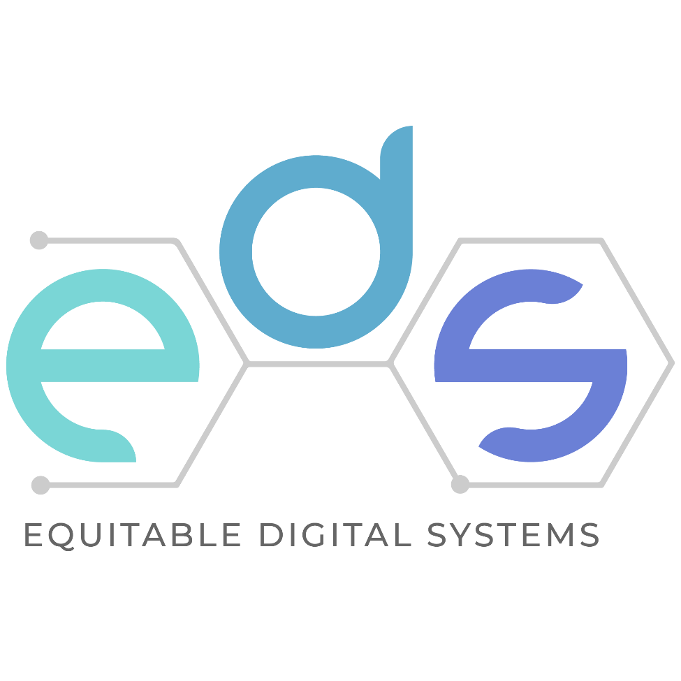

Delivered to:  
Accessibility Standards Canada  
[Attribution 4.0 International (CC-BY 4.0)](https://creativecommons.org/licenses/by/4.0/)  
Date: March 31, 2023

# Collaborators and Contributors

This work is the collective effort of over 75 contributors: over 55 experts with lived experience of disability and over 20 experts from disability advocacy or disability research organizations. The full list of contributors follows this page.

This project was led by [Inclusive Design Research Centre](https://idrc.ocadu.ca/) at OCAD University in collaboration with:

* [L'Arche Canada](https://larche.ca)
* [CNIB Foundation](https://cnib.ca)
* [Wavefront Centre for Communication Accessibility](https://wavefrontcentre.ca)
* [March of Dimes Canada](https://marchofdimes.ca)
* [Montage Support Services](https://montagesupport.ca/)
* [Fable](https://makeitfable.com)
* [IRIS Institute](https://irisinstitute.ca)
* [Accessibility Institute, Carleton University](https://carleton.ca/read/can/)
* [Centre for Independent Living in Toronto](https://cilt.ca/)
* [Canadian Council of the Blind](https://ccbnational.net)

Attribution 4.0 International (CC-BY 4.0) <https://creativecommons.org/licenses/by/4.0/>

Date: March 31, 2023

Funder: Accessibility Standards Canada <https://accessible.canada.ca/>

EDS (Equitable Digital Systems) web site: <https://idrc.ocadu.ca/eds/>

# Contributors

Bernard Akuoko

Taryn Allen

Claire Andrews

Pedro Luis Aranguren Marquez

Michael Bach

Michael Baillargeon

Joy Borgonia

Rhonda Briggs

Chris Butler

Marco Chiaramonte

Anthony Chiu

Logan Churchill

Awo Dirie

Jessica Diskant

Tracey Dowhaniuk

Alexis Dowsett

Jessica Dumelie

Lynn Eyland

Adrianne Fitch

Deborah Floden

W. Francis Fung

Miron Gazda

Krista Giguere

Laura Goodchild

Keith Gordon

Robert Gray

John Guido

Mary-Rose Hackbart

Kaitlyn Hundt-Lippett

Rainbow Hunt

Kelly Johnson

Kate Kalcevich

Roger Khouri

Kim Kilpatrick

Ka Li

Lisa Liskovoi

Amanda Ma

Michael MacKenzie

Jamie Mcdonald

David Meyers

Anthony Micallef

Tara Mikiovic

Sophia Mincheva

Jess Mitchell

Shelley Ann Morris

Brandon Mowers

Sloane Mulligan

Novlette Murray

Olav Naas

Rytch Newmiller

Miracle Okeuga

Ryan Ollis

Christine Paterson

David H. Pereyra

Irene Pollock

Christopher Polson

Jaclyn Pope

Wendy Porch

Doris Rajan

Ron Reddam

Vera Roberts

Janet Rodriguez

Skittles Roshan

Mirvat Sanaallah

Shalaine Sedres

Bo Louie Siu

Connor Stewart

Mahadeo A. Sukhai

Christopher Sutton

Sandra Tavares

Nicole Tilley

Ana Tobar

Jim Tokos

Jutta Treviranus

Gift Tshuma

Abid Virani

Boris Vukovic

Bailey Wagner

Ruth Warick

Ian White

Valerie Wolbert

Patrick Wong

Cheryl Zinyk

# Table of Contents

Collaborators and Contributors 2

Contributors 3

Table of Contents 4

Executive Summary 6

Recommendations and Considerations 7

Challenges ahead 8

Background 9

COVID-19 9

Initial Research Scans 11

Digital Tools and Barriers 12

Existing Standards and Regulations 15

Co-Design Research 15

How we co-designed 16

Co-design 1: Digital system interactions, barriers, and approaches 17

Edgar’s Experience 18

Janeesha’s Experience 19

Sumi’s Experience 20

Jacobi’s Experience 21

Co-designs 2 & 4: The Imaginary (Ideal Worlds) and Book Club Co-analysis 22

Stories 22

Co-analysis 22

Co-Design 3: The Letters 23

Love letter 23

Break-up letter 24

Compromise letter 25

Recommendations and Considerations: 26

Communications 26

Systems for Hiring, Assessment and Advancement 27

Flexibility, Adaptability and Emergency Preparedness 27

Gatekeeping 28

Procurement Policies for Accessible and Inclusive Systems and Services 28

Systems in Place 29

How Systems Are Used 29

How Systems Are Maintained 29

How Systems Are Updated 30

How Systems Meet Conformance 30

How People Are Trained on Systems 30

Systems and Tools Individualized to an Employee 31

Automation and automatic systems 31

The Impact 31

The Next Accelerating Challenge 32

Appendices 34

Barriers to Digital Tools & Systems 35

Approach 35

Potential Barriers by Functional Requirements 35

Co-Designs in more detail 39

Details of CD1: Digital system interactions, barriers and approaches 39

Details of CD2: The Imaginary 41

Details of CD3: The Letters 42

Details of CD4: Book Club Co-Analysis of The Imaginary 45

# Executive Summary

This report is the culmination of the [*Future of Work: Equitable Digital Systems (EDS) Project*](https://idrc.ocadu.ca/projects/future-of-work-equitable-digital-systems/) that was funded by Accessibility Standards Canada. The goal of the project was to inform accessibility standards development for digital systems, particularly those associated with work. The project began with two scans: 1) an enumeration of digital systems and 2) a jurisdictional review of existing disability related standards and regulations so that we could identify gaps in existing standards and co-design approaches to mitigate them.

The voice and perspective of the disability community was a central focus of the project and along with ten disability research and advocacy organizations, 55 individuals with lived experience of disability contributed to the project over 12 co-design research sessions. Co-designs enhanced our understanding of barriers within digital systems by placing those systems and the experiences of people with disabilities who use or are impacted by them within the full context of people’s lives—their lived experiences and the intersections of technology, work, and life.

This project began October 13, 2020 within the COVID lockdown which upended the way that workers, especially those with desk jobs, did their jobs. 2020 ushered in the work from home era (WFH) and work and home became intertwined in ways that had been unthinkable less than a year earlier. The impacts of COVID-19 were felt across Canada in all contexts, not just work. For people with disabilities, the impacts were particularly severe and extensive in areas that had a direct impact on individuals, their employment context, and the availability of assistance they’d come to depend upon. The strain of the first four months of the pandemic on people with disabilities was described in a report by Statistics Canada (August 2020); work related impacts were many.

We undertook a scan of digital tools in the initial phases of the EDS project and identified barriers to digital tools and systems. We first approached our scan as an enumeration of existing tools but found that this approach was not a useful way to understand digital systems. Instead, we focused on the systems of work and the barriers that occur in these spaces:

* Pre-employment—seeking work, preparing to apply, application, assessment and hiring decision
* Employment—the activities of work
* Productivity--the tools to manage or complete tasks
* Training—professional development and onboarding
* Workplace systems-the internal tools used to manage the workforce
* Procurement-the processes and policies for purchase decisions for goods and services

In addition to the digital tools scan and barriers report, we carried out a thorough jurisdictional scan of international standards and regulations related to disability and technology and have shared this [Compendium](https://airtable.com/shrXY0H5jiOFTS74B) as a viewable and downloadable resource.

We approach research with the understanding that we have limited knowledge and that those who have lived experience of disability and barriers to access are the experts in their experience. As co-design researchers we can pool everyone’s expertise and experience to develop shared understandings and move towards co-creation of approaches and shared learning. In this project there were 4 main co-design themes with 3 sessions per theme for a total of 12 co-designing events. The four co-designs and their session structures were:

1. Digital System Experiences, Barriers, and Approaches
2. Imagining Ideal Interactions with Technology
3. The Letters to Technologies
4. Imaginary Stories: Book Club Co-Analysis

In this research report, we gather the insights from the scans, monthly partner meetings and 12 co-design sessions, and present them as a series of recommendations and considerations for the development of standards related to technology and disability.

## Recommendations and Considerations

Over the duration of the project, the following topics have emerged as necessary but not sufficient for making Information and Communication Technologies (ICT) inclusive of everyone in work. The following recommendations and considerations are explored and explained throughout this document.

1. Every employee must know how to use and have access to alternative communication systems that support people who are Deaf or hard of hearing as well as those with communication disabilities (see for example, https://www.cdacanada.com/resources/communication-disabilities/communication-methods/).
2. Any policy related to technology (its development, design, deployment, procurement, use, evaluation) must never disadvantage people with disabilities and must preserve dignity.
3. Standards must look forward to what we cannot predict or know with flexibility, adaptability, and emergency preparedness plans.
4. Gatekeeping of supports leaves the most precarious among us out of any mechanisms of protection when the unpredictable happens—forward-looking policies must address this chasm.
5. Federal and Provincial services need to coordinate and harmonize approaches to supporting organizations and individuals in having the assistive technologies and technologies that support their independence and safety.
6. Procurement policies must prioritize inclusive systems and services.
7. Procurement policies and tenders must prioritize systems in which accessibility is integrated.
8. All systems must be operable by assistive technologies and people with diverse needs.
9. Inclusion needs to be incorporated into every aspect of the workplace culture.
   1. All employees will need to use integrated accessibility features in digital tools to realize inclusion of all colleagues and all employees will need frequent training and setting of expectations to produce accessible content, policies, and systems.
   2. All technology and information technology departments responsible for maintaining centralized systems need to be aware of accessibility features and interoperability of assistive technologies (ATs) with those systems.
   3. Technical teams tasked with implementing technology should not cause incompatibility with existing tools or create new barriers (e.g., an implementation or upgrade should not render a digital tool inoperable with assistive technologies)
   4. Conformance rules must include the technology’s ability to conform not just to the highest level of standards for ICTs (Information and Communication Technology), but also interoperate with the various ATs used by employees.
   5. Employees must know how to switch between different modes of communication using the tools that are available.
10. Workplace accommodations should prioritize the needs and wishes of the individual. Systems procured for another individual may not be the most usable option.
11. All systems that are automated such as IT support ticket systems should also have direct access to a human.

## Challenges ahead

This project and the engagement with the many insightful co-designers are comparatively small gestures to prepare for the enormous task ahead. This work must continue, it is never complete. Both the opportunities and the threats will emerge on an accelerating time frame. To achieve equity for people with disabilities will require a commensurate effort. Diversity is our greatest asset, and inclusion is our greatest challenge. In disability we find the greatest diversity of perspectives, and the most insightful understanding of future risks. In addressing this enormous challenge of inclusion, we benefit our society as a whole.

# Background

This report is the culmination of the [*Future of Work: Equitable Digital Systems (EDS) Project*](https://idrc.ocadu.ca/projects/future-of-work-equitable-digital-systems/) that was funded by Accessibility Standards Canada. The goal of the project was to inform accessibility standards development for digital systems, particularly those associated with work. The project began with two scans: 1) an enumeration of digital systems and 2) a jurisdictional review of existing disability related standards and regulations so that we could identify gaps in existing standards and co-design approaches to mitigate them.

The voice and perspective of the disability community was a central focus of the project and along with ten disability research and advocacy organizations, 55 individuals with lived experience of disability contributed to the project over 12 co-design research sessions. Co-designs enhanced our understanding of barriers within digital systems by placing those systems and the experiences of people with disabilities who use or are impacted by them within the full context of people’s lives—their lived experiences and the intersections of technology, work, and life.

## COVID-19

This project began October 13, 2020 within the COVID lockdown which upended the way that workers, especially those with desk jobs, did their jobs. 2020 ushered in the work from home era (WFH) and work and home became intertwined in ways that had been unthinkable less than a year earlier. The impacts of COVID-19 were felt across Canada in all contexts, not just work. For people with disabilities, the impacts were particularly severe and extensive in areas that had a direct impact on individuals, their employment context, and the availability of assistance they’d come to depend upon. The strain of the first four months of the pandemic on people with disabilities was described in a report by Statistics Canada (August 2020); work related impacts were many:

* Unemployment / job loss: “Over one-third of research participants with long-term conditions or disabilities report experiencing a temporary or permanent job loss or reduced hours during the pandemic”
* Working from home: “The majority of employed participants with long-term conditions or disabilities report working from home”
* Reliance on non-employment income sources: “Almost half of participants have relied exclusively on non-employment income since March”
* Decreased household income: “Almost one-third of participants report that their household income decreased since the start of the pandemic” “Over half of participants have difficulty meeting at least one financial obligation or essential need”
* Food insecurity: The ability to meet food and grocery needs and needs for personal protective equipment are the most commonly reported impacts of the pandemic”

Others also documented the disproportionate impact on vulnerable populations:

* “During the first wave of the pandemic (March through August 2020), **residents of nursing and seniors' homes accounted for more than 80% of all reported COVID-19 deaths** (Canadian Institute for Health Information, 2020).”[1]
* “What we found was very troubling . . .. We saw that the pandemic was having a disproportionate impact on a group that was already socially, politically, and culturally marginalized and experiencing a constellation of issues.
* “This is a group [those with chronic health conditions] already earning less and more likely to be in retail and service jobs impacted by the pandemic. . .. What’s more, many people with disabilities and chronic health conditions are unemployed, under-employed or unable to work, which meant that they were ineligible for the Canada Emergency Response Benefit (CERB).” [2]

Canadian Council of the Blind, an EDS partner found similar impacts for the blind and low vision community in a survey[3] of their community:

* Almost half the respondents who were working from home said they had all the necessary accessible technology and devices to do their job from home, while an additional 30% said they had some of the technology required to work from home.
* More than half the respondents (56%) who needed technology to work from home said that **their employer wouldn’t supply the accessible technology or devices for the employee to work from home** and a further 20% said that their employer would only provide some but not all of the accessible technology or devices they needed. A large number of respondents self-funded the technology they need to work from home, with more than half of those self-funding (59%) having spent more than $1,000.
* 29% of respondents said that they were concerned that they may not have the financial capability to maintain their present standard of living without financial assistance.

*This* was the context within which the work for this project was done. It was an unprecedented time that highlighted the vulnerability of people dependent on services and assistance. The notion of what was “essential” came into focus in a way that no other event had made clear. The pandemic and the resultant shutdowns and quarantines and fear of illness had many effects and impacts:

* Financial impact
* Precarious housing
* Isolation from family and friends
* Fear of infection
* Anxiety and stress
* Uncertainty about the future
* Isolation from services
* Limits on medical attention (surgeries and preventative medical practices)

This unique context gave the project team a magnification of how people with disabilities are further marginalized when something unpredictable happens. It helped us to discuss ‘what is essential’ and who decides? It also raised concern about discriminatory behaviours when companies who previously declared people could not work from home were now exclusively (and often overnight) working from home. Prior to the pandemic, people with disabilities had been told by these exact employers that they could not work from home–now the entire workforce was working from home. It was a false barrier and while the outcome of flexibility in where one works is positive, it raises the question, what other arbitrary barriers are created in the workplace that make it difficult for people with disabilities to work according to their preference?[4] The urgency to return to “normal” (pre-pandemic ways) or, in the case of work, return to office (RTO) raised concerns and an opportunity for people with disabilities to weigh in on how “normal” was disabling:

Normal never really worked for me[5]

Experts on the project echoed this frustration with the dominant narrative and urgency to get back to “normal.” This perspective helped keep the research focused on the context, understanding how the context was impacting people, and exploring how it was a magnification of the stresses and challenges and barriers people with disabilities often experience.

# Initial Research Scans

Every job involves digital systems. While digital technologies can certainly help some overcome barriers, they are as likely to introduce more barriers because technology has not, and in many cases is not be built with accessibility in mind.[6] Historically and presently, the lack of accessibility in digital tools and systems has impacted the lives of people with disabilities, their ability to participate and to work.

## Digital Tools and Barriers

We undertook a scan of digital tools in the initial phases of the EDS project and identified barriers to digital tools and systems. We first approached our scan as an enumeration of existing tools but found that this approach was not a useful way to understand digital systems. Instead, we focused on the systems of work and the barriers that occur in these spaces. This is consistent with the social model of disability that situates the individual in a *context* with an *intention* or *need* and availability of some digital tools—the performance of those tools in that context can either meet the needs and intentions or fail to.[7] For the purposes of this project, we differentiated the tools from the systems they make up to both illustrate the complexities around the creation of all that is necessary for work and because a system is not the sum of its parts. A system can be made up of completely accessible tools and still be inaccessible. Both tools and systems can be disabling where bias, inaccessibility, and attitudes, such as thinking of people with disabilities as an afterthought, occur.

The tools are enabling or disabling. And the systems created around the tools—the policies, practices, and procedures—are enabling or disabling. And *both* are points of entry for the biases of decision-makers.

Within this project, the context is work and places where work occurs. And the tools are often combined into systems that are meant to function in a particular way toward work productivity. Below we situate the tools of work into the systems of work where they are used and how they are acquired:

* Pre-employment — seeking work, preparing to apply, application, assessment and hiring decision
  + Hiring systems include tools like job recommenders, job sites, job descriptions, skill tests, personality tests, resume filters, application portals and interviews.
  + The underlying technologies include artificial intelligence, data analytics, hardware, software, automation, web technologies.
* Employment — the activities of work
  + Employment systems include any tools needed to get work done individually and collaboratively such as software applications, file sharing, communication devices and software, equipment interfaces, etc.
  + The underlying technologies include things like telecommunications, VOIP, cloud networking, IOT (Internet of Things), authentication, security, operating systems, etc.
* Productivity — the tools to manage work
  + Productivity systems include tools that enable an efficiency in completing work and managing the activities of the workplace such as calendars, project management, smart systems, booking, etc.
  + Underlying technologies include cloud computing, web, surveillance, AI (Artificial Intelligence), sensors.
* Training — professional development and onboarding
  + Training systems include tools such as learning management systems for multimedia digital, manuals, presentations, lectures, apprenticeships and mentoring and assessments, digital office tools.
  + The underlying technologies include communications tools, surveillance, web, and cloud computing.
* Workplace systems — the internal tools used to manage the workforce.
  + The workplace systems include tools like Human Resource systems, advancement and promotion systems, cameras, time tracking, intranets.
  + The underlying technologies include surveillance, IOT (Internet of Things), AI (artificial intelligence), web.
* Procurement — the processes and policies for purchase decisions for goods and services
  + The procurement tools include policies/requirements documents, template language for tenders, rubrics and practices used to evaluate, select, purchase, and integrate any and all tools as well as techniques of work such as all of the above.
  + Underlying technologies include web-based systems, collaborative systems.

The pipeline of these systems of work and the tools that are used within them make up the context within the workplace. The social model of disability tells us that the combination of these tools within these systems of work can either meet the needs and intentions of the individual or else fail. The tools and systems are either enabling or disabling. The people deciding to procure, maintain, and provide those tools and systems accountable for the context created.

Below, we outline some of those systems of work and highlight some of the potential barriers they can create—ways they can be disabling to getting work done for all in the workplace.

* Pre-employment
  + Before they become job applicants, job seekers require access to systems that allow them to apply to jobs. When those systems are not accessible, they eliminate job candidates with disabilities.
  + Employers often employ systems to filter job applications. Those filters can cause bias, intentionally or unintentionally filtering out candidates who have disabilities.[8]
* Employment
  + Employees with disabilities sometimes require assistive technologies (ATs) to perform the duties of work. The decisions about what AT is procured is not always made by the person with the need.
  + Employers sometimes associate this step of accommodation with concerns about cost and fears about how to integrate and work with AT users.
* Productivity
  + Employees with disabilities require accessible technologies and accessible content to be productive at work. This requires that all colleagues create accessible content and use tools that can integrate effectively with ATs.
  + Employers have a responsibility to set expectations for accessibility to be a forethought in all activities, and from the beginning.
* Training
  + Employers need to ensure all employees understand how to create content that is accessible. All people need to understand the different ways of interacting with each other and the technologies that can help with that. The burden to train should not be disproportionately on people with disabilities.
* Workplace systems
  + People with disabilities must be able to operate all internal tools and systems associated with work.
  + Employers must ensure all internal systems work for all employees.
* Advancement
  + What does it look like for a person with a disability to advance? Are the tools used to judge employee performance biased?
* Procurement
  + The barriers people with disabilities experience are enmeshed and intertwined in technological, social, economic, and political phenomena; but in the context of work, they all share a common pathway: procurement. Procurement is a point at which organizations can have a profound impact on whether or not inaccessible software, devices and services that do not interoperate or produce accessible content enter the workplace. While the problem of inaccessibility is more complex and involves many facets, procurement is a problem that can be fore-fronted and addressed through a strong, accessible procurement policy and guidelines and standards to support that policy. Procurement must still be paired with accessible policymaking throughout the pipeline.

The identified barriers in our barriers report are not at all surprising. They are barriers that people with disabilities encounter commonly–ones that can make everyday life frustrating. To extend the social model of disability: when the *work* world hasn’t been designed with you in mind, you are reminded of that every day.

The technological/digital barriers are listed here as barriers that limit people with disabilities in the dignity of work:

* Inaccessible communication tools
* Inaccessible file formats
* Authoring tools that fail to produce accessible content
* Inaccessible interfaces
* Essential software that does not interoperate with alternative access systems
* Cost of assistive technologies/having to provide one’s own ATs

In the workplace the barriers are deeply entangled in social, cultural, and economic dynamics. A common scenario is one where the employer is enthusiastic at first to hire people with disabilities. There might be an awareness-raising campaign, an added budget item for additional technology needs and a re-examination of processes like onboarding. Then, as time goes by, the time and budget constraints become heavier. The new hire slips out of the communications loop when the technology that the workplace uses is not accessible. The accessible technology requires an upgrade, which requires additional budget. The mainstream applications that were chosen do not integrate with the assistive technologies and the company purchased it because it was popular, knowing it did not meet the needs of everyone. First the person with a disability is a social novelty, then a marginalized add-on that “mainstream” ICT solutions leave behind. Eventually, the person with a disability becomes a problem: one usually feared and avoided and sequestered to legal or HR.

Gaps begin to emerge for people with disabilities because they are not part of the decision-making processes around creating new technologies or adopting them. All too often people with disabilities are seen as ‘customers’ of an industry–not participants and definitely not experts. They are dependent upon the generosity of those who *choose* to include them and are meant to be thankful for it. In this scenario, the gaps amplify the inequity of the systems: from procurement to work output. It does beg the question, “where do people with disabilities have any agency when it comes to procurement, development, design processes, testing, product, co-worker, leader, decision-maker?”

All of the gaps above point to the failure of thinking of the one-size-fits-all solution where technology at scale (for most) trumps technology that works for each person.

## Existing Standards and Regulations

In addition to the digital tools scan and barriers report, we carried out a thorough jurisdictional scan of international standards and regulations related to disability and technology and have shared this [Compendium](https://airtable.com/shrXY0H5jiOFTS74B) as a viewable and downloadable resource.

# Co-Design Research

“Co-design” has come to be a term used loosely within the design community. In many cases it is used to describe research that is not actually co-designed. Our use of this term in the context of this project and this report is meant to represent a depth and breadth of authentic co-design. The work presented here represents the contributions of (55) people. The partners in this project also directly represent the needs and experiences of people with disabilities. The project team has extensive experience working alongside people with disabilities.

Genuine co-design involves engaging with experts early and often in the ‘design process’ – valuing their lived experience and perspective and representing that with a high level of fidelity to their own words and ideas. This report has been written with just that ethos: experts were involved deeply in all aspects of this project from design to analysis. This approach helps ensure that the outcomes of this work represent people with disabilities because it has been conducted with and by people with disabilities from the beginning.

Within the context of this project there were 4 main co-design themes with 3 sessions per theme for a total of 12 co-designing events. The four co-designs and their session structures were:

1. Digital System Experiences, Barriers, and Approaches
   1. Learn (What?)
   2. Try (So What? / Now What?)
   3. Recommend (This is What!)
2. Imagining Ideal Interactions with Technology
   1. Develop story ideas and characters
   2. Write a Story Collaboratively
   3. Add to the Story with Supplemental Elements
3. The Letters to Technologies
   1. Love Letter
   2. Break-Up Letter
   3. Compromise Letter
4. Imaginary Stories: Book Club Co-Analysis
   1. Analyse Story 1
   2. Analyse Story 2
   3. Analyse the Group’s Own Story

## How we co-designed

We approach research with the understanding that we have limited knowledge and that those who have lived experience of disability and barriers to access are the experts in their experience. As co-design researchers we can pool everyone’s expertise and experience to develop shared understandings and move towards co-creation of approaches and shared learning. Ideally, co-design includes:

1. A shared understanding of the issue
2. gathering life experience,
3. co-creating a way to express,
4. analysis/interpretation of the result.

#### Recruiting co-design researchers

Co-design researchers were recruited by the partner organizations, all of which are organizations for, by, or of people with disabilities. In our recruitment strategy, we strove to build a co-designer group that interconnects diverse identities, relationships, different abilities, and social factors that shape people’s lives, creating intersectionality. Intersectionality helps identify hidden structural barriers and supports understanding how individual experiences differ. Only intersectionality creates spaces for reflexive consideration and critical engagement that address the multiple forms of discrimination that people with disabilities experience in their everyday lives.

#### Fair compensation for time and expertise

We acknowledge and value the life experience and skills of people with disabilities. Therefore, we provided honorariums that acknowledge the co-designers’ contribution to the research and their time commitment.

## Co-design 1: Digital system interactions, barriers, and approaches

The first co-design was intentionally broad to enable greater freedom to discover barriers to technology experienced by the experts. We structured the three sessions as: 1) “What?”, 2) “So What?/Now What?” and 3) “This is What!” In the first session, experts shared experiences with technology, they were not restricted to any specific context (e.g., at work). In the second session they analyzed the interaction more deeply to understand the impact of the barrier and considered how to address it. In the third session, the approach was operationalized into recommendations and considerations for policy development. Following are a few of the results from this co-design:

Edgar’s Experience

When communication goes well and is supported by technology, then it's a great experience.  
--co-designer

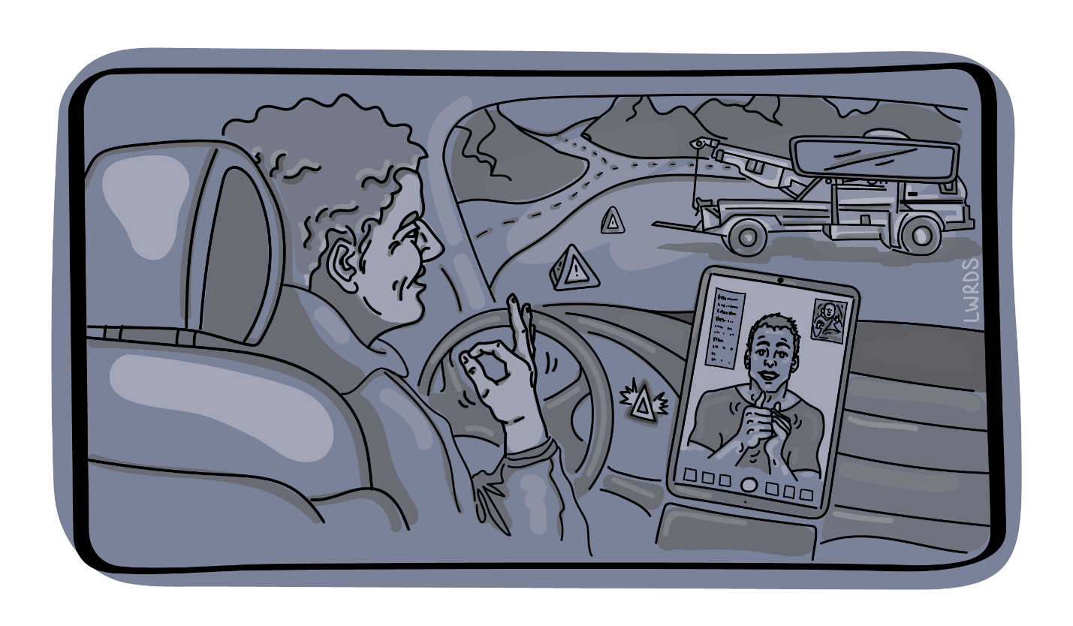Figure Edgar sits in his broken-down car and uses sign language with someone on a digital device.

Edgar has a flat tire on his truck. He’s on a major highway in Alberta. There is traffic, he’s pulled over onto the shoulder. He’s called for help. He’s Deaf. Fortunately, the RCMP (Royal Canadian Mounted Police) were prepared when Edgar called, and they used a video relay service to communicate with Edgar. The tow truck driver was also informed, equipped, and trained. He used transcription software on his phone to communicate directly with Edgar. Help was on the way and Edgar now could rest assured that they would be able to communicate effectively to help him.

#### Take-home from Edgar’s experience

Because the communications technologies and practices were both available and used effectively, Edgar felt safe, understood, and as though he’d get the help he needed to get on with his day. This inconvenience (the tire) would be the only inconvenience he’d have to contend with – communication was covered!

Recommendation: Every employee must know how to use and have access to alternative communication systems.

Janeesha’s Experience

When inclusion in work is the goal, individuals should not have to (continually) ask for captions, accessible documents, and other accommodations already discussed. --co-designer

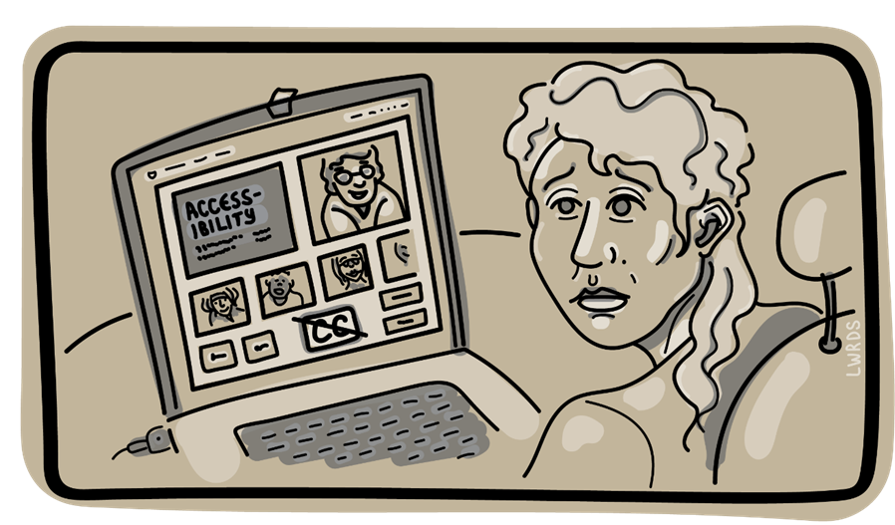

Figure Janeesha sits at a computer using video conferencing software. There are no captions available.

A company states they have a commitment to diversity, equity, and inclusion. Yet, Janeesha, a team member who is deaf was expected to attend a weekly work meeting despite constantly stating they could not participate due to lack of closed captions. Although Janeesha voiced concerns, the employer responded by making them attend and get as much out of the meetings as possible. After Janeesha consistently voiced concerns, their employer excused them from meetings, only later to question accommodation requests again. Janeesha wasn’t surprised because the company training video on accessibility wasn’t accessible either.

#### Take-home from Janeesha’s experience

Practices within the workplace that are supported by technology (e.g.: training, meetings, internal documents, resources, processes, and equipment) need to be inclusive. When people with disabilities are not considered in decisions or viewed as contributors, policy, practice, tools, technologies, and systems that can be equitable reinforce exclusion instead. When a colleague has to explain (again) what they need, it can be demoralizing and insulting and makes the person feel like an afterthought, a burden, an inconvenience, and certainly not an equal.

Recommendation: Any policy related to technology (its development, design, deployment, procurement, use, evaluation) must never disadvantage people with disabilities.

Sumi’s Experience

Supposedly...easier... to book... Then I found...a lot of shortcomings when it came to being compliant.... I’m just going to have to book in the old-fashioned way. --Co-designer

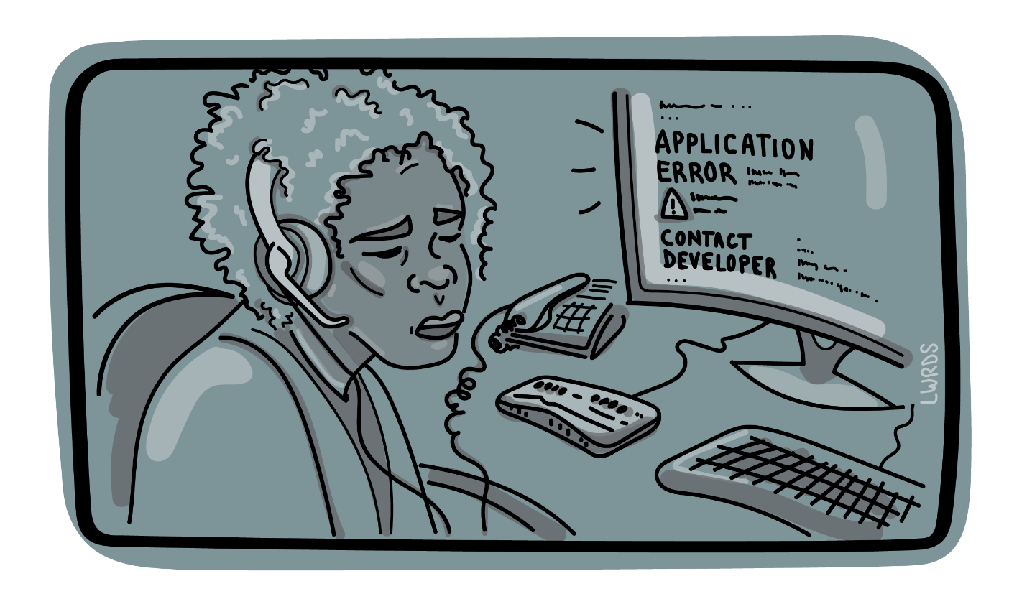

Figure Sumi sits at her computer with a braille device attached. The screen reports: Application Error: contact developer.

Sumi’s job at a clinic requires the use of software that allows them to book people's appointments and manage the calendar. It is well-known at the clinic that Sumi uses JAWS screen reader with technology and yet, this application was purchased for the clinic without knowing whether it works with JAWS. Now Sumi can’t do their job – Sumi has been ‘disabled’ because the company bought an application that did not meet the needs of ALL employees or potential employees. Sumi tried to get help: the software company said it was a JAWS issue (which isn’t true), the internal IT team said they couldn’t do anything about it… that’s the software that the ‘committee’ picked, and now Sumi has to ask for help whenever they want to make a change to the calendar.

#### Take-home from Sumi’s experience

Procurement is an important point at which disability can be perpetuated/created or eliminated. Where accessible technologies exist, they must be chosen to create inclusive workplaces and vendors should know that this requirement will be implemented. People with disabilities are often forced into roles where they have to resolve interoperability issues with their assistive technologies and be technologists. In addition, people with disabilities often have to advocate for their system needs within their organization.

Recommendation: Procurement policies must prioritize inclusive systems and services

Jacobi’s Experience

They talk for you, they talk about you, but they don’t talk to you. Just ask me what I need and how we can best work together!! –Co-designer

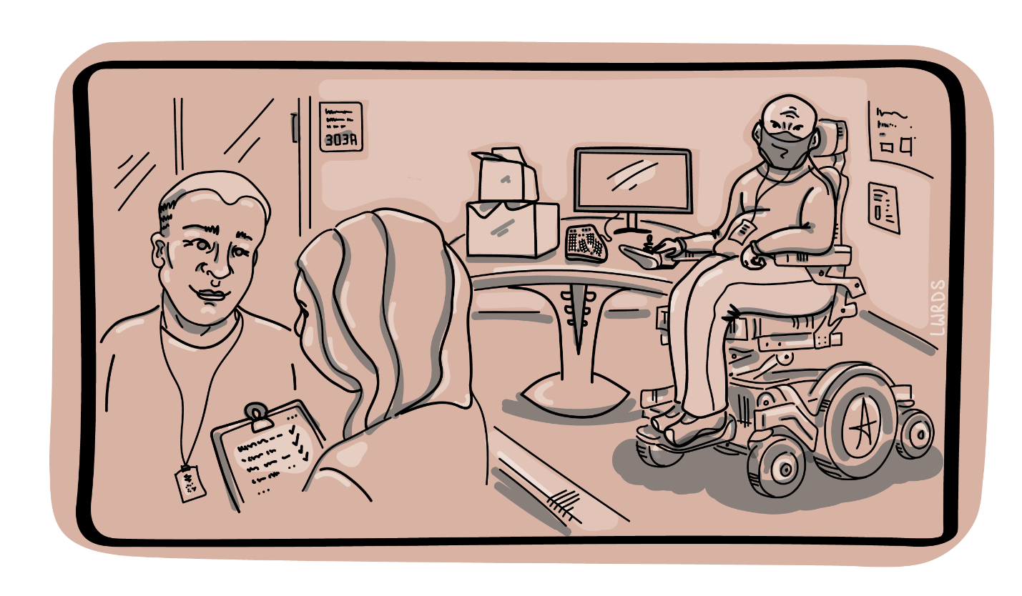

Figure Jacobi sits with their devices in one corner while a consultant and another team member discuss their needs in another corner.

When Jacobi started working at a new company, no one spoke to them at first. Jacobi has a visible disability, so they felt as though they were like a big elephant in the room—no one knew how to talk to them about their disability or how to work with them. It made Jacobi feel really alone at the beginning of their new job. They felt like saying, “yes, I’m disabled, there’s no point pretending and not asking! Just ask me what I need and how we can best work together!!”

The company didn’t even ask Jacobi about work needs; instead, they brought in a consultant who wrote a report and determined what Jacobi “qualified” for. Eventually, Jacobi got the equipment the consultant said they needed but not what Jacobi actually needed or preferred. Jacobi could have sped up and simplified this whole process, if the company had just talked to them in the first place. Now Jacobi has to wait longer to get what they need to do the job.

#### Take-home from Jacobi’s experience

People with disabilities know what they need, but employers talk to consultants instead. Fundamentally, it’s important to talk with people, and let them decide what works best for them.

Recommendation: Workplace accommodations should prioritize the needs and wishes of the individual. Systems procured for another individual may not be the most usable option.

## Co-designs 2 & 4: The Imaginary (Ideal Worlds) and Book Club Co-analysis

In our second co-design, our experts imagined ideal interactions with technology. Each group combined the experiences and set them within a narrative that they shared as a slideshow. The use of the imaginary acts as a contrast that brings into prominence the very “normal” things that people with disabilities do not expect—the kinds of things that people who are not disabled take for granted. Their stories were narrated and captioned and shared online.

### Stories

* Jumper Gets a Job: <https://youtu.be/w_7nyT_EXlo>
* Jessica looks for Job: <https://youtu.be/EVuTl2PG0O8>
* Friendship Chronicle: <https://youtu.be/wFXHNHVnyQ4>
* Adventure is in the land of ID: <https://youtu.be/Ux2Agx919GY>
* A Typical Day: <https://youtu.be/1AGB6-l351c>
* Working with Accessibility Needs Normalized: <https://youtu.be/4vosjCltLqA>
* Riley's Day at Work: <https://youtu.be/ok4GL9-n9_U>

### Co-analysis

For the fourth co-design, we analysed the stories from *The Imaginary* using narrative analysis. We structured the process as a book club where people talk about things in the story that happen and how the story is told. Groups spent each of the three sessions analyzing a story. For each story analysed, each group listened to and viewed a PowerPoint presentation and discussed what they noticed and discovered about the story. In the first two sessions, each group analysed the story from another group and in the last session, each group worked on its own story.  In this way, each of the stories was analyzed three time. We compiled each of the three analyses into a single insights document.

For example, insights generated from *Jessica Looks for a Job* are shown here:

When reflecting on the positive outcomes of the story and contrasting these with some of the real-world circumstances that people with disabilities face, there are some main takeaways worth considering:

1. job coaches need better training for people with disabilities.
2. the hiring/interview process needs to be more inclusive.
3. workplace culture needs to be more open to people with disabilities.
4. relevant technology needs to be available for employees to succeed.
5. employers should understand specific employee needs (i.e., working from home if possible, working with family schedule, technology for text-to-speech for example)
6. supports should be in place for accommodating service animals if necessary.
7. there should be safe spaces where work can be done privately.

We’ve incorporated insights from the stories into our recommendations.

## Co-Design 3: The Letters

The third co-design focused on the relationships that people with disability have with technology. Like many relationships, there are power differences, dependencies, happiness, and compromise. We used the format of three letters to surface these relationships. In each of the three sessions, the co-designer prepared a letter to a technology of their choice. In the first session, the co-designers wrote a love letter, the following week, each prepared a break-up letter and finally, in the third week, a compromise letter. For the compromise letter, writers were encouraged to set limits for what they would tolerate and timelines for issues to be addressed. At least in the letter-writing exercise, we wanted our experts to have agency and control of the technologies that they rely on and are often disappointed by. Co-designers were able to prepare their letter in any format (e.g., video, audio, document).

Here is an example from one of the co-designers who identifies as being hard of hearing. Their relationship is with Zoom ™ live transcriptions.

### Love letter

Dear Zoom Live Transcription,

I wanted to write this letter because thanks to you, I can now participate in online meetings with any number of people. For the first time in my life, my hearing loss does not present a significant barrier. The COVID pandemic has unfortunately caused so much illness, death, and loss over the past two years. However, the advent of so many people working and meeting remotely using your technology, which grew out of the pandemic, has been nothing short of revolutionary!

When we first met, I highly doubted you could work properly. I thought Artificial Intelligence could never be as accurate as a real live person. I thought you would be too slow, make tons of mistakes and leave me more confused and isolated than ever. But when I saw how beautifully and accurately you caption pretty much everything people say, I was so thrilled and excited!

Undoubtedly, you have changed my life. For the first time, I don’t have to sit through a 2-hour meeting without a single clue what people are talking about, or struggle to understand ASL interpreters when ASL is not my first language, or strain to hear ASL voicers who are translating for hearing people but certainly not for me, or have someone with no training (and in some cases, no desire) type for me on a laptop whatever THEY deem important enough for me to know. Thanks to you, none of those things need ever happen again. I can now fully take part in any online meeting, and I am so grateful!

I fondly remember the first meeting I attended, a co-op meeting, where I could understand everything and actually participate for the first time. I didn’t have to sit through the entire meeting without contributing, not because I lack interest, intelligence, or creativity but because I do not hear well enough to follow the discussion. I didn’t have to worry about feeling humiliated because I just commented on something they finished talking about five minutes ago. At this meeting, I spoke up several times and was always acknowledged. I felt a wonderful sense of respect, belonging, self-confidence and excitement!

I love so many things about you. Not only can I see captions at the bottom of my screen, but I can open a transcript and scroll up to read over what I missed. I can save that transcript, use it to compile highly accurate meeting minutes and refer to it anytime I wish. Even when I am not responsible for taking minutes, I can send that transcript to the minute taker, who invariably has no idea you exist and is so happy and grateful! This is a great example of how technology that people might assume is only for those with hearing loss can benefit everyone.

You have made my life so much better because you have opened up new possibilities and opportunities for me on a professional, community and personal level. You have guided me through a successful job interview and made it possible for me attend and lead meetings while working remotely, which I absolutely love! Thanks to you, I have participated in several online community meetings and events, including my co-op’s monthly meeting, a panel discussion for an art exhibit to which I contributed, and the Future of Work: Equitable Digital Systems project. You even helped me lead a virtual Passover Seder when the pandemic prevented my family from gathering for our favourite Jewish holiday.

I have many hopes for our future together. I want to reach higher in my professional life and find a position where I can fully utilize my talents, skills and experience, with fewer communication barriers than ever before. I want to participate more fully in my community. I want to show the world that deaf, hard of hearing and deaf-blind people are everywhere, we are competent and capable, and we deserve the same access and opportunities as everyone else. My hope is that you continually improve yourself so that you can help me and others with hearing loss connect with anyone, anywhere. Zoom Live Transcription, I adore you!

### Break-up letter

Dear Zoom Live Transcription,

We’ve been together for about five months now and although we got along great in the beginning, the honeymoon phase is over. You have made my professional life a lot better by making online meetings accessible, but sometimes you screw things up and leave me feeling frustrated. I’ve had relationships with Microsoft Teams and Google Meet, and I wonder if maybe they would be a better match for me.

Lately I have been losing trust in you because you sometimes lag. Even if it’s a short lag, like five to seconds, it keeps everyone at a meeting waiting and it really embarrasses me! For example, sometimes I put my hand up because I want to ask a question or contribute to the discussion, and the facilitator calls on me. While I am watching for my name to appear, the facilitator and everyone at the meeting wonders why I’m not saying anything.

Can’t you offer something to click on so that facilitator can let me know immediately that it’s my turn to speak? You may not realize this but people with hearing impairment are very cautious about interrupting the conversation. Once, while taking a course, you were lagging for 20 seconds, which is completely unacceptable for a live meeting! It took a lot of work, time and patience until I figured out that the problem was with my laptop, not with you or my internet connection. Still, you’re not off the hook for that, why do you only work properly with certain equipment?

Speaking of having problems and trying to figure things out, why is it completely impossible to contact you or anyone at Zoom? Why don’t you don’t have a help line I could call, or a customer service chat function, or even an email address for asking questions and reporting problems? At this point, my best bet is to look for online videos, offered by kind souls out there and hopefully captioned, to show me how to navigate you and do certain things. Come on, Zoom, where’s your customer service? And speaking of service, why are you only accessible to customers with paid accounts? You’re a vital, necessary part of Zoom technology, and limiting your availability only to those who are employed or who can afford paid accounts is nothing short of discrimination!

One habit of yours that drives me nuts is when you let the Chat function block you. Once, in a Zoom meeting on my cell phone, a well-meaning person kept sending me chat messages whenever you got something wrong. Each time, you were completely blocked by the chat window, and I ended up missing a whole lot more than a few words here and there. I missed huge parts of the conversation and pretty much lost the thread of that meeting! And although I can usually figure things out based on the context, you do get things wrong sometimes. If someone has a strong accent or a speech impediment, your captions make absolutely no sense. Can’t you get better AI to improve your transcription abilities?

Another time I was leading a meeting and had to leave for about ten minutes, so a colleague took over leading the meeting. When the meeting was almost over, my colleague ended the meeting for everyone before I had a chance to save the transcript, which was a disaster! Why can’t you be more like Microsoft Teams and offer a function where the transcript is saved automatically?

It hasn’t been all bad but sometimes I worry that you are holding me back from my dreams of complete access and inclusion. There’s a lot you still offer me, but your shortcomings have been making me so unhappy lately, I don’t think I can trust you to get me through online meetings anymore. Sorry Zoom Live Transcription, but I’m afraid it’s over between us. I’m going back to Microsoft Teams.

Regretfully,

### Compromise letter

Dear Zoom, Live Transcription,

After some soul searching, I have decided to take you back, though I cannot guarantee I won’t be seeing Microsoft Teams and Google Meet from time to time, depending on the situation. Even though you aren’t perfect, I realize that no technology is absolutely perfect every moment. Despite your flaws, you have enough good qualities to keep me returning to you more than any other technology out there.

Please understand that I still have high expectations for you, and I expect you to continue to work on eliminating your lag, developing a “your turn to speak” feature, improving your customer service, coordinating better with the Chat function, keeping your captioning mistakes to a minimum, and saving transcripts automatically. Unless I see improvement in these things, I am gone for good!

On the other hand, I still appreciate your good qualities and I recognize that you are the best technology for captioning live meetings. On my end, I am going to work on being extra alert to signals that it’s my turn to speak, speaking up during the meeting if someone’s chat is blocking the conversation, and saving a transcript at the very first sign that the meeting is winding down. I think I am being fair to both of us.

I hope we can both grow together for a long time in the future. You have opened new opportunities for me in my personal and professional life and given me a degree of access I would never have thought possible. I would be very sorry to see our relationship come to an end. Let’s both continue to learn and improve ourselves!

With love and gratitude,

# Recommendations and Considerations:

Many recommendations and considerations surfaced in each of the co-designs, meetings, and research activities; these have been compiled into 11 main items and six sub-items across 7 areas:

* Communications
* Systems for Hiring, Assessment and Advancement
* Flexibility, Adaptability and Emergency Preparedness
* Procurement
* Systems in Place
* Individualized Systems and Tools
* Automation and Automatic Systems

## Communications

We saw from stories like Edgar’s in co-design 1 that accessible communication systems are critical for employee independence and effectiveness. The burden for knowing how to use and access alternative systems must be on every employee. The burden cannot just fall on people with disabilities who require alternative communications tools. All team members and colleagues should have curiosity and access to alternative systems and at least a rudimentary understanding of how they work to support everyone’s productivity and ability to communicate about work.

All systems of work need to support flexible access. Systems that require one mode of communications or fixed formats will not provide the flexibility required to support diverse needs of employees. It will perpetuate a barrier if not addressed. All content must be accessible to all colleagues.

1. Every employee must know how to use and have access to alternative communication systems.

## Systems for Hiring, Assessment and Advancement

A range of systems and tools are part of hiring, assessment, and advancement. Hiring systems can include the platforms where positions are posted, the platform used for applying for positions, candidate selector systems, online entrance tests, interview platforms, systems to “measure” productivity and desirable traits for advancement, in-person, and remote training technologies.

"That feeling of not belonging or excluded or dismissed. Definitely, those have been feelings that I felt over time, whether it's at work or using government services or websites or apps. Because if you can't access something, you feel like, wow, I guess I'm not important, I guess I don't feel like I'm part of the fold here." – co-designer

In our co-designs, experts expressed the indignity of and frustration with having to disclose, re-disclose, and continue to disclose needs throughout their employment lifetime (from job seeking to longevity within a position). This never-ending barrage of being one’s own self-advocate is both frustrating and unnecessary. Janeesha’s story from co-design 1 illustrates this consideration.

1. Any policy related to technology -- its development, design, deployment, procurement, use, evaluation -- must never disadvantage people with disabilities and must preserve dignity.

## Flexibility, Adaptability and Emergency Preparedness

Standards often look at the past to make policy for the future. The future we are looking forward to is one where environmental disasters are more frequent, weather is more extreme, economic disparities are more extreme, discriminatory behaviours are well-entrenched, ableist bias is prevalent, and we cannot anticipate what will come. This unknowability poses a difficulty for addressing complex issues like the more equitable use of technology in the workplace.

“It's not an easy process for [people with long COVID] just to get some help, just to go back to work. It's not fair." –co-designer

We cannot simply consider technology in isolation from the larger social, cultural, political, economic, health, and global context. The various responses to the global pandemic illustrate how seemingly arbitrary policies, biased practices, and gatekeeping further marginalize people with disabilities in the workplace.

Shutdowns and quarantines in Canada showed us both inequities, and the value of flexibility. Flexibility and adaptability will be the tools that help us through the unpredictable future. Where workplaces had inflexible work-in-office policies, many were forced to change to work-from-home exclusively, overnight. And they did—organizations that had said it wasn’t possible made the switch as quickly as they could, showing that it was always possible and it was a human-level decision that created an inflexible policy that disadvantaged many.

1. Standards must look forward to what we cannot predict or know with flexibility, adaptability, and emergency preparedness plans.

### Gatekeeping

What happens when access to support programs is meted out based on a medical professional’s acknowledgement of need or parameters on how you can use support that you receive? What we see historically and from the example of ‘long covid’ is that if a pathology is not yet understood or acknowledged, then the person in need of help will not qualify. Because medicine has not yet caught up with the experiences of individuals, they cannot qualify as having a disability or impairment. They are not eligible for assistance.

1. Gatekeeping of supports leaves the most precarious among us out of any mechanisms of protection when the unpredictable happens—forward-looking policies must address this chasm.

Similarly, with technologies for work crossing between home and workplace in the same way that work and home have become more intertwined, rules about how supported technology may be used also lack flexibility and have not adapted to the modern world.

“When you are using devices for work funding is not allowed but when it related to personal use its a green light- It seems very backwards.” –co-designer

1. Federal and Provincial services need to coordinate and harmonize approaches to supporting organizations and individuals in having the assistive technologies and technologies that support their independence or that of their employees.

## Procurement Policies for Accessible and Inclusive Systems and Services

Procurement policies should all include requirements for inclusion of people with disabilities. Any system or service that is procured must meet a minimum level of accessibility (ideally beyond what is the minimum requirement of standards). All services, technical, educational, consulting, etc. must be fully accessible and available to all employees to use equitably.

1. Procurement policies must prioritize inclusive systems and services.
2. Procurement policies and tenders must prioritize systems in which accessibility is integrated.
3. All systems must be operable by assistive technologies and people with diverse needs.

## Systems in Place

Accessible procurement is not sufficient to guarantee the accessibility of workplace systems. Systems that are already part of the workplace must also have standards for how they are used, maintained, updated, and assessed for conformance, and accessibility training should be embedded at every level, role, and policy of the organization

1. Inclusion needs to be incorporated into every aspect of the workplace culture.

### How Systems Are Used

And since inclusion can be expressed and manifested in how people use their tools, it is not just the availability of the system that can present a challenge, it is in how it is expected to be used.

“It is important to welcome and acknowledge multiple forms of communication, as well as the additional challenges associated with ESL and language barriers. Additionally, tactile, non-verbally focused modes of communication should be considered. Basically, we need flexibility in how information is provided in order for inclusive experiences and environments.” --co-designer

* 1. All employees will need to use system accessibility features to realize inclusion of all colleagues and all employees will need frequent training and setting of expectations to produce accessible content, policies, and systems.

Fundamentally, all systems used must be used in inclusive ways by all employees. All content must be created in accessible formats. All collaboration tools must be used in ways that enable all accessibility features by default. With this approach, the individual no longer has to request alternatives, no longer has to remind colleagues of their needs, and is able to have agency to simply use technologies in ways that work best for them—according to their needs and preferences.

### How Systems Are Maintained

* 1. All technology and information technology departments responsible for maintaining centralized systems need to be aware of accessibility features and interoperability of assistive technologies (ATs) with those systems.

This is a point where the assumption is that users of ATs will troubleshoot their own technical issues—that they are technologists of their own ATs. The burden on people with disabilities is greater because they are dependent upon tools that others aren’t familiar with or use.

* 1. Technical support services expect that people with disabilities can answer technical questions and understand technical jargon regarding specifications about ATs.

Services intended to help employees do their jobs well should be available to all employees.

### How Systems Are Updated

“Compliance issues and mismatch between new apps’ upgrades and existing AT that I use. It could be ‘harmful.’ The update should not go out until it is tested; for example, who could this update harm?” **--** co-designer

Updates should not happen in isolation of testing with assistive technologies used within the organization.

* 1. Technical teams tasked with implementing technology should not break tools for work for colleagues.

### How Systems Meet Conformance

* 1. Conformance rules must include the technology’s ability to conform not just to the highest level of standards for ICTs, but also interoperate with the various ATs used by employees.

The details of this must be handled internally at the organization with accountability, with demonstrable results, and must move beyond the bare minimum compliance. Practices that blame the user ‘because the standards has been met’ are not acceptable. There should be an anonymous and genuinely de-identifiable way to report issues without risk.

### How People Are Trained on Systems

“Relevant training is necessary so that people with disabilities can thrive in the workplace. Employers also need to spend more time understanding the specific needs of their employees during the training process, which is sometimes a process that is ongoing.” – co-designer

* 1. Employees must know how to switch between different modes of communication using the tools that are available.

The mere availability of the alternative communication mode to the person with disability is not enough—everyone must be able to effectively use the communications tools together.

## Systems and Tools Individualized to an Employee

1. Workplace accommodations should prioritize the needs and wishes of the individual. Systems procured for another individual may not be the most usable option.

As illustrated in Jacobi’s experience in co-design 1, the expert is not given agency to choose what works best for them. Our co-design experts were resolute in relaying that they should be consulted directly on matters that pertain to their needs and preferences.

## Automation and automatic systems

Automated systems were set in place to remove the middleman, however, the barrier these systems create deter people with disabilities more than what's documented. Human in-person or over-the-phone interaction is preferred as concerns and requests would be better addressed rather than navigating platforms that can’t "answer back" right away and provide guidance and instruction.

The push to automation means fewer person-to-person interactions. And when empathy and other human-only qualities are missing, people who need assistance or additional help suffer most. Whether your issue gets resolved sometimes is entirely dependent upon whether or not a person cares to keep track and take care of your problem. Experts stated there should be a choice of human support whenever possible. When people experience enough frustration with a system they will give up. In those cases, co-designers stated that a more humanized approach could mitigate this barrier.

1. All systems that are automated such as IT support ticket systems should also have direct access to a human.

# The Impact

Below are some quotes from our expert co-designers’ letters to technologies from co-design 3. In these cases, points were made that seem to capture the need for and belief in technology alongside the deeply personal impacts that it has on people with disabilities when it fails to work. The quotes also highlight the significant compromises that individuals must make to maintain the often-imperfect access digital systems provide them. These quotes, we felt, were important to include in this report:

"I realize that a lot of the problem isn’t you, and it isn’t me. It’s a whole bunch of stupid systems and devices out there that just aren’t designed with you and me in mind. I feel like there’s still hope, for us, for our relationship. And I want to make it work. I have to make it work. Or I have to give you up and live a diminished, impoverished existence, out of step with everything and everyone else." – co-designer in a compromise letter to their debit card.

"All your promises were nothing but lip service. You know I’m severely hard of hearing, yet you totally ignore my need for captioning and don't offer it at all during Zoom free account meetings. . .. For starters, we need to start seeing a Computer Programmer (Counselor) [sic] to work out your glitches. You would also need to make some changes, such as, being inclusive for all, having captioning available for paid AND unpaid chat sessions, and having better accuracy of captioning - 65 % accuracy is not an acceptable accommodation. Communication is a right. Not a privilege." – co-designer in a compromise letter to Zoom

"I need you to understand that by putting limitations on myself and others, you're taking away my independence. With the issues you present to me on a daily basis it is no wonder employers are nervous to employ the Visually Impaired community."; "It is important that you work on these things because I want to discover who I am meant to be and I want the same opportunities as everyone in society."; "If you continue to fail to meet my needs, then I will continue my education till I know enough to design my own magnification program; one that listens to the community and chooses to incorporate their ideas and gives the user setting controls." – co-designer in a compromise letter to Zoom Text

# The Next Accelerating Challenge

Geoffrey West characterized our current period in history as jumping from one accelerating escalator to the next.[9] The trajectory of change has become exponential, not linear. People with disabilities feel the extremes of both the opportunities and the risks of change. This report and this project are only snapshots of the opportunities and risks at this moment in time. The patterns noted here will have echoes in the future. The insights gained in this project will prepare us to adapt to the coming changes, but the insights will need to be continuously updated. Interventions must be timely and proactive in a system in flux.

To date emerging technology systems have posed a largely passive and indirect risk to people with disabilities. They are not designed with people with disabilities in mind. This lack of accessibility thereby prevents the participation of people with disabilities in the many activities the technologies are intended to enable, including employment. Undeniably this does great indirect harm, leading to soul-crushing and mundane barriers and the exclusion of people with disabilities from essential activities that make up our human existence. However, this past decade has seen the emergence of new technical systems that are actively and directly hostile to people with disabilities. They are designed to discriminate against difference and primed to view difference as something to be eliminated. In discriminating against difference these new technology systems flag people with disabilities as suspicious, decide against persons with disabilities in high impact decisions, filter persons with disabilities out when dispensing employment and education opportunities, and deem people with disabilities as acceptable collateral damage. Discrimination against difference has been mechanized and is poised to be automated. Automation will exonerate implementing parties of responsibility. At the same time the emerging innovations have the potential to remove seemingly insurmountable barriers as they take over mechanizable human tasks and functions. This is a new class of threat (and opportunity) and requires a rethinking of strategies to support disability rights and freedoms for people with disabilities.

These new emerging systems are also poised to transform employment, human labour, and work as we know it. It is imperative that people with disabilities help to guide this transformation. People with disabilities offer some of the greatest catalysts for innovation and are most aware of the weak signals of potential flaws in our plans.

This project and the engagement with the many insightful co-designers are comparatively small gestures to prepare for the enormous task ahead. This work must continue, it is never complete. Both the opportunities and the threats will emerge on an accelerating time frame. To achieve equity for people with disabilities will require a commensurate effort. Diversity is our greatest asset, and inclusion is our greatest challenge. In disability we find the greatest diversity of perspectives, and the most insightful understanding of future risks. In addressing this enormous challenge of inclusion, we benefit our society as a whole.

# Appendices

Barriers to Digital Tools & Systems 35

Approach 35

Potential Barriers by Functional Requirements 35

Co-Designs in more detail 39

Details of CD1: Digital system interactions, barriers and approaches 39

Details of CD2: The Imaginary 41

Details of CD3: The Letters 42

Details of CD4: Book Club Co-Analysis of The Imaginary 45

Barriers to Digital Tools & Systems

Approach

The following sources of information and techniques were used to gather the information about barriers:

* Literature review
* Review of litigation
* Press review
* Disability advocacy organizations
* Research, reviews, and summative reports
* Interviews with key organizations of people with disabilities
* Interviews with disability studies organizations
* Interviews with organizations for people with disabilities

Potential Barriers by Functional Requirements

The following operational requirements may present barriers.

Device Manipulation Barriers

Physical Barriers

* biometric identification
* devices sensing body parts (e.g., capacitive or infrared controls)
* devices designed for a specific hand
* iris or other eye identification

Fine Motor Control

* writing (e.g., form-filling, signatures, stylus, “mouse signatures” etc.)
* physical manipulatives (e.g., swipe cards, etc.)
* devices with small controls (e.g., keypads, keyboards)
* devices requiring accurate pointing or gestures (e.g., mouse, touch screens, flat membrane keyboards)
* devices employing tactile feedback

Gross Motor Control

* devices that are easily damaged
* devices that are sharp or otherwise dangerous
* requirement to communicate in-person (as opposed to by phone or online)
* web sites or software lacking keyboard accessibility
* time constraints on use of communication

Effort & Reach

* excessive force
* reach (e.g., touchscreens)
* sustained effort (e.g., stylus)
* use of both arms simultaneously
* operating two parts simultaneously
* tight grasping
* pinching
* twisting of the wrist
* quick repetition (e.g., mouse clicks)
* device controls out of sight/reach from sitting position (e.g., kiosk)

Communication Barriers

Speech

* as primary communication mode (e.g., language, spoken, gestural)
* voice recognition (e.g., software, phone systems)
* voice identification
* barriers to lip reading (e.g., camera position, speaking quickly, masks)

Modality

Information conveyed through visual means:

* print documents and other text (e.g., forms, publications, books)
* graphics (e.g., images showing placement of blood pressure cuff)
* videos
* visual feedback/indicators/alarms
* dynamic communication devices (e.g., touch screens, soft controls such as buttons depend on mode)
* web sites or software (lacking keyboard accessibility, semantic markup for visual layout or other supports)
* colour-coding or colour indicators

Information conveyed through sounds:

* auditory feedback
* indicators/alarms
* lack of volume control

Cognitive Load

* complex or unnecessary information
* lack of attention cues
* lengthy phone menus
* expectation of continuous concentration (e.g., more than 15 mins)
* lack of memory cues and supports (e.g., instructions)
* expectation to retain and recall information

Processing

* complex or inconsistent text (e.g., forms, signs, etc.)
* text-intensive information displays
* time constraints on use or communication
* complex or unnecessary use of numbers or math
* time-telling, calendar use
* lack of word prediction or spell-checking support

Other Barriers

Equipment Barriers

* not operable with AT
* older equipment (e.g., due to constraints on technology refresh funding) may not meet system requirements
* underpowered equipment (e.g., graphics card that cannot support function of screen magnifier)
* ATs break often with software updates, leaving employees behind in terms of their ability to complete and participate in work

Attitudinal Barriers

* when no other barrier exists, an individual who is older, has a disability or is in some other way perceived as vulnerable, may still be prevented from performing an action by a person in authority with a biased attitude

Privacy & Security

* privacy threats (e.g., remote setting limits privacy, audio output overheard)
* information and data security (e.g., network security)

Barriers Identified by Subject Matter Experts

The following are barriers and requirements identified by subject matter experts. This is not intended to be an exhaustive list of all concerns - only those that were mentioned in conversations.

Access

* Access to a computer or device capable of performing required functions
* Functions include screen sharing and remote screen control
* Internet access may not be optimal due to context (hardware, geography, service, infrastructure)
* Access to services may not be convenient
* Access may depend on access to email or phone
* Bias, discrimination
* Transportation requirements
* Hours of operation / pandemic shutdown
* Limited services offered to demographic

Effort and Reach

* Change camera position
* Ability to properly face the microphone or screen

Understandability and comprehension

* Digital literacy / Is the person comfortable using the software?
* Language preferred vs. what is offered
* Audio quality which can be impacted by microphone quality and type (i.e., speaker phone), and network quality.

Personal and Privacy

* Is the person comfortable sitting for X minutes?
* Is the person okay with digital privacy concerns?
* Lack of private space
* Finding a virtual meeting platform that is accessible

Trust

* Trust in software

Co-Designs in more detail

Each co-design built on learnings from the co-design before it. We started broadly with a focus on barriers then moved to a focus on an imagined ideal experience. In the third co-design individuals worked in groups or independently to articulate their relationships with technology in through a series of letters to the technology of their choice. In the fourth session, we asked our second session co-designers to return and carry out a narrative analysis of stories created in the imaginary (two from other groups and their own). Many co-designers participated in all of the sessions, this built layers of understanding, capacity and trust amongst the co-researchers, but care was taken to ensure that any new participants felt equally able to contribute.

Details of CD1: Digital system interactions, barriers and approaches

CD1 Session 1: What?

The first session was oriented toward learning, exploring, and sharing ideas about using technology that might come from experts’ experiences or practices, prompted around three questions: What are we having trouble with? What is working? What isn’t?

Some of the explored areas were:

* Tech options and tech market - their barriers and issues
* Troubling tech scenarios
* Common user experiences with Tech
* Type of tech devices, what works, what doesn’t
* Tech preferences during the pandemic
* Tech platforms for social and learning activities

CD1 Session 2: So What? / Now What?

The objective of the second session was to explore barriers and develop approaches or figure out what things are essential for standards development committees to keep in mind when creating rules about digital systems for people who work in places like government offices or airports. There were two streams that we’d like all co-designers to tune into:

1. So What? –why is this problem important?
2. Now what? –how can we improve this problem?

CD1 Session 3: This is What)

Finally, co-designers worked on what needs to be considered or included when making rules about the accessibility of these systems. Each group thought about how each member’s identified barriers could be improved or removed. Then, each group reflected on the following questions:

1. What does the standards committee need to understand about this problem?
   1. What is the impact of this barrier?
   2. How is this barrier connected to other aspects of personal or work life?
2. How might the problem be improved? (policies, and practices need to adjust)
   1. Who would have to be involved?
   2. What other policies or practices would also have to change/adjust?
3. How might your approach be implemented?
   1. Who would have to be involved?
   2. What other policies or practices would also have to change/adjust?
   3. What/who will be a blocker—how can this barrier be addressed?

Details of CD2: The Imaginary

In our second co-design, the Imaginary, we used the storytelling technique, which is helpful for its heuristic and collaborative capacity. The sharing of collected experiences and story-building helps to include, energize and actively empower persons with disabilities in shaping and conveying their role in the exercise.

Stories allow people to select and share the most relevant parts of their life experiences in today’s society, interpret their actions or roles, create meaning, communicate uncertainties, and give new perspectives to problems that seem to have no solution. People with disabilities’ stories can describe complexity because they provide the space for diverse and, at times, opposing points of view.

Ella Slatmarshe firmly affirms that collective storytelling can [change cultural and mythic narratives](https://ssir.org/articles/entry/using_story_to_change_systems) by bringing communities together and guiding a complex system to change. Because “Stories shape how we understand the world, our place in it, and our ability to change it.” [Slatmarshe] In our research, we have found that a story has many qualities that make it worthwhile to understand a complex problem better:

1. It gives a different perspective that we usually do not consider.
2. It is a direct route to the emotions of our experts and, therefore, critical to decision-making.
3. It connects communities by engendering empathy across differences.
4. It enables the possibility to feel probable in ways our rational minds cannot comprehend.
5. The story is foundational in changing a system’s values, attitudes, rules, and goals.

In the Imaginary co-design, co-designers imagined and wrote a story in small groups of what an ideal experience with technology would be like, especially when working. Stories are an important way to understand experiences, they are memorable, illustrative, and most importantly, human. The readers of the stories will be able to learn things that experts like and don’t like about the many technologies that can be part of a day at work.

The EDS team developed the co-design structure into a pre-work and three sessions. Two weeks before the first session, participants were asked to gather 3-5 experiences by audio, video, writing or images. The experts were asked to reflect on how their needs are met or not met as potential worker who uses information and communication technology (ICT) products and services and to imagine a magic wand solution to problems that they encountered. The team gave all the experts a worksheet to help guide the experience gathering. The worksheet was in three forms: 1) Printable, 2) Digital, and 3) Webform.

Based on the concept of intersectionality and the experiences gathered, the team organized experts into seven groups.

In the first session, experts joined their group and planned the story, starting with experts sharing their experiences for inspiration and the planned aspects of the story, such as characters and the outline. Those experiences included anything about what it is like to be a worker or job seeker, like how they plan their time, communicate with others, learn, make, order, and get paid. They thought about how their employer knows what they do and how they use any technology like call centres, order systems, websites, and other software.

In the second session, each group wrote a story, and in the final session, experts worked on getting the meaning from the story that could be of interest to the Standards Development Committee. Many groups were not able to complete their stories until the third session so the analysis after co-design 3 was not complete.

Stories from The Imaginary

Jumper Gets a Job: <https://youtu.be/w_7nyT_EXlo>

Jessica looks for Job: <https://youtu.be/qFfzw3fGnKQ>

Friendship Chronicle: <https://youtu.be/wFXHNHVnyQ4>

Adventure is in the land of ID: <https://youtu.be/Ux2Agx919GY>

A Typical Day: <https://youtu.be/1AGB6-l351c>

Working with Accessibility Needs Normalized: <https://youtu.be/4vosjCltLqA>

Riley's Day at Work: <https://youtu.be/ok4GL9-n9_U>

Details of CD3: The Letters

For the third co-design, teams of co-designers wrote letters to technology. The intention was to capture a day-to-day technology function and redesign that by reimagining that. Co-designers created three letters about technologies they regularly use or know well, which may be used in a workplace or as part of a job.

To make the co-design fully accessible, the EDS team made available different ways to write the letters:

1. A fill-in-the-blank form with guidance.
2. They could type the letter in the form but write it however they liked without guidance,
3. They could create the letter in another format, like a video or audio recording.

First Session: Love Letter

Love letters focused on:

* Positive interaction
* What went right
* How was it useful

Example:

Dear Microsoft Forms,

I was thinking about how much more organized I feel with you and wanted to let you know how much I appreciate you. When I first met you, I wondered if you would meet all of my data needs, but I wanted to find out. I’ve had relationships with Google Forms and Survey Monkey in the past and felt a bit unsure that you could be the one.

There is so much that I like about you. You let me look at my data in tables and charts, and that makes it so easy for me to understand the information. I also really love how you export data in excel and even put the data in the SharePoint folder that I choose.

You are also accessible and have options to listen to the questions. I think that is so inclusive of you. I really admire that.

I remember when we worked together creating resumes and cover letters in another co-design. You were great!

I hope that we can continue to be together collecting data for a long time.

Love,

Vera

Second Session: Break-up letter

Break-up letters centred on:

* Negative interaction
* Where did it go wrong
* How did that make you feel

Example:

Dear Microsoft Forms,

I was making a new form and started to feel really frustrated. I wanted to let you know that I’m starting to have doubts about you. When I first met you, I wondered if you would meet all of my data needs, but I wanted to find out. I’ve had relationships with Google Forms and Survey Monkey in the past and felt a bit unsure that you could be the one. There is a lot that you do for me, but I want more than you seem to offer.

Lately, I’ve been feeling unhappy with you because you don’t check that the right kind of information goes into the answer field of a form. You can’t even check that an answer looks like a valid email address. That seems really immature of you. Lots of other survey platforms have been doing that for years. I also think that you are a bit limited in the kinds of questions you offer. How about a slider for a change or better branching?

It hasn’t been all bad, but I’m starting to think that you make my life more difficult because you won’t do the things I need even when I try over and over again. It’s nice that you are accessible, but I’m not sure that you are stretching your abilities. I feel limited in what I can accomplish with you, and I worry that you are holding me back from my dreams of amazing surveys and forms.

I remember when I wanted to let people upload files with you, and you wouldn’t do that for anyone outside of my organization. I get that it’s a security risk, but there must be another way to manage that. It’s been good, but I think it is over.

I hope we can still be friends,

Vera

Third Session: Compromise letter

These letters centred on:

* Reimagining the relationship
* How can this be fixed?
* What needs to be addressed?
* Problems that the letter writer would and would not accept

Example:

Dear Microsoft Forms,

I’ve given it some thought, and I’ve decided to take you back. Even though you don’t do everything that I need, you are my best option for collecting data and using it in my other Microsoft applications. In a way, I feel like we never broke up. I keep coming back to you because there is a lot that you do to make my life better despite your flaws.

I hope that you understand that this isn’t an ideal situation for me. I would rather be with form software that meets all of my needs, and I’m hoping that you will work at providing more accessible question options and better options for validating data.

I’m willing to compromise with you, but I need you to understand that you are making it difficult for me to make sure that the correct kind of information goes into my forms. Your rank order questions are really cumbersome, and it’s disappointing that you don’t have scales with emojis instead of words, stars or numbers for ratings. This really limits me in how and what I ask in my forms. I need you to work on these things and improve on them, or I will have to make our break permanent.

I’m going to learn more about the kinds of questions that you do offer and consider ways that I can extend what you already do well. I hope that we both can make this work, but I’m ready to move on if you just can’t do a better job.

Yours,

Vera

The EDS team collected all the information for the final analysis.

Details of CD4: Book Club Co-Analysis of The Imaginary

For the fourth co-design, we used a method called “narrative analysis,” It works like a book club where people talk about things in the story that happen and how the story is told. The co-design was organized again in three sessions. First, co-designers analyzed the stories created in the second co-design, “The Imaginary” in which co-designers imagined a story where their interactions with technology went well; some groups chose this option, and others created an account where barriers were experienced. For each story analysed, each group listened to and viewed a PowerPoint presentation and discussed what they noticed and discovered about the story. In the first two sessions, each group analysed the story from another group and in the last session, each group worked on its own story.

Co-designers were provided with an overview of narrative analysis and were asked to consider:

* how the group structured the story
* what functions does the story serve,
* what is the substance of the story.

Guided by a facilitator the groups examined particular characteristics of each story, such as plot elements. In addition, we studied the substance of narratives and determined, for example, what motifs were presented in each story by asking:

1. What makes this experience important? Or What is the impact of the experience?
2. What are the things that made this experience good?
3. What needs to change/not change to make those things typical?
4. Who can make those changes or make sure that things don’t change? (think of the systems/technology: the person who makes it? The person who buys it? The training for the person who uses it? The boss? Lawmakers?)
5. What might the character(s) be feeling at this point? Why might they be feeling this way?
6. What could the character do to improve their circumstances?
7. Who/what is responsible for creating this barrier? If it’s a person/entity, can they also find a solution to this problem?
8. What is the central message of the story?
9. What would you want a recommendations committee to know about this story? // Can you relate to the character’s experiences? If so, how?
10. Is there anything you would change or add to the story?
11. Pick a moment/experience from the story that you thought was important. How might you explain this experience’s importance to someone untrained in matters relating to disability?

1. <https://www150.statcan.gc.ca/n1/pub/45-28-0001/2021001/article/00025-eng.htm>
2. <https://www.utoronto.ca/news/canadians-disabilities-chronic-health-conditions-hit-hard-covid-19-u-t-study>
3. <https://ccbnational.net/shaggy/2020/05/05/covid-19-survey-results/>
4. <https://www.marketwatch.com/story/theres-no-excuse-for-not-offering-remote-work-the-coronavirus-induced-work-from-home-revolution-feels-like-vindication-for-some-workers-with-disabilities-2020-05-01>
5. <https://www.cbc.ca/radio/asithappens/as-it-happens-friday-edition-1.6044261/why-this-disability-advocate-doesn-t-want-things-to-go-back-to-normal-after-the-pandemic-1.6044878>
6. <https://medium.com/@jutta.trevira/too-candid-im-sorry-but-not-really-sorry-6255cfd5d730>
7. <https://www.un.org/esa/socdev/enable/disberk2.htm>
8. <https://www.hrreporter.com/focus-areas/automation-ai/are-ai-hiring-systems-biased-against-people-with-disabilities/361810>
9. https://complexity.simplecast.com/episodes/36