Edgar’s Experience

When communication goes well and is supported by technology, then it's a great experience.  
--co-designer

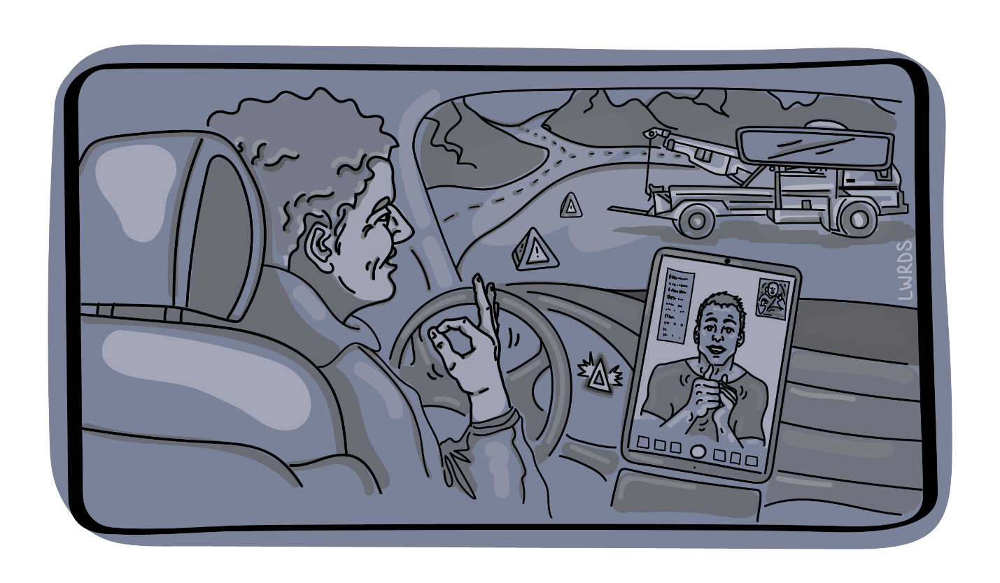Figure Edgar sits in his broken-down car and uses sign language with someone on a digital device.

Edgar has a flat tire on his truck. He’s on a major highway in Alberta. There is traffic, he’s pulled over onto the shoulder. He’s called for help. He’s Deaf. Fortunately, the RCMP (Royal Canadian Mounted Police) were prepared when Edgar called, and they used a video relay service to communicate with Edgar. The tow truck driver was also informed, equipped, and trained. He used transcription software on his phone to communicate directly with Edgar. Help was on the way and Edgar now could rest assured that they would be able to communicate effectively to help him.

#### Take-home from Edgar’s experience

Because the communications technologies and practices were both available and used effectively, Edgar felt safe, understood, and as though he’d get the help he needed to get on with his day. This inconvenience (the tire) would be the only inconvenience he’d have to contend with – communication was covered!

Recommendation: Every employee must know how to use and have access to alternative communication systems.

Janeesha’s Experience

When inclusion in work is the goal, individuals should not have to (continually) ask for captions, accessible documents, and other accommodations already discussed. --co-designer

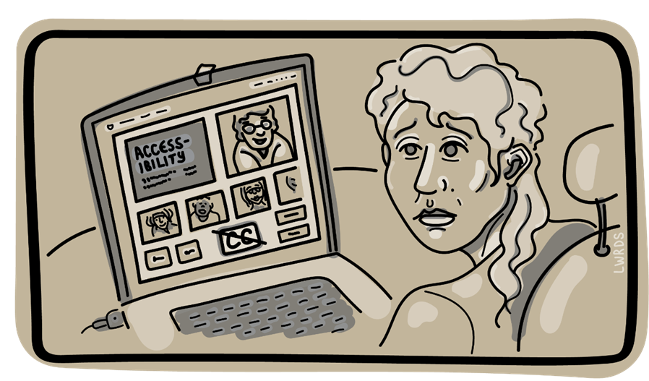

Figure Janeesha sits at a computer using video conferencing software. There are no captions available.

A company states they have a commitment to diversity, equity, and inclusion. Yet, Janeesha, a team member who is deaf was expected to attend a weekly work meeting despite constantly stating they could not participate due to lack of closed captions. Although Janeesha voiced concerns, the employer responded by making them attend and get as much out of the meetings as possible. After Janeesha consistently voiced concerns, their employer excused them from meetings, only later to question accommodation requests again. Janeesha wasn’t surprised because the company training video on accessibility wasn’t accessible either.

#### Take-home from Janeesha’s experience

Practices within the workplace that are supported by technology (e.g.: training, meetings, internal documents, resources, processes, and equipment) need to be inclusive. When people with disabilities are not considered in decisions or viewed as contributors, policy, practice, tools, technologies, and systems that can be equitable reinforce exclusion instead. When a colleague has to explain (again) what they need, it can be demoralizing and insulting and makes the person feel like an afterthought, a burden, an inconvenience, and certainly not an equal.

Recommendation: Any policy related to technology (its development, design, deployment, procurement, use, evaluation) must never disadvantage people with disabilities.

Sumi’s Experience

Supposedly...easier... to book... Then I found...a lot of shortcomings when it came to being compliant.... I’m just going to have to book in the old-fashioned way. --Co-designer

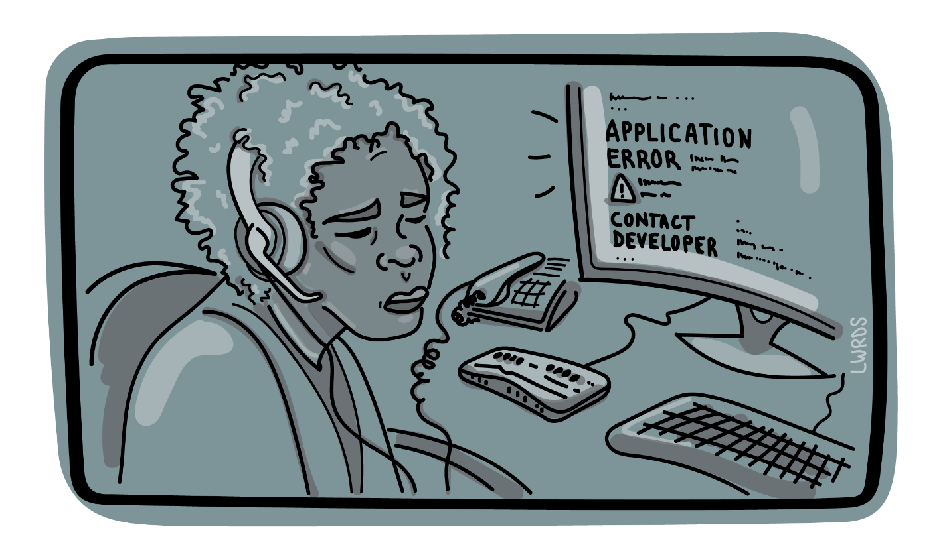

Figure Sumi sits at her computer with a braille device attached. The screen reports: Application Error: contact developer.

Sumi’s job at a clinic requires the use of software that allows them to book people's appointments and manage the calendar. It is well-known at the clinic that Sumi uses JAWS screen reader with technology and yet, this application was purchased for the clinic without knowing whether it works with JAWS. Now Sumi can’t do their job – Sumi has been ‘disabled’ because the company bought an application that did not meet the needs of ALL employees or potential employees. Sumi tried to get help: the software company said it was a JAWS issue (which isn’t true), the internal IT team said they couldn’t do anything about it… that’s the software that the ‘committee’ picked, and now Sumi has to ask for help whenever they want to make a change to the calendar.

#### Take-home from Sumi’s experience

Procurement is an important point at which disability can be perpetuated/created or eliminated. Where accessible technologies exist, they must be chosen to create inclusive workplaces and vendors should know that this requirement will be implemented. People with disabilities are often forced into roles where they have to resolve interoperability issues with their assistive technologies and be technologists. In addition, people with disabilities often have to advocate for their system needs within their organization.

Recommendation: Procurement policies must prioritize inclusive systems and services

Jacobi’s Experience

They talk for you, they talk about you, but they don’t talk to you. Just ask me what I need and how we can best work together!! –Co-designer

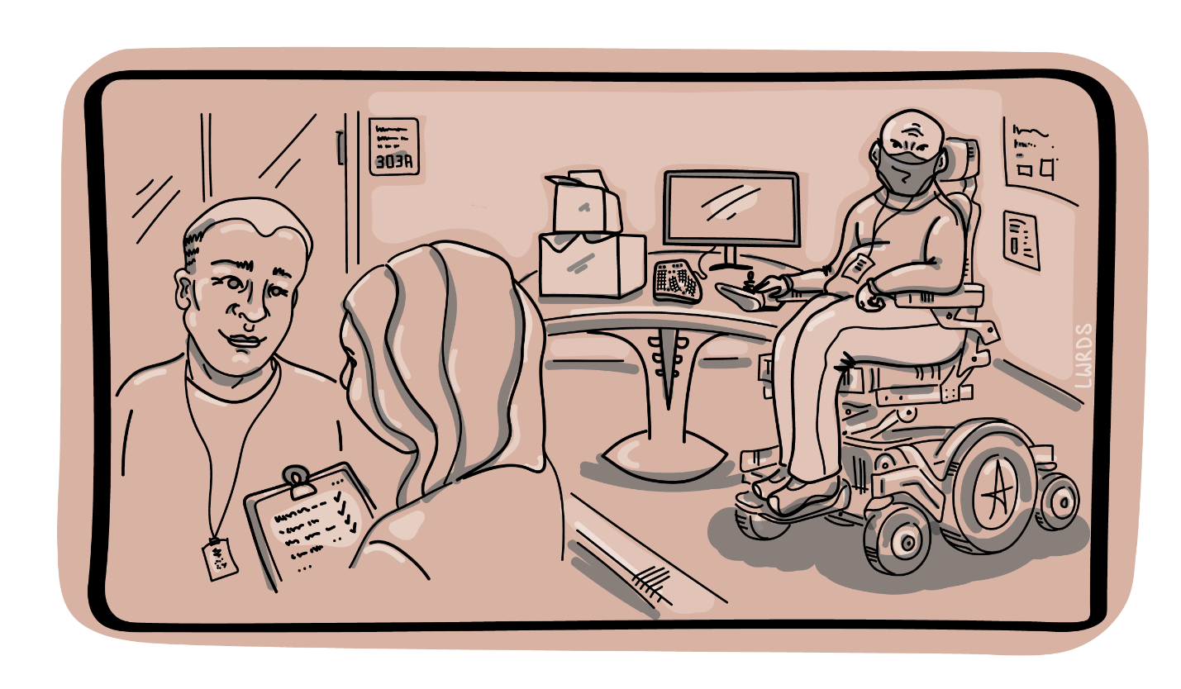

Figure Jacobi sits with their devices in one corner while a consultant and another team member discuss their needs in another corner.

When Jacobi started working at a new company, no one spoke to them at first. Jacobi has a visible disability, so they felt as though they were like a big elephant in the room—no one knew how to talk to them about their disability or how to work with them. It made Jacobi feel really alone at the beginning of their new job. They felt like saying, “yes, I’m disabled, there’s no point pretending and not asking! Just ask me what I need and how we can best work together!!”

The company didn’t even ask Jacobi about work needs; instead, they brought in a consultant who wrote a report and determined what Jacobi “qualified” for. Eventually, Jacobi got the equipment the consultant said they needed but not what Jacobi actually needed or preferred. Jacobi could have sped up and simplified this whole process, if the company had just talked to them in the first place. Now Jacobi has to wait longer to get what they need to do the job.

#### Take-home from Jacobi’s experience

People with disabilities know what they need, but employers talk to consultants instead. Fundamentally, it’s important to talk with people, and let them decide what works best for them.

Recommendation: Workplace accommodations should prioritize the needs and wishes of the individual. Systems procured for another individual may not be the most usable option.