Inclusion   
Self-Assessment   
Instrument

Mapping the path to greater inclusion in standards development processes

Inclusion Self-Assessment Instrument 3

Instruments vs Lens, Frameworks and Guidelines 3

What is the ISAI 3

ISAI Mapping Diagram 4

ISAI Mapping Table 5

How to use the ISAI 5

Assessment Areas 5

Subjective Interpretations of Effort and Resource Allocation 6

Getting Started 8

Area 1: General Considerations 8

Approaches for general considerations 9

Self-reflection questions for general considerations 9

Area 2: Public Engagement 10

Approaches for public engagement: 10

Self-reflection questions for public engagement: 11

Area 3: Communication 12

Approaches for public understanding of standards 12

Self-reflection questions for public understanding of standards: 13

Approaches for inviting others 13

Self-reflection questions for inviting others: 14

Area 4: Organizing Technical Committees 14

Approaches for selection of technical committee members 14

Self-reflection questions for selection of technical committee members: 15

Approaches for technical committee member onboarding and support 15

Self-reflection questions for technical committee member on-boarding and supoprt: 16

# Inclusion Self-Assessment Instrument

The Inclusion Self-Assessment Instrument (ISAI) enables standards development organizations (SDOs) to self-assess their standards development processes and understand the opportunities to improve them. The instrument provides new approaches to consider and questions for self-reflection in a number of areas. The ISAI was developed based on input from ASC, our research, CSA, 3 chairpersons from ASC standards technical committees, and through conducting co-designs (3 sessions) with people with disabilities who are interested in standards development.

## Instruments vs Lens, Frameworks and Guidelines

Terms like lens, framework, and guidelines carry negative associations and do not represent the intent of using the ISAI. Lens refers to taking a different perspective. While useful as a metaphor and reminder to step out of a default perspective, “lens” perpetuates the notion that accessibility is something that is stepped into or taken on as an empathy exercise, not something that is the default expectation or cultural norm. When we perpetuate accessibility as an extra, it can too easily fall into an afterthought. A framework similarly has a sense of framing a problem instead of re-framing the default. Frameworks can also be rigid and inflexible, making it challenging to adapt quickly and easily to accessibility concerns. Guidelines, on the other hand, can be interpreted as optional and can be too general and lack actionable items.

## What is the ISAI

An instrument supports collection of information, analysis and monitoring. The ISAI is a set of thought-provoking questions plus a matrix for understanding where current approaches and decisions measure on continuums of inclusion and innovation. The ISAI will help SDO’s reflect upon the following:

* + How is the SDO doing in the area being assessed?
  + What are the next steps to deepen or broaden the SDO’s efforts in inclusion in this area?

**The ISAI is not binary**—depicting right/wrong or good/bad. The ISAI is a spectrum where ideas, practices, approaches, and processes can coexist and overlap in unpredictable ways.

**The ISAI is not a checklist**—the intent is not to do everything and be “done”. The ISAI, its ideas and concepts are meant to evolve, grow, be refined over time, and be applied multiple times as a way of continual improvement.

**The ISAI is flexible** and can be used to examine anything from high-level concepts to low-level implementation details. For example, the ISAI can cover the practices at a particular stage of the standards development process; it can then be applied to focus on a specific aspect of the stage or used on another stage.

### ISAI Mapping Diagram

The ISAI includes a diagram on which to map what you are doing now and what you could endeavour to do (either deepening existing practices, or trying something new). An alternative to the visual map is the mapping table. The diagram is structured in this way:

* **Approaches** (current and hypothetical) are mapped left to right with more fixed or traditional approaches on the left progressing to more flexible approaches to the right.
* **New ideas** such as novel opportunities and practices to consider are placed in the top half.
* **Existing practices** are represented on the bottom half of the diagram. Those practices can be interrogated and improved.
* **Level of effort required** is represented by the distance from the centre point, increasing in effort as you radiate away from the centre. Effort here can be measured differently for each SDO and each question. Examples of ways to measure ‘level of effort’ are degrees of difficulty, cost, time, quality, etc.

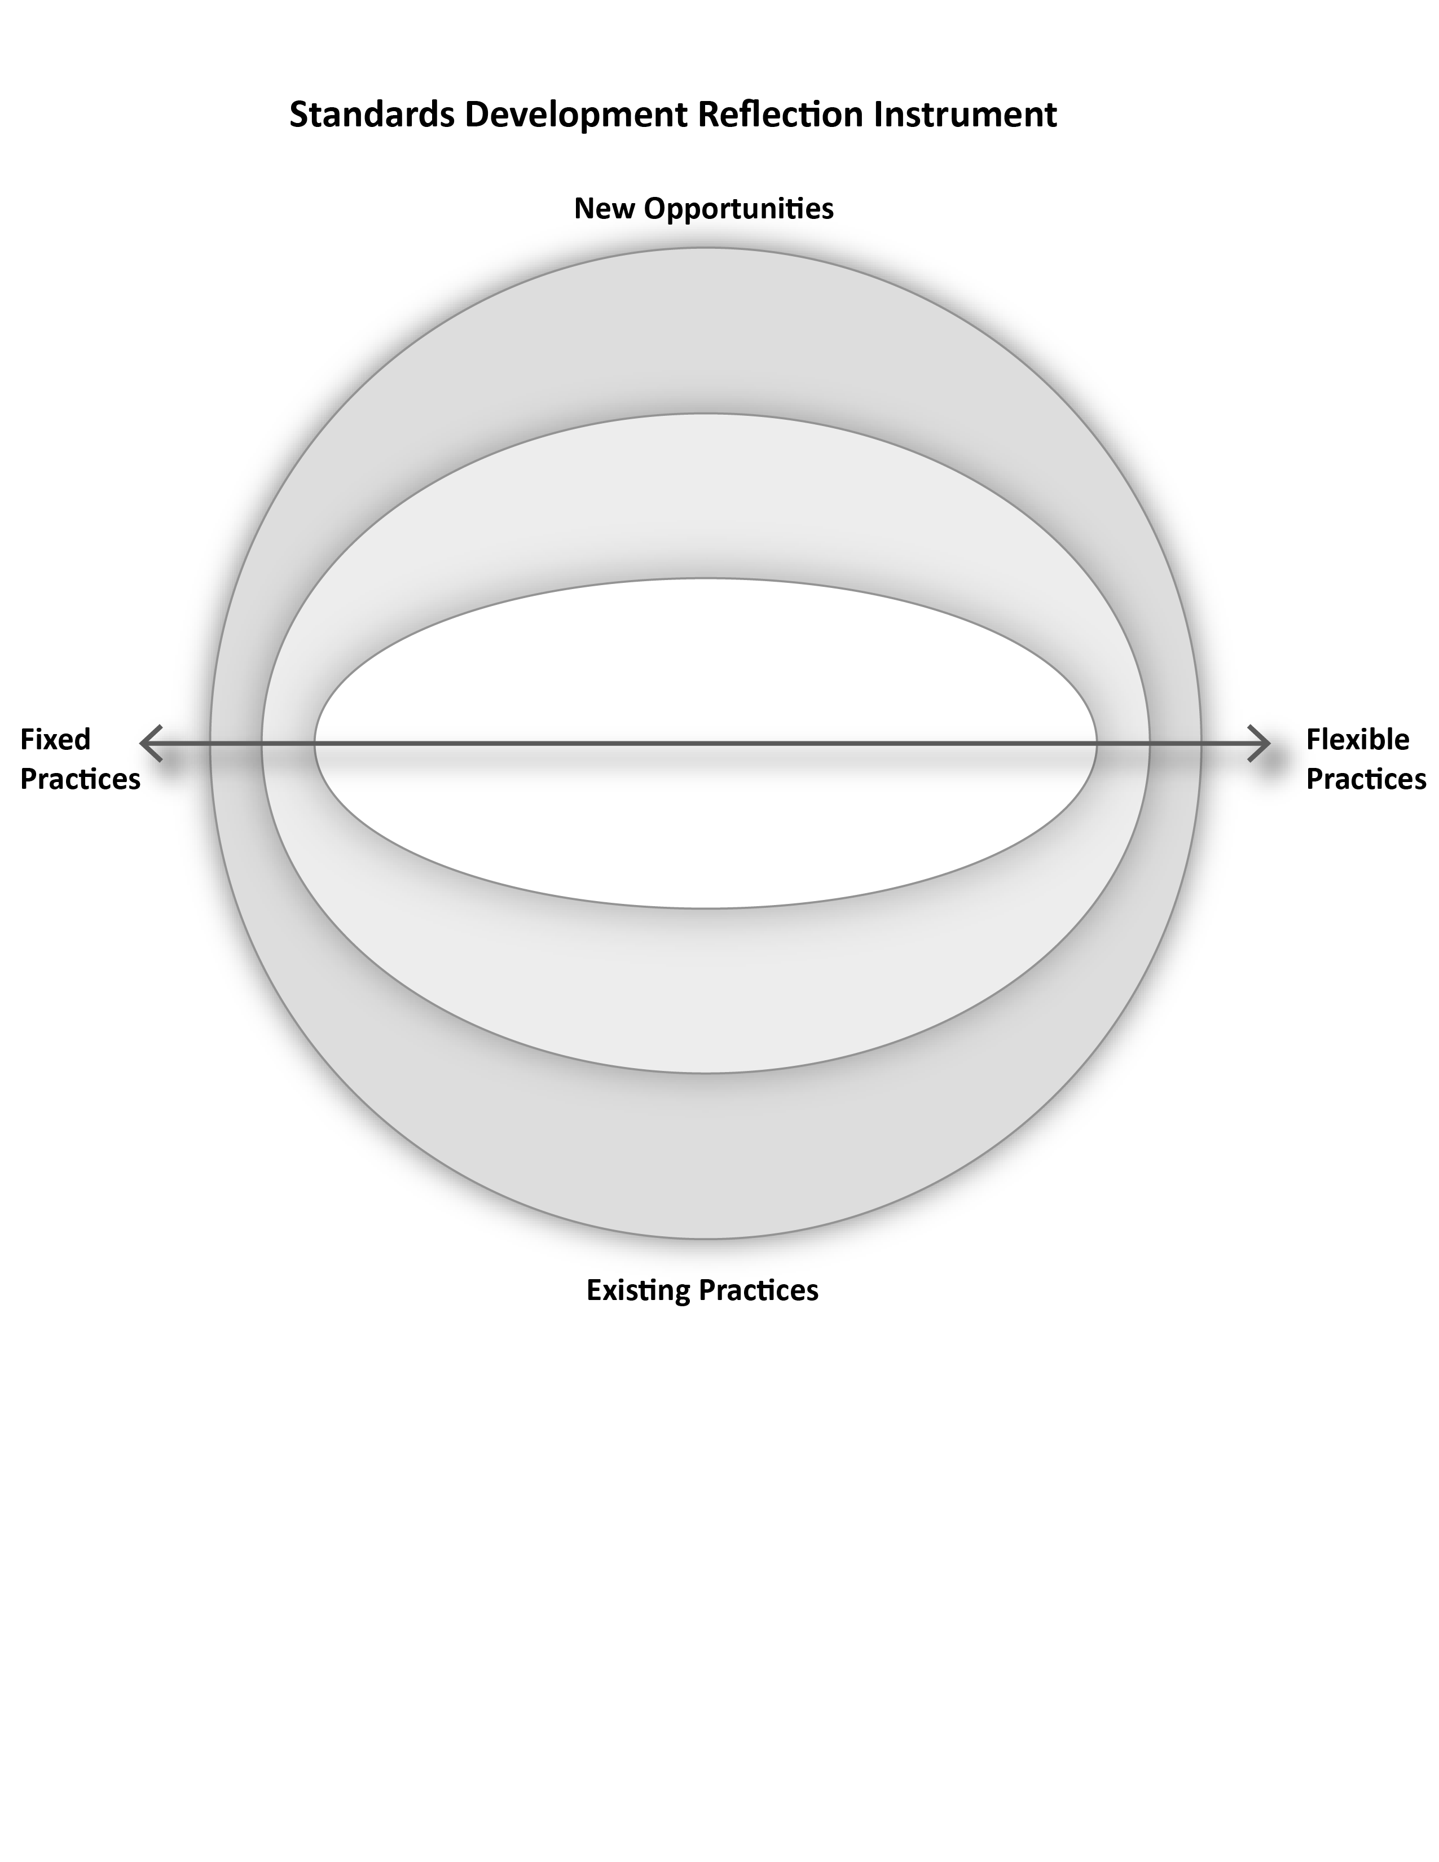

Figure 1: Self-assessment map

### ISAI Mapping Table

An alternative to the mapping diagram is this assessment table.

| Dimension of the area under assessment | Position on Fixed/Flexible Practices Continuum | New Opportunity or Existing Practice | Level of Effort Required | Reflections |
| --- | --- | --- | --- | --- |
|  |  |  |  |  |
|  |  |  |  |  |
|  |  |  |  |  |
|  |  |  |  |  |

Figure 2: ISAI Mapping Table

## How to use the ISAI

The people who gather to use this instrument will vary depending on organizational readiness within any of the areas that are being assessed. Individuals involved can include any person involved in development of or impacted by standards. Generally, team members within SDOs can come together to first, rank your own practices based on the approaches prompts (where approaches are areas that SDOs make some decisions that can have an impact on accessibility and inclusion) and then Second, reflect on it with the self-reflection questions. Have conversations about different ways to improve inclusion and accessibility. And ideally involve people with disabilities in the conversations.

1. Choose an area or issue to assess.
2. Begin with subjective interpretations for that area/issue and map them using the self-assessment map or table.
3. Reflect on where you are and where you want to go using the provided questions and prompts.
4. Do this for as many areas and issues as you like
5. Iterate on your plan and continue to assess and add diverse perspectives.

### Assessment Areas

There are four areas in this ISAI:

1. General Considerations
2. Public Engagement
3. Communication
4. Organizing Technical Committees

However, these are just starting points, the ISAI approach can be used in multiple areas and levels of granularity.

### Subjective Interpretations of Effort and Resource Allocation

Organizations and individuals will differ in where they place concepts on the diagram. The interpretation of where you are is meant to represent where you *think* you are now. For example, a more well-resourced SDO may deem a specific approach as low effort, while a less well-resourced one may consider it to be high effort. There is no one, correct answer. The instrument is meant to facilitate reflection and discussion rather than “correctly” define where a concept belongs within the space.

**Reflect on where the SDO is currently:** use the list of approaches in each area to map out existing processes and practices. Then use the self-reflection questions to engage in conversation about if that is where the SDO wants to be.

**Brainstorm more inclusive approaches:**  use the ISAI to inspire thinking in any area where you want to change the SDO’s maturity of addressing a particular issue:

* map new practices and processes that would move the SDO in a more inclusive direction.
* map how existing processes could be made more inclusive.
* Brainstorm using the self-reflection questions to get you started

**Monitor your efforts by mapping your practices over time and reflect on your progress.**

The diagram is split into 6 vertical sections along the x axis. From left to right: highly fixed, more fixed, somewhat fixed, somewhat flexible, more flexible, highly flexible. 



Figure 3: Areas denoting degrees of flexibility.

When mapping consider the above six demarcations along the continuum between fixed and flexible practices. This continuum is not one of judgment. You can have inclusive, fixed practices and inaccessible flexible practices.

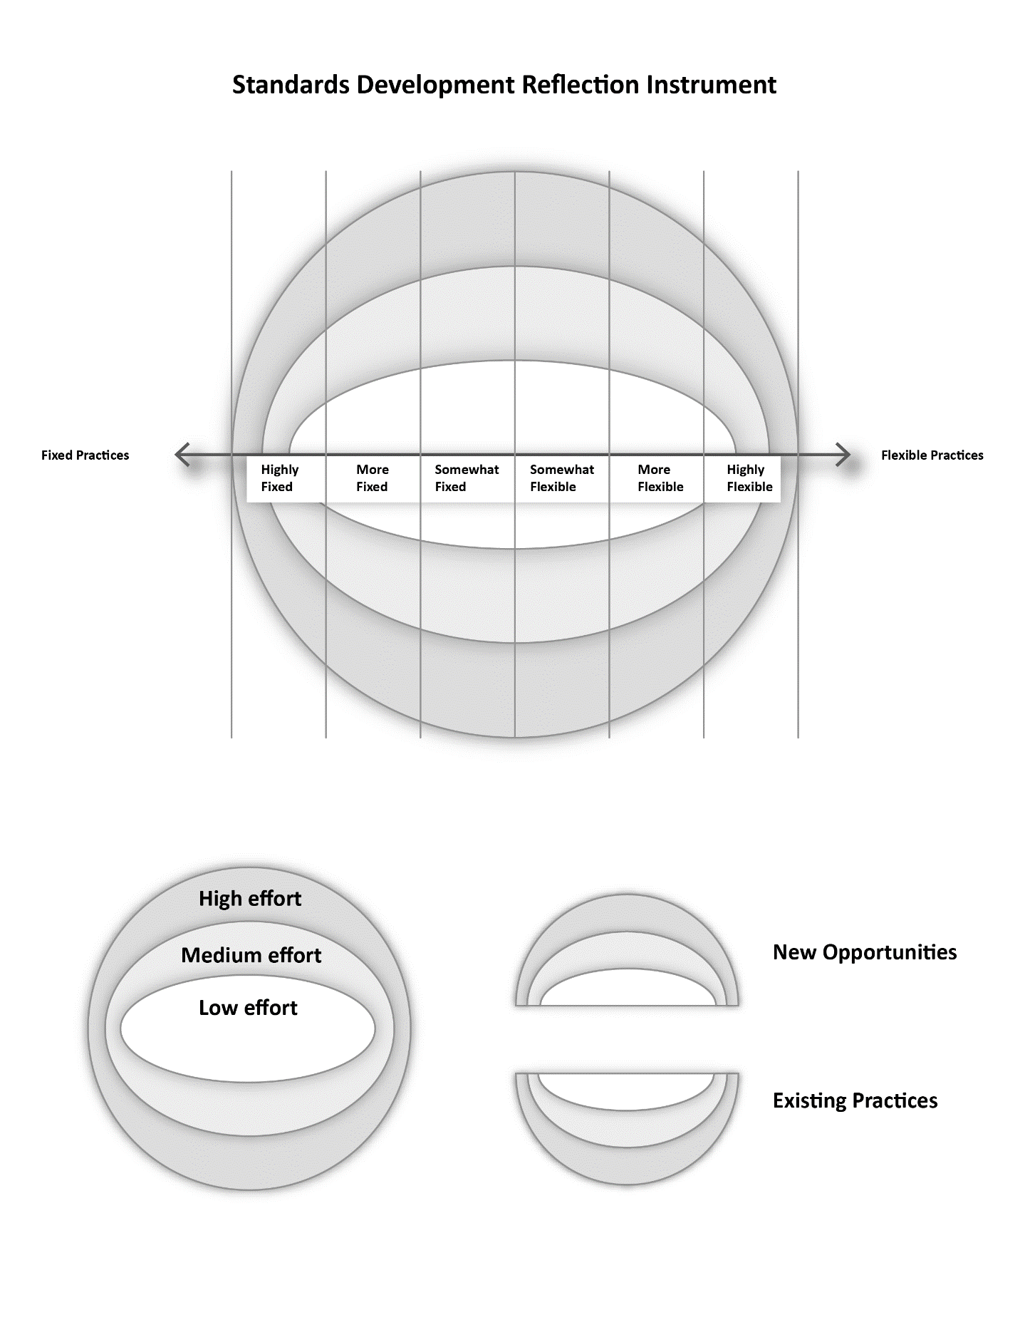

Figure 4: Levels of effort

Map the level of effort for yourself or your organization using the concentric rings. The level of effort is something you will determine based on the factors meaningful for your own organization. Examples of ways you might measure “level of effort” include difficulty, cost, time, quality, etc.



Figure 5: New opportunities and existing practices

If you want to use the instrument to map existing practices, then all of your approaches will be represented in the bottom hemisphere.

# Getting Started

The ISAI is presented with four areas; however, new areas for self-assessment may be created as needed. We provide sample self-assessments for the first two areas. Each area, begins with approaches where your SDO has considered, has culturally established an informal or established way, or formalized a way of addressing an aspect of standards development. Once you have read through the approaches, ask yourself where your SDO might map your practice onto the diagram. E.g., How does your SDO make decisions? In particular, what is your approach to using data to make decisions? Where would you place yourself on the diagram?

## Area 1: General Considerations

This area refers to overarching aspects of the organization and its processes.

### Approaches for general considerations

* “One-size-fits-all” universalist approaches may give the benefit of efficiency and reproducibility, but at the expense of understandability, relevance, and usability. Universalist approaches can make it harder for those at the margins to engage meaningfully. Aim to have more flexible approaches that can be easily adapted and customized to meet particular needs and unanticipated situations.
* Decision-making based on statistical trends or averages can inadvertently exclude critical/important edge cases or confirm biases by giving an incomplete picture. Invert trend-seeking decisions by looking at the statistical outliers and consider how decisions made by including the edges can often benefit the whole.
* Consider the frequency and opportunity for checkpoints to help make iterative improvements and course corrections. These checkpoints can involve gathering input or feedback from other parties (like the public) or introspection by the team.
* Flexible systems, formats, processes, etc. make it easier to adapt and adjust to new circumstances. Flexible systems naturally and gradually improve over time.

### Self-reflection questions for general considerations

1. How do you continually strive for better in all aspects (communication, tech committee management, public engagement, etc.) the next time around? What are the checkpoints to pause and examine/reflect on the process? What are the known pain points?
2. How are metrics being used? Do they confirm biases or exclude critical outliers?
3. Are standards that are created the minimum for others to follow, or an exemplar of better practices? Can the standard be written to convey both the minimum and the ideals to strive for?

We’ve provided a sample mapping for this area that includes several examples of approaches and how they can be mapped onto the instrument.

**Note: this example is not complete**

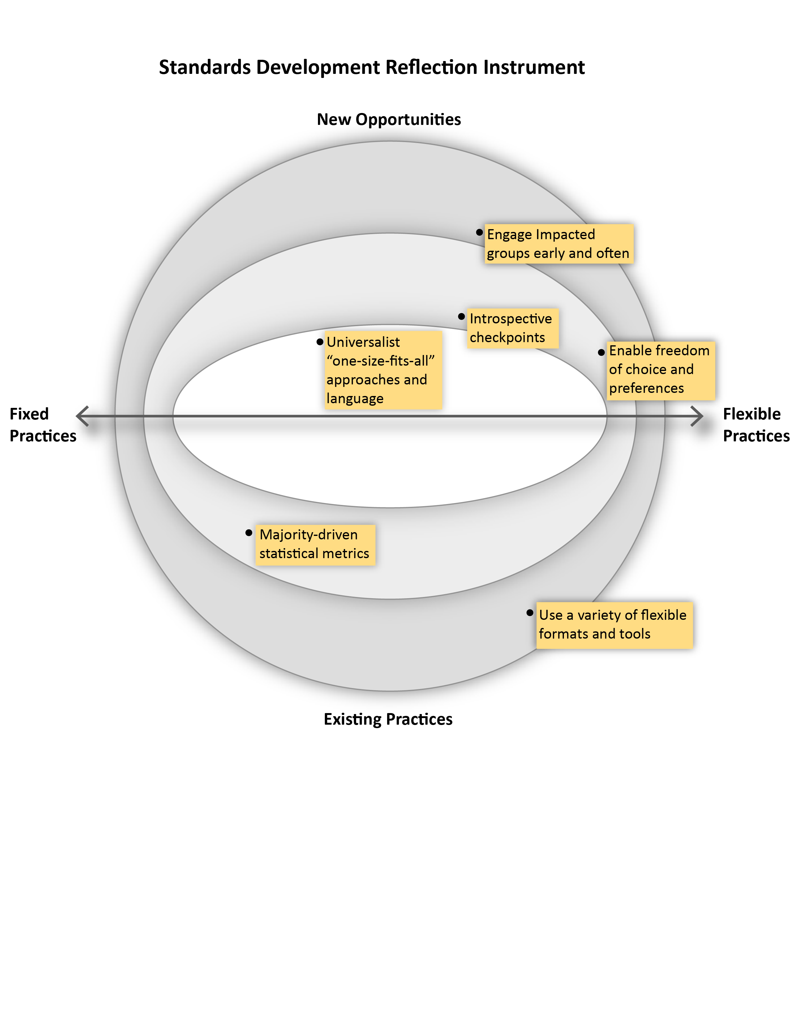

Figure 6: Sample mapping of general considerations for an SDO

## Area 2: Public Engagement

This area refers to the way and moments that the general public is engaged in the standards development process.

### Approaches for public engagement:

* In most standard development processes, the Enquiry stage is the only major touch point for public involvement. Consider additional opportunities to engage the public earlier at the 3Ps (Preliminary, Proposal, Preparatory stages), and more frequently.
* Consider public engagement to build relationships, capacity, understanding, and knowledge with underrepresented groups. These groups can then be invited to engage in feedback (i.e., at the Enquiry stage or other opportunities).
* There is no single, fixed way to communicate. Communication should be an ongoing and malleable process that involves learning, listening, and adapting.
* Provide different feedback loops for the public that are accessible and easy for their context. Engaging with groups early to understand their needs will help inform the different modes of access and features needed to support their meaningful contribution. For example, a particular community may desire analog ways of participating in an Enquiry. Collaborating with this community may reveal different approaches such as mail-in forms, phone hotlines, or small group focus meetings.
* Ensure communication across all channels is consistent, current, clear, and complete.
  + For example, if a standard is open for public feedback can it be easily found on the website and other communication channels?

### Self-reflection questions for public engagement:

1. People “at the margins” will experience the impacts of standards more acutely – how are they being involved in its development?
2. How are people unfamiliar with standards learning about standards?
3. Who is receiving your message and is it reaching the broadest possible audience?
4. How are you listening and learning from affected groups? How does this impact the way you communicate?
5. Is the Enquiry stage receiving the desired feedback? How is this being measured? How might the Enquiry stage adapt to give more opportunities for more public involvement?

We’ve provided a sample mapping for this area that includes several examples of approaches and how they can be mapped onto the instrument.

**Note: this example is not complete**

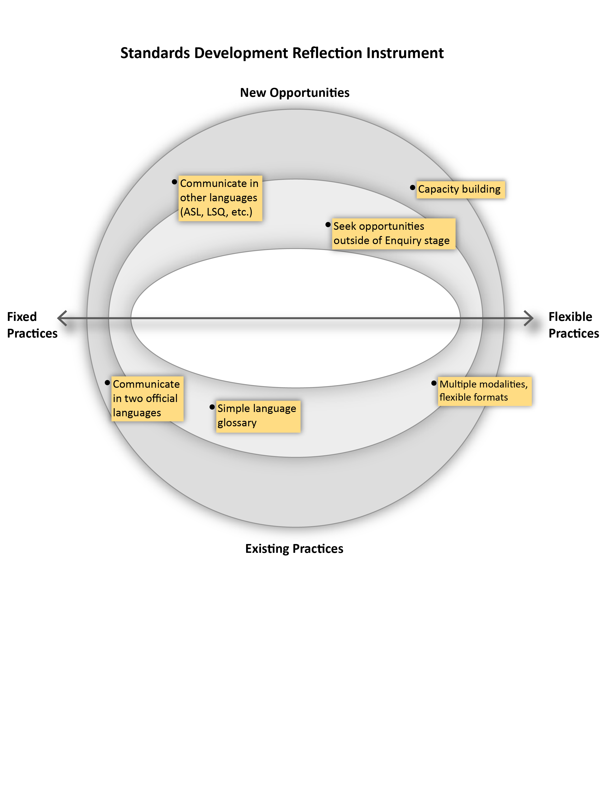

Figure 7: Public Engagement Considerations for SDOs

## Area 3: Communication

This area is sub-divided to represent two aspects of communication: 1) being understood and 2) inviting others.

### Approaches for public understanding of standards

* Standards development is unfamiliar to many people. Make sure to define important unfamiliar terms and use simple language.
* There are many different audiences with different backgrounds. Therefore a “one-size fits all” approach to communicating will not be effective. Consider approaches that enable ease of access (i.e., different formats and modalities) and ease of transformation (i.e., translations or other interpretations) that enhance understanding by specific audiences. For example, talking about the standards process to a newcomer to Canada should be different.
  + Build relationships with specific communities to understand their needs to effectively communicate with them.

### Self-reflection questions for public understanding of standards:

1. How might the process benefit from communication other than the official languages?
2. How might translations or transformations be facilitated in your process?
3. How do you evaluate comprehension and/or effectiveness of communication?
4. What details are necessary to communicate?
5. What communication channels are being used? Are these channels reaching the intended audience?
6. How are standards being published and announced? How do people become aware of them?
7. Think outside the page – how else can this content be presented to be more engaging?

### Approaches for inviting others

* Use multiple ways to announce a standard is open to public input including different media channels, modalities, and formats. Also, see “Engage the public to better understand the standards development process” above**.**
* During the enquiry, consider different ways to get focused feedback. For example:
  + Seek input on portions of a standard instead of the whole.
  + Intentionally invite specific communities to give feedback on the draft standard.
* Provide multiple ways of contributing comments to a standard (i.e., not just through an online portal). Consider different degrees of accessibility and modality, and not just for electronic/online interactions. Possible approaches:
  + Provide an email address for feedback and input.
  + Allow the public to download a copy of the draft standard in different, accessible formats so they can add their comments and submit it.
  + Analog approaches like postal mail, telephone hotlines, and small group workshops.
* When providing feedback during enquiry, there can be a tension between the desire for privacy (anonymity) and the desire to share personal information and experiences that are relevant to the standard. Strict privacy can be more secure but can diminish the richness of feedback. There should be ways for individuals to make informed choices about their private information and provide safeguards.

### Self-reflection questions for inviting others:

* What are the ways the public is being informed about public enquiries? What are some different ways to boost public engagement?
* What are the possible barriers to participating in a public enquiry? Go ask them!
  + Lack of awareness
  + Availability and time requirements
  + Perceived required expertise or knowledge in the subject matter.
  + Lack of understanding of standards in general
  + Accessibility of materials or platform used.
* How do you measure the effectiveness of the enquiry stage? Quality, quantity, diversity of representation, or some other metric?
  + A lack of feedback or feedback from a small population is not an indicator of support for a draft standard.
* Does the enquiry process allow the public to share their personal experiences and contextual information that may be relevant to the standard? How is their privacy protected?

## Area 4: Organizing Technical Committees

This area refers to the timing and ways that technical committees are formed as well as the practices within those committees.

### Approaches for selection of technical committee members

* Selecting technical committee members from a pool of known experts (i.e., industry experts, researchers, policymakers, advocacy groups etc.) can be efficient and bring some diverse input but can lack critical perspectives that lie outside of the usual pool of expertise. Ensure more diversity on a technical committee by making the selection an open process by informing the public that a standard is to be drafted and an open application process is being held. Committee members are selected according to published criteria including lived experience and intersectionality. The selection process is transparent.
* Consider the phrase “nothing for us, without us”. If a new standard is going to impact certain groups more significantly than others, then those groups should be involved in the creation of the standard and not just at the enquiry stage.
* Consider how the composition of the technical committee can be more flexible and change over time depending on the need.
* Those who are not selected for a technical committee can be given the option to participate in other ways like being involved in a working group or invited to the enquiry.
* People who applied but were not selected for a technical committee should be informed.
* Communicate expectations to allow committee candidates to make informed decisions before joining. This includes payment details, time commitment, how the work is to be done, accessibility, etc.
* The public should be able to find some general/abstracted information about who is on a technical committee for a standard that impacts them. This can help increase transparency and accountability.

### Self-reflection questions for selection of technical committee members:

1. How do you achieve diverse representation on a technical committee?
2. Is membership on the technical committee fixed or flexible?
3. How are candidates for a technical committee decided upon?
4. How do people learn about joining a technical committee and what is involved in being a committee member?
5. What is the process of deciding who will be on a technical committee? What role does diversity play in this?
6. Is there transparency and accountability in this process? How does someone learn more about the committee that is creating the standard? What information can be shared that balances privacy, accountability, and transparency?

### Approaches for technical committee member onboarding and support

* Standardized tools and procedures for technical committees can make administration easier but can be a significant barrier for some members. For example, a software tool may be popular and widely used but may have accessibility or interoperability issues for someone using an assistive technology. Consider how technical Committee members are supported throughout the process that enables them to fully participate in the standard development process.
* Don’t assume training materials are enough to help a committee member in their role. Provide regular and ongoing support.
* Be mindful of cognitive load and not expect members to learn everything in one setting. Consider what is important for new committee members to understand right now and what can be addressed as needed.
* Issues with technology, accessibility, and language (not just official languages) can create barriers and fatigue that prevent members from participating fully.
* Understand the unique needs of technical committee members, especially those experiencing disabilities, and make it a baseline for all technical committees. For example, if some members require additional time to make their contributions the process should allow for more flexible schedules if needed and this should be the default going forward.
* Ensure that the SDO / project manager understands access needs and is equipped to help the technical committee. This may require regular training and upkeep of knowledge and skills.

### Self-reflection questions for technical committee member on-boarding and supoprt:

1. How can the experiences of the technical committee improve the way a standard is created for the SDO as a whole? Is there a way for a committee member to ask questions or give feedback?
2. How are the needs of committee members addressed? What are some ways to anticipate the needs of diverse technical committee members?
3. Are all materials, tools, platforms, etc. equally accessible to all members?
   1. How are documents shared?
   2. How is communication happening?
   3. Synchronous and asynchronous methods of collaboration – is it all accessible?
4. What are the checkpoints for the Technical Committee to reflect on progress?
   1. How is the pace? Need to go slower to get sufficient input/research?

## ISAI Mapping Diagram and Table for Reproduction

The following pages contain a blank mapping diagram and table that can be copied and re-used or printed.

**Area of assessment: ________________________________________**



**Notes:**

| Dimension of the area under assessment | Position on Fixed/Flexible Practices Continuum | New Opportunity or Existing Practice | Level of Effort Required | Reflections |
| --- | --- | --- | --- | --- |
|  |  |  |  |  |
|  |  |  |  |  |
|  |  |  |  |  |
|  |  |  |  |  |
|  |  |  |  |  |