A-Prompt: Promoting the Habituation of Accessible Web Authoring
Chris Ridpath  Adaptive Technology Resource Center,  University Of Toronto, Canada  chris.ridpath@utoronto.ca | Jutta Treviranus  Adaptive Technology Resource Centre, University of Toronto, Canada  Jutta@utoronto.ca

Abstract

A-Prompt is a tool that enables web developers to check for and repair barriers to access in their developed site pages. A-Prompt was developed with three principles in mind: automation, integration and education. The result is a web content accessibility checking and repair tool. Survey results indicate that the founding principles of A-Prompt are sound and that further development of the tool is merited. Issues related to development, integration and standardization of A-Prompt are discussed and future directions for the tool’s development are considered.

Introduction

A-Prompt had its origin, in 1995, in a collaborative project between the Adaptive Technology Resource Centre (ATRC) and SoftQuad Inc. The aim was to build prompting and guidance regarding accessibility directly into the most popular HTML authoring tool at the time, namely: HoTMetaL. Since then, thanks to funding from National Institute on Disability and Rehabilitation Research (NIDRR), A-Prompt has been recreated as a free standing evaluation and repair application and as a DLL that can be integrated into HTML authoring tools to test for both W3C Web Content Accessibility Guidelines compliance and US Rehab 508 compliance.

Throughout its evolution A-Prompt has always been designed with three precepts in mind:
- automate as many evaluations and repairs as possible so that the author’s energies can be devoted to evaluations and repairs requiring human judgment,
- wherever and whenever possible integrate support for access into the initial authoring process, and
- educate authors on accessible design, but also design the tool so that even authors without the knowledge or the will necessary to produce accessible documents will be supported in creating accessible web sites.

A-Prompt exemplifies the implementation of a carefully developed set of heuristics and diagnostics to identify and repair barriers to access. The A-Prompt techniques form the basis for and closely follow the Techniques for Accessibility and Evaluation and Repair Tools (AERT) developed by the Evaluation and Repair Tools Working Group of the W3C Web Accessibility Initiative. While the AERT techniques are now being integrated with the documentation of the Authoring Tools Working Group and the Web Content Accessibility Guidelines Working Group, it remains significant as an outline of strategies that evaluation and repair tools may use to uncover accessibility problems and repair them.

These principles form the basis of objectives for the A-Prompt project: to enable seamless checking for accessibility issues in web development environments, to repair and log repair decisions so that burden on the author is minimized, to help develop standard practices for issue detection and repair and to move towards integration of A-Prompt functionality into commercial development environments.

Survey Support for A-Prompt Objectives

Before starting on the development for version 2 of A-Prompt, the ATRC undertook a study to determine user needs. A form containing 28 questions was made available at the A-Prompt web site that allowed users to enter general and specific data regarding their A-Prompt use. An email inviting users to complete the form was distributed to several listserves and our mailing list of A-Prompt users.

Participants
Over 70 users completed the survey to date. Fifty-two participants describe their development experience as expert or intermediate and half (35) of the respondents are website managers or content creators.

Results and Discussion
In our survey we asked users about their A-Prompt use and discovered that use declined over time (see figure 1).

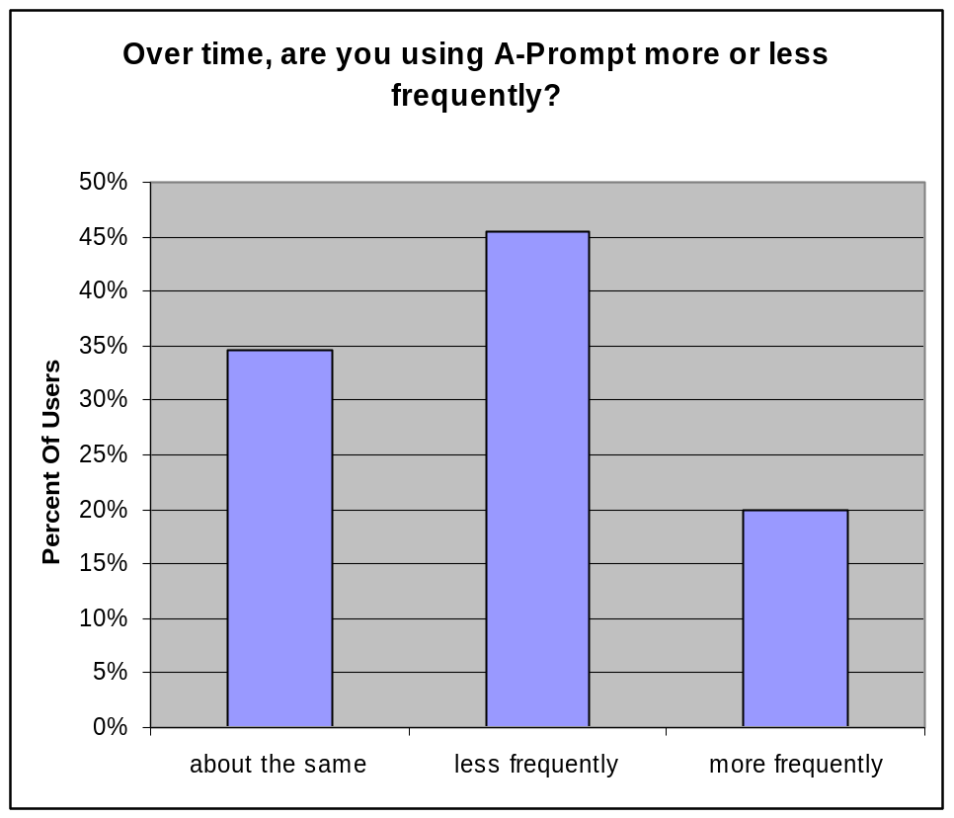
Figure 1: A-Prompt use over time

A central goal of A-Prompt is to educate users about accessibility issues and to train them in creating more accessible web pages. The product contains extensive help files that not only identify the accessibility problems but describe how and why they must be corrected. Each dialog that repairs an accessibility problem includes text that describes the problem and offers suggestions for making the repair. Our intention was that eventually the user would modify their authoring practices to create more accessible content. The reason that most users (31%) gave as the reason for their decreased use was that they could now find and repair accessibility problems themselves indicating that our educational approach was working.

In our user survey, we asked users why they were checking for accessibility and found that the largest response was to make the site more useful (figure 2). While government regulations and company policy were major factors, general usability and a personal concern for people with disabilities encouraged more people to consider accessibility checking.

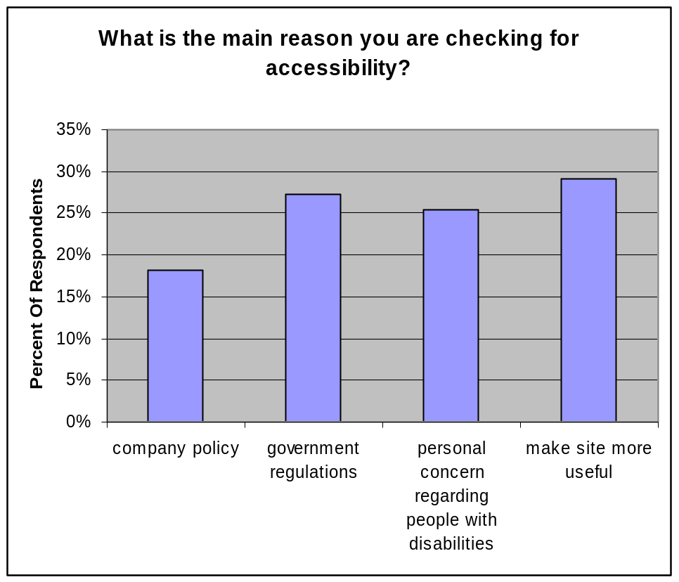
Figure 2: Main reason people check for accessibility problems

There exist several legislations throughout the world that force web authors to make their sites more accessible. In Canada there is the Common Look And Feel guidelines that apply to all federally governed sites. The United States has section 508 of The Rehabilitation act, Germany has enacted BITV and there are others. The result of these laws has been to increase the awareness of web accessibility and to encourage web authors to include accessibility as part of their authoring process. While these laws have been necessary, the A-Prompt philosophy has been to encourage accessibility as part of general usability. Documentation in the product has stressed that as a site becomes more accessible to people with disabilities, the site is also more accessible to all users. Sites that comply with accessibility standards offer advantages over non-compliant sites. Users can find information quicker, the site displays well on a wider range of user agents and a wider population can access the site. We have found that business leaders, while cognizant of government regulations, are more likely to listen to arguments that will encourage more and happier customers. The response to this survey question has further strengthened our belief in the philosophy that accessibility is usability and that increased usability is a helpful selling point for businesses unwilling to change their web sites for accessibility reasons alone.

A-Prompt Development and Integration

The key A-Prompt objective is to promote creation of accessible web content. Several factors are associated with meeting this goal successfully: developer needs and acceptance, site owner business objectives, standards of practice and transparency of the tool. Each of these factors has been addressed by the development team in a variety of ways. The development of A-Prompt and actions taken by the ATRC to enable successful implementation and acceptance of A-Prompt are outlined in the following sections.

Public Interface for A-Prompt and Integration with Other Tools

A-Prompt contains a public Application Programming Interface (API) that allows other programs to integrate and use the A-Prompt functionality. The API takes the form of a simple DLL with exported function calls that may be accessed by programs written in most common languages such as C, C++ or Visual Basic. It was our intention that HTML authoring programs would make use of this API and integrate the A-Prompt functionality much like a traditional spell checker utility. We envisioned that as the user authored their HTML document, A-Prompt would be called on a periodic basis to validate and repair its accessibility. We’ve had a great deal of interest in the API but have been unable to announce that a commercial HTML editor program has integrated A-Prompt.

Future development of the API

Version 2 of A-Prompt will contain an updated version of the API that exposes more components of the program’s functionality. It will be possible for host programs to have fine control over each repair that A-Prompt performs. The host program will also be able to control which accessibility checks and heuristics are applied in A-Prompt’s evaluation engine.

Open Standards for Checking and Repair

A common complaint from users performing accessibility checking is the lack of consistency between validation tools. All of the current accessibility checking software programs use different testing criteria. This lack of consistency is discouraging to users and weakens the acceptance of accessibility guidelines. If we liken accessibility validation to the use of a spell checker then we must promote the use of a single dictionary of testing criteria for all tools.

A-Prompt’s accessibility checking is based upon the Web Accessibility Initiative (WAI) technical document titled Accessibility Evaluation and Repair Techniques (AERT). This document lists, as much as possible, all the checks that must be performed to validate a document for compliance with the WAI’s Web Content Accessibility Guidelines WCAG). Unfortunately, not all the WAI guidelines can be validated by a series of checks and not all are detailed in the AERT. This gap has lead to the variance in the checking techniques used by different software tools.

The ATRC has been working with other accessibility validation tools to create a common set of algorithms for HTML accessibility. If adopted, this common set would also allow for the interoperability of checking tools. For example, a tool that just performs accessibility evaluations could pass invalid HTML code to a tool, like A-Prompt, that can repair the HTML code.

Each accessibility check that is performed by A-Prompt will be fully exposed and documented so that other checking programs can determine our compliance to accessibility standards. These checks will be made available to the user so they can modify or create their own standards. For example, some companies have currently adopted a low conformance rating but are moving towards a higher standard and will to include some, but not all, of the higher standard’s accessibility checks. A-Prompt’s checklist is stored in a separate file using the EARL standard format. The checklist file may be easily shared amongst users so they have a common set of accessibility checks. The checklist file may also be used in the creation of accessibility validation reports that will then be more accurate and detailed.

Expanded Registry & EARL

As part of the accessibility validation process, the user must make decisions about many of the document components. For example, if an image appears in an HTML document, the user must decide if the image is complex enough that it requires a textual description beyond what is contained in the short ‘alternate’ text. Even a relatively simple document may require dozens of user decisions in order to make a complete evaluation. These user decisions must be recorded and stored so the user is not asked to repeat their decisions each time the document is evaluated.

A standard method of recording this accessibility evaluation information has been developed and is used by A-Prompt. Called EARL, for Evaluation And Report Language, it is a Resource Description Language (RDF) dialect that allows accessibility checking tools to state exact information about their evaluations. Information stored in this standard format may be re-used by other tools to provide other accessibility reports. A-Prompt’s use of EARL is intended to reduce the number of redundant decisions that are required for a complete accessibility evaluation.

Conclusion

Ideally, all Web authoring interfaces, would in themselves provide utilities to prompt the creation of accessible content, this would insure that accessible authoring does not require retrofitting and becomes a naturally integrated, habitual step in creating resources for the web. Until this ideal is the norm rather than the exception, A-Prompt and systems like it provide the tools and model developers need to produce accessible web sites. Throughout it’s relatively long history, A-Prompt has been used to pilot and model the support of accessible authoring practices and has thereby played an important role in the market and in the efforts of the Web Accessibility Initiative. Ongoing development of A-Prompt is planned so that the tool will continue to enable developers using new techniques such as XML and dynamic web content or courseware environments to continue to create accessible content.

