Regulating the
Digital Domain:
Final Research Report
Executive Summary

  - New approaches to improve accessibility of digital technologies

Inclusive Design Research Centre
March 31, 2026
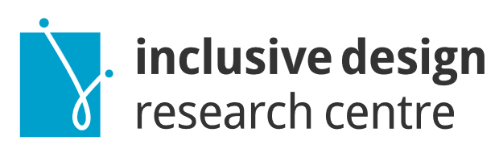

Executive Summary
The Regulating the Digital Domain (RtDD) project looked at why many digital tools and services are still not accessible, even though there are laws, standards, and guidelines. People told us that accessibility problems continue because accessibility is often not built into systems from the start.
To better understand these problems, we worked with people with disabilities, community members, advisors, designers, and developers. We met online, shared experiences, and discussed real examples of digital barriers. People’s lived experience shaped the work throughout the project, and many co-researchers said this was the first time their experience had been treated as valuable expertise.
From this work, we created three models to help make digital systems more accessible:
- Process-Based Compliance Model
Helps organisations build accessibility into their everyday work. This includes planning ahead, testing regularly, involving people with disabilities, and checking progress over time instead of waiting until the end.
- Inclusive Learning Framework
Helps teachers, trainers, and organisations include accessibility in teaching and learning. It supports people in building skills over time and helps create a culture where inclusion is expected.
- Digital Inclusion Framework
Helps teams design new technologies, including AI tools, in ways that are safe, inclusive, and accessible. It makes sure people with disabilities are involved in decisions, that people stay involved in important choices, and that tools are tested in real-world situations.
These three models help address the main challenges identified at the start of the project, including rapid technological change, the wide range of accessibility needs, and the need for meaningful participation. The Inclusive Learning Framework is especially important because it helps address all six challenges by building understanding and skills across the system.
Together, these models show a different way forward. They focus on people, learning, shared responsibility, and systems that can improve over time. They offer practical tools that governments, organisations, and communities can use to build a more inclusive digital world.
Co-researchers said it mattered that their lived experience was treated as valuable knowledge. Their feedback helped strengthen the models and improve the accessibility of the materials. They also identified areas for more work, including testing the models in real settings, providing clearer guidance on how to use them, and making sure people with lived experience are fully involved throughout.
The RtDD models offer a practical new approach to digital accessibility. They focus on ongoing learning, better ways of working, responsible innovation, and the leadership of people with disabilities. Together, they can help support more inclusive and accessible digital systems across Canada.

Acknowledgements
OCAD University acknowledges the ancestral and traditional territories of the Mississaugas of the Credit, the Haudenosaunee, the Anishinaabe and the Huron-Wendat, who are the original owners and custodians of the land on which we stand and create.
This project has been made possible in part by Accessibility Standards Canada/the Government of Canada.

