**A Review of the Standards Development Process:   
Co-Design 1 Results**

Identifying areas and ways to improve inclusion of people with disabilities

Inclusive Design Research Centre

Accessibility Standards Canada

**March 2024**

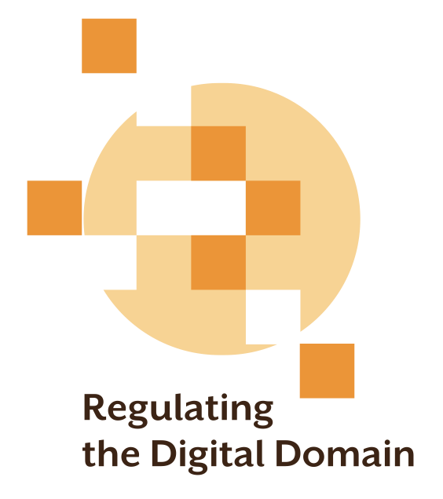  
  
  
  
Project made possible with funding from:

# Collaborators and Contributors

This work is the collective effort of over 20 contributors including more than 16 co-design experts with disclosed disabilities and the team of researchers at the [Inclusive Design Research Centre](https://idrc.ocadu.ca/) (IDRC).

This project was led by the team at the [Inclusive Design Research Centre](https://idrc.ocadu.ca/) at OCAD University in collaboration with co-design experts.

Attribution 4.0 International (CC-BY 4.0) <https://creativecommons.org/licenses/by/4.0/>

Date: March 31, 2024

Funder: Accessibility Standards Canada <https://accessible.canada.ca/>

Review of the Review Website: <https://idrc.ocadu.ca/projects/rotr/>

Table of Contents

Collaborators and Contributors 2

Overview 6

Co-design Research Activity 6

Co-design challenges 7

A game to play 7

Game development 8

Game prototype co-design with ASC 9

Recruiting co-design researchers 9

Fair compensation for time and expertise 10

Session 1 – Education 10

Session 2 – Play the Game 10

Session 3 – Hack the Game 11

Findings 11

Capacity building, education and communication 12

1. Build capacity in the community to engage in standards development 13

2. Create audience-appropriate learning content 13

3. Make standards understandable 13

4. Make the message of standards discoverable and accessible 14

Diversity and representation 14

5. Embark on an ongoing journey toward diversity and representation. 14

6. Broadly announce the accessible enquiry stage 15

7. Seek opportunities beyond enquiry. 15

Empowering Participation 15

8. Provide flexible and understandable onboarding and training 15

9. Engage with individuals regarding any necessary accommodations. 16

10. Leverage technical knowledge of people with disabilities. 16

11. Take regular pauses for critical reflection 16

12. Increase public engagement 16

13. Be transparent and accountable. 16

Appendix A: Standards Development Game Overview 18

About the game 18

About the game board 19

What are the three phases of the game? 20

What does gameplay look like? 20

How do I collect tokens? 20

What are Event Cards? 21

What are role-specific actions? 22

Project Manager (SDO) / Researcher (TC) / 📝 22

Board Member (SDO) / Industry Expert (TC) 🛠️ 22

COO (SDO) / Policymaker (TC) 🏢 23

CEO (SDO) / Lived experience expert (TC) ♿ 23

What is the Feedback Loop? 23

What are End Game Cards? 24

Appendix B: Event Cards 25

Standards Development Board Game Event and End Game Cards 25

Event Cards 25

End Game Cards 30

Appendix C: Co-design with ASC game prototype revisions 31

Table of Figures

Figure 8: Gameplay components 19

Figure 9: Gameboard 21

Figure 10: Token Vault 22

Figure 11: Event Cards 23

Figure 12: Technical Committee team roles 24

# Overview

In Fall 2023, The Regulating the Digital Project team and Review of the Review project teams collaborated with co-design experts with lived experiences of disability in a co-design research activity that would illuminate effective strategies for the meaningful inclusion and active participation of individuals with disabilities in the standards development process. The Regulating the Digital Team was particularly interested in exploring ways to engage and empower people with disabilities and their communities to shape regulatory requirements, inform methods of meeting requirements, identify regulatory gaps, and continuously refine the regulatory system (project challenge #6). This report is a condensed version of a comprehensive report describing the joint activities. The full report prepared by the Inclusive Design Research Centre (IDRC) for Accessibility Standards Canada (ASC) can be [downloaded on the Review of the Review project web page](https://idrc.ocadu.ca/projects/rotr/).

# Co-design Research Activity

To authentically honour “nothing about us without us,” we created a series of three co-design sessions that brought people with disabilities from across Canada together. No two co-designs are the same and, in this project, we took seriously the challenge of asking people with disabilities to contribute to and critique a process that they were not previously aware of in many cases. The standards development process takes time to understand, and co-designers might not have felt comfortable critiquing an existing process that was unfamiliar and complex.

In the co-design sessions we conducted, we made clear that people with a lived experience with disability were the experts in the room simply by being themselves and living a life where the environment, services, and tools are often disabling. This is an approach that builds upon the social model of disability. It centres people experiencing disabilities as experts and innovators in solving the barriers they encounter in the socially disabling world often with great technical proficiency.

## Co-design challenges

The co-design process needed to address two main complexities:

* **How could we help co-designers to meaningfully engage with an existing process that is opaque and difficult to understand?** The standards development process is complicated and contains a lot of jargon and terminology not intuitive to people outside of standards development. To re-envision or disrupt the process for the better, we first needed to help co-designers have a deeper understanding of what happens in the existing process.
* **How could we empower co-designers to envision a different process when the existing process contains fixed phases and aspects that cannot be changed significantly?** Because standards development is governed by standards accreditation bodies and must follow a consistent set of steps and procedures, there were some limitations we wanted to clearly communicate to co-designers to set up realistic expectations.

## A game to play

The IDRC team conceived a light-hearted approach to solving the problem of asking co-design experts to weigh in on the confusing, existing, formal standards development process. Play is a great way to break from deeply formal processes and to help co-designers feel free to try something, break something, or impact something that might otherwise seem intimidating.

The first session of the co-designs needed to be dedicated to education to familiarize participants with the basics about ASC, standards, standards development, and how co-designs function. The risk with beginning with a didactic experience was that co-designers might feel too overwhelmed by all the new information. Introducing the game to play later (during the second session), was both necessary and intentional to allow experts time and space to process what they have learned.

During the second session, co-designers were divided into groups playing the standards development game developed and designed by the IDRC. The game helped experts engage with the standards development process they had only just learned, and the low-stakes setting helped enhance understanding.

The game is intended to:

* Teach co-designers about the standard development process in a more active and engaging manner, going beyond a didactic presentation.
* Keep things light, fun, and open to empower co-designers to share ideas freely without feeling intimidated or worried about getting things wrong.
* Promote discussion and questioning of aspects of the process in a more approachable way.
* Invite co-designers to “hack” the game, asking them to re-imagine how standards development could engage them more meaningfully.
* Use game mechanics to provide constraints, differentiating between aspects of the process co-designers could not change (the stages of the standards development process), and those they could re-envision (who participates and how, what happens at each stage, etc.)

## Game development

An early prototype of the game was created based on the Standards Development Operational Requirements document. The prototype was designed to have four players collaborate to develop and pass a standard working their way from the Preliminary stage all the way to Review and Maintenance. Along the way, the players encounter situations they must resolve as a team using special abilities assigned to roles adopted by each player. To complete the game, players need to collect a certain number of “progress tokens” before reaching the 10th step. We wanted to find a balance between abstracting the process, while also representing some of the complexities of standards development.

* Collaboration is a key component of the game. The team must work together and strategize how to use their unique powers to progress through the board.
* To complete the standard the team needs to collect a certain number of progress tokens. Participants can gain tokens through event cards, or by performing role-specific actions.
* To represent the non-linear aspects of standard development, it is possible for the players to lose progress tokens but have a chance to redeem them. In the game, this is captured by the Feedback Loop. Each time the team loses progress tokens, the tokens are moved to the Feedback Loop, and feedback can then be traded back into progress tokens. This process of losing and redeeming tokens illustrates how a technical committee or SDO can learn from mistakes to improve the standard they are developing.
* In the early prototype, the game had four roles:
  + Researcher
  + Industry expert
  + Policy maker
  + Lived experience expert

Each role represents one of the four stakeholder groups within a Technical Committee that works on developing a standard. Each role has a special ability (also called “Superpowers”) in the game, representing the unique perspectives and strengths of each stakeholder group. There may be more roles that could be added to the game, but these four were chosen to keep the game manageable while being representative of the groups that contribute to an actual standard.

The design of the game helps the co-designers playing the game accomplish a few things. First, the co-designers have to work collaboratively and understand the superpowers they each have to help the team make progress – highlighting the importance of diverse perspectives and experiences in the creation of a standard. Second, the game provides a way for co-designers to challenge and tweak the standards development process by questioning the game rules and structure. Finally, the game challenges typical notions of completion when players have to slow down to further understand the standards development stages and ensure that each member can contribute to the team’s progress – emphasizing the importance of unity and iteration in creating a standard.

See Appendix A for a complete set of game rules, and Appendix B for event cards from the game.

## Game prototype co-design with ASC

The IDRC team played through the first game prototype with a team of ASC members. With insights and feedback provided by ASC, adjustments were made to reflect the standards development process more accurately. The additional detail and nuance added to the game because of this co-design helped our invited experts better understand the process. Reference Appendix C: Co-design with ASC game prototype revisions for details on the changes made to the game prototype.

## Recruiting co-design researchers

Co-design researchers were recruited by the IDRC team via an open call for expert collaborators using a large contact list maintained by the IDRC, leveraging connections with organizations by and for people with disabilities, and through membership of accessibility and inclusive design communities, groups, and forums. Within a week, 150 applications were received for the intended 16 co-designer positions.

One of the goals of the co-design sessions was to maintain small working groups so that co-designers could engage more freely and be able to receive needed support if required. The group of applicants was chosen based on their availability, willingness to play a game online, and their self-disclosure of having a disability. The aim in selecting the participants this way was to represent a diversity of experiences on all levels of human diversity including ability, language, culture, gender, age, and other forms of human difference. The following information was gathered from the co-design session application process:

* if the applicant was above 18 years old,
* if they could attend all 3 co-design sessions planned,
* their first and last name, their email address,
* if they required CART/Captions, ASL, or any other accessibility needs to support their full participation,
* if they had ever played an online game in a video conference before,
* if they wanted to disclose their disability,
* if they identified as having a disability.

Applicants were selected to have a diversity of perspectives and experiences. Applicants who did not have experience playing an online game were not excluded from participating and were grouped with co-designers who had online game experience.

## Fair compensation for time and expertise

To acknowledge and value the life experience and skills of people with disabilities, and to respect their time and commitment honorariums were provided as a way to acknowledge the co-designer’s contribution to the research. The team especially made efforts to convey appreciation and commitment to the integrity of their feedback to us as experts.

## Session 1 – Education

In the first session, we introduced co-designers to the standards development process. A member of Accessibility Standards Canada, Collinda Joseph, delivered a presentation explaining the ASC process and respectfully answered questions. Facilitators intervened to encourage questions, clarify terminology and concepts, and initiate a discussion on how the standards development process fits in with regulations and laws. The entirety of the session was focused on learning, answering questions, and getting clarification on the process. The participants were all deeply engaged: asking questions and sharing personal experiences.

One challenge in the session was the need to keep the vocabulary as plain language as possible while still using terminology specific to the standards development process and including meaningful words that differentiate things like jurisdictional scope.

From a facilitation perspective, the goal of co-design 1 was to educate, include, welcome, and create a tone of openness and playfulness. This was important given what we wanted participants to do in Sessions 2 and 3.

## Session 2 – Play the Game

In the second session, co-designers were introduced to the standards development game. Co-designers were divided into small groups which became their team during the game. The facilitators in each small group led the would-be players through the instructions and transitioned to playing the game to demonstrate how it worked.

Some co-designers were eager to jump in and start playing, while others desired more clarity and instruction before starting. The facilitators helped each team become comfortable with the gameplay, and the collaborative gameplay (unlike a competitive game) helped encourage everyone to be united and progress in learning the game together.

The facilitators helped participants understand their roles, their ‘superpowers,’ and the ways they could collaborate within their teams. Each team created a community of their own in playing the game and came to know each other and trust each other as they progressed through the game.

Through play, each team was familiarizing themselves with the real events that can and do happen during standards development processes – such as situations that can help advance a standard or circumstances that can slow or set back progress.

Facilitators needed to balance the progressing gameplay with highlighting important details (such as transitioning between development stages) so co-designers could get a better understanding of the standards process and how they might want to change it to better fit their lived experiences.

Teams and facilitators also had to contend with the online nature of the game and the virtual meeting platform which can disconnect people from actively engaging. This required everyone, especially facilitators, to be encouraging and patient to help teams along.

The smaller groups helped to encourage openness and free conversations. This was important as these discussions helped each participant deepen their understanding of the standards process that will allow them to critique the process in the third session – hacking the game.

## Session 3 – Hack the Game

By the third co-design session, participants became more familiar with the game, the standards process, and the goals of the co-design. Teams were comfortable replaying parts of the game and making suggestions and changes to the rules along the way. Contrasting the feedback and suggestions from Session 1, the comments and insights from co-designers were more nuanced and complex – demonstrating an understanding of the larger ecosystem of standards and the elaborate process that creates them.

# Findings

We begin with our principal recommendations, encapsulating the essence of our findings:

Theme 1: Capacity building, education and communication

1. Build capacity in the community to engage in standards development.
2. Create audience-appropriate learning content.
3. Make standards understandable.
4. Make the message of standards discoverable and accessible.

Theme 2: Diversity and Representation

1. Embark on an ongoing journey toward diversity and representation.
2. Broadly announce the accessible enquiry stage.
3. Seek opportunities beyond enquiry.

Theme 3: Empowering Participation

1. Provide flexible and understandable onboarding and training.
2. Engage with individuals regarding any necessary accommodations.
3. Leverage technical knowledge of people with disabilities.
4. Take regular pauses for critical reflection.
5. Increase public engagement.
6. Be transparent and accountable.

Many of these recommendations are interconnected and build upon each other. It is possible that addressing one recommendation begins to address another.

## Capacity building, education and communication

Even though standards have a broad impact, many individuals are not familiar with the standards that impact their daily activities nor with the process for developing standards. This lack of familiarity creates a barrier to engaging people in the standards development and review processes. Building capacity in disability communities and the general public to engage with standards development is a key step to bringing diverse perspectives to technical committees, public feedback, greater participation during enquiry stages, and boosting transparency and accountability. Capacity building in communities, is only a starting point, once engaged, capacity building should continue to ensure that those participating in the process can participate effectively and with confidence.

Communication can fall into two categories: the subject matter, and the methods in which it is communicated. An effective communication strategy will enable someone to learn about standards, discover what it means to them, and equip them with the information and pathways needed for them to get involved if they wish. Effectiveness in these two areas will help improve the approachability of standards development and form the foundation for other recommendations like Building capacity in the community to engage in standards development and Empowering Participation.

### Build capacity in the community to engage in standards development

Through co-design research, it was revealed that co-researchers became interested in standards but had no idea they would be interested until they were introduced to it by participating in the co-design.

We began by reaching out to members of the disability community directly and through disability advocacy organizations. We have been able to build an extensive mailing list of disability community members through our public activities and events where we have built relationships of trust and demonstrated fairness and respect.

In our co-research, standards development was a foreign concept to co-design researchers, many of whom have intersectional identities. Preparing adequate scaffolding for understanding and engagement required some trial-and-error, understanding the audience, and customizing the content to fit (see Co-design, below). Ultimately, co-designers were enthusiastic and eager to be involved in standards development and they had a nuanced understanding of it after just three co-design sessions.

### Create audience-appropriate learning content

Effective participation requires understandable materials that engage and empower individuals. Communications and learning materials about the standards work that are relatable and accessible are the beginning of the welcoming experience that signals to individuals with disabilities that their access needs are being thought of. Once individuals engage in the process, they must be provided with learning materials that support their understanding and empowers them to actively engage.

The co-design demonstrated that the complex process of standards development can be effectively communicated and taught to those unfamiliar with it. Participants ultimately felt familiar enough with the process to be able to suggest changes and improvements to the process which are documented throughout this report.

Learning content should “speak their language” in a way that makes standards and standards development relevant to the audience. This starts with listening to and learning from those affected by standards, especially those with intersectional identities as they are impacted by standards (and policies created from standards) in amplified ways.

### Make standards understandable

Making standards understandable to others begins with knowing and understanding the intended recipients of the message. What are their experiences and encounters with standards? How has it impacted them? For example, the content created for a technical committee should be different than the content for a community advocacy group. Working with the intended recipients will help guide the creation of the content in a way that is understandable and relevant to them.

Using simple language, defining obscure terms, using examples, explaining logic, minimizing acronyms, etc. can help. See The Instrument for more approaches.

### Make the message of standards discoverable and accessible

There are many ways to get the message out about standards, and the methods used should reflect the diversity of the intended audience. Do they use a particular social media network, or do they prefer more analog methods, or both? Is the content easily accessible in different ways, in different languages (e.g., does it unintentionally exclude immigrants who might not know much English)? While it may be efficient to publish content to the Web or in a single format, it may not be easily discoverable or accessible. An unintended consequence of assuming one method of dissemination (e.g., digital) is that it will not include those for whom the method is not preferred, is not easy, or is not accessible.

## Diversity and representation

Diversity and representation can seem like a challenging and unachievable task, especially if viewed from a goal-oriented perspective. Diversity and representation should be viewed as a journey or progression where each successive step includes more diverse perspectives. Keep in mind that people with diverse, intersectional backgrounds and identities *want* to be involved throughout the entire process not just at the enquiry stage. For people at the edges – people with intersectional needs and diverse backgrounds – their own lived experience should lead the development of standards. If standards are going to have an amplified impact on their lives, then their needs and voices must be central to the work.

### Embark on an ongoing journey toward diversity and representation.

Diversity and representation can begin with meeting people where they are and understanding and actively listening and learning from their experiences. Be transparent and accountable to support diversity and representation.

Many people with a lived experience of disability or those with intersectional identities experience tokenism and exploitation by others. A clear way to avoid both is to communicate intentions using both transparency and accountability. To avoid the pitfalls of tokenism and superficial diversity

* Be clear and open about goals and intentions
* Keep thorough records of meetings, minutes, and recordings that are accessible by others outside of the organization.
* Track and publish how decisions are made.
* Publicly demonstrate how diversity and representation are making tangible differences within the organization, its processes, and the standards created.
* Involve people with diverse backgrounds in decision-making and engage them from the outset.

### Broadly announce the accessible enquiry stage

Many co-design participants expressed that they were not aware they could be part of a public enquiry for a standard. Once learning about the opportunity, it was not clear to participants how they could get involved.

Opportunities for public enquiry should be announced broadly using different methods and formats (not just electronic platforms). Using the knowledge gained from building relationships with diverse communities (see Build capacity in the community) will help.

The tools and methods used to gather input during the enquiry stage can facilitate or create barriers to someone contributing. Care should be taken to use a variety of methods to gather input during enquiry – not just relying on a digital platform or electronic forms of access. The Instrument provides a way to help assess practices and brainstorm possible approaches.

Allow anonymous comments on the standard as some may feel reluctant to identify themselves. A way to do this is to communicate that at minimum name or email is required to submit comments, but there will be no associated identification when the comments are published or reviewed. This can help de-bias the process of dispositioning in the Enquiry stage.

### Seek opportunities beyond enquiry.

Many co-design participants expressed the desire to have more involvement and more opportunity to have input in the creation of a standard, not just at the Enquiry stage. They did not want to be consulted superficially.

## Empowering Participation

Anticipating and addressing these needs will empower participation and foster committee success. Diversity is a strength. However, properly supporting and nurturing diversity requires constant and consistent listening, learning, reflection, and adaptation.

### Provide flexible and understandable onboarding and training

Use shorter sessions and smaller groups to gently introduce members to the process. Use a combination of online synchronous, offline asynchronous, and hybrid methods of communication. Encourage knowledgeable members to help informally educate others and encourage all members to engage in self-directed training. In group work there will be extra work that some will voluntarily take on. The SDO should work to support those doing ‘extra’ work. Provide training materials in multiple modalities and formats.

### Engage with individuals regarding any necessary accommodations.

Some committee members will have a disability and will have experienced accessibility issues in their lives and have a favoured means for dealing with them. For example, members may use assistive technology and have set it up in a way that works for them. Where accommodations for a member are needed, involve them from the start to determine how to proceed effectively. They have the expertise and can contribute to the process. If the SDO knows of other solutions, they should consult with the individual as to whether they are appropriate.

### Leverage technical knowledge of people with disabilities.

Standards developed by ASC are concerned with what is needed to remove accessibility barriers. People with disabilities often have technical knowledge about what they need and are their own technical experts. They understand the value of flexible approaches that support individual choice in “solutions.” This perspective will enrich a committee’s ability to develop a successful standard that removes barriers. ASCs performance-based standards are built to welcome the technical expertise of those who encounter barriers. That is a powerful way to build standards that can work for everyone.

### Take regular pauses for critical reflection

The SDO and the technical committee should establish regular checkpoints to critically evaluate progress and participation by people with disabilities. These checkpoints should explore what has worked and what has not worked and commit to improving both. These are inflection points where a group could use The Inclusion Self-Assessment Instrument to check on, reflect upon, and potentially adopt different practices for future technical committees.

### Increase public engagement

The Enquiry stage is the only touch point where the public is openly invited to participate, but that is not sufficient. Seek opportunities to engage public communities and interest groups earlier and often to continually receive feedback on the development of the standard.

### Be transparent and accountable.

Be open regarding progress, meetings, updates, upcoming teleconferences, and reviews. Maintain and make available meeting minutes, decisions made at committee meetings and the rationale for those decisions. Overall, the goal should be to create a culture of learning, unlearning, and continually improving.

# Appendix A: Standards Development Game Overview

You can use this document to familiarize yourself with the game you will be playing next week. Your facilitator will be managing the game components while screen sharing and describing the play. It’s a new game for everyone so we will also be learning as we go. Let’s have fun!

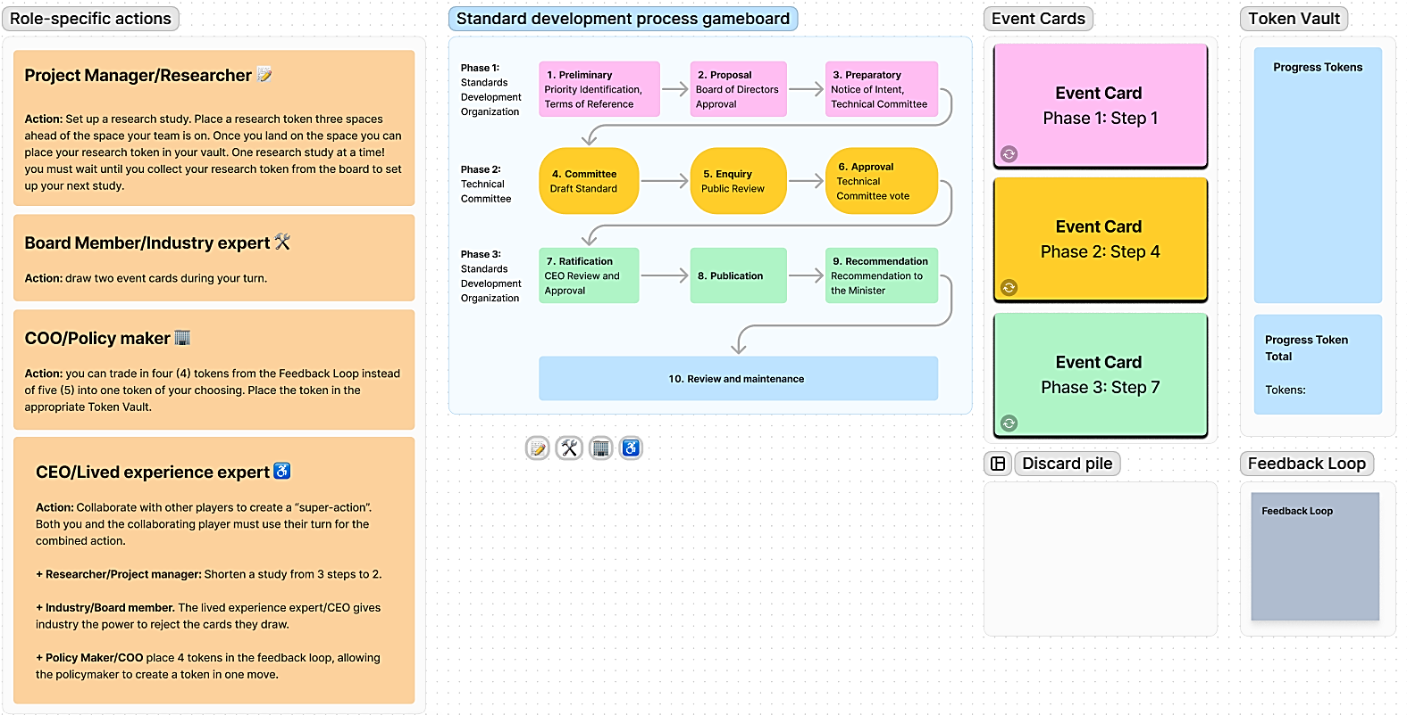

Figure : Gameplay components

## About the game

The goal of the Standards Development game is to create a Standard. While this is what your team is trying to accomplish, don’t rush to the end. Focus on the process of the game. Stay present and curious and question the process.

The Standards Development game is a collaborative game of strategy played as a team.

The game has three phases. In Phase 1 and 3 your team will represent the Standards Development Organization (SDO), in Phase 2, your team will represent the Technical Committee (TC). The game rules and the abilities of team members are the same for all three phases.

Your team is made up of four different dual roles each with their own “superpowers” during gameplay. At the beginning of game play each team member chooses their role. *All four roles must be represented on your team; in teams of more than four, you can have duplicate player roles*:

* Project Manager (SDO) / Researcher (TC)
* Board Member (SDO) / Industry Expert (TC)
* COO (SDO) / Policymaker (TC)
* CEO (SDO) / Lived experience expert (TC)

You will have successfully created a Standard when your team lands on the last space of the board, with 10 progress tokens (or more) in your vaults.

## About the game board

The playing board is made up of ten (10) spaces divided into three phases ending with a final review and maintenance step. The team plays the gameboard in sequence from one to ten. Once you reach space 10, the team counts the tokens in their vault and chooses an End Game card to complete the game.

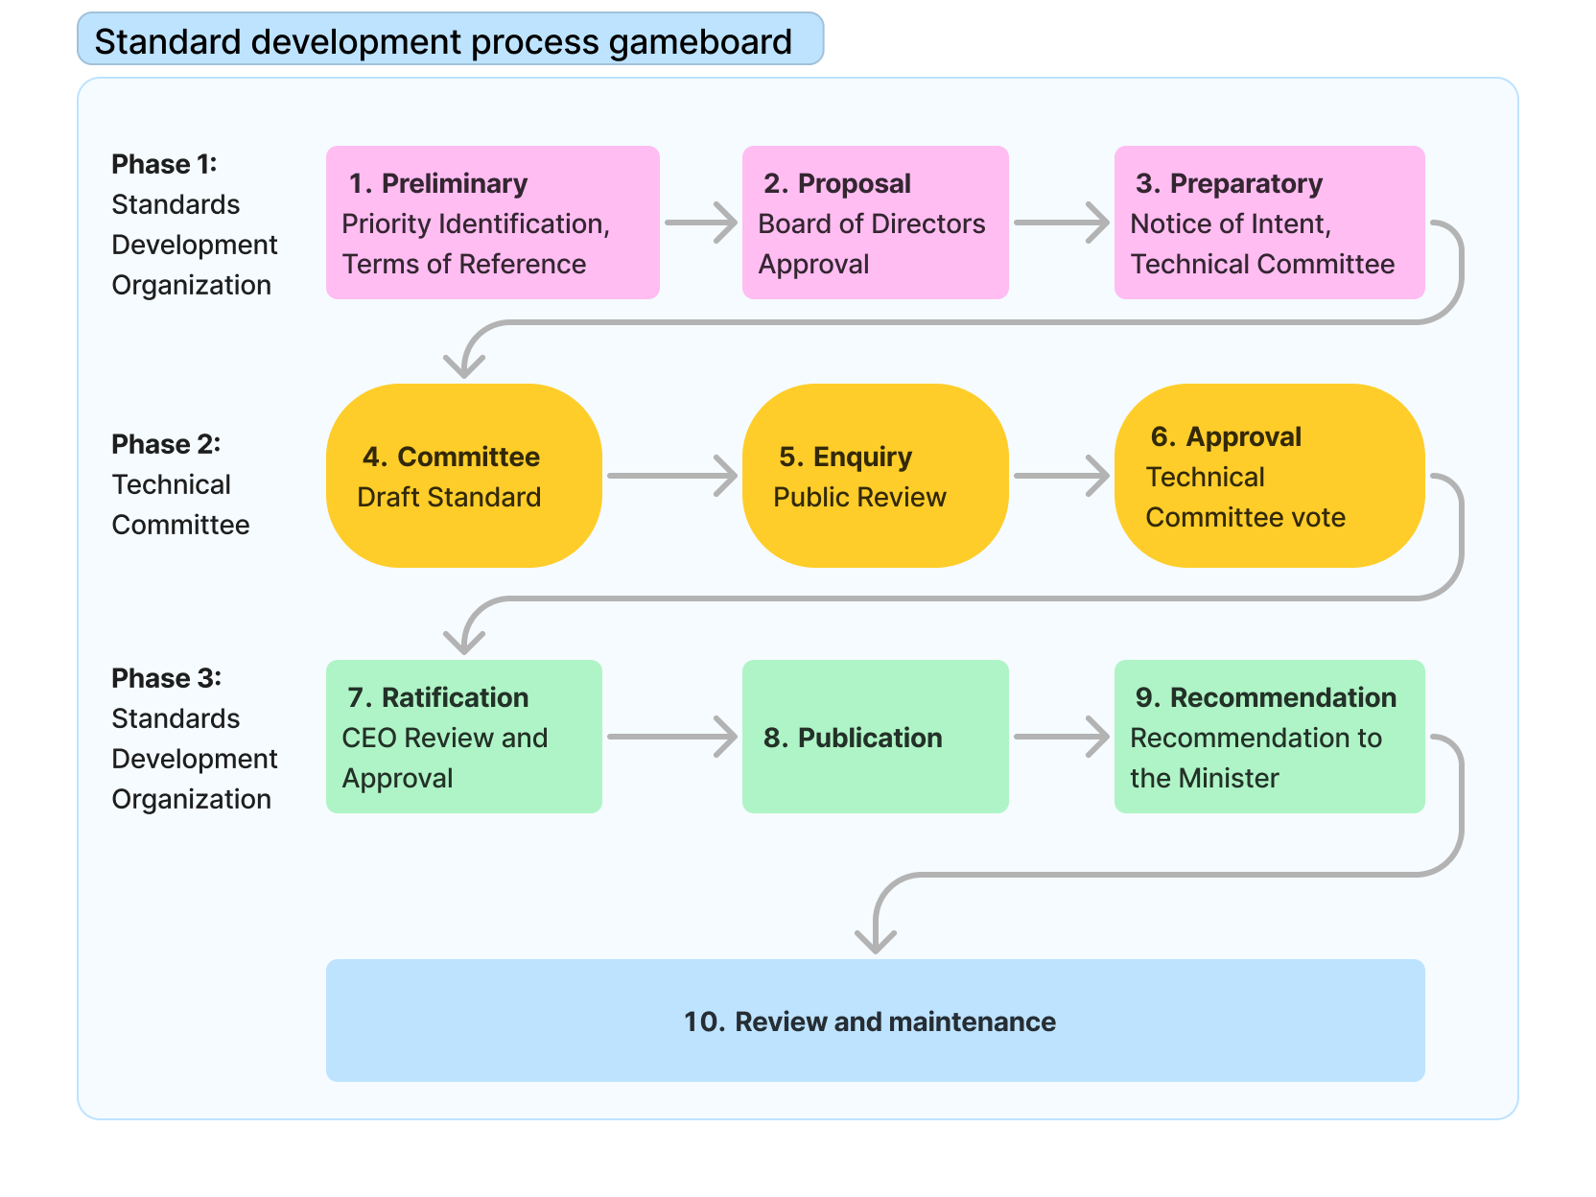

Figure : Gameboard

## What are the three phases of the game?

The gameplay steps are divided into three phases. Phase 1 and Phase 3 are guided by the Standards Development Organization (SDO). Phase 2 is guided by the Technical Committee (TC). Depending on the phase, your role will either represent a member of the Standards Development Organization (SDO) or a member of the Technical Committee (TC). Your “superpowers” will remain the same in all phases.

## What does gameplay look like?

* Each space on the gameboard represents a gameplay round. One gameplay round includes one action from each member of the team. A player can perform one of the following actions:
  + 1. Select an event card.
    2. Perform a role-specific action.
    3. Trade in Feedback Loop tokens.
  + Once each player has performed their action your team moves to the next space on the gameboard.

## How do I collect tokens?

* To successfully create a Standard, you need 10 tokens in your Token Vault when your team reaches the last space on the game board. *If your team has more than 10 tokens at the end, give yourselves extra congratulations and fist bumps :-).*

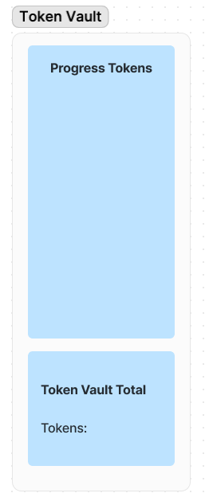

Figure : Token Vault

* You collect tokens through event card actions and role-specific actions.
* Some event card actions will take away your tokens. If this happens, strategize with your team on how to build up the number of tokens in your vault.
* If you lose a token, place it in the Feedback Loop.
* If you have 5 tokens in the Feedback Loop, learn from your mistakes and take back one token of your choice, discarding the rest.
  + Exception: COO (SDO) / The Policy Maker (TC) can trade in 4 rather than 5 tokens at their turn.
* During a round consider when might be the best time to convert tokens from the Feedback Loop into tokens for the Token Vault. For example, you may want to wait until the end of the round to trade in your tokens because it may be less likely that you will lose them during a gameplay round.

## What are Event Cards?

Event cards can be selected by any player at each turn. You can gain or lose Progress Tokens when you select an event card.

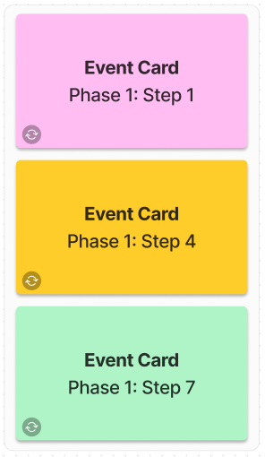

Figure : Event Cards

## What are role-specific actions?

Each player is assigned a role, and each role can perform certain unique actions – your superpower! The roles and their actions are:

### Project Manager (SDO) / Researcher (TC) / 📝

Your research can help inform a great standard.

**Action:** Set up a research study. Place a research token three spaces ahead of the space your team is on. Once you land on the space you can place your research token in your vault. One research study at a time! you must wait until you collect your research token from the board to set up your next study.

### Board Member (SDO) / Industry Expert (TC) 🛠️

You have a technical and financial understanding of the requirements.

**Action:** draw two event cards during your turn.

### COO (SDO) / Policymaker (TC) 🏢

You have an in-depth understanding of bringing standards into practice and can address feedback.

**Action:** you can trade in four (4) tokens from the Feedback Loop instead of five (5) for one Progress token. Place the token in the Token Vault.

### CEO (SDO) / Lived experience expert (TC) ♿

Your expertise gives you the ability to collaborate with other players.

**Action:** collaborate with other players to create “super-actions”. Both you and the collaborating player must use their turn for the combined action.

Collaborations and super-actions are:

* With the **Project Manager (SDO) / Researcher (TC):** Shorten a study from 3 steps to 2.
* With the **Board member (SDO) / Industry (TC):** The lived experience expert gives industry the power to reject the cards they draw.
* With the **COO (SDO) / Policy Maker (TC):** place 4 tokens in the feedback loop, allowing the policymaker to create a token in one move.

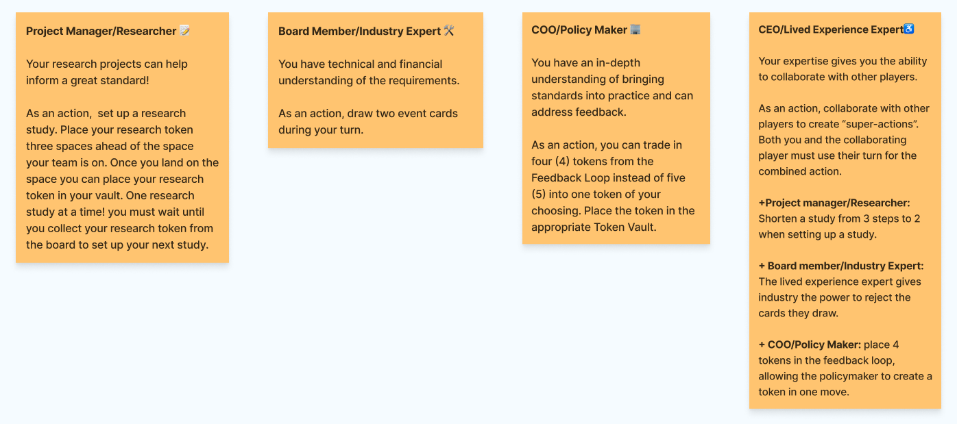

Figure : Technical Committee team roles

## What is the Feedback Loop?

The Feedback Loop is where the team learns from losing tokens. For example, an event card indicates that you lose a token from the Vault because the document the technical committee team has published receives a negative comment from the public. Yes, you lose a token, but your team learns from the experience and the feedback can result in a better standard in the long run.

Feedback is an important part of the standard’s iteration process. Once feedback is integrated into the standard it is no longer relevant. Tokens are, therefore, removed from the Feedback Loop at the end of each gameplay step.

Tokens are moved to the Feedback Loop in three ways:

1. You select an event card that indicates that you lose a token.
2. You select an Event Card that asks you to repeat a step or go back to a previous step.
3. A lived experience expert places a token in the Feedback Loop as an action, in collaboration with the COO (SDO) / Policy Maker (TC).

Once there are 5 tokens in the Feedback Loop, any player can redeem them into a single token as an action during their turn.

Two player roles have special powers when it comes to tokens in the feedback pile:

1. A COO (SDO) / Policy Maker (TC) can redeem 4 rather than 5 tokens from the Feedback Loop into a single Progress Token.
2. A Lived Experience Expert can place 4 feedback tokens in the feedback loop as a collaborative action with the COO (SDO) / Policy Maker (TC) to create a progress token.

## What are End Game Cards?

Once you have reached the end of the game (Step 10), count your tokens and select the card from the End Game decks that matches your team status. Your card will reveal more details about your game results. There are two possible end-game scenarios:

* You have enough progress tokens to successfully complete a standard.
* You do not have enough progress tokens to complete the standard.

Enjoy the game!

# Appendix B: Event Cards

## Standards Development Board Game Event and End Game Cards

### Event Cards

#### Phase 1: token event cards

##### Preliminary

Gain

* Seed Document researchers identified all gaps in standards that have already been published in this field. Gain one token.
* Your seed document is informed by a brand-new report from the EU. Gain one token.
* It’s the Friday before a long weekend and you’ve just emailed the final Terms of Reference document to the Board of Directors. You feel a great sense of relief. Gain one token.

Lose

* Your idea falls outside of the 7 priority areas. Lose one token.
* An idea for the standard is dependent on a new standard you know is coming from another Standards Development Organization, your team slows down and waits for the new standard to be published. Lose one token.
* The Board of Directors does not approve the Terms of Reference for the standard and asks for significant changes. More research is required. Lose one token.

##### Proposal

Gain

* Good news, the Board of Directors received the Terms of Reference document! Gain one token.
* All (part-time) Board of Directors members are working on the same day at the same time. They work synchronously to review the Terms of Reference document and get back to you quickly with a positive response. Gain one token.
* Your partnership with an academic group reveals new relevant research. Gain one token.

Lose

* The Board of Directors has some questions about your Terms of Reference document. This slows down progress as you set up meetings. Lose one token.
* Five Board members have reached the end of their appointment and must have an extension, renewal, or replacement with new Board members. Lose one token.

##### Preparatory

Gain

* Offer letters are sent out to qualified technical committee member applicants. Good news! All applicants accept the letter of offer. Gain one token.
* The chair and vice-chair of the technical committee have been selected! Congratulations, Gain one token.
* The members of the technical committee represent a wide range of diverse perspectives. Gain one token.

Lose

* Your researcher is busy scoping/completing the seed document and needs to take a leave of absence. A new researcher happily joins the team. The seed document is delayed. Lose one token.
* You are alerted to another standard being done that is similar to your priority area – you are told it would be a duplication to publish the Notice of Intent. Place all tokens gained at this step into the Feedback Loop and repeat the Preliminary Step.
* Oh dear, you did not receive enough technical committee applications to proceed. You need to reopen the application process to find more candidates. Lose one token.
* Oh no! All qualified technical committee applicants are from the same geographic region. You cannot select them because they do not meet the geographic diversity requirements. A new application process needs to be started. Lose a progress token.

Neutral

* Offer letters are sent out to qualified technical committee member applicants. One applicant has to decline the offer because of other commitments. Project manager must reach out to an alternate candidate. Neither gain nor lose a token.
* You’ve received a large number of technical committee applications, and many are highly qualified. How will you ever decide who will be on your technical committee? You do not gain or lose a token (but you may lose some sleep).

#### Phase 2: token event cards

##### Committee

Gain

* An organization completes a Seed Document, and you hand it over to the new technical committee. Gain one token.
* Your technical committee is diverse and represents a wide range of perspectives. Your draft receives positive feedback from the public. Gain one token.
* An impact report has been published that provides insight into the standard being developed. Gain one token.
* A coalition of disability organizations submits a series of recommendations for the draft standard. Gain one token.

Lose

* The minimum number of committee members cannot make a scheduled meeting and it is cancelled. Lose one token.
* The committee decides the document is not ready to proceed to the next step. Lose one token.
* An industry stakeholder insists that parts of the document are not economically feasible. Lose one token.

##### Enquiry

Gain

* The committee has a two-day, inclusive hybrid meeting and gains some momentum in pushing the standard forward. Gain one token.
* You received a positive comment on your document from the public. Gain one token for public support.

Lose

* You have taken too long to respond to feedback and your technical committee forgot the context. Lose all of the tokens in your Feedback Loop.
* You do not get substantial public engagement on the Draft Standard. You have doubts about moving forward. Lose one token.
* The Technical Committee can’t access the documents from the SDO. Lose one token.

Misc.

* The legal team asks that you make two publishable documents for public review: one in standard language and the other in plain language. This slows down the publication process but communicates the documents more clearly. Neither gain nor lose tokens, but good on ya!

##### Approval

Gain

* The technical committee votes to approve the Draft Standard. Gain one token.
* Another jurisdiction (USA) is influenced by your Draft and wants to incorporate it into their work. Gain one token.
* Your standard receives positive feedback from the public because your technical committee is diverse, and a wide range of perspectives is represented. Gain one token for public support.
* The draft standard is shared using different formats including different modalities and languages. Gain one token.

Lose

* You missed something! Your technical committee lacks representation from an impacted group. Lose one token.
* There is an ongoing disagreement among committee members, and they are unable to find a solution that meets everyone’s needs. Lose one token.

Misc.

* Urgent safety issues have been identified. The public review period is shortened from 90 days to 45 days. You accept that your standard will be timely but will have less input from the public. Neither gain nor lose a token.
* The public review period is lengthened from 90 days to 120 days. You accept that you take longer but gain more feedback from the public. Neither gain nor lose a token.

#### Phase 3: token event cards

##### Ratification

Gain

* The CEO is so proud of what the committee has put together that they write a blog post about the new Standard coming out. Gain one token.
* The CEO is excited about the new standard. They give everyone who worked on it a day off. Gain one token.
* The CEO incorporates some aspects of the standard into their own workflow immediately, improving inclusion at the SDO. Gain one token.

Lose

* The CEO breaks their ankle ice skating on the Rideau and has to have surgery. They can’t review the Standard, so you have to wait. Lose one token.
* More work is needed and you’re not quite ready to proceed to the next step. Place all tokens gained at this step in the Feedback Loop and repeat the turn.
* The Board has some questions about the Standard the CEO passes along. Lose one token.

##### Publication

Gain

* Your Standard will be reviewed to see if it can be published. Your team included all relevant evidence in an understandable way to support the publication of a National Standard of Canada. Gain one token.
* The legal team reviews your standard and provides comments. Changes from legal improve the standard and are doable by the team in a timely manner. The project stays on track. Gain one token.

Lose

* Oops! The standard contains copyrighted materials. The issue is identified too late in the process to be able to proceed. Standard is delayed as the licencing agreement is dealt with. Lose a token.
* The SDO server crashes and the document versions are lost. Lose one token.
* The legal team reviews your standard and provides comments. While the changes will improve the standard, they will take time and delay the project. Lose one token.

##### Recommend

Gain

* Your standard is heading to the Minister with a gold star of recommendation on it. Gain one token.
* The Minister sends an email asking for the Standard – they’re already eager to start the process of making it into a regulation. Gain two tokens.

Lose

* Somehow a bunch of public review comments that had been submitted were found. They weren’t DISPOSITIONED in Step 5: Enquiry. Lose all tokens and head back to Step 5.
* The team has identified significant accessibility challenges to some requirements. Lose half of the tokens in your vault and return to stage 4.

Misc.

* You must abandon the standard. Move all tokens to the Feedback Loop and go back to Step 1.

Repeat steps

* More work is needed and you’re not quite ready to proceed to the next step. Place all tokens gained at this step in the Feedback Loop and repeat the turn.

### End Game Cards

#### Not enough tokens

* Although there was consensus on the technical committee, public consultations have revealed that more public outreach and consultation is needed before continuing in the process.
* The draft standard your technical committee was deliberating on has been withdrawn because a competing standard has gained wider support and was approved.
* Public consultation has revealed unanticipated potential impacts. More time is needed to conduct research to revise the draft standard.
* A similar standard was approved in another jurisdiction and has been undergoing scrutiny by the public and industry. The technical committee has decided to monitor and research the emerging criticism.
* The standards development board has recognized the importance of the draft standard and its overlap with another standard under development. The board has decided to withdraw the draft your team has been working on and merge efforts with the other standard.

#### Approved Standard Cards

* The standard has been approved and the federal government has begun drafting a new regulation based on the standard.
* The standard has been approved and various federal agencies have begun to incorporate it into their departmental policies.
* The standard has been approved and several industry organizations have begun to comply with the standard without regulation to compel them.

# Appendix C: Co-design with ASC game prototype revisions

Based on an early co-design with ASC, the following changes were made:

1. **Split the game into 3 phases.** In the first iteration of the game, the entire game was played from the perspective of the technical committee. The ASC team suggested that we break the game into 3 phases, two of which are led by the SDO, and one led by the technical committee:
   * Phase 1 lead by the SDO: stages 1 (Preliminary) to 3 (Preparatory)
   * Phase 2 lead by the technical committee: stages 4 (Committee) to 6 (Approval)
   * Phase 3 lead by the SDO: stages 7 (Ratification) to 9 (Recommendation)
   * Step 10: End game
2. **Added SDO player roles.** The ASC and IDRC teams decided that during stages 1-3, and 7-9, the player team plays SDO roles, during stages 4-6 they play Technical Committee roles. SDO and Technical committee role “superpowers” remained the same throughout the game for simplicity. This allowed us to communicate the process and participation of the SDO/Technical Committee more accurately, without overwhelming players with having to switch their abilities/strategies.
   * Lived experience expert (Technical Committee) = CEO (SDO)
   * Industry (Technical Committee) = Board member (SDO)
   * Researcher (Technical Committee) = Project manager (SDO)
   * Policymaker (Technical Committee) = COO (SDO)
3. **Changed the superpower of the Lived Experience expert/CEO**. The initial superpower of the lived experience expert role (being able to add a token into the feedback loop) was not powerful enough. In the second iteration of the game, we added the ability to combine with the other three team roles to create “super-actions.” This helped to encourage collaboration and discussion among the players.
4. **Created unique events for each of the 10 stages of the game**. Initially, event cards were general so that the cards could be shuffled and applied at any stage in the game. However, the ASC team emphasized the uniqueness of each stage in standards development. Therefore, additional unique event cards were created for each of the 10 stages in the standards process. This more accurately and meaningfully represents what could occur at each step.
5. **Modified the way feedback tokens worked.** In the playthrough we realized Feedback Loop tokens were safer than progress tokens, motivating players to “hoard” them. To encourage more active gameplay, new event cards were created that resulted in the loss of Feedback Loop tokens. An additional rule was introduced resulting in one feedback token lost at the end of each round, thus encouraging the players to use Feedback Loop tokens in a timely manner, analogous to addressing feedback in a timely manner in the standards development process.
6. **Improved the layout of the game.** To improve accessibility, we increased the text size of event cards and decreased the space occupied by the token vault.