Regulating the Digital Domain

Co-Research Three Results

Re-imagining Digital Accessibility Regulations

Inclusive Design Research Centre

Accessibility Standards Canada

**March 2025**

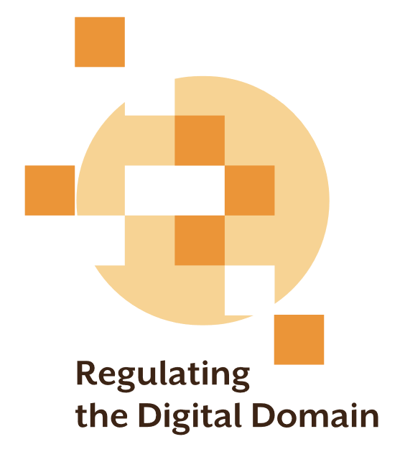

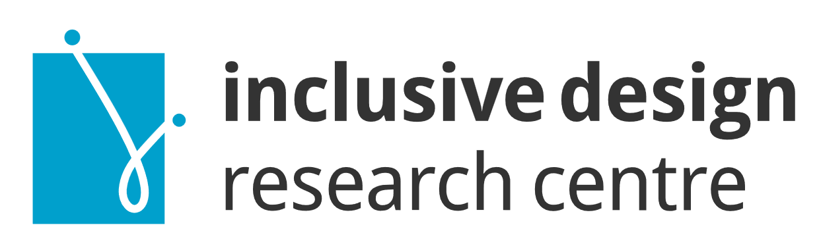

OCAD University acknowledges the ancestral and traditional territories of the Mississaugas of the Credit, the Haudenosaunee, the Anishinaabe and the Huron-Wendat, who are the original owners and custodians of the land on which we stand and create.

# Contributors

This report summarizes contributions of members of the advisory panel who formed the research group and the IDRC team.

*Boris Vukovic*

*Caren Watkins*

*Christopher Sutton*

*Darryl Kingston*

*David Pereyra*

*Erick Nettel*

*Lori Vaanholt*

*Vera Roberts*

*W. Francis Fung*

# Re-use of the report

This report is licensed under the Creative Commons Attribution 4.0 International license (CC BY 4.0). Below is a summary, not a substitute, of the license. The full licence can be reviewed in full at <https://creativecommons.org/licenses/by/4.0/legalcode>.

You are free to:

**Share:** copy and redistribute the material in any medium or format

**Adapt:** remix, transform, and build upon the material for any purpose, even commercially

The licensor cannot revoke these freedoms if you follow the license terms. Under the following terms:

**Attribution:** You must give appropriate credit, provide a link to the license, and indicate if changes were made. You may do so in any reasonable manner, but not in any way that suggests the licensor endorses you or your use.

**No additional restrictions:** You may not apply legal terms or technological measures that legally restrict others from doing anything the license permits.

# Contents

Contributors 2

Re-use of the report 2

Contents 3

Co-Research: Re-imagining Digital Accessibility Regulations 4

Co-design Research Method 4

Round One: 4

Round Two: 4

Round Three: 5

Generated Approaches 5

1. Standards Development 5

2. Creators and Consumers 5

3. Standards Implementation 6

4. Regulating Processes (vs regulating outcomes) 6

5. Education 6

6. Harmonization 7

7. Addressing technology outside of regulatory jurisdictions 7

8. Bridging Innovation and Inclusion 7

9. Involving People with Disabilities 8

10. Integrated Accessibility 8

11. Sandbox for Accessibility Testing 8

Next Steps 9

# Co-Research: Re-imagining Digital Accessibility Regulations

In this co-design session, we re-imagined regulatory processes for accessible digital technologies.

The purpose of accessibility regulations and standards for digital technologies is to ensure that digital tools and environments are equitable. However, current regulations frequently fail to produce accessible products and services. The regulatory model is not working. In this session, IDRC facilitators worked with six of the project advisors and partners to address these challenges through a structured and collaborative methodology.

Using an adapted version of the [1-2-4-All methodology](https://www.liberatingstructures.com/1-1-2-4-all/), we discussed approaches in increasingly larger groups to reflect, share, and build upon each other’s ideas. In our session, we began with three groups of two and then changed the pairs for another round of three groups of two and finished in a single group of six. The session took place on Microsoft Teams Meetings, using breakout rooms for small group discussions.

## Co-design Research Method

Prior to meeting synchronously, we shared the findings from our previous co-research activities with the advisory group, as well as the challenge that would be addressed in the co-research session. When we came together on November 6, 2024, we began with a review of the challenge and an overview of the 1-2-4 All method.

### Round One:

* Collaborators were asked to think about the challenge question on their own for a minute before moving to groups of two to discuss their ideas. The challenge question was:

*Current regulations aren't producing accessible products and services. We want to re-imagine our regulatory processes so we do get accessible products and services. Think about aspects of accessibility regulations and standards for digital technologies: What would you change, and how would you change them?*

* Co-researchers reflected individually for one minute and in pairs in breakout rooms for 10 minutes.

### Round Two:

* Pairs returned to the main room and prior to being rotated into different groups of two for a 15-minute discussion, they were instructed to:

*Consider similarities and differences in your ideas and consider how you might revise your approach or integrate different approaches.*

* Participants worked in pairs to expand on the approaches from the first round, considering whether the ideas could work together or stood as separate approaches.

### Round Three:

* Finally, for the last thirty minutes of the session, everyone reconvened in the main room to highlight standout ideas from their discussions.
* In the plenary session, the group considered how these approaches could function as an integrated system, discussing similarities, differences, and success factors.

# Generated Approaches

Co-researchers worked together to build on previous co-research findings and share their ideas for model approaches to digital regulation. The objective of RtDD co-research activities was to first explore experiences, next to understand challenges and then to consider approaches. Eleven ideas at different levels of development were generated for consideration in the project. In this section we provide some background framing for each idea followed by related questions or guidance that were raised by co-researchers or, during the analysis, by the IDRC team. The next step for these ideas will be to select some to extend to model approaches that can be iterated on over the final year of the project.

## Standards Development

The development of accessibility standards often excludes individuals with disabilities due to the complexity of the process and accessibility barriers that make it difficult to understand, navigate, and contribute meaningfully. To address this, the process must:

* be simplified to ensure clarity and usability,
* actively involve individuals with disabilities from the beginning to incorporate their lived experiences, and
* create accessible mechanisms for participation.
* prioritize consultation and fair compensation for contributions to support and value contributors.

## Creators and Consumers

Many accessibility regulations for the digital domain focus on the needs of consumers or end-users of the design or product and ignore the needs of the creators of that content. A notable exception is W3C’s Authoring Tool Accessibility Guidelines (ATAG). We need to develop standards and regulations that ensure accessibility is both client and creator/employee-facing.

* What processes can ensure that the needs of people with disabilities are considered beyond front-facing interactions, addressing internal structures and staff needs as well?

## Standards Implementation

Smaller enterprises and organizations may lack the resources to easily meet accessibility requirements. There may be a need to address this resource gap to ensure that everyone can afford to build in compliance.

Questions to consider:

* What resources could be shared? How?
* What could a funding model look like? Are there ways to provide financial support besides direct funding?

## Regulating Processes (vs regulating outcomes)

An idea for regulating process was proposed: the idea is a certification system that encourages and requires organizations to consistently follow inclusive design practices and accessibility standards. This system could involve multiple checkpoints and requirements such as having consultations with people with disabilities, conducting accessibility audits, and running compliance tests. A similar approach is quality assurance ISO certifications (e.g., [ISO 9001](https://www.iso.org/standard/62085.html)) for manufacturing processes. Certification could be connected to corporate social responsibility and other incentives such as government procurement preference or tax deductions. This approach encourages companies to make accessibility a key part of their processes, making it important for both meeting legal requirements and enhancing their reputation. The idea is to bring requirements checkpoints throughout the development process rather than as an end checkpoint.

Questions to consider:

* What could and inclusive and accessible process certification system look like?
* What regulatory bodies could provide this certification?
* What would the checkpoints be? How would they be assessed?

## Education

There's a push for better education about accessibility that speaks to different groups. This means including inclusive design ideas in the training for future designers, getting the general public to see why accessibility standards matter, and showing businesses the benefits of investing in accessibility. The idea is that education can help change how people think about universal design in the digital world.

Questions to consider:

1. How do we change curriculum so that it must include ID?
2. Why doesn’t the market already show that ID is beneficial? Can it be addressed
3. How do we achieve a mindset shift in the digital environment similar to what we have seen in the built environment?

## Harmonization

The rules and guidelines for accessibility can be confusing and vary from region to region. Harmonization aims to bring these different standards together, so they work better across various areas, regions, and international rules. By encouraging teamwork and reducing duplicate efforts, this approach aims to create a simpler and more unified system.

Questions to consider:

How can we:

* Simplify complexity of all SDOs (e.g. a central hub)—does SCC do this?
* Harmonize standards across jurisdictions?
  + Which standards?
  + Which jurisdictions?
  + Who leads/how is this accomplished
* Address the barrier of paywalls with harmonization?
  + (e.g. what could be done to support shared clauses from difference SDOs without having to pay every time?)
* Harmonize by using existing standards but also developing new requirements to meet changing digital environment

## Addressing technology outside of regulatory jurisdictions

Even with harmonization, some technology will be developed in countries that are outside of the reach of Canadian Regulations. These digital products and services may not meet Canadian standards for accessibility.

How do we engage multinational companies operating outside Canadian jurisdiction to ensure accessibility remains a central priority?

Questions to consider:

* What strategies can influence international companies outside Canada's regulatory reach to adopt accessibility standards?

## Bridging Innovation and Inclusion

Accessibility is often overlooked at the beginning of the tech development lifecycle as innovators focus on solving problems or commercializing ideas. However, integrating accessibility into early stages of design is vital to avoid retroactive fixes and ensure that technologies are inclusive from the start. This approach can help foster a culture of innovation that naturally incorporates accessibility as a core principle.

Questions to consider:

* How can we motivate startups and innovators to embed accessibility into their initial designs?
* What frameworks or incentives could encourage early adoption of inclusive practices?
* How do we balance rapid technological development / leaps (e.g., AI) with the need to include accessibility from the outset?
* What incentives can we provide to support slowing down movement of products and services to market to enable co-research and inclusive design?

## Involving People with Disabilities

This approach emphasizes the value of lived experiences, the importance of diverse voices in consultation, and fair compensation for contributions. It’s all about making sure people with disabilities have a voice in developing products, services, and processes. This means setting up ways to get their input, appreciating their real-life experiences, and making it a normal thing to pay them for their contributions.

Questions to consider:

* How can we ensure that people with disabilities are actively involved in the design and regulation processes from the start?
* How can we ensure that individuals with disabilities are fairly compensated for their lived expertise?
* How can we ensure that consultation is meaningful, avoiding tokenism, and is designed to reflect the actual experiences of people with disabilities?

## Integrated Accessibility

Assistive technologies (AT), such as screen readers and communication devices, have developed separate from mainstream technologies rather than having them built in or integrated. AT products are often made by small, specialized companies. This has made interoperability—the ability for AT devices to work with products made by mainstream companies—challenging and shifts the responsibility for access and accessible design to customers and niche companies.

Questions to consider:

* How can regulations encourage built-in accessibility features to reduce the need for separate assistive technologies?
* How can assistive technology companies be engaged in efforts to integrate their work?
* How can an accessibility regulation be constructed so that it encourages or requires integrated assistive technologies in products and/or assures ongoing interoperability with assistive technologies?
* How can the burden of procuring and maintaining assistive technologies be lifted from the individual with disabilities?

## Sandbox for Accessibility Testing

The idea is to set up experimental spaces or digital environments where new technologies can be tried out for accessibility (closed or open source). This could include scenario testing, feedback from people with disabilities and accessibility audits. This hands-on testing approach provides a safe space to develop products and services that meet accessibility needs before they hit the market.

Questions to consider:

* How can we encourage companies to invest in accessibility testing sandboxes despite resource and time challenges?
* How can sandboxes be designed to support meaningful participation of people with disabilities in sandbox testing?
* How can we encourage sharing learnings from sandbox testing?

# Next Steps

We have gathered numerous strategies that highlight what actions are necessary to enhance the regulation of digital services and products. Now, we must shift our focus to detailing the "how-to" for these strategies. Our goal in the coming year is to operationalize these ideas and understandings to create model approaches that could be implemented by standards development organizations and possibly by industry to create a culture of inclusion where digital products and services are accessible by design.

Moving forward, we will:

* Continue gathering community input and build the RtDD Community on Canvas through a social media campaign and Canvas discussion forum.
* With the guidance of the advisory panel, select ideas and co-design implementation approaches for the ideas generated.