The **We Count** Recount: April 2021



We Count is a community-driven project that addresses the inherent bias against small minorities and outliers in artificial intelligence and data analytics.

# A Message from Our Director

Friends and colleagues,

Impact is determined by how many people benefit from the same thing, evidence by how many repeatable effects can be documented in research, worthiness by how many people support the same action in votes or petitions. In the civilization we have created, truth and value come down to counting things that are the same. What if you are different, so different that there isn’t anyone like you, but your needs are critical? You won’t have impact, evidence or worthiness behind you. These are the incentives needed by researchers, politicians and investors.

This pattern is amplified and automated in our technical systems. We have designed our technology so that value comes down to popularity or profit. What is “liked” gets attention and becomes more popular. What is deemed profitable gets more investment and becomes more profitable.

When technology is used to optimize productivity, efficiency or learning, it uses data from the past to optimize the patterns of the past. What if your interests are not popular and your contribution has not been monetized? What if there is no data about you because you haven’t been given a chance to participate? Worse yet, you won’t be understood and you’ll be flagged as an anomaly by security systems.

… and yet we know that diversity and diversification is the key to our survival.

These are some of the conundrums we are exploring in the We Count project, with our guest speakers Steffen Mau and Virginia Eubanks and our co-design sessions.

All my best,

Jutta

# News from the Field

[Quantization Podcast, Episode 16](http://quantization.ca/podcast/episode-16-signal-vol-13-fungi-network-part-1/)

Dr. Jutta Treviranus and Bianca Wylie discuss housing and homelessness in this [Quantization podcast episode](http://quantization.ca/podcast/episode-16-signal-vol-13-fungi-network-part-1/).

## [Industry AI Ethics 101](https://www.radicalai.org/industry-ai-ethics)

Find out what designing ethical AI actually entails in this [Radical AI Podcast episode](https://www.radicalai.org/industry-ai-ethics) with Kathy Baxter.

[The digital revolution in the world of work impacts all. How does it impact people with disabilities? Which chances and potential barriers does digitalised work bring for disability inclusion? What are the actions to ensure nobody is left behind and the digital divide is closed? The report "An inclusive digital economy for people with disabilities", developed by the ILO Global Business and Disability Network and Fundación ONCE in the framework of Disability Hub Europe, aims to answer those and other relevant questions. The publication was launched at the Zero Project conference on 10 February 2021. Live captioning and International Sign were provided.

Download the publication at http://www.businessanddisability.org/news/an-inclusive-digital-economy-for-people-with-disabilities/](https://youtu.be/eS9nNz0IDmU)

## [An Inclusive Digital Economy for People with Disabilities](https://youtu.be/eS9nNz0IDmU)

This Zero Project webinar brings awareness of the impact of a digital world of work on people with disabilities and identify actions needed to shape a future of work in a more disability-inclusive way.

## [Stories of Transformation](https://radiopublic.com/universal-design-in-life-and-work-WRZj23/s1!6c5ca)

In this Universal Design in Life and Work [podcast episode](https://radiopublic.com/universal-design-in-life-and-work-WRZj23/s1!6c5ca), Dr. Jutta Treviranus talks about inclusive design versus universal design, AI bias and non-linear logic models.

## [Algorithms and the Coronavirus Pandemic](https://wecount-cms.inclusivedesign.ca/wp-content/uploads/2021/03/Algorithms-and-the-Coronavirus-Pandemic.pdf)

Check out this [Financial Times article](https://wecount-cms.inclusivedesign.ca/wp-content/uploads/2021/03/Algorithms-and-the-Coronavirus-Pandemic.pdf) about the increasing public backlash over governments’ use of automated decision making tools.

## [Algorithmic Fairness](https://connectedsocialmedia.com/19030/algorithmic-fairness-with-alice-xiang-intel-on-ai-season-2-episode-12/)

In this [Intel on AI podcast episode](https://connectedsocialmedia.com/19030/algorithmic-fairness-with-alice-xiang-intel-on-ai-season-2-episode-12/), Alice Xiang and Abigail Hing Wen discuss the goals of the Partnership on AI, the importance of being able to explain AI model reasoning, and the proliferation of criminal justice risk assessment tools.

## [How Do You Lip Read a Robot? – Recruitment AI Has a Disability Problem](https://youtu.be/ndA-Z_wJ31s)

[This Zero Project conference session explored the unacknowledged risks to the more than 1.3 billion persons with disabilities triggered by the fast-growing use of Artificial Intelligence (AI)-powered recruitment tools. Why do leaders of the global ethical AI debate disregard the potential harm to more than 1.3 billion people living today with disabilities and to the hundreds of millions who will become disabled in time? Will the HR cost savings generated by AI technology outweigh the potential damage to the life chances of so many? The discussants were Yves Veulliet (IBM), Susan Scott-Parker (business disability international), and Stefan Trömel (ILO Global Business and Disability Network).

Resources mentioned in this webinar:
- Designing AI applications to treat people with disabilities fairly https://www.ibm.com/blogs/age-and-ability/2020/12/03/designing-ai-applications-to-treat-people-with-disabilities-fairly/
- Recruitment AI has a disability problem: questions employers should be asking to ensure fairness in recruitment https://osf.io/preprints/socarxiv/emwn5/

Learn more about the ILO Global Business and Disability Network: http://www.businessanddisability.org/](https://youtu.be/ndA-Z_wJ31s)Explore the unacknowledged risks to the more than 1.3 billion persons with disabilities that are triggered by the fast-growing use of AI-powered recruitment tools in this Zero Project webinar.

## [How Can the AI Sector Improve Diversity Standards?](https://www.openaccessgovernment.org/how-can-the-ai-sector-improve-diversity-standards/100334/)

Nikolas Kairinos delves into the difficult subject of diversity standards in the AI space and highlights the importance of transparency in this [Open Access Government article](https://www.openaccessgovernment.org/how-can-the-ai-sector-improve-diversity-standards/100334/).

## [In AI (Can) We Trust?](https://www.forbes.com/sites/forbestechcouncil/2021/02/09/in-ai-can-we-trust/)

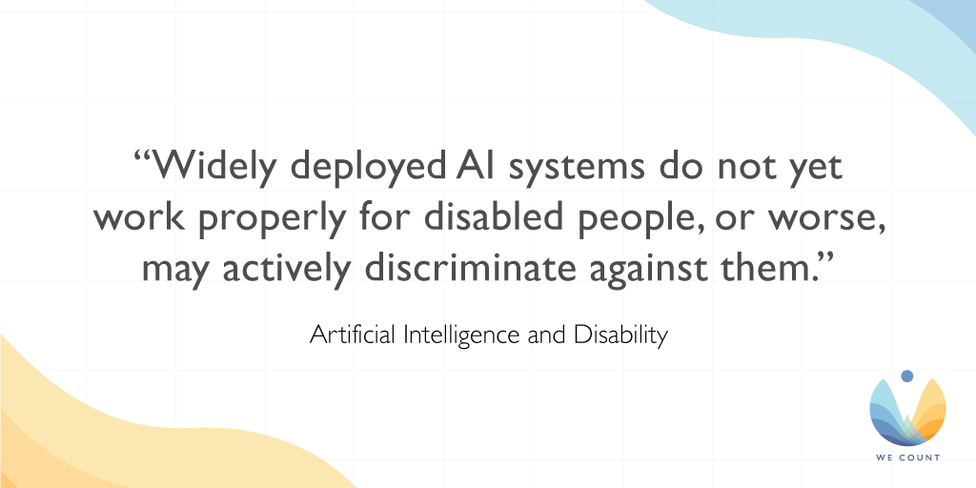This [Forbes article](https://www.forbes.com/sites/forbestechcouncil/2021/02/09/in-ai-can-we-trust/) discusses whether AI decision-making can be trusted, suggesting that the root of the problem goes far deeper than AI ethics, becoming a question of human morality and how "fairness" is defined.

## [Artificial Intelligence and Disability: Too Much Promise, Yet Too Little Substance?](https://link.springer.com/article/10.1007/s43681-020-00004-5)

Read and comment on [this opinion piece](https://link.springer.com/article/10.1007/s43681-020-00004-5) that explores the day-to-day realities of how AI can support, and frustrate, disabled people, drawing conclusions about how AI might best be developed in the future.

## [AI Needs to Face Up to Its Invisible-Worker Problem](https://www.technologyreview.com/2020/12/11/1014081/ai-machine-learning-crowd-gig-worker-problem-amazon-mechanical-turk/)

Did you know that machine learning models are trained by low-paid online gig workers? Find out more in this [interview](https://www.technologyreview.com/2020/12/11/1014081/ai-machine-learning-crowd-gig-worker-problem-amazon-mechanical-turk/) with Saiph Savage.

## [The Algorithm Audit: Scoring the Algorithms That Score Us](https://journals.sagepub.com/doi/full/10.1177/2053951720983865)

Read about a new proposed framework for auditing algorithms in this [Big Data & Society paper](https://journals.sagepub.com/doi/full/10.1177/2053951720983865).

## [The Algorithmic Auditing Trap](https://onezero.medium.com/the-algorithmic-auditing-trap-9a6f2d4d461d)

Learn about the promise and pitfalls of algorithmic assessments in this [op-ed](https://onezero.medium.com/the-algorithmic-auditing-trap-9a6f2d4d461d) by Mona Sloane.

# This Month

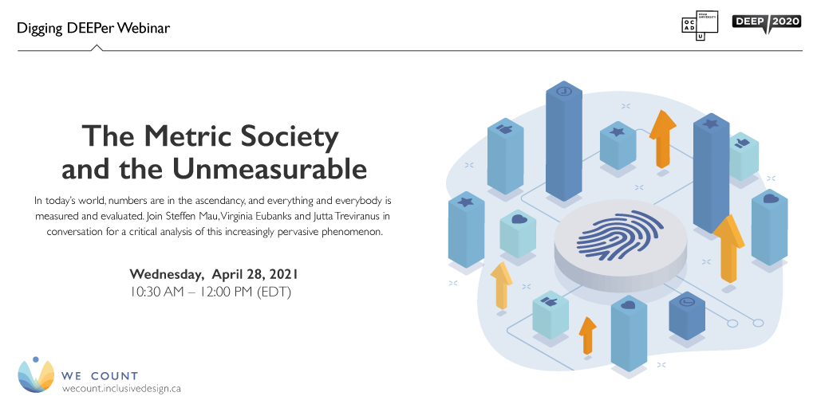

[The Metric Society and the Unmeasurable](https://wecount.inclusivedesign.ca/initiatives/metric-society/)

In today’s world, numbers are in the ascendancy. Societies dominated by star ratings, scores, likes and lists are rapidly emerging, as data are collected on virtually every aspect of our lives. From annual university rankings, ratings agencies and fitness tracking technologies to our credit score and health status, everything and everybody is measured and evaluated. Join Steffen Mau, Virginia Eubanks and Jutta Treviranus in conversation for a critical analysis of this increasingly pervasive phenomenon.

Wednesday, April 28, 2021, 10:30 AM – 12:00 PM (EDT)

# Initiatives

## What Is a We Count Challenge?

[We Count, a project of the Inclusive Design Research Centre at OCAD University, was created to address bias, discrimination and barriers to participation and employment for persons with disabilities within the field of data science and data-driven systems. Learn more at: https://wecount.inclusivedesign.ca/.

To achieve We Count’s goal of an inclusive and balanced data ecosystem for persons with disabilities, We Count is issuing an ongoing call for inclusion challenges. Nominate your challenge at: https://wecount.inclusivedesign.ca/inclusion-challenges/.

Video created by Francisco Uy
Music: Good Starts - Jingle Punks youtu.be/NstTz8iyl-c](https://youtu.be/cEnONDRi-_U)

Watch We Count's latest video and discover how we're helping to create an inclusive and balanced data ecosystem for persons with disabilities through our ongoing call for challenges.

## [Building Indigenous Future Imaginaries](https://youtu.be/R4FME84Sn2I)

[Webinar: 22nd-Century Proto-Typing: Strategies for Building Indigenous Future Imaginaries

Based on Jason Lewis’s research-creation work over the last two decades, this webinar will explore the concept of the future imaginary and make an argument as to why it is important that Indigenous people engage in creating them. Drawing on material from the Aboriginal Territories in Cyberspace research network, the Initiative for Indigenous Futures partnership, the Illustrating the Future Imaginary commissions, the Skins Workshops on Aboriginal Storytelling and Video Game Design, and the Indigenous Protocol and Artificial Intelligence Working Group, Lewis will discuss the strategies that his collaborators and he have developed for articulating desired futures, and building the capacity to make them real.

Guest Speaker:

Jason Lewis is a digital media theorist, artist, and software designer. He founded Obx Laboratory for Experimental Media, where he directs research/creation projects exploring computation as a creative and cultural material. Lewis is deeply committed to developing intriguing new forms of expression by working on conceptual, critical, creative and technical levels simultaneously. He is the University Research Chair in Computational Media and the Indigenous Future Imaginary as well as Professor of Computation Arts at Concordia University, Montreal. Born and raised in northern California, Lewis is Hawaiian and Samoan.

Originally recorded on December 9, 2020.

We Count, a project of the Inclusive Design Research Centre at OCAD University, was created to address bias, discrimination and barriers to participation and employment for persons with disabilities within the field of data science and data-driven systems. Learn more at: https://wecount.inclusivedesign.ca/.](https://youtu.be/R4FME84Sn2I)Our Building Indigenous Future Imaginaries webinar video is now available on our website and YouTube channel! Based on Jason Lewis’s research-creation work, this webinar explores the concept of the future imaginary and makes an argument as to why it is important that Indigenous people engage in creating them.

[Future of Work and Disability: AI Hiring System Policies](https://youtu.be/Tq230FBgoiU)

It's not too late to participate in our Future of Work and Disability webinar series!

Our second installment on AI Hiring System Policies delves into how machine learning models can carry bias when selecting candidates, affecting persons with disabilities and other individual differences. This webinar features:

Alexandra Reeve Givens, Center for Democracy & Technology

Julia Stoyanovich, New York University

[Webinar: Identifying and Addressing Bias in Machine Learning Models on Selection of Candidates from a Policy Perspective

Transcript available here: https://wecount.inclusivedesign.ca/initiatives/recinyosm2lkaazcd/

Panelists discuss how machine learning models can carry bias when selecting candidates, affecting persons with disabilities and other individual differences. We focus on the many legal and ethical implications of machine learning bias as we explore the best policies and practices that should be adopted by both tech companies in the design of their algorithms and the employment organizations that use them. This webinar offers an understanding of the policy issues at stake within this area of algorithmic bias.

Panelists:

Alexandra Reeve Givens is the CEO of the Center for Democracy & Technology, a leading U.S. think tank that focuses on protecting democracy and individual rights in the digital age. The organization works on a wide range of tech policy issues, including consumer privacy to data and discrimination, free expression, surveillance, internet governance and competition.

Julia Stoyanovich is an Assistant Professor of Computer Science and Engineering and of Data Science at New York University. Julia’s research focuses on responsible data management and analysis, including operationalizing fairness, diversity, transparency and data protection in all stages of the data science lifecycle. She is the founding director of the Center for Responsible AI at NYU, a comprehensive laboratory that is building a future in which responsible AI will be the only kind of AI accepted by society.

Moderator:

Dr. Vera Roberts is Senior Manager Research, Consulting and Projects at the Inclusive Design Research Centre (IDRC) at OCAD University. Vera’s primary research area is generating a culture of inclusion through outreach activities and implementation of inclusive technology and digital sharing platforms.

Originally recorded on November 17, 2020.

We Count, a project of the Inclusive Design Research Centre at OCAD University, was created to address bias, discrimination and barriers to participation and employment for persons with disabilities within the field of data science and data-driven systems. Learn more at: https://wecount.inclusivedesign.ca/.](https://youtu.be/Tq230FBgoiU)

Visit our [YouTube channel](https://www.youtube.com/channel/UC6iJU0P9YVg9oes1gE6AV3g) to see past webinar recordings. New videos are released regularly, so be sure to subscribe.

# We Count Badges

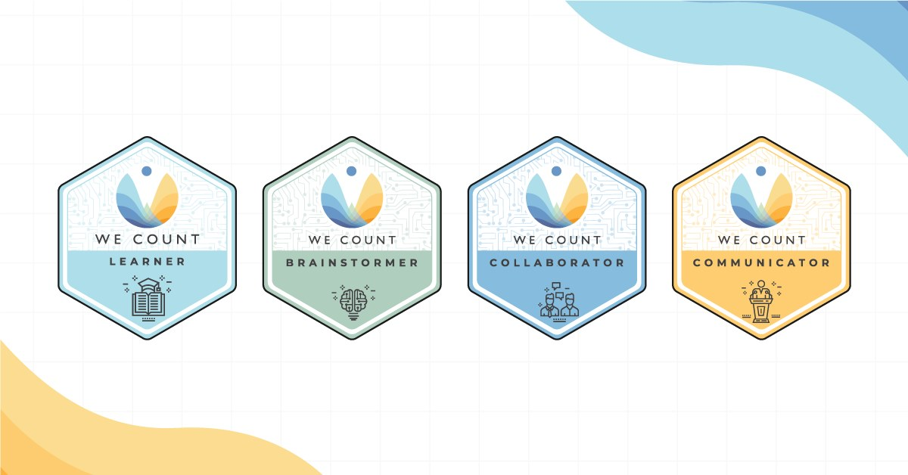

Earn badges with We Count! Our badges enable earners to showcase their proficiency in AI, data systems and inclusive data practices. To find out more about the types of badges we offer and which badges are currently available, [visit our website](https://wecount.inclusivedesign.ca/badges/).

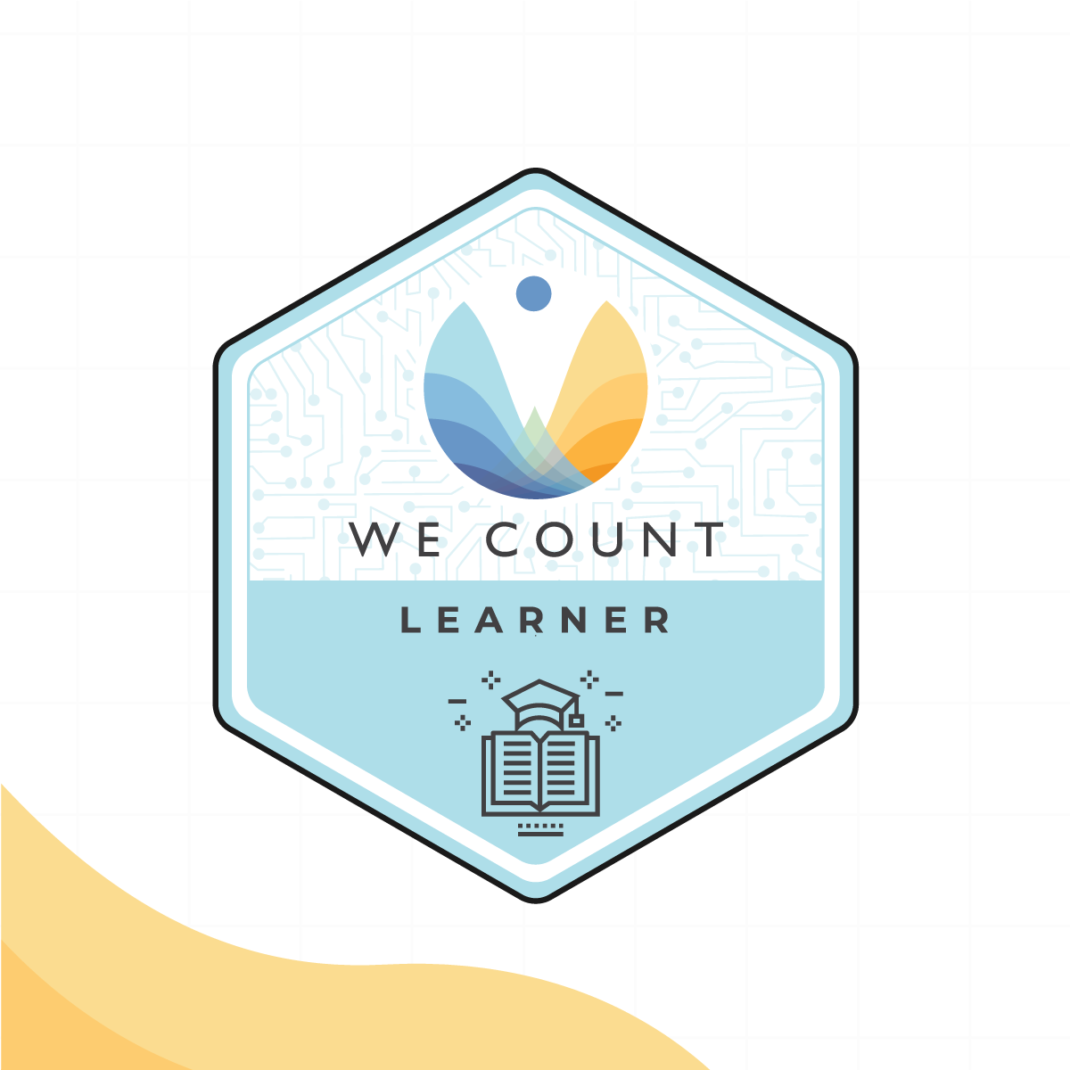

Badge Spotlight: AI and AT Apps Learner Badge

The AI and AT Apps webinar digs deeper into the possibilities of AI-powered assistive technology mobile apps and focuses on an important question: Artificial intelligence is rapidly advancing to think like us and to deep dream through machine learning, so how can it be used to improve accessibility?

For the AI and AT Apps Learner badge you will learn:

How AI systems within various commercial software applications impact persons with disabilities and marginalized communities

About accessibility features and design considerations present in current assistive technology applications

By sharing your experience with technology in an AI-supported world in a succinct and organized format

Apply for this badge and explore the other badges in this series on our [Initiatives page](https://wecount.inclusivedesign.ca/initiatives/ai-and-at-apps/).

# IDRC News

Open Robot Kit

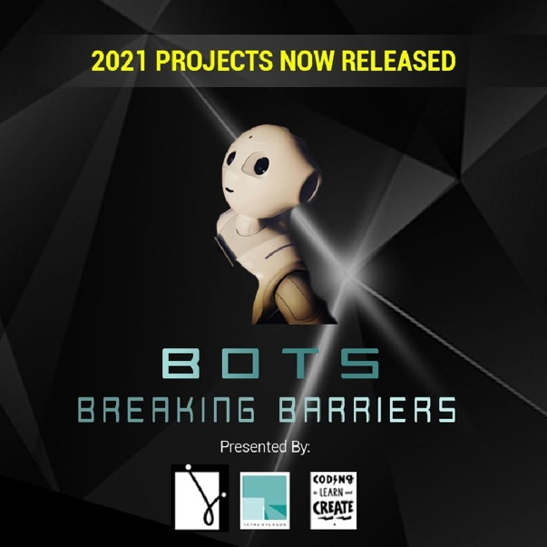Weavly (formerly the Inclusive Coding Environment) is being designed to work with a variety of coding robots. Off the shelf robots are often inaccessible for many learners, which is why Tetra Ryerson is creating an Open Robot Kit to enable educators to easily create a "one-size-fits-one" robot that works with Weavly.

Students are working in groups to create robots that are reasonably affordable, composed of easy to acquire parts, robust and safe enough for students to play with. The robots are designed with composable parts and will have a Robot Building Guide with easy to follow instructions. The guide will be freely available in the Educator’s Toolkit.

Learn more about the kit on the [Coding to Learn and Create website](https://www.codelearncreate.org/blog/open-robot-kit/).

## Community Workshops and Design Crits

On Tuesdays, the inclusive design community gathers together to learn and discuss various topics in the form of a workshop or a design critique.

Workshops provide the inclusive design community with an opportunity for engaging with a broader community to stimulate creative processes.

Design critiques are an opportunity for community members to examine and discuss a creative artifact in an informal and constructive setting.

The next event on April 20 is a design critique entitled "Looseleaf: CSS for Prototyping." Visit the [Wiki page](https://wiki.fluidproject.org/display/fluid/Community+workshops+and+design+crits) for more information.

# Learn More

[Learn about We Count and its work to foster an inclusive, fair and accessible data ecosystem.
https://wecount.inclusivedesign.ca/](https://youtu.be/mFvXgQMLdNw)

Discover how We Count is addressing bias and developing new machine learning strategies that recognize and serve people with disabilities in this video.

Are you interested in hearing about We Count activities or do you want to be contacted to learn about ways you can participate? If you are, then send us your contact information using our [contact form](https://forms.gle/WuCk59iQtiRX3sLC7).

# Contact Us

We would love to hear from you!

Inclusive Design Research Centre

OCAD University

205 Richmond St. W, Toronto, ON, M5V 1V3

[wecount@inclusivedesign.ca](mailto:wecount@inclusivedesign.ca)

Visit the [We Count website](https://wecount.inclusivedesign.ca/) and follow us on social media (@WeCountProject).

# We Count acknowledges the support of:



