The We Count Recount: March 2021



We Count is a community-driven project that addresses the inherent bias against small minorities and outliers in artificial intelligence and data analytics.

# A Message from Our Director

Friends and colleagues,

At the IDRC we are aware that the escalating innovations that change our lives are not designed for everyone. Often, the people that need them the most and are most vulnerable to the unintended harm, are the people that are excluded. This harms everyone eventually and impoverishes our society. We believe that to change this pattern requires the full participation of the communities that are currently excluded, from the very start. Unfortunately, the very process of innovation and design is structured to exclude. The language is not understandable. The issues are overwhelming and complex. Many important pieces of information are kept from the people that will feel the greatest impact. It is hard to participate meaningfully in a process when you don’t have the essential information.

Data science and artificial intelligence is one of these complex innovations that is sweeping through our world. If you are average or typical you can just trust that the innovation is made for you. You don’t need to get involved and you don’t need to understand the possible harms and benefits. If you live with a disability you don’t have this luxury. It is most likely that you will be the first to feel the unintended harms and new barriers. Unless you fight for the potential benefits, the market incentives will not naturally produce things for you.

This newsletter is a small step to address this. We hope to translate the obtuse geek speak and academic lingo so it is more understandable. We will find the important and relevant pieces of information in the overwhelming sea of chatter. We hope that it will make it possible for the most important people, those with lived experience of the barriers and opportunities, to participate meaningfully in this innovation.

All my best,

Jutta

PS: While writing this and feeling the enormity of the task before us, I heard the news that my dear friend [Justin Clark](https://youtu.be/TWWsW1w-BVo) has died. Words fail to express the sadness and loss, but the reflection on the magnitude of the change he wrought in his too short life bolsters my hope and resolve. If Justin can change the pattern of century-old institutions and mindsets with everything stacked against him, we can collectively push this innovation in more inclusive directions.

# [What technologists and advocates need to do to ensure that AI helps instead of harms people with disabilities While it's clear that AI-based technologies like natural language processing and computer vision are powerful tools to help with accessibility, there are also areas where AI technologies inject bias against people with disabilities by contrasting them again "norms" established in databases. This panel will look at examples of where that is happening – in employment software, benefits determination or even self-driving cars, for example, - and approaches that will help address these issues from the ground up. Lydia X. Z. Brown, Policy Counsel, Privacy and Data Project, CDT Jutta Treviranus, Director, Inclusive Design Research Centre Moderator: Jim Fruchterman, Founder, Benetech](https://youtu.be/iX3YnSyxtAY)News from the Field

[Auditing for Algorithmic Discrimination](https://www.gender-sti.org/women-in-leadership-campaign-iwd-2021/)

A [Computer Weekly article](https://youtu.be/mFvXgQMLdNw) asserts that, despite the abundance of decision-making algorithms with social impacts, many companies are not conducting specific audits for bias and discrimination that can help mitigate their potentially negative consequences.

## [Disability Rights and Inventing the Accessible Future](https://www.cbc.ca/radio/sunday/november-25-2018-the-sunday-edition-with-michael-enright-1.4911588/how-justin-clark-s-fight-for-independence-transformed-disability-rights-in-canada-1.4911590)

[When technologists design exciting new innovations, those designs rarely include blind people. Access to technology and information is a civil right. Yet when technologists design exciting new innovations, those designs rarely include blind people. Advocates urge us to employ a variety of strategies, from education to litigation, to ensure accessibility is baked into all future tech and information systems. Harvard Law’s first Deafblind graduate Haben Girma, disability rights attorney Lainey Feingold, and Chief Innovations officer with the DAISY Consortium, George Kerscher, will discuss strategies for creating a future fully accessible to disabled people, including those who are Black, Indigenous, People of Color.


Lainey Feingold, Disability Rights Lawyer
Haben Girma, Disability Rights Lawyer
George Kerscher, Chief Innovations Officer, DAISY Consortium
Moderator: Megan Rose Dickey, Senior Reporter, TechCrunch](https://www.cbc.ca/radio/sunday/november-25-2018-the-sunday-edition-with-michael-enright-1.4911588/how-justin-clark-s-fight-for-independence-transformed-disability-rights-in-canada-1.4911590)The Sight Tech Global 2020 Disability Rights and Inventing the Accessible Future panel discusses strategies for creating a future fully accessible to people with disabilities.

## [In AI Ethics, “Bad” Isn’t Good Enough](https://askell.io/posts/2020/12/bad-isnt-good-enough)

While AI ethicists focus on the harmful consequences of AI systems, this [blog post](https://www.computerweekly.com/feature/Auditing-for-algorithmic-discrimination) discusses how we shouldn't conflate arguments that AI systems have harmful consequences with arguments about what we should do.

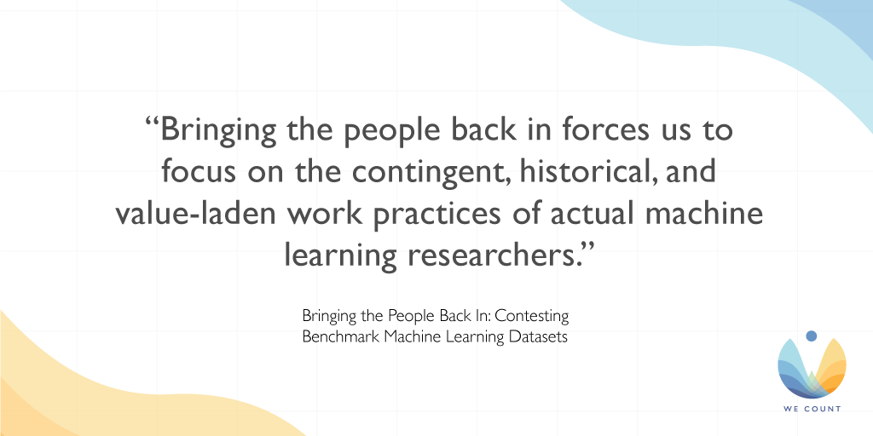

## [Bringing the People Back In: Contesting Benchmark Machine Learning Datasets](https://wecount-cms.inclusivedesign.ca/wp-content/uploads/2021/01/Bringing-the-People-Back-In.pdf)

A [new paper](https://wecount.inclusivedesign.ca/views/the-future-of-work-and-disability/) about the creation of datasets and the values that influence the choices of data collection.

## [Study Finds Diversity in Data Science Teams Is Key in Reducing Algorithmic Bias](https://venturebeat.com/2020/12/09/columbia-researchers-find-white-men-are-the-worst-at-reducing-ai-bias/)

A new study on the sources of bias among AI developers stresses how more diverse teams will reduce the chance for compounding biases. Read the [VentureBeat article](https://www.computerweekly.com/feature/Auditing-for-algorithmic-discrimination) for more details.

## [Gender Shades](https://forms.gle/WuCk59iQtiRX3sLC7)

[The Gender Shades Project pilots an intersectional approach to inclusive product testing for AI.

Gender Shades is a preliminary excavation of inadvertent negligence that will cripple the age of automation and further exacerbate inequality if left to fester. The deeper we dig, the more remnants of bias we will find in our technology. We cannot afford to look away this time, because the stakes are simply too high.  We risk losing the gains made with the civil rights movement and women's movement under the false assumption of machine neutrality. Automated systems are not inherently neutral. They reflect the priorities, preferences, and prejudices—the coded gaze—of those who have the power to mold artificial intelligence.

Video produced by Joy Buolamwini and Jimmy Day

More information at: https://www.media.mit.edu/projects/gender-shades/overview/ 
License: Creative Commons Attribution-NonCommercial-NoDerivatives 4.0 International Public License
 (https://creativecommons.org/licenses/by-nc-nd/4.0/legalcode)](https://forms.gle/WuCk59iQtiRX3sLC7)Explore the Gender Shades project and how it evaluates the accuracy of AI-powered gender classification systems, demonstrating the need for increased transparency in the performance of any AI products and services that focus on human subjects in this video.

## [The Robots Occupying Our Sidewalks](https://askell.io/posts/2020/12/bad-isnt-good-enough)

Technology companies often fail to design and develop AI with persons with disabilities in mind. As this [TechCrunch article](https://wecount.inclusivedesign.ca/) highlights, no-contact delivery robots are just one of many examples of this systemic issue.

# Initiatives

[Webinar: Risks and Opportunities of AI, Smart Systems and Automation for Employment of Persons with Disabilities

A group of expert panellists give an introduction to AI and machine learning with a focus on how AI creates both barriers and new opportunities for persons with disabilities in the hiring, training and retention of employees. 

Panelists:

Anhong Guo is an Assistant Professor in Computer Science & Engineering at the University of Michigan. He has also worked in the Ability and Intelligent User Experiences groups in Microsoft Research, the HCI group of Snap Research, the Accessibility Engineering team at Google, and the Mobile Innovation Center of SAP America.

Shari Trewin manages the IBM Accessibility Leadership Team, chairs the Association for Computing Machinery (ACM) Special Interest Group on Accessible Computing (SIGACCESS), and is a Distinguished Scientist of the ACM, a member of ACM’s Diversity and Inclusion Council.

Ben Tamblyn is the Director of Inclusive Design at Microsoft. He tells stories about Microsoft and the human impact of technology. Ben has worked in a wide range of marketing, design and technical roles, and has a passion for design, inclusion and potential impact of technology on the world.

Chancey Fleet was a 2018–19 Fellow at Data & Society and is currently an Affiliate-in-Residence whose writing, organizing and advocacy aims to catalyze critical inquiry into how cloud-connected accessibility tools benefit and harm, empower and expose disability communities. Chancey is also the Assistive Technology Coordinator at the New York Public Library.

Moderator:

Dr. Vera Roberts is Senior Manager Research, Consulting and Projects at the Inclusive Design Research Centre (IDRC) at OCAD University. Vera’s primary research area is generating a culture of inclusion through outreach activities and implementation of inclusive technology and digital sharing platforms.

Originally recorded on November 3, 2020.

Learn more at: https://wecount.inclusivedesign.ca/](https://youtu.be/Zzwek-EqGfg)

1 - Future of Work and Disability: AI Employment Systems

It's not too late to participate in our Future of Work and Disability webinar series!

Our first installment on AI Employment Systems provides an introduction to AI and machine learning with a focus on how AI creates barriers and opportunities for persons with disabilities in the hiring, training and retention of employees. This webinar features:

Anhong Guo, University of Michigan

Shari Trewin, IBM

Ben Tamblyn, Microsoft

Chancey Fleet, Data and Society

Visit our [YouTube channel](https://www.youtube.com/channel/UC6iJU0P9YVg9oes1gE6AV3g) to see past webinar recordings. New videos are released regularly, so be sure to subscribe.

# We Count Badges

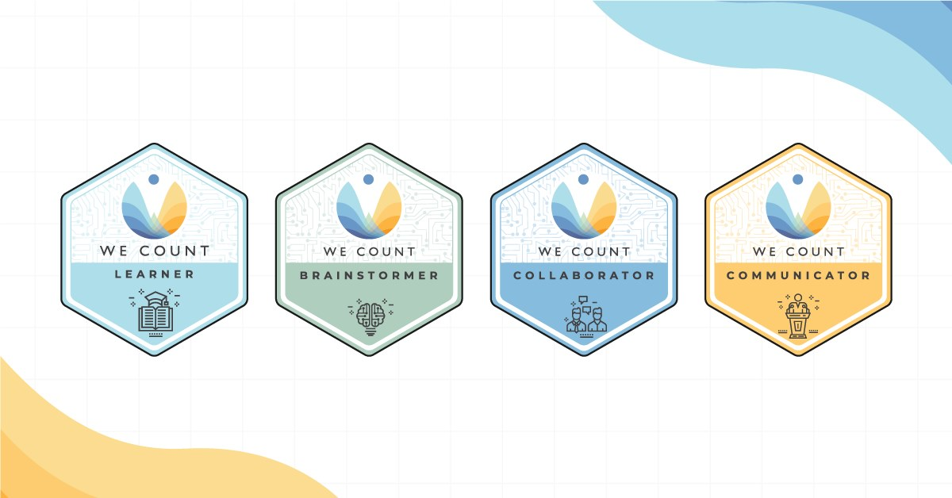

Earn badges with We Count! Our badges enable earners to showcase their proficiency in AI, data systems and inclusive data practices. To find out more about the types of badges we offer and which badges are currently available, [visit our website](https://techcrunch.com/2020/08/11/the-robots-occupying-our-sidewalks/).

# IDRC News

## Gender Equality in Science, Technology and Innovation

The IDRC is excited to be a partner in the Gender STI project. Gender STI is an international research project that aims to analyze the participation of women in science, technology and innovation (STI) dialogues between Europe and third countries. The project will focus on four key areas:

* Gender equality in scientific careers
* Gender balance in decision-making
* Integrating gender dimension in Research and Innovation (R&I) content
* 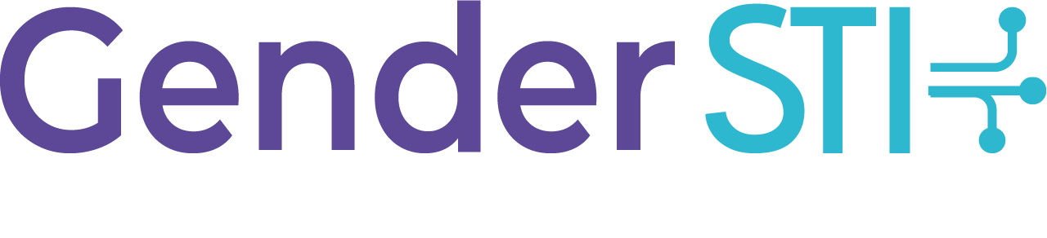Co-designing solutions to common challenges found in these areas through a design-thinking process

The [Gender STI](https://techcrunch.com/2020/08/11/the-robots-occupying-our-sidewalks/) consortium is made up of partners from sixteen countries in four continents. The project is honouring International Women's Day 2021 with the [#WomenInLeadership](https://venturebeat.com/2020/12/09/columbia-researchers-find-white-men-are-the-worst-at-reducing-ai-bias/) campaign, which celebrates women leaders in science, technology and innovation and sheds light on their journeys, challenges and goals.

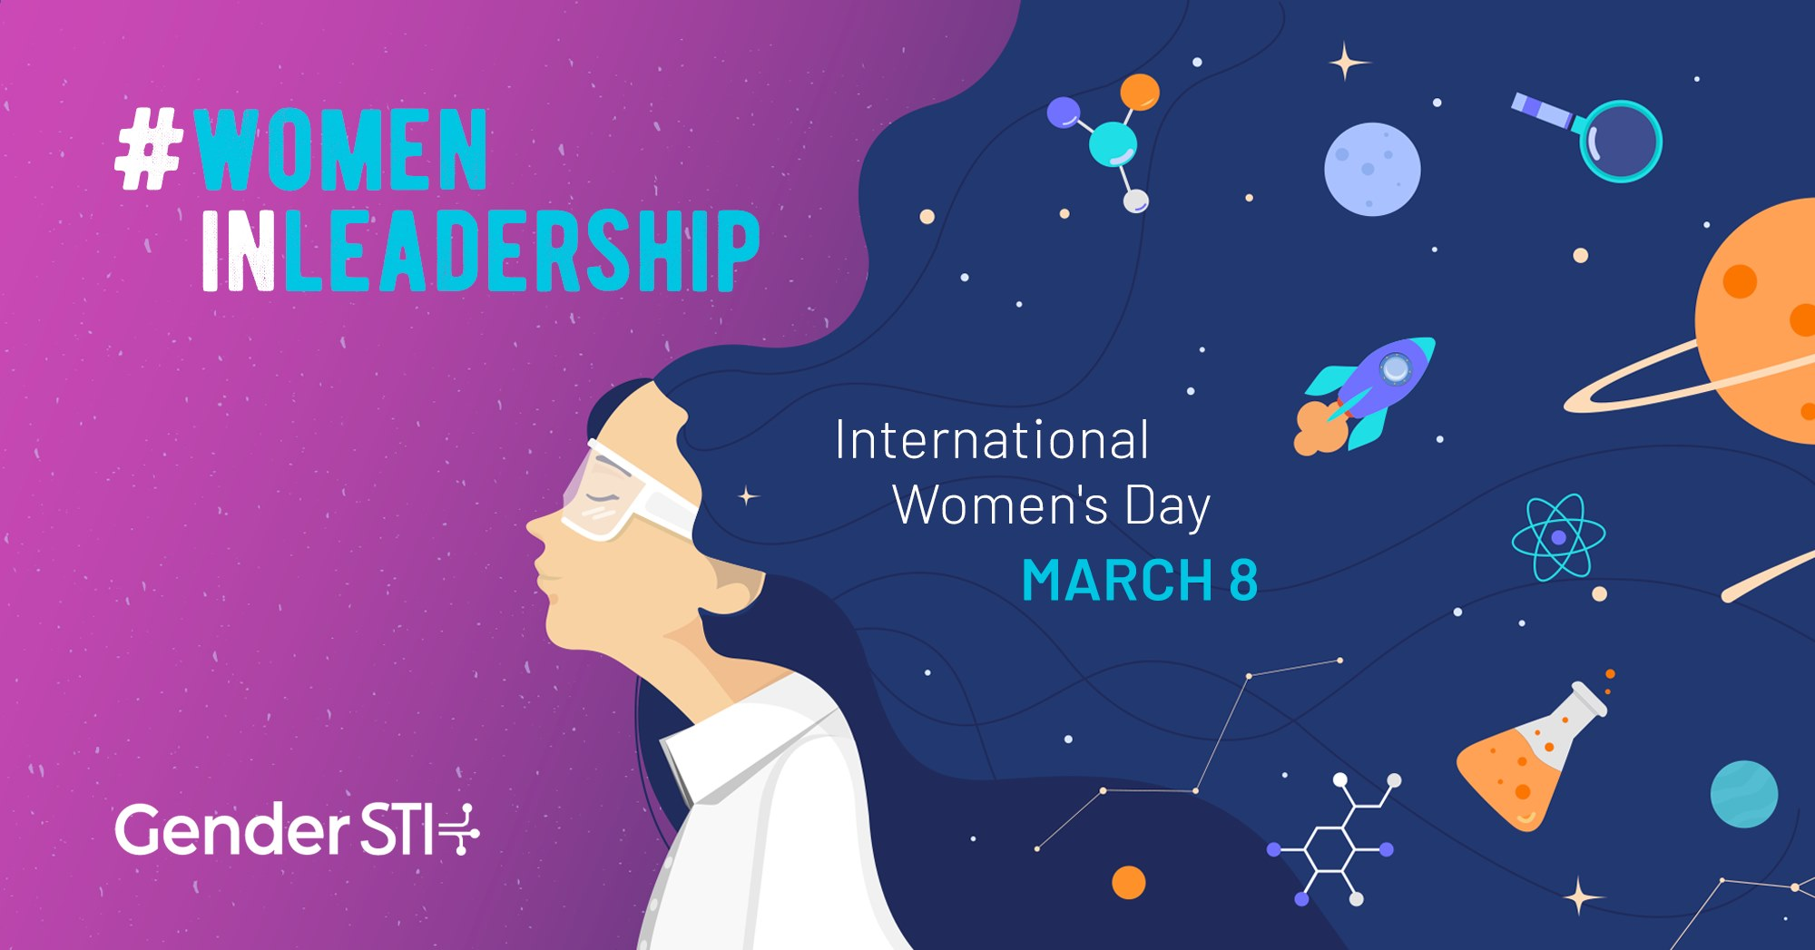

2 - [https://www.gender-sti.org/women-in-leadership-campaign-iwd-2021/](https://wecount-cms.inclusivedesign.ca/wp-content/uploads/2021/01/Bringing-the-People-Back-In.pdf)

## Future of Work and Disability

The Future of Work and Disability project is in the process of preparing a report that summarizes the project's efforts to understand and examine intersecting topics of AI, automation, standards and employment as they relate to persons with disabilities with the assistance of their fifteen-person study group.

In addition to the report currently under development for Accessibility Standards Canada, the FWD project created:

Learning opportunities from our webinars

Badges that can be used by learners to demonstrate their proficiency in the field

A learning program that will be publicly available at the close of the project

Find out more about the project in the [Future of Work and Disability summary.](https://www.gender-sti.org/)

# Learn More

[Learn about We Count and its work to foster an inclusive, fair and accessible data ecosystem.
https://wecount.inclusivedesign.ca/](https://wecount.inclusivedesign.ca/badges/)Discover how We Count is addressing bias and developing new machine learning strategies that recognize and serve people with disabilities in this video.

Are you interested in hearing about We Count activities or do you want to be contacted to learn about ways you can participate? If you are, then send us your contact information using our [contact form](https://www.gender-sti.org/women-in-leadership-campaign-iwd-2021/).

# Contact Us

We would love to hear from you!

Inclusive Design Research Centre

OCAD University

205 Richmond St. W, Toronto, ON, M5V 1V3

[wecount@inclusivedesign.ca](mailto:wecount@inclusivedesign.ca)

Visit the [We Count website](https://youtu.be/C_2lFeH9y2I) and follow us on social media (@WeCountProject).

# OCAD U Imagination Is EverythingInclusive Design Research CentreWilliam and Flora Hewlett FoundationWe Count acknowledges the support of:

