**SLURRY MACHINE, Model: MP205**

To achieve consistent crystal size from vacuum pan boiling it is important to inject the pan with slurry being micron sized sugar.

This is best obtained using refined sugar mixed with either absolute alcohol or methylated spirits.

The mixture is then poured through the spout of the ball mill and ground over an 8 hour period to produce an average size of 4 to 8 microns.

This unit comprises a stainless steel drum mounted on a base frame and coupled with variable gear motor drive. It is adjustable from 1 rpm to 100 rpm through inverter control.

To improve the blending results,10 stainless steel rods are poured in stainless steel drum. A clutch rod is fixed for adjustment of stainless steel drum for pouring and removing the samples.

**Specifications:**

Height: 1500 mm

Base: 1500 x 850 mm (LxW)

Net weight:....60 kg

Power : :220V, 50Hz, 3-phase

**Contact:**

291-A, Lasani Town, Sargodha Road.

Faisalabad, 38000 Pakistan.

Tel: 041-886 2329, 886 3329 Fax: 041-886 3329

Cell no: 0300 –866 2329

E-mail: [shaukat.hayat@mechnolink.com.pk](mailto:shaukat.hayat@mechnolink.com.pk)

Web: www.mechnolink.com.pk



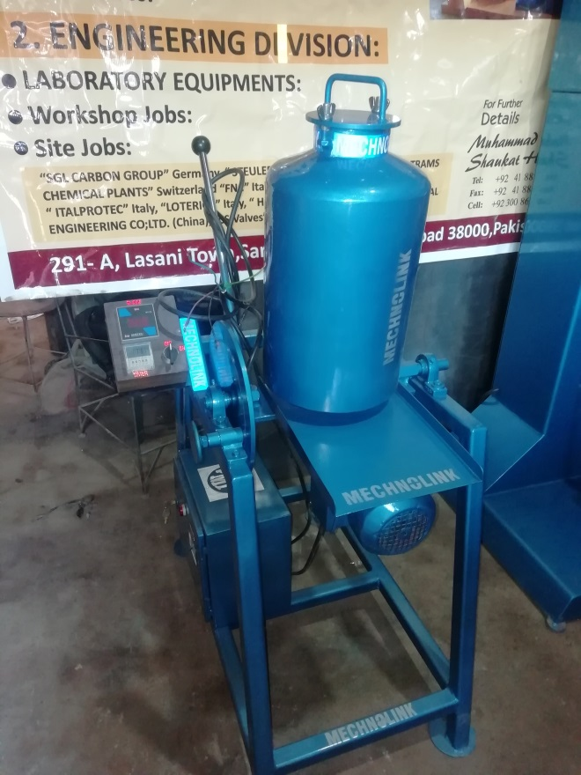

Fig.1 Slurry Machine (Model: MP205)

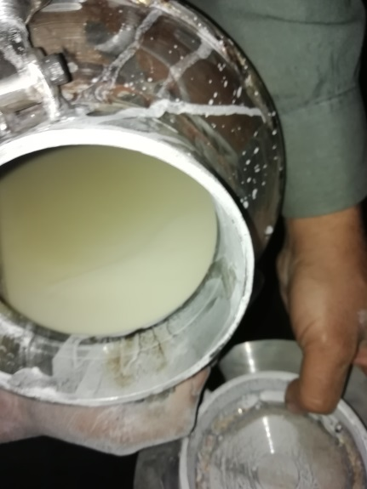

Fig.2 Slurry Mixture size 6-8 Micron