**TUMBLER MACHINE, Model: MP 210**

Mechnolink International has developed new model of “Tumbler Machine” for sugar cane analysis by mixing / blending of fiberized sugar cane with water.

Its designed capacity is 2 Kg Fiberized cane with 10 Liters of water.

The test is carried out on a sample of cane after the shredding. The percentage of cane plant cells which have been ruptured by the cane preparation equipment is used as a measure of the effectiveness of cane knives and cane shredder.

The percentage of brix in the ruptured cells to total brix in the cane is known as the preparation index.

As close to100% the percentage of preparation index obtained higher the efficiency of the mill preparation for sucrose extraction.

This unit comprises a stainless steel drum mounted on a base frame and coupled with variable gear motor drive. It is adjustable from 1 rpm to 100 rpm through inverter control. To improve the blending results, 10 stainless steel rods were poured in stainless steel drum. A clutch rod is fixed for adjustment of stainless steel drum for pouring and removing the samples.

**Specifications:**

Height: 1500 mm

Base: 1500 x 850 mm (L x W)

Net weight:....60 kg

Power : :220V, 50Hz, 3-phase



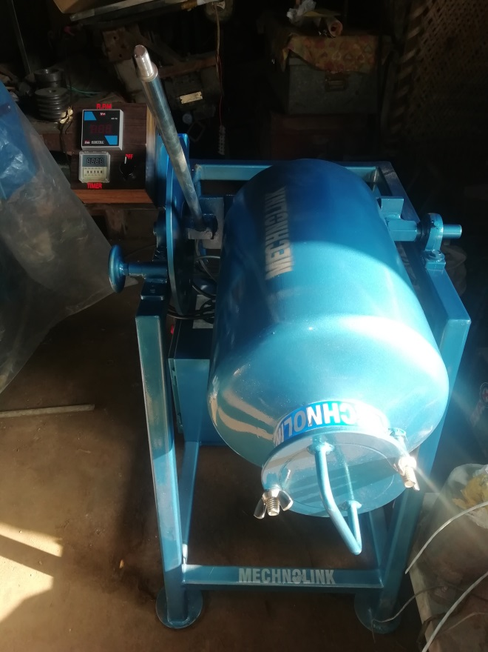

Fig.1 Tumbler Machine (Model: MP210)

291-A, Lasani Town,

Sargodha Road.

Faisalabad, 38000 Pakistan.

Tel: 041-886 2329, 886 3329

Fax: 041-886 3329

Cell no: 0300 –866 2329

E-mail: shaukat.hayat@mechnolink.com.pk

Web: www.mechnolink.com.pk