

1

Web Application Development
Project
Course Code: SESE3143 | Instructor: Rubab Javaid
Marks: 20 | Semester: Fall 2025
Deadline of Project: [19th Jan, 2026, 11:55 PM]

Submission by:
Name | Roll Number
Ahmed Tahir | L1F23BSSE0123
Muhammad Maaz Javeed | L1F23BSSE0104
Muhammad Ahmad | L1F23BSSE0108
Rana Muhammad Ahmad | L1F23BSSE0112

Section:SEE5

User Endpoints:
Collection link: https://ahmedtahir929pk-8873345.postman.co/workspace/My-Workspace~d43d98a6-4c44-449c-b9bb-f3387c373ce9/request/48945590-18bc533c-38ff-47d2-8195-b23a28b59230?action=share&creator=48945590&ctx=documentation
/*
Password for customer is Customer@123
Password for admin is Admin@1234
Password for driver is Driver@123
*/

http://localhost:3000/api/user/signup
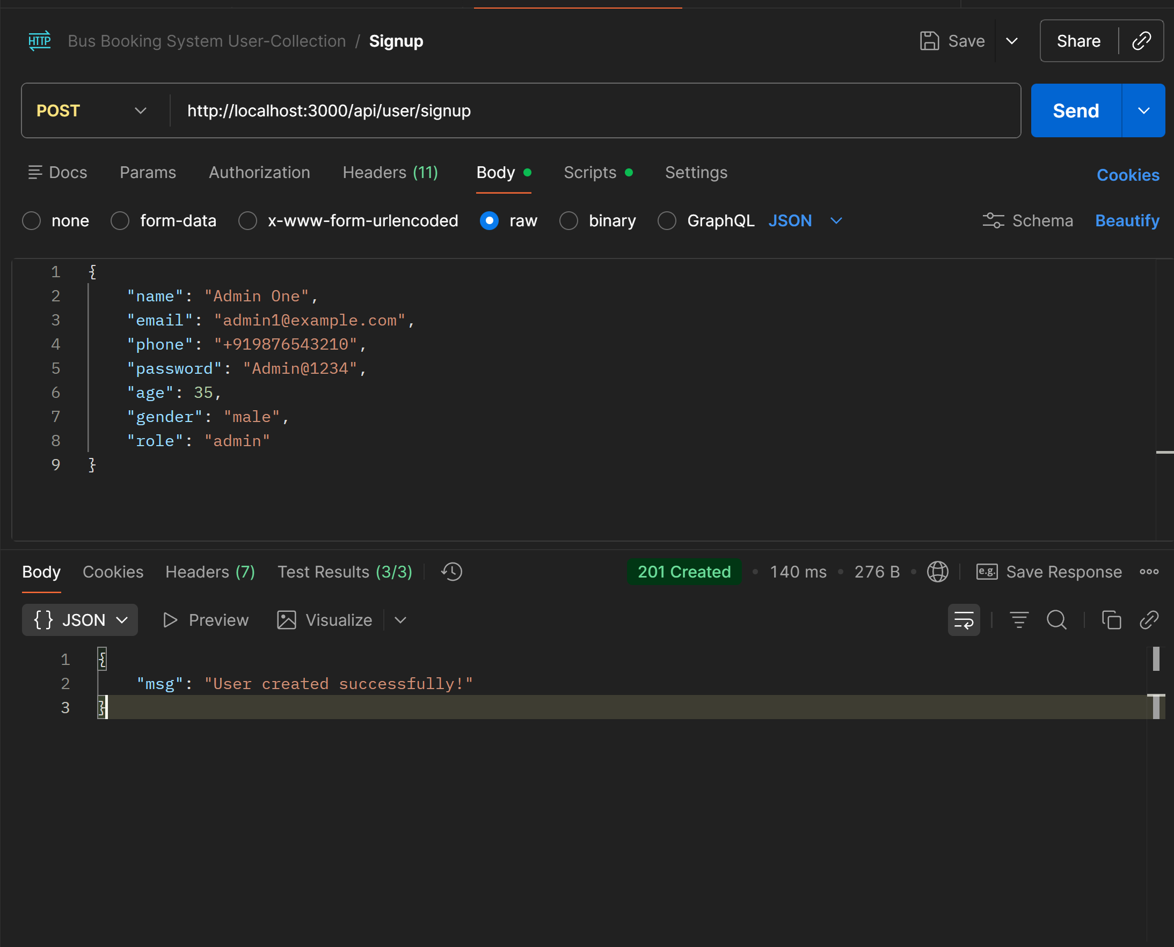
http://localhost:3000/api/user/login
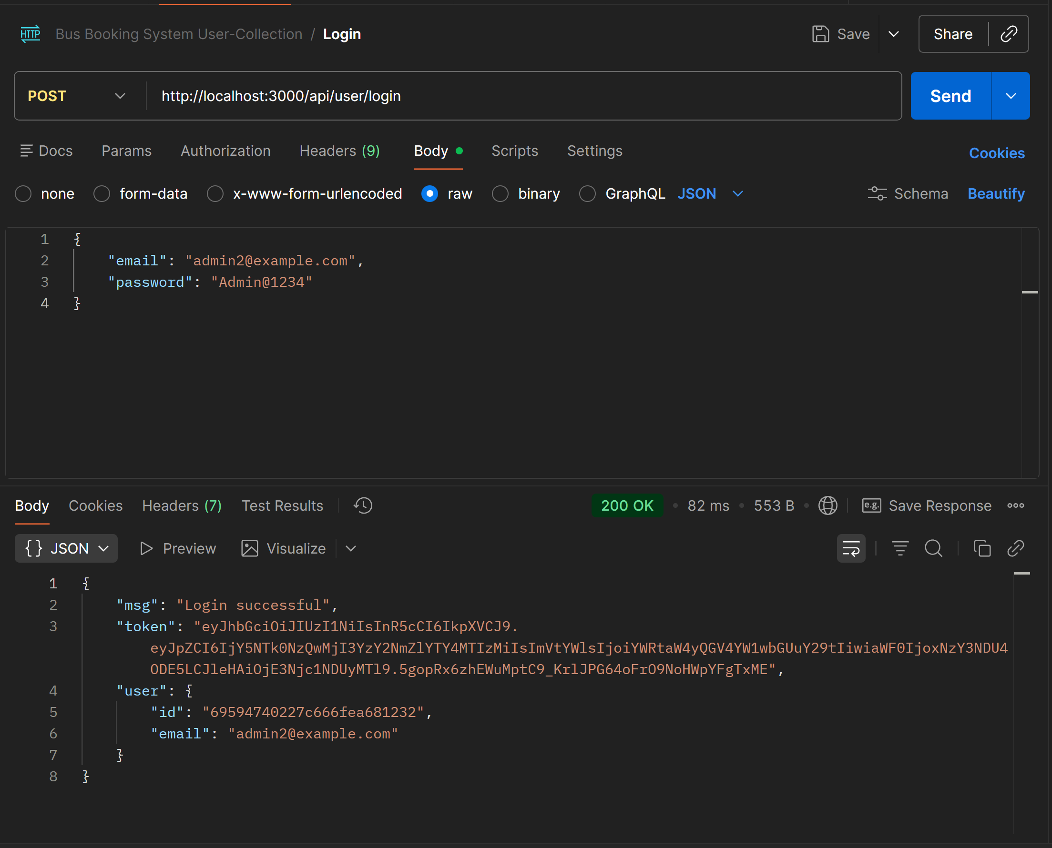
http://localhost:3000/api/user/profile
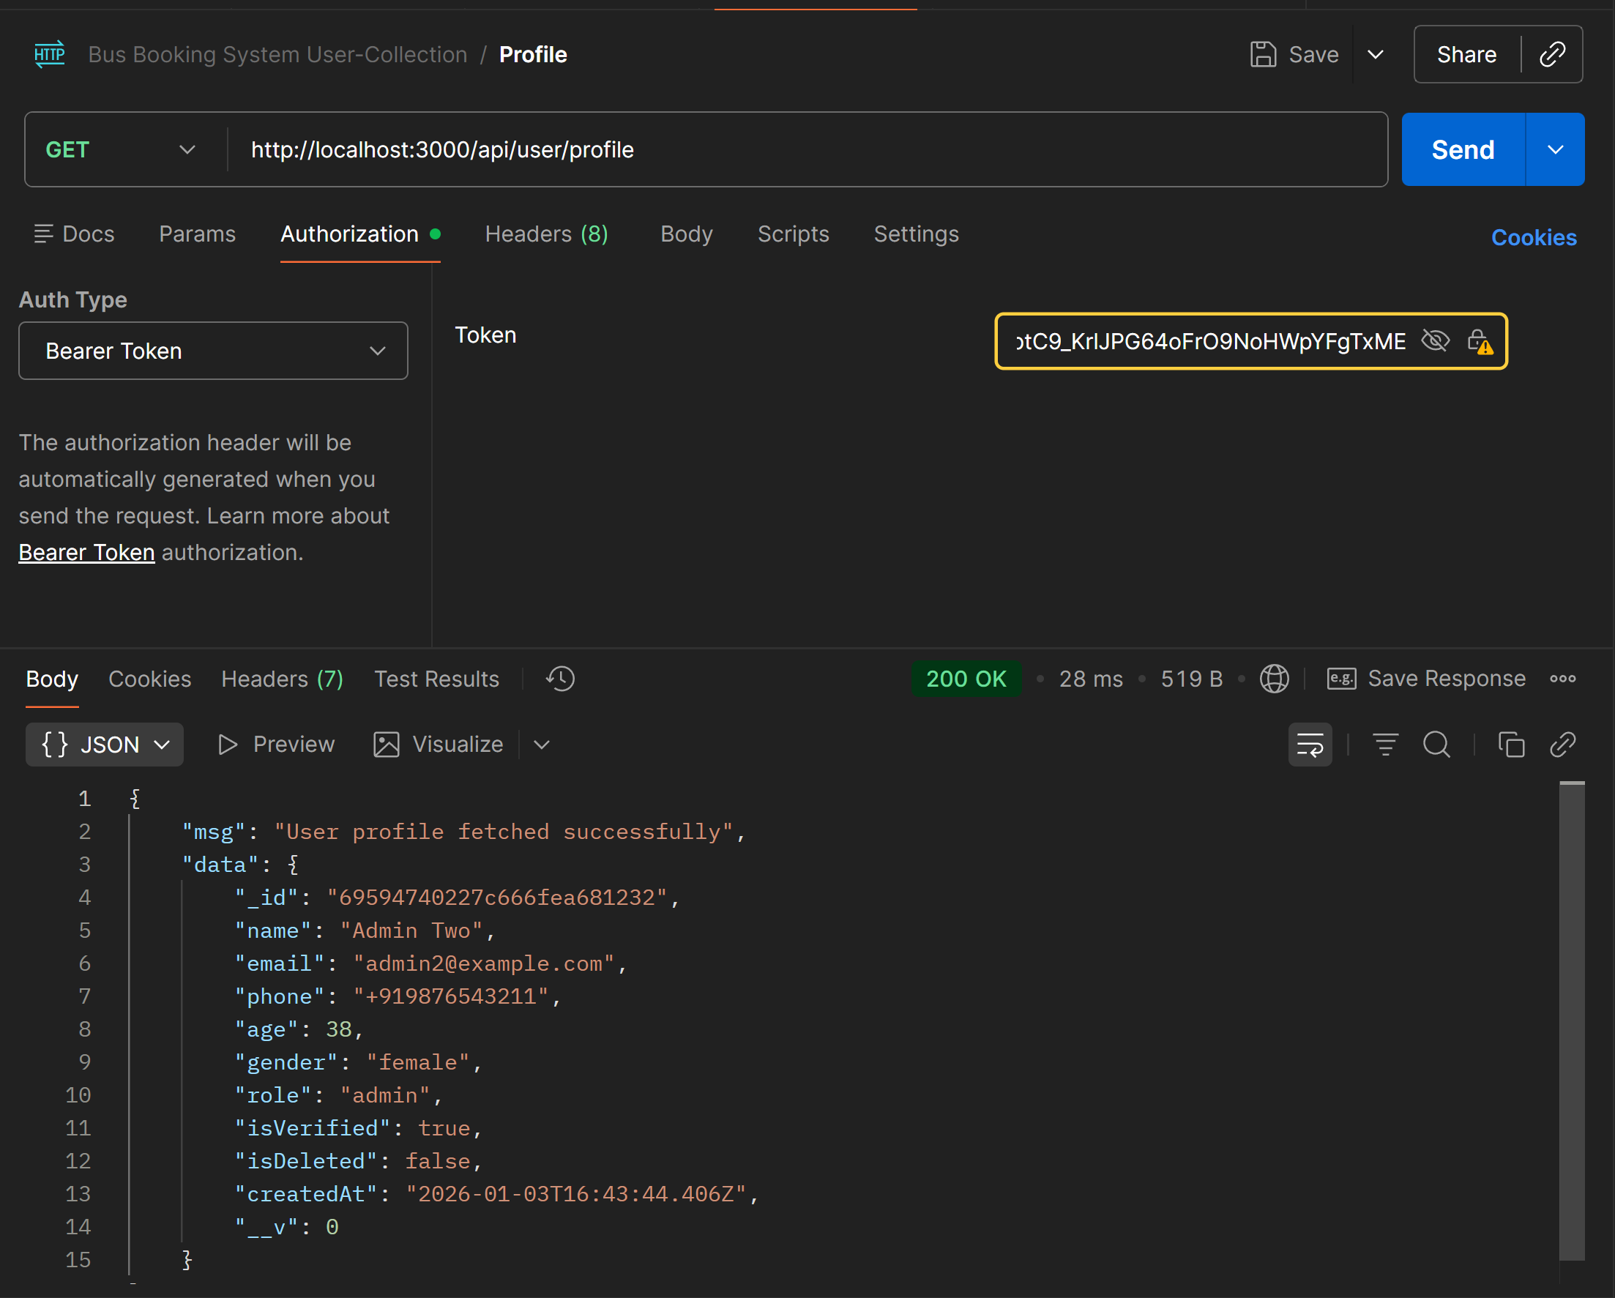
http://localhost:3000/api/user/customer-details (customer cannot access all customer details)
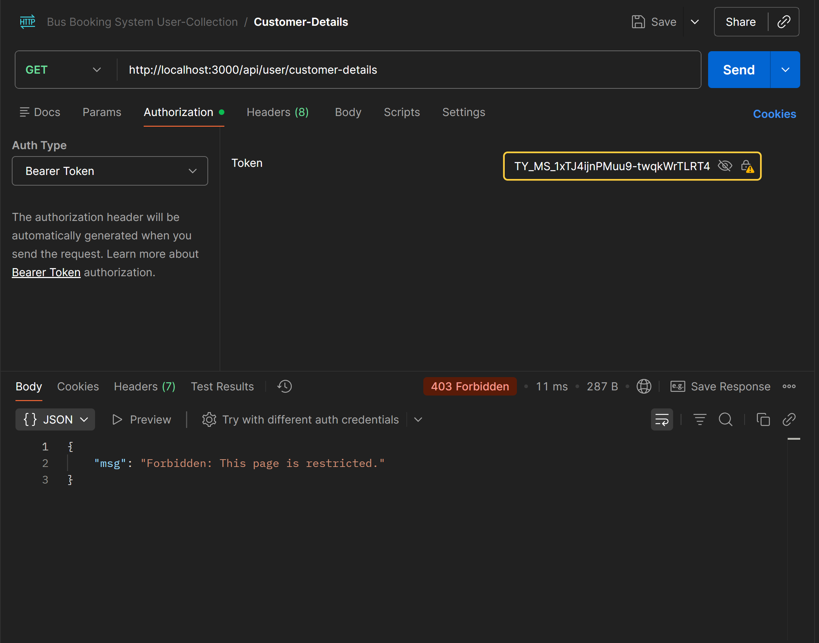
http://localhost:3000/api/user/customer-details (driver can also not access all customer-details)
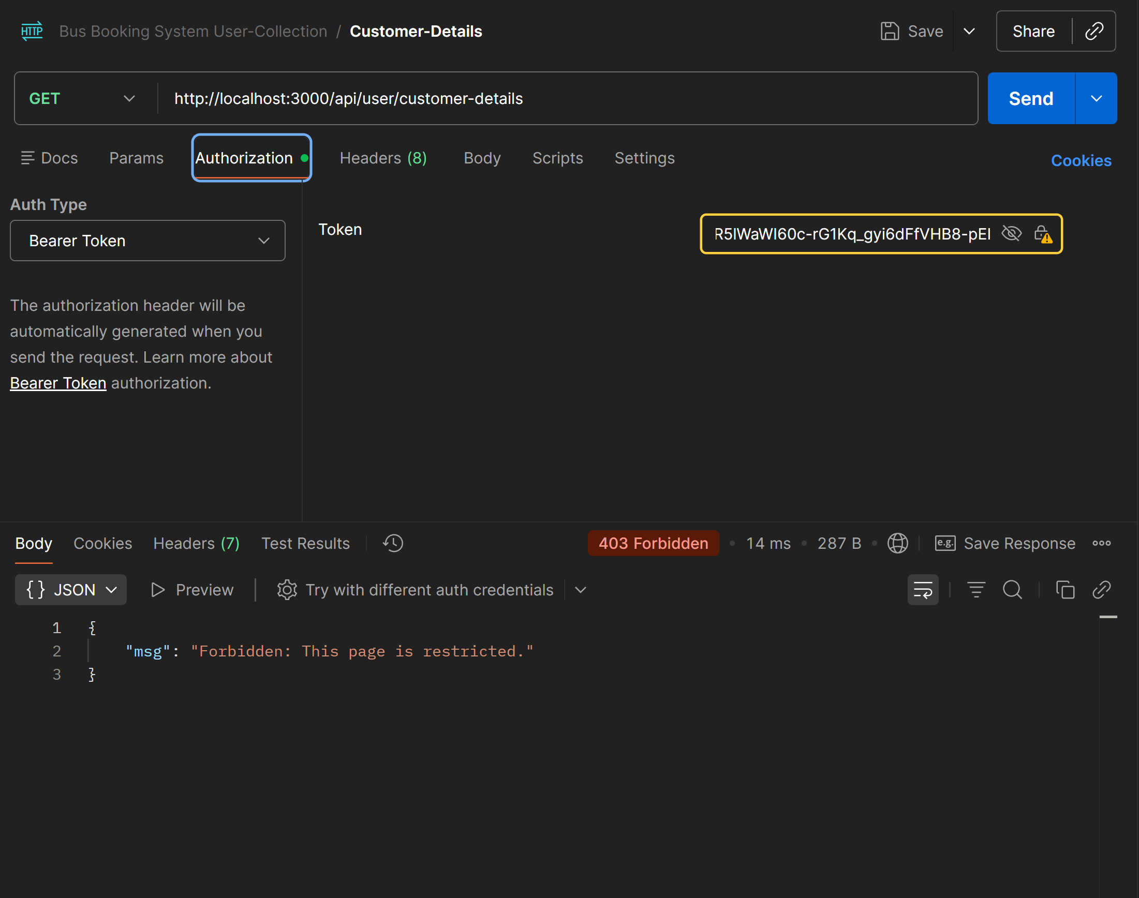
http://localhost:3000/api/user/customer-details (Only Admins can access both customer and driver details)
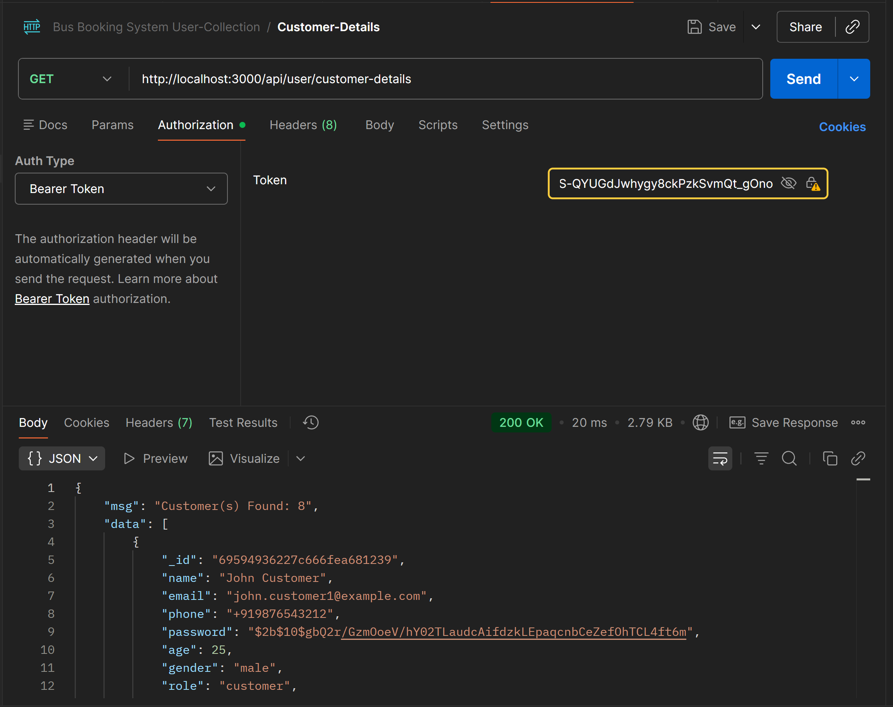
http://localhost:3000/api/user/driver-details
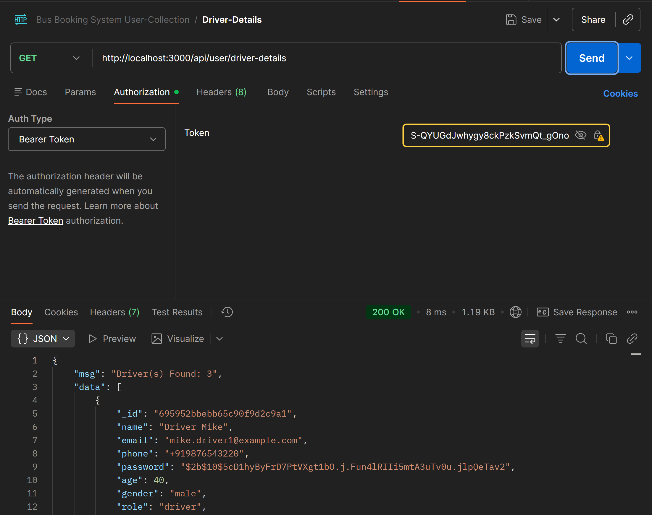
http://localhost:3000/api/user/change-email
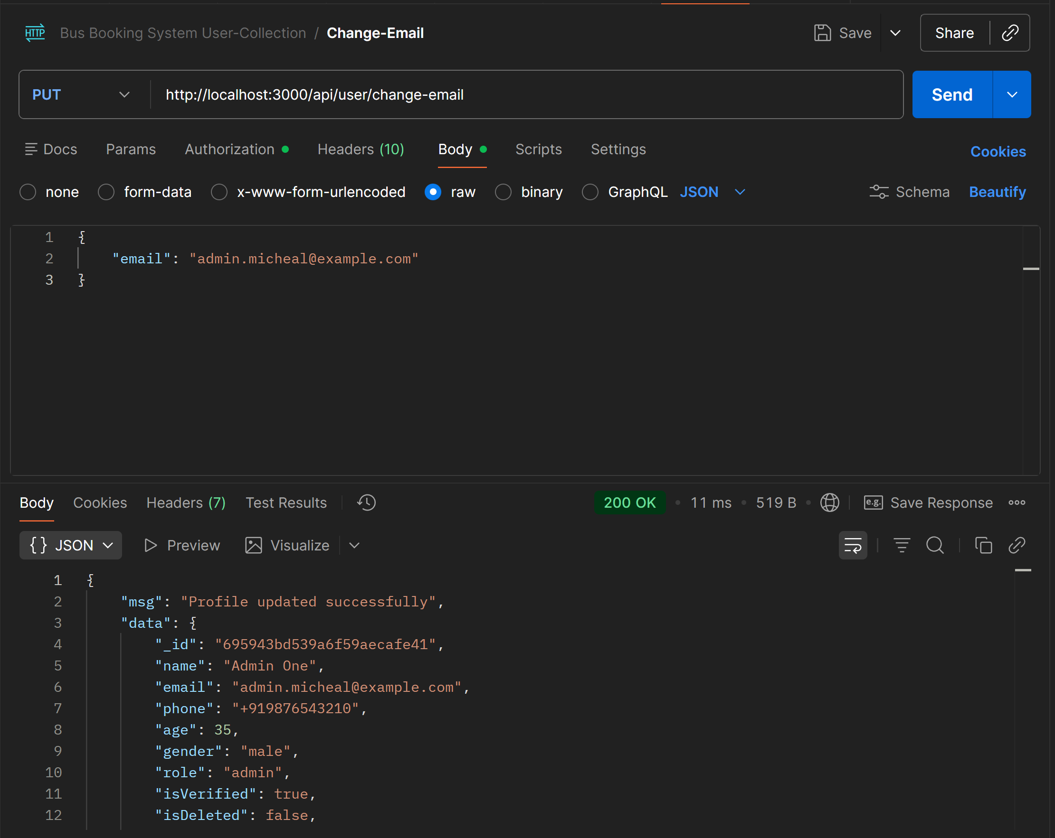
http://localhost:3000/api/user/change-phone
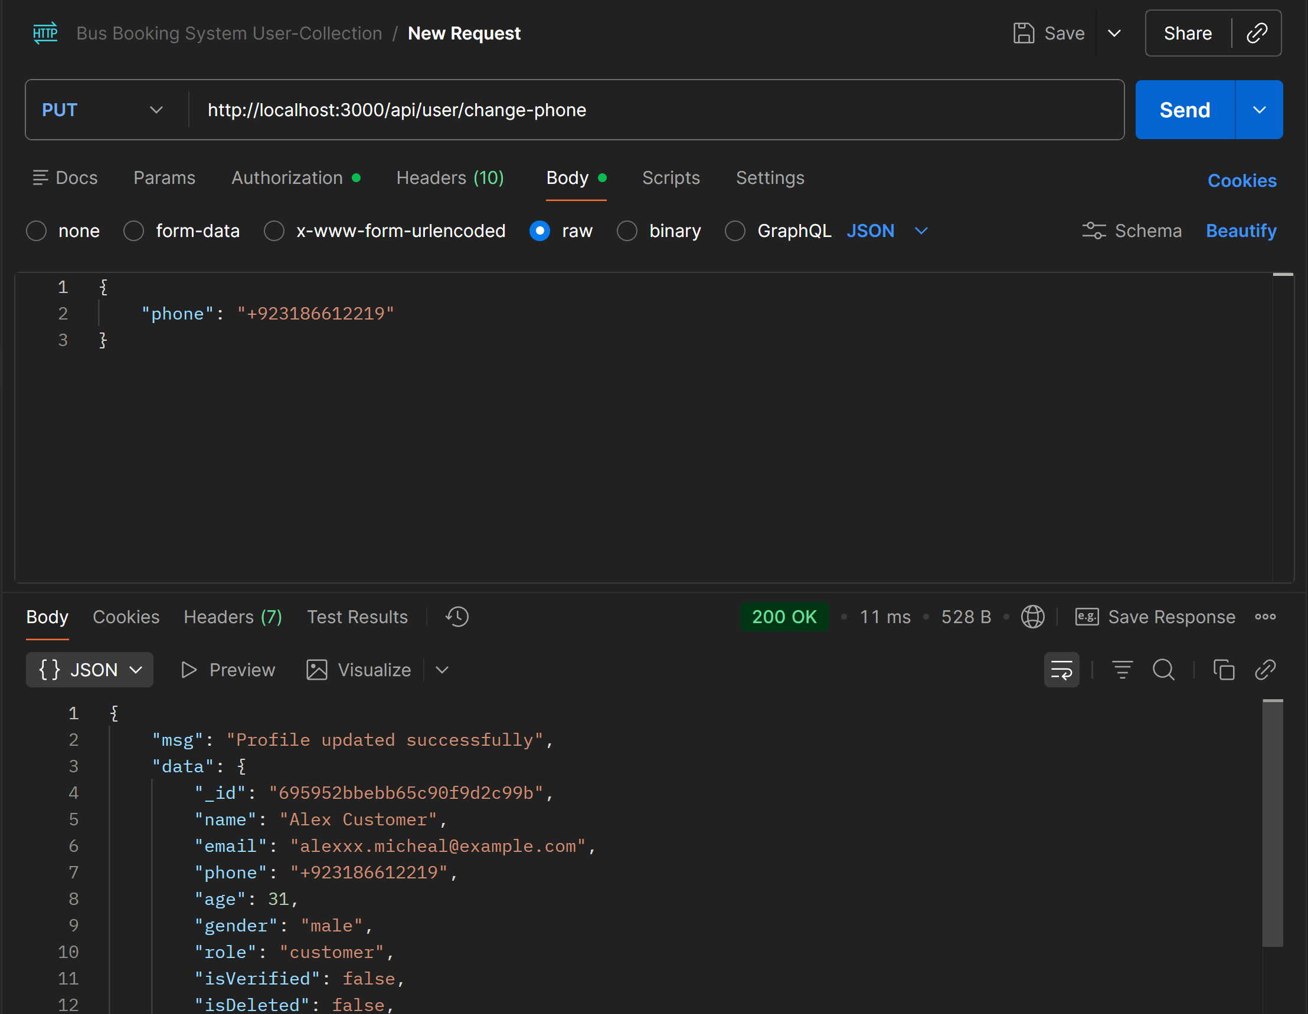
http://localhost:3000/api/user/change-password
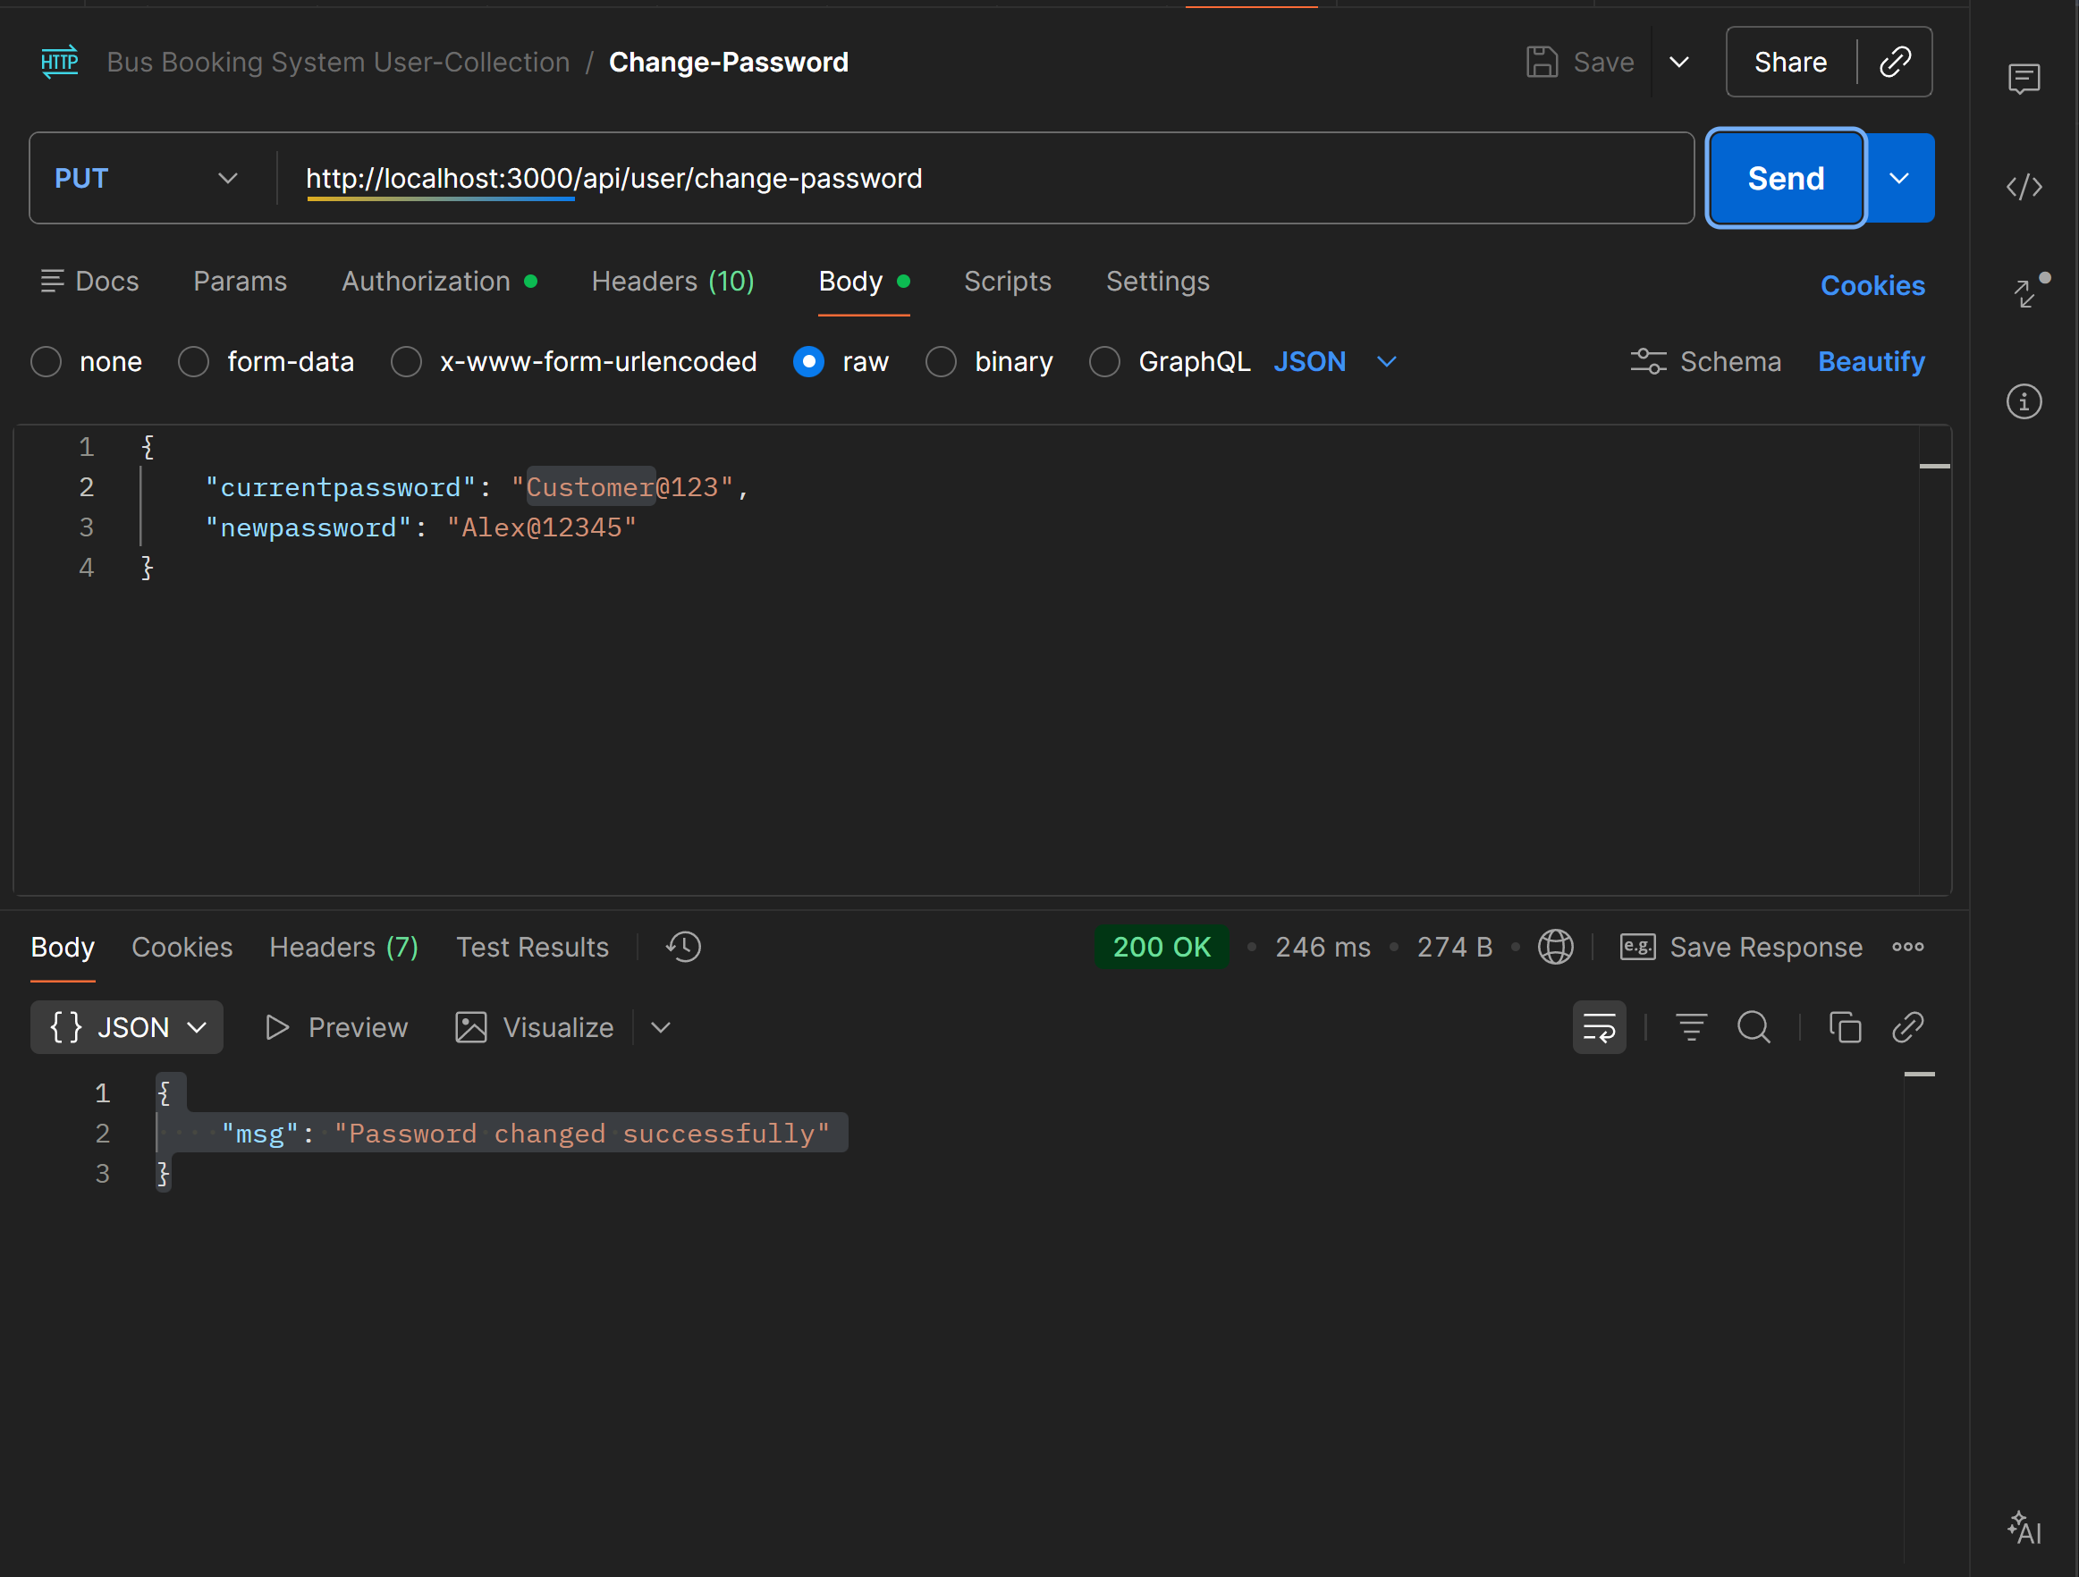
http://localhost:3000/api/user/delete-account
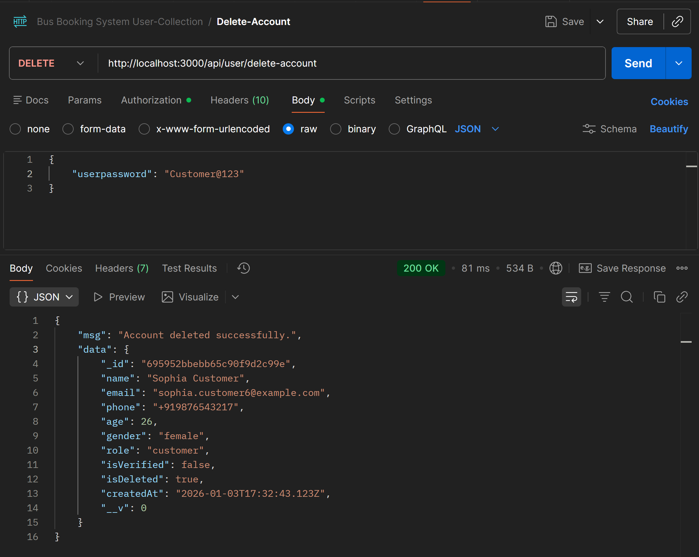

Route Endpoints
Collection Link: https://maaz-javeed2005-9007721.postman.co/workspace/Maaz-Javeed's-Workspace~90914847-54d0-4bc0-8704-77005f85d0db/collection/49770149-f4a1d21a-90bd-4cb4-a39e-d604b87786f8?action=share&creator=49770149

- Route Create
http://localhost:3000/api/route/create
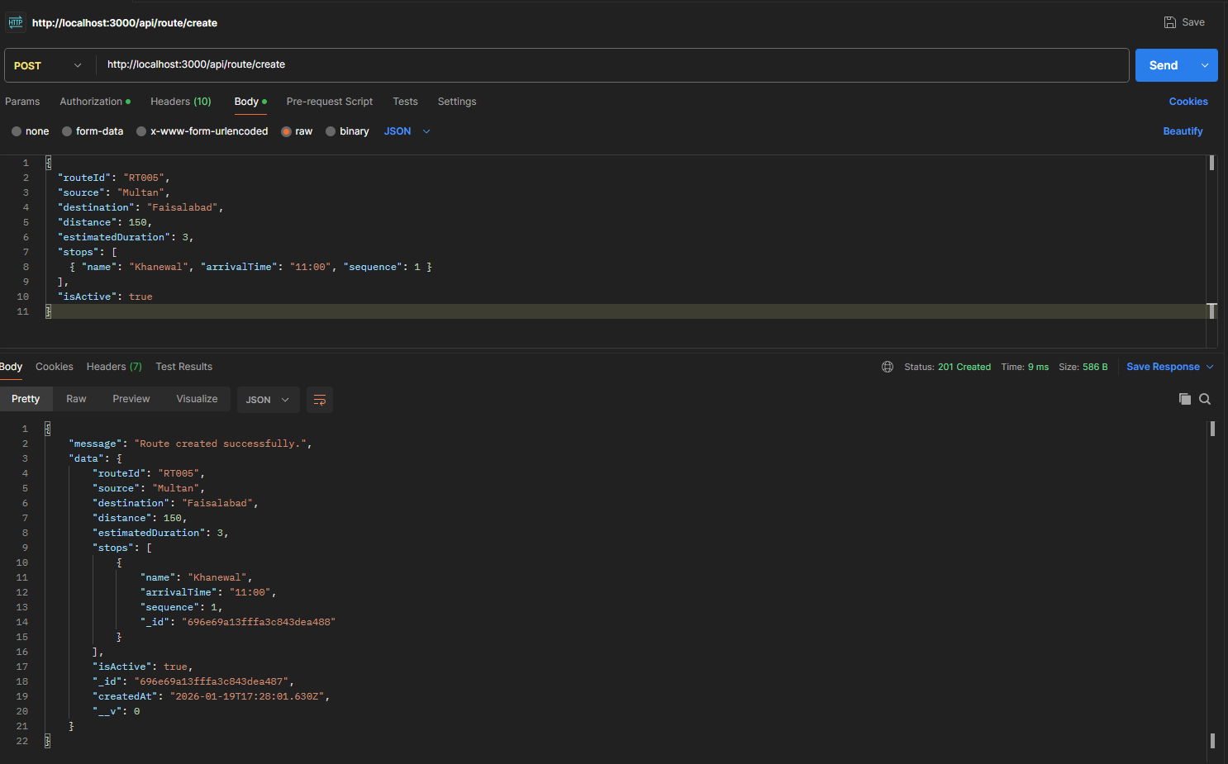

- Get Routes
http://localhost:3000/api/route/all
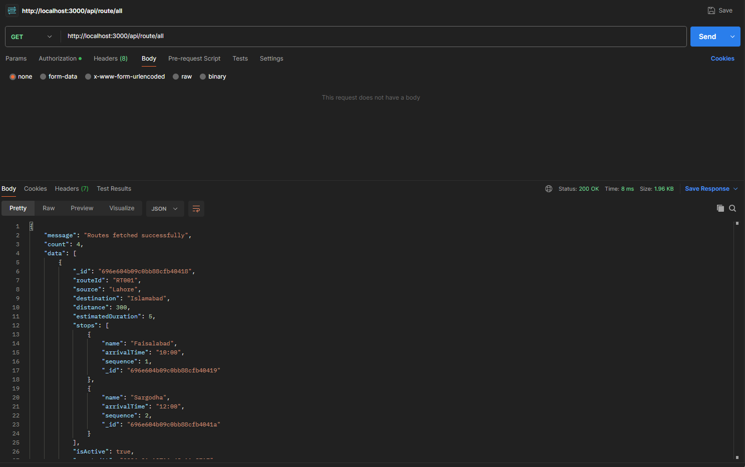

- Get Routes By ID
http://localhost:3000/api/route/696e604b09c0bb88cfb40418
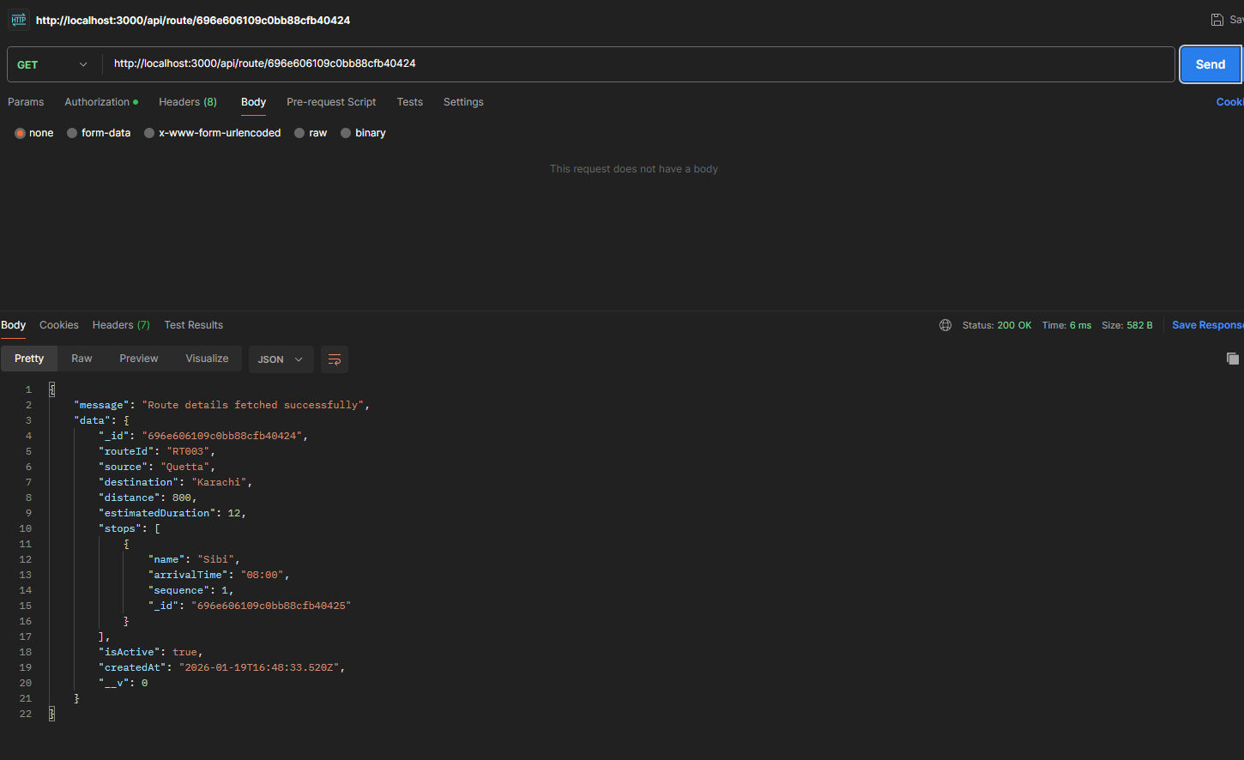

- Update Route By ID
http://localhost:3000/api/route/update/696e604b09c0bb88cfb40418
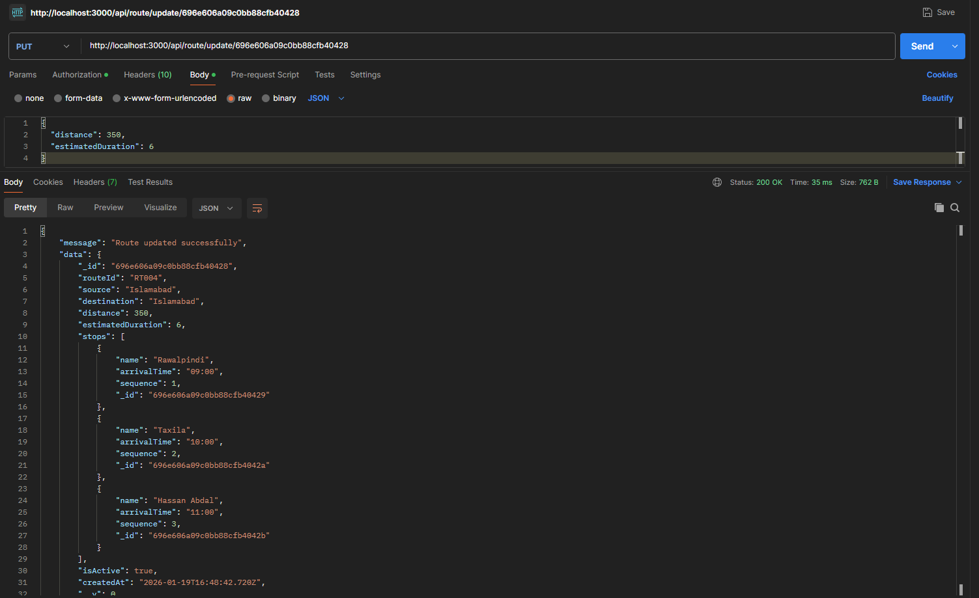

- Delete By ID
http://localhost:3000/api/route/delete/696e604b09c0bb88cfb40418 (Only Soft Delete)
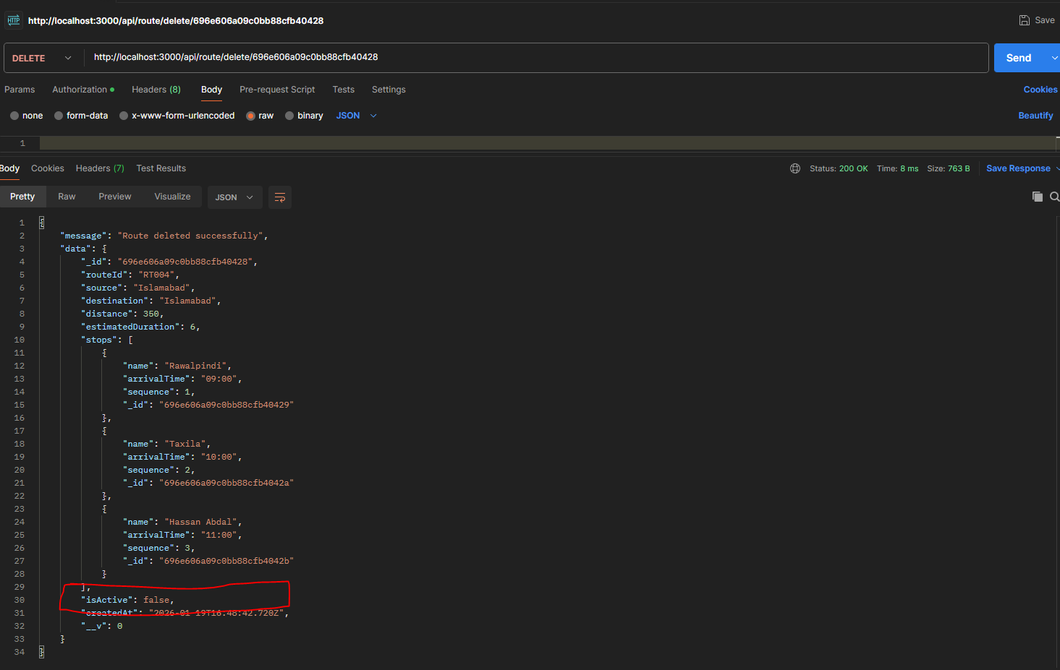

- Get Route By Source
http://localhost:3000/api/route/search/source/Lahore
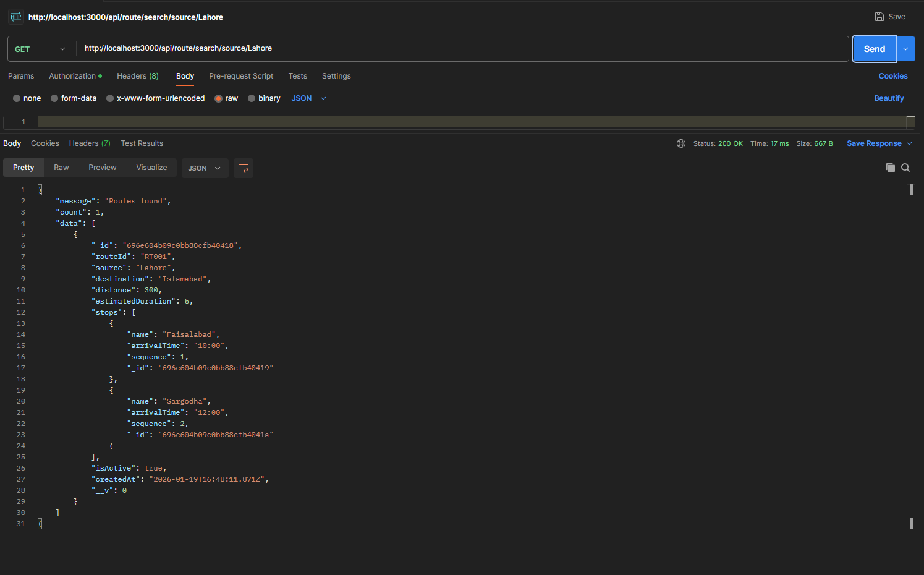

Trip Endpoints

- Trip Post
http://localhost:3000/api/trip/create
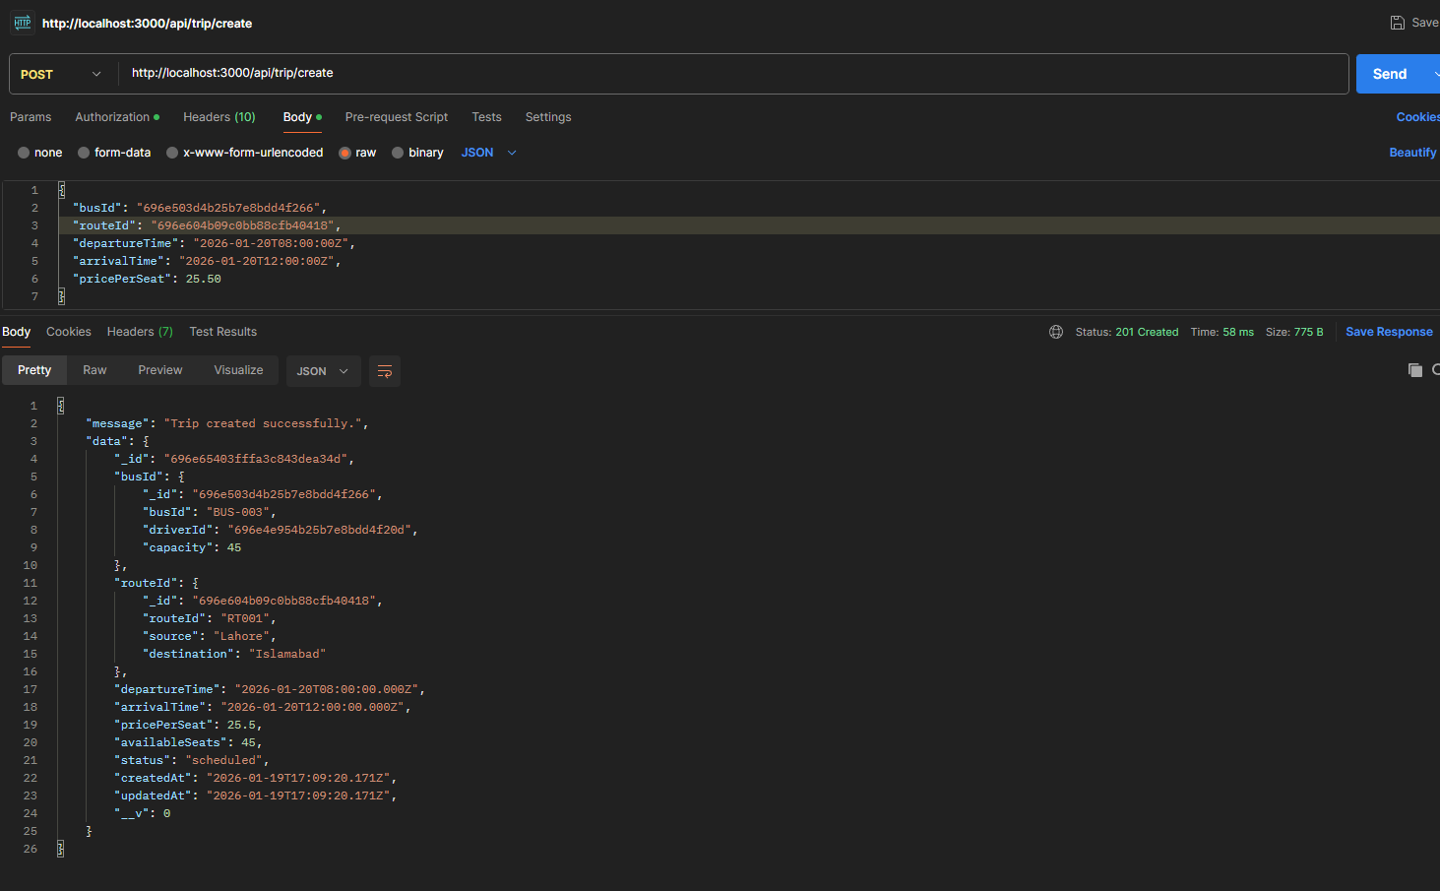

- GET ALL Trips
http://localhost:3000/api/trip/all
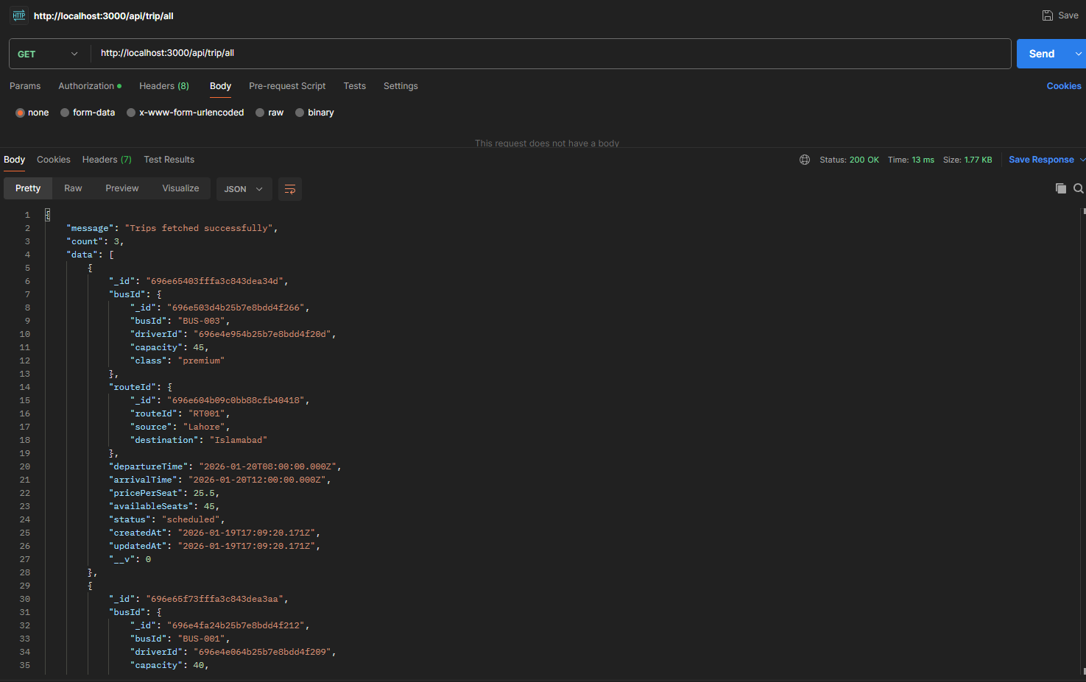

- GET By TripID
http://localhost:3000/api/trip/696e65f73fffa3c843dea3aa
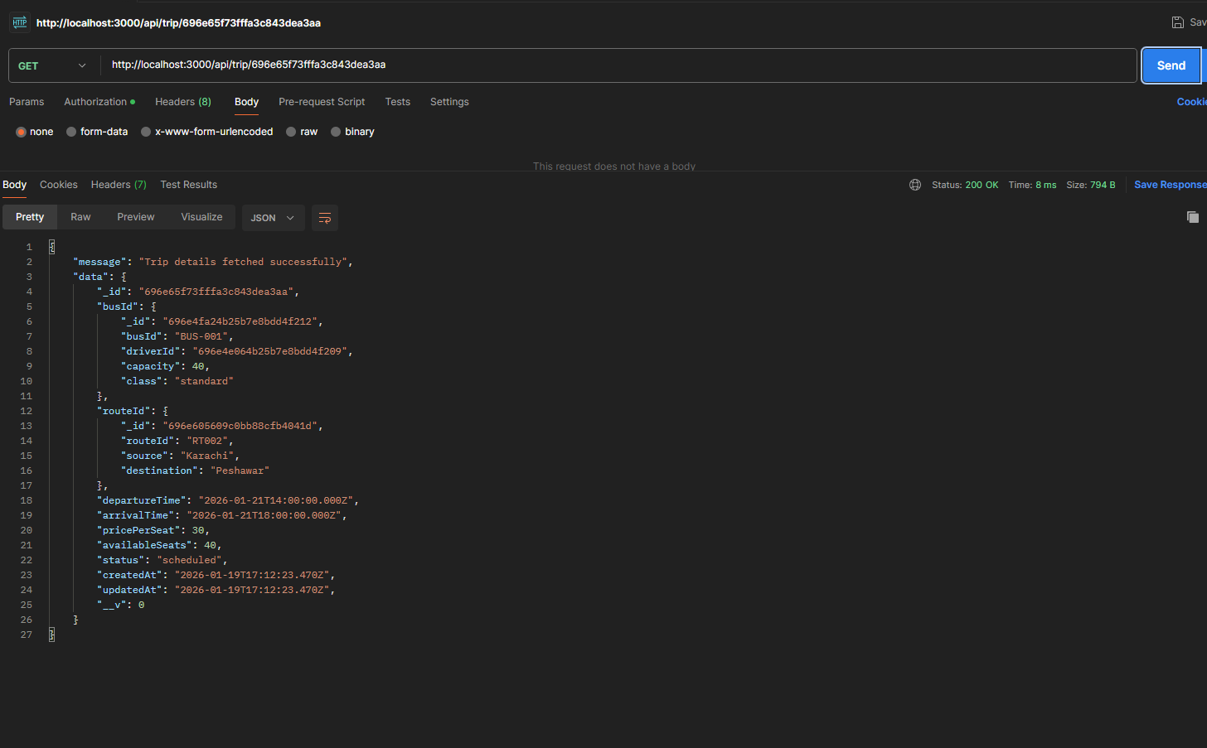

- GET By BusID
http://localhost:3000/api/trip/bus/696e4fa24b25b7e8bdd4f212
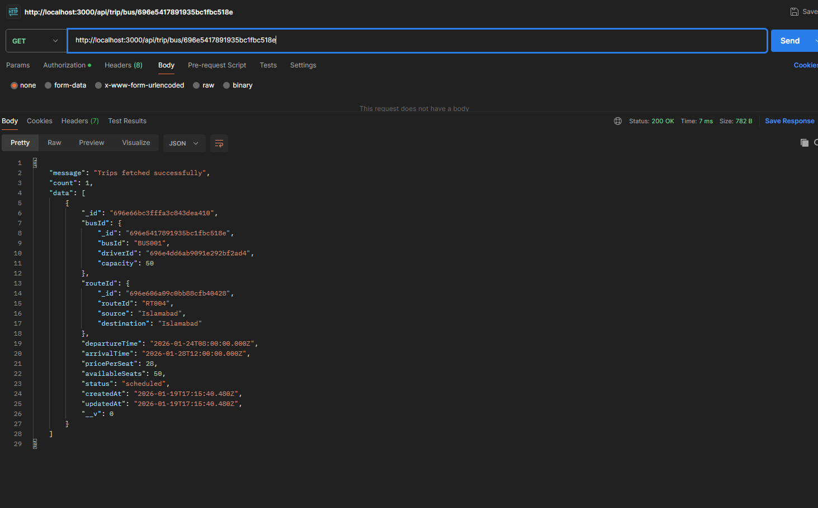

- Put Request
http://localhost:3000/api/trip/update/696e65f73fffa3c843dea3aa
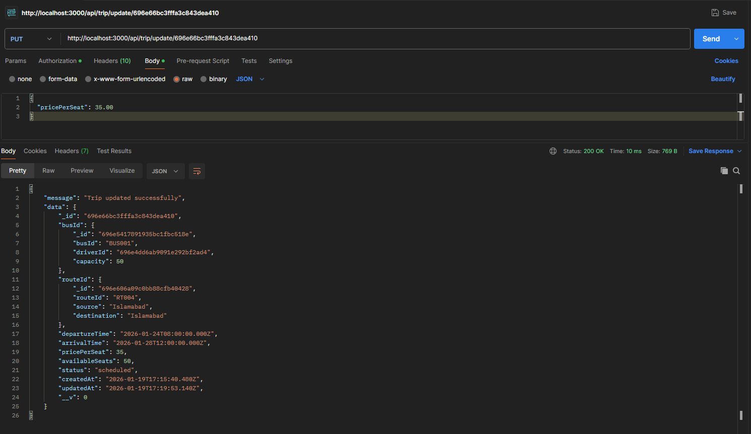

- Put: Cancel Trip
http://localhost:3000/api/trip/cancel/696e66bc3fffa3c843dea410
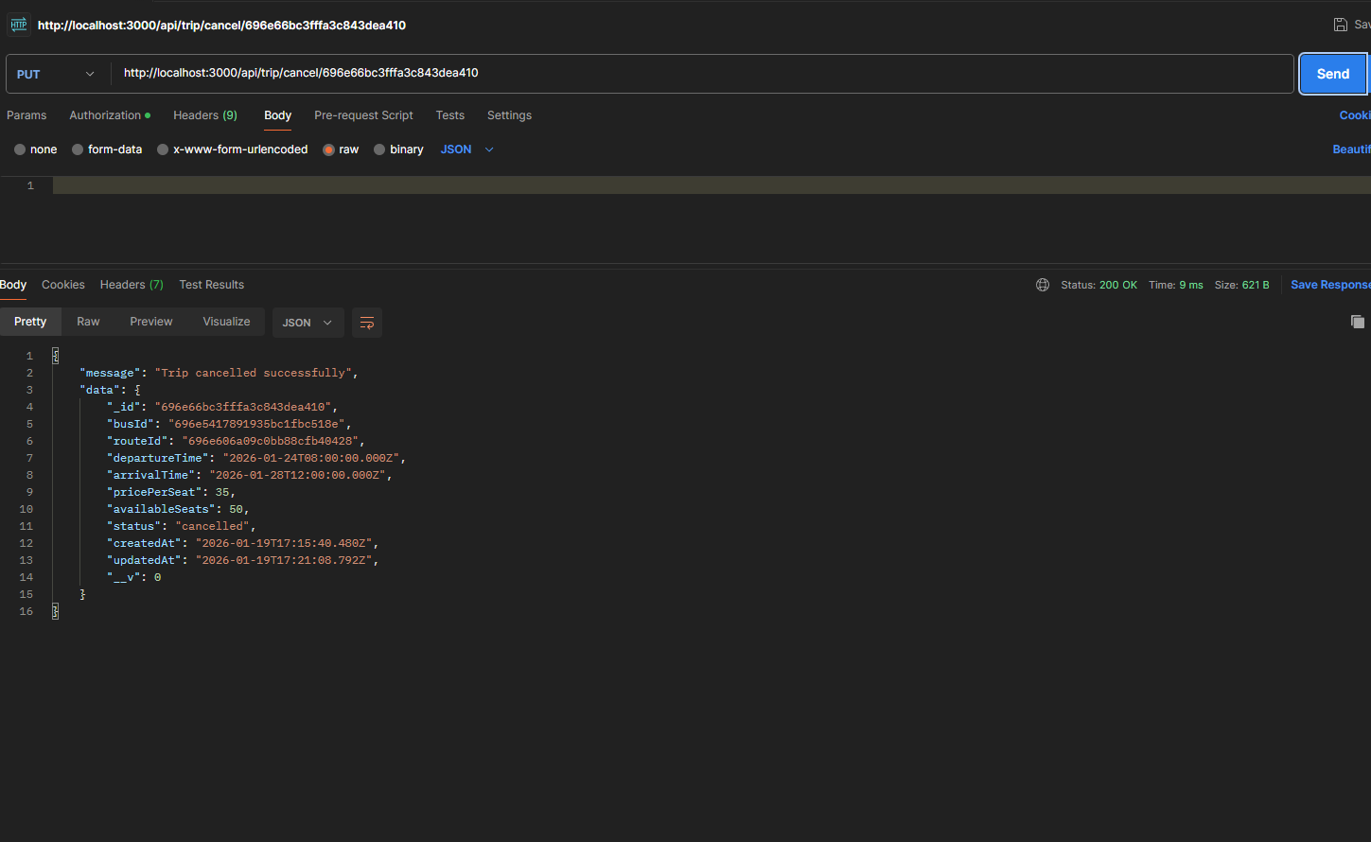

- Get Available Seats
http://localhost:3000/api/trip/696e65403fffa3c843dea34d/seats
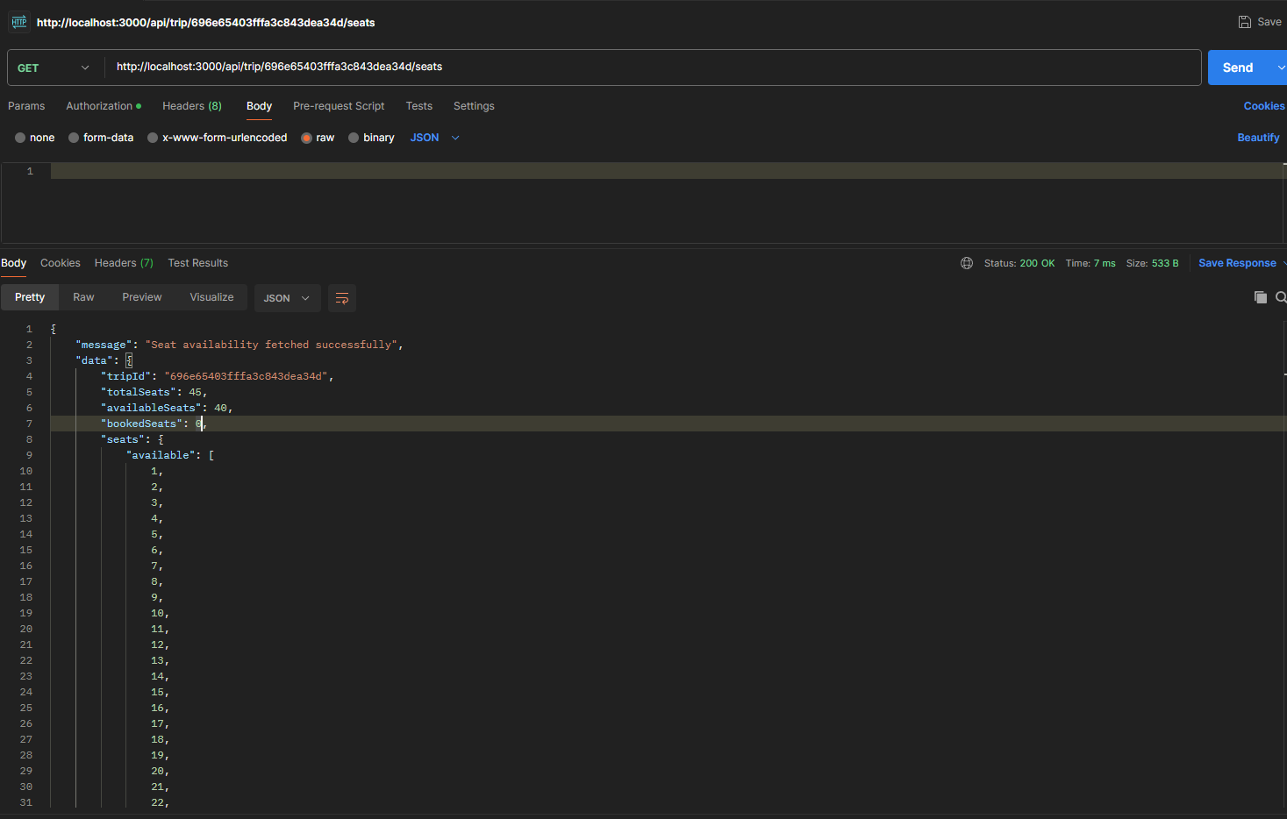

Trip Endpoints

- Add
http://localhost:3000/api/bus/add

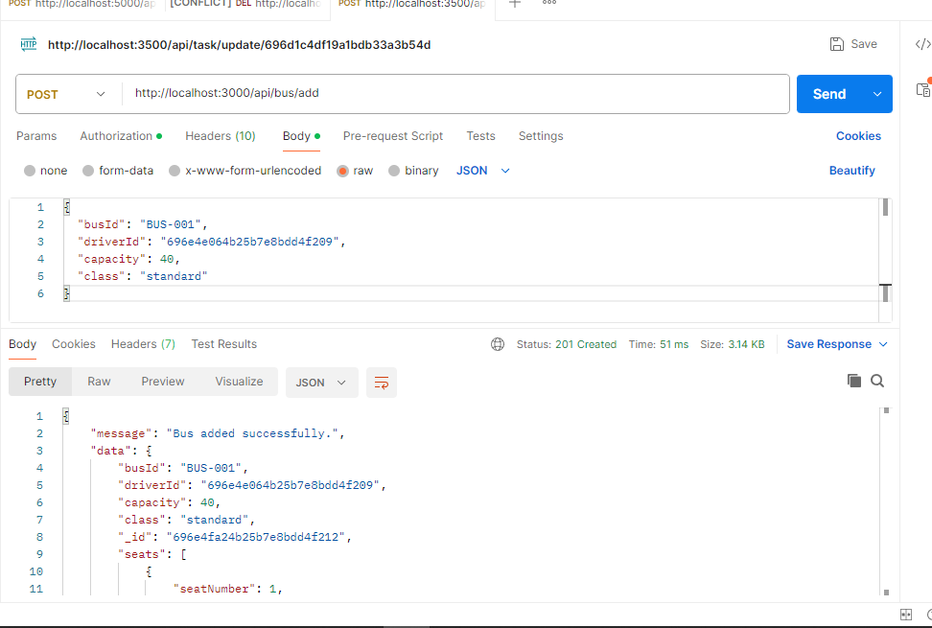

- GET ALL
http://localhost:3000/api/bus/all

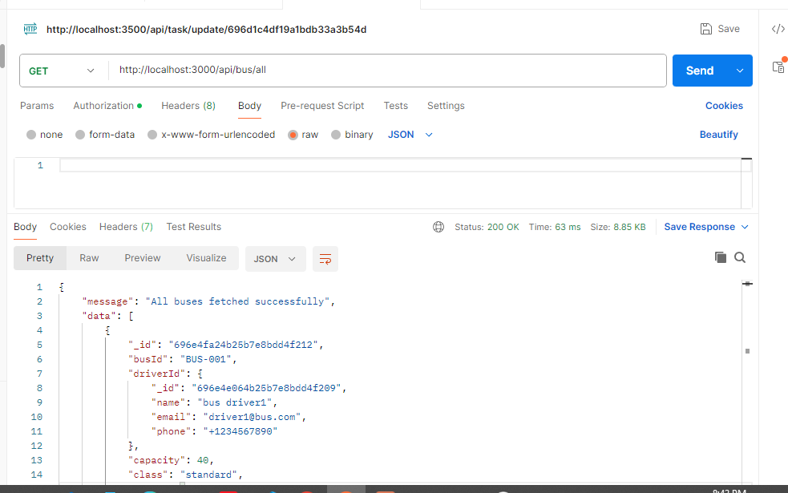

- Get By Id
http://localhost:3000/api/bus/696e503d4b25b7e8bdd4f266

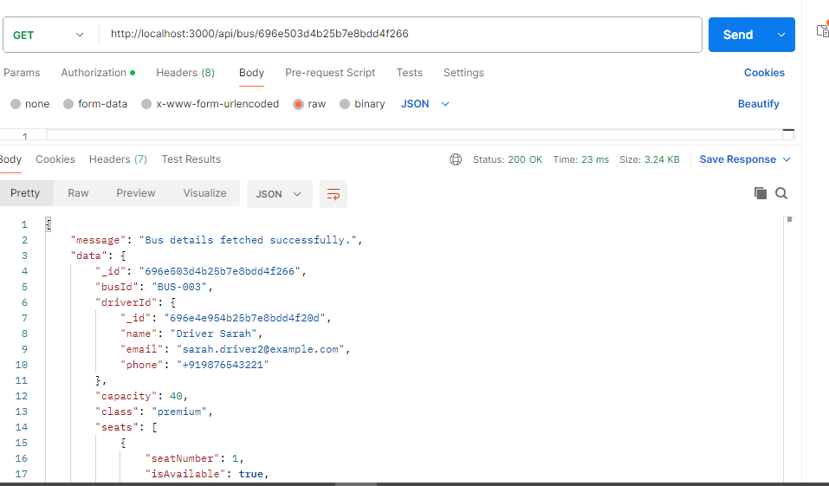

- Get By Driver
http://localhost:3000/api/bus/driver/696e4e614b25b7e8bdd4f20b

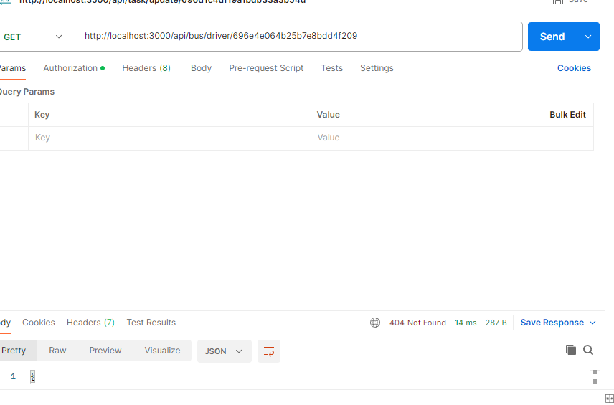

- update by id
http://localhost:3000/api/bus/update/696e503d4b25b7e8bdd4f266

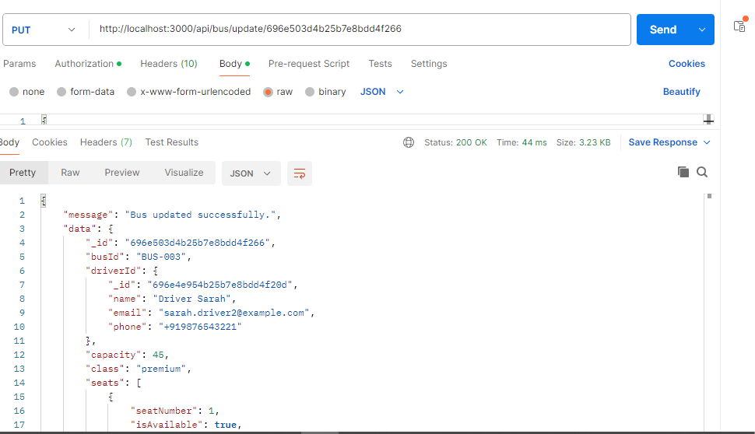

- Delete
http://localhost:3000/api/bus/delete/696e50124b25b7e8bdd4f23e

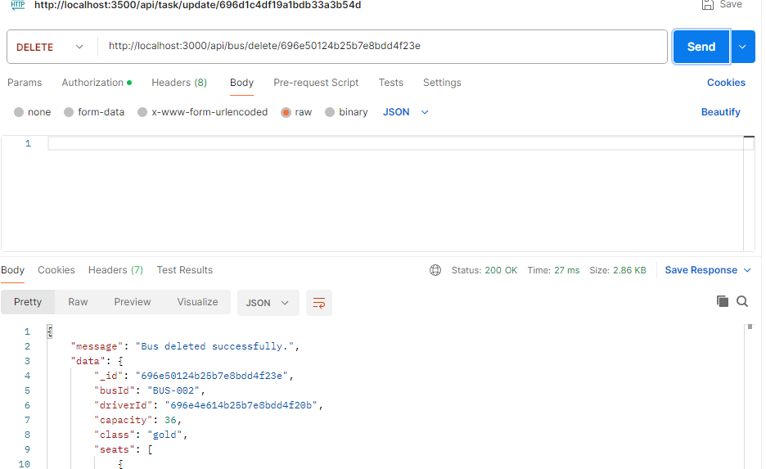

Ticket Endpoints:

Ticket creation:

http://localhost:3000/api/ticket/book
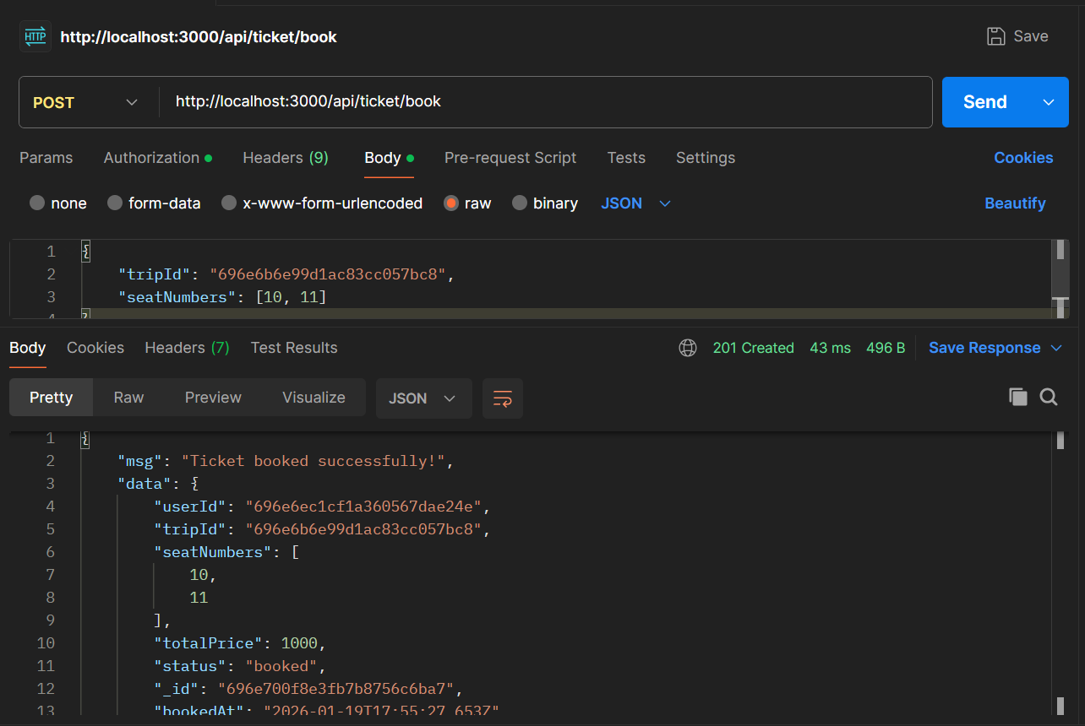

Ticket view:

http://localhost:3000/api/ticket/view
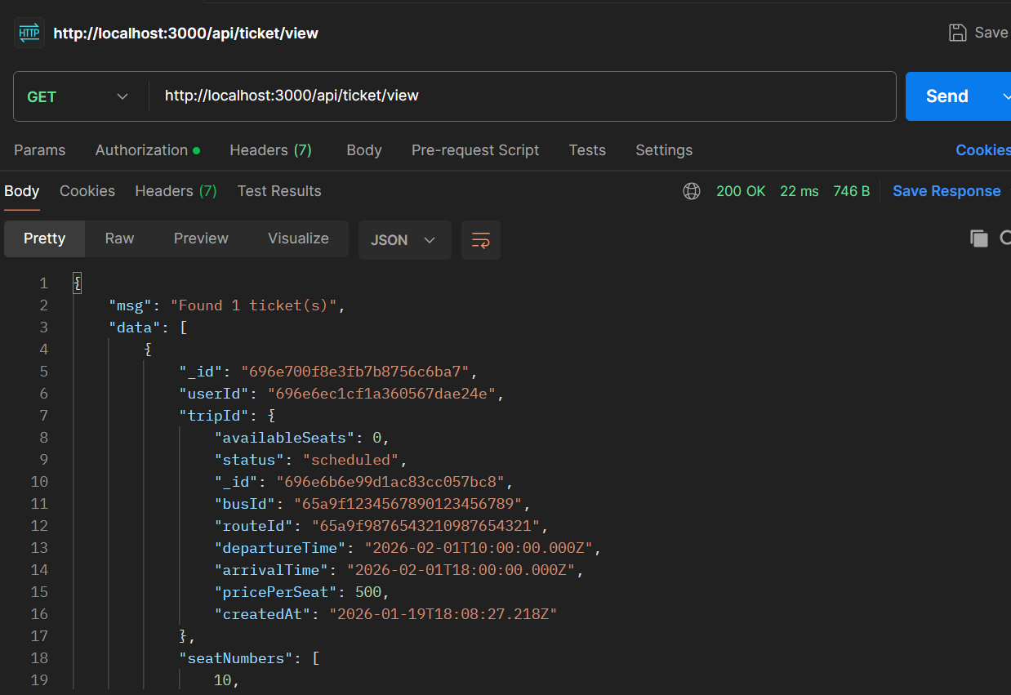

Ticket cancellation:

http://localhost:3000/api/ticket/cancel/696e700f8e3fb7b8756c6ba7
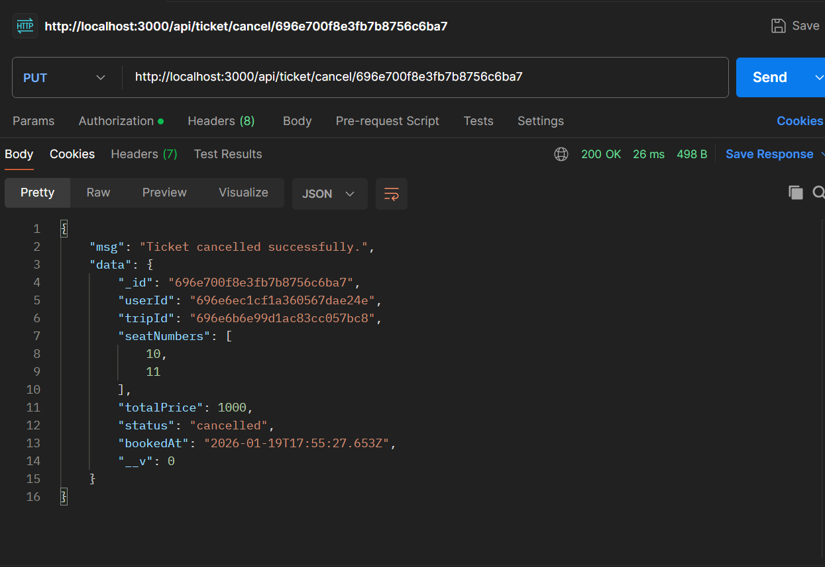

Ticket Refund:

http://localhost:3000/api/ticket/refund/696e700f8e3fb7b8756c6ba7
