2018

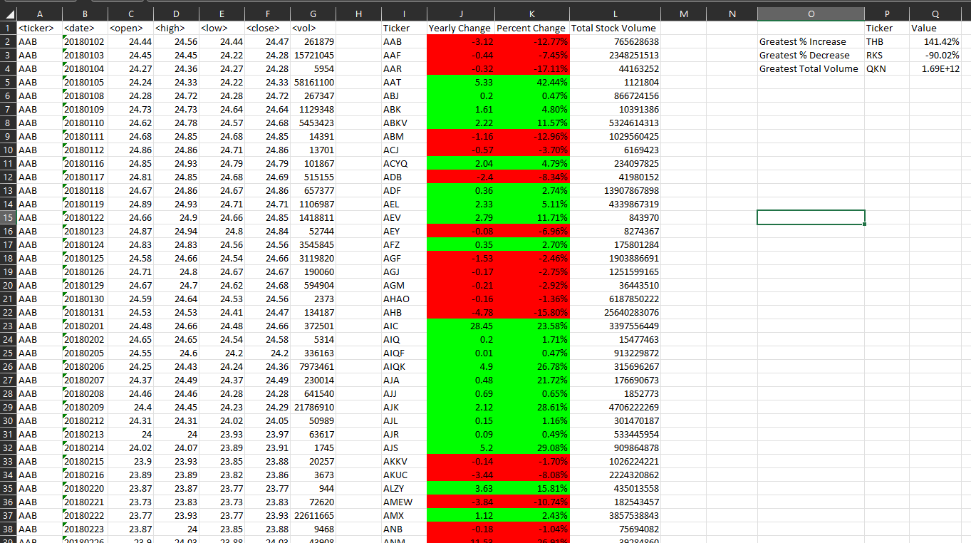

2019

2020

